Week: 8 Preparing date: 27/10/2024
Period: 29 Teaching date: 29/10/2024

Unit 5: Things we can do
Lesson 1 (1, 2, 3)
A. OBJECTIVES:
By the end of the lesson, Ss will be able to:
1. Knowledge:
- understand and correctly repeat the sentences in two communicative contexts (pictures) in which pupils ask and answer questions about someone’s abilities.
- correctly say the phrases and use Can you …….? – Yes, I can. / No, I can’t. to ask and answer questions about someone’s abilities.
- enhance the correct use of Can you ……..? – Yes, / No, ……... to ask and answer questions about pupils’ abilities in a freer context.
- Vocabulary: ride a bike, ride a horse, play the piano, play the guitar.
- Skills: speaking and listening
Students integrate: Read the words: ride a bike, ride a horse, play the piano, play the guitar.
2. Competences:
- Critical Thinking: self-introduce
- Co-operation: ready to help friends in pair work/ group work.
- Sociability: Talk to each other, say good words to others.
3. Attitude/ Qualities:
- Kindness: Help partners to complete learning tasks.
- Show pride in what they can do and great respect for other people’s abilities by using appropriate gestures and intonation when asking and answering about abilities.
B. TEACHING AIDS:
- Teacher: Teacher’s guide Pages 68,69,70, audio Tracks 46,47, website hoclieu.vn, posters, laptop, pictures, textbook, lesson plan, TV or projector.
- Students: Pupil’s book Page 34, notebooks, workbooks, school things.
C. PROCEDURES:
Teacher’s activities | Students’ activities
1.Warm- up: (3’)  Sing: The hobby song  *Aims: to create a friendly and active atmosphere in the class to beginning the lesson.  *Procedure:  - Show the song on the screen.  https://www.youtube.com/watch?v=90LfcLAjLiI  - Ask Ss to listen, sing and dance the song.  - Say “Open your book page 34” and look at “Unit 5, Lesson 1 (1,2,3)”.  2. Presentation(16’)  Activity 1. Vocabulary.  *Aims: Ss will be able to know the vocabulary in the new lesson.  *Procedure:  -T elicits the new words  + ride a bike : đạp xe (picture)  + ride a horse : cưỡi ngựa (picture)  + play the piano :chơi đàn pi-a-no (mime)  + play the guitar : chơi đàn ghi ta (mime)  - T models (3 times).  - T writes the words on the board.  - Checking: Matching  Activity 2. Look, listen and repeat:  *Aims: Ss will be able to understand and correctly repeat the sentences in two communicative contexts (pictures) in which pupils ask and answer questions about someone’s abilities.  *Procedure:  - Have Ss look at Pictures a and b and identify the characters in the pictures.  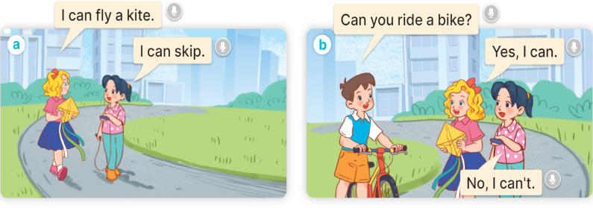  - Play the audio twice (sentence by sentence). Correct their pronunciation where necessary.  - Have Ss to practice the dialogue  - T invites a few pairs to the front of the class to practice.  - T checks pronunciation for ss.  Activity 3 2. Listen, point and say.  *Aims: Ss will be able to correctly say the phrases and use Can you ……...? – Yes, I can. /No, I can’t. to ask and answer questions about someone’s abilities  *Procedure:  * Model sentences:  - T asks Ss look at picture a and helps Ss know the structure from the dialogue.  - T introduces new structure for Ss.  - T explains, models and gives meaning.  - Have Ss repeat the model sentences.  A: Can you ride a bike?  B: Yes, I can./ No, I can’t.  3.Practice: (7’)  *Drill pictures  - Elicit and check comprehension the name of each character.  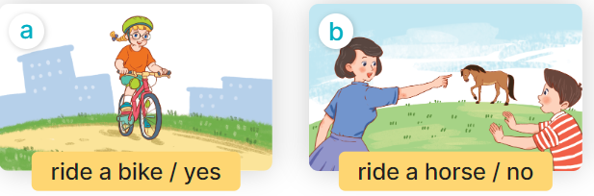  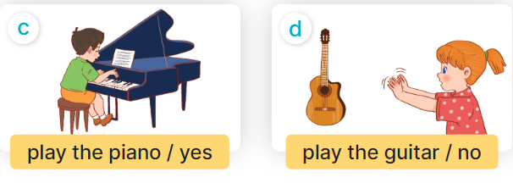  - Run through all the pictures.  - Run through model sentences.  - Have Ss to practise:  + T asks, Ss answer picture a  + Ss ask, T answers picture b  + Group A ask, group B answer picture c  + Group B ask, group A answer picture d  - Ask Ss to work in pairs.  - T controls and corrects.  - Invite a few pairs to come to the front of the classroom and point at the pictures and say the questions and answers in front of the class.  - T gives feedbacks.  4.Production: (7’)  Activity 4. Let’s talk.  *Aims: Ss will be able to enhance the correct use of Can you …. ? – Yes, / No, …... to ask and answer questions about pupils’ abilities in a freer context.  *Procedure:  - T asks ss to guess each character and what the children say.  + What can you see in the picture?  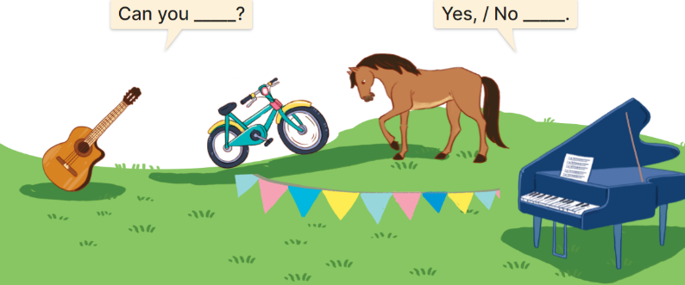  - T fills the gaps and writes the sentences on the board.  - T models  - T asks Ss to ask and answer questions using Can you? –Yes/ No, ………...  - Invite some pairs to perform.  - Give feedbacks  *Consolidation  *Aims: Ss will be able consolidate and wrap up the content of the lesson.  *Procedure:  - T asks ss to answer the following questions:  + What have you learnt from the lesson today?  +What are the core values of the lesson? (if the teacher can take from the lesson).  - T review the vocabulary and model sentences.  - T praises some Ss who are hardworking / active/ good…. as well as encourage others to try more.  5. Homework. (2’)  - Learn the vocabulary and model sentences by heart  - Prepare the new lesson: Unit 5, Lesson 1 (4,5,6). | - Ss sing and dance the song  - Ss open their books  Students integrate: Read the words: ride a bike, ride a horse, play the piano, play the guitar.  -Ss listen and answer  - - Ss listen and repeat  + Choral repetition (3 times).  + Individual repetition (3 ss)  - Ss take note  - Ss look, remember and match  -Look at the pictures and get to know the characters in the pictures.  + In picture a:  Mary: I can fly a kite.  Mai: I can skip.  + In picture b:  Minh: Can you ride a bike?  Mary: Yes, I can.  Mai: No, I can't.  -Ss listen and repeat in chorus (twice)  -Ss work in pairs to practice  -Ss practice the dialogue  -Ss listen  -Ss look at the picture and answer.  -Ss listen  -Ss listen and repeat  -Ss repeat to the the sentences  - Ss look, listen and answer  + Picture a: a girl riding a bike  + Picture b: a boy who can’t ride a horse  + Picture c: a boy playing the piano  + Picture d: a girl who can’t play the guitar  -Ss listen and repeat  -Ss practice in chorus  -Ss practice in chorus  -Ss work in pairs to practice  -Ss point and say  -Ss listen.  -Ss look at the picture and answer  A summer camp poster. There are four activities in the poster.  -Ss note  - Ss say the completed sentences.  -Ss work in pairs  -Ss perform in front of the class.  -Ss answer the questions  - Ss listen  -Ss listen and clap their hands  -Ss listen and take note

D. ADJUSTMENTS (if necessary):
………………………………………………………………………………………….…..……………………………………………………………………………...………………………………………….…..……………………………………………………………………………….……………………………………………………………………...

