Week: 11 Preparing date: 20/11/2024
Period: 44 Teaching date: 22/11/2024

Unit 7: Our timetables
Lesson 1 (1, 2, 3)
A. OBJECTIVES:
By the end of the lesson, Ss will be able to:
1. Knowledge:
- use the words English, maths, science, Vietnamese in relation to the topic “Our timetable”
- use What subjects do you have today? – I have ……. to ask and answer questions about school subjects
- Vocabulary: English, maths, science, Vietnamese, subject
- Skills: speaking and listening
Students integrate: Read the words: English, maths, science, Vietnamese, subject
2. Competences:
- Co-operation: ready to help friends in pair work/ group work.
- Sociability: Talk to each other, say good words to others.
3. Attitude/ Qualities:
- Show their responsibility to follow the timetable and prepare their subjects before school.
B. TEACHING AIDS:
- Teacher: Teacher’s guide Pages 100, 101, audio Tracks 67, 68, website hoclieu.vn, posters, laptop, pictures, textbook, lesson plan, TV or projector.
- Students: Pupil’s book Page 50, notebooks, workbooks, school things.
C. PROCEDURES:
Teacher’s activities | Students’ activities
1.Warm- up: (3’)  Sing: Baby shark  *Aims: to create a friendly and active atmosphere in the class to beginning the lesson.  *Procedure:  - Show the song on the screen.  https://www.youtube.com/watch?v=XqZsoesa55w  - Ask Ss to listen, sing and dance the song.  - Say “Open your book page 50” and look at “Unit 7, Lesson 1 (1,2,3)”.  2. Presentation (16’)  Activity 1. Vocabulary.  *Aims: Ss will be able to know the vocabulary in the new lesson.  *Procedure:  -T elicits the new words  + English : môn tiếng anh (realia)  + Vietnamese : môn tiếng việt (realia)  + Maths :môn toán (realia)  + Science : môn khoa học (realia)  + subject : môn học (translation)  - T models (3 times).  - T writes the words on the board.  - Checking: Rub out and remember  Activity 2. Look, listen and repeat:  *Aims: Ss will be able to understand and correctly repeat the sentences in two communicative contexts in which characters ask and answer questions about what subjects they have.  *Procedure:  - Have Ss look at Pictures a and b and identify names of the speakers in the pictures.  + Who is he / she?  + Where is he / she?  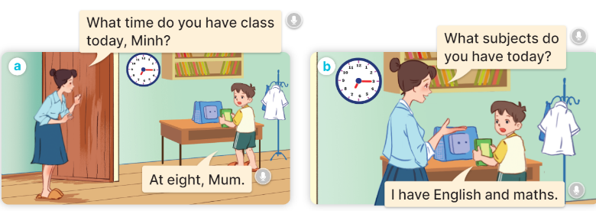  - Play the audio twice (sentence by sentence). Correct their pronunciation where necessary.  - Have Ss to practice the dialogue  - T invites a few pairs to the front of the class to practice.  - T checks pronunciation for ss.  Activity 3 2. Listen, point and say.  *Aims: Ss will be able to correctly say the words and use What subjects do you have today? – I have …….. to ask and answer questions about school subjects. *Procedure:  * Model sentences:  - T asks Ss look at picture b and helps Ss know the structure from the dialogue.  - T introduces new structure for Ss.  - T explains, models and gives meaning.  -Have Ss repeat the model sentences.  A: What subjects do you have today?  B: I have English.  3.Practice: (7’)  *Drill pictures  - Ask pupils to look at Pictures a, b, c and d and identify the names of the subjects.  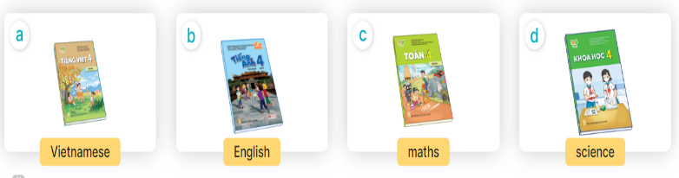  - Play the recording for pupils to listen to and repeat the words under the pictures in chorus and individually.  - Play the recording for pupils to listen to and repeat the sentences in both bubbles a few times.  - Let pupils practise asking and answering questions in pairs.  - Invite a few pairs to point at the pictures and ask and answer questions about what subject they have today.  4.Production: (7’)  Activity 4. Let’s talk.  *Aims: Ss will be able to enhance the correct use of What subjects do you have today? – I have …… to ask and answer questions about school subjects in a freer context.  *Procedure:  - Ask questions to help them identify the context  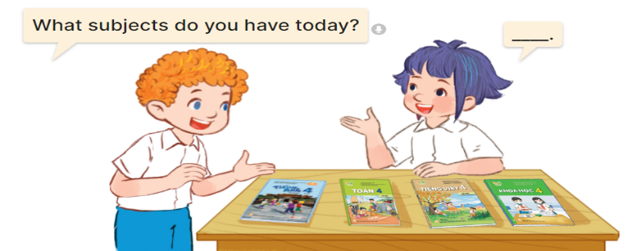  - Elicit the missing words in the speech bubble and write them on the board.  - Get pupils to say the completed sentences.  - Put pupils into pairs to practice the exchanges.  - Invite a few pairs to point at the pictures and ask and answer questions about school subjects.  *Consolidation  *Aims: Ss will be able consolidate and wrap up the content of the lesson.  *Procedure:  - T asks ss to answer the following questions:  + What have you learnt from the lesson today?  +What are the core values of the lesson? (if the teacher can take from the lesson).  - T review the vocabulary and model sentences.  - T praises some Ss who are hardworking / active/ good…. as well as encourage others to try more.  5. Homework. (2’)  - Learn the vocabulary and model sentences by heart  - Prepare the new lesson: Unit 7, Lesson 1 (4,5,6). | - Ss sing and dance the song  - Ss open their books  Students integrate: Read the words: English, maths, science, Vietnamese, subject  -Ss listen and answer  - - Ss listen and repeat  + Choral repetition (3 times).  + Individual repetition (3 ss)  - Ss take note  - Ss look, remember and write  -Look at the pictures and say  + In picture a:  Mum: What time do you have school today, Minh?  Minh: At eight, Mum.  + In picture b:  Mum: What subjects do you have today?  Minh: I have English and maths.  -Ss listen and repeat in chorus (twice)  -Ss work in pairs to practice  -Ss practice the dialogue  -Ss listen  -Ss look at the picture and answer.  -Ss listen  -Ss listen and repeat  -Ss repeat  - Ss look, listen and answer  + Picture a: A Vietnamese textbook  + Picture b: An English textbook  + Picture c: A maths textbook  + Picture d: A science textbook  -Ss listen and repeat  -Ss listen and repeat  -Ss practice  -Ss point, ask and answer.  -Ss look at the picture and answer  + a boy and a girl talking about school subjects with four textbooks (Vietnamese, English, maths, science) on a desk  -Ss listen and answer  -Ss say the completed sentences  -Ss work in pairs  -SS point, ask and answer.  -Ss answer the questions  - Ss listen  -Ss listen and clap their hands  -Ss listen and take note
D. ADJUSTMENTS (if necessary):
………………………………………………………………………………………….…..……………………………………………………………………………...………………………………………….…..……………………………………………………………………………….……………………………………………………………………...

