Week: 11 Preparing date: 20/11/2024
Period: 43 Teaching date: 22/11/2024

Unit 6: Our school facilities
Lesson 3 (4, 5, 6)
A. OBJECTIVES:
By the end of the lesson, Ss will be able to:
1. Knowledge:
- use the words city, mountains, town, village in relation to the topic "Our school facilities".
- use Where’s your school? – It’s in the …... to ask and answer questions about the location of a school;
- read and demonstrate understanding of simple communicative contexts in relation to the topic “Our school facilities”.
- write and draw about school locations and describe the surrounding.
- Vocabulary: Review
- Skills: speaking, listening, reading and writing.
Students integrate: Read some sentences of the paragraph (4/49)
2. Competences:
- Co-operation: ready to help friends in pair work/ group work.
- Self-control and independent learning: perform listening tasks.
3. Attitude/ Qualities:
- Show pride in where they’re from and great respect for other people’s locations by using appropriate gesture and intonation when asking and answering about school locations
B. TEACHING AIDS:
- Teacher: Teacher’s guide Pages 98, 99; website hoclieu.vn, posters, laptop, pictures, textbook, lesson plan, TV or projector.
- Students: Pupil’s book Page 49, notebooks, workbooks, school things.
C. PROCEDURES:
Teacher’s activities | Students’ activities
1.Warm- up: (5’)  Game: “Chant”  *Aims: to review the vocabulary and structure about greet and respond to greetings.  *Procedure:  - Ask Ss chant and do the actions in Unit 6, Lesson 3 page 48 in groups.  - Give point for the groups and encourage them.  - Say “Open your book page 49” and look at “Unit 6, Lesson 3 (4, 5, 6)”.  2.Practice: (8’)  Activity 1. Read and complete:  *Aims: Ss will be able to read a paragraph about a school and complete four gapped sentences about its location and facilities.  *Procedure:  - Elicit and introduce the context.  - Have Ss read aloud the words to fill in.  - Model the first blank with Ss to make sure that they know how to do the task.  - Give Ss enough time to complete the text.  - Check the answers as a class.  - Have Ss read the text aloud.  Key: 1. village 2. three  3. garden 4. big playground  3.Production: (19’)  Activity 2. Let’s write  *Aims: Ss will be able to read, understand and complete a gapped paragraph about their own school locations and facilities.  *Procedure:  - Explain to the class the goal of this activity.  - Have pupils to guess the missing information and complete the sentence with their own information.  - Give pupils time to write their answers.  - Get pupils to swap books and correct their answers in pairs.  - Invite a pupil to stand up and read his / her completed sentences.  Key: Pupils’ answer  Ex: My school is big. There are three buildings at my school. There is a big garden. My school has a playground. We can play football, badminton and volleyball there. I love my school!  Activity 3. Project.  *Aims: Ss will be able to draw pupils’ schools and its facilities and present their drawings to the class  *Procedure:  - Point at the sample drawing and explain that pupils are going to talk about the drawings of their schools including its location and some of its facilities.  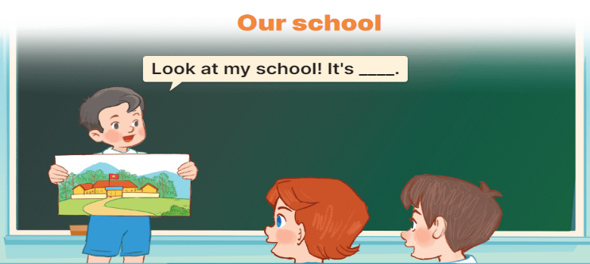  - Have pupils show their drawings that they have prepared for the project.  - Give pupils time to practise their presentations by themselves.  - Give pupils some time to use their drawings to practise presenting in groups.  - Select a few pupils to give their presentations in front of the class.  - Get other pupils to give comments, and give corrections and feedback as necessary.  *Consolidation  *Aims: Ss will be able consolidate and wrap up the content of the lesson.  *Procedure:  - T asks ss to answer the following questions:  + What have you learnt from the lesson today?  +What are the core values of the lesson? (if the teacher can take from the lesson).  - T praises some Ss who are hardworking / active/ good…. as well as encourage others to try more.  4. Homework. (3’)  - Prepare the new lesson: Unit 7, Lesson 1 (1, 2, 3). | - Ss listen and chant  - Ss open their books  Students integrate: Read some sentences of the paragraph (4/49)  - Ss listen and answer  -Ss read the words and fill  -Ss fill in the gap  -Ss complete the text  -Ss check their answer  -Ss read aloud  -Ss listen  -Ss guess the missing word  -Ss write the answers  -Ss swap books and check the answer  -SS read aloud  -Ss listen  -Ss show the picture  -Ss practice  -Ss work in groups and practice  -Ss present in front of the class  -Ss comments, and give corrections  -Ss answer the questions  -Ss listen and clap their hands  -Ss listen and take note
D. ADJUSTMENTS (if necessary):
………………………………………………………………………………………….…..……………………………………………………………………………...…………

