Week: 10 Preparing date: 13/11/2024
Period: 40 Teaching date: 15/11/2024

Unit 6: Our school facilities
Lesson 2 (1, 2, 3)
A. OBJECTIVES:
By the end of the lesson, Ss will be able to:
1. Knowledge:
- use How many ….. are there at your school? – There is ….. / There are …… to ask and answer questions about the quantity of school facilities;
-listen to and demonstrate understanding of simple communicative contexts in relation to the topic “Our school facilities”.
-draw their school with some facilities and present it to the class.
- Vocabulary: building, garden.
- Skills: speaking and listening
Students integrate: Read the words: building, garden, playground, computer room.
2. Competences:
- Co-operation: ready to help friends in pair work/ group work.
- Sociability: Talk to each other, say good words to others.
3. Attitude/ Qualities:
- Kindness: Help partners to complete learning tasks.
- Honesty: tell the truth about feelings and emotions
B. TEACHING AIDS:
- Teacher: Teacher’s guide Pages 82, 83, 84; audio Tracks 61, 62, website hoclieu.vn, posters, laptop, pictures, textbook, lesson plan, TV or projector.
- Students: Pupil’s book Page 46, notebooks, workbooks, school things.
C. PROCEDURES:
Teacher’s activities | Students’ activities
1.Warm- up: (3’)  Game: Guessing and Choosing  *Aims: to create a friendly and active atmosphere in the class to beginning the lesson.  *Procedure:  - T shows 4 pictures of places and calls 4 Ss to come to the board and choose.  - T asks 4 Ss to come to the board and choose 1 picture of place and keep them in secret by covering them.  - The others will write their place in the board at their desks and keep their ideas in secret.  - The Ss on the board will 1 by 1 show their pictures they choose.  - When the teacher says the word of the pictures 1 by 1 shown on the board, who has the same places will raise their board or raise their hands.  - The Ss on the board will get the same points as the numbers of Ss raising their hands.  - Say “Open your book page 46” and look at “Unit 6, Lesson 2 (1,2,3)”.  2. Presentation (16’)  Activity 1. Vocabulary.  *Aims: Ss will be able to know the vocabulary in the new lesson.  *Procedure:  -T elicits the new words  + building : tòa nhà (picture)  + garden : khu vườn (picture)  - T models (3 times).  - T writes the words on the board.  - Checking: What and where  Activity 2. Look, listen and repeat:  *Aims: Ss will be able to understand and correctly repeat the sentences in two communicative contexts focusing on asking and answering questions about the quantity of school facilities.  *Procedure:  - Have Ss look at Pictures a and b and identify the characters in the pictures.  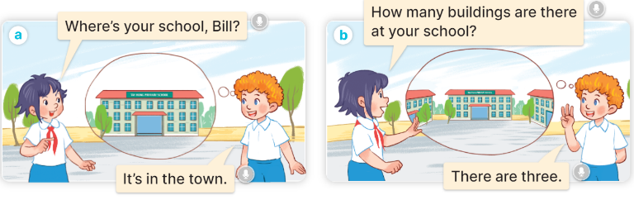  - Play the audio twice (sentence by sentence). Correct their pronunciation where necessary.  - Have Ss to practice the diaguage  - T invites a few pairs to the front of the class to practice.  - T checks pronunciation for ss.  Activity 3. Listen, point and say.  *Aims: Ss will be able to correctly say the phrases and use How many …… are there at your school? – There is …….. / There are …….. to ask and answer questions about the quantity of school facilities.  *Procedure:  * Model sentences:  - T asks Ss look at picture a and helps Ss know the structure from the dialogue.  - T introduces new structure for Ss.  - T explains, models and gives meaning.  - Have Ss repeat the model sentences.  A: How many buildings are there at your school?  B: – There is one. / There are two.  3.Practice: (7’)  *Drill pictures  - Have Ss look at the pictures and elicit the names of the places  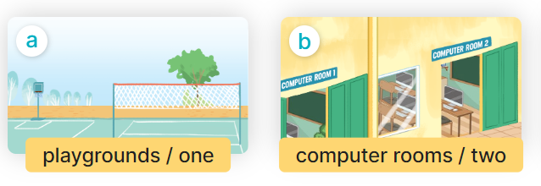  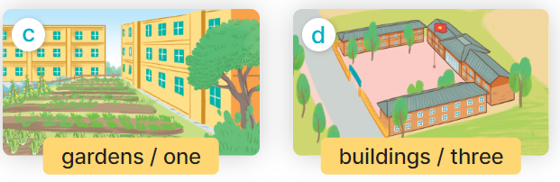  - Run through all the pictures.  - Run through model sentences.  - Have Ss to practise:  + T say – Ss respond (change role).  + Ss – Ss (change role).  - Ask Ss to work in pairs.  - T controls and corrects.  - Invite a few pairs to come to the front of the classroom, point at the pictures and say the questions and answers in front of the class.  - T gives feedbacks.  4.Production: (7’)  Activity 4. Let’s talk.  *Aims: Ss will be able to enhance the correct use of How many…… are there at your school? and There is …….. / There are ……… to ask and answer questions about the quantity of school facilities in a freer context.  *Procedure:  - Ask questions to help them identify the context.  + What can you see in the picture?  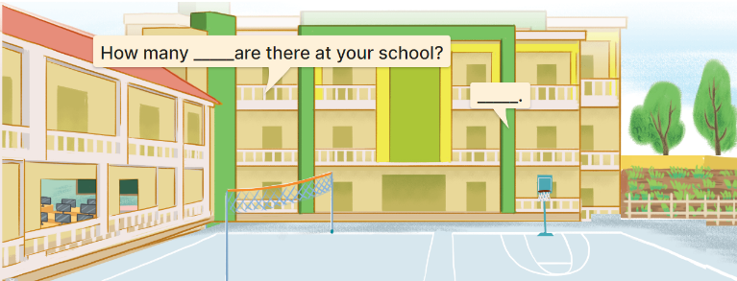  - Elicit the missing words in the speech bubbles and write them on the board. Get pupils to say the completed sentences.  - Have pairs of pupils practise asking and answering the questions about the quantity of school facilities in the picture.  - Invite some pairs to practise asking and answering questions about the quantity of school facilities in front of the class.  *Consolidation  *Aims: Ss will be able consolidate and wrap up the content of the lesson.  *Procedure:  - T asks ss to answer the following questions:  + What have you learnt from the lesson today?  - T review the vocabulary and model sentences.  - T praises some Ss who are hardworking / active/ good…. as well as encourage others to try more.  5. Homework. (2’)  - Learn the vocabulary and model sentences by heart  - Prepare the new lesson: Unit 6, Lesson 2 (4,5,6). | - Ss listen  - Ss play the game  -Ss play game  - Ss open their books  Students integrate: Read the words: building, garden, playground, computer room.  -Ss listen and answer  - - Ss listen and repeat  + Choral repetition (3 times).  + Individual repetition (3 ss)  - Ss take note  - Ss look, remember and slap  -Look at the pictures and get to know the characters in the pictures.  + In picture a:  Linh: Where’s your school, Bill?  Bill: It’s in the town.  – In picture b:  Linh: How many buildings are there at your school?  Bill: There are three.  -Ss listen and repeat in chorus (twice)  -Ss work in pairs to practice  -Ss practice the diaguage  -Ss listen  -Ss look at the picture and answer.  -Ss listen  -Ss listen and repeat  -Ss repeat to the hobbies  -Ss listen and answer  +Picture a: one playground  +Picture b: two computer rooms  +Picture c: one garden  +Picture d: three buildings  - Ss look, listen and repeat  - Ss practice in chorus  - Ss practice in chorus  -Ss work in pairs to practice  -Ss listen  -Ss go to the board and point and say  -Ss listen  -Ss look at the picture and answer  + a school with two buildings, a playground, a computer room and a garden  -Ss listen and answer  -Ss work in pairs and ask, answer  -Ss perform in font of the class.  -Ss answer the questions  - Ss listen  -Ss listen and clap their hands  -Ss listen and take note
D. ADJUSTMENTS (if necessary):
………………………………………………………………………………………….…..……………………………………………………………………………...……………

