Week: 10 Preparing date: 13/11/2024
Period: 39 Teaching date: 15/11/2024

Unit 6: Our school facilities
Lesson 1 (4, 5, 6)
A. OBJECTIVES:
By the end of the lesson, Ss will be able to:
1. Knowledge:
- use the words city, mountains, town, village in relation to the topic "Our school facilities";
- use Where’s your school? – It’s in the ……. to ask and answer questions about the location of a school;
- listen to and demonstrate understanding of simple communicative contexts in relation to the topic “Our school facilities”.
- read and write about school locations
- Vocabulary: Review
- Skills: speaking, listening, reading and writing.
Students integrate: Complete and read sentence 1, 2 (5/45)
2. Competences:
- Critical Thinking: self-introduce
- Co-operation: ready to help friends in pair work/ group work.
- Self-control and independent learning: perform listening tasks.
3. Attitude/ Qualities:
- Kindness: Help partners to complete learning tasks.
- Honesty: tell the truth about feelings and emotions.
- Diligence: complete learning tasks.
B. TEACHING AIDS:
- Teacher: Teacher’s guide Pages 80,81,82; audio Tracks 60; website hoclieu.vn, posters, laptop, pictures, textbook, lesson plan, TV or projector.
- Students: Pupil’s book Page 45, notebooks, workbooks, school things.
C. PROCEDURES:
Teacher’s activities | Students’ activities
1.Warm- up: (5’)  Game: play the Doraemon Game ( ppt)  *Aims: to create a friendly and active atmosphere in the class to beginning the lesson.  *Procedure:  - Divide the class into 3 teams.  - Pupils from each team choose a letter, then answer the question  - Pupils answer correctly get some points corresponding to the number of pies.  - Say “Open your book page 45” and look at “Unit 6, Lesson 1 (4,5,6)”.  2.Practice: (27’)  Activity 1. Listen and number:  *Aims: Ss will be able to listen to and understand four communicative contexts in which pupils ask and answer questions about school locations and number the correct pictures.  *Procedure:  - Point at the pictures respectively to explain the context.  + How many pictures are there?  + What can you see in each picture?  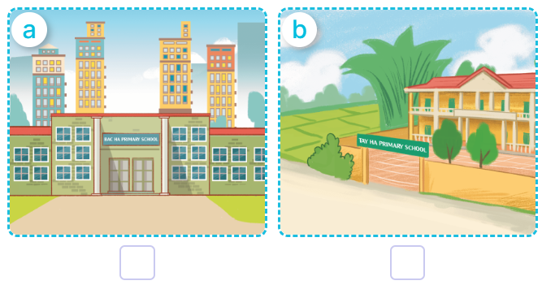  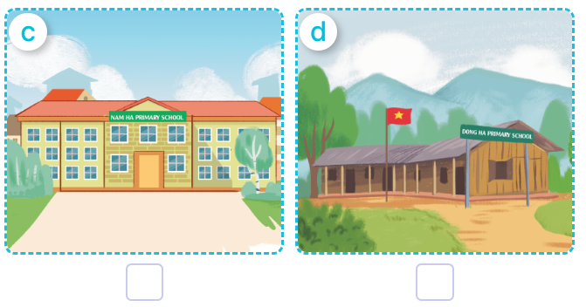  - T ask Ss to guess the answers.  + T writes Ss’guessing on the board.  - Listen to the tape:  + Play the recording  + Play the recording again and get Ss to swap books with their partners.  + Play the recording again to check answers together as a class.  + Write the answers on the board for Ss to correct their answers. Then checks Ss’ guessing.  - Play the recording, sentence by sentence, for the class to listen and repeat in chorus.  Key: 1. c 2. d 3.a 4.b  Activity 2. Look, complete and read  *Aims: Ss will be able to complete four target gapped exchanges with the help of picture cues  *Procedure:  - Ask pupils to look at the pictures and identify the school locations in the four pictures.  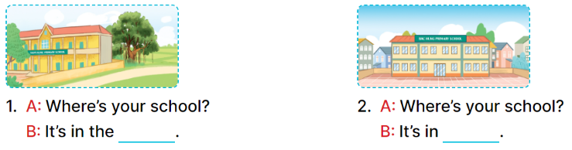  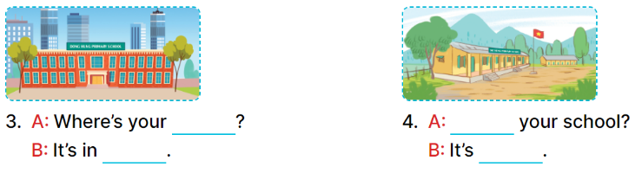  - Have Ss look at the four dialogue and the pictures. Elicit and model with picture 1  + Ask Ss to read the sentence 1 in chorus.  + Ask them what is missing in the question (village). Then have them complete the gap (Is It’s in the village).  -Have Ss work in pairs and complete the dialogue 2, 3, 4.  - Ask a few Ss to stand up and read the sentences aloud.  -T gives feedbacks.  Key:  1. village 2. the town  3. school, the city  4. Where’s, in the mountains  Activity 3. Let’s play  Matching pairs  *Aims: Ss will be able to review the words mountains, village, city and town by playing the game Matching pairs.  *Procedure:  -Tell pupils that they are going to find four pairs of pictures and words as quickly as possible.  - Stick the picture cards face down in the left column on the board. Stick the word cards face down in the right column on the board.  - Invite one pupil to play the game by selecting a picture card and a word card, turning them over.  + If two cards are a matching pair, ask the pupil to say the word aloud.  + The pupil can continue to take another turn.  + If the cards do not make a match, ask the pupil to turn them face down again, and invite another pupil to take the next turn.  - Let pupils play the game until all pairs have been matched.  - Play the game several times if there is enough time.  *Consolidation  *Aims: Ss will be able consolidate and wrap up the content of the lesson.  *Procedure:  - T asks ss to answer the following questions:  + What have you learnt from the lesson today?  +What are the core values of the lesson? (if the teacher can take from the lesson).  - T praises some Ss who are hardworking / active/ good…. as well as encourage others to try more.  3. Homework. (3’)  - Practice part 5 again.  - Prepare the new lesson: Unit 6, Lesson 2 (1,2,3). | - Ss read the words  - Ss play game  -Ss play game  - Ss open their books  -Look at the pictures and say:  + Picture a. a school in the city  + Picture b. a school in the village  + Picture c. a school in the town  + Picture d. a school in the mountains  -Ss guess the answers  - Ss listen to the tape and number  - Ss listen again, number and swap books with their partners.  - Ss check their answers and guessing  -Ss listen and repeat.  Students integrate: Complete and read sentence 1, 2 (5/45)  -Ss look at the picture and say  -Ss look and answer  -Ss read  -Ss say and complete  -Ss work in pairs and complete  -Ss read aloud  - Ss listen  -Ss listen  -Ss play the game  -Ss play the game  -Ss play the game  -Ss answer the questions  -Ss listen and clap their hands  -Ss listen and take note
D. ADJUSTMENTS (if necessary):
………………………………………………………………………………………….…..……………………………………………………………………………...………………………………………….…..……………………………………………………………………………….……………………………………………………………………...

