Week: 10 Preparing date: 10/11/2024
Period: 38 Teaching date: 12/11/2024

Unit 6: Our school facilities
Lesson 1 (1, 2, 3)
A. OBJECTIVES:
By the end of the lesson, Ss will be able to:
1. Knowledge:
- use the words city, mountains, town, village in relation to the topic "Our school facilities".
- use Where’s your school? – It’s in the …………. to ask and answer questions about the location of a school;
-listen to and demonstrate understanding of simple communicative contexts in relation to the topic “Our school facilities”.
- read and write about school locations
- Vocabulary: city, mountains, village, town
- Skills: speaking and listening
Students integrate: Read the words: city, mountains, village, town
2. Competences:
- Co-operation: ready to help friends in pair work/ group work.
- Sociability: Talk to each other, say good words to others.
3. Attitude/ Qualities:
- Kindness: Help partners to complete learning tasks.
- Honesty: Show pride in where they’re from and great respect for other people’s locations by using appropriate gesture and intonation when asking and answering about school locations.
B. TEACHING AIDS:
- Teacher: Teacher’s guide Pages 78,79, audio Tracks 58, 59, website hoclieu.vn, posters, laptop, pictures, textbook, lesson plan, TV or projector.
- Students: Pupil’s book Page 44, notebooks, workbooks, school things.
C. PROCEDURES:
Teacher’s activities | Students’ activities
1.Warm- up: (3’)  Sing: Jigsaw puzzle  *Aims: to create a friendly and active atmosphere in the class to beginning the lesson.  *Procedure:  - Divide class into 4 groups: Tom, Jerry, Miu and Chit.  - Ask Ss look at the pieces of picture.    - Ask Ss go to the board and jigsaw puzzle into the correct picture.  -T checks who’s the winner?  - Say “Open your book page 44” and look at “Unit 6, Lesson 1 (1,2,3)”.  2. Presentation (16’)  Activity 1. Vocabulary.  *Aims: Ss will be able to know the vocabulary in the new lesson.  *Procedure:  -T elicits the new words  + city : thành phố (picture)  + mountain : vùng núi (picture)  + town :thị trấn (picture)  + village : ngôi làng (picture)  - T models (3 times).  - T writes the words on the board.  - Checking: Matching  Activity 2. Look, listen and repeat:  *Aims: Ss will be able to understand and correctly repeat the sentences in two communicative contexts focusing on asking and answering questions about the location of a school.  *Procedure:  - Have Ss look at Pictures a and b and guess the locations of the schools.  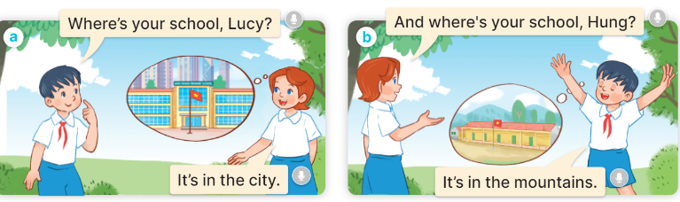  - Play the audio twice (sentence by sentence). Correct their pronunciation where necessary.  - Have Ss to practice the dialogue  - T invites a few pairs to the front of the class to practice.  - T checks pronunciation for ss.  Activity 3 Listen, point and say.  *Aims: Ss will be able to correctly say the words and use Where’s your school? – It’s in the ……….. to ask and answer questions about the location of a school.  *Procedure:  * Model sentences:  - T asks Ss look at picture a and helps Ss know the structure from the dialogue.  - T introduces new structure for Ss.  - T explains, models and gives meaning.  -Have Ss repeat the model sentences.  A: Where is your school?  B: It’s in the village.  3.Practice: (7’)  *Drill pictures  - Elicit and check comprehension the places of school  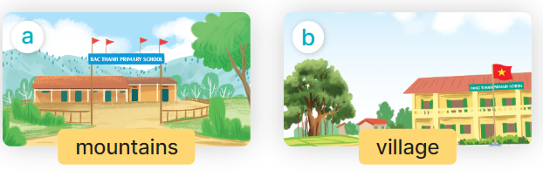  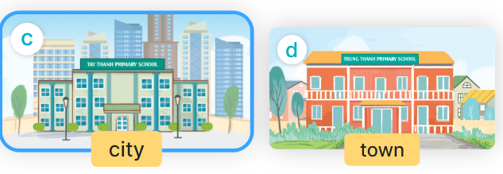  - Run through all the pictures.  - Run through model sentences.  +Run through the question sentences  +Run through the answer sentences  - Have Ss to practise:  + T asks, Ss answer picture a  + Ss ask, T answers picture b  + Group A ask, group B answer picture c  + Group B ask, group A answer picture d  - Ask Ss to work in pairs.  - T controls and corrects.  - Invite a few pairs to come to the front of the classroom and point at the pictures and say the questions and answers in front of the class.  - T gives feedbacks.  4.Production: (7’)  Activity 4. Let’s talk.  *Aims: Ss will be able to enhance the correct use of Where’s your school? – It’s in the ……. to ask and answer questions about the location of a school in a freer context *Procedure:  - Have Ss look at the picture and elicit the question and the answer in context.  + What can you see in the picture?  + How many places are there?  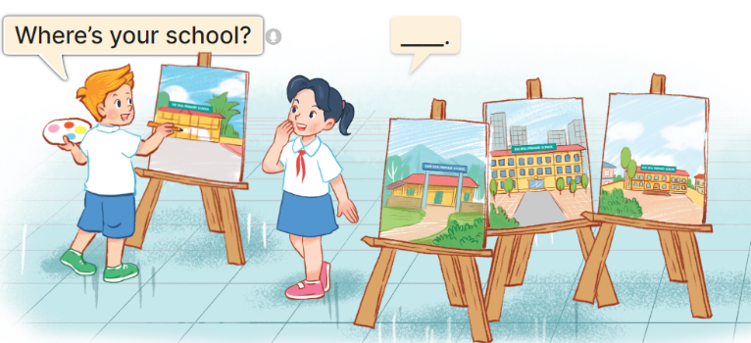  - Ask pupils to look at the second bubble and identify what the answer should be.  -Give an example answer It’s in the village. - Get pupils to repeat the question and the answer several times.  - Have pairs of pupils practise asking and answering questions about the locations of the schools in the paintings.  - Invite some pairs of Ss to the front of the class to perform their conversations.  *Consolidation  *Aims: Ss will be able consolidate and wrap up the content of the lesson.  *Procedure:  - T asks ss to answer the following questions:  + What have you learnt from the lesson today?  +What are the core values of the lesson? (if the teacher can take from the lesson).  - T review the vocabulary and model sentences.  - T praises some Ss who are hardworking / active/ good…. as well as encourage others to try more.  5. Homework. (2’)  - Learn the vocabulary and model sentences by heart  - Prepare the new lesson: Unit 6, Lesson 1 (4,5,6). | - Ss listen  -Ss look at the pieces of the picture  -Ss put into the correct picture  -Ss check  - Ss open their books  Students integrate: Read the words: city, mountains, village, town  -Ss listen and answer  - - Ss listen and repeat  + Choral repetition (3 times).  + Individual repetition (3 ss)  - Ss take note  - Ss look, remember and match  -Look at the pictures and say  + In picture a:  Hung: Where’s your school, Lucy?  Lucy: It’s in the city  + In picture b:  Lucy: And where’s your school, Hung?  Hung: It’s in the mountains  -Ss listen and repeat in chorus (twice)  -Ss work in pairs to practice  -Ss practice the dialogue  -Ss listen  -Ss look at the picture and answer.  -Ss listen  -Ss listen and repeat  -Ss repeat to the place  - Ss look, listen and answer  + Picture a. a school in the mountains  + Picture b. a school in the village  + Picture c. a school in the city  + Picture d. a school in the town  -Ss listen and repeat  -Ss practice in chorus  -Ss work in pairs to practice  -Ss point and say  -Ss listen.  -Ss look at the picture and answer  + I can see 4 places…  + There are 4 pictures  -Ss look and answer  -Ss pay attention and answer  -Ss repeat and answer  -Ss work in pairs to ask and answer  -Ss perform in front of the class.  -Ss answer the questions  - Ss listen  -Ss listen and clap their hands  -Ss listen and take note
D. ADJUSTMENTS (if necessary):
………………………………………………………………………………………….…..……………………………………………………………………………...………………………………………….…..……………………………………………………………………………….……………………………………………………………………...

