Week: 10 Preparing date: 10/11/2024
Period: 37 Teaching date: 12/11/2024

Extension activities
A. OBJECTIVES:
By the end of the lesson, Ss will be able to:
1. Knowledge:
- take part in fun activities to apply their language knowledge and competences.
- Vocabulary: Review
- Skills: speaking, writing and listening
Students integrate: Look and write about the names of the countries (1/42)
2. Competences:
- Co-operation: ready to help friends in pair work/ group work.
- Sociability: Talk to each other, say good words to others.
3. Attitude/ Qualities:
- Kindness: Help partners to complete learning tasks.
- Honesty: tell the truth about feelings and emotions
B. TEACHING AIDS:
- Teacher: Teacher’s guide Pages 76, 77; website hoclieu.vn, posters, laptop, pictures, textbook, lesson plan, TV or projector.
- Students: Pupil’s book Page 42, 43, notebooks, workbooks, school things.
C. PROCEDURES:
Teacher’s activities | Students’ activities
1.Warm- up: (3’)  Sing: Head, shoulders, knees and toes  *Aims: to create a friendly and active atmosphere in the class to beginning the lesson.  *Procedure:  - Show the song on the screen.  https://www.youtube.com/watch?v=WX8HmogNyCY  - Ask Ss to listen, sing and dance the song.  - Say “Open your book page 42, 43” and look at “Extension activites”.  2. Practice (30’)  Activity 1. Look and write  *Aims: Ss will be able to identify five different countries in the pictures.  *Procedure:  - Have Ss look at the pictures and ask  + What do you see in the pictures?  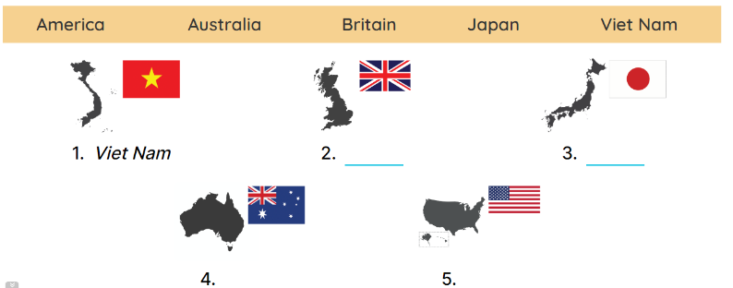  - Draw pupils’ attention to the pictures.  - Ask Where is Viet Nam? and encourage pupils to point to it. Write Viet Nam on the board.  - Point and ask about the other pictures: England, Japan, Australia and America.  - Have pupils complete the activity by writing the name next to each country.  - Check answers together as a class.  Key: 1. Viet Nam 2. England  3. Japan 4. Australia 5.America.  Activity 2. Look and write  *Aims: Ss will be able to identify the different times in different countries.  *Procedure:  - Have pupils look at the clocks. 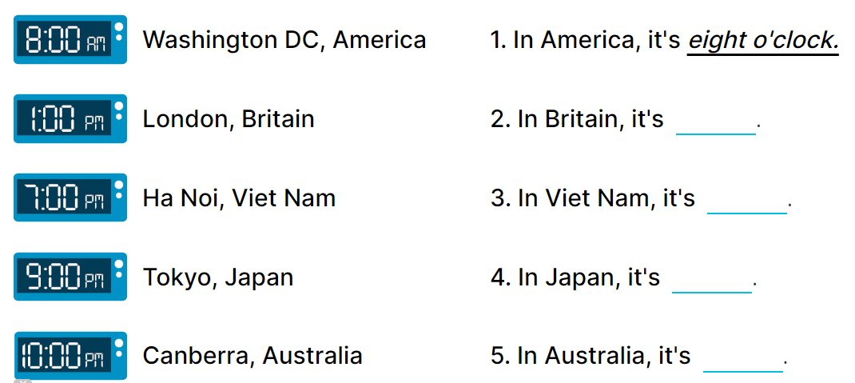  - Draw pupils’ attention to the different times in different countries.  - Write In America, it’s _____. on the board.  -Read the first part of the sentence aloud and encourage pupils to complete it. When pupils answer correctly, write the answer on the board: 8:00 AM.  - Have pupils work in pairs and complete the activity by completing the sentences.  - Check answers as a class.  Key: 1. 8:00 AM 2. 1:00 PM  3. 7:00 PM 4. 9:00 PM  5. 10:00 PM  Activity 3. Read the questions. Then tick the answers.  *Aims: Ss will be able to read the questions and tick the correct answers, then say what countries are near / far from Viet Nam.  *Procedure:  - Draw pupils’ attention to Question 1 and read it as a class.  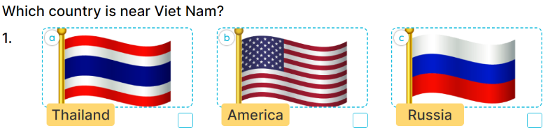  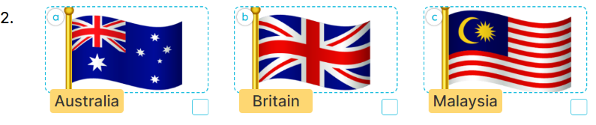  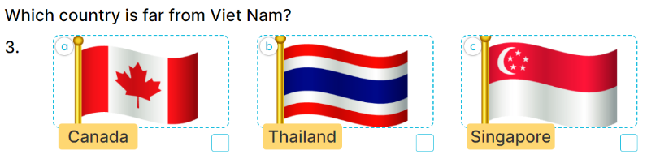  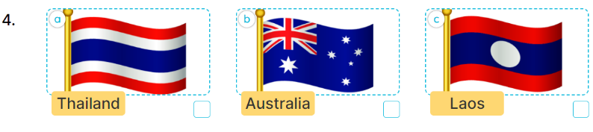  - Ask pupils to look at Answer A with three answer options a, b and c.  - Explain the new word Russia. Get them to look at the flags of Thailand, America and Russia, elicit the right answer and tick it (Picture a).  - Repeat the same procedure with Answer B and question 2.  - Get pupils to swap books with a partner, then check answers together as a class.  - Write the correct answers on the board for pupils to correct their answers.  - Have pupils say the answers by asking them Questions 1 and 2  Key: 1. A. It’s Thailand. B. It’s Malaysia  . 2. A. It’s Canada. B. It’s Australia.  *Consolidation  *Aims: Ss will be able consolidate and wrap up the content of the lesson.  *Procedure:  - T asks ss to answer the following questions:  + What have you learnt from the lesson today?  +What are the core values of the lesson? (if the teacher can take from the lesson).  - T praises some Ss who are hardworking / active/ good…. as well as encourage others to try more.  3. Homework. (2’)  - Prepare the new lesson: Unit 6, Lesson 1 (1,2,3). | - Ss listen  - Ss sing a song  -Ss open the book  Students integrate: Look and write about the names of the countries (1/42)  -Ss look at the picture and answer  - - Ss note  -Ss answer  -SS point and answer  -Ss do the task  -Ss check their answer  -Ss look at the clocks  -Ss pay attention  -Ss listen and answer  -Ss answer  -Ss complete the sentences  -Ss check their answers  - Ss look, listen and answer  - Ss answer  -Ss listen and answer  -Ss do the task  -Ss swap books and check their answer.  -Ss write the correct answer on the board  - Ss ask and answer the questions  -Ss answer the questions  -Ss listen and clap their hands  -Ss listen and take note

D. ADJUSTMENTS (if necessary):
………………………………………………………………………………………….…..……………………………………………………………………………...………………………………………….…..……………………………………………………………………………….……………………………………………………………………...

