Week: 7 Preparing date: 23/10/2024
Period: 27 Teaching date: 25/10/2024

Unit 4: My birthday party
Lesson 3 (1, 2, 3)
A. OBJECTIVES:
By the end of the lesson, Ss will be able to:
1. Knowledge:
- correctly repeat the sounds of the letters j and w in isolation, in the words jam and water, and in the sentences I like jam. and I want some water.
- listen to and demonstrate understanding of simple communicative to identify the target words jam and water while listening.
- say the chant with the correct pronunciation and rhythm.
- Vocabulary: Review
- Skills: speaking, listening, reading and writing.
Students integrate: Correctly repeat the sounds of the letters j and w in isolation, in the words jam and water, and in the sentences I like jam. and I want some water.
2. Competences:
- Co-operation: ready to help friends in pair work/ group work.
- Sociability: Talk to each other, say good words to others.
3. Attitude/ Qualities:
- Kindness: show self-respect to what they want and what others want
- Honesty: tell the truth about feelings and emotions
B. TEACHING AIDS:
- Teacher: Teacher’s guide Pages 64,65; audio Tracks 43,44,45; website hoclieu.vn, posters, laptop, pictures, textbook, lesson plan, TV or projector.
- Students: Pupil’s book Page 32, notebooks, workbooks, school things.
C. PROCEDURES:
Teacher’s activities | Students’ activities
1.Warm- up: (5’)  Game: Pass the ball  *Aims: to create a friendly and active atmosphere in the class to beginning the lesson.  *Procedure:  - T gives Ss a ball.  - T asks Ss to listen to music and transfer a ball around the class.  - When the music stops, Ss who keep a ball have to answer the question using: What do you want to eat/ drink? and I want some…..  - T gives feedback.  - Say “Open your book page 32” and look at “Unit 4, Lesson 3 (1,2,3)”.  2. Presentation (9’)  Activity 1. Listen and repeat:  *Aims: Ss will be able to correctly repeat the sounds of the letters j and w in isolation, in the words jam and water, and in the sentences I like jam. and I want some water.  water.  *Procedure:  - T gives instruction to the letter j and w, in the words jam and water, and in the sentences I like jam. and I want some water.  - Play the recording for the letter j, w.  - Encourage Ss to point at the letter /word/ sentence while listening.  - Play the recording again and encourage Ss to listen and repeat.  - Do this several times until Ss feel confident.  - T calls some Ss to practice.  - T gives feedbacks.  3.Practice: (19’)  Activity 2. Listen and circle.  *Aims: Ss will be able to identify the target words jam and water while listening.  *Procedure:  - Elicit the sentences and the gap-fill options.  - T ask Ss to guess the answers.  + T writes Ss’guessing on the board.  - Listen to the tape:  + Play the recording  + Play the recording again and get Ss to swap books with their partners.  + Play the recording again to check answers together as a class.  + Write the answers on the board for Ss to correct their answers. Then checks Ss’ guessing.  - Play the recording, sentence by sentence, for the class to listen and repeat in chorus.  - Invite one or two Ss to stand up and read the completed sentences.  Key: 1.b 2.c  Activity 3. Let’s chant  *Aims: Ss will be able to say the chant with the correct rhythm and pronunciation.  *Procedure:  - Introduce the title and lyrics of the chant.  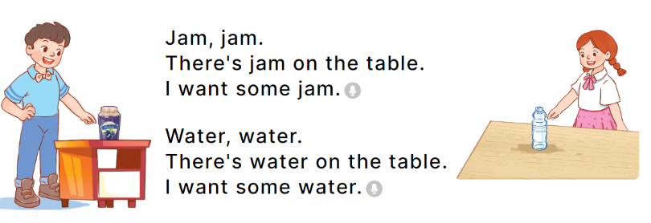  - Play the recording for Ss to listen to the whole chant.  + Have them repeat the title and lyrics line by line.  + Ask Ss to attend to the sounds of the letters j and w and the words jam and water..  - Play the recording all the way through for Ss to listen to pronunciation and melody.  - Play the recording line by line for Ss to listen and repeat  - Play the recording for Ss to chant and clap along.  - Ask Ss to practice chant and clap along in pairs or groups.  - Invite groups to the front of the classroom to perform the chant  -T gives feedback.  *Consolidation  *Aims: Ss will be able consolidate and wrap up the content of the lesson.  *Procedure:  - T asks ss to answer the following questions:  + What have you learnt from the lesson today?  +What are the core values of the lesson? (if the teacher can take from the lesson).  - T praises some Ss who are hardworking / active/ good…. as well as encourage others to try more.  4. Homework. (2’)  - Practice the chant more.  - Prepare the new lesson: Unit 4, Lesson 3 (4,5,6). | - Ss listen  -Ss play the game  - Ss open their books  Students integrate: Correctly repeat the sounds of the letters j and w in isolation, in the words jam and water, and in the sentences I like jam. and I want some water.  - Ss recognize the differences about color of letter  - - Ss listen  - Ss listen and point  - Ss listen again and repeat  -Ss listen again and repeat  -Ss practice  -Ss listen  -Ss listen and say:  + Number 1: I want some…….  + Number 2: There is some….on the table.  -Ss guess the answers  - Ss listen to the tape and circle  - Ss listen again, circle and swap books with their partners.  - Ss check their answers and guessing  -Ss listen and repeat.  -Ss read the sentences  - Ss look and listen.  -Ss listen to the chant  - Ss listen and repeat line by line without clap their hands  -Ss note the sounds, words  -Ss listen to melody of the chant  - Ss listen and chant line by line.  - Ss chant and clap along.  - Ss work in groups (two groups) to chant  -Ss perform in front of the class.  -Ss listen  -Ss answer the questions  -Ss listen and clap their hands  -Ss listen and take note

D. ADJUSTMENTS (if necessary):
………………………………………………………………………………………….…..……………………………………………………………………………...………………………………………….…..……………………………………………………………………………….……………………………………………………………………...

