Week: 7 Preparing date: 20/10/2024
Period: 26 Teaching date: 22/10/2024

Unit 4: My birthday party
Lesson 2 (4, 5, 6)
A. OBJECTIVES:
By the end of the lesson, Ss will be able to:
1. Knowledge:
- listen to and understand two communicative contexts in which pupils ask and answer questions about what they want to eat / drink and tick the correct pictures.
- complete two gapped dialogues with the help of picture cues.
- revise the target vocabulary items through playing the game Board race.
- Vocabulary: Review
- Skills: speaking, listening, reading and writing.
Students integrate: Complete dialogue 1 with the help of picture cues(5/31).
2. Competences:
- Critical Thinking: self-introduce
- Co-operation: ready to help friends in pair work/ group work.
- Self-control and independent learning: perform listening tasks.
3. Attitude/ Qualities:
- Kindness: show kindness in inviting someone to a birthday party and offering them food and drink they want.
- Honesty: tell the truth about feelings and emotions.
- Diligence: complete learning tasks.
B. TEACHING AIDS:
- Teacher: Teacher’s guide Pages 62,63; audio Tracks 42; website hoclieu.vn, posters, laptop, pictures, textbook, lesson plan, TV or projector.
- Students: Pupil’s book Page 31, notebooks, workbooks, school things.
C. PROCEDURES:
Teacher’s activities | Students’ activities
1.Warm- up: (5’)  Game: Guessing game  *Aims: to create a friendly and active atmosphere in the class to beginning the lesson.  *Procedure:  - T introduces and explains the game.  - How to play:  + T will show some pictures which is hidden.  + Ss look at the pictures in the screen.  + Ss tell what someone is doing.  - T models. (jam)  - Ss play the game.  - T gives feedback.  - Ex:  1. jam 2. grapes 3. chips  4. milk 5. lemonade 6.chicken  - Say “Open your book page 31” and look at “Unit 4, Lesson 2 (4,5,6)”.  2.Practice: (27’)  Activity 1. Listen and tick:  *Aims: Ss will be able to listen to and understand two communicative contexts in which pupils ask and answer questions about what they want to eat / drink and tick the correct pictures.  *Procedure:  - Elicit the names of the food and drink items.  - Point at the pictures respectively to explain the context.  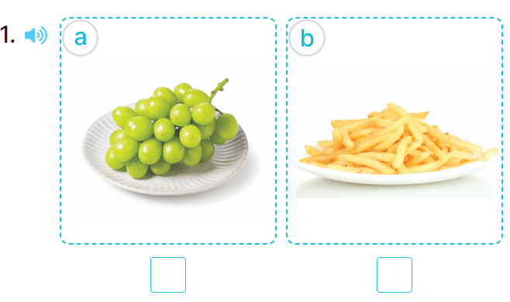  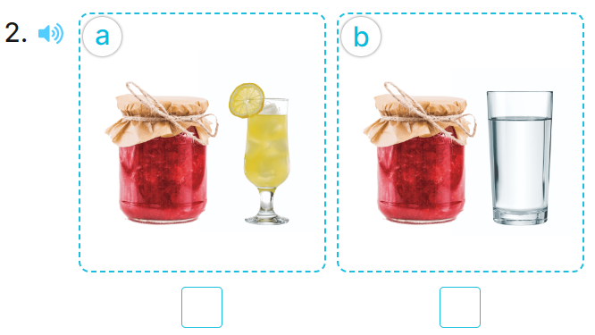  - T ask Ss to guess the answers.  + T writes Ss’guessing on the board.  - Listen to the tape:  + Play the recording  + Play the recording again and get Ss to swap books with their partners.  + Play the recording again to check answers together as a class.  + Write the answers on the board for Ss to correct their answers. Then checks Ss’ guessing.  - Play the recording, sentence by sentence, for the class to listen and repeat in chorus.  Key: 1. a 2.a  Activity 2. Look, complete and read.  *Aims: Ss will be able to complete two gapped dialogues with the help of picture cues.  *Procedure:  - Have pupils look at the pictures and identify the food and drink items in the pictures.  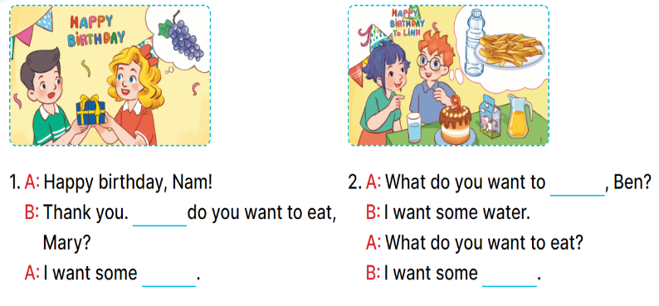  - Have pupils look at the two incomplete dialogues.  - Model Dialogue 1, ask pupils what is missing in the question (What) and the answer (the food).  - Ask pupils to complete the gap (What do you want to eat, Mary? – I want some grapes.).  - Have pupils complete the dialogues individually.  - Ask a few pairs to read them aloud.  - Correct their pronunciation where necessary, praise the readers, and get the class to clap or cheer if their pronunciation is good  Key: 1. What; grapes 2. drink; chips  Activity 3. Let’s play.  *Aims: Ss will be able to revise the target vocabulary items through playing the game Board race.  *Procedure:  - Tell pupils the goal of the game and how to play it.  - Divide pupils into two teams. They take turns going to the board and each pupil tries to write one word in the columns Drinks and Food as fast as possible.  - The team that writes the most words in the set time wins.  - Point to the words and have pupils read the words out loud.  - Have pupils play the game using other word sets, ex: months, countries, days of the week.  *Consolidation  *Aims: Ss will be able consolidate and wrap up the content of the lesson.  *Procedure:  - T asks ss to answer the following questions:  + What have you learnt from the lesson today?  +What are the core values of the lesson? (if the teacher can take from the lesson).  - T praises some Ss who are hardworking / active/ good…. as well as encourage others to try more.  3. Homework. (3’)  - Practice about the pictures on page 31.  - Prepare the new lesson: Unit 4, Lesson 3 (1,2,3). | - Ss listen  -Ss play game  - Ss open their books  -Look at the pictures and say:  + Picture 1a: grapes  + Picture 1b: chips  + Picture 2a: jam ad lemonade  + Picture 2b: jam and water  -Ss guess the answers  - Ss listen to the tape and write number  - Ss listen again, write and swap books with their partners.  - Ss check their answers and guessing  -Ss listen and repeat.  Students integrate: Complete dialogue 1 with the help of picture cues(5/31).  -Ss look at the pictures and say  -Ss listen and pay attention  -Ss read and answer  -Ss complete the sentence  -Ss complete the second dialogues  -Ss read aloud  - Ss listen  -Ss listen  -Ss play the game  -Ss play the game  -Ss listen to the teacher.  -Ss answer the questions  -Ss listen and clap their hands  -Ss listen and take note
D. ADJUSTMENTS (if necessary):
………………………………………………………………………………………….…..……………………………………………………………………………...………………………………………….…..……………………………………………………………………………….……………………………………………………………………...

