Week: 7 Preparing date: 20/10/2024
Period: 25 Teaching date: 22/10/2024

Unit 4: My birthday party
Lesson 2 (1, 2, 3)
A. OBJECTIVES:
By the end of the lesson, Ss will be able to:
1. Knowledge:
- understand and correctly repeat the sentences in two communicative
contexts focusing on what someone wants to eat / drink.
- correctly say the phrases and use What do you want to eat / drink? – I want ……….to ask and answer questions about what someone wants to eat / drink.
- enhance the correct use of What do you want to eat / drink? – …….. to ask and answer questions about what someone wants to eat / drink in a freer context.
- Vocabulary: chips, grapes, jam, juice.
- Skills: speaking and listening
Students integrate: Read the words: chips, grapes, jam, juice.
2. Competences:
- Oral Communication: speak about names, ask and answer the questions
- Co-operation: ready to help friends in pair work/ group work.
- Sociability: Talk to each other, say good words to others.
3. Attitude/ Qualities:
- Kindness: Help partners to complete learning tasks.
- Honesty: tell the truth about feelings and emotions
- Diligence: complete learning tasks
B. TEACHING AIDS:
- Teacher: Teacher’s guide Pages 59, 60, 61, audio Tracks 40, 41, website hoclieu.vn, posters, laptop, pictures, textbook, lesson plan, TV or projector.
- Students: Pupil’s book Page 30, notebooks, workbooks, school things.
C. PROCEDURES:
Teacher’s activities | Students’ activities
1.Warm- up: (3’)  Sing a song  *Aims: to create a friendly and active atmosphere in the class to beginning the lesson.  *Procedure:  - Sing the song When’s your birthday? on page 29.  - Say “Open your book page 30” and look at “Unit 4, Lesson 2 (1,2,3)”.  2. Presentation (16’)  Activity 1. Vocabulary.  *Aims: Ss will be able to know the vocabulary in the new lesson.  *Procedure:  -T elicits the new words  + chips : khoai tây chiên (realia)  + grapes : quả nho (realia)  +jam :mứt (realia)  + juice : nước ép (realia)  - T models (3 times).  - T writes the words on the board.  - Checking: Rub out and remember  Activity 2. Look, listen and repeat:  *Aims: Ss will be able to understand and correctly repeat the sentences in two communicative contexts focusing on what someone wants to eat / drink.  *Procedure:  - Have pupils look at Pictures a and b and identify the characters in the pictures.  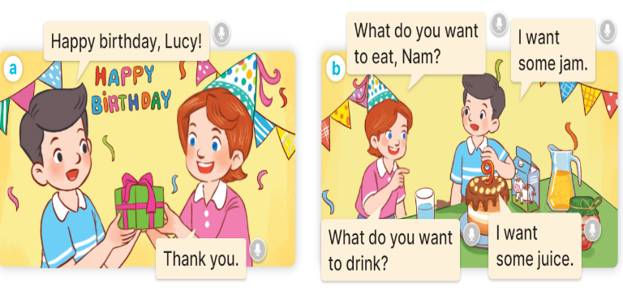  -  Play the audio twice (sentence by sentence). Correct their pronunciation where necessary.  - Have Ss to practice the dialogue  - T invites a few pairs to the front of the class to practice.  - T checks pronunciation for ss.  Activity 3 Listen, point and say.  *Aims: Ss will be able to correctly say the phrases and use What do you want to eat / drink? – I want ……… to ask and answer questions about what someone wants to eat / drink  *Procedure:  * Model sentences:  - T asks Ss look at picture a, b and helps Ss know the structure from the dialogue.  - T introduces new structure for Ss.  - T explains, models and gives meaning.  -Have Ss repeat the model sentences.  A: What do you want to eat/ drink?  B: I want some chips/ milk..  3.Practice: (7’)  *Drill pictures  - Have pupils look at the pictures and elicit the names of the food and drinks.  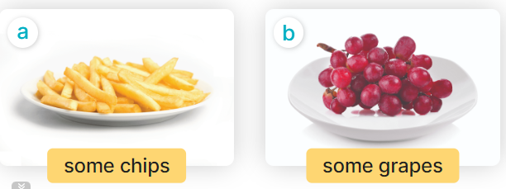  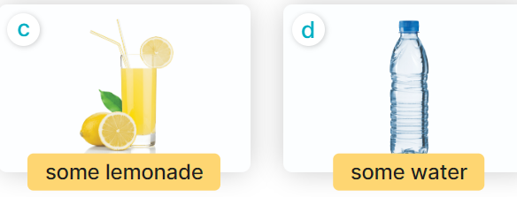  - Run through all the pictures.  - Run through model sentences.  + Run through the questions.  + Run through the answers.  - Have Ss to practise:  + T asks the first – Ss answer (change role).  + Ss – Ss (change role).  - Ask Ss to work in pairs to ask and answer the question What do you want to eat/ drink? I want……  - T controls and corrects.  - Invite a few pairs to point at the pictures and giving the instructions in front of the class.  - Encourage Ss to practise speaking English.  - T gives feedbacks.  4.Production: (7’)  Activity 4. Let’s talk.  *Aims: Ss will be able to enhance the correct use of What do you want to eat / drink? – I want ……... to ask and answer questions about what someone wants to eat / drink in a freer context.  *Procedure:  - Have Ss look at the picture and answer the questions:  +Who are they?  + What are they doing?  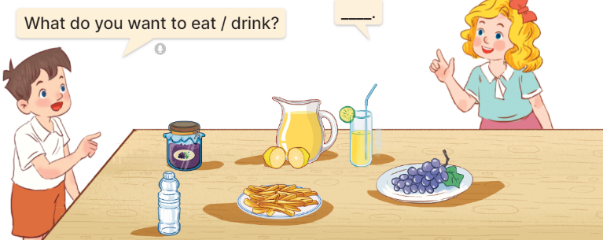  - Have pupils look at the bubbles to understand how the sentence pattern is used. - Have pupils role-play to practise asking the questions and giving their answers in pairs, using the picture cue.  - Invite some pupils to practise asking and answering questions in front of the class.  - Have pupils ask and answer questions about what they want to eat / drink at a birthday party, using the structure learnt.  *Consolidation  *Aims: Ss will be able consolidate and wrap up the content of the lesson.  *Procedure:  - T asks ss to answer the following questions:  + What have you learnt from the lesson today?  +What are the core values of the lesson? (if the teacher can take from the lesson).  - T review the vocabulary and model sentences.  - T praises some Ss who are hardworking / active/ good…. as well as encourage others to try more.  5. Homework. (2’)  - Learn the vocabulary and model sentences by heart  - Prepare the new lesson: Unit 4, Lesson 2 (4,5,6). | -Ss listen, sing and dance  - Ss open their books  Students integrate: Read the words: chips, grapes, jam, juice.  -Ss listen and answer  - - Ss listen and repeat  + Choral repetition (3 times).  + Individual repetition (3 ss)  - Ss take note  - Ss look, remember and write  -Look at the pictures and get to know the characters in the pictures.  + In picture a:  Nam: Happy birthday, Lucy.  Lucy: Thank you.  + In pucture b:  Lucy: What do you want to eat, Nam?  Nam: I want some jam.  Lucy: What do you want to drink?  Nam: I want some juice.  -Ss listen and repeat in chorus (twice)  -Ss work in pairs to practice  -Ss practice the dialogue  -Ss listen  -Ss look at the picture and answer.  -Ss listen  -Ss listen and repeat  -Ss look at the picture and answer  + In picture a: some chips  + In picture b: some grapes  + In picture c: a glass of lemonade  + In picture d: a bottle of water  - Ss look, listen and repeat  -Ss practice in chorus  -Ss work in pairs to practice  -Ss point and ask and answer  -Ss listen.  -Ss take turns pointing at the pictures, asking and answering the question in front of the class.  -Ss look at the picture and listen  Minh and Mary asking and answering questions about food and drink items on a table at a birthday party: jam, lemonade, water, chips, and grapes  -Ss look and pay attention  -Ss work in pairs  -Ss perform in front of the class.  -Ss says about the birthday party.  -Ss answer the questions  - Ss listen  -Ss listen and clap their hands  -Ss listen and take note
D. ADJUSTMENTS (if necessary):
………………………………………………………………………………………….…..……………………………………………………………………………...………………………………………….…..……………………………………………………………………………….……………………………………………………………………...

