Week: 6 Preparing date: 13/10/2024
Period: 21 Teaching date: 15/10/2024

Unit 3: My week
Lesson 3 (1, 2, 3)
A. OBJECTIVES:
By the end of the lesson, Ss will be able to:
1. Knowledge:
- correctly repeat the sounds of the letter u in isolation, in the word music (/ju/) as in the sentence I listen to music on Saturdays, and the word Sunday (/ʌ/) as in I do housework on Sundays.
- identify the target words music and Sunday while listening.
- say the chant with the correct pronunciation and rhythm.
- Vocabulary: Review
- Skills: speaking, listening, reading and writing.
Students integrate: Repeat the sounds of the letter u in isolation, in the word music and Sunday
2. Competences:
- Listening: listen and recognize someone, then repeat
- Co-operation: ready to help friends in pair work/ group work.
- Sociability: Talk to each other, say good words to others.
3. Attitude/ Qualities:
- Kindness: Help partners to complete learning tasks.
- Honesty: tell the truth about feelings and emotions
B. TEACHING AIDS:
- Teacher: Teacher’s guide Pages 51,52,53; audio Tracks 33, 34,35; website hoclieu.vn, posters, laptop, pictures, textbook, lesson plan, TV or projector.
- Students: Pupil’s book Page 26, notebooks, workbooks, school things.
C. PROCEDURES:
Teacher’s activities | Students’ activities
1.Warm- up: (5’)  Game: Find and circle the words  *Aims: to create a friendly and active atmosphere in the class to beginning the lesson.  *Procedure:  L U N C H R S C S T  H C T H N O H C U H  C L U A A M A O N I  L E L N N U T S D N  A A W K E S O E A K  S N J Z R I I I Y B  S R O E E C V C A H  S T U E S D A Y A Y  D T S S R I O T S M  - Divide class into 2 groups  - Ask Ss to find and circle the words and characters that they learnt.  - Which groups find the best correct words is winner.  - Give Ss time to play the game.  Rows: lunch, Tuesday  Columns: Music, Sunday  -T checks who’s winner?  - Say “Open your book page 26” and look at “Unit 3, Lesson 3 (1,2,3)”.  2. Presentation (9’)  Activity 1. Listen and repeat:  *Aims: Ss will be able to correctly repeat the sounds of the letter u in isolation, in the words music and Sunday, and in the sentences I listen to music on Saturdays. and I do housework on Sundays. with the correct pronunciation and intonation.  *Procedure:  - T gives instruction to the letter u in isolation, the words music and Sunday, and the sentences I listen to music on Saturdays. and I do housework on Sundays  - Play the recording for the letter u  - Encourage Ss to point at the letter/ word/ sentence while listening.  - Play the recording again and encourage Ss to listen and repeat.  - Do this several times until Ss feel confident.  - T calls some Ss to practice.  - T gives feedbacks.  3.Practice: (19’)  Activity 2. Listen and circle  *Aims: Ss will be able to identify the target words music and Sunday while listening.  *Procedure:  - Tell pupils that they are going to listen to the recording and circle the correct options.  -Get them to read the options and guess the sentences they may hear in the recording.  - Play the recording for pupils to listen.  - Play the recording again for pupils to listen and circle the correct options.  - Tell pupils to swap books with a partner, then check the answers together as a class.  -Write the correct answers on the board.  - Play the recording again for pupils to double-check their answers.  - Invite one or two pupils to stand up, listen to and repeat the sentences.  Key: 1.a 2.b  Activity 3. Let’s chant  *Aims: Ss will be able to say the chant with the correct pronunciation and rhythm.  *Procedure:  - Introduce the title and lyrics of the chant.  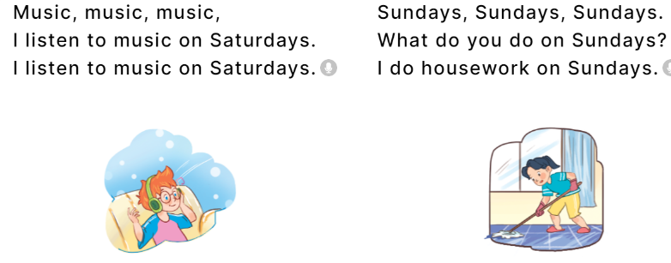  - Play the recording for Ss to listen to the whole chant.  + Have them repeat the title and lyrics line by line.  + Ask Ss to attend to the sounds of the letters u and the words music and Sunday.  - Play the recording all the way through for Ss to listen to pronunciation and melody.  - Play the recording line by line for Ss to listen and repeat  - Play the recording for Ss to chant and clap along.  - Ask Ss to practice chant and clap along in pairs or groups.  - Invite groups to the front of the classroom to perform the chant  -T gives feedback.  *Consolidation  *Aims: Ss will be able consolidate and wrap up the content of the lesson.  *Procedure:  - T asks ss to answer the following questions:  + What have you learnt from the lesson today?  +What are the core values of the lesson? (if the teacher can take from the lesson).  - T review the vocabulary and model sentences.  - T praises some Ss who are hardworking / active/ good…. as well as encourage others to try more.  4. Homework. (2’)  - Practice the chant more.  - Draw and colour three pictures of your friends.  - Prepare the new lesson: Unit 3, Lesson 3 (4,5,6). | - Ss listen  -Ss listen the rules  - Ss play the game  - Ss open their books  Students integrate: Repeat the sounds of the letter u in isolation, in the word music and Sunday  - Ss recognize the differences about color of letter  - - Ss listen  - Ss listen and point  - Ss listen again and repeat  -Ss listen again and repeat  -Ss practice  -Ss listen  -Ss listen and circle  -Ss read and guess the answers  - Ss listen to the tape and circle.  - Ss listen again and circle the correct answers  - Ss listen and swap books with their partners.  -Ss write the correct answer  - Ss check their answers  -Ss listen and repeat.  - Ss look and listen.  -Ss listen to the chant  - Ss listen and repeat line by line without clap their hands  -Ss note the sounds, words  -Ss listen to melody of the song  - Ss listen and chant line by line.  - Ss chant and clap along.  - Ss work in groups (two groups) to chant  -Ss perform in front of the class.  -Ss listen  -Ss answer the questions  - Ss listen  -Ss listen and clap their hands  -Ss listen and take note

D. ADJUSTMENTS (if necessary):
………………………………………………………………………………………….…..……………………………………………………………………………...………………………………………….…..……………………………………………………………………………….……………………………………………………………………...

