Week: 2 Preparing date: 55/09/2024
Period: 6 Teaching date: 17/09/2024

Unit 1: My friends
Lesson 1 (4, 5, 6)
A. OBJECTIVES:
By the end of the lesson, Ss will be able to:
1. Knowledge:
- use the words America, Australia, Britain, and Viet Nam in relation to the
topic “My friends”;
- listen to and demonstrate understanding of simple communicative contexts
in relation to the topic “My friends”.
- read and write about where someone comes from.
- Vocabulary: Review
- Skills: speaking, listening, reading and writing.
Students integrate: Complete sentence 1, 2 (5/11)
2. Competences:
- Critical Thinking: self-introduce
- Co-operation: ready to help friends in pair work/ group work.
- Self-control and independent learning: perform listening tasks.
3. Attitude/ Qualities:
- Kindness: Help partners to complete learning tasks.
- Honesty: Show pride in where they come from and great respect for where someone
comes from by using appropriate gestures and intonation when asking and
answering about nationality
- Diligence: complete learning tasks.
B. TEACHING AIDS:
- Teacher: Teacher’s guide Pages 20,21; audio Tracks 8, 9; website sachmem.vn, posters, laptop, pictures, textbook, lesson plan, TV or projector.
- Students: Pupil’s book Page 11, notebooks, workbooks, school things.
C. PROCEDURES:
Teacher’s activities | Students’ activities
1.Warm- up: (5’)  Game: “Lucky number”  *Aims: to create a friendly and active atmosphere in the lesson.  *Procedure:  - Divide the class into 3 teams.  - Pupils from each team choose a number (or throw sticky balls on the grid to choose the number), then have 2 pupils  from each team ask and answer with the picture in that number.  - Pupils or teachers click on the flag to reveal the icons indicating the points for that team.  - After 9 numbers, the team with the most points is the winner  - Say “Open your book page 11” and look at “Unit 1, Lesson 1 (4,5,6)”.  2.Practice: (27’)  Activity 1. Listen and number:  *Aims: Ss will be able to listen to and understand four communicative contexts in which pupils ask and answer questions about where someone is from and number the correct pictures.  *Procedure:  - Elicit the names of the characters in the pictures. Point at the pictures respectively to explain the context.  +Who is he/ she?  +Where is he/ she from?  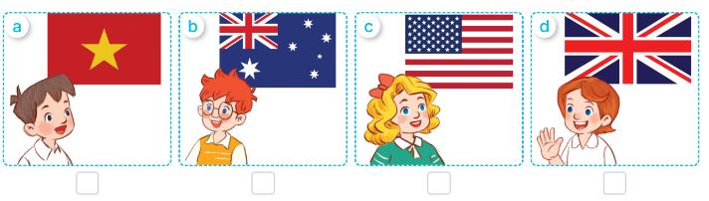  - T ask Ss to guess the answers.  + T writes Ss’guessing on the board.  - Listen to the tape:  + Play the recording  + Play the recording again and get Ss to swap books with their partners.  + Play the recording again to check answers together as a class.  + Write the answers on the board for Ss to correct their answers. Then checks Ss’ guessing.  - Invite one pupil to read aloud sentences 1 and 2 and a pair of pupils to act out Exchanges 3 and 4 in front of the  class.  Key: 1. b 2. d 3. C 4. a  Activity 2. Look, complete and read.  *Aims: Ss will be able to complete the gapped sentences and read them aloud with the help of the picture cues.  *Procedure:  - Get Ss to look at the pictures and identify the characters  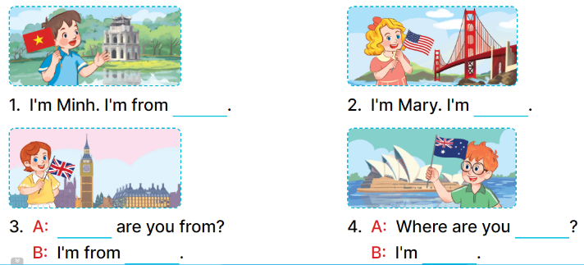  - Have Ss look at the four incomplete sentences and elicits the missing words in the sentences.  - T models with sentence 1  + Ask Ss what is missing in the sentence.  + Have Ss look at the picture and complete the gap, then read the completed sentence in chorus.  -Have Ss work in groups and complete the sentences 2,3 and 4.  - Ask a few Ss to stand up and read the completed sentences aloud.  -T gives feedbacks.  Key:  1. Viet Nam 2. from America  3. Where; Britain  4. from; from Australia  Activity 3. Let’s sing.  *Aims: Ss will be able to sing the song I’m from … with the correct pronunciation, rhythm and melody  *Procedure:  - Introduce the title and lyrics of the song: “Where are you from” song.  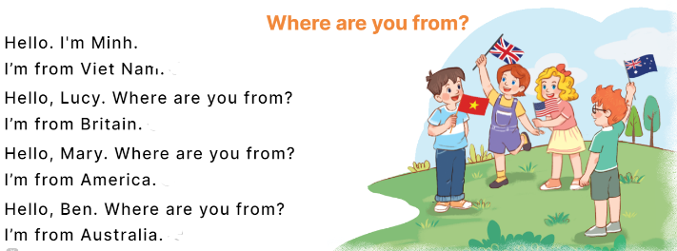  - Play the recording for Ss to listen to the whole song.  + Have them repeat the title and lyrics line by line.  + Tell Ss to point at the relevant character while singing his or her name.  - Play the recording all the way through for Ss to listen to pronunciation and melody of the song.  - Play the recording line by line for Ss to listen, repeat and point at the relevant character.  - Play the recording for Ss to sing and do actions.  - Ask Ss to practice singing and doing actions in pairs or groups.  - Invite groups to the front of the classroom to perform the song  -T gives feedback.  *Consolidation  *Aims: Ss will be able consolidate and wrap up the content of the lesson.  *Procedure:  - T asks ss to answer the following questions:  + What have you learnt from the lesson today?  +What are the core values of the lesson? (if the teacher can take from the lesson).  - T praises some Ss who are hardworking / active/ good…. as well as encourage others to try more.  3. Homework. (3’)  - Learn the song by heart  - Prepare the new lesson: Unit 1, Lesson 2 (1,2,3). | - Ss listen and pay attention  - Ss play the game  -Ss listen and clap their hands  - Ss open their books  -Look at the pictures and say:  + Picture a: . Minh from Viet Nam  + Picture b: Ben from Australia  + Picture c: ary from America  + Picture d: ucy from Britain  -Ss guess the answers  - Ss listen to the tape and number the pictures  - Ss listen again, write number and swap books with their partners.  - Ss check their answers and guessing  -Ss listen and read aloud  Students integrate: Complete sentence 1, 2 (5/11)  -Ss look at the picture and say:  + They’re Minh, Mary, Lucy and Bill.  -Ss look and answer  -Ss answer: I’m from Viet Nam  -Ss look, complete and read the completed sentence in chorus.  -Ss complete the sentence  -Ss work in groups and complete  -Ss read aloud  -Ss listen  - Ss look and listen.  -Ss listen to the song  - Ss listen and repeat line by line without the action.  -Ss point to the character while singing  -Ss listen to melody of the song  - Ss listen and sing line by line.  - Ss sing and do actions.  + Ss work in groups (two groups) to sing.  -Ss perform in front of the class.  -Ss listen  -Ss answer the questions  -Ss listen and clap their hands  -Ss listen and take note
D. ADJUSTMENTS (if necessary):
………………………………………………………………………………………….…..……………………………………………………………………………...……………

