Week 9 Preparing date: 3/11/2024
Period 33 Teaching date: 6/11/2024

Unit 5: My future job
Lesson 3 (1, 2, 3)
A. OBJECTIVES:
By the end of the lesson, Ss will be able to:
1. Knowledge:
- correctly pronounce the two-syllable words with the stress on the first syllable as in ꞌteacher and ꞌdentist in isolation and as in the sentences My mother’s a ꞌteacher. and My father’s a ꞌdentist.
- identify the stress on some two-syllable words and circle the word with a different stress pattern from the other two words
- say the chant with the correct pronunciation, word stress and rhythm.
- Vocabulary: Review
- Skills: speaking, listening, reading and writing.
2. Competences:
- Communication and collaboration: work in pairs and groups to complete the learning tasks.
- Self-control and independent learning: perform pronunciation and listening tasks.
3. Attitude/ Qualities:
- Show their interest in their future job.
B. TEACHING AIDS:
- Teacher: Teacher’s guide Pages 85, 86; audio Tracks 52, 53, 54; website hoclieu.vn, posters, laptop, pictures, textbook, lesson plan, TV or projector.
- Students: Students’ book Page 38, notebooks, workbooks, school things.
C. PROCEDURES:
Stages&Time | Teacher’s activities | Students’ activities
1.Warm- up and review: (5’)  2. Presentation (13’)  3.Practice: (10’)  4.Consolidation  (5 mins)  5. Homework  (2 mins) | Chatting  *Aims: to revise the words about jobs.  *Procedure:  - Place different pictures of free time jobs on the board.  - Have Ss say the words related to the pictures.  - Tell Ss they are going to ask and answer the question about someone’s future jobs in a freer context.  - Invite pairs of volunteers to the board. One asks the question, another one answers the question and points to the suitable picture.  - Continue until practicing all the vocabulary set. Praise Ss if they perform well.  - Say “Open your book page 38” and look at “Unit 5, Lesson 3 (1,2,3)”.  Activity 1. Listen and repeat:  *Aims: Ss will be able to correctly pronounce the two-syllable words with the stress on the first syllable as in ꞌteacher and ꞌdentist in isolation and as in the sentences My mother’s a ꞌteacher. and My father’s a ꞌdentist.  *Procedure:  - Have Ss point at the words ꞌteacher and ꞌdentist with the stress on the first syllable, in isolation and in the sentences My mother’s a ꞌteacher. and My father’s a ꞌdentist  - Play the recording for Ss to listen and repeat in chorus and individually until they feel confident.  - Let Ss work in pairs or groups, saying the words and reading the sentences.  - T invites some Ss to practice.  Activity 2. Circle, listen and check.  *Aims: Ss will be able to identify the stress on some two-syllable words and circle the word with a different stress pattern from the other two words.  *Procedure:  - Tell Ss circle the word having a different stress from each line. Then listen to the recording to check their answers.  - Set a time for Ss to do the task.  - Play the recording, once or twice, for Ss to listen and check their answers.  - Get Ss to swap books with a partner and check their answers before checking as a class.  - Play the recording again for Ss to double-check their answers.  - Invite a few Ss to read aloud all the words in the words.  Key: 1. c 2. a 3. a  Activity 3. Let’s chant  *Aims: Ss will be able to say the chant with the correct pronunciation, word stress and rhythm.  *Procedure:  - Introduce the title and lyrics of the chant.  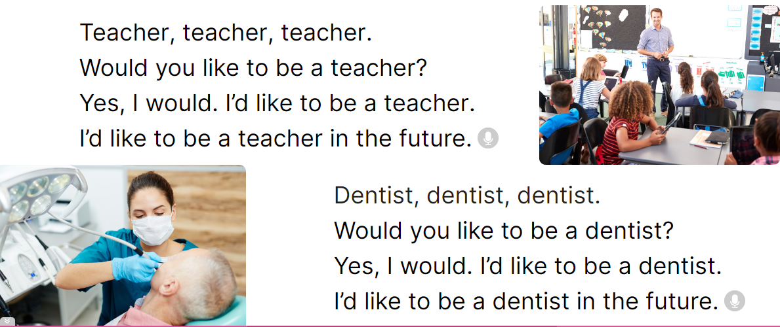  - Play the recording for Ss to listen to the whole chant.  + Have them repeat the title and lyrics line by line.  + Ask Ss to attend to two-syllable words with the stress on the first syllable in the chant, teacher future and dentist.  - Play the recording all the way through for Ss to listen to pronunciation and melody.  - Play the recording line by line for Ss to listen and repeat  - Play the recording for Ss to chant and clap along.  - Ask Ss to practice chant and clap along in pairs or groups.  - Invite groups to the front of the classroom to perform the chant  3. Fun corner and wrap- up  Game: Chanting game  - Tell Ss to close their book, listen to the chant  - Ask Ss to listen again and clap their hands on the word stress.  - Ask Ss to chant like a robot.  - Learn Vocabulay with future job  - Prepare Unit Unit 5: Lesson 3(4,5,6) | - Follow the T’s instructions.  -Ss pay attention and say  Ex:  A: What would you like to be in the future?  B: I’d like to be a…………..  - Ss open their books  - - Ss point and pay attention  - Ss listen to the recording again and repeat.  -Ss work in pairs and practice  -Ss say the words and sentences  - Ss pay and listen to the teacher’s explanation.  - Ss do the task  - Ss listen to the recording to check their answers (individual)  - Ss swap books with a partner and check the answers  - Ss listen to the recording again and check their answers again.  - Ss stand up and read aloud the words.  - Ss look and listen.  - Ss listen to the chant  - Ss listen and repeat line by line without clap their hands  - Ss note the rhythm and pronunciation.  -Ss listen to melody of the chant  - Ss listen and chant line by line.  - Ss chant and clap along.  - Ss work in groups (two groups) to chant  -Ss perform in front of the class.  -Ss listen  -Ss listen and clap the hands  -Ss chant
D. ADJUSTMENTS (if necessary):
Warm up: Play guessing games : Job

Week 9 Preparing date: 3/11/2024
Period 34 Teaching date: 6/11/2024

Unit 5: My future job
Lesson 3 (4, 5, 6)
A. OBJECTIVES:
By the end of the lesson, Ss will be able to:
1. Knowledge:
- read an email and complete three gapped sentences about future jobs
- complete a gapped letter about people’s future jobs
- conduct a report about the future jobs that the class members would like to do in the future and use it to practise talking in the class during Project time.
- Vocabulary: Review
- Skills: speaking, listening, reading and writing.
2. Competences:
- Communication and collaboration: work in pairs and groups to complete the learning tasks.
- Self-control and independent learning: perform reading and writing tasks.
3. Attitude/ Qualities:
- Show their interests in their future jobs.
B. TEACHING AIDS:
- Teacher: Teacher’s guide Pages 87, 88; website hoclieu.vn, posters, laptop, pictures, textbook, lesson plan, TV or projector.
- Students: Student’s book Page 39, notebooks, workbooks, school things.
C. PROCEDURES:
Stages &Time | Teacher’s activities | Students’ activities
1.Warm- up and review: (5 mins)  2.Presentation  (10 mins)  3.Practice: (8 mins)  4.Production: (10 mins)  5.Homework  (2 mins) | Game: Pictionary  *Aims: to revise the new words and structures from previous lessons.  *Procedure:  - Call a member from each team and give them a clue.  - Give a chalkboard or marker for that member to draw a clue so the entire class can see the clue.  - If the team member guessed the word, they would get one point. If the other team member guessed the word, they would get the point.  - Ss clap their hands on the stress of the word that they guess to get extra points for their team.  - Say “Open your book page 39” and look at “Unit 5, Lesson 3 (4,5,6)”.  Activity 1. Read and circle:  *Aims: Ss will be able to read and show understanding of a text by answering four questions about Laura’s free-time activities at the weekend  *Procedure:  - Set a time limit and ask Ss to read through the email to get a general idea of it.  - Tell Ss to read the email again to choose the correct answer  - Set a time limit for Ss to do the task independently.  - Get Ss to swap books with a partner and check the answers before checking  as a class.  - Ask a few Ss to read the sentences in front of the class.  - Ask Ss to choose key information about Peter and Mary, ex. firefighter, help people, work in a team, take care of other people, gardener, plant trees, flowers, beautiful gardens. Have Ss work in pairs and talk about them.  Key: 1. b 2. c 3. a  Activity 2. Let’s write  *Aims: Ss will be able to write an email about future jobs using a gapped paragraph *Procedure:  - Ask Ss to read the rubrics and think about the jobs that they would like to do in the future.  - Ask Ss to read the questions and use them as clues to complete the email.  - Give Ss enough time to write their emails.  (work in pairs or groups)  - Have some Ss read their completed email aloud.  Key: Pupil’s answer  Ex:  Hi Peter,  In the future, I would like to be a gardener. I want to plant a lot of trees and flowers. My brother Minh loves travelling and meeting people. He would like to be a pilot in the future. Bye!  Kitty  Activity 3. Project.  *Aims: Ss will be able to carry out a survey on the jobs that the classmates would like to do in the future and present a report to the class.  *Procedure:  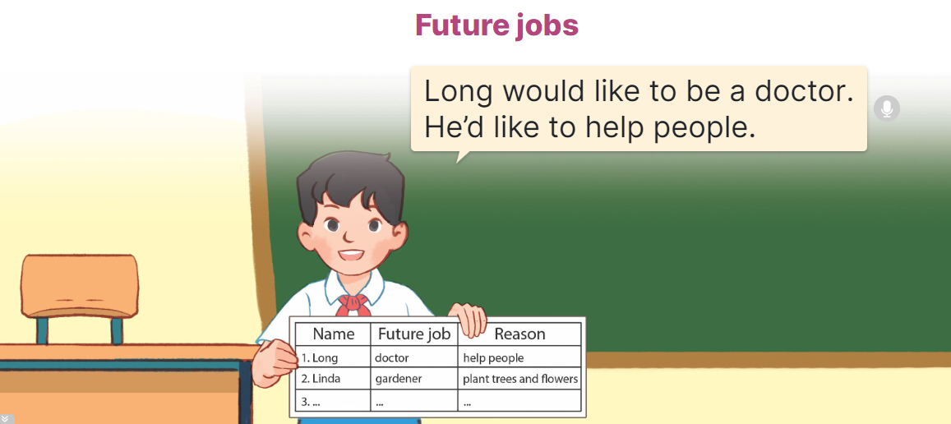  - Point at the sample survey and explain that Ss are going to report the results of their surveys about their classmates’ future jobs and the reasons why they would like to do the jobs.  - Give Ss some time to practise their presentations by themselves and within groups.  - Select a few Ss to give their presentations in front of the class.  4. Fun corner and wrap- up  Game: Pass the ball  - T gives Ss a ball.  - T asks Ss to listen to music and transfer a ball around the class.  - When the music stops, Ss who keep a ball have to answer the question using: I’d would like to be a teacher in the future.  - T gives feedback.  - Learn Vocabulay with topic Job  - Prepare Review 1 | - Ss listen  - Ss listen to the rules  -Ss play game  - Ss open their books  - Ss pay attention to the email and read  - Ss look at the incomplete sentences and answer options.  - Ss read the text again and circle the correct answers.  - Ss swap books and check answers  - Ss read the sentences  - Ss work in pairs and talk  - Ss read the rubrics and think  - Ss read the questions and complete the email.  - Ss write their emails.  - Ss read their completed email aloud  -Ss listen to the teacher  - Ss work in groups and tell the group about their friend’s future jobs.  - Ss talk about their future jobs in front of the class.  -Ss listen to the teacher  -Ss play the game
D. ADJUSTMENTS (if necessary):
………………………………………………………………………………………….…..……………………………………………………………………………...……

Week 9 Preparing date: 5/11/2024
Period 35, 36 Teaching date: 7/11/2024

Review 1
Parts 1, 2, 3, 4, 5
A. OBJECTIVES:
By the end of the lesson, Ss will be able to:
1. Knowledge:
- listen to five questions and circle the correct answers a, b or c.
- ask and answer questions using picture cues.
- read and match pairs of target sentence patterns.
- read and complete a gapped table about a boy named Henry.
- read, understand and complete the passage using word cues.
- Vocabulary: Review
- Skills: speaking, listening, reading and writing.
2. Competences:
- Communication and collaboration: work in pairs and teams to complete the learning tasks.
- Self-control and independent learning: perform reading and writing tasks.
3. Attitude/ Qualities:
- Study hard to review the vocabulary and sentence patterns they have learnt.
- Be honest in the learning tasks.
B. TEACHING AIDS:
- Teacher: Teacher’s guide Pages 84,85, 86, 87; Track 55; website hoclieu.vn, posters, laptop, pictures, textbook, lesson plan, TV or projector.
- Students: Student’s book Page 40, 41, notebooks, workbooks, school things.

C. PROCEDURES:
Stages &Time | Teacher’s activities | Students’ activities
1.Warm- up: (5’)  2.Presentation  (20’)  2.Practice: (25’)  4.Production: (18’)  5. Homework  (2’) | Game: Whispering  *Aims: to revise the sentence structures they have learnt.  *Procedure:  - Divide class into 2 groups.  -Ask 5 Ss in each group stand in a straight line.  - T says a word or phrase to the first student in this line.  - Then, the first student whispers what she/ he hear to the second person in line; the second one whispers what he/ she hears to the third one and so on until the last student in group hears the word or phrase.  - The last student says the word or phrase out loud.  - The faster group has correct word or phrase is the winner.  - Say “Open your book page 40, 41” and look at Review 1.  Activity 1. Listen and circle a, b or c:  *Aims: Ss will be able to listen to five questions and circle the correct answers a, b or c.  *Procedure:  - Draw Ss’ attention to the first set of suggested answers and have ss read the answer options.  - Play the recording for Ss to do the task. (three times)  - Get Ss to swap books with a partner, then check answers as a class.  - Write the correct answers on the board.  - Play the recording for S to double-check their answers.  - Play the recording, have Ss listen and repeat in chorus.  Key: 1. b, 2. b, 3. c, 4. c, 5. a  Activity 2. Ask and answer:  *Aims: Ss will be able to ask and answer questions using picture cues.  *Procedure:  - Get Ss to look at the bubble to identify the activity shown in it 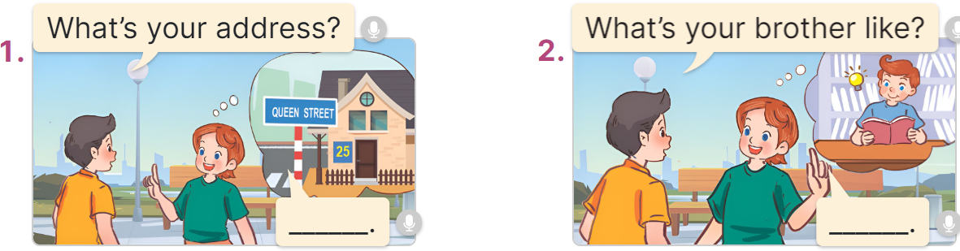  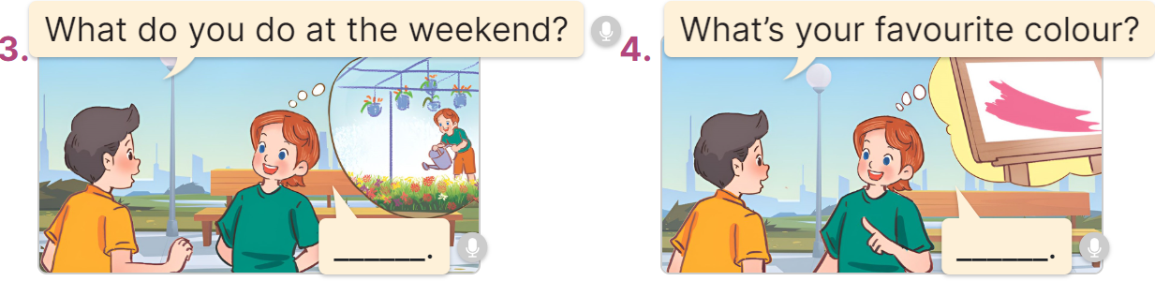  - Have Ss look at the picture to answer the question.  - Have Ss work in pairs to role-play the four exchanges.  - Invite pairs of Ss to stand up and take it in turns to role-play the target exchanges.  Key: 1. It’s 25 Queen Street.  2. He’s clever.  3. I water the flowers.  4. It’s / I like pink.  Activity 3. Read and match  *Aims: Ss will be able to read and match pairs of target sentence patterns.  *Procedure:  - Tell Ss about this activity. Point at sentence 1, elicit the answer and models.  - Give Ss work in pairs to do the sentence 2,3,4,5.  - Tell Ss to swap their books with their partners, then check answers together as a class.  - Write the correct answers on the board for Ss to correct their answers.  - Invite some pairs to stand up and read the matched exchanges aloud.  Key: 1.d, 2. a, 3. e, 4. c, 5. b  Activity 4. Read and complete  *Aims: Ss will be able to read and complete a gapped table about a boy named Henry  *Procedure:  - Have Ss read the passage about Henry.  - Have Ss look at the gapped passage.  - Point at the sentence with the first gap and read it as a class.  - Elicit the missing word and give feedback. Complete the sentence and get Ss to read the completed sentence in chorus.  - Get Ss to swap books with a partner, then check answers as a class. Write the correct answer on the board.  - Invite some Ss to stand up and read the completed passage aloud.  Key:  1. 5 2. Australian 3. 72  4. surfing the Internet 5. gardener  Activity 5. Let’s write  *Aims: Ss will be able to complete a gapped text with the help of picture cues.  *Procedure:  -Tell the class the goal of this activity: to read the gapped text and fill in the gaps using picture cues.  - Write the sentence with the first gap on the board. Read the sentence as a class. When you reach the gap, ask pupils to point at the picture and write (My name is……).  - Ask Ss complete the other sentences.  - Invite a few Ss to read the sentences they have completed aloud in front of the class.  Key: Pupil’s answer  4. Fun corner and wrap- up (3’)  Game: “Pass the ball”  - Give two different colored balls to two pupils, a blue ball (ask the question) and a white ball (answer the question).  - Ask Ss to listen to music and pass the balls.  - Stop music suddenly. Have the student with a blue ball make a question. Have the student with a white ball answer the question.  - Repeat the game several times.  - Prepare Extension Activities | - Ss listen  -Ss play game  -Ss praise the winner.  - Ss open their books  - Ss read the answer options.  - Ss listen to the recording and do the task.  - Ss swap books with a partner, then check answers as a class.  - Ss listen to the recording to double-check their answers.  - Ss listen to the recording and repeat  -Look at the pictures and say:  + Picture 1:  Nam: What’s your address?  Lucy: …………….  + Picture 2:  Nam: What’s your brother like?  Lucy: …………..  + Picture 3:  Nam: What do you do at the weekend?  Lucy: ………….  + Picture 4:  Nam: What’s your favourite colour?  Lucy: ………..  - Ss look at and answer.  - Ss work in pairs to role play  - Ss role play  -Ss look at the sentence 1 and say  -Ss work in pairs and match  -Ss swap their books and match  -Ss check their answer  -Ss read aloud  -Ss read the passage  -Ss look at the passage  -Ss point at the first gap and read  -Ss complete the missing word  -Ss swap their books and check their answer.  -Ss read aloud  -Ss pay attention  -Ss point and answer the first gap  -Ss complete the sentences  -Ss read aloud.  -Ss listen to the teacher  -Ss play the game  Ex: A: What’s your favourite food?  B: It’s chicken  -Ss continue playing the game.
D. ADJUSTMENTS (if necessary):
Production: play game: Bank vocabulary

