Week 27 Preparing date: March 16th,2025
Period 105 Teaching date: March 17th, 2025

Extension activities
A. OBJECTIVES:
By the end of the lesson, Ss will be able to:
1. Knowledge:
- show understanding of food types by colouring in a picture.
- categorise a wider range of food and drink items by their food types.
- Vocabulary: Review
- Skills: speaking, writing and listening
2. Competences:
- Co-operation: ready to help friends in pair work/ group work.
- Sociability: Talk to each other, say good words to others.
3. Attitude/ Qualities:
- Kindness: Help partners to complete learning tasks.
B. TEACHING AIDS:
- Teacher: Teacher’s guide Pages 254, 255, 256; website hoclieu.vn, posters, laptop, pictures, textbook, lesson plan, TV or projector.
- Students: Student’s book Page 38, 39, notebooks, workbooks, school things.
C. PROCEDURES:
Stages/Time | Teacher’s activities | Students’ activities
1.Warm- up: (3’)  2. Practice (28’)  3. Fun corner and wrap- up (4’) | Sing: Head, shoulders, knees and toes  *Aims: to create a friendly and active atmosphere in the class to beginning the lesson.  *Procedure:  - Show the song on the screen.  https://www.youtube.com/watch?v=WX8HmogNyCY  - Ask Ss to listen, sing and dance the song.  - Say “Open your book page 38, 39” and look at “Extension activites”.  Activity 1. Look, read and colour  *Aims: Ss will be able to show understanding of food types by colouring in a picture.  *Procedure:  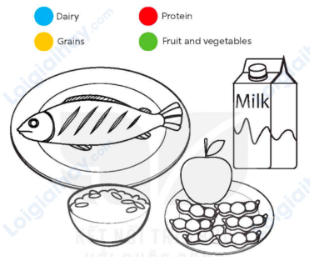  - Tell the class the goal of this activity: They need to identify the food types by colouring in the picture, according to the key above.  - Have ss say them aloud and elicit some examples of each food type.  + Ask questions to check comprehension, such as What colour is protein? (red) and What colour should bread be? (yellow).  - Put ss into pairs and have them decide which colour each food / drink item should be.  - Set a time for ss to complete the activity independently.  - Check answers as a class by pointing to the food / drink items and having ss call out the food, the correct food type and the colour (ex: fish, protein, red).  - Invite a few ss to the front of the class and have them present their work to the class. Model what they need to say, ex: Fish is protein. Rice is grains.  Key:  fish: protein / red  milk: dairy / blue  rice: grains / yellow  apple and peas: fruit and vegetables / green  Activity 2. Look and write  *Aims: Ss will be able to categorise a wider range of food and drink items by their food types.  *Procedure:  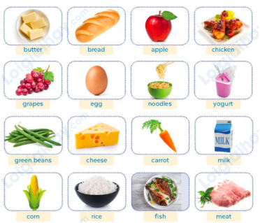  - Tell the class the goal of this activity: They need to categorise the foods by writing the names of the food and drink items in the correct columns of the table.  - Write the table on the board and have ss say the four headings aloud.  - Set a time limit for ss to complete the activity.  - Have check answers in pairs.  - Check answers as a class by pointing to the pictures and having ss call out the correct food type.  - Invite a few ss to the front of the class and have them present their work to the class.  Key:  Grains: noodles, rice, bread.  Protein: chicken, egg, fish, meat  Dairy: butter, cheese, yogurt, milk  Fruit and vegetables: apple, grapes, green beans, carrot, corn.  Activity 3. Write and say  *Aims: Ss will be able to create a healthy breakfast and present it to the class.  *Procedure:  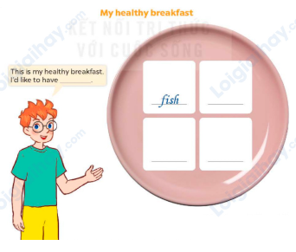  - Tell the class that they are going to create a healthy breakfast and present it to the class. They need to think of four food and drink items to create the breakfast.  - Draw Ss’ attention to the picture and have them identify the bowl and the blank spaces.  - Ask Ss what they usually eat for breakfast. Make a list of their answers on the board. Ask Is this food/drink healthy? And allow Ss to respond.  - Have ss create their healthy breakfast by writing down the food and drink items  - Have ss check their answers in pairs.  - Invite a few ss to share their healthy breakfasts with the class.  - Have ss create a healthy lunch and dinner and present them to the class.  Suggested answers:  This is my healthy breakfast. I’d like to have noodles, green beans and fish. I’d like to drink milk.  Game: “Kim’s game”  - Divide the class into two teams.  - Display many words and phrases on the board. Give sls two minutes to memorise these words and phrases.  - Turn the word cards face down on the board. In their teams, the ss try to write down many words as they can remember.  - Check the answers as the class.  - Count the points for each team and announce the winner. The team with the most points wins. | - Ss listen  - Ss sing a song  -Ss open the book  - Ss listen to the teacher’s explanation.  - Ss look at the four food types given in the activity on the board.  - Ss answer the questions.  - Ss pay attention and follow the teacher’s instructions.  - Ss complete the activity independently.  - Ss check the answers and call out the food, the correct food type and the colour.  - Ss come to the front of the class and present their work to the class.  - Ss listen to the teacher’s explanation.  - Ss say the four headings aloud.  - Ss complete the table independently  - Ss check answers in pairs.  - Ss check answers as a class and call out the correct food type.  - Ss come to the front of the class and present their work to the class.  - Ss listen to the teacher’s explanation.  - Ss look at the picture, identify the bowl and the blank spaces.  - Ss listen and answer the questions.  - Ss write down the food and drink items.  - Ss check the answer  -Ss share their healthy breakfasts  -Ss come to the front of the class and present their work to the class.  - Ss listen to the teacher  -Ss play the game  Ex: bread, apple, chicken, grapes, egg, noodles, yogurt, green beans, cheese, carrot, milk, water, apple juice, corn, rice, fish,  -Ss praise the winner
D. ADJUSTMENTS (if necessary):
………………………………………………………………………………………….…..……………………………………………………………………………...……
Week 27 Preparing date: March 16th,2025
Period 107 Teaching date: March 17th,2025

Unit 16: Seasons and the weather
Lesson 1 (1, 2, 3)
A. OBJECTIVES:
By the end of the lesson, Ss will be able to:
1. Knowledge:

- understand and correctly repeat the sentences in two communicative contexts

focusing on asking and answering questions about the weather in different seasons;

- correctly say the words summer, autumn, winter, spring, hot, cool, cold and warm and use How’s the weather in Ha Noi in ___? - It’s____. to ask and answer questions about the weather in Ha Noi in different seasons;

- use How’s the weather in Ha Noi in ___? – It’s ___. in a freer context.

- Vocabulary: summer, autumn, winter, spring, hot, cool, cold and warm

- Structures:
A: How’s the weather in Ha Noi in summer?
B: It’s hot
- Skills: speaking and listening
2. Competences:
- Critical thinking and creativity: learn how to ask and answer questions about the weather in Ha Noi in different seasons correctly and fluently.
- Self-control and independent learning: perform speaking tasks.
3. Attitude/ Qualities:
- Show their love and interest in the weather and seasons.
- Express their knowledge about the weather of each season.
B. TEACHING AIDS:
- Teacher: Teacher’s guide Pages 257, 258, 259, audio Tracks 52, 53, website hoclieu.vn, posters, laptop, pictures, textbook, lesson plan, TV or projector.
- Students: Students’ book Page 40, notebooks, workbooks, school things.
C. PROCEDURES:
Stages/Time | Teacher’s activities | Students’ activities
1.Warm- up and review: (3’)  2. Presentation (15’)  A: How’s the weather in Ha Noi in summer?  B: It’s hot  3.Practice: (7’)  4. Production: (6’)  5. Fun corner and wrap- up (4’) | Game: Slap the board  *Aims: to revise the vocabulary about different weather that pupils have learnt in English 3.  *Procedure:  - Prepare some flashcards about different jobs and stick on the board  (sunny, rainy, windy, cloudy)  - Divide class into 2 groups: Tom and Jerry.  - How to play:  + Each group chooses five Ss to play.  + Class will read aloud.  + Look at the picture, listen and slap the picture you heard.  + Who faster will get 1 mark.  + Which group with higher mark is the winner.  - Say “Open your book page 40” and look at “Unit 16, Lesson 1 (1,2,3)”.  Activity 1. Vocabulary.  *Aims: Ss will be able to know the vocabulary in the new lesson.  *Procedure:  -T elicits the new words  + summer: mùa hè (picture)  + autumn: mùa thu (picture)  + winter: mùa đông (picture)  + spring: mùa xuân (picture )  + hot: nóng (situation)  + cold: lạnh (mime)  + cool: mát mẻ (mime)  + warm: ấm áp (translation  - T models (3 times).  - T writes the words on the board.  - Checking: Matching  Activity 2. Look, listen and repeat:  *Aims: Ss will be able to understand and correctly repeat the sentences in two communicative contexts focusing on asking and answering questions about the weather in different seasons.  *Procedure:  - Have Ss look at Pictures a and b and identify the characters and say what they can see in the pictures.  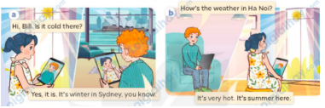  - Play the audio twice (sentence by sentence). Correct their pronunciation where necessary.  - Have Ss to practice the dialogue  - T invites a few pairs to the front of the class to practice.  - T checks pronunciation for ss.  Activity 3 Listen, point and say.  *Aims: Ss will be able to correctly say the words and use How’s the weather in Ha Noi in ___? - It’s ____.to ask and answer questions about the weather in Ha Noi in different seasons.  *Procedure:  * Structures:  - T asks Ss look at picture b in activity 1 and helps Ss know the structure from the dialogue.  - T introduces new structures for Ss.  - T explains, models and gives meaning.  - Have Ss repeat the structures  *Drill pictures  - Have Ss look at the pictures and say what they can see in the pictures.  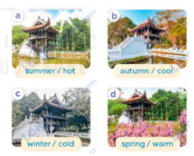  - Have Ss point at pictures, listen and run through all the pictures.  - Have Ss point at the bubbles, listen and run through model sentences.  - Have Ss to practise:  + T asks the first picture, Ss answer  + Ss asks the second picture, T answers  + Group A asks the third picture, group B  answers  + Group B asks the last picture, group A  - Ask Ss to work in pairs to practise asking and answering the How’s the weather in Ha Noi in ___? - It’s ___  - T controls and corrects.  - Invite a few pairs to point at the pictures and say the questions and answers in front of the class.  Activity 4. Let’s talk.  *Aims: Ss will be able to use How’s the weather in Ha Noi in ___? - _It’s ______.in a freer context.  *Procedure:  - Ask Ss to look at the pictures and ask questions to revise the relevant seasons and the weather concepts.    - Point at the ﬁrst picture and elicit the question in the ﬁrst speech bubble How’s the weather in Ha Noi in ___? and the answer in the second speech bubble It’s ___ as an example.  - Give Ss time to work in pairs and take turns pointing at each picture to ask and answer using structures.  - Invite a few pairs to come to the front of the classroom and act out the exchanges.  Game: Guess the picture  - Tell the class they are going to take turns looking at a part of the picture and guess the name of the season.  - Use pictures (spring, summer, autumn, winter).  - In turn, show a part of the picture. Ask ss to raise their hand to say the name of the season.  - If they say the correct word, they will get stickers from the teacher.  - Praise ss. | -Ss listen and pay attention  - Ss listen to the teacher  -Ss play the game  .  -Ss continue playing the game  - Ss listen and open their books  -Ss listen and answer  - - Ss listen and repeat  + Choral repetition (3 times).  + Individual repetition (3 ss)  - Ss take note  - Ss look and match  -Look at the pictures and say.  + In picture a:  Linh: Hi, Bill. Is it cold there?  Bill: Yes, it is. It’s winter in Sydney, you know.  + In picture b:  Bill: How’s the weather in Ha Noi?  Linh: It’s very hot. It’s summer here.  -Ss listen and repeat in chorus (twice)  -Ss work in pairs to practice  -Ss come to the front of the classroom to practice.  -Ss listen  - Ss look at the picture and answer.  -Ss listen  -Ss listen and repeat  -Ss repeat to the structures  - Ss look, listen and repeat  +Picture a: Ha Noi’s One-Pillar Pagoda in summer  + Picture b: Ha Noi’s One-Pillar Pagoda in autumn  + Picture c: Ha Noi’s One-Pillar Pagoda in winter  + Picture d: Ha Noi’s One-Pillar Pagoda in spring  -Ss point at pictures, listen and repeat  -Ss point at the bubbles, listen and repeat  -Ss practice in chorus  -Ss practice in chorus  -Ss work in pairs to practise asking and answering the question  - Pairs of Ss point at the pictures and say in front of the class  -Ss look at the picture and say  + the Huc Bridge across Hoan Kiem Lake, Ha Noi, in different seasons: winter, spring, summer and autumn.  - Ss look at the first picture and elicit the missing words in speech bubbles and say the completed sentences.  - Ss role-play to practise asking and answering questions  - Ss practise asking and answering questions in front of the class.  -Ss listen to the teacher  -Ss play the game  -Ss continue the game
D. ADJUSTMENTS (if necessary):
………………………………………………………………………………………….…..……………………………………………………………………………...……

Week 27 Preparing date: March 16th,2025
Period 107 Teaching date: March 19th,2025

Unit 16: Seasons and the weather
Lesson 1 (4, 5, 6)
A. OBJECTIVES:
By the end of the lesson, Ss will be able to:
1. Knowledge:
- listen to and understand four communicative contexts in which characters ask and answer questions about different seasons and weather conditions, and number the pictures
- complete four exchanges with the help of picture cues
- sing the song How’s the weather in Ha Noi? with the correct pronunciation, rhythm and melody.
- Vocabulary: Review
- Skills: speaking, listening, reading and writing.
2. Competences:
- Communication and collaboration: work in pairs and groups to complete the learning tasks.
- Self-control and independent learning: perform listening and reading tasks.
3. Attitude/ Qualities:
- Show their love and interest in the weather and seasons.
- Express their feelings about the weather of each season.
- Show their knowledge of choosing suitable clothes in different seasons.
B. TEACHING AIDS:
- Teacher: Teacher’s guide Pages 260, 261, 262; audio Tracks 54, 55; website hoclieu.vn, posters, laptop, pictures, textbook, lesson plan, TV or projector.
- Students: Student’s book Page 41, notebooks, workbooks, school things.
C. PROCEDURES:
Stages/Time | Teacher’s activities | Students’ activities
1.Warm- up and review: (5’)  2.Practice: (25’)  3. Fun corner and wrap- up (5’) | Game: Slap the board  *Aims: to create a friendly and active atmosphere in the class to beginning the lesson.  *Procedure:  - Divide the class into two teams. Each team has eight ss.  - Have each team stand in a line.  - Tell ss how the game is played. Give an example.  - Stick the flashcards (spring, summer, autumn, winter) on the board.  - Teacher says a word. Ask two ss from two teams to listen to the word and slap the flash card as correctly and quickly as possible.  - The first student who slaps the correct flash card gets one point and continues playing the game.  - The student who gets the highest points will be the winner. Praise the winner.  - Say “Open your book page 41” and look at “Unit 16, Lesson 1 (4,5,6)”.  Activity 1. Listen and number:  *Aims: Ss will be able to listen to and understand four communicative contexts in which characters ask and answer questions about different seasons and weather conditions, and number the pictures.  *Procedure:  - Draw ss’ attention to each picture and ask questions to elicit the place and the season illustrated by the sceneries.    - T ask Ss to guess the answers.  + T writes Ss’guessing on the board.  - Listen to the tape:  + Play the recording  + Play the recording again for ss to do the task.  + Play the recording a third time for ss to check their answers.  - Get Ss to swap books with their partner, then check answers as a class.  + Write the answers on the board for Ss to correct their answers. Then checks Ss’ guessing.  - If time allows, play the recording, sentence by sentence, for Ss to listen and repeat individually and in chorus  Key: 1. b, 2. d, 3. a, 4. c  Activity 2. Read and complete  *Aims: Ss will be able to complete four exchanges with the help of picture cues.  *Procedure:  - Draw ss’ attention to the season in the picture, particularly the peach blossom(ex: spring).  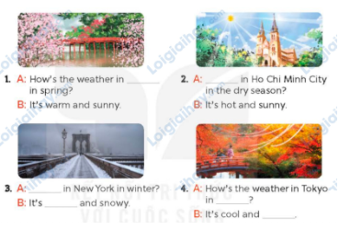  - Give Ss a time limit to read the gapped dialogues, look at the pictures and do the task independently.  - Get Ss to swap books with a partner and check their answers before checking as a class.  + Invite one student to write the answers on the board.  - Invite two pairs of Ss to act out the completed dialogues.  Key:  1. in spring  2. How’s the weather  3. How’s the weather, cold  4. autumn, windy  Activity 3. Let’s sing  *Aims: Ss will be able to sing the song How’s the weather in Ha Noi? with the correct pronunciation, rhythm and melody.  *Procedure:  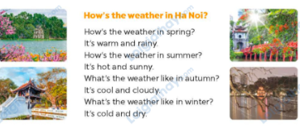  - Introduce the title and lyrics of the song: How’s the weather in Ha Noi?  - Play the recording for Ss to listen to the whole song.  + Have them repeat the title and lyrics line by line.  - Play the recording all the way through for Ss to listen to pronunciation and melody of the song.  - Play the recording line by line for Ss to listen, repeat  - Play the recording for Ss to sing and do actions.  - Ask Ss to practice singing and doing actions in pairs or groups.  - Invite groups to the front of the classroom to perform the song  -T gives feedback.  Game: A matching game  - Tell the class that they are going to play a matching game. Tell them that the aim of the game is to review vocabulary and structures about asking and answering the question about the weather in different seasons.  - Explain how to play the game: ask ss to work in teams of five. T gives the same sets of word cards for groups to make sentences  - Set a time limit for the teams to play the game. Monitor the activity.  - Call on two teams to play the game in front of the class. Remember to praise ss who do well. | -Ss listen to the teacher  -Ss play the game  -Ss continue playing the game  - Ss open their books  -Look at the pictures and say:  + Picture 1: Hoan Kiem Lake in summer  + Picture 2: Hoan Kiem Lake in spring  + Picture 3: Hoan Kiem Lake in winter  + Picture 4: Hoan Kiem Lake in summer  -Ss guess the answers  - Ss listen to the tape  - Ss listen again and do the task.  - Ss listen and check their answers  - Ss swap books with their partner, then check answers as a class  -Ss check the guessing  -Ss listen and repeat  -Ss look at the picture and read, fill the gap  - Ss do the task independently.  - Ss swap books with a partner and check their answers.  - Ss write the answers in the notebook  - Pairs of Ss read the completed dialogues aloud  -Ss look and listen to the teacher  -Ss listen to the song  - Ss listen and repeat line by line without the action.  -Ss listen to melody of the song  - Ss listen and sing line by line.  - Ss sing and do actions.  - Ss work in groups (two groups) to sing.  -Ss perform in front of the class.  -Ss listen  -Ss listen to the teacher  - Ss play the game.  - Ss continue playing the game.  - Ss praise the winner.
D. ADJUSTMENTS (if necessary):
………………………………………………………………………………………….…..……………………………………………………………………………...…..…

Week 27 Preparing date: March 16th,2025
Period 108 Teaching date: March 19th,2025
Unit 16: Seasons and the weather
Lesson 2 (1, 2, 3)
A. OBJECTIVES: By the end of the lesson, Ss will be able to:
1. Knowledge:

- understand and correctly repeat the sentences in two communicative contexts related to the weather and clothing choices during a specific season

- correctly say the words blouse, trousers, jeans and jumper and use What do you usually wear in ____? - I wear _____. to ask and answer questions about what someone wears in different seasons

- use What do you usually wear in ___? - I wear _____. in a freer context.

- Vocabulary: blouse, trousers, jeans and jumper
- Structures:
A: What do you usually wear in winter?
B: I wear a jumper.
- Skills: speaking and listening
2. Competences:
- Critical thinking and creativity: learn how to ask and answer questions about what someone wears in different seasons correctly and fluently
- Self-control and independent learning: perform pronunciation and speaking tasks.
3. Attitude/ Qualities:
- Express their feelings about the weather of each season.
- Show their knowledge of choosing suitable clothes in different seasons.
B. TEACHING AIDS:
- Teacher: Teacher’s guide Pages 262, 263, 264, audio Tracks 56, 57; website hoclieu.vn, posters, laptop, pictures, textbook, lesson plan, TV or projector.
- Students: Students’ book Page 42, notebooks, workbooks, school things.
C. PROCEDURES:
Stages/Time | Teacher’s activities | Students’ activities
1.Warm- up and review: (3’)  2. Presentation (15’)  3.Practice: (7’)  4. Production: (6’)  5. Fun corner and wrap- up (4’) | Game: Questions and answers  *Aims: to create a friendly and active atmosphere in the class to beginning the lesson.  *Procedure:  - Tell ss that they are going to look at the pictures and ask and answer questions about the weather in different seasons.  - Model the activity. Stick a picture (summer) on the board. Invite a pair of volunteers to ask and answer the question about the picture, ex: How’s the weather in spring? - It’s hot and sunny.  - Divide the class into teams of four. Give them a set of pictures. Have them practice asking and answering questions about the weather in different seasons.  - Say “Open your book page 42” and look at “Unit 16, Lesson 2 (1,2,3)”.  Activity 1. Vocabulary.  *Aims: Ss will be able to know the vocabulary in the new lesson.  *Procedure:  -T elicits the new words  + blouse: áo cánh nữ (realia)  + trousers: quần dài (realia)  + jeans: quần bằng vải bông (realia)  + jumper: áo len cao cổ (realia)  + coat: áo khoác, áo choàng (realia)  + wear ; mặc (mime)  - T models (3 times).  - T writes the words on the board.  - Checking: Rub out and remember  Activity 2. Look, listen and repeat:  *Aims: Ss will be able to understand and correctly repeat the sentences in two communicative contexts related to the weather and clothing choices during a specific season.  *Procedure:  - Have Ss look at Pictures a and b and identify the characters and say what they are talking about.  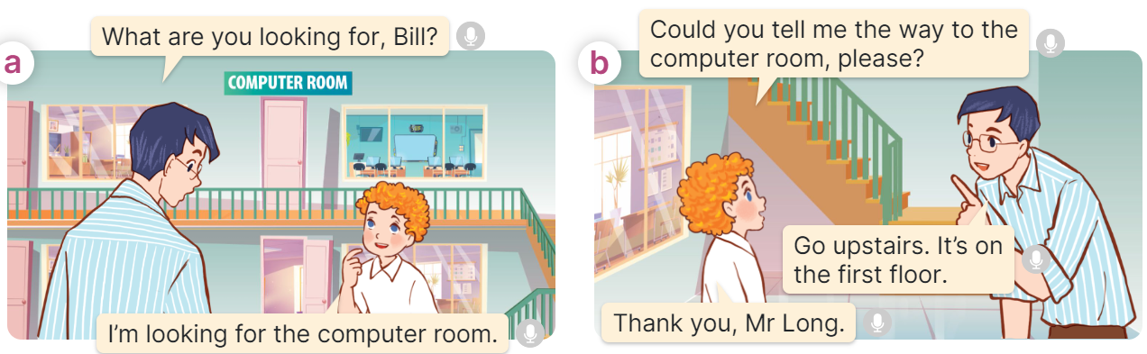  - Play the audio twice (sentence by sentence). Correct their pronunciation where necessary.  - Have Ss to practice the dialogue  - T invites a few pairs to the front of the class to practice.  - T checks pronunciation for ss.  Activity 3 Listen, point and say.  *Aims: Ss will be able to correctly say the words and use What do you usually wear in ____? - I wear ____. to ask and answer questions about what someone wears in a season.  *Procedure:  * Structures:  - T asks Ss look at picture b in activity 1 and helps Ss know the structure from the dialogue.  - T introduces new structures for Ss.  - T explains, models and gives meaning.  - Have Ss repeat the structures  A: What do you usually wear in winter?  B: I wear a jumper.  *Drill pictures  - Have Ss look at the pictures and say what they can see in the pictures.  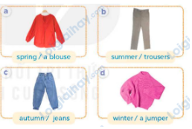  - Have Ss point at pictures, listen and run through all the pictures.  - Have Ss point at the bubbles, listen and run through model sentences.  - Have Ss to practise:  + T asks the first picture, Ss answer  + Ss asks the second picture, T answers  + Group A asks the third picture, group B  answers  + Group B asks the last picture, group A  - Ask Ss to work in pairs to practise asking and answering the question What do you usually wear in ____? - I wear ____.  - T controls and corrects.  - Invite a few pairs to point at the pictures and say the questions and answers in front of the class.  Activity 4. Let’s talk.  *Aims: Ss will be able to use How’s the weather in Ha Noi in ____? – It’s ____. and What do you usually wear in ____? - I wear ____. in a freer context.  *Procedure:  - Ask Ss to look at the pictures and elicit the seasons and pieces of clothing.  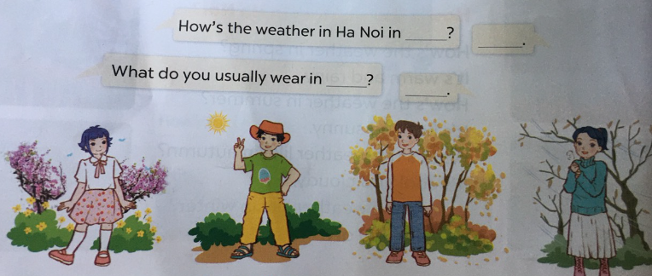  - Remind Ss that How’s the weather in Ha Noi in ____? What do you usually wear in ____? are used to talk about the weather and clothing choices in different seasons in Ha Noi.  - Give Ss time to work in pairs and take turns pointing at each picture to ask and answer using How’s the weather in Ha Noi in __? What do you usually wear in ___?  - Invite a few pairs to come to the front of the classroom and act out the exchanges.  Game: Who’s faster?  - Tell the ss the goal of the game and how to play it. Ask them to revise all vocabulary about clothes.  - Divide the class into groups of four ss. Each group has 30 seconds to write as many words as possible about pieces of clothing in four seasons.  - The groups with more correct words will be the winner. | -Ss listen and pay attention  -Ss play the game  -Ss play the game  - Ss listen and open their books  -Ss listen and answer  - - Ss listen and repeat  + Choral repetition (3 times).  + Individual repetition (3 ss)  - Ss take note  - Ss look, remember and write  -Look at the pictures and say.  + In picture a:  Ben: How’s the weather in Ha Noi in winter?  Nam: It’s cold and dry.  + In picture b:  Minh: What do you usually wear in winter?  Ben: I wear a jumper.  -Ss listen and repeat in chorus (twice)  -Ss work in pairs to practice  -Ss come to the front of the classroom to practice.  -Ss listen  - Ss look at the picture and answer.  -Ss listen  -Ss listen and repeat  -Ss repeat to the structures  - Ss look, listen and repeat  +Picture a: a blouse  + Picture b: a pair of trousers  + Picture c: a pair of jeans  + Picture d: a jumper  -Ss point at pictures, listen and repeat  -Ss point at the bubbles, listen and repeat  -Ss practice in chorus  -Ss practice in chorus  -Ss work in pairs to practise asking and answering the question  - Pairs of Ss point at the pictures and say in front of the class  -Ss look at the picture and say  - Ss listen to the teacher  - Ss role-play to practise asking and answering questions about address  - Ss practise asking and answering questions in front of the class.  -Ss listen to the teacher  -Ss play the game  -Ss play the game  -Ss congratulate the winner.
D. ADJUSTMENTS (if necessary):
……………………………………………………………………………………….…..……………………………………………………………………………...……

