Week 18 Preparing date: 5/1/2025
Period 69 Teaching date: 6/1/2025

Review 2
Parts 3, 4, 5
A. OBJECTIVES:
By the end of the lesson, Ss will be able to:
1. Knowledge:
- read and match five pairs of target sentence patterns.
- read a text about Lan’s trip with her class to Ba Na Hills and number the sentences in order (from 1 to 4)
- write a short paragraph about someone’s trip the previous Sunday.
- Vocabulary: Review
- Skills: speaking, listening, reading and writing.
2. Competences:
- Communication and collaboration: work in pairs and teams to complete the learning tasks.
- Self-control and independent learning: perform reading and writing tasks.
3. Attitude/ Qualities:
- Study hard to review the vocabulary and sentence patterns they have learnt.
- Be honest in the learning tasks.
B. TEACHING AIDS:
- Teacher: Teacher’s guide Pages 174, 175; website hoclieu.vn, posters, laptop, pictures, textbook, lesson plan, TV or projector.
- Students: Pupil’s book Page 75, notebooks, workbooks, school things.
C. PROCEDURES:
Stages/  Time | Teacher’s activities | Students’ activities
1.Warm- up and review: (5’)  2.Practice: (18’)  3.Production: (8’)  4. Fun corner and wrap- up (4’) | Game: Kim’s game  *Aims: to revise the sentence structures they have learnt.  *Procedure:  - Divide the class into two teams.  - Display many words and phrases on the board. Give ss two minutes to memorise these words and phrases.  Ex: play the guitar, dance around the campfire, listen to music, read books, plant trees, crayon, glue stick, friendly, active, clever, pencil sharpener, ...  - Turn the word cards face down on the board. In their teams, the ss try to write down many words as they can remember.  - Check the answers as the class.  - Count the points for each team and announce the winner. The team with the most points wins.  - Say “Open your book page 75” and look at Review 2.  Activity 1. Read and match  *Aims: Ss will be able to read and match five pairs of target sentence patterns  *Procedure:  - Tell Ss about this activity. Point at sentence 1, elicit the answer and models.  - Give Ss work in pairs to do the sentence 2,3,4,5.  - Tell Ss to swap their books with their partners, then check answers together as a class.  - Write the correct answers on the board for Ss to correct their answers.  - Invite some pairs to stand up and read the matched exchanges aloud.  Key: 1. e 2. d 3. a 4. b 5. c  Activity 2. Read and number  *Aims: Ss will be able to read a text about Lan’s trip with her class to Ba Na Hills and number the sentences in order (from 1 to 4).  *Procedure:  - Elicit the words showing the sequences of activities, ex: first, then, after that  - Have ss read the text and the jumbled sentences below the text and number the sentences from 1 to 4.  - Set a time limit for ss to do the task.  - Get ss to swap their answers with a partner, then check answers together as a class.  Key:  2. a. They visited the old buildings and the wax museum.  4. b. They went home late in the afternoon.  3. c. They played some games at the amusement park.  1. d. Lan and her classmates walked on the Golden Bridge and liked the cable car ride.  Activity 3. Let’s write  *Aims: Ss will be able to write a short paragraph about someone’s trip the previous Sunday.  *Procedure:  - Ask ss to read the guiding questions  - Model the first question together and ask ss to read the question and elicit where they went the previous Sunday.  - Give ss time to complete the paragraph independently.  - Get ss to swap their writings with a partner  - Invite a few Ss to read their writings in front of the class.  Suggested answer:  Last Sunday, I went to Hoan Kiem Lake with my friends. In the morning, we walked around the lake. We visited Ngoc Son Temple. In the afternoon, we went to see the water puppet show at the water puppet theatre by the lake. Our trip was a lot of fun!  Game: Hot seat  - Tell ss that they are going to listen to music and answer the question.  - Divide the class into five groups.  - Elect one student from each group to sit in the Hot Seat, facing the classroom with the board behind him/her.  - Write a word on the board. One of the group members of the pupil in the Hot Seat must help the student guess the word by describing it. They have a limited amount of time and cannot say, spell or draw the word.  - Continue until each group member has described a word to the student in the Hot Seat. | - Ss listen and pay attention  -Ss play game  -Ss praise the winner.  - Ss open their books  -Ss look at the sentence 1 and say  -Ss work in pairs and match  -Ss swap their books and match  -Ss check their answer  -Ss read aloud  - Ss pay attention and follow the teacher’s instructions.  - Ss read the text and the jumbled sentences  - Ss do the task.  - Ss swap books and check answers  - Ss read the guiding questions.  - Ss read the question and and write the first sentence.  - Ss complete the paragraph independently.  - Ss swap their writings  - Ss read their writings in front of the class.  -Ss listen to the teacher  -Ss play the game  Ex: A: What did you do yesterday?  B: We………..  -Ss continute playing the game.
D. ADJUSTMENTS (if necessary):
………………………………………………………………………………………….…..……………………………………………………………………………...…….

Week 18 Preparing date: 5/1/2025
Period 70 Teaching date: 6/1/2025

Extension activities
A. OBJECTIVES:
By the end of the lesson, Ss will be able to:
1. Knowledge:
- revise vocabulary related to activities by correctly categorising activities.
- write details about a holiday.
- review the target vocabulary and sentence patterns by playing a board game.
- Vocabulary: Review
- Skills: speaking, writing and listening
2. Competences:
- Co-operation: ready to help friends in pair work/ group work.
- Sociability: Talk to each other, say good words to others.
3. Attitude/ Qualities:
- Kindness: Help partners to complete learning tasks.
B. TEACHING AIDS:
- Teacher: Teacher’s guide Pages 175, 176, 177; website hoclieu.vn, posters, laptop, pictures, textbook, lesson plan, TV or projector.
- Students: Student’s book Page 76, 77, notebooks, workbooks, school things.
C. PROCEDURES:
Stages/  Time | Teacher’s activities | Students’ activities
1.Warm- up: (3’)  2. Practice (28’)  3. Fun corner and wrap- up (4’) | Game: Pass the cards  *Aims: to create a friendly and active atmosphere in the class to beginning the lesson.  *Procedure:  - Give a card to a student.  - Play music. Have that student pass the card to the next one.  - Stop music suddenly. Have the student holding a card to ask a question and invite another student to answer the question.  - Repeat the game several times.  - Say “Open your book page 76, 77” and look at “Extension activites”.  Activity 1. Write the activities in the correct places  *Aims: Ss will be able to revise vocabulary related to activities by correctly categorising activities.  *Procedure:  - Have Ss read the activities in the word box aloud and check understanding.  - Model the activity and ask: When do you do ice skating? Where? What kind of holiday is its?  - Have Ss work in pairs and complete the activity.  - Have Ss check their answers in groups of four.  - Ask ss write the answer on the board, taking turns until the category boxes are complete.  Key:  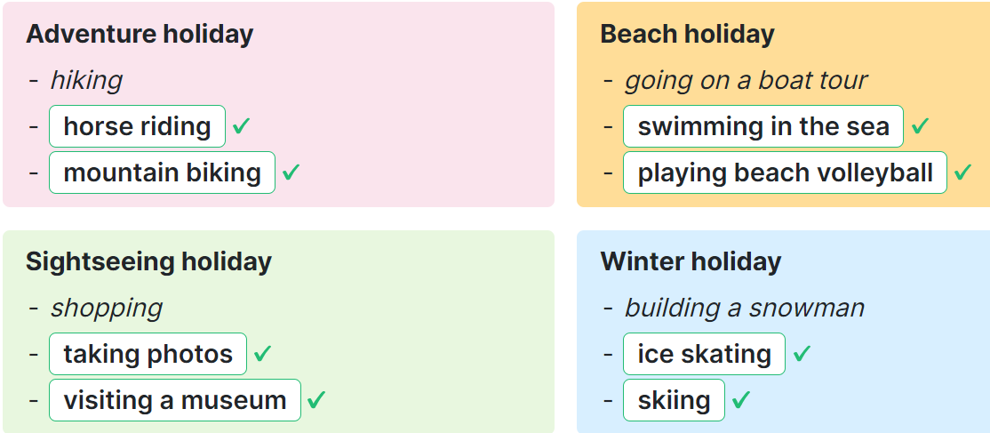  Activity 2. Answer the questions about your last holiday.  *Aims: Ss will be able to write detail about a holiday.  *Procedure:  - Tell Ss the goal of the activity.  - Have Ss read the questions and elicit and answer.  - Have Ss time to complete the activity independenlty.  - Have ss check their answer in pairs, before checking as a class.  Suggested answer:  1. I went to Da Nang.  2. It was a sightseeing holiday.  3. I went with my family.  4. I went swimming, went to a seafood market and played volleyball.  5. Yes, I did. Because I really love the beach and traveling.  Activity 3. Board game. Roll a dice. Listen and answer.  *Aims: Ss will be able to review the target vocabulary and sentence patterns by playing a board game.  *Procedure:  - Tell Ss the goal of the activity  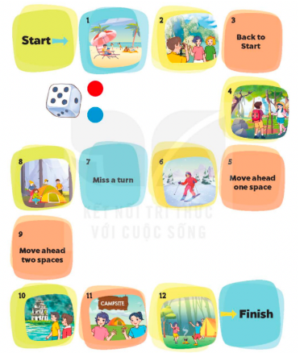  - Divide class into four groups  - Each group rolls the dice in turn. A member of each group moves the group’s counter forward by the number of spaces indicated by the dice.  - When a counter lands on a space with a picture, ask the corresponding question.  + If they do not give a correct answer, their counter must be moved back two spaces and their turn ends  - The game continues until one or all groups reach the “Finish” space.  Key:  1.It’s a beach holiday.  2.They tak photos.  4.Yes, they do.  6.It’s a winter holiday.  8.They put up the tent.  10.Yes, they did.  11.Yes, they were  12.They danced around the campfire.  Sing a song: A ram sam sam  - Show the song on the screen.  https://www.youtube.com/watch?v=SwjvlJCelN0  - Ask Ss to listen, sing and dance the song. | - Ss listen  - Ss play the game  Ex: A: Where did you go last weekend?  B: I went to Ly Son Island.  -Ss continute playing the game  -Ss open the book  -Ss read and say  - - Ss answer: I do it on winter holiday and write ice skating on the board  -Ss do the task  -Ss check together  -Ss write the answer  -Ss listen to the teacher  -Ss read and answer  -Ss read and do the task  -Ss check the answer together  -Ss pay attention  -Ss listen to the teacher  -Ss play the game  -Ss play the game  -Ss play the game  - Ss listen, sing and dance together
D. ADJUSTMENTS (if necessary):
………………………………………………………………………………………….…..……………………………………………………………………………...……

Week 18 Preparing date: 5/1/ 2025
Period 71, 72 Teaching date: 8/1/ 2025

The first term test

A. OBJECTIVES:
By the end of the lesson, Ss will be able to:
1. Knowledge:
- Check Ss’ comprehension about this theme and get marks.
- Vocabulary: Review
- Model sentences: Review
- Skills: speaking, writing, reading and listening
2. Competences:
- Co-operation: ready to help friends in pair work/ group work.
- Sociability: Talk to each other, say good words to others.
3. Attitude/ Qualities:
- Kindness: Help partners to complete learning tasks.
- Honesty: tell the truth about feelings and emotions
B. TEACHING AIDS:
- Teacher: Textbook, lesson plan, TV or projector, wordsheets.
- Students: School things.
C. PROCEDURES:
HOA QUANG NAM PRIMARY SCHOOL THE FIRST TERM TEST
Full name: …………………………… SCHOOL YEAR 2024-2025
Class: 5 …. SUBJECT: ENGLISH – GRADE 5
TIME : 35 minutes
I. LISTENING: ( 2.5pts)
Task 1: Listen and tick a box. Here is an example.

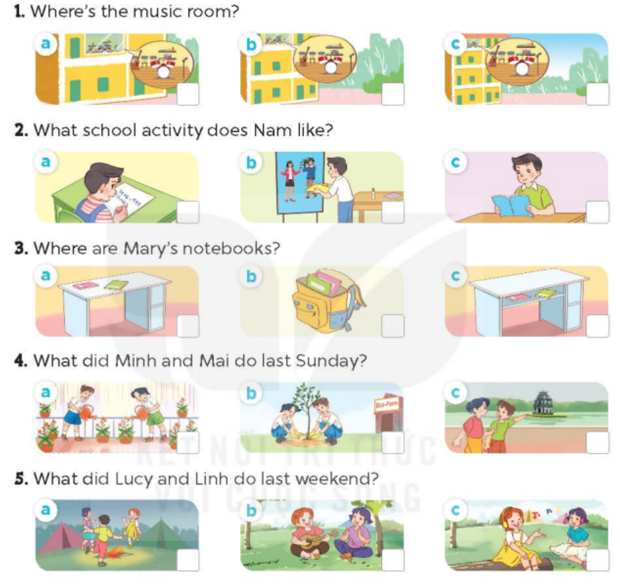
R

Task 2: Listen and circle.
1. Where were you last Sunday? - We were at the_..................
A. campsite B. funfair C. theatre
2. What did you do this morning? - We ______ around the lake.
A. cycled B. walked C. visited
3. What did you do in the afternoon? - We visited the _______.
A. theater B. farm C. zoo
4. What did you do in the evening? - I _.........__________.
A. played the guitar B. walked around the lake C. danced around the campfire

Task 3: Circle, listen and check. There is one example
1. A. teacher B. artist C. address
2. A. dentist B. arrive C. because
3. A. farmer B. prefer C. enjoy

II. VOCABULARY& GRAMMAR (1,5pts)
Task 4: Choose the correct answers.
1. My classroom is ___________ the second floor.
A.at B.in C. to D. on
2. What did she ____________ yesterday? She ________ computer games.
A.do / played B. does/ play C. did / played D. does/ playing
3. Why would you like to be a doctor? - ________ I’d like to help sick people.
A. And B. Because C. So D. but
4. He is from Australia, so he is ______________.
A. America B Australia C. Australian D. Malaysia
5.What do you like doing in your free time? I like _________ to music.
A. listening B. listened C. to listen D. listens
6. My friends ________ at the fun fair yesterday.
A. are B. is C. was D. were

III. READI NG (2pts)
Task 5: Read and tick True or False
Our school is amazing! It’s big and new. There are many rooms. I’m in Class 5C. It’s on the second floor. To get there, go upstairs and turn left. The music room is on the ground floor. Go along the corridor and turn right. Our music classes are really fun! Our library is quiet and comfortable. I often read stories there. It’s on the fourth floor. How can you get there? Go past the art room and turn left. Then go upstairs.
1. The school is big and new. …….
2. Class 5C is on the ground floor. …….
3. To get to the music room, go along the corridor and turn left. ……….
4. The library is on the fourth floor. ………

Task 6: Read and choose the correct answer
During school days, Sarah, a Malaysian student, likes reading and solving maths problems. She also joins the sports club and science projects. In her free time, she enjoys painting and playing the guitar. On weekends, she explores outdoor activities like watching fish at the aquarium in a Malaysian theme park. Once, when she was on the way to the sports centre for a badminton match, she met some her friends she talked and helps with doing projects.

1. What school activities does Sarah like doing?
A. Solving maths problems. B. Reading C. Both A &B are right.
2. What club does she join in?
A. Sports club B. Arts club C. Reading club
3. What is her favourite activity in her free time?
A. Playing sports. B. Playing the guitar. C. Watching fish.
4. Did she go to the sports centre for a badminton match?
A. Yes, she did. B. Yes, she does C. Yes, she do.

IV. WRITING (2pts)
Task 7: Reorder the words / phrases to complete the sentences.
- Linh’s / square / her / is / set / on / desk.
…………………………………………………………………………………
- tell me /to the / Could / the way / you / music room.?
………………………………………………………………………………
- I/ surf / in my / sometimes / the internet / free time./
………………………………………………………………………………
- danced / We sang / the campfire. / around / and /
……………………………………………………………………………..
Task 8: Look at the pictures and answer these following questions.
1.What would you like to be in the future? 2. What school activity does he like?
=> ……………………………………… => …………………………………………
……………………………………….. ………………………………………..

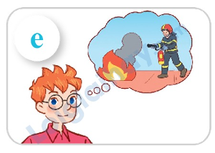
3.Why would you like to be a reporter? 4. Were you and Nam at the aquarium yesterday?
=> ……………………………………… => ……………………………………….
…………………………………………. ………………………………………..



