Week 14 Preparing date: December 8th, 2024
Period 53 Teaching date: December 9th, 2024

Unit 8: In our classroom
Lesson 2 (4, 5, 6)
A. OBJECTIVES:
By the end of the lesson, Ss will be able to:
1. Knowledge:
- listen to and understand two communicative contexts in which characters ask and answer questions about the locations of school things and possession and tick the correct pictures.
- complete two gapped exchanges with the help of picture cues.
- revise target words about possession and school things by playing the game Whose pen is this?
- Vocabulary: Review
- Skills: speaking, listening, reading and writing.
2. Competences:
- Communication and collaboration: work in pairs and groups to complete the learning tasks.
3. Attitude/ Qualities:
- Show their pride in school things they have and great respect for other people’s school things by using appropriate gestures and intonation when asking and answering about school things.
B. TEACHING AIDS:
- Teacher: Teacher’s guide Pages 122, 123 124; audio Tracks 82; website hoclieu.vn, posters, laptop, pictures, textbook, lesson plan, TV or projector.
- Students: Student’s book Page 59, notebooks, workbooks, school things.
C. PROCEDURES:
Stages/ Time | Teacher’s activities | Students’ activities
1.Warm- up and review: (5’)  2.Practice: (25’)  3. Fun corner and wrap- up (5’) | Game: Flower picking!  *Aims: to revise the sentence structures Whose ___ is this? - It’s ___. to ask and answer questions about possession.  *Procedure:  - Tell Ss that they are going to pick up the flowers, then look at the things and ask and answer questions about possession.  - Divide the class into two groups. Two Ss from each group will play the game in turns.  - If ss ask and answer the questions correctly, they will get points for their group.  - Continue the game until all the flowers are picked.  - The group with more points wins the game. Praise the winner.  - Say “Open your book page 59” and look at “Unit 8, Lesson 2 (4,5,6)”.  Activity 1. Listen and tick:  *Aims: Ss will be able to listen to and understand two communicative contexts in which characters ask and answer questions about the locations of school things and possession and tick the correct pictures.  *Procedure:  - Have Ss look at the pictures and help ss identify the locations of the three crayons and set squares  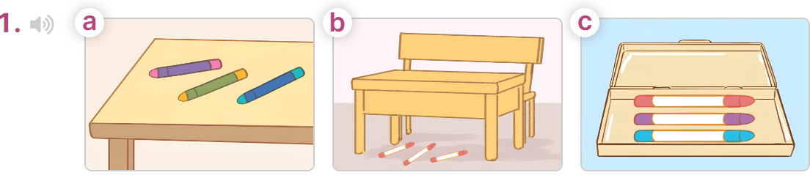  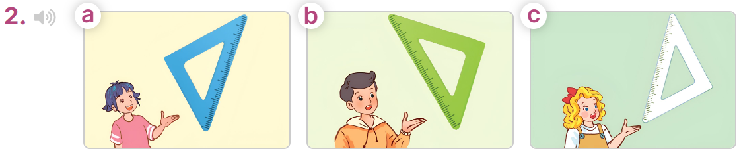  - T ask Ss to guess the answers.  + T writes Ss’guessing on the board.  - Listen to the tape:  + Play the recording  + Play the recording again for pupils to do the task.  + Play the recording a third time for pupils to check their answers.  - Get Ss to swap books with their partner, then check answers as a class.  + Write the answers on the board for Ss to correct their answers. Then checks Ss’ guessing.  - If time allows, play the recording, sentence by sentence, for Ss to listen and repeat individually and in chorus  Key: 1. b 2. a  Activity 2. Read and complete  *Aims: Ss will be able to complete two gapped exchanges with the help of picture cues.  *Procedure:  - Have Ss look at the pictures and identify the directions to the rooms in the pictures.  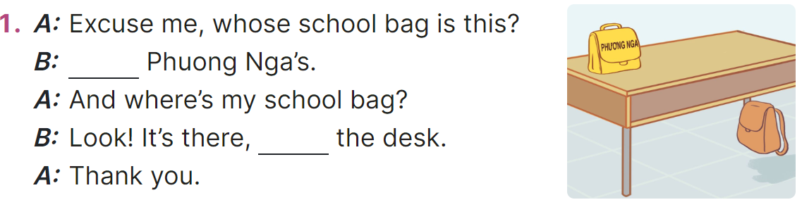  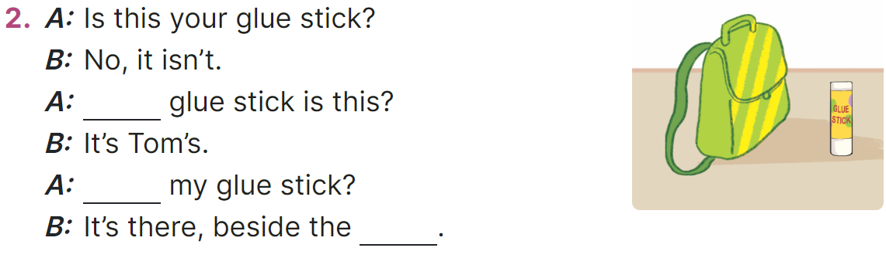  - Model the first sentence: have Ss read the question and ask what words are missing (It’s)  - Give Ss a time limit to read the gapped dialogues, look at the pictures and do the task independently.  - Get Ss to swap books with a partner and check their answers before checking as a class.  + Invite one student to write the answers on the board.  - Invite two pairs of Ss to act out the completed dialogues.  Key: 1. It’s; under,  2. Whose; Where’s; school bag Activity 3. Let’s play  *Aims: Ss will be able to revise target words about possession and school things by playing the game Whose pen is this?  *Procedure:  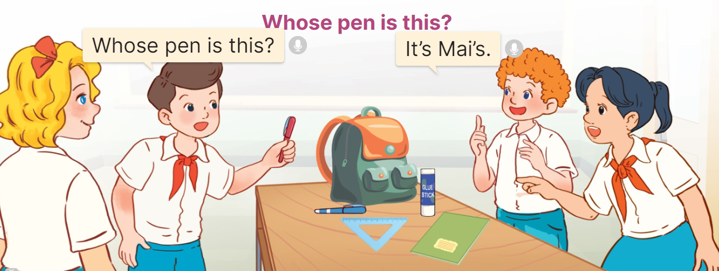  - Tell ss that they are going to play Whose pen is this? game in groups of four.  - The teams take turns asking and answering about possession.  - When a team gives a correct answer, they get one point. The winning team is the one that gets the most points.  - Have ss work in groups. Invite two groups to the front of the class to play the game.  Game: Pass the balls  - Give two different colored balls to two pupils, a red ball (ask the question) and a yellow ball (answer the question).  - Ask ss to listen to music and pass the balls.  - Stop music suddenly.  - Have the student with a red ball ask a question. Have the student with a yellow ball answer the question. | - Ss listen to the teacher’s explanation.  - Ss work in two groups and play the game  - Ss continue playing the game until all the flowers are picked.  - Pupils praise the winner.  - Ss open their books  -Look at the pictures and say:  + Picture 1a: three pencils on a desk  + Picture 1b: three pencils under a desk  + Picture 1c: three pencils in a pencil case  + Picture 2a: Linh’s set square  + Picture 2b: Nam’s set square  + Picture 2c: Mary’s set square  -Ss guess the answers  - Ss listen to the tape  - Ss listen again and do the task.  - Ss listen and check their answers  - Ss swap books and check answers and guessing  -Ss write the answer on the board  -Ss listen and repeat  -Ss look at the picture and say  -Ss follow the teacher  - Ss do the task independently.  - Ss swap books with a partner and check their answers.  - Ss write the answers on the board  - Pairs of Ss read the completed dialogues aloud  - Ss listen to the teacher’s explanation.  - Ss work in two groups to ask and answer about possession.  - The team that gives a correct answer will get one point.  - Ss comes to the front of the class to play the game.  -Ss listen to the teacher  - Ss play the game.  Ex: A: Whose pen is this?  B: It’s Linh’s.
D. ADJUSTMENTS (if necessary):
………………………………………………………………………………………….…..……………………………………………………………………………...…..…
* Start preparing for the Project: Tell Ss about the project on page 61, Lesson 3, Activity 6. Ask them to draw their study corners with the locations of school things, and present their group’s pictures to the class at Project time.

Week 14 Preparing date: December 8th, 2024
Period 54 Teaching date: December 9th, 2024

Unit 8: In our classroom
Lesson 3 (1, 2, 3)
A. OBJECTIVES:
By the end of the lesson, Ss will be able to:
1. Knowledge:
- correctly pronounce the two-syllable words a’bove and be’side with the stress on the second syllable, in isolation and as in the sentences The picture is a’bove the window. and The map is be’side the board.
- identify the stress on some two-syllable words and circle the word with a different stress pattern from the other two words.
- say the chant with the correct pronunciation, word stress and rhythm.
- Vocabulary: Review
- Skills: speaking, listening, reading and writing.
2. Competences:
- Communication and collaboration: work in pairs and groups to complete the learning tasks.
- Self-control and independent learning: perform pronunciation and listening tasks.
3. Attitude/ Qualities:
- Show their pride in school things they have and great respect for other people’s school things by using appropriate gestures and intonation when asking and answering about school things.
B. TEACHING AIDS:
- Teacher: Teacher’s guide Pages 124, 125; audio Tracks 83, 84, 85; website hoclieu.vn, posters, laptop, pictures, textbook, lesson plan, TV or projector.
- Students: Students’ book Page 60, notebooks, workbooks, school things.
C. PROCEDURES:
Stages/  Time | Teacher’s activities | Students’ activities
1.Warm- up and review: (5’)  2. Presentation (9’)  3.Practice: (17’)  3. Fun corner and wrap- up (4’) | Dance: Chicken dance  *Aims: to create a friendly and active atmosphere in the class to beginning the lesson.  *Procedure:  - Show the song on the screen.  https://www.youtube.com/watch?v=WZJAIkmT3Rg  - Ask Ss to listen, sing and dance the song.  - Say “Open your book page 60” and look at “Unit 8, Lesson 3 (1,2,3)”.  Activity 1. Listen and repeat:  *Aims: Ss will be able to correctly pronounce the two-syllable words a’bove and be’side with the stress on the second syllable, in isolation and as in the sentences The picture is a’bove the window. and The map is be’side the board.  *Procedure:  - Have Ss point at the a’bove and be’side with the stress on the second syllable, in isolation and in the sentences The picture is a’bove the window. and The map is be’side the board.  - Play the recording for Ss to listen and repeat in chorus and individually until they feel confident.  - Let Ss work in pairs or groups, saying the words and reading the sentences.  - T invites some Ss to practice.  Activity 2. Circle, listen and check.  *Aims: Ss will be able to identify the stress on some two-syllable words and circle the word with a different stress pattern from the other two words.  *Procedure:  - Tell Ss circle the word having a different stress from each line. Then listen to the recording to check their answers.  - Set a time for Ss to do the task.  - Play the recording, once or twice, for Ss to listen and check their answers.  - Get Ss to swap books with a partner and check their answers before checking as a class.  - Play the recording again for Ss to double-check their answers.  - Invite a few Ss to read aloud all the words in the words.  Key: 1. b 2. b 3. B  Activity 3. Let’s chant  *Aims: Ss will be able to say the chant with the correct pronunciation, word stress and rhythm.  *Procedure:  - Introduce the title and lyrics of the chant.  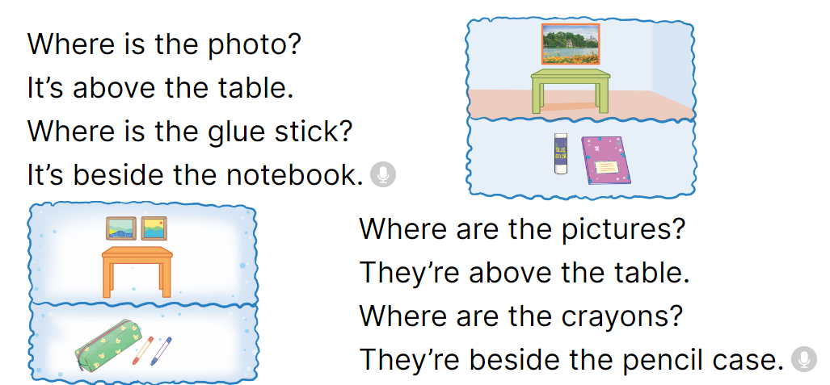  - Play the recording for Ss to listen to the whole chant.  + Have them repeat the title and lyrics line by line.  + Ask Ss to attend to two-syllable words with the stress on the second syllable in the chant, above and beside.  - Play the recording all the way through for Ss to listen to pronunciation and melody.  - Play the recording line by line for Ss to listen and repeat  - Play the recording for Ss to chant and clap along.  - Ask Ss to practice chant and clap along in pairs or groups.  - Invite groups to the front of the classroom to perform the chant  Game: Pictionary  - Prepare pictures about the locations of school things and a real bag. Put the pictures in the bag.  - Divide the class into two groups.  - Ask one student from each group to choose a picture from the bag, ex: a picture of a crayon beside the pencil case.  - Tell him/ her to draw a picture (a picture of a crayon beside the pencil case) on the board and encourage their group to guess it and say the sentence | - Ss sing and dance the song  - Ss open their books  - - Ss point and pay attention  - Ss listen to the recording again and repeat.  -Ss work in pairs and practice  -Ss say the words and sentences  - Ss pay and listen to the teacher’s explanation.  - Ss do the task  - Ss listen to the recording to check their answers (individual)  - Ss swap books with a partner and check the answers  - Ss listen to the recording again and check their answers again.  - Ss stand up and read aloud the words.  - Ss look and listen.  - Ss listen to the chant  - Ss listen and repeat line by line without clap their hands  - Ss note the rhythm and pronunciation.  -Ss listen to melody of the chant  - Ss listen and chant line by line.  - Ss chant and clap along.  - Ss work in groups (two groups) to chant  -Ss perform in front of the class.  -Ss listen  -Ss play the game  -Ss play the game
D. ADJUSTMENTS (if necessary):
………………………………………………………………………………………….…..……………………………………………………………………………...……

Week 14 Preparing date: December 8th, 2024
Period 55 Teaching date: December 10th,2024

Unit 8: In our classroom
Lesson 3 (4, 5, 6)
A. OBJECTIVES:
By the end of the lesson, Ss will be able to:
1. Knowledge:
- read and show understanding of a text about the locations of characters’ school things by answering the questions.
- complete four sentences about someone’s school things by writing the target words in the gaps with the help of picture cues.
- present their group’s pictures of study corners to the class by using the target language.
- Vocabulary: Review
- Skills: speaking, listening, reading and writing.
2. Competences:
- Communication and collaboration: work in pairs and groups to complete the learning tasks.
- Self-control and independent learning: perform reading and writing tasks.
3. Attitude/ Qualities:
- Show their pride in school things they have and great respect for other people’s school things by using appropriate gestures and intonation when asking and answering about school things.
B. TEACHING AIDS:
- Teacher: Teacher’s guide Pages 125, 126, 127; website hoclieu.vn, posters, laptop, pictures, textbook, lesson plan, TV or projector.
- Students: Pupil’s book Page 61, notebooks, workbooks, school things.
C. PROCEDURES:
Stages/  Time | Teacher’s activities | Students’ activities
1.Warm- up and review: (5’)  2.Practice: (8’)  3.Production: (18’)  4. Fun corner and wrap- up (4’) | Game: Musical cards  *Aims: to revise the new words and structures from previous lessons.  *Procedure:  - Stick the cards on the board. Ask ss to say the words related to the cards.  - Hand out the cards to different ss around the class.  - Play the song “Where are they? Ask ss to pass the cards to the ss next to them while the music is playing.  - Stop the music suddenly. Invite a student to ask the question “Where are the pens?”.  Ask the student who is holding the card to answer the question, ex: They’re beside the books.  - Play the music again and repeat the activity.  - Ask ss to check their friends’ pronunciation.  - Say “Open your book page 61” and look at “Unit 8, Lesson 3 (4,5,6)”.  Activity 1. Read and answer:  *Aims: Ss will be able to read and show understanding of a text about the locations of characters’ school things by answering the questions.  *Procedure:  - Have ss read the questions carefully and pay attention to key words such as Whose set square.  - Ask Ss scan the text for relevant information.  - Set a time limit for ss to do the task independently.  - Get ss to swap books with their partners and check the answers before checking as a class. - Have ss read the sentences in the reading text that help them find the correct information.  - Invite some pairs to take turns asking and answering the questions.  - Ask ss some more questions, ex: Whose pencils are in front of his pencil sharpener? Whose school bag is under her desk? Where is Hung’s story book?  Key:  1. Trang’s (set square is on her desk).  2. They are on his desk, in front of his pencil sharpener.  3. Trang’s (storybook is in her school bag).  4. It’s in the desk.  Activity 2. Let’s write  *Aims: Ss will be able to complete four sentences about someone’s school things by writing the target words in the gaps with the help of picture cues.  *Procedure:  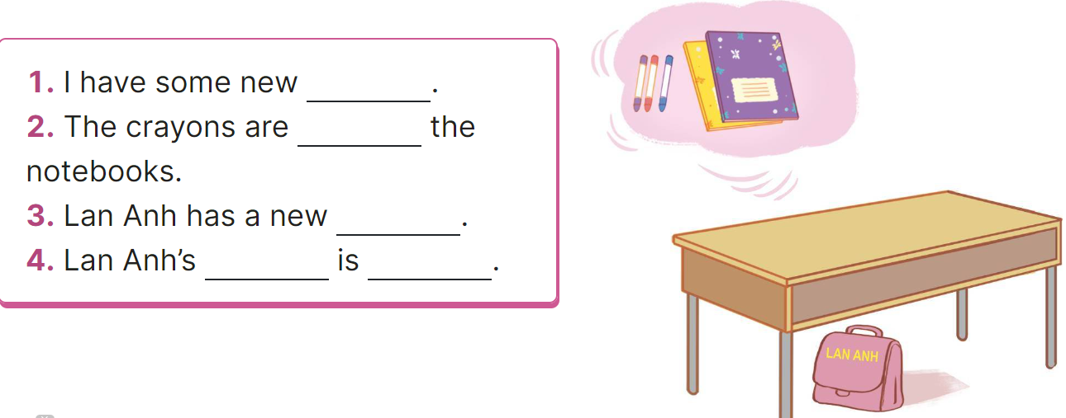  - Explain that ss have to read the four incomplete sentences and fill in the gaps with specific information about someone’s school things and their locations.  - Have ss do the first gapped sentence together as an example. Ex: crayons  - Give ss time to complete the sentences independently.  - Get ss to swap their books with a partner and check their answers before checking as a class.  - Invite a few ss to read their completed texts in front of the class.  Suggested key:  1. crayons.  2. beside  3. school bag.  4. school bag / under the desk.  Activity 3. Project.  *Aims: Ss will be able to present their group’s pictures of study corners to the class by using the target language  *Procedure:  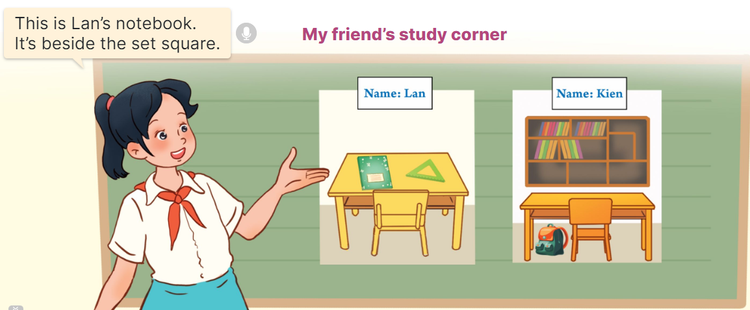  - Tell Ss about the goal of the activity.  - Have Ss work in groups of three. Each student looks at his/ her picture and talks about the locations of their school things in the picture.  - Invite a representative from each group to tell the class about their group's pictures  Ex: This is Lan’s notebook. It’s beside the set square.  - Have the rest of the class applaud if ss perform well.  Game: Missing cards  - Prepare pictures related to the topic “In our classroom”. Explain how to play the game.  - Divide the class into four groups. Take turns sticking four cards on the board, Ex: a glue stick, a crayon, a notebook, a pencil.  - Ask the first group to look at the cards and name the things illustrated on the cards. Ask the group to close their eyes for 10 seconds, then take out a card from the set, Ex: a pencil. - Let ss open their eyes and say out the word for that card.  - Count the points for each group and announce the winner. | - Ss listen and say  - Ss play the game  - Ss play the game  - Ss open their books  - Ss follow the teacher’s instructions.  -Ss scan the text  - Ss do the task independently.  - Ss swap books and check the answers  - Ss give the evidence to explain their answers.  - Ss ask and answer the questions.  - Ss answer the questions.  - Ss listen to the teacher’s instruction.  - Ss do the first gapped  - Ss complete the sentences independently.  - Ss swap their books and check their answers  - Ss read their completed texts  - Ss listen to the teacher  - Ss work in groups of three and say about their pictures of study corners  - Ss tell the class about their groups’ pictures of study corners  - Ss congratulate the groups perform well  -Ss listen to the teacher  -Ss play the game  -Ss congratulate the winner
D. ADJUSTMENTS (if necessary):
………………………………………………………………………………………….…..……………………………………………………………………………...……

Week 14 Preparing date: December 8th, 2024
Period 56 Teaching date: December 10th, 2024

Unit 9: Our outdoor activities
Lesson 1 (1, 2, 3)
A. OBJECTIVES:
By the end of the lesson, Ss will be able to:
1. Knowledge:

- understand and correctly repeat the sentences in two communicative contexts focusing on asking and answering about where someone was in the past.

- correctly say the words theatre, aquarium, campsite, funfair and use Were you at the ___ yesterday? - Yes, we were. / No, we weren’t. to ask and answer questions about where someone was in the past.

- use Were you at the ___ yesterday? - _____ in a freer context.

- Vocabulary: theatre, aquarium, campsite, funfair

- Structures:
A: Were you at the theatre yesterday?
B: Yes, we were. / No, we weren’t.
- Skills: speaking and listening
2. Competences:
- Critical thinking and creativity: learn how to ask and answer questions about where someone was in the past correctly and fluently.
- Communication and collaboration: work in pairs and groups to complete the learning tasks.
3. Attitude/ Qualities:
- Show their love and interest in outdoor activities.
- Show their knowledge of doing outdoor activities safely.
B. TEACHING AIDS:
- Teacher: Teacher’s guide Pages 141, 142, 143, 144, audio Tracks 86, 87; website hoclieu.vn, posters, laptop, pictures, textbook, lesson plan, TV or projector.
- Students: Students’ book Page 62, notebooks, workbooks, school things.
C. PROCEDURES:
Stages/  Time | Teacher’s activities | Students’ activities
1.Warm- up and review: (3’)  2. Presentation (15’)  3.Practice: (7’)  4. Production: (6’)  5. Fun corner and wrap- up (4’) | Game: Matching game  *Aims: to revise the phrases about places.  *Procedure:  - Tell the class they are going to match the phrases with the correct pictures.  - Stick the pictures and the phrases on the board. Have Ss read the phrases once or twice.  - Model the Picture 1. Have one student choose a phrase suitable with Picture 1.  - If the Ss give the correct answers, they will get stickers.  - Continue the game until all the pictures and phrases are matched.  - Say “Open your book page 62” and look at “Unit 9, Lesson 1 (1,2,3)”.  Activity 1. Vocabulary.  *Aims: Ss will be able to know the vocabulary in the new lesson.  *Procedure:  -T elicits the new words  + theatre : nhà hát (picture)  + aquarium : thủy cung (picture)  + campsite : địa điểm cắm trại (picture)  + funfair : hội chợ giải trí (picture)  - T models (3 times).  - T writes the words on the board.  - Checking: Matching  Activity 2. Look, listen and repeat:  *Aims: Ss will be able to understand and correctly repeat the sentences in two communicative contexts focusing on asking and answering about where someone was in the past.  *Procedure:  - Have Ss look at Pictures a and b and identify the characters and what they can see in the pictures.  + Where was Mai?  + Where were Mai’s family? 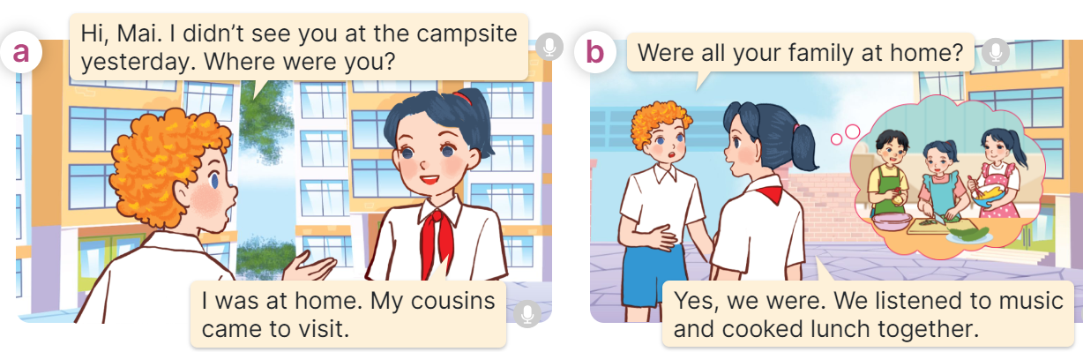  - Play the audio twice (sentence by sentence). Correct their pronunciation where necessary.  - Have Ss to practice the dialogue  - T invites a few pairs to the front of the class to practice.  - T checks pronunciation for ss.  Activity 3 Listen, point and say.  *Aims: Ss will be able to correctly say the words theatre, aquarium, campsite, funfair and use Were you at the ___ yesterday? - Yes, we were. / No, we weren’t. to ask and answer questions about where someone was in the past.  *Procedure:  * Structures:  - T asks Ss look at in activity 1 and helps Ss know the structure from the dialogue.  - T introduces new structures for Ss.  - T explains, models and gives meaning.  - Have Ss repeat the structures  A: Were you at the theatre yesterday?  B: Yes, we were. / No, we weren’t.  *Drill pictures  - Have Ss look at the pictures and identify the places. 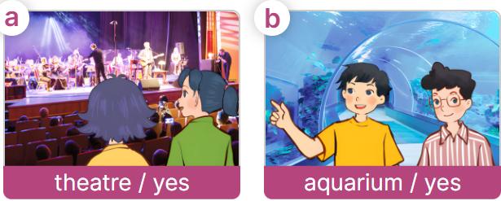  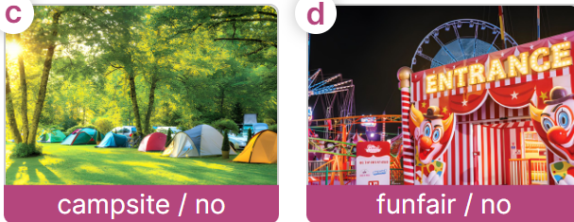  - Have Ss point at pictures, listen and run through all the pictures.  - Have Ss point at the bubbles, listen and run through model sentences.  - Have Ss to practise:  + T asks the first picture, Ss answer  + Ss asks the second picture, T answers  + Group A asks the third picture, group B  answers  + Group B asks the last picture, group A  - Ask Ss to work in pairs to practise asking and answering the Were you at the ___ yesterday? - Yes, we were. / No, we weren’t.  - T controls and corrects.  - Invite a few pairs to point at the pictures and say the questions and answers in front of the class.  Activity 4. Let’s talk.  *Aims: Ss will be able to use Were you at the ____ yesterday? - Yes, we were. / No, we weren’t in a freer context  *Procedure:  - Ask Ss to look at the pictures and say the words they have learnt.  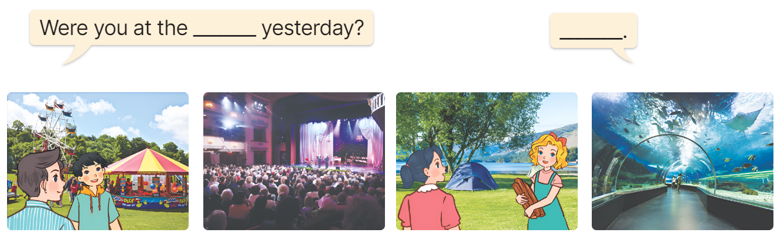  - Point at the ﬁrst building and elicit the question in the ﬁrst speech bubble Were you at the ___ yesterday? and the answer in the second speech Yes, we were. / No, we weren’t.as an example.  - Give Ss time to work in pairs and take turns pointing at each picture to ask and answer using Were you at the ___ yesterday? - Yes, we were. / No, we weren’t.  - Invite a few pairs to come to the front of the classroom and act out the exchanges.  Game: Pass the card  - Have Ss stand in two lines.  - Give a student of each group a card.  - Play music. Ask the student to pass the card to the next one.  - Stop music. Ask the student holding the card to ask a question. Invite another student to answer the question.  - If ss ask and answer the questions correctly, they will get stickers.  - Continue the game until all the words are said. | - Ss listen to the teacher  - Ss look at the pictures and read  - Ss follow the teacher  - Ss continue the game.  - Ss listen and open their books  -Ss listen and answer  - - Ss listen and repeat  + Choral repetition (3 times).  + Individual repetition (3 ss)  - Ss take note  - Ss look and match  -Look at the pictures and say.  + In picture a:  Bill: Hi, Mai. I didn’t see you at the campsite yesterday. Where were you?  Mai: I was at home. My cousins came to visit.  + In picture b:  Bill: Were all your family at home? Mai: Yes, we were. We listened to music and cooked lunch together.  -Ss listen and repeat in chorus (twice)  -Ss work in pairs to practice  -Ss come to the front of the classroom to practice.  -Ss listen  - Ss look at the picture and answer.  -Ss listen  -Ss listen and repeat  -Ss repeat to the structures  - Ss look, listen and repeat  +Picture a: two girls at the theatre  + Picture b: two boys at the aquarium  + Picture c: a campsite and the words campsite / no underneath  + Picture d: a funfair and the words funfair / no underneath  -Ss listen to the teacher  -Ss point at pictures, listen and repeat  -Ss point at the bubbles, listen and repeat  -Ss practice in chorus  -Ss practice in chorus  -Ss work in pairs to practise asking and answering the question  - Pairs of Ss point at the pictures and say in front of the class  -Ss look at the picture and say  - Ss look at the first building and elicit the missing words in speech bubbles and say the completed sentences.  - Ss role-play to practise asking and answering questions  - Ss practise asking and answering questions in front of the class.  -Ss listen to the teacher  -Ss play the game  -Ss continue to play the game
D. ADJUSTMENTS (if necessary):
………………………………………………………………………………………….…..……………………………………………………………………………...……

