Week 11 Preparing date: November 17th, 2024
Period 41 Teaching date: November 18th, 2024

Unit 6: Our school rooms
Lesson 2 (4, 5, 6)
A. OBJECTIVES:
By the end of the lesson, Ss will be able to:
1. Knowledge:
- listen to and understand two communicative contexts in which people ask for and give directions at school and tick the correct pictures
- complete two gapped exchanges with the help of picture cues
- revise the target vocabulary items and structures by playing Memory game.
- Vocabulary: Review
- Skills: speaking, listening, reading and writing.
2. Competences:
- Communication and collaboration: work in pairs and groups to complete the learning tasks.
3. Attitude/ Qualities:
- Show their pride in their school and raise awareness about the location of different rooms in their school.
B. TEACHING AIDS:
- Teacher: Teacher’s guide Pages 88, 89, 90; audio Tracks 62; website hoclieu.vn, posters, laptop, pictures, textbook, lesson plan, TV or projector.
- Students: Student’s book Page 47, notebooks, workbooks, school things.
C. PROCEDURES:
Stages/ Time | Teacher’s activities | Students’ activities
1.Warm- up and review: (5’)  2.Practice: (25’)  3. Fun corner and wrap- up (5’) | Game: Bad luck Billy  *Aims: to revise the learned words  *Procedure:  - Ask Ss to stand up and read the words on the screen.  - If the lightning struck while a student is reading, that student as to sit down.  - At the end of the game, the Ss still standing is the winner(s).  - Have Ss read all the words one more time.  - Say “Open your book page 47” and look at “Unit 6, Lesson 2 (4,5,6)”.  Activity 1. Listen and tick:  *Aims: Ss will be able to listen to and understand two communicative contexts in which people ask for and give directions at school, and tick the correct pictures.  *Procedure:  - Draw Ss’ attention to the pictures of the three arrows showing the directions to the art room.  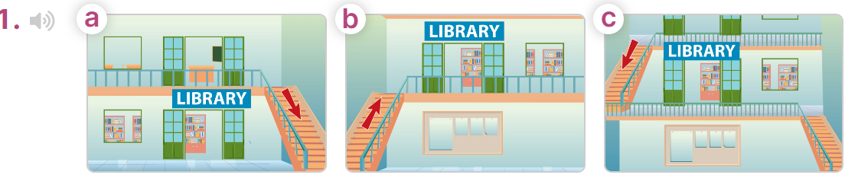  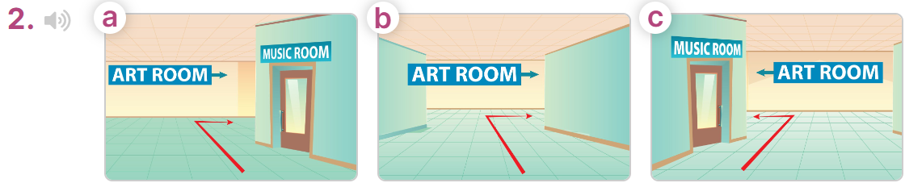  - T ask Ss to guess the answers.  + T writes Ss’guessing on the board.  - Listen to the tape:  + Play the recording  + Play the recording again for pupils to do the task.  + Play the recording a third time for pupils to check their answers.  - Get Ss to swap books with their partner, then check answers as a class.  + Write the answers on the board for Ss to correct their answers. Then checks Ss’ guessing.  - If time allows, play the recording, sentence by sentence, for Ss to listen and repeat individually and in chorus  Key: 1. c 2. a  Activity 2. Read and complete  *Aims: Ss will be able to complete two gapped exchanges with the help of the picture cues  *Procedure:  - Have Ss look at the pictures and identify the directions to the rooms in the pictures.  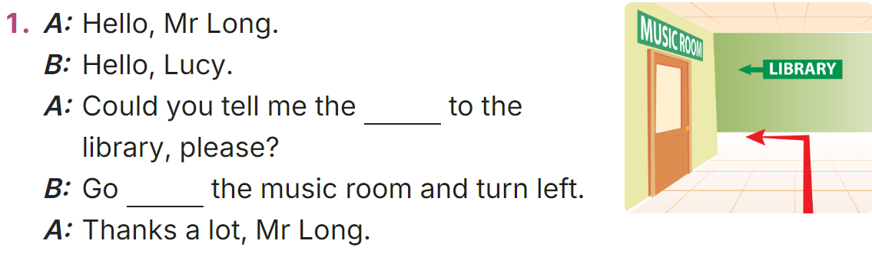  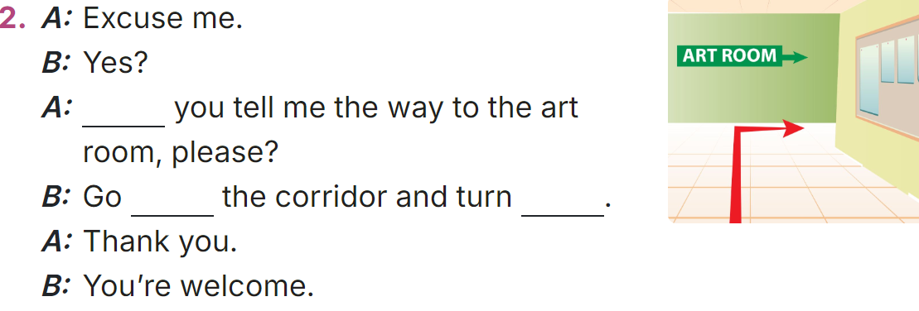  - Model sentences: have Ss read the question and ask what words are missing (way)  - Give Ss a time limit to read the gapped dialogues, look at the pictures and do the task independently.  - Get Ss to swap books with a partner and check their answers before checking as a class.  + Invite one student to write the answers on the board.  - Invite two pairs of Ss to act out the completed dialogues.  Key: 1. way, past  2 Could, along, right  Activity 3. Let’s play  *Aims: Ss will be able to revise the target vocabulary items and structures by playing Memory game.  *Procedure:  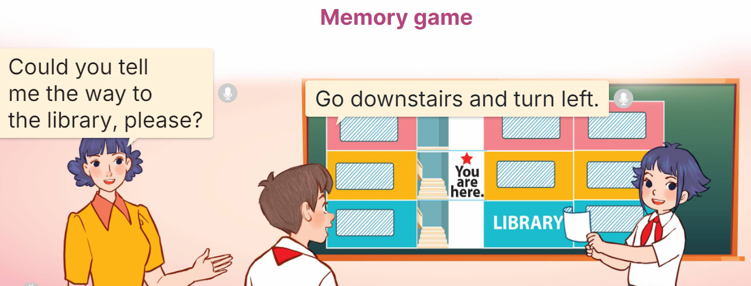  - Tell Ss that they are going to play Memory game using the language learnt in Lessons 1 and 2.  - Draw a map with school rooms on the board.  + Divide the class into two teams. Have Ss look at the school rooms on the map for 20 seconds, then cover the room names with paper / cards. (Ex: Could you tell me the way to the library, please?), then ask one student in a team to give you directions while the other pupil in the same team follows the directions and opens the right card to find the room.  + If he / she finds the right room by following the directions, the team gets one point.  + If he / she doesn't end up at the right room, he / she covers the room name up again and it becomes the other team’s turn.  - The team that has the most points at the end of the game wins.  Game: Guessing Game  * Review vocabulary  - Have Ss look at the pictures on the screen and say the appropriate phrases.  - Check the pronunciation when necessary.  * Review stress and syllable  - Show some words on the screen and ask pupils to decide whether they are two or three syllable words. Then sort out.  - Explain what the word stress and stress mark is, if necessary. | -Ss listen to the teacher  -Ss play the game  -Ss read the words  - Ss open their books  -Look at the pictures and say:  + Picture 1a: a library on the ground floor, an arrow showing the direction of going downstairs  + Picture 1b: a library on the first floor, an arrow showing the direction of going upstairs  + Picture 1c: a library on the first floor, an arrow showing the direction of going downstairs  + Picture 2a: an arrow showing the direction of going along the corridor, past the music room and turning right to reach the art room  + Picture 2b: an arrow showing the direction of going along the corridor and turning right to reach the art room  + Picture 2c: an arrow showing the direction of going along the corridor, past the music room and turning left to reach the art room  -Ss guess the answers  - Ss listen to the tape  - Ss listen again and do the task.  - Ss listen and check their answers  - Ss swap books and check answers as a class and guessing  -Ss write the answer on the board  -Ss listen and repeat  -Ss look at the picture and say  -Ss follow the teacher  - Ss do the task independently.  - Ss swap books with a partner and check their answers.  - Ss write the answers on the board  - Pairs of Ss read the completed dialogues aloud  -Ss listen to the teacher  - Ss play the game.  - Ss praise the winner.  -Ss listen to the teacher  - Ss play the game.
D. ADJUSTMENTS (if necessary):
………………………………………………………………………………………….…..……………………………………………………………………………...…..…

Week 11 Preparing date: November 17th , 2024
Period 42 Teaching date: November 18th , 2024

Unit 6: Our school rooms
Lesson 3 (1, 2, 3)
A. OBJECTIVES:
By the end of the lesson, Ss will be able to:
1. Knowledge:
- correctly stress the two-syllable words up’stairs and down’stairs in isolation and in the sentences He’s going up’stairs. and She’s running down’stairs.
- identify the word stress on some two-syllable words and circle the word with a different stress pattern from the other two words
- say the chant with the correct pronunciation, word stress and rhythm.
- Vocabulary: Review
- Skills: speaking, listening, reading and writing.
2. Competences:
- Communication and collaboration: work in pairs and groups to complete the learning tasks.
- Self-control and independent learning: perform pronunciation and listening tasks.
3. Attitude/ Qualities:
- Show their pride in their school and raise awareness about the location of different rooms in their school.
B. TEACHING AIDS:
- Teacher: Teacher’s guide Pages 97, 98, 99; audio Tracks 63, 63, 65; website hoclieu.vn, posters, laptop, pictures, textbook, lesson plan, TV or projector.
- Students: Students’ book Page 48, notebooks, workbooks, school things.
C. PROCEDURES:
Stages/  Time | Teacher’s activities | Students’ activities
1.Warm- up and review: (5’)  2. Presentation (9’)  3.Practice: (17’)  3. Fun corner and wrap- up (4’) | Chatting  *Aims: to create a friendly and active atmosphere in the class to beginning the lesson.  *Procedure:  - Teacher divides the class into 2 teams.  - Each team takes turns asking and answering about the room on the screen, using the structures learnt.  - Teacher checks the answer with the whole class.  - Pss choose a box and get the point(s).  - The team with more points is the winner.  - Say “Open your book page 48” and look at “Unit 6, Lesson 3 (1,2,3)”.  Activity 1. Listen and repeat:  *Aims: Ss will be able to correctly stress the two-syllable words up'stairs and down'stairs in isolation and in the sentences He’s going up'stairs. and She’s running down'stairs.  *Procedure:  - Have Ss point at the words up'stairs and down'stairs with the stress on the second syllable, in isolation and in the sentences He’s going up'stairs. and She’s running down'stairs.  - Play the recording for Ss to listen and repeat in chorus and individually until they feel confident.  - Let Ss work in pairs or groups, saying the words and reading the sentences.  - T invites some Ss to practice.  Activity 2. Circle, listen and check.  *Aims: Ss will be able to identify the word stress on some two-syllable words and circle the word with a different stress pattern from the other two words.  *Procedure:  - Tell Ss circle the word having a different stress from each line. Then listen to the recording to check their answers.  - Set a time for Ss to do the task.  - Play the recording, once or twice, for Ss to listen and check their answers.  - Get Ss to swap books with a partner and check their answers before checking as a class.  - Play the recording again for Ss to double-check their answers.  - Invite a few Ss to read aloud all the words in the words.  Key: 1. a 2. c 3. b  Activity 3. Let’s chant  *Aims: Ss will be able to say the chant with the correct pronunciation, word stress, and rhythm  *Procedure:  - Introduce the title and lyrics of the chant.  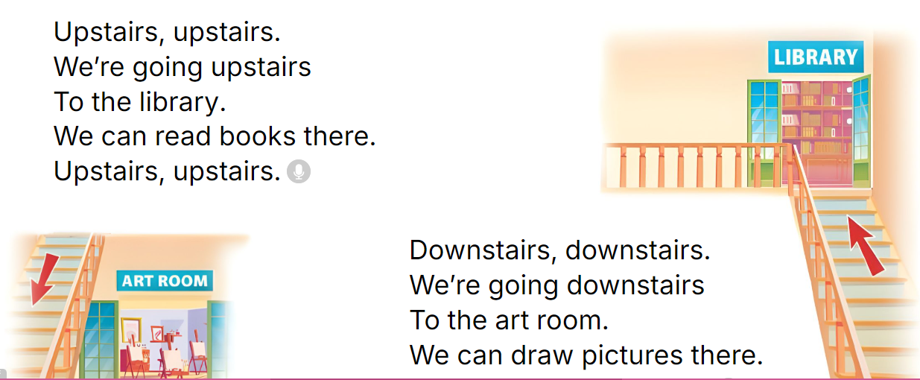  - Play the recording for Ss to listen to the whole chant.  + Have them repeat the title and lyrics line by line.  + Ask Ss to attend to two-syllable words with the stress on the second syllable in the chant, upstaisr and downstairs.  - Play the recording all the way through for Ss to listen to pronunciation and melody.  - Play the recording line by line for Ss to listen and repeat  - Play the recording for Ss to chant and clap along.  - Ask Ss to practice chant and clap along in pairs or groups.  - Invite groups to the front of the classroom to perform the chant  Review syllables and stress.  - T writes a word on the board then says. (two syllable words)  - Ss will clap their hands twice if the stress of that word is on the first syllable.  - Ss will clap their hands once if the stress of that word is on the second syllable.  - Invite a student to come to the front and draw the stress mark for that word.  - Word list: downstairs, second, active, happy, along, ahead, upstairs. | - Follow the T’s instructions.  -Ss play the game  - Ss open their books  - - Ss point and pay attention  - Ss listen to the recording again and repeat.  -Ss work in pairs and practice  -Ss say the words and sentences  - Ss pay and listen to the teacher’s explanation.  - Ss do the task  - Ss listen and check their answers (individual)  - Ss swap books with a partner and check the answers  - Ss listen again and check their answers again.  - Ss stand up and read aloud the words.  - Ss look and listen.  - Ss listen to the chant  - Ss listen and repeat without clap their hands  - Ss note the rhythm and pronunciation.  -Ss listen to melody of the chant  - Ss listen and chant line by line.  - Ss chant and clap along.  - Ss work in groups (two groups) to chant  -Ss perform in front of the class.  -Ss listen  -Ss play the game  -Ss play the game
D. ADJUSTMENTS (if necessary):
………………………………………………………………………………………….…..……………………………………………………………………………...……

Week 11 Preparing date: November 17th, 2024
Period 43 Teaching date: November 18th, 2024

Unit 6: Our school rooms
Lesson 3 (4, 5, 6)
A. OBJECTIVES:
By the end of the lesson, Ss will be able to:
1. Knowledge:
- read a text about rooms in a school and show understanding by deciding whether some statements are true or false;
- read and complete the table about rooms in their school;
- make a picture of a favourite school and present it to the class by using the target language.
- Vocabulary: Review
- Skills: speaking, listening, reading and writing.
2. Competences:
- Communication and collaboration: work in pairs and groups to complete the learning tasks.
- Self-control and independent learning: perform reading and writing tasks.
3. Attitude/ Qualities:
- Show their knowledge about their schools.
B. TEACHING AIDS:
- Teacher: Teacher’s guide Pages 99, 100; website hoclieu.vn, posters, laptop, pictures, textbook, lesson plan, TV or projector.
- Students: Pupil’s book Page 49, notebooks, workbooks, school things.
C. PROCEDURES:
Stages/  Time | Teacher’s activities | Students’ activities
1.Warm- up and review: (5’)  2.Practice: (8’)  3.Production: (18’)  4. Fun corner and wrap- up (4’) | Game: Odd one out  *Aims: to revise the new words and structures from previous lessons.  *Procedure:  - Divide the class into two teams.  - Each team has a representative to play “Rock, paper, scissors” to play first.  - The winning team answers the question first. Ss get the points if their team answers the question.  - Say “Open your book page 49” and look at “Unit 6, Lesson 3 (4,5,6)”.  Activity 1. Read and tick True or False:  *Aims: Ss will be able to read a text about rooms in a school and show understanding by deciding whether some statements are true or false.  *Procedure:  - Draw Ss’ attention to the text and read it together as a class.  - Draw ss’ attention to the four statements below the text and four boxes to tick True or False.  - Have ss pay attention to the sentences about the rooms in the school.  - Give Ss time to tick the correct boxes.  - Tell ss to swap books with a partner, then check answers together as a class.  - Ask Ss to read the text aloud in front of the class.  - Have Ss write sentences to compare the location of and direction to the rooms in the reading and the rooms in their school.  Ex: Our computer room is on the ground floor, but their computer room is on the second floor.  Key: 1. True 2. True 3. False 4. True  Activity 2. Let’s write  *Aims: Ss will be able to read and complete the table about rooms in their school.  *Procedure:  - Ask Ss to read the gapped letter and explain that they need to fill in the gaps with information about the boy in the pictures’ free-time activities.  - Have Ss complete the first, second and third gaps with names and an activity of their choice from the pictures.  - Give Ss time to complete the rest of the letter independently.  - Get Ss to swap their books with a partner and check each other’s spelling  before checking as a class.  Key: Pupil’s answer  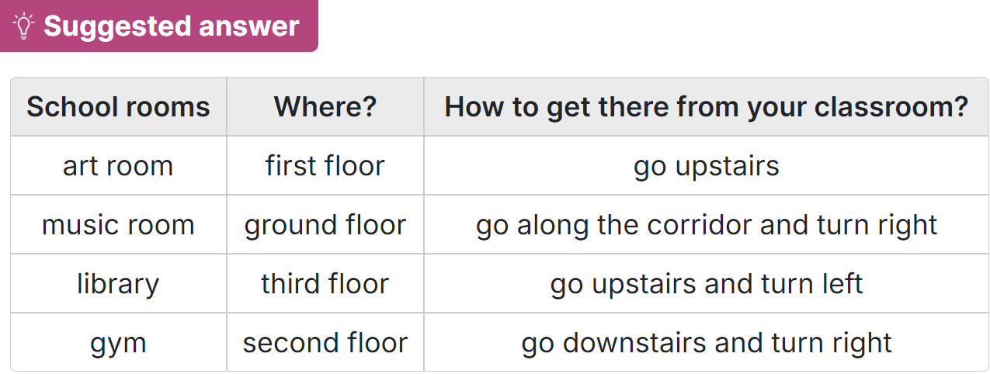  Activity 3. Project.  *Aims: Ss will be able to make a picture of a favourite school and present it to the class by using the target language.  *Procedure:  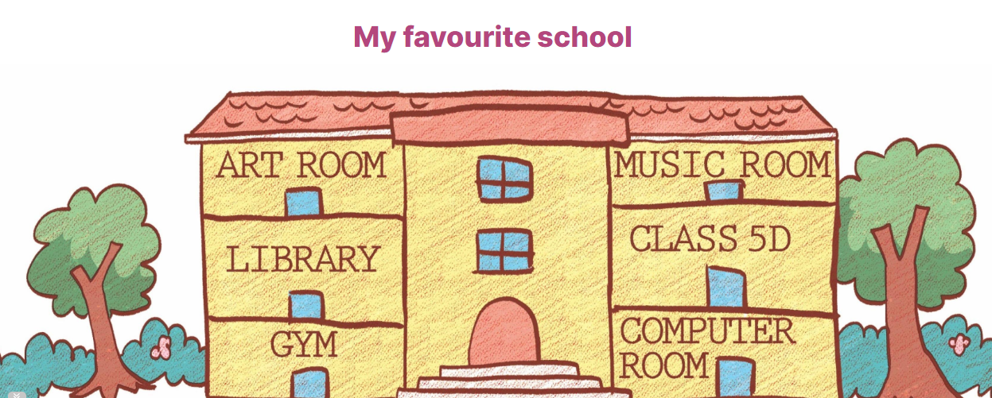  - Tell Ss about the goal of the activity.  - Have Ss work in groups. Each student shows a picture that he / she has drawn at home and tells the group about his / her favourite school,  - Invite a few ss show their work and talk about their favourite schools in front of the class, ex: This is my favourite school. It has many rooms in it.  -T gives feedback  * Presentation: Talk to your friend  - Ss show their pictures to their classmates, and present the school to the class at the Project time.  - Have Ss work in groups of four.  - Call some volunteers to perform in front of the class.  - Praise Ss if they perform well. | - Ss listen  -Ss play game  - Ss open their books  - Ss pay attention to the text and read  - Ss read the four statements and find the information  -Ss pay attention  -Ss do the task  - Ss swap books and check  - Ss read the text aloud in front of the class.  - Ss write the sentences  - Ss listen to the teacher  - Ss complete the first, second and third gaps with names and an activity  - Ss complete the rest of the letter independently.  - Ss swap their and check  - Ss listen to the teacher  - Ss work in groups of five.  - Ss show their work and talk  - Ss listen  -Ss listen to the teacher  -Ss work in groups  -Ss perform  -Ss congratulate the perform well
D. ADJUSTMENTS (if necessary):
………………………………………………………………………………………….…..……………………………………………………………………………...……

Week 11 Preparing date: November 17th, 2024
Period 44 Teaching date: November 19th, 2024

Unit 7: Our favourite school activities
Lesson 1 (1, 2, 3)
A. OBJECTIVES:
By the end of the lesson, Ss will be able to:
1. Knowledge:

- understand and correctly repeat the sentences in two communicative contexts focusing on asking and answering questions about someone’s favourite school activity.

- correctly say the phrases and use What school activity does he / she like? – He / She likes ____. to ask and answer questions about someone’s favourite school activity.

- use What school activity does he / she like? – He / She likes ______. in a freer context

- Vocabulary: do projects, read books, play games, solve maths problems, activity.

- Structures:
A: What school activity does he / she like?
B: He/ she likes reading books.
- Skills: speaking and listening
2. Competences:
- Communication and collaboration: work in pairs and groups to complete the learning tasks.
- Self-control and independent learning: perform speaking tasks.
3. Attitude/ Qualities:
- Show their pride in their school and show their interest in their favorite school activities.
B. TEACHING AIDS:
- Teacher: Teacher’s guide Pages 101, 102, 103, audio Tracks 66, 67; website hoclieu.vn, posters, laptop, pictures, textbook, lesson plan, TV or projector.
- Students: Students’ book Page 50, notebooks, workbooks, school things.
C. PROCEDURES:
Stages/  Time | Teacher’s activities | Students’ activities
1.Warm- up and review: (3’)  2. Presentation (15’)  3.Practice: (7’)  4. Production: (6’)  5. Fun corner and wrap- up (4’) | Game: Guessing game  *Aims: to revise the vocabulary about different activities.  *Procedure:  - T introduces and explains the game.  - How to play:  + T will show some pictures which is hidden about different activities.  + Ss look at the pictures in the screen.  + Ss tell what someone is doing.  - T models. (painting a mask)  - Ss play the game.  - T gives feedback.  - Say “Open your book page 50” and look at “Unit 7, Lesson 1 (1,2,3)”.  Activity 1. Vocabulary.  *Aims: Ss will be able to know the vocabulary in the new lesson.  *Procedure:  -T elicits the new words  + do projects : làm các bài tập dự án (explain)  + read books : đọc sách (picture)  + play games : chơi trò chơi (picture)  + solve maths problem : giải các bài toán (explain)  + activity :hoạt động (translation)  - T models (3 times).  - T writes the words on the board.  - Checking: Matching  Activity 2. Look, listen and repeat:  *Aims: Ss will be able to understand and correctly repeat the sentences in two communicative contexts (pictures) on the phone, focusing on greetings, asking and answering questions about someone’s favourite school activitiy.  *Procedure:  - Have Ss look at Pictures a and b and identify the characters and what they can see in the pictures.  + Who is he/ she?  + Where is he/ she?  + What is he/ she doing?  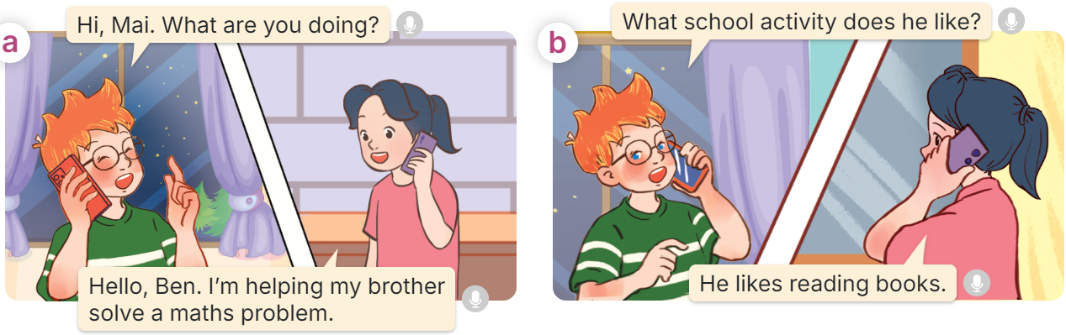  - Play the audio twice (sentence by sentence). Correct their pronunciation where necessary.  - Have Ss to practice the dialogue  - T invites a few pairs to the front of the class to practice.  - T checks pronunciation for ss.  Activity 3 Listen, point and say.  *Aims: Ss will be able to correctly say the phrases and use What school activity does he / she like? – He / She likes …. to ask and answer questions about someone’s favourite school activity.  *Procedure:  * Structures:  - T asks Ss look at picture b in activity 1 and helps Ss know the structure from the dialogue.  - T introduces new structures for Ss.  - T explains, models and gives meaning.  - Have Ss repeat the structures  A: What school activity does he / she like?  B: He/ she likes reading books.  *Drill pictures  - Have Ss look at the pictures and identify the characters and their activities.   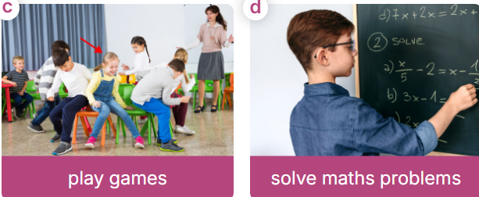  - Tell Ss that in the question, the verb like follows does, so is in the base form (like). But in the answer, like + s must be used after He or She, like + Verb with -ing  - Have Ss point at pictures, listen and run through all the pictures.  - Have Ss point at the bubbles, listen and run through model sentences.  - Have Ss to practise:  + T asks the first picture, Ss answer  + Ss asks the second picture, T answers  + Group A asks the third picture, group B  answers  + Group B asks the last picture, group A  - Ask Ss to work in pairs to practise asking and answering the What school activity does he / she like? – He / She likes ….  - T controls and corrects.  - Invite a few pairs to point at the pictures and say the questions and answers in front of the class.  Activity 4. Let’s talk.  *Aims: Ss will be able to enhance the correct use of What school activity does he/ she like? - He/ she likes……… to ask and answer questions about school activity in freer contexts.  *Procedure:  - Ask Ss to look at the pictures and elicit the context  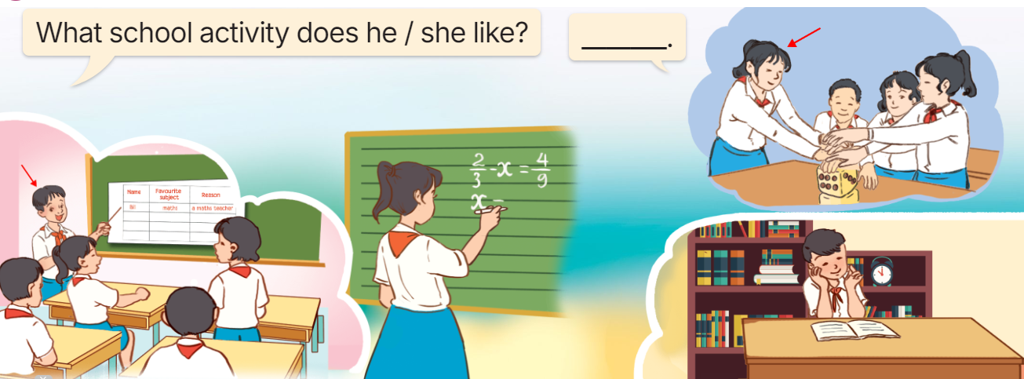  - Point at the ﬁrst building and elicit the question in the ﬁrst speech bubble What school activity does he/ she like? and the answer in the second speech He/ she likes…….. as an example.  - Give Ss time to work in pairs and take turns pointing at each picture to ask and answer using What school activity does he/ she like? - ………..  - Invite a few pairs to come to the front of the classroom and act out the exchanges.  Game: Pass the teddy bears  - Give two different colored teddy bears to two Ss, a black teddy bear (ask the question) and a white teddy bear (answer the question).  - Ask Ss to listen to music and pass the teddy bears.  - Stop music suddenly. Have the student with a black teddy bear make a question. Have the student with a white teddy bear answer the question.  - Repeat the game several times. | -Ss listen and pay attention  - Ss listen to the teacher  -Ss play the game  .  - Ss listen and open their books  -Ss listen and answer  - - Ss listen and repeat  + Choral repetition (3 times).  + Individual repetition (3 ss)  - Ss take note  - Ss look and match  -Look at the pictures and say.  + In picture a:  Ben: Hi, Mai. What are you doing?  Mai: Hello, Ben. I’m helping my brother solve a maths problem.  + In picture b:  Ben: What school activity does he like?  Mai: He likes reading books.  -Ss listen and repeat in chorus (twice)  -Ss work in pairs to practice  -Ss come to the front of the classroom to practice.  -Ss listen  - Ss look at the picture and answer.  -Ss listen  -Ss listen and repeat  -Ss repeat to the structures  - Ss look, listen and repeat  +Picture a: a boy doing a project  + Picture b: a girl - reading a book  + Picture c: a girl playing a game in class with her classmates  + Picture d: a boy - solving a maths problem at the board  -Ss listen to the teacher  -Ss point at pictures, listen and repeat  -Ss point at the bubbles, listen and repeat  -Ss practice in chorus  -Ss practice in chorus  -Ss work in pairs to practise asking and answering the question  - Pairs of Ss point at the pictures and say in front of the class  -Ss look at the picture and say  - Ss look at the first building and elicit the missing words in speech bubbles and say the completed sentences.  - Ss role-play to practise asking and answering questions  - Ss practise asking and answering questions in front of the class.  -Ss listen to the teacher  -Ss play the game  Ex:  A: What school activity does she like?  B: She likes doing projects.  -Ss read all the words again.
D. ADJUSTMENTS (if necessary):
………………………………………………………………………………………….…..……………………………………………………………………………...……

