Week 7 Preparing date: October 20th, 2024
Period 25 Teaching date: October 21st, 2024

Unit 4: Our free-time activities Lesson 2 (1, 2, 3)

OBJECTIVES:
By the end of the lesson, Ss will be able to:

Knowledge:
    - understand and correctly repeat the sentences in two communicative contexts in which characters ask and answer questions about what someone does at the weekend;
    - correctly say the words and use What do you do at the weekend? – I . to ask and answer questions about what someone does at the weekend
    - use What do you do at the weekend? – I . in a freer context
    - Vocabulary: always, usually, often, sometimes, rarely, never
    - Structures:
A: What do you do at the weekend? B: I usually listen to music.
    - Skills: speaking and listening

Competences:
    - Critical thinking and creativity: learn how to ask and answer questions about personal information correctly and fluently.
    - Self-control and independent learning: perform speaking tasks.

Attitude/ Qualities:
    - Explore new interests and develop a healthier and balanced lifestyle, then improve general well-being.

TEACHING AIDS:
    - Teacher: Teacher’s guide Pages 66, 67, 68, audio Tracks 38, 39; website hoclieu.vn, posters, laptop, pictures, textbook, lesson plan, TV or projector.
    - Students: Students’ book Page 30, notebooks, workbooks, school things.

PROCEDURES:

Stages/  Time | Teacher’s activities | Students’ activities
1.Warm- up and review: (3’) | Game: Slap the board  *Aims: to revise the vocabulary about different activities.  *Procedure:

2.  Presentation (15’) | - Prepare some flashcards about different activities and stick on the board  (play football, listen to music, read books, watch TV, clean the floor…)  - Divide class into 2 groups: Tom and Jerry.  - How to play:  + Each group chooses five Ss to play.  + Class will read aloud.  + Look at the picture, listen and slap the picture you heard.  + Who faster will get 1 mark.  + Which group with higher mark is the winner.  - Say “Open your book page 30” and look at “Unit 4, Lesson 2 (1,2,3)”.  Activity 1. Vocabulary.  *Aims: Ss will be able to know the vocabulary in the new lesson.  *Procedure:  -T elicits the new words  + always : luôn luôn (explain)  + usually: thường thường (explain)  + often : hay, thường (explain)  + sometimes : thỉnh thoảng (explain)  - T models (3 times).  - T writes the words on the board.  - Checking: Matching | -Ss listen and pay attention  - Ss listen to the teacher  -Ss play the game  .  -Ss continute playing the game  - Ss listen and open their books  -Ss listen and answer  - Ss listen and repeat  + Choral repetition (3 times).  + Individual repetition (3 ss)  - Ss take note  - Ss look and match

 | Activity 2. Look, listen and repeat:  *Aims: Ss will be able to understand and correctly repeat the sentences in two communicative contexts in which characters ask and answer questions about what someone does at the weekend.  *Procedure:  - Have Ss look at Pictures a and b and identify the characters and their activities. + Who is he/ she?  + Where is he/ she?  + What is he/ she doing in the picture?  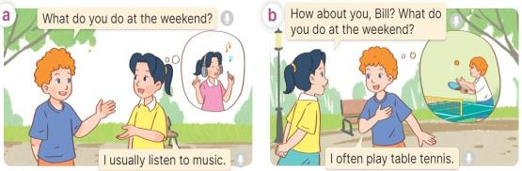  - Play the audio twice (sentence by sentence). Correct their pronunciation where necessary.  - Have Ss to practice the dialogue  - T invites a few pairs to the front of the class to practice.  - T checks pronunciation for ss.  Activity 3 Listen, point and say.  *Aims: Ss will be able to correctly say the words and use What do you do at the weekend? – I . to ask and answer questions about what they do at the weekend.  *Procedure: | -Look at the pictures and say.  + In picture a:  Bill: What do you do at the weekend?  Mai: I usually listen to music  + In picture b:  Mai: How about you, Bill? What do you do at the weekend?  Bill: I often play table tennis.  -Ss listen and repeat in chorus  (twice)  -Ss work in pairs to practice  -Ss come to the front of the classroom to practice.  -Ss listen

3.Practice: (7’) | * Structures:  - T asks Ss look at picture a and b in activity 1 and helps Ss know the structure from the dialogue.  - T introduces new structures for Ss.  - T explains, models and gives meaning.  - Have Ss repeat the structures |  | - Ss look at the picture and answer.  -Ss listen  -Ss listen and repeat  -Ss repeat to the structures
 |  | A: What do you do at the weekend B: I usually listen to music.
 | *Drill pictures  - Have Ss look at the pictures and identify the characters and their activities.  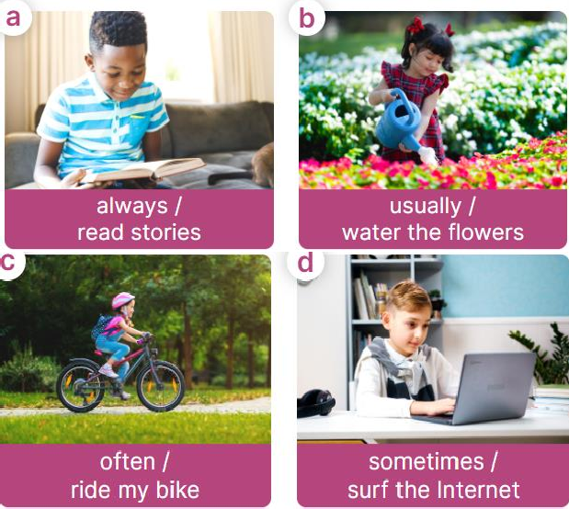  - Have Ss point at pictures, listen and run through all the pictures.  - Have Ss point at the bubbles, listen and run through model sentences.  - Have Ss to practise:  + T asks the first picture, Ss |  | - Ss look, listen and repeat  +Picture a: a boy reading a story and the words always / read stories underneath  + Picture b: a girl watering the flowers and the words usually / water the flowers underneath  + Picture c: a girl riding her bike in the park and the words often / ride my bike underneath  + Picture d: a boy surfing the Internet and the words sometimes / surf the Internet underneath  -Ss point at pictures, listen and repeat  -Ss point at the bubbles, listen and repeat

4.  Production: (6’) | answer  + Ss asks the second picture, T answers  + Group A asks the third picture, group B  answers  + Group B asks the last picture, group A  - Ask Ss to work in pairs to practise asking and answering the What do you do at the weekend? - I .  - T controls and corrects.  - Invite a few pairs to point at the pictures and say the questions and answers in front of the class.  Activity 4. Let’s talk.  *Aims: Ss will be able to correctly use What do you do at the weekend? – . to ask and answer questions about what they do at the weekend in a freer context.  *Procedure:  - Ask Ss to look at the pictures and elicit the context  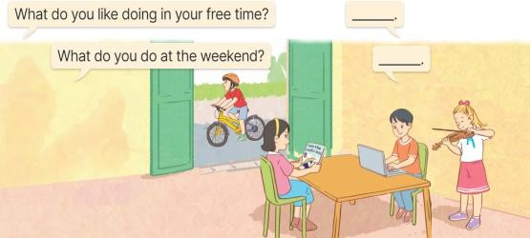  - Point at the first building and elicit the question in the first speech bubbl What do you like doing in your free time? and What do you do at the weekend? and the answer in the second speech | -Ss practice in chorus  -Ss practice in chorus  -Ss work in pairs to practise asking and answering the question  - Pairs of Ss point at the pictures and say in front of the class  -Ss look at the picture and say  - Ss look at the first building and elicit the missing words in speech bubbles and say the completed sentences.

5. Fun corner and wrap- up (4’) | bubble I like……… and I……….  as an example.  - Give Ss time to work in pairs and take turns pointing at each picture to ask and answer using What do you like doing in your free time? - ………..  - Invite a few pairs to come to the front of the classroom and act out the exchanges.  Game: Lucky number  - Explain that Ss will play this game in three teams.  + There are six numbers, they have to choose the number and answer the free-time activity behind the number.  + If the answer is correct, their team can get the point. The number of candies behind the picture will be the points they get.  - Ask Ss to read all the words  again. | - Ss role-play to practise asking and answering questions  - Ss practise asking and answering questions in front of the class.  -Ss listen to the teacher  -Ss play the game  -Ss read all the words again.

ADJUSTMENTS (if necessary):
…………………………………………………………………………………………
.…..……………………………………………………………………………...……
Week 7 Preparing date: October 20th, 2024
Period 26 Teaching date: October 21st, 2024

- OBJECTIVES:

Unit 4: Our free-time activities Lesson 2 (4, 5, 6)

By the end of the lesson, Ss will be able to:

Knowledge:

  - listen to and understand two communicative contexts about what someone does at the weekend and tick the correct pictures
  - complete two gapped exchanges with the help of picture cues
  - listen to and complete the song What do you like doing in your free time? and to sing it with the correct pronunciation, rhythm and melody.
  - Vocabulary: Review
  - Skills: speaking, listening, reading and writing.

Competences:
  - Communication and collaboration: work in pairs and groups to complete the learning tasks.

Attitude/ Qualities:
  - Explore new interests and develop healthier and balanced lifestyle, then improve general well-being.

TEACHING AIDS:
  - Teacher: Teacher’s guide Pages 69, 70; audio Tracks 40, 41; website hoclieu.vn, posters, laptop, pictures, textbook, lesson plan, TV or projector.
  - Students: Student’s book Page 31, notebooks, workbooks, school things.

PROCEDURES:

Stages/ Time | Teacher’s activities | Students’ activities
1.Warm- up and review: (5’) | Game: Lucky number  *Aims: to revise the learned words  *Procedure:  - Divide the class into three teams.  - Have Ss take turns to choose a number.  - Ask Ss to look at the picture and say the activity.  - If the answer is correct, Teacher clicks the picture to open the hidden points.  - The team that gets more points wins. Praise the winner.  - Say “Open your book page 31” and look at “Unit 4, Lesson 2 (4,5,6)”. | -Ss listen to the teacher  -Ss play the game  - Ss open their books

2.Practice: (25’) | Activity 1. Listen and tick:  *Aims: Ss will be able to listen to and understand two communicative contexts about what someone does at the weekend and tick the correct pictures.  *Procedure:  - Ask questions to help Ss identify the characters and their free-time activities.  + What’s he/she doing?  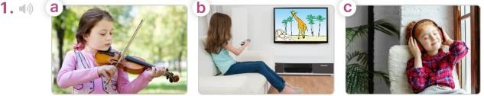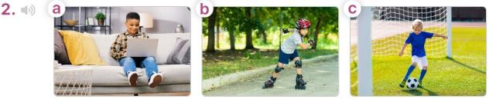  - T ask Ss to guess the answers.  + T writes Ss’guessing on the board.  - Listen to the tape:  + Play the recording  + Play the recording again for pupils to do the task.  + Play the recording a third time for pupils to check their answers.  - Get Ss to swap books with their partner, then check answers as a class.  + Write the answers on the board for Ss to correct their answers. Then checks Ss’ guessing.  - Play the recording, sentence by | -Look at the pictures and say:  + Picture 1a: a girl playing the violin + Picture 1b: a girl watching a cartoon on TV  + Picture 1c: a girl listening to music + Picture 2a: a boy surfing the net  + Picture 2b: a boy roller skating in the park  + Picture 2c: a boy playing football  -Ss guess the answers  - Ss listen to the tape  - Ss listen again and do the task.  - Ss listen and check their answers  - Ss swap books, check answers as a class and guessing  -Ss write the answer on the board

 | sentence, for Ss to listen and repeat individually and in chorus  Key: 1. b 2. a  Activity 2. Read and complete  *Aims: Ss will be able to complete two gapped exchanges with the help of picture cues.  *Procedure:  - Have Ss look at the pictures and identify the activities of the characters in the pictures.  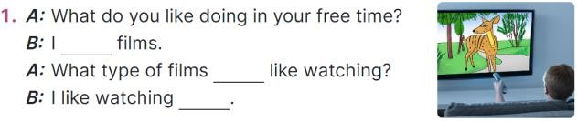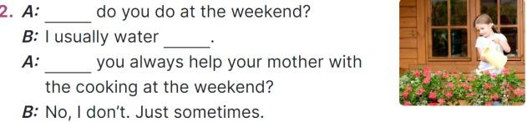  -Model sentences: have Ss read the question and ask what words are missing (like watching)  - Give Ss a time limit to read the gapped dialogues, look at the pictures and do the task independently.  - Get Ss to swap books with a partner and check their answers before checking as a class.  + Invite one student to write the answers on the board.  - Invite two pairs of Ss to act out the completed dialogues.  Key: 1. like watching; do you; cartoons  2. What; the flowers; Do  Activity 3. Listen, complete and sing  *Aims: Ss will be able to listen to and complete the song What do you like | -Ss listen and repeat  -Ss look at the picture and say  -Ss follow the teacher  - Ss do the task independently.  - Ss swap books with a partner and check their answers.  - Ss write the answers on the board  - Pairs of Ss read the completed dialogues aloud

3. Fun corner and wrap- up (5’) | doing in your free time? and to sing it with the correct pronunciation, rhythm and melody.  *Procedure:  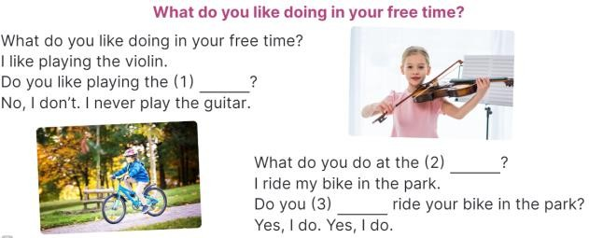  - Draw Ss’ attention to the gapped sentences.  - Play the recording the whole song.  + Then play the recording again to fill in the gaps with missing words.  - Check answers as a class.  + Play the recording line by line for Ss to listen and repeat.  - Play the recording all the way through for Ss to sing along and clap along with the recording.  Game: The football game  - Divide the class into 3 teams.  - Tell Ss that they are going to play football.  - Ss take turns to choose a number, read the question and say the answer.  - If the answer is correct, they will get points for their teams.  - If not, move to another team.  - The group with more points wins the game. | - Ss guess the missing words  - Ss listen all song.  - Ss listen again and fill in the gaps  - Ss listen and repeat.  - Ss listen and sing along  -Ss listen to the teacher  - Ss play the game.  - Ss praise the winner.

ADJUSTMENTS (if necessary):
…………………………………………………………………………………………
.…..……………………………………………………………………………...…..…

Week 7 Preparing date: October 20th, 2024
Period 27 Teaching date: October 23rd, 2024

- OBJECTIVES:

Unit 4: Our free-time activities Lesson 3 (1, 2, 3)

By the end of the lesson, Ss will be able to:

Knowledge:
  - correctly pronounce the two-syllable words ꞌalways and ꞌsometimes with the stress on the first syllable, in isolation and in the sentences I ꞌalways listen to music. and She ꞌsometimes plays the violin.
  - identify the stress on some two-syllable words and circle the word with a different stress pattern from the other two words
  - say the chant with the correct pronunciation, word stress and rhythm.
  - Vocabulary: Review
  - Skills: speaking, listening, reading and writing.

Competences:
  - Communication and collaboration: work in pairs and groups to complete the learning tasks.
  - Self-control and independent learning: perform pronunciation and listening tasks.

Attitude/ Qualities:
  - Explore new interests and develop healthier and balanced lifestyle, then improve general well-being.

TEACHING AIDS:
  - Teacher: Teacher’s guide Pages 71, 72, 73; audio Tracks 42, 43, 44; website hoclieu.vn, posters, laptop, pictures, textbook, lesson plan, TV or projector.
  - Students: Students’ book Page 32, notebooks, workbooks, school things.

PROCEDURES:

Stages/  Time | Teacher’s activities | Students’ activities
1.Warm- up and review: (5’) | Chatting  *Aims: to revise the words about someone’s appearance and personality  *Procedure:

2.  Presentation (9’) | - Place different pictures of free time activities on the board.  - Have Ss say the words related to the pictures.  - Tell Ss they are going to ask and answer the question about someone’s free-time activities in a freer context.  - Invite pairs of volunteers to the board. One asks the question, another one answers the question and points to the suitable picture.  - Continue until practicing all the vocabulary set. Praise Ss if they perform well.  - Say “Open your book page 32” and look at “Unit 4, Lesson 3 (1,2,3)”.  Activity 1. Listen and repeat:  *Aims: Ss will be able correctly pronounce the two-syllable words ꞌalways and ꞌsometimes with the stress on the first syllable, in isolation and in the sentences I ꞌalways listen to music. and She ꞌsometimes plays the violin.  *Procedure:  - Have Ss point at the words ꞌalways and ꞌsometimes with the stress on the first syllable, in isolation and in the sentences I ꞌalways listen to music. and She ꞌsometimes plays the violin.  - Play the recording for Ss to listen and repeat in chorus and individually until they feel confident.  - Let Ss work in pairs or groups, | - Follow the T’s instructions.  -Ss pay attention and say  Ex:  A: What do you like doing in your free time?  B: I like playing badinton.  - Ss open their books  - Ss point and pay attention  - Ss listen to the recording again and repeat.  -Ss work in pairs and

3.Practice: (17’) | saying the words and reading the sentences.  - T invites some Ss to practice.  Activity 2. Circle, listen and check.  *Aims: Ss will be able to identify the stress on some two-syllable words and circle the word with a different stress pattern from the other two words.  *Procedure:  - Tell Ss circle the word having a different stress from each line. Then listen to the recording to check their answers.  - Set a time for Ss to do the task.  - Play the recording, once or twice, for Ss to listen and check their answers.  - Get Ss to swap books with a partner and check their answers before checking as a class.  - Play the recording again for Ss to double-check their answers.  - Invite a few Ss to read aloud all the words in the words.  Key: 1. c 2. b 3. b  Activity 3. Let’s chant  *Aims: Ss will be able to say the chant with the correct pronunciation, word stress and rhythm.  *Procedure:  - Introduce the title and lyrics of the chant. | practice  -Ss say the words and sentences  - Ss pay and listen to the teacher’s explanation.  - Ss do the task  - Ss listen to the recording to check their answers (individual)  - Ss swap books with a partner and check the answers  - Ss listen to the recording again and check their answers again.  - Ss stand up and read aloud the words.  - Ss look and listen.

3. Fun corner and wrap- up (4’) | 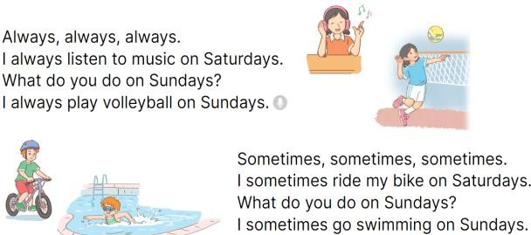  - Play the recording for Ss to listen to the whole chant.  + Have them repeat the title and lyrics line by line.  + Ask Ss to attend to two-syllable words with the stress on the first syllable in the chant, always and sometimes.  - Play the recording all the way through for Ss to listen to pronunciation and melody.  - Play the recording line by line for Ss to listen and repeat  - Play the recording for Ss to chant and clap along.  - Ask Ss to practice chant and clap along in pairs or groups.  - Invite groups to the front of the classroom to perform the chant  Game: Jump  - Flash cards (football, table tennis, Japan, England, dolphin, giraffe)  - Tell Ss they are going to play the game Jump. If the word is the same as the flash card, Ss jump. If it isn’t, they keep still. Ask them to say the word on the flash card.  - Ask Ss to stand at their desks.  - Hold up a flash card from the | - Ss listen to the chant  - Ss listen and repeat line by line without clap their hands  - Ss note the rhythm and pronunciation.  -Ss listen to melody of the chant  - Ss listen and chant line by line.  - Ss chant and clap along.  - Ss work in groups (two groups) to chant  -Ss perform in front of the class.  -Ss listen  -Ss play the game

 | vocabulary set and say a word.  - Raise all the flash cards for Ss to say the words. | -Ss read the words

ADJUSTMENTS (if necessary):
…………………………………………………………………………………………
.…..……………………………………………………………………………...……

Week 7 Preparing date: October 20th, 2024 Period 28 Teaching date: October 23rd, 2024

- OBJECTIVES:

Unit 4: Our free-time activities Lesson 3 (4, 5, 6)

By the end of the lesson, Ss will be able to:

Knowledge:
  - read and show understanding of a text by answering four questions about Laura’s free-time activities at the weekend
  - complete a letter to a pen friend about someone’s free-time activities at the weekend by writing the target words in the gaps using picture cues
  - present their free-time activities to the class.
  - Vocabulary: Review
  - Skills: speaking, listening, reading and writing.

Competences:
  - Communication and collaboration: work in pairs and groups to complete the learning tasks.
  - Self-control and independent learning: perform reading and writing tasks.

Attitude/ Qualities:
  - Show their love and interest in leisure activities and entertainment

TEACHING AIDS:
  - Teacher: Teacher’s guide Pages 72, 73, 74; website hoclieu.vn, posters, laptop, pictures, textbook, lesson plan, TV or projector.
  - Students: Pupil’s book Page 33, notebooks, workbooks, school things.

PROCEDURES:

Stages/  Time | Teacher’s activities | Students’ activities

- Warm- up and review: (5’)  - Practice: (8’) | Game: Spin the wheel  *Aims: to revise the new words and structures from previous lessons.  *Procedure:  - Tell Ss they are going to look at the pictures and answer the questions.  - Divide the class into 3 teams.  - Ss take turns to choose a number and answer the question.  - Check the Ss’ answers as a whole class.  - If they give the correct answers, they can spin the wheel to get points.  - The team with the most points will be the winner.  - Say “Open your book page 33” and look at “Unit 4, Lesson 3 (4,5,6)”.  Activity 1. Read and answer:  *Aims: Ss will be able to read and show understanding of a text by answering four questions about Laura’s free-time activities at the weekend  *Procedure:  - Have Ss read the questions carefully and tell ss to read Question 1 and identify the keywords (She always plays the violin).  - Explain the type of information | - Ss listen  - Ss listen to the rules  -Ss play game  - Ss open their books  - Ss read Question 1 and pay attention to keywords  - Ss read and answer question 2,3,4

3.Productio n: (18’) | they need for each answer.  - Set a time limit for Ss to do the task independently.  - Get Ss to swap books with a partner and check the answers before checking as a class.  - Invite some pairs to take turns asking and answering the questions.  - Ask Ss some more questions to check their comprehension of the text.  Ex: Who likes listening to music? Does she like playing sports and games?  What does she help her mother do? Key:  - She always plays the violin (at the weekend).  - She usually plays volleyball (on Saturdays).  - She often goes for a walk on Sundays.  - She helps her mother with the cooking on Sundays.  Activity 2. Let’s write  *Aims: Ss will be able to complete a letter to a penfriend about someone’s free-time activities at the weekend by writing the target words in the gaps using picture cues.  *Procedure: | - Ss read the text again and write the correct answers.  - Ss swap books and check answers  - Ss ask and answer the questions.  - Ss answer the questions.

 | 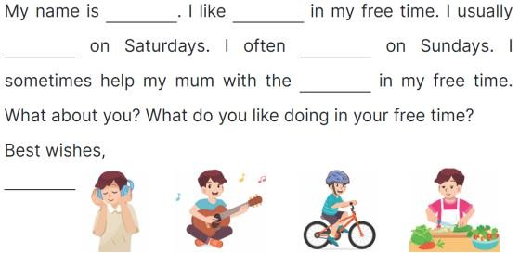  - Ask Ss to read the gapped letter and explain that they need to fill in the gaps with information about the boy in the pictures’ free-time activities.  - Have Ss complete the first, second and third gaps with names and an activity of their choice from the pictures.  - Give Ss time to complete the rest of the letter independently.  - Get Ss to swap their books with a partner and check each other’s spelling before checking as a class. Key: Pupil’s answer  Ex:  Hi Kitty,  My name is Hoang. I like listening to music in my free time. I usually play the guitar on Saturdays. I often ride my bike on Sundays. I sometimes help my mum with the cooking in my free time. What about you? What do you like doing in your free time?  Love, Hoang  Activity 3. Project.  *Aims: Ss will be able to present their free-time activities to the | - Ss listen to the teacher  - Ss complete the first, second and third gaps with names and an activity  - Ss complete the rest of the letter independently.  - Ss swap their and check

4. Fun corner and wrap- up (4’) | class.  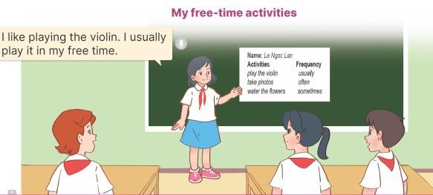  *Procedure:  - Tell Ss about the goal of the activity.  - Have Ss work in groups. Each student looks at their lists and tells the group about their free-time activities.  - Invite a few ss to look at their lists and tell the class about them, ex: I like playing the guitar. I usually play it in my free time.  -T gives feedback  Game: Slap the board  - Divide the class into two or three teams.  - Teacher puts up a set of pictures or words on a board.  - A student from each team comes up to the board with fly swatters.  - They listen as the teacher calls out a word or a sentence and they race to slap the correct picture.  - Whoever is the fastest with the correct slap gets a point for their team.  - Team with the most points is the  winner. | - Ss listen to the teacher  - Ss work in groups of five.  - Ss show their work and talk about their free-time activities in front of the class.  - Ss listen  -Ss listen to the teacher  -Ss play the game  -Ss congratulate the winner

ADJUSTMENTS (if necessary)

