Week 5 Preparing date: October 6th, 2024
Period 17 Teaching date: October 7th, 2024

Unit 3: My foreign friends
Lesson 1 (1, 2, 3)
A. OBJECTIVES:
By the end of the lesson, Ss will be able to:
1. Knowledge:

- understand and correctly repeat the sentences in two communicative contexts in which characters ask and answer questions about someone’s nationality.

- correctly say the words for nationalities and use What nationality is he / she? - He’s / She’s _____. to ask and answer questions about someone’s nationality.

- enhance the correct use of What nationality is he / she? - _____. to ask and answer questions about someone’s nationality in a freer context.

- Vocabulary: nationality, Australian, Malaysian, American, Japanese

- Structures: A: What nationality is he / she?
B: He’s/ She’s Australian.
- Skills: speaking and listening
2. Competences:
- Critical thinking and creativity: learn how to ask and answer questions about personal information correctly and fluently.
- Self-control and independent learning: perform speaking tasks.
3. Attitude/ Qualities:
- Show their pride in where they come from and great respect for where someone comes from by asking and answering about nationality
B. TEACHING AIDS:
- Teacher: Teacher’s guide Pages 44, 45, 46, audio Tracks 25, 26, website hoclieu.vn, posters, laptop, pictures, textbook, lesson plan, TV or projector.
- Students: Students’ book Page 22, notebooks, workbooks, school things.
C. PROCEDURES:
Stages/  Time | Teacher’s activities | Students’ activities
1.Warm- up and review: (3’)  2. Presentation (15’)  3.Practice: (7’)  4. Production: (6’)  5. Fun corner and wrap- up (4’) | Game: Slap the board  *Aims: to revise the vocabulary about different countries that pupils have learnt in English 4.  *Procedure:  - Prepare some flashcards about different countries and stick on the board (America, Australia, Japan, Viet Nam, Malaysia…)  - Divide class into 2 groups: Tom and Jerry.  - How to play:  + Each group chooses five Ss to play.  + Class will read aloud.  + Look at the picture, listen and slap the picture you heard.  + Who faster will get 1 mark.  + Which group with higher mark is the winner.  - Say “Open your book page 22” and look at “Unit 3, Lesson 1 (1,2,3)”.  Activity 1. Vocabulary.  *Aims: Ss will be able to know the vocabulary in the new lesson.  *Procedure:  -T elicits the new words  + American : người Mỹ (explain)  + Australian: người Úc (explain)  + Malaysian : người Ma-lai-xi-a  (explain)  + Japanese : người Nhật (explain )  + nationality: quốc tịch (translation)  - T models (3 times).  - T writes the words on the board.  - Checking: Matching  Activity 2. Look, listen and repeat:  *Aims: Ss will be able to understand and correctly repeat the sentences in two communicative contexts in which characters ask and answer questions about someone’s nationality  *Procedure:  - Have Ss look at Pictures a and b and identify the characters and say what they are talking about.  + Who is he/ she?  + Where is he/ she?  + What are they talking about?  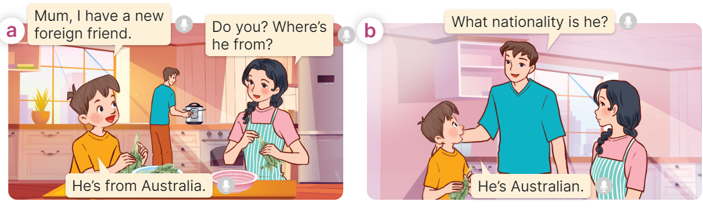  - Play the audio twice (sentence by sentence). Correct their pronunciation where necessary.  - Have Ss to practice the dialogue  - T invites a few pairs to the front of the class to practice.  - T checks pronunciation for ss.  Activity 3 Listen, point and say.  *Aims: Ss will be able to correctly say the words for nationalities and use What nationality is he / she? - He’s / She’s _____. to ask and answer questions about someone’s nationality.  *Procedure:  * Structures:  - T asks Ss look at picture b in activity 1 and helps Ss know the structure from the dialogue.  - T introduces new structures for Ss.  - T explains, models and gives meaning.  - Have Ss repeat the structures  A: What nationality is he / she?  B: He’s/ She’s Australian.  *Drill pictures  - Have Ss look at the pictures and say what they can see in the pictures.  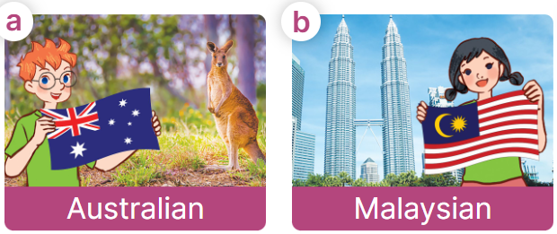  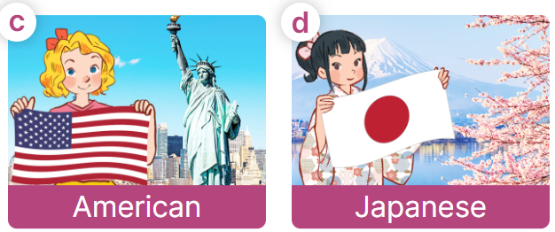  - Have Ss point at pictures, listen and run through all the pictures.  - Have Ss point at the bubbles, listen and run through model sentences.  - Have Ss to practise:  + T asks the first picture, Ss answer  + Ss asks the second picture, T answers  + Group A asks the third picture, group B  answers  + Group B asks the last picture, group A  - Ask Ss to work in pairs to practise asking and answering the What nationality is he / she? – He’s/ She’s ____.  - T controls and corrects.  - Invite a few pairs to point at the pictures and say the questions and answers in front of the class.  Activity 4. Let’s talk.  *Aims: Ss will be able to enhance the correct use of What nationality is he / she? - _____. to ask and answer questions about someone’s nationality in freer contexts.  *Procedure:  - Ask Ss to look at the pictures and elicit the context  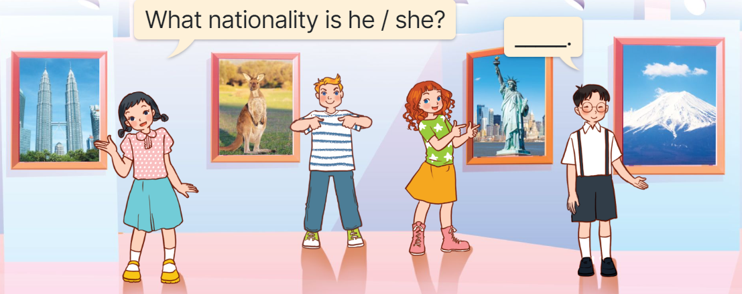  - Point at the ﬁrst picture and elicit the question in the ﬁrst speech bubble What nationality is he / she? and the answer in the second speech bubble He’s/ She’s…. as an example.  - Give Ss time to work in pairs and take turns pointing at each picture to ask and answer using What nationality is he / she? - _____.  - Invite a few pairs to come to the front of the classroom and act out the exchanges.  Game: Sentence Puzzle  - Divide the class into groups of four.  - Give each group a sentence that is broken/cut into pieces.  - Ask them to arrange them to make a complete sentence, then read it aloud.  - The group who makes it first will be the winner. | -Ss listen and pay attention  - Ss listen to the teacher  -Ss play the game  .  - Ss continue playing the game  - Ss listen and open their books  -Ss listen and answer  - - Ss listen and repeat  + Choral repetition  (3 times).  + Individual repetition  (3 ss)  - Ss take note  - Ss look and match  -Look at the pictures and say.  + In picture a: Minh and mum in the kitchen, talking Minh’s new friend.  Minh: Mum, I have a new foreign friend.  Mum: Do you? Where’s he from?  Minh: He’s from Australia.  + In picture b: Dad joining the conversation, asking about the nationality of Minh’s new friend.  Dad: What nationality is he?  Minh: He’s Australian.  -Ss listen and repeat in chorus (twice)  -Ss work in pairs to practice  -Ss come to the front of the classroom to practice.  -Ss listen  - Ss look at the picture and answer.  -Ss listen  -Ss listen and repeat  -Ss repeat to the structures  - Ss look, listen and repeat  +Picture a: Ben, Australian flag, a kangaroo and the word Australian underneath.  + Picture b: a girl, Malaysian flag, Petronas Twin tower and the word Malaysian underneath.  + Picture c: Mary, American flag, the Statue of Liberty and the word American underneath  + Picture d: a girl, Japanese flag, Sakura blossoms and the word Japanese underneath  -Ss point at pictures, listen and repeat  -Ss point at the bubbles, listen and repeat  -Ss practice in chorus  -Ss practice in chorus  -Ss work in pairs to practise asking and answering the question  - Pairs of Ss point at the pictures and say in front of the class  -Ss look at the picture and say  + Picture of four characters at the exhibition introducing their countries  - Ss look at the first picture and elicit the missing words in speech bubbles and say the completed sentences.  - Ss role-play to practise asking and answering questions  - Ss practise asking and answering questions in front of the class.  -Ss listen to the teacher  -Ss play the game  Ex:  is  he?  nationality  What  -Ss congratulate the winner
D. ADJUSTMENTS (if necessary):
………………………………………………………………………………………….…..……………………………………………………………………………...…..

Week 5 Preparing date: October 6th, 2024
Period 18 Teaching date: October 7th, 2024

Unit 3: My foreign friends
Lesson 1 (4, 5, 6)
A. OBJECTIVES:
By the end of the lesson, Ss will be able to:
1. Knowledge:
- listen to and understand four communicative contexts in which speakers ask and answer questions about someone’s nationality and tick the correct pictures.
- circle correct words in four exchanges with the help of picture cues.
- sing the song My friends with correct pronunciation, rhythm and melody.
- Vocabulary: Review
- Skills: speaking, listening, reading and writing.
2. Competences:
- Communication and collaboration: work in pairs and groups to complete the learning tasks.
- Self-control and independent learning: perform listening and reading tasks.
3. Attitude/ Qualities:
- Show their pride in where they come from and great respect for where someone comes from by asking and answering about nationality.
B. TEACHING AIDS:
- Teacher: Teacher’s guide Pages 47, 48; audio Tracks 27, 28; website hoclieu.vn, posters, laptop, pictures, textbook, lesson plan, TV or projector.
- Students: Student’s book Page 23, notebooks, workbooks, school things.
C. PROCEDURES:
Stages/ Time | Teacher’s activities | Students’ activities
1.Warm- up and review: (5’)  2.Practice: (25’)  3. Fun corner and wrap- up (5’) | Game: “Flashcard walk”  *Aims: to revise the learned different nationalities.  *Procedure:  - Divide the class into four groups.  - Place several word cards on the classroom floor.  - Have Ss from each group come up the front.  - Play some music and have the Ss walk around the word cards.  - Stop the music and say the name of one flashcard, ex: she / American  - Have the Ss pick up the correct word card and say a sentence using the word on the word card, ex: she’s American.  - Give the first group to make a correct sentence at one point.  - The group with the most points wins the game.  - Say “Open your book page 23” and look at “Unit 3, Lesson 1 (4,5,6)”.  Activity 1. Listen and tick:  *Aims: Ss will be able to listen to and understand four communicative contexts in which speakers ask and answer questions about someone’s nationality and tick the correct pictures.  *Procedure:  - Draw Ss’ attention to the pictures and ask questions  + What nationality is she/ he?  + What’s he/ she doing?  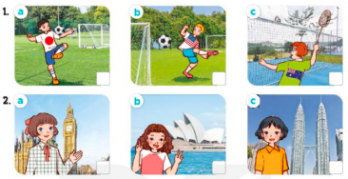  - T ask Ss to guess the answers.  + T writes Ss’guessing on the board.  - Listen to the tape:  + Play the recording  + Play the recording again for pupils to do the task.  + Play the recording a third time for pupils to check their answers.  - Get Ss to swap books with their partner, then check answers as a class.  + Write the answers on the board for Ss to correct their answers. Then checks Ss’ guessing.  - Play the recording, sentence by sentence, for Ss to listen and repeat individually and in chorus  Key: 1. a 2. b  Activity 2. Read and circle  *Aims: Ss will be able to circle correct words in four exchanges with the help of picture cues.  *Procedure:  - Have Ss read the sentences and elicit the answer to fill in the gap.  (ex: America).  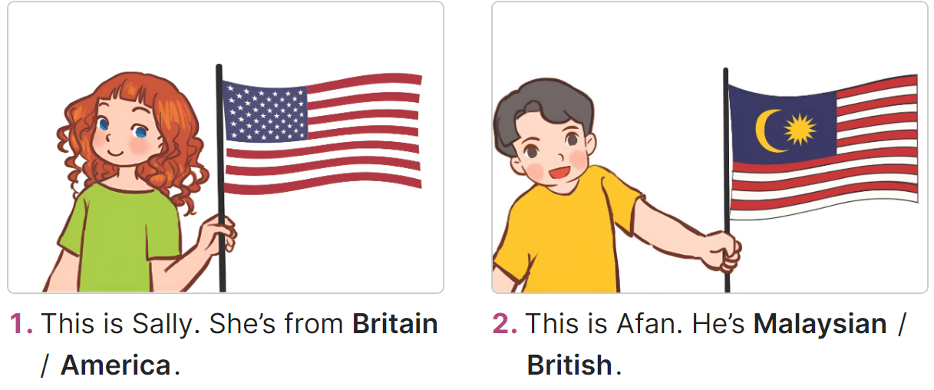  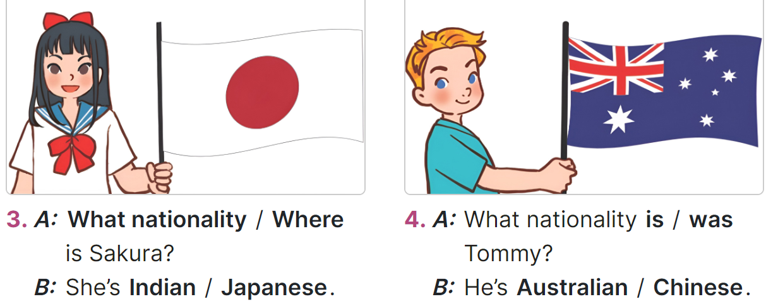  - Give Ss a time limit to read the gapped dialogues, look at the pictures and do the task independently  - Get Ss to swap books with a partner and check their answers before checking as a class.  + Invite one student to write the answers on the board.  + Ask questions to have Ss explain why they choose the options. Ex: for picture B, ask why do you choose Malaysian? - Because there’s a flag of Malaysia.  - Invite two pairs of Ss to act out the completed dialogues.  Key: 1. America 2. Malaysian  3. What; Japanese 4. is, Australian  Activity 3. Let’s sing  *Aims: Ss will be able to sing the song My friends with correct pronunciation, rhythm and melody.  *Procedure:  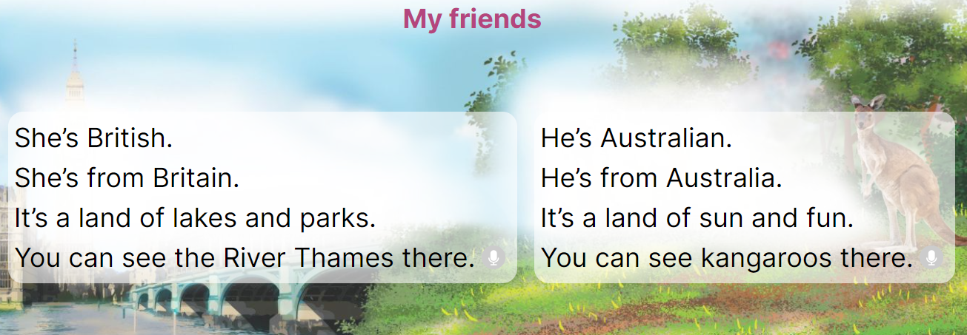  - Draw Ss’ attention to the title and lyrics of the song.  - Have Ss read and listen to the song.  - Play the recording again and let ss listen to and practise singing the song, line by line.  - Ask Ss to listen to and sing the whole song while doing actions or clapping their hands when they hear the keywords such as British, Britain, Australian, Australia, land, see.  - Invite a few groups to the front of the class to sing the song.  Game: Lucky stars  - Divide the class into two groups. Have a student from each group play one, two, three to find the group going first.  - Have two Ss from each group choose a colour star, look at the picture given and ask and answer the question about someone’s nationality.  - Ask the class to check their friends’ pronunciation. If they are correct, they will get points for their group.  - Continue the game until all the words are said.  - The group with more points wins the game. Praise the winner. | -Ss listen to the teacher  -Ss play the game  - Ss open their books  -Look at the pictures and say:  + Picture 1a: a Japanese boy playing football  + Picture 1b: an American boy playing football  + Picture 1c: an Australian boy playing badminton  + Picture 2a: a British girl standing in front of Big Ben  + Picture 2b: an Australian girl standing in front of Sydney Opera House  + Picture 2c: a Malaysian girl standing in front of Petronas twin tower  -Ss guess the answers  - Ss listen to the tape  - Ss listen again and do the task.  - Ss listen and check their answers  - Ss swap books with their partner, then check answers as a class  -Ss check their guessing  -Ss listen and repeat  -Ss look at the picture and read, fill the gap  - Ss do the task independently.  - Ss swap books with a partner and check their answers.  - Ss write the answers on the board  -Ss explain why  - Pairs of Ss read the completed dialogues aloud  - Ss pay attention to the title and lyrics of the song.  - Ss read and listen to the song  - Ss listen to the recording again and practise singing the song  - Ss listen to and sing the whole song while doing actions  - Ss come to the front of the class to sing the song.  -Ss listen to the teacher  - Ss play the game.  - Ss continue playing the game.  - Ss praise the winner.
D. ADJUSTMENTS (if necessary):
………………………………………………………………………………………….…..……………………………………………………………………………...…..…

Week 5 Preparing date: October 6th, 2024
Period 19 Teaching date: October 8th, 2024

Unit 3: My foreign friends
Lesson 2 (1, 2, 3)
A. OBJECTIVES:
By the end of the lesson, Ss will be able to:
1. Knowledge:

- understand and correctly repeat the sentences in two communicative contexts in which characters ask and answer questions about someone’s personality.

- correctly say the words and use What’s he / she like? - He’s / She’s ____. to ask and answer questions about someone’s personality.

- enhance the correct use of What’s he / she like? - _____. to ask and answer questions about someone’s personality in freer contexts.

- Vocabulary: friendly, helpful, clever, active
- Structures: A: What’s he / she like?
B: He’s/ She’s friendly.
- Skills: speaking and listening
2. Competences:
- Critical thinking and creativity: learn how to ask and answer questions about personal information correctly and fluently.
- Self-control and independent learning: perform pronunciation and speaking tasks.
3. Attitude/ Qualities:
- Raise their awareness of good personality.
B. TEACHING AIDS:
- Teacher: Teacher’s guide Pages 49, 50, 51, audio Tracks 29, 30, website hoclieu.vn, posters, laptop, pictures, textbook, lesson plan, TV or projector.
- Students: Students’ book Page 24, notebooks, workbooks, school things.
C. PROCEDURES:
Stages/  Time | Teacher’s activities | Students’ activities
1.Warm- up and review: (3’)  2. Presentation (15’)  3.Practice: (7’)  4. Production: (6’)  5. Fun corner and wrap- up (4’) | Game: Circle the words  *Aims: to revise the words about different nationalities.  *Procedure:  - Divide the class into groups of three.  - Have each group take out one paper and two pens with different colours.  - Ask one student to write down the eight words of countries and nationality in random order then give it to his/ her friends.  - When he/ she calls out one word (ex: Japanese), the other two pupils try to circle that word as fast as possible.  - The student who circles more words wins.  - Have some groups demonstrate the activity in front of the class. Praise the winner.  - Say “Open your book page 24” and look at “Unit 3, Lesson 2 (1,2,3)”.  Activity 1. Vocabulary.  *Aims: Ss will be able to know the vocabulary in the new lesson.  *Procedure:  -T elicits the new words  + friendly : thân thiện (situation)  + helpful : hay giúp đỡ (picture)  + clever : thông minh (situation)  + active : năng động (translation)  - T models (3 times).  - T writes the words on the board.  - Checking: Rub out and remember  Activity 2. Look, listen and repeat:  *Aims: Ss will be able to understand and correctly repeat the sentences in two communicative contexts in which characters ask and answer questions about someone’s personality.  *Procedure:  - Have Ss look at Pictures a and b and identify the characters and predict what Lily’s nationality is.  + What can you see in the picture?  + What are they talking about?  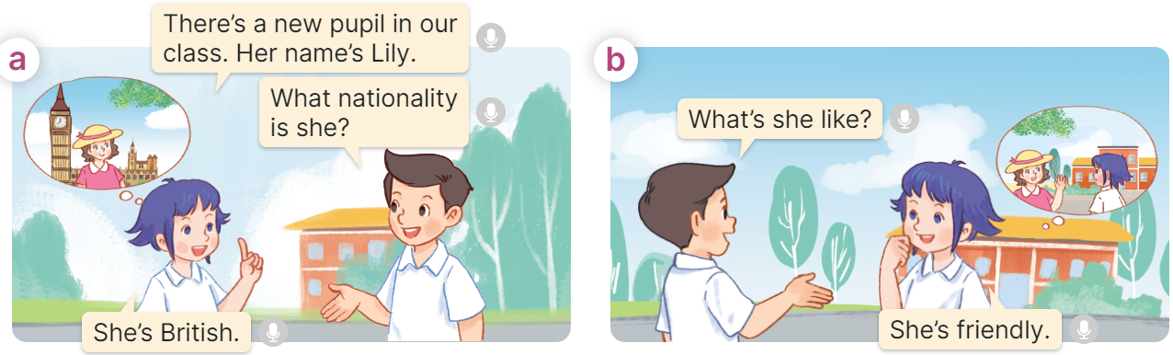  - Play the audio twice (sentence by sentence). Correct their pronunciation where necessary.  - Have Ss to practice the dialogue  - T invites a few pairs to the front of the class to practice.  - T checks pronunciation for ss.  Activity 3 Listen, point and say.  *Aims: Ss will be able to correctly say the words and use What’s he / she like? - He’s / She’s ____. to ask and answer questions about someone’s personality.  *Procedure:  * Structures:  - T asks Ss look at picture b in activity 1 and helps Ss know the structure from the dialogue.  - T introduces new structures for Ss.  - T explains, models and gives meaning.  - Have Ss repeat the structures  A: What’s he / she like?  B: He’s/ She’s friendly.  *Drill pictures  - Have Ss look at the pictures and say what they can see in the pictures.  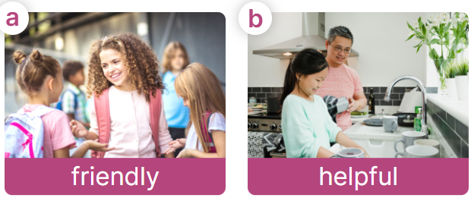  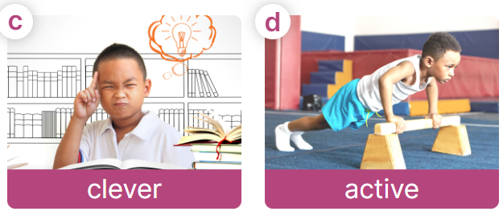  - Have Ss point at pictures, listen and run through all the pictures.  - Have Ss point at the bubbles, listen and run through model sentences.  - Have Ss to practise:  + T asks the first picture, Ss answer  + Ss asks the second picture, T answers  + Group A asks the third picture, group B  answers  + Group B asks the last picture, group A  - Ask Ss to work in pairs to practise asking and answering the question What’s he/ she like? – He’s/ She’s __.  - T controls and corrects.  - Invite a few pairs to point at the pictures and say the questions and answers in front of the class.  Activity 4. Let’s talk.  *Aims: Ss will be able to enhance the correct use of What’s he / she like? - _____. to ask and answer questions about someone’s personality in a freer context.  *Procedure:  - Ask Ss to look at the pictures and elicit the personality of each character in the picture.  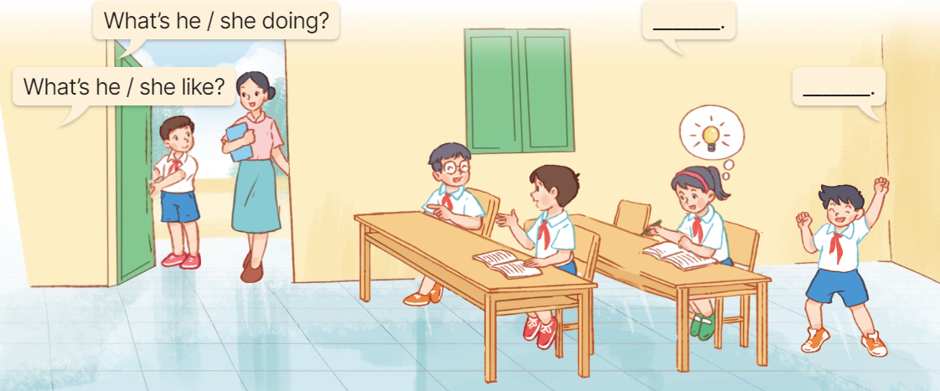  - Remind Ss that What’s he / she like? and - ___. are used to ask and answer questions about someone’s personality.  - Give Ss time to work in pairs and take turns pointing at each picture to ask and answer using What’s he / she like? and - ___.  - Invite a few pairs to come to the front of the classroom and act out the exchanges.  Game: Whisper  - Divide the class into two groups. Have each group stand in a line.  - Model the activity. Give the first pupil in each line a flash card.  + Explain that he/she must read the word (without saying it out loud!) and then whisper it to the next pupil in the line.  +The second student must then whisper it to the third, and so on.  + When the word reaches the last student in the line, he/she should call it out. The first group to call out a correct word wins.  - Praise the winner. | -Ss listen and pay attention  - Ss listen to the teacher  -Ss play the game  -Ss continue playing the game  - Ss listen and open their books  -Ss listen and answer  - - Ss listen and repeat  + Choral repetition  (3 times).  + Individual repetition  (3 ss)  - Ss take note  - Ss look, remember and write  -Look at the pictures and say.  + In picture a: Linh and Nam talking about a new friend in their class.  Linh: There’s a new pupil in our class. Her name’s Lily.  Nam: What nationality is she?  Linh: She’s British.  + In picture b: Nam asking about the new friend’s personality  Nam: What’s she like?  Linh: She’s friendly.  -Ss listen and repeat in chorus (twice)  -Ss work in pairs to practice  -Ss come to the front of the classroom to practice.  -Ss listen  - Ss look at the picture and answer.  -Ss listen  -Ss listen and repeat  -Ss repeat to the structures  - Ss look, listen and repeat  +Picture a: a friendly girl talking to her friends  + Picture b: a helpful girl doing the dishes  + Picture c: a clever boy reading and thinking of a new idea  + Picture d: an active boy exercising  -Ss point at pictures, listen and repeat  -Ss point at the bubbles, listen and repeat  -Ss practice in chorus  -Ss practice in chorus  -Ss work in pairs to practise asking and answering the question  - Pairs of Ss point at the pictures and say in front of the class  -Ss look at the picture and say  - Ss listen to the teacher  - Ss role-play to practise asking and answering questions  - Ss practise asking and answering questions in front of the class.  -Ss listen to the teacher  -Ss play the game  -Ss play the game  -Ss congratulate the winner.
D. ADJUSTMENTS (if necessary):
………………………………………………………………………………………….…..……………………………………………………………………………...……

Week 5 Preparing date: October 6th, 2024
Period 20 Teaching date: October 8th, 2024

Unit 3: My foreign friends
Lesson 2 (4, 5, 6)
A. OBJECTIVES:
By the end of the lesson, Ss will be able to:
1. Knowledge:
- listen to and understand two communicative contexts in which pupils ask and answer questions about someone’s personality and number the pictures.
- complete two gapped exchanges with the help of picture cues.
- review the target vocabulary related to the topic “My foreign friends” by playing the game The longest sentence.
- Vocabulary: Review
- Skills: speaking, listening, reading and writing.
2. Competences:
- Communication and collaboration: work in pairs and groups to complete the learning tasks.
- Self-control and independent learning: perform listening and reading tasks.
3. Attitude/ Qualities:
- Raise their awareness of good personality.
B. TEACHING AIDS:
- Teacher: Teacher’s guide Pages 51, 52; audio Tracks 31; website hoclieu.vn, posters, laptop, pictures, textbook, lesson plan, TV or projector.
- Students: Student’s book Page 25, notebooks, workbooks, school things.
C. PROCEDURES:
Stages/ Time | Teacher’s activities | Students’ activities
1.Warm- up and review: (5’)  2.Practice: (25’)  3. Fun corner and wrap- up (5’) | Game: Slap the board  *Aims: to revise the words about someone’s appearance and personality.  *Procedure:  - - Divide the class into two groups. Ask Ss to stand in two lines.  - Stick the cards with words on the board.  - Call out a word and have the first student from each group race to slap the correct card on the board and say it correctly.  - The first student to slap the correct card wins a point for their group.  - The group with the most points wins. Praise the winner.  - Say “Open your book page 25” and look at “Unit 3, Lesson 2 (4,5,6)”.  Activity 1. Listen and number:  *Aims: Ss will be able to listen to and understand four communicative contexts in which speakers ask and answer questions about someone’s personality and number the pictures.  *Procedure:  - Draw Ss’ attention to the pictures and ask questions to elicit the personalities of the people in the pictures.  + What can you see in this picture?  + Is he friendly? + Is he active?  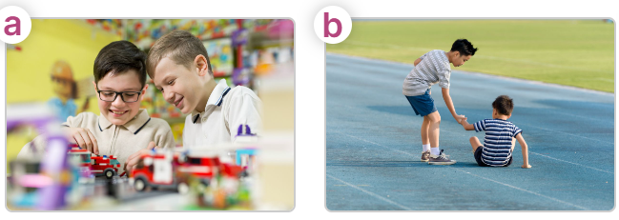  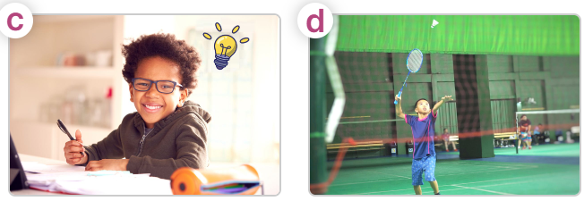  - T ask Ss to guess the answers.  + T writes Ss’guessing on the board.  - Listen to the tape:  + Play the recording  + Play the recording again for pupils to do the task.  + Play the recording a third time for pupils to check their answers.  - Get Ss to swap books with their partner, then check answers as a class.  + Write the answers on the board for Ss to correct their answers. Then checks Ss’ guessing.  - Play the recording, sentence by sentence, for Ss to listen and repeat individually and in chorus  Key: 1. b 2. a 3.d 4.c  Activity 2. Read and complete.  *Aims: Ss will be able to complete two gapped exchanges with the help of picture cues.  *Procedure:  - Have Ss read the dialogue and guess the missing words.  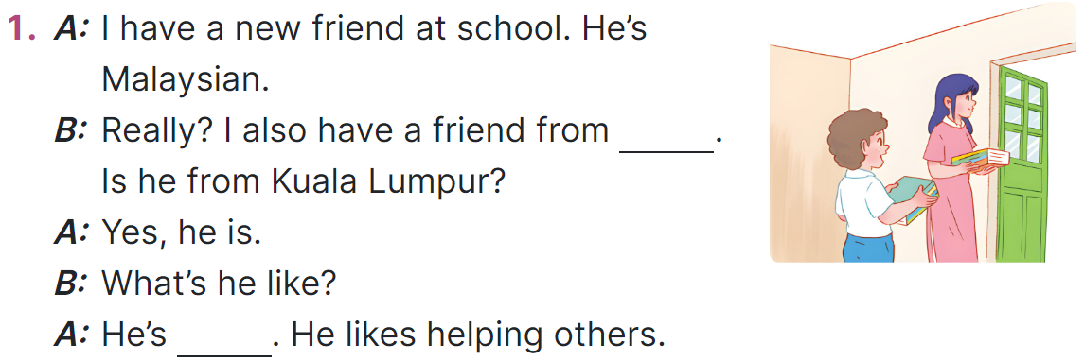  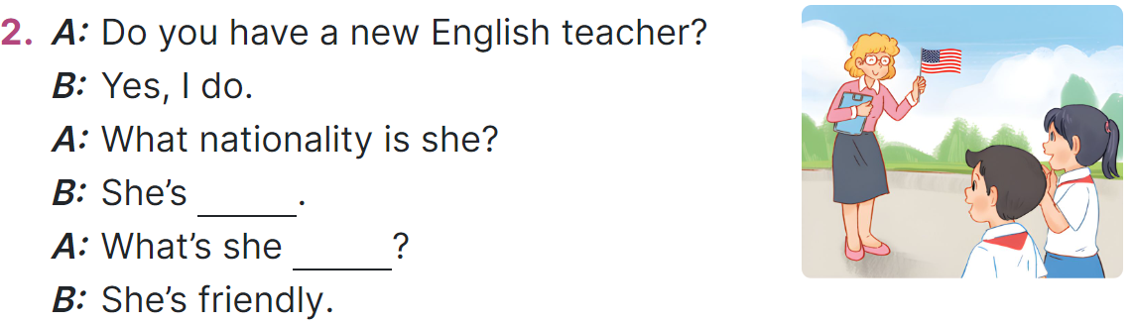  - Model the first gapped  + Elicit the missing word  + Ask What nationality is a new friend? - He’s Malaysian. Where is he from? - He’s from Malaysia.  - Give Ss a time limit to read the gapped dialogues, look at the pictures and fill in the gaps independently.  - Get Ss to swap books with a partner and check their answers before checking as a class.  + Invite one student to write the answers on the board.  - Invite two pairs of Ss to act out the completed dialogues.  Key: 1. Malaysia 2. helpful  3. American 4. like  Activity 3. Let’s play  *Aims: Ss will be able to review the target vocabulary related to the topic My foreign friends by playing the game The longest sentence.  *Procedure:  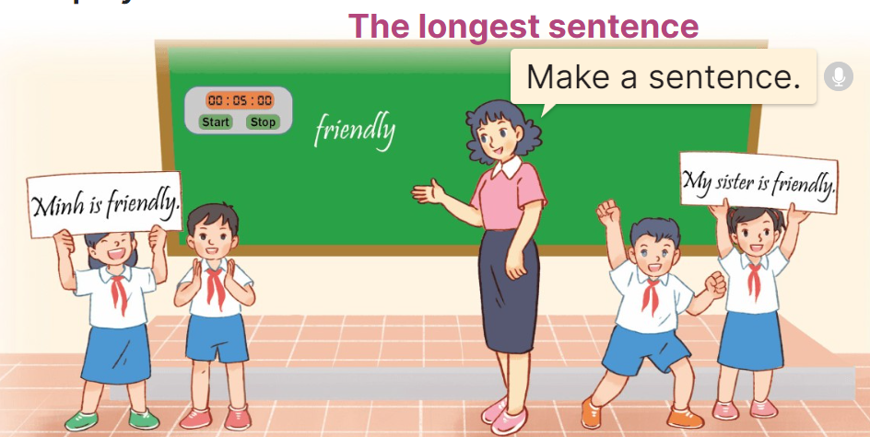  - Divide the class into 8 - 10 groups. Give each group a piece of paper.  - Write a word on the board (ex: friendly) and ask the groups to write a sentence using the word within one minute.  - After one minute, the groups hold up the sentences and say them aloud. The group with the longest sentences wins.  - Play the game with another word.  Game: Spin the wheel!  - Tell Ss they are going to ask and answer the question about their friends’ personality in a freer context.  - Invite pairs of volunteers to the board. One student asks the question about his/ her friend, another one answers the question about him/ her.  - Have pairs of Ss continue practising with other friends.  - Praise Ss if they perform well. | - Ss listen to the teacher  - Ss play the game  -Ss congratulate the winner  - Ss open their books  -Look at the pictures and say:  + Picture a: a friendly boy talking to his friends  + Picture b: a helpful boy helping a child  + Picture c: a clever boy thinking of a new idea  + Picture d: an active boy playing badminton  -Ss guess the answers  - Ss listen to the tape  - Ss listen again and do the task.  - Ss listen and check their answers  - Ss swap books with their partner, then check answers as a class and guessing  -Ss listen and repeat  -Ss follow the teacher  - Ss follow the teacher’s instruction.  - Ss complete the gapped independently.  - Ss swap books with a partner and check their answers.  -Ss write the answers on the board.  - Pairs of Ss read the completed dialogues aloud  - Ss work in groups.  - Ss look at the word on the board and write a sentence  - Ss say the sentences aloud.  - Ss continue playing the game.  -Ss listen to the teacher  - Ss play the game.  Ex: A: What’s she like?  B: She’s friendly.  -Ss congratulate the winner
D. ADJUSTMENTS (if necessary):
………………………………………………………………………………………….…..……………………………………………………………………………...…..…
* Preparation for the project: Tell pupils about the project on page 27. Ask them to spend time outside of the class searching for the names of at least five countries and their nationality adjectives. Then, make a poster to show the names of the countries and the nationalities they have found. They may add some information about the countries such as people, flags, maps. Next, each group gives a presentation to introduce the poster in class at Project time.

