Week 2 Preparing date: September 15th , 2024
Period 5 Teaching date: September 16th , 2024

Unit 1: All about me!
Lesson 1 (1, 2, 3)
A. OBJECTIVES:
By the end of the lesson, Ss will be able to:
1. Knowledge:
- understand and correctly repeat the sentences in two communicative contexts focusing on asking and answering questions about personal information.
- correctly say the words and use Can you tell me about yourself? - I’m in ………...; I live in the……………. to ask and answer questions about personal information.
- use Can you tell me about yourself? - I’m in ………...; I live in the…………. in freer contexts.
- Vocabulary: city, class, countryside
- Structures:
A: Can you tell me about yourself?
B: I’m in class 5D. I live in the countryside.
- Skills: speaking and listening
2. Competences:
- Communication and collaboration: work in pairs and groups to complete the learning tasks.
- Self-control and independent learning: perform pronunciation and speaking tasks.
3. Attitude/ Qualities:
- Show their pride in their personal information and where they live.
B. TEACHING AIDS:
- Teacher: Teacher’s guide Pages 18, 19, 20, 21, audio Tracks 5,6, website hoclieu.vn, posters, laptop, pictures, textbook, lesson plan, TV or projector.
- Students: Students’ book Page 10, notebooks, workbooks, school things.
C. PROCEDURES:
Stages/Time | Teacher’s activities | Students’ activities
1.Warm- up: (3’)  2. Presentation (15’)  3.Practice: (7’)  4. Production: (6’)  5. Fun corner and wrap- up (4’) | Sing a song: Hello, nice to meet you  *Aims: to create a friendly and active atmosphere in the class to beginning the lesson.  *Procedure:  - Show the song on the screen.  https://www.youtube.com/watch?v=ANrSdZq8sCk  - Ask Ss to listen, sing and dance the song  - Say “Open your book page 10” and look at “Unit 1, Lesson 1 (1,2,3)”.  Activity 1. Vocabulary.  *Aims: Ss will be able to know the vocabulary in the new lesson.  *Procedure:  -T elicits the new words  + city : thành phố (picture)  + class : lớp học (picture)  + countryside:nông thôn (picture)  - T models (3 times).  - T writes the words on the board.  - Checking: Rub out and remember  Activity 2. Look, listen and repeat:  *Aims: Ss will be able to understand and correctly repeat the sentences in two communicative contexts focusing on asking and answering questions about personal information.  *Procedure:  - Have Ss look at Pictures a and b and identify the characters in the pictures.  + Who is he/ she?  + Where is he/ she?  + What are they talking about?  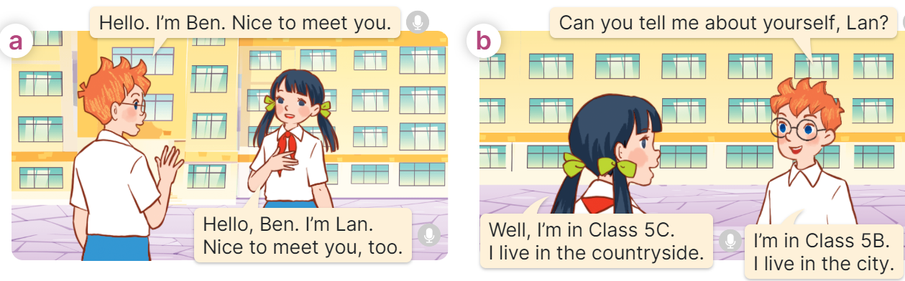  - Play the audio twice (sentence by sentence). Correct their pronunciation where necessary.  - Have Ss to practice the dialogue  - T invites a few pairs to the front of the class to practice.  - T checks pronunciation for ss.  Activity 3 Listen, point and say.  *Aims: Ss will be able to correctly say the words and use Can you tell me about yourself? - I’m in ……..; I live in the ….. to ask and answer questions about personal information.  *Procedure:  * Structures:  - T asks Ss look at picture b in activity 1 and helps Ss know the structure from the dialogue.  - T introduces new structures for Ss.  - T explains, models and gives meaning.  - Have Ss repeat the model sentences.  A: Can you tell me about yourself?  B: I’m in class 5D. I live in the countryside.  *Drill pictures  - Elicit and check comprehension the personal information of each character.  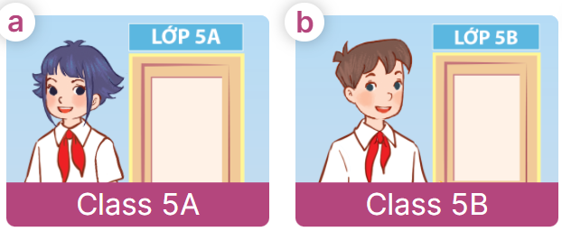  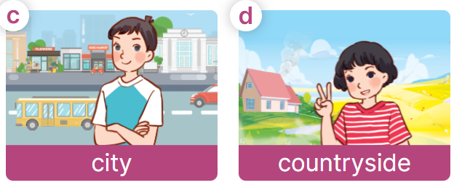  - Have Ss point at pictures, listen and run through all the pictures.  - Have Ss point at the bubbles, listen and run through model sentences.  - Have Ss to practise:  + T asks the first picture, Ss answer  + Ss asks the second picture, T answers  + Group A asks the third picture, group B answers  + Group B asks the last picture, group A  - Ask Ss to work in pairs to practise asking and answering the question Can you tell me about yourself? - I’m in ……….; I live in the…….  - T controls and corrects.  - Invite a few pairs to point at the pictures and say the questions and answers in front of the class.  Activity 4. Let’s talk.  *Aims: Ss will be able to use Can you tell me about yourself? - I’m in …….; I live in the ……… in a freer context.  *Procedure:  - T asks ss to identify the character’s information in each picture  +What can you see in the picture?  +Who are they?  +Where does he/ she live?  +What class is he/ she in?  +When’s her/ his birthday?  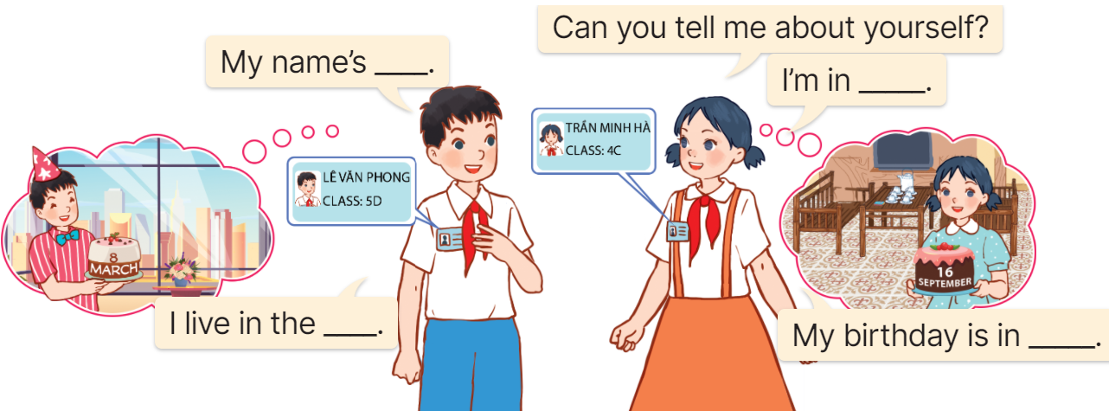  - Elicit the answer in the speech bubble and write it on the board. Get Ss to say the completed sentences.  - Have Ss role-play to practise asking the questions and giving their answers in pairs, using the picture cue.  - Invite a few pairs to point at the pictures and ask and answer questions.  Game: Pass the teddy bears  - Give two different coloured teddy bears to two Ss, a black teddy bear (ask the question) and a white teddy bear (answer the question).  - Ask Ss to listen to music and pass the teddy bears.  - Stop music suddenly. Have the student with a black teddy bear make a question. Have the student with a white teddy bear answer the question.  - Repeat the game several times. | - Sing and dance the song together.  - Ss listen and open their books  -Ss listen and answer  - - Ss listen and repeat  + Choral repetition  (3 times).  + Individual repetition  (3 ss)  - Ss take note  - Ss look, remember and write  -Look at the pictures and get to know the characters in the pictures.  +In picture a:  Ben: Hello, I’m Ben. Nice to meet you.  Lan: Hello, Ben. I’m Lan. Nice to meet you, too.  + In picture b:  Ben: Can you tell me about yourself, Lan?  Lan: Well, I’m in Class 5C. I live in the countryside.  Ben: I’m in Class 5B. I live in the city  -Ss listen and repeat in chorus (twice)  -Ss work in pairs to practice  -Ss come to the front of the classroom to practice.  -Ss listen  - Ss look at the picture and answer.  -Ss listen  -Ss listen and repeat  -Ss repeat to the structures  - Ss look, listen and repeat  +Picture a: a girl standing at the door of Class 5A.  + Picture b: a boy standing at the door of Class 5B.  + Picture c: high buildings in the city.  + Picture d: a girl standing in front of a house in the countryside.  -Ss point at pictures, listen and repeat  -Ss point at the bubbles, listen and repeat  -Ss practice in chorus  -Ss practice in chorus  -Ss work in pairs to practise asking and answering the question  - Pairs of Ss point at the pictures and say in front of the class  -Ss look at the picture and answer  + a picture of two pupils showing their personal information (classes they are in and places they live in).  - Ss say the completed sentences.  -Ss work in pairs to ask and answer  Can you tell me about yourself?  - My name’s ……. I’m in ………….I live in the …… My birthday is in ……  -Ss perform in front of the class.  - Ss listen  -Ss listen and play the game  Ex:  A: Can you tell me about yourself?  B: I’m in Class 5A. I live in the city.  -Ss continue to play the game.
D. ADJUSTMENTS (if necessary):
………………………………………………………………………………………….…..……………………………………………………………………………...………………………………………….…..………………………………………………

Week 2 Preparing date: September 15th , 2024
Period 6 Teaching date: September 16th , 2024

Unit 1: All about me!
Lesson 1 (4, 5, 6)
A. OBJECTIVES:
By the end of the lesson, Ss will be able to:
1. Knowledge:
- listen to and understand two communicative contexts in which pupils ask and answer questions about personal information and tick the correct pictures.
- complete four gapped exchanges with the help of picture cues.
- sing the song All about me! with the correct pronunciation, rhythm and melody.
- Vocabulary: Review
- Skills: speaking, listening, reading and writing.
2. Competences:
- Communication and collaboration: work in pairs and groups to complete the learning tasks.
- Self-control and independent learning: perform pronunciation and intonation, listening and reading tasks.
3. Attitude/ Qualities:
- Show their pride in their personal information and where they live.
B. TEACHING AIDS:
- Teacher: Teacher’s guide Pages 21, 22, 23; audio Tracks 7, 8; website hoclieu.vn, posters, laptop, pictures, textbook, lesson plan, TV or projector.
- Students: Student’s book Page 11, notebooks, workbooks, school things.
C. PROCEDURES:
Stages/ Time | Teacher’s activities | Students’ activities
1.Warm- up and review: (5’)  2.Practice: (25’)  3. Fun corner and wrap- up (5’) | Game: “Spin the wheel”  *Aims: to revise the learned sentence structures.  *Procedure:  - Ask Ss if they remember the previous sentence structures to ask and answer questions about personal information.  - Write the question and answers on the board.  - Prepare the numbers on the wheels to match with Ss’ numbers in the class.  - Spin the wheel to choose two numbers. Invite two Ss with those numbers, one pupil asks the question Can you tell me about yourself? and one pupil answers the question.  - Ask their friends to check their pronunciation.  - Continue spinning the wheel for pupils to practice sentence structures.  - Say “Open your book page 11” and look at “Unit 1, Lesson 1 (4,5,6)”.  Activity 1. Listen and tick:  *Aims: Ss will be able to listen to and understand two communicative contexts in which pupils ask and answer questions about personal information and tick the correct pictures.  *Procedure:  - Elicit the personal information of the character (name, grade, place of living) in each picture.  +What’s his/ her name?  +What class is he/ she in?  +Where does he/ she live?  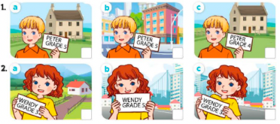  - T ask Ss to guess the answers.  + T writes Ss’guessing on the board.  - Listen to the tape:  + Play the recording  + Play the recording again for pupils to do the task.  + Play the recording a third time for pupils to check their answers.  - Get Ss to swap books with their partner, then check answers as a class.  + Write the answers on the board for Ss to correct their answers. Then checks Ss’ guessing.  - Ask Ss to look at the picture, say the information about Peter and Wendy.  ex: Peter is a pupil. He’s in Grade 5. He lives in the countryside.  Key: 1. a 2. c  Activity 2. Read and complete.  *Aims: Ss will be able to complete four gapped exchanges with the help of picture cues.  *Procedure:  - Get Ss to look at the pictures and identify the characters  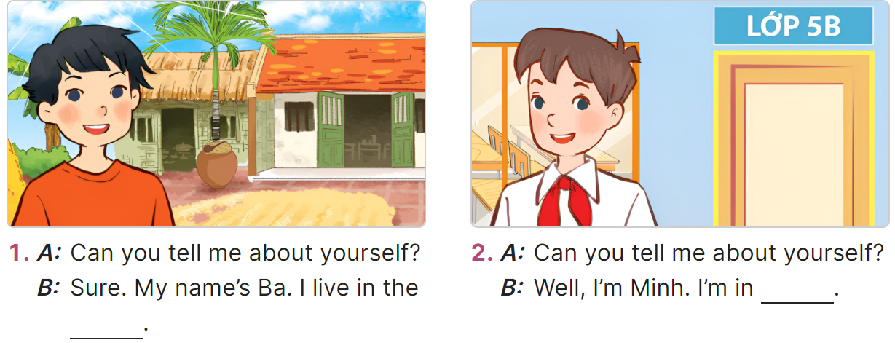  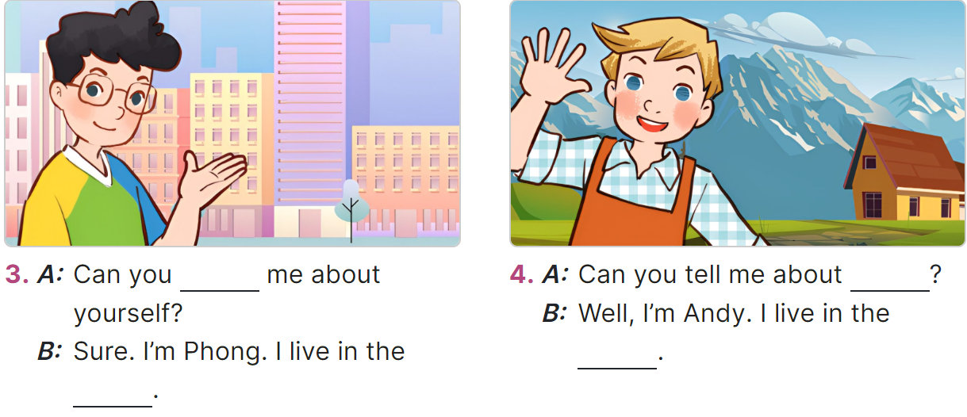  - Have Ss look at the four incomplete exchanges and elicits the missing words in the sentences.  - T models with sentence 1  + Ask Ss what is missing in the sentence (a place of living)  + Have Ss look at the picture and identify the needed information (countryside).  - Have Ss work in groups and complete the sentences 2, 3 and 4.  - Get Ss to swap books with a partner and check their answers before checking as a class.  -T gives feedbacks.  Key:  1. countryside / village  2. Class 5B 3. tell; city  4. yourself; mountains  Activity 3. Let’s sing.  *Aims: Ss will be able to sing the song All about me! with the correct pronunciation, rhythm and melody. *Procedure:  - Introduce the title and lyrics of the song: “All about you!” song.  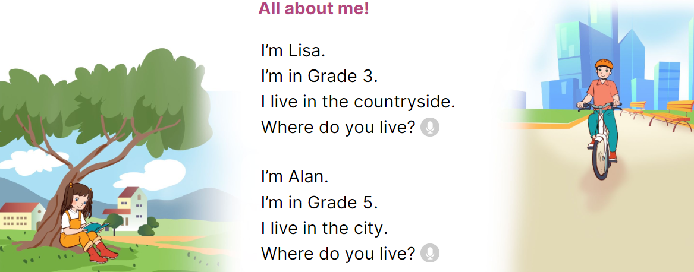  - Play the recording for Ss to listen to the whole song.  + Have them repeat the title and lyrics line by line.  - Play the recording all the way through for Ss to listen to pronunciation and melody of the song.  - Play the recording line by line for Ss to listen, repeat.  - Play the recording for Ss to sing and do actions.  - Ask Ss to practice singing and doing actions in pairs or groups.  - Invite groups to the front of the classroom to perform the song  -T gives feedback.  Game: Roll the dice  - Divide the class into groups of six. Have each student count the numbers from one to six.  - Ask a student from each group to roll the dice to choose a pupil asking the question.  - Ask that student to ask the question and invite another pupil of the group to answer the question about his / her personal information.  - The Ss giving the correct answer will continue rolling the dice.  - The Ss giving the incorrect answer will lose their turns. | - Give the sentence structures.  - Look at the question and answers on the board.  - Ask and answer the question Can you tell me about yourself?  - Check their friends’ pronunciation  - Continue playing the game.  - Ss open their books  -Look at the pictures and say:  + Picture 1a: His name is Peter, he’s in grade 5, he lives in the countryside.  + Picture 1b: His name is Peter, he’s in grade 5, he lives in the city.  + Picture 1c: His name is Peter, he’s in grade 4, he lives in the countryside.  + Picture 2a: Her name is Wendy, she’s in grade 3, she lives in the countryside.  + Picture 2b: Her name is Wendy, she’s in grade 5, she lives in the city.  + Picture 2c: Her name is Wendy, she’s in grade 3, she lives in the city.  -Ss guess the answers  - Ss listen to the tape  - Ss listen again and do the task.  - Ss listen and check their answers  - Ss swap books with their partner, then check answers as a class and guessing  -Ss listen and read aloud  -Ss look at the picture, say the information about Peter and Wendy.  -Ss look at the picture and identify personal information of the character in each picture.  -Ss look and follow the teacher demonstrating the exchange 1.  -Ss listen and pay attention  -Ss answer: (I live in the countryside.)  -Ss complete the sentences  -Ss swap books with a partner and check their answers before checking as a class.  -Ss listen  - Ss listen and pay attention  -Ss listen to the song  - Ss listen and repeat line by line without the action.  -Ss listen to melody of the song  - Ss listen and sing line by line.  - Ss sing and do actions.  + Ss work in groups (two groups) to sing.  -Ss perform in front of the class.  -Ss listen  - Ss listen  -Ss listen and play the game  Ex:  A: Can you tell me about yourself?  B: I’m in Class 5B. I live in the countryside.  - Ss continue playing the game
D. ADJUSTMENTS (if necessary):
………………………………………………………………………………………….…..……………………………………………………………………………...……

Week 2 Preparing date: September 15th , 2024
Period 7 Teaching date: September 17th , 2024

Unit 1: All about me!
Lesson 2 (1, 2, 3)
A. OBJECTIVES:
By the end of the lesson, Ss will be able to:
1. Knowledge:
- understand and correctly repeat the sentences in two communicative contexts focusing on asking and answering questions about someone’s favourite things.
- correctly say the words and use What’s your favourite ……..? - It’s ……... to ask and answer questions about someone’s favourite things.
- use What’s your favourite ……….? - It’s ………. in freer contexts.
- Vocabulary: dolphin, pink, sandwich
- Structures: A: What’s your favourite colour?
B: It’s pink.
- Skills: speaking and listening
2. Competences:
- Critical thinking and creativity: learn how to ask and answer questions about someone’s favourite things correctly and fluently.
- Communication and collaboration: work in pairs and groups to complete the learning tasks.
3. Attitude/ Qualities:
- Show their love and interest in sports, colours, animals and food.
B. TEACHING AIDS:
- Teacher: Teacher’s guide Pages 23, 24, 25, 26; audio Tracks 9, 10, website hoclieu.vn, posters, laptop, pictures, textbook, lesson plan, TV or projector.
- Students: Student’s book Page 12, notebooks, workbooks, school things.
C. PROCEDURES:
Stages/Time | Teacher’s activities | Students’ activities
1.Warm- up and review: (4’)  2. Presentation (16’)  3.Practice: (6’)  4.Production: (5’)  5. Fun corner and wrap- up (4’) | Game: Pass the ball  *Aims: to revise the words about sports, colours, animals and food.  *Procedure:  - T gives Ss a ball.  - T asks Ss to listen to music and transfer a ball around the class.  - When the music stops, Ss who keep a ball have to look at the picture and answer the question about colours, animals, food and sports.  - T gives feedback.  - Say “Open your book page 12” and look at “Unit 1, Lesson 2 (1,2,3)”.  Activity 1. Vocabulary.  *Aims: Ss will be able to know the vocabulary in the new lesson.  *Procedure:  -T elicits the new words  + dolphin : cá heo (picture)  + pink: màu hồng (realia)  + sandwich: bánh mì kẹp  (realia)  - T models (3 times).  - T writes the words on the board.  - Checking: Rub out and remember  Activity 2. Look, listen and repeat:  *Aims: Ss will be able to provide context and get pupils interested.  *Procedure:  - Have Ss look at Pictures a and b and identify the characters in the pictures.  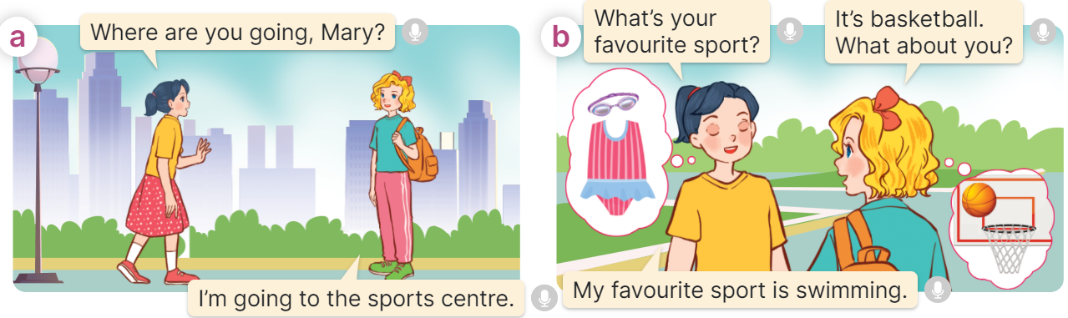  - Play the recording for them to listen.  - Play the recording again (sentence by sentence) for Ss to listen and repeat Correct their pronunciation where necessary.  - Invite a few pairs to the front of the classroom to listen to and repeat the sentences.  - T checks pronunciation for ss.  Activity 3. Listen, point and say.  *Aims: Ss will be able to correctly say the words and use What’s your favourite ……….? - It’s ………. to ask and answer questions about someone’s favourite things.  *Procedure:  * Structures:  - T asks Ss look at picture b and helps Ss know the structure from the dialogue.  - T introduces new structure for Ss.  - T explains, models and gives meaning.  - Have Ss repeat the structures.  A: What’s your favourite colour?  B: It’s pink.  *Drill pictures  - Have Ss look at the pictures and elicit the names of the things in the pictures.  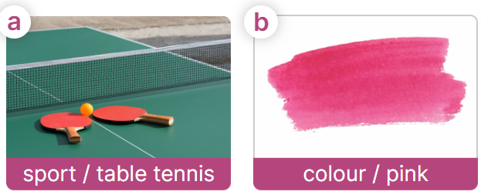  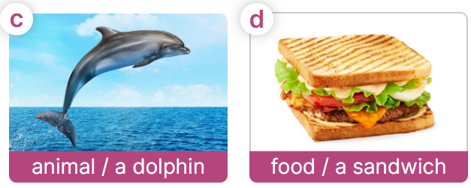  - Have Ss point at pictures, listen and run through all the pictures.  - Have Ss point at the bubbles, listen and run through model sentences.  - Have Ss to practise:  + T asks the first picture, Ss answer  + Ss asks the second picture, T answers  + Group A asks the third picture, group B  answers  + Group B asks the last picture, group A  - Ask Ss to work in pairs to practise asking and answering the question What’s you favourite sports? – It’s table tennis.  - T controls and corrects.  - Invite a few pairs to point at the pictures and say the questions and answers in front of the class.  - T gives feedbacks.  Activity 4. Let’s talk.  *Aims: Ss will be able to use Can you tell me about yourself? - I’m in ___. I live in ___. and What’s your favourite ___? - It’s ____. in freer contexts.  *Procedure:  - Ask questions to help Ss identify favourite things of the characters  + What does Linh playing?  +What colour does Lucy wearing and holding a teddy bear?  +What does Minh watching?  +What does Bill eating?  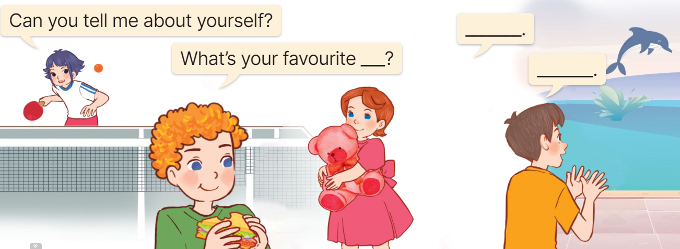  - Elicit the answer in the speech bubble and write it on the board. Get Ss to say the completed sentences.  - Have Ss role-play to practise asking the questions and giving their answers in pairs, using the picture cue.  - Invite a few pairs to point at the pictures and ask and answer questions.  - Have Ss ask and answer questions about their favourite things (toys / colour / food / animal / school subject / book …), using the structures and vocabulary learnt.  Game: Lucky windows  - Prepare pictures of the words (table tennis, pink, a dolphin, a sandwich).  - Show the windows on the board/ slide. Each window contains a picture and different points. And there are two lucky windows with two lucky stars.  - Divide the class into two groups.  - Explain how the game is played. Have a pair of Ss from each group choose a window, look at the picture, then ask and answer questions about someone’s favourite things.  Ex: A: What’s your favourite sport?  B: It’s table tennis.  - Give points to the group having the correct answer.  - Continue with the other Ss.  - The group that gets more points wins. Praise the winner. | - Ss listen and keep the ball  - Ss listen to music and play the game  Ex: T: What colour is it?  Ss: It’s red.  - Ss open their books  -Ss listen and answer  - - Ss listen and repeat  + Choral repetition (3 times).  + Individual repetition (3 ss)  - Ss take note  - Ss look, remember and write  -Look at the pictures and get to know the characters in the pictures.  + In picture a:  Mai: Where are you going, Mary?  Mary: I’m going to the sports centre.  – In picture b:  Mai: What’s your favourite sport?  Mary: It’s basketball. What about you?  Mai: My favourite sport is swimming.  -Ss listen  -Ss listen and repeat in chorus  - Pairs of Ss listen and repeat  -Ss listen  -Ss look at the picture and answer.  -Ss listen  -Ss listen and repeat  -Ss repeat to the structures.  - Ss look, listen and answer  a. a ping pong table and racquets  b. pink colour  c. a dolphin  d. a sandwich  -Ss point at pictures, listen and repeat  -Ss point at the bubbles, listen and repeat  -Ss practice in chorus  -Ss practice in chorus  -Ss work in pairs to practise asking and answering the question  - Pairs of Ss point at the pictures and say in front of the class  -Ss listen  -Ss look at the picture and answer  + Linh is playing table tennis  + Lucy is wearing a pink dress and holding a pink teddy bear  +Minh is watching a dolphin dancing in the lake  +Bill is eating a sandwich  - Ss say the completed sentences.  -Ss work in pairs to ask and answer  Can you tell me about yourself?  - My name’s ……. I’m in ………….  What’s your favourite……..? It’s …..  -Ss perform in front of the class.  - Ss ask and answer  - Work in two groups.  - Listen to the teacher’s explanation.  - Play the game  - Continue playing the game.
D. ADJUSTMENTS (if necessary):
………………………………………………………………………………………….…..……………………………………………………………………………...……

Week 2 Preparing date: September 15th , 2024
Period 8 Teaching date: September 17th , 2024

Unit 1: All about me!
Lesson 2 (4, 5, 6)
A. OBJECTIVES:
By the end of the lesson, Ss will be able to:
1. Knowledge:
- listen to and understand three communicative contexts in which speakers ask and answer questions about favourite things and match the characters with the right pictures.
- complete two target gapped exchanges with the help of picture cues.
- revise the target vocabulary items and structures through the game.
- Vocabulary: Review
- Skills: speaking, listening, reading and writing.
2. Competences:
- Communication and collaboration: work in pairs and groups to complete the learning tasks.
3. Attitude/ Qualities:
- Show their love and interest in sports, colours, animals and food.
B. TEACHING AIDS:
- Teacher: Teacher’s guide Pages 26, 27, 28; audio Tracks 11; website hoclieu.vn, posters, laptop, pictures, textbook, lesson plan, TV or projector.
- Students: Pupil’s book Page 13, notebooks, workbooks, school things.
C. PROCEDURES:
Stages/Time | Teacher’s activities | Students’ activities
1.Warm- up and review: (4’)  2. Practice: (27’)  3. Fun corner and wrap- up (4’) | Play a game: “Whisper”  *Aims: to revise the sentence structure What’s your favourite ___? - It’s ____. to ask and answer questions about someone’s favourite things.  *Procedure:  - Divide the class into two teams. Tell each team to form a line.  - Explain that when you whisper a sentence to the first pupil in each line, he/ she must in turn whisper it to the second pupil in the line. The second pupil then whispers it to the third, and so on. When the sentence reaches the last pupil in the line, he / she should call it out. A correct sentence scores one point.  - Have Ss play the game.  - Count the points for each team and announce the winner. The team with more points wins.  - Say “Open your book page 13” and look at “Unit 1, Lesson 2 (4,5,6)”.  Activity 1. Listen and match:  *Aims: Ss will be able to listen to and understand three communicative contexts in which speakers ask and answer questions about favourite things and match the characters with the right pictures  *Procedure:  - Elicit the names of the characters in the pictures and the favourite things  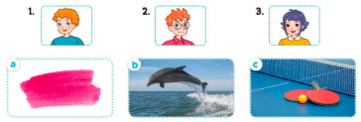  - T ask Ss to guess the answers.  + T writes Ss’guessing on the board.  - Listen to the tape:  + Play the recording  + Play the recording again and get Ss to swap books with their partners.  + Play the recording again to check answers together as a class.  + Write the answers on the board for Ss to correct their answers. Then checks Ss’ guessing.  - Play the recording, sentence by sentence, for the class to listen and repeat in chorus.  Key: 1.b 2. c 3.a  Activity 2. Read and complete  *Aims: Ss will be able to complete two target gapped exchanges with the help of picture cues.  *Procedure:  - Ask Ss to identify the characters and their favourite things (animal / food) in the pictures. 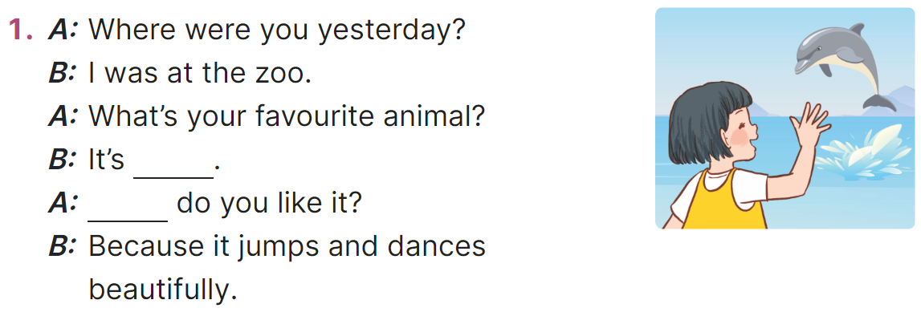  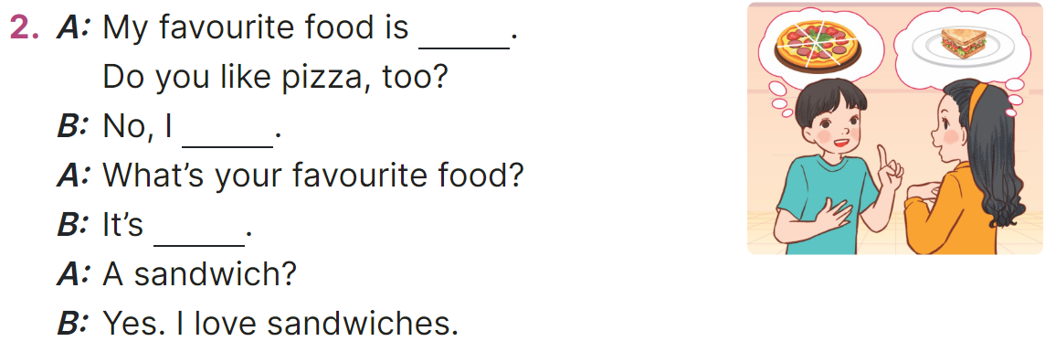  - Have Ss look at the incomplete exchanges and elicits the missing words in the sentences.  - T models with exchange 1  + Ask Ss what is missing in the sentence (favourite animal).  + Have Ss look at the picture and identify the needed information (It’s a dolphin.).).  - Have Ss work in pairs and complete the sentences 2, 3 and 4.  - Get Ss to swap books with a partner and check their answers before checking as a class.  Key:  1. a dolphin, Why  2. pizza, don’t, a sandwich  Activity 3. Let’s play.  *Aims: Ss will be able to revise the target vocabulary items and structures through the game Find someone who…  *Procedure:  - Tell Ss that they are going to play Find someone who … using the language learnt in Lesson 2.  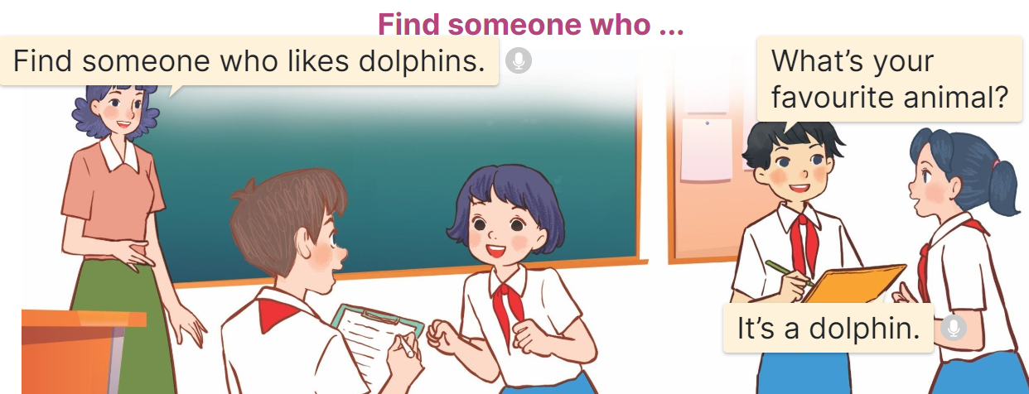  - Divide the class into four teams.  + Give each team a task: Ex: Find someone who likes dolphins/ table tennis / pink / sandwiches.  + The members of each team should walk around the classroom, ask their classmates questions ex. What’s your favourite animal / colour / sport / food? to get information about their favourite things.  + When they find someone they write the name in the blank provided.  - Set time for Ss to play the game.  - The team that finds the most Ss at the end of the game wins.  Game: Guessing game  - Stick different pictures of sports, colours, animals and food on the board.  - Have Ss say the words related to the pictures.  - Invite pairs of volunteers to the board. One student asks the question, another one answers the question and points to the suitable picture.  - Continue until practicing all the vocabulary set. | - Ss pay attention.  -Ss play the game  -Ss play the game  Ex. My favourite sport is badminton.  -My favourite colour is yellow.  -My favourite animal is a rabbit.  -My favourite food is a sandwich.  - Ss congratulate to the winner  - Ss open their books  - Look at the pictures and say:  1. a picture of Bill  2. a picture of Ben  3. a picture of Linh  a. an image of pink colour  b. a picture of a dolphin  c. a picture of a ping pong table and two racquets  -Ss guess the answers  - Ss listen to the tape and match  - Ss listen again, match and swap books with their partners.  - Ss check their answers and guessing  - Ss answer and check  -Ss listen and repeat.  -Ss look at the picture and say  -Ss follow the teacher demonstrating the exchange 1.  -Ss read and answer  -Ss work in pairs and fill in the gaps  - Ss swap books and check  - Ss listen  -Ss listen and pay attention  - Ss work in four teams. Ss find someone, and write the name in the blank provided  -Ss play the game  -Ss play the game  -Ss play the game  Ex:  A: What’s your favourite colour?  B: It’s green.
D. ADJUSTMENTS (if necessary):
………………………………………………………………………………………….…..……………………………………………………………………………...……
* Preparation for the project: Tell Ss about the project at page 15. Ask them to prepare for it at home by making posters about their favourite things. Remind Ss to bring the posters to class to present them at Project time.

