Week 32
Preparing date: April 20th ,2025
Teaching date: April 21st, 2025
Period 125
Unit 19: Outdoor activities
Lesson 1 (4, 5, 6)
A. OBJECTIVES:
By the end of the lesson, Ss will be able to:
1. Knowledge:
- listen to and understand two communicative contexts about what someone is doing.
- read and complete four target sentence patterns with the help of the picture cues.
- sing the song Painting and singing with the correct pronunciation, rhythm and melody.
- Vocabulary: Review
- Skills: speaking, listening, reading and writing.
2. Competences:
- Critical Thinking: talk about friends
- Co-operation: ready to help friends in pair work/ group work.
- Self-control and independent learning: perform listening tasks.
3. Attitude/ Qualities:
- Kindness: Help partners to complete learning tasks.
- Honesty: tell the truth about feelings and emotions.
- Diligence: complete learning tasks.
B. TEACHING AIDS:
- Teacher: Teacher’s guide Pages 233, 234; audio Tracks 86, 87; website sachmem.vn, posters, laptop, pictures, textbook, lesson plan, TV or projector.
- Students: Pupil’s book Page 59, notebooks, workbooks, school things.
C. PROCEDURES:
Stages/Time | Teacher’s activities | Students’ activities
1.Warm- up:  (5’)  2.Practice: (27’)  3. Homework. (3’) | Game: Sing the song in Unit 18, Lesson 1.  *Aims: to create a friendly and active atmosphere in the class to beginning the lesson.  *Procedure:  - Ask Ss to sing the song  - Invite some of them come to the board to role play, the rest of the Ss will sing.  - Say “Open your book page 59” and look at “Unit 19, Lesson 1 (4,5,6)”.  Activity 1. Listen and tick:  *Aims: Ss will be able to listen to and understand two communicative contexts about what someone is doing.  *Procedure:  - Elicit the names of character and the word for the action in each picture  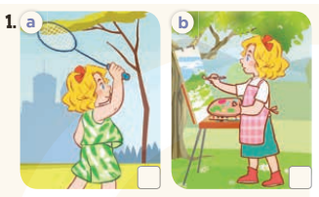  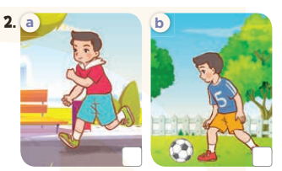  - T ask Ss to guess the answers.  + T writes Ss’guessing on the board.  - Listen to the tape:  + Play the recording  + Play the recording again and get Ss to swap books with their partners.  + Play the recording again to check answers together as a class.  + Write the answers on the board for Ss to correct their answers. Then checks Ss’ guessing.  - Play the recording, sentence by sentence, for the class to listen and repeat in chorus.  Key: 1. a 2. a  Activity 2. Look, complete and read  *Aims: Ss will be able to read and complete four target sentence patterns with the help of the picture cues.  *Procedure:  - Get Ss to look at the pictures and identify the characters (a boy or a girl) in the pictures.  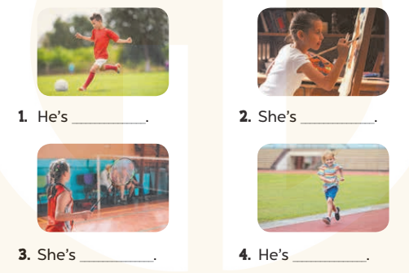  - Have Ss look at the four sentences and the pictures. Elicit and model with picture 1  + Ask Ss to read the sentence 1 in chorus.  + Ask them what is missing in the question (playing football). Then have them complete the gap (he’s playing football.).  -Have Ss work in pairs and complete the dialogue 2, 3, 4.  - Ask a few Ss to stand up and read the sentences aloud.  -T gives feedbacks.  Key:  1. playing football 2. painting  3. playing badminton 4. running  Activity 3. Let’s sing  *Aims: Ss will be able to sing the song Painting and singing with the correct pronunciation.  *Procedure:  - Introduce the title and lyrics of the song: “Painting and singing?”  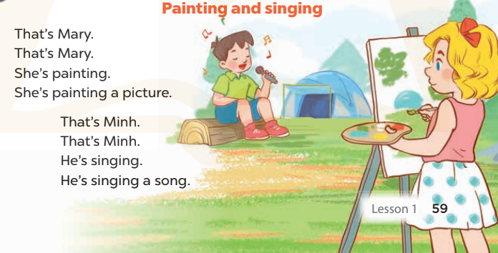  - Play the recording for Ss to listen to the whole song.  + Have them repeat the title and lyrics line by line.  + Tell Ss to point at the pictures while singing.  - Play the recording all the way through for Ss to listen to pronunciation and melody of the song.  - Play the recording line by line for Ss to listen, repeat and point to the pictures  - Play the recording for Ss to sing and do actions.  - Ask Ss to practice singing and doing actions in pairs or groups.  - Invite groups to the front of the classroom to perform the song  -T gives feedback.  *Consolidation  *Aims: Ss will be able consolidate and wrap up the content of the lesson.  *Procedure:  - T asks ss to answer the following questions:  + What have you learnt from the lesson today?  - T praises some Ss who are hardworking / active/ good…. as well as encourage others to try more.  - Prepare the new lesson: Unit 19, Lesson 2 (1,2,3). | - Ss listen  - Ss sing a song  - Ss open their books  -Look at the pictures and say:  + Picture 1a: Mary is badminton.  + Picture 1b: Mary is painting.  + Picture 2a: Nam is running.  + Picture 2b: Nam is playing football.  -Ss guess the answers  - Ss listen to the tape and tick  - Ss listen again, tick and swap books with their partners.  - Ss check their answers and guessing  -Ss listen and repeat.  -Ss look at the picture and say  -Ss look and answer  -Ss read  -Ss say and complete  -Ss work in pairs and complete  -Ss read aloud  - Ss listen  -Ss listen to the song  - Ss listen and repeat line by line without the action.  -Ss point to the pictures while singing  -Ss listen to melody of the song  - Ss listen and sing line by line.  - Ss sing and do actions.  + Ss work in groups (two groups) to sing.  -Ss perform in front of the class.  -Ss listen  -Ss answer the questions  -Ss listen and clap their hands  -Ss listen and take note
D. ADJUSTMENTS (if necessary):
………………………………………………………………………………………….…..……………………………………………………………………………...………………………………………….…..……………………………………………………………………………….……………………………………………………………………...
Week 32
Preparing date: April 21st, 2025
Teaching date: April 23rd, 2025
Period 126
Unit 19: Outdoor activities
Lesson 2 (1, 2, 3)
A. OBJECTIVES:
By the end of the lesson, Ss will be able to:
1. Knowledge:
- use What’s he / she doing? − He’s / She’s ….. to ask and answer questions about what someone is doing outdoors.
- enhance the correct use of What’s he / she doing? − He’s / She’ s …... to ask and answer questions about what someone is doing outdoors.
- Vocabulary: skating, cycling, flying a kite, skipping.
- Model sentences:
A: What’s he/ she doing?
B: He’s/ She’s skating
- Skills: speaking and listening
2. Competences:
- Co-operation: ready to help friends in pair work/ group work.
- Sociability: Talk to each other, say good words to others.
3. Attitude/ Qualities:
- Kindness: Help partners to complete learning tasks.
- Honesty: tell the truth about feelings and emotions
B. TEACHING AIDS:
- Teacher: Teacher’s guide Pages 235, 236; audio Tracks 88, 89, website sachmem.vn, posters, laptop, pictures, textbook, lesson plan, TV or projector.
- Students: Pupil’s book Page 60, notebooks, workbooks, school things.
C. PROCEDURES:
Stages/Time | Teacher’s activities | Students’ activities
1.Warm- up:  (3’)  2. Presentation  (16’)  3.Practice: (7’)  4.Production: (7’)  5. Homework. (2’) | Game: Pass the ball  *Aims: to create a friendly and active atmosphere in the class to beginning the lesson.  *Procedure:  - Stand up and pass the ball with music.  - When music stops, those who keep the ball must look at a picture on the board and say a sentence. He’s/ She’s……………  - Say “Open your book page 60” and look at “Unit 19, Lesson 2 (1,2,3)”.  Activity 1. Vocabulary.  *Aims: Ss will be able to know the vocabulary in front of starting the new lesson.  *Procedure:  -T elicits the new words  + skating : trượt pa tin (picture)  + cycling: đạp xe đạp (picture)  + flying a kite : thả diều (picture)  + skipping : nhảy dây (mime)  - T models (3 times).  - T writes the words on the board.  - Checking: Rub out and remember  Activity 2. Look, listen and repeat:  *Aims: Ss will be able to understand and correctly repeat the sentences in two communicative contexts (pictures) focusing on what someone is doing outdoors  *Procedure:  - Have Ss look at Pictures a and b and elicit the names of the speakers in the pictures.  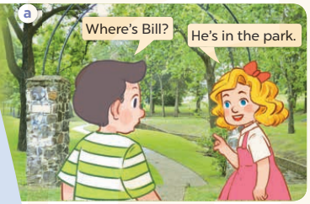  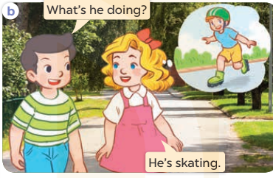  - Play the audio twice (sentence by sentence). Correct their pronunciation where necessary.  - Have Ss to practice the dialogue  - T invites a few pairs to the front of the class to practice.  - T checks pronunciation for ss.  Activity 3. Listen, point and say.  *Aims: Ss will be able to correctly use What’s he / she doing? − He’s / She’ s …... to ask and answer questions about what someone is doing outdoors.  *Procedure:  * Model sentences:  - T asks Ss look at picture a, b and helps Ss know the structure from the dialogue.  - T introduces new structure for Ss.  - T explains, models and gives meaning.  - Have Ss repeat the model sentences.  A: What’s he/ she doing?  B: He’s/ She’s skating  *Drill pictures  - Have Ss look at the pictures and identify the characters (a boy or a girl) and their actions  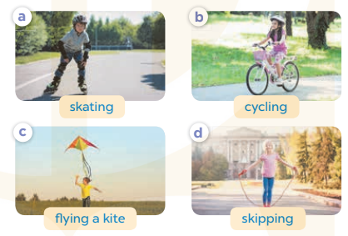  - Run through all the pictures.  - Run through model sentences.  +Run through the question sentences  +Run through the answer sentences  - Have Ss to practise:  + T asks, Ss answer picture a  + Ss ask, T answers picture b  + Group A ask, group B answer picture c  + Group B ask, group A answer picture d  - Ask Ss to work in pairs.  - T controls and corrects.  - Invite a few pairs to come to the front of the classroom, point at the pictures and say in front of the class.  - T gives feedbacks.  Activity 4. Let’s talk.  *Aims: Ss will be able to enhance the correct use of What’s he / she doing? − …... to ask and answer questions about what someone is doing outdoors.  *Procedure:  - Have Ss look at the picture and elicit the question and answer: What’s he/ she doing? He’s/ She’s…..  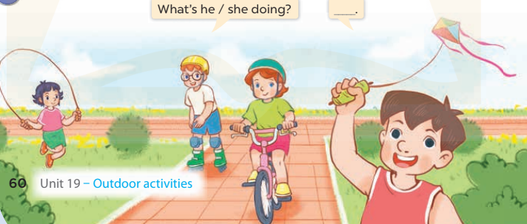  - Ask Ss work in pairs to ask and answer questions about what someone is doing outdoors.  - Invite some pairs to role play in front of the class to point at the activity in the picture cue in their books.  *Consolidation  *Aims: Ss will be able consolidate and wrap up the content of the lesson.  *Procedure:  - T asks ss to answer the following questions:  + What have you learnt from the lesson today?  - T review the vocabulary and model sentences.  - T praises some Ss who are hardworking / active/ good…. as well as encourage others to try more.  - Learn the vocabulary and model sentences by heart  - Prepare the new lesson: Unit 19, Lesson 2 (4,5,6). | - Ss listen  - Ss play the game  - Ss open their books  -Ss listen and answer  - - Ss listen and repeat  + Choral repetition (3 times).  + Individual repetition (3 ss)  - Ss take note  - Ss look, remember and write  -Look at the pictures and get to know the characters in the pictures.  + In picture a: Nam asks: Where’s Bill? Mary answers: He’s in the park.  – In picture b: Nam asks: What’s he doing? And Mary says: He’s skating  -Ss listen and repeat in chorus (twice)  -Ss work in pairs to practice  -Ss practice the dialogue  -Ss listen  -Ss look at the picture and answer.  -Ss listen  -Ss listen and repeat  -Ss repeat  -Ss listen and answer  +Picture a: a boy is skating. +Picture b: a girl is cycling.  +Picture c: a boy is flying a kite.  +Picture d: a girl is skipping.  - Ss look, listen and repeat  - Ss practice in chorus  -Ss work in pairs to practice  -Ss listen  -Ss go to the board and point and say  -Ss listen  -Ss look at the picture and answer  -Ss work in pairs  -Ss practise in pair in front of the class.  -Ss answer the question  - Ss listen  -Ss listen and clap their hands  -Ss listen and take note
D. ADJUSTMENTS (if necessary):
………………………………………………………………………………………….…..……………………………………………………………………………...……………

Week 32
Preparing date: April 21st, 2025
Teaching date: April 23rd, 2025
Period 127
Unit 19: Outdoor activities
Lesson 2 (4, 5, 6)
A. OBJECTIVES:
By the end of the lesson, Ss will be able to:
1. Knowledge:
- listen to and understand four communicative contexts in which pupils ask and answer questions about what someone is doing outdoors.
- read and complete four target sentence patterns in four sentences and dialogues with the help of picture cues.
- listen to and repeat target words about outdoor activities.
- Vocabulary: Review
- Skills: speaking, listening, reading and writing.
2. Competences:
- Critical Thinking: talk about outdoor activities
- Co-operation: ready to help friends in pair work/ group work.
- Self-control and independent learning: perform listening tasks.
3. Attitude/ Qualities:
- Kindness: Help partners to complete learning tasks.
- Honesty: tell the truth about feelings and emotions.
- Diligence: complete learning tasks.
B. TEACHING AIDS:
- Teacher: Teacher’s guide Pages 237, 238; audio Tracks 90; website sachmem.vn, posters, laptop, pictures, textbook, lesson plan, TV or projector.
- Students: Pupil’s book Page 61, notebooks, workbooks, school things.
C. PROCEDURES:
Stages/Time | Teacher’s activities | Students’ activities
1.Warm- up:  (5’)  2.Practice: (27’)  3. Homework. (3’) | Sing a song: “Matching pairs”  *Aims: to create a friendly and active atmosphere in the class to beginning the lesson.  *Procedure:  - Divide the class into two teams Tiger and Lion. Ask Ss to choose the matching pairs (words with pictures)  - Ss come to the front and choose the pictures in order to match with the words. Who can make it will have points for the team.  - Give points for the Ss.  - Encourage the Ss join the activity.  - Say “Open your book page 61” and look at “Unit 19, Lesson 2 (4,5,6)”.  Activity 1. Listen and number:  *Aims: Ss will be able to listen to and understand four communicative contexts in which pupils ask and answer questions about what someone is doing outdoors *Procedure:  - Elicit the characters and their outdoor activities 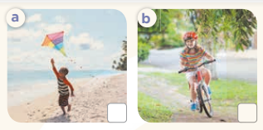  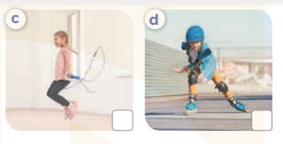  - T ask Ss to guess the answers.  + T writes Ss’guessing on the board.  - Listen to the tape:  + Play the recording  + Play the recording again and get Ss to swap books with their partners.  + Play the recording again to check answers together as a class.  + Write the answers on the board for Ss to correct their answers. Then checks Ss’ guessing.  - Play the recording, sentence by sentence, for the class to listen and repeat in chorus.  Key: 1.d 2. a 3.b 4.c  Activity 2. Look, complete and read.  *Aims: Ss will be able to read and complete four target sentence patterns in four sentences and dialogues with the help of picture cues  *Procedure:  - Have Ss look at the pictures and identify the actions in the picture.  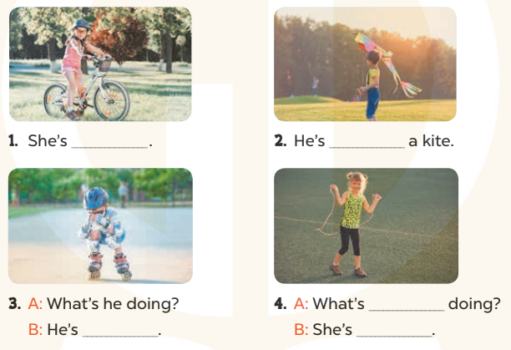  - T models with sentence 1.  + Have Ss look at the sentence.  + Ask them what is missing in the answer (cycling).  + Have Ss complete the gap.  + Have Ss read the completed sentence in chorus.  -Have Ss work in pairs and complete the sentences 2, 3 and 4.  - Invite pairs of pupils to stand up and read aloud the sentences.  - T gives feedbacks.  Key: 1. cycling 2. Flying  3. skating 4. she; skipping  Activity 3. Let’s play.  *Aims: Ss will be able to listen to and repeat target words about outdoor activities.  *Procedure:  - Tell Ss that they are going to play Whispering game. Write Whispering game on the board.  - Divide the class into two teams and have both teams line up in front of the board.  - Whisper a word or sentence about outdoor activities (ex: skating) to the first member of each team.  + Then each member whispers the words to the next member in the team until the words reach the last member of each team.  +The last member must say the word aloud.  + The team which correctly repeats the words first receives a point.  - Have the first Ss go to the end of their teams’ lines and replay the game until every pupil has had a chance to go first  - At the end of the game, the team with the most points wins.  *Consolidation  *Aims: Ss will be able consolidate and wrap up the content of the lesson.  *Procedure:  - T asks ss to answer the following questions:  + What have you learnt from the lesson today?  +What are the core values of the lesson? (if the teacher can take from the lesson).  - T praises some Ss who are hardworking / active/ good…. as well as encourage others to try more.  - Prepare the new lesson: Unit 19, Lesson 3 (1,2,3). | - Ss listen and play the game  - Ss open their books  -Look at the pictures and say:  + Picture a: a boy is flying a kite.  + Picture b: a girl is cycling.  + Picture c: a girl is skipping.  + Picture d: a boy is skating.  -Ss guess the answers  - Ss listen to the tape and write number  - Ss listen again, write number and swap books with their partners.  - Ss check their answers and guessing  -Ss listen and repeat.  -Ss look at the pictures and say  -Ss listen and answer  -Ss read and complete  -Ss work in pairs and do the task  -Ss read aloud  - Ss listen  -Ss play the game  -Ss play the game  -Ss listen and answer  -Ss listen and take note

D. ADJUSTMENTS (if necessary):
………………………………………………………………………………………….…..……………………………………………………………………………...………………………………………….…..……………………………………………………………………………….……………………………………………………………………...

Week 32
Preparing date: April 21st, 2025
Teaching date: April 23rd , 2025
Period 128
Unit 19: Outdoor activities
Lesson 3 (1, 2, 3)
A. OBJECTIVES:
By the end of the lesson, Ss will be able to:
1. Knowledge:
- correctly repeat the sounds of the letters pl and fl in isolation, the words play and fly and the sentences She’s playing volleyball. and He’s flying a kite. with the correct pronunciation and intonation.
- identify the target words play and fly while listening.
- say the chant with the correct rhythm and pronunciation.
- Vocabulary: Review
- Skills: speaking, listening, reading and writing.
2. Competences:
- Co-operation: ready to help friends in pair work/ group work.
- Self-control and independent learning: perform listening tasks.
3. Attitude/ Qualities:
- Kindness: Help partners to complete learning tasks.
- Honesty: tell the truth about feelings and emotions
B. TEACHING AIDS:
- Teacher: Teacher’s guide Pages 238, 239; audio Tracks 91, 92, 93; website sachmem.vn, posters, laptop, pictures, textbook, lesson plan, TV or projector.
- Students: Pupil’s book Page 62, notebooks, workbooks, school things.
C. PROCEDURES:
Stages/Time | Teacher’s activities | Students’ activities
1.Warm- up:  (5’)  2. Presentation  (9’)  3.Practice: (19’)  4. Homework. (2’) | Game: Find and circle the words  *Aims: to create a friendly and active atmosphere in the class to beginning the lesson.  *Procedure:  - Divide class into 2 groups  - Ask Ss to find and circle the words that they learnt.  - Which groups find the best correct words is winner.  - Give Ss time to play the game.  Rows: place, flag  Columns: play, fly, please  -T checks who’s winner?  - Say “Open your book page 62” and look at “Unit 19, Lesson 3 (1,2,3)”.  Activity 1. Listen and repeat:  *Aims: Ss will be able to correctly pronounce the sounds of the letters pl and fl in isolation, the words play and fly and the sentences She’s playing volleyball. and He’s flying a kite. with correct pronunciation and intonation.  *Procedure:  - T gives instruction to the letters pl and fl in isolation, the words play and fly and the sentences She’s playing volleyball. and He’s flying a kite.  - Play the recording for the letter pl and fl  - Encourage Ss to point at the letter/ word/ sentence while listening.  - Play the recording again and encourage Ss to listen and repeat.  - Do this several times until Ss feel confident.  - T calls some Ss to practice.  - T gives feedbacks.  Activity 2. Listen and circle.  *Aims: Ss will be able to identify the target words play and fly while listening.  *Procedure:  - Elicit the sentences and explain that they have to listen.  - T ask Ss to guess the answers.  + T writes Ss’guessing on the board.  - Listen to the tape:  + Play the recording  + Play the recording again and get Ss to swap books with their partners.  + Play the recording again to check answers together as a class.  + Write the answers on the board for Ss to correct their answers. Then checks Ss’ guessing.  - Play the recording, sentence by sentence, for the class to listen and repeat in chorus.  - Invite one or two Ss to stand up and read the completed sentences.  Key: 1.b 2.b  Activity 3. Let’s chant  *Aims: Ss will be able to say the chant with the correct rhythm and pronunciation.  *Procedure:  - Introduce the title and lyrics of the chant.  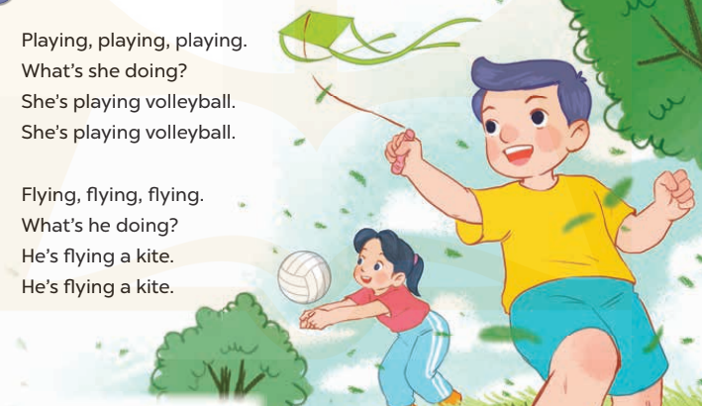  - Play the recording for Ss to listen to the whole chant.  + Have them repeat the title and lyrics line by line.  + Ask Ss to attend to the sounds of the letters pl and fl and the words play and fly.  - Play the recording all the way through for Ss to listen to pronunciation and melody.  - Play the recording line by line for Ss to listen and repeat  - Play the recording for Ss to chant and clap along.  - Ask Ss to practice chant and clap along in pairs or groups.  - Invite groups to the front of the classroom to perform the chant  -T gives feedback.  *Consolidation  *Aims: Ss will be able consolidate and wrap up the content of the lesson.  *Procedure:  - T asks ss to answer the following questions:  + What have you learnt from the lesson today?  +What are the core values of the lesson? (if the teacher can take from the lesson).  - T praises some Ss who are hardworking / active/ good…. as well as encourage others to try more.  - Practice the chant more.  - Prepare the new lesson: Unit 19, Lesson 3 (4,5,6). | - Ss listen  -Ss play game  - Ss open their books  - Ss recognize the differences about color of letter  - - Ss listen  - Ss listen and point  - Ss listen again and repeat  -Ss listen again and repeat  -Ss practice  -Ss listen  -Ss listen and say:  + Number 1: Mai is…….  + Number 2: Minh is……  -Ss guess the answers  - Ss listen to the tape and circle  - Ss listen again, circle and swap books with their partners.  - Ss check their answers and guessing  -Ss listen and repeat.  -Ss read the sentences  - Ss look and listen.  -Ss listen to the chant  - Ss listen and repeat line by line without clap their hands  -Ss note the sounds, words  -Ss listen to melody of the chant  - Ss listen and chant line by line.  - Ss chant and clap along.  - Ss work in groups (two groups) to chant  -Ss perform in front of the class.  -Ss listen  -Ss listen.  -Ss answer the questions  -Ss listen and clap their hands  -Ss listen and take note
  D | B | K | K | E | P | S | C | P | T
  P | E | S | E | E | D | D | X | L | H
  L | E | S | Y | Y | E | C | Z | E | I
  A | A | N | M | F | C | F | Y | A | N
  Y | A | G | N | N | R | L | S | S | K
  G | J | G | S | M | E | Y | W | E | B
  S | P | L | A | C | E | V | T | G | H
  M | M | R | K | K | C | S | E | A | Y
  D | F | L | A | G | C | I | N | S | M
  A | C | E | B | F | A | Z | Y | W

D. ADJUSTMENTS (if necessary):
……………………………………………………………………………………….
…………………………………………………………………………………………

