Week 18
Preparing date: January 5th, 2025
Teaching date: January 6th, 2025
Period 69
Review 2
Parts 3, 4, 5
A. OBJECTIVES:
By the end of the lesson, Ss will be able to:
1. Knowledge:
- correctly use the following sentence patterns:
correctly use the following sentence patterns:
+ Is this our ………..? – Yes, it is. / No, it isn’t.
+ Let’s go to the………….. – OK, let’s go.
+…………. , please.
+ May I…………..? − Yes, you can. / No, you can’t.
+ I have………..
+ Do you have………….? − Yes, I do. / No, I don’t.
+ What colour is it? − It’s……………..
+ What colour are they? − They’re ……………..
+ I………….. at break time.
+ What do you do at break t time? − I ………….
- Vocabulary: Review
- Skills: speaking, listening, reading and writing.
2. Competences:
- Critical Thinking: self-introduce
- Co-operation: ready to help friends in pair work/ group work.
- Self-control and independent learning: perform listening tasks.
3. Attitude/ Qualities:
- Kindness: Help partners to complete learning tasks.
- Honesty: tell the truth about feelings and emotions.
- Diligence: complete learning tasks.
B. TEACHING AIDS:
- Teacher: Teacher’s guide Pages 136, 137; website sachmem.vn, posters, laptop, pictures, textbook, lesson plan, TV or projector.
- Students: Pupil’s book Page 75, notebooks, workbooks, school things.
C. PROCEDURES:
Stages/Time | Teacher’s activities | Students’ activities
1.Warm- up:  (5’)  2.Practice: (27’)  3. Homework. (3’) | Game: Whispering  *Aims: to review the vocabulary and structure about greet and respond to greetings.  *Procedure:  - Divide class into 2 groups.  -Ask 5 Ss in each group stand in a straight line.  - T says a word or phrase to the first pupil in this line.  - Then, the first pupil whispers what she/ he hear to the second person in line; the second one whispers what he/ she hears to the third one and so on until the last pupil in group hears the word or phrase.  - The last pupil says the word or phrase out loud.  - The faster group has correct word or phrase is the winner.  - Say “Open your book page 75” and look at Review 2.  Activity 1. Read and match  *Aims: Ss will be able to read and match pairs of target sentence patterns  *Procedure:  - Tell Ss about this activity. Point at sentence 1, elicit the answer and models.  - Give Ss work in pairs to do the sentence 2,3,4,5.  - Tell Ss to swap their books with their partners, then check answers together as a class.  - Write the correct answers on the board for Ss to correct their answers.  - Invite some pairs to stand up and read the matched exchanges aloud.  Key:  1. e 2. d 3. b 4. c 5. a  Activity 2. Look, complete and read.  *Aims: Ss will be able to understand and complete two incomplete sentence patterns and two exchanges.  *Procedure:  - Elicit the missing words and the conversation.  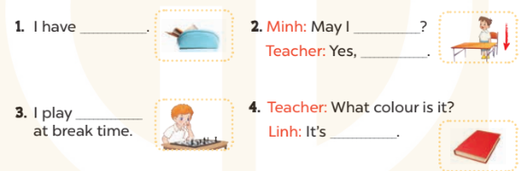  - Tell Ss about this activity. Point at number 1, elicit the answer and models.  - Give Ss work in pairs to do the task  - Tell Ss to swap their books with their partners, then check answers together as a class.  - Write the correct answers on the board for Ss to correct their answers.  - Invite some pairs to stand up and read the matched exchanges aloud.  Key:  1. a pencil case  2. stand up, you can  3. chess  4. red  Activity 3. Ask and answer  *Aims: Ss will be able to read and understand five question patterns, then take it in turns to ask and answer the questions.  *Procedure:  - Ask Ss to read the question and elicit the answer  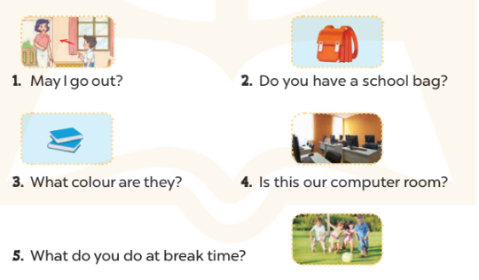  - Get Ss to role-play the exchange with sentence 1  - Give Ss time to take it in turns to role-play the five question.  - Invite some pairs to stand up and role-play.  Key:  1. Yes, you can. / No, you can’t.  2. Yes, I do.  3. They’re blue.  4. Yes, it is.  5. I play football.  * Game: Pass the ball  - Divide class into 3 teams.  - Each team has 1 sticky ball.  - Play the music, students in each team take turn to pass the ball. After the music ends, 3 students have the ball – stand up and say the name, using the sentence model.  *Consolidation  *Aims: Ss will be able consolidate and wrap up the content of the lesson.  *Procedure:  - T asks ss to answer the following questions:  + What have you learnt from the lesson today?  +What are the core values of the lesson?  - T praises some Ss who are hardworking / active/ good…. as well as encourage others to try more.  - Prepare Fun time 2. | - Ss listen  -Ss play game  - Ss open their books  -Ss look at the sentence 1 and say  -Ss work in pairs and match  -Ss swap their books and match  -Ss check  -Ss read aloud  -Ss listen and answer  -Ss look at the dialogue and say number 1  -Ss work in pairs and complete  -Ss swap their books and match  -Ss check  -Ss read aloud  -Ss listen and answer  -Ss role play sentence 1  -Ss work in pairs  -Ss role play  -Ss listen and play game  -Ss listen and answer  -Ss listen and clap their hands  -Ss listen and take note
D. ADJUSTMENTS (if necessary):
………………………………………………………………………………………….…..……………………………………………………………………………...…………
Week 18
Preparing date: January 5th, 2025
Teaching date: January 6th, 2025
Period 70
Fun time 2
A. OBJECTIVES:
By the end of the lesson, Ss will be able to:
1. Knowledge:
- take part in three fun activities relating to their language knowledge and competences.
- Vocabulary: Review
- Skills: speaking, writing and listening
2. Competences:
- Critical Thinking: self-introduce
- Co-operation: ready to help friends in pair work/ group work.
- Sociability: Talk to each other, say good words to others.
3. Attitude/ Qualities:
- Kindness: Help partners to complete learning tasks.
- Honesty: tell the truth about feelings and emotions
B. TEACHING AIDS:
- Teacher: Teacher’s guide Pages 137, 138, 139; website sachmem.vn, posters, laptop, pictures, textbook, lesson plan, TV or projector.
- Students: Pupil’s book Page 76, 77, notebooks, workbooks, school things.
C. PROCEDURES:
Stages/Time | Teacher’s activities | Students’ activities
1.Warm- up:  (3’)  2. Practice  (30’)  3. Homework. (2’) | Sing: Head, shoulders, knees and toes  *Aims: to create a friendly and active atmosphere in the class to beginning the lesson.  *Procedure:  - Show the song on the screen.  https://www.youtube.com/watch?v=WX8HmogNyCY  - Ask Ss to listen, sing and dance the song.  - Say “Open your book page 76, 77” and look at “Fun time”.  Activity 1. Find and circle  *Aims: Ss will be able to revise learnt vocabulary by doing the word search.  *Procedure:  - Have Ss look at the pictures and ask +What’s this?  + What can you see in the pictures?  + What colour is it?  - Write the words or stick the flash cards of the words, one by one, on the board.  - Point at each word on the board and have Ss say the word as a class.  - Point at the picture of the school, and circle it in the word search as an example.  - Tell Ss to find the rest of the words in the word search.  - Have Ss check and correct their answers in pairs  - Have Ss work in pairs, one points at the pictures and the other points at the circled words in the word search and say them aloud.  Key:  Activity 2. Quiz time  *Aims: Ss will be able to revise vocabulary and sentence patterns related to asking and answering questions that help to identify school things and their colours.  *Procedure:  - Elicit the words and stick the flash cards on the board one by one as Ss say the corresponding words.  - Point at each flash card and have Ss say the word as a class.  - Point at a flash card and elicit the answers to the questions  + Do you have …….?  +What colour is it?  + What colour are they?  - Hold up a textbook, point at a picture of a school thing and ask these questions again.  - Show the class how to complete the task: Point at a picture of a school thing and ask the questions in pairs.  - Have Ss work in pair to as and answer about their school things  - Invite a few pairs to the front of the class to interact with each other.  Activity 3. Look and write  *Aims: Ss will be able to understand how mixing two colours makes a third colour  *Procedure:  - T elicits the names of the three colours: red, blue, yellow.  - Use crayons or paints to show pupils what happens when you mix red and blue.  - Explain that this third colour is called purple. Write purple on the  board and model it for pupils to repeat.  - Repeat for red and yellow (orange), yellow and blue (green).  - Have Ss complete the colour sums.  - Check answers together as a class.  Key: 1. purple 2. orange 3. green  *Consolidation  *Aims: Ss will be able consolidate and wrap up the content of the lesson.  *Procedure:  - T asks ss to answer the following questions:  + What have you learnt from the lesson today?  +What are the core values of the lesson? (if the teacher can take from the lesson).  - T praises some Ss who are hardworking / active/ good…. as well as encourage others to try more.  repare the first test. | - Ss listen  - Ss sing a song  -Ss look at the picture and answer  - - Ss note  - Ss say the word  - Ss point and circle  -Ss find the words  -Ss check their answer  -Ss say aloud  -Ss listen  -Ss listen and say the word  -Ss point and say  -Ss point, ask and answer  -Ss listen  -Ss work in pairs  -Ss present  - Ss look, listen and answer  - Ss look and answer  -Ss listen and write  -Ss do the task  -Ss write their answer.  -Ss check  -Ss listen and take note

D. ADJUSTMENTS (if necessary):
………………………………………………………………………………………….…..……………………………………………………………………………...………………………………………….…..……………………………………………………………………………….……………………………………………………………………..
Week 18
Preparing date: January 5th, 2025
Teaching date: January 8th, 2025
Period 71, 72

The first term test

A. OBJECTIVES:
By the end of the lesson, Ss will be able to:
1. Knowledge:
- Check Ss’ comprehension about this theme and get marks.
- Vocabulary: Review
- Model sentences: Review
- Skills: speaking, writing and listening
2. Competences:
- Co-operation: ready to help friends in pair work/ group work.
- Sociability: Talk to each other, say good words to others.
3. Attitude/ Qualities:
- Kindness: Help partners to complete learning tasks.
- Honesty: tell the truth about feelings and emotions
B. TEACHING AIDS:
- Teacher: - Teacher: Textbook, lesson plan, TV or projector, word sheets.
- Students: School things.
C. PROCEDURES:
HOA QUANG NAM PRIMARY SCHOOL THE FIRST SEMESTER TEST
Name:…………………………………….. Grade :3 Time:35 minutes
Class:…………… School year: 2024-2025

Listening | Reading and writing | Speaking | Mark
PART1: LISTENING
1. Listen and circle(1p)(Nghe và khoanh tròn)
1. a. We play badminton at school.
b. I have a blue notebook.
2. a. This is my new pen.
b. There are five pencils.
3. a. They are my books.
b. Let’s go home!
4. a. Stand up, please!
b. Can you speak louder, Mai?
2. Listen and tick(1p)(Nghe và đánh v)
1 | 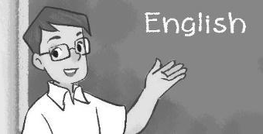  a.❑ | 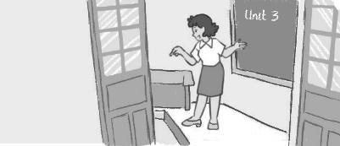  b.❑ | 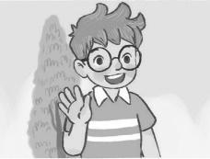  c.❑
2 |   a.❑ |   b.❑ | 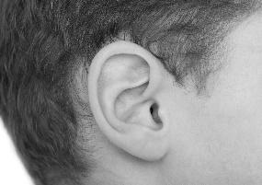  c.❑
3 | 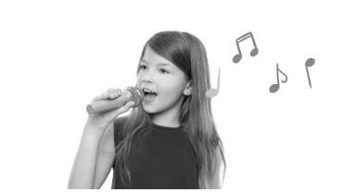  a.❑ |   b.❑ |   c.❑
4 | 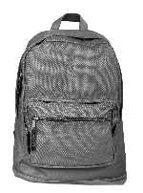a.❑ |   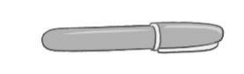  b.❑ | 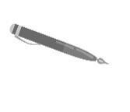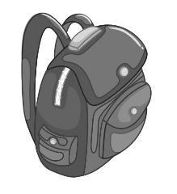  c.❑

PART 2: READING AND WRITING
3. Read and tick (1p)(đọc và đánh v cho phù hợp)
1. A: Hi. I’m Nam.
B: Hi, Nam. I’m Mary.
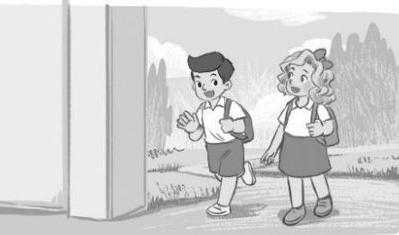  a.❑ | 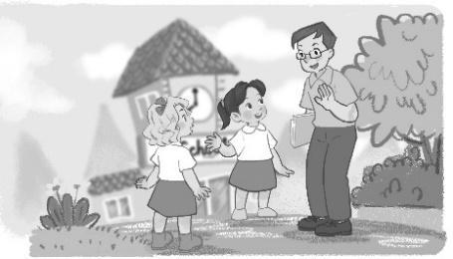  b.❑ | 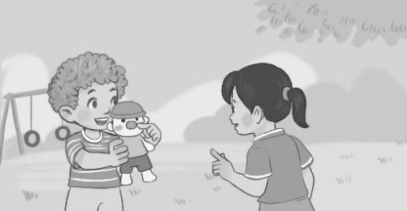 c.❑

2. A: May I come in?
B: Yes, you can.
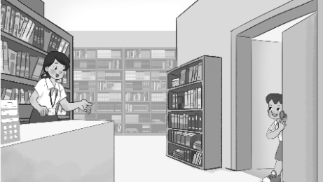  a.❑ | 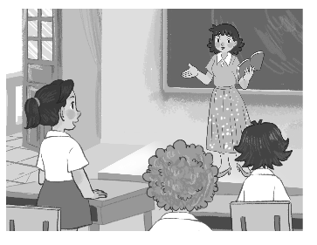 b.❑ |  c.❑

3. A: What colour are they?
B: They are black and white.

  a.❑ |   b.❑ |   c.❑

4. A: What do you do at break time?
B: I play table tennis.
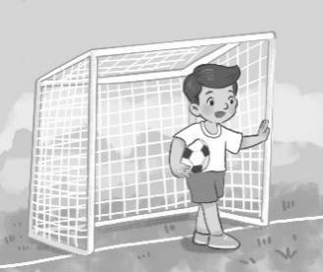  a.❑ | 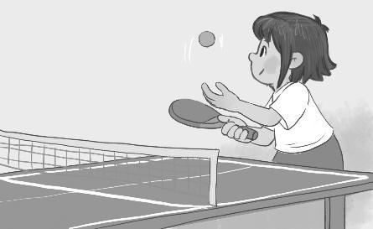  b.❑ | 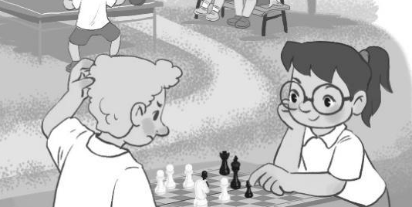  c.❑

4. Look and write (1p)(Nhìn và viết)

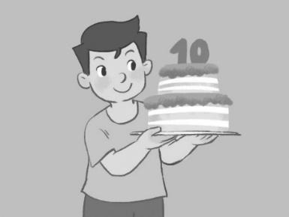 | 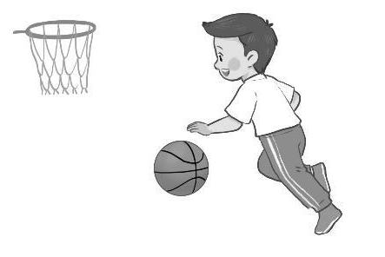 | 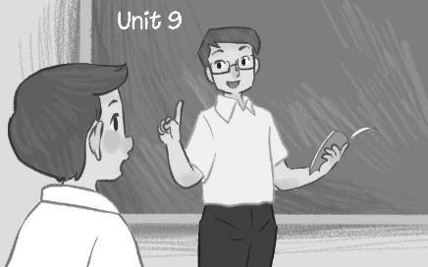

Hi! I (1) ________ Nam. I’m (2) ________ years old. I like playing (3) ________. At school, my favourite subject is (4) ________.

5. Read and match((1p)(Đọc và nối)

A | B
1.What colour is it? | a.No.I don’t | 1
2.Do you have a red pen? | b.Yes,you can | 2
3.May I speak English? | c.Yes.it is | 3
4.Is this our library? | d. It’s blue | 4

6/Circle the odd one out.(1p)( loại một từ )
1. a. pencil | b. hello | c. hi | d. good morning
2. a. library | b. gym | c. open | d. play ground
3. a. notebook | b. school bag | c. eraser | d. ask
4. a. go | b. come | c. stand | d. pencil case

7.Reorder the words to make sentences(2ps)(Sắp xếp các từ sau để tạo thành câu đúng)
1.two / I / pencil cases. / have / yellow
……………………………………………………………………………………
2.break time. / I / with / chat / my / at / friends
……………………………………………………………………………………
3.go / music room ./ to / Let’s / the
…………………………………………………………………………………
4.swimming. / hobby / My / is
…………………………………………………………………………………

