Week 6 Preparing date: 13/10, 2024
Period 21 Teaching date: 14/10, 2024

Unit 3: My foreign friends
Lesson 3 (1, 2, 3)
A. OBJECTIVES:
By the end of the lesson, Ss will be able to:
1. Knowledge:
- correctly repeat with correct stress in the two syllable words, as in the words ‘active and ‘friendly, and in the sentences He’s an active boy. and She’s a friendly girl.
- identify the word stress on the two syllable words and circle the word with a different stress pattern from the other two words.
- say the chant with the correct pronunciation, word stress and rhythm.
- Vocabulary: Review
- Skills: speaking, listening, reading and writing.
2. Competences:
- Communication and collaboration: work in pairs and groups to complete the learning tasks.
- Self-control and independent learning: perform pronunciation and listening tasks.
3. Attitude/ Qualities:
- Raise their awareness of good personality
B. TEACHING AIDS:
- Teacher: Teacher’s guide Pages 53, 54; audio Tracks 32,33, 34; website hoclieu.vn, posters, laptop, pictures, textbook, lesson plan, TV or projector.
- Students: Students’ book Page 26, notebooks, workbooks, school things.
C. PROCEDURES:
Stages/  Time | Teacher’s activities | Students’ activities
1.Warm- up and review: (5’)  2. Presentation (9’)  3.Practice: (17’)  3. Fun corner and wrap- up (4’) | Game: Crossword puzzle  *Aims: to revise the words about someone’s appearance and personality  *Procedure:  - Tell Ss that they are going to complete the crossword puzzle.  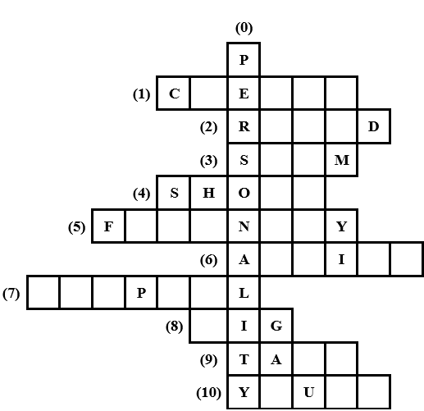  - Have Ss work in two groups. Give each group a crossword puzzle.  - Model with the first word  ex: personality.  - Ask two groups to look at the crossword puzzle carefully, then complete the words in it.  - Give Ss two minutes to do the task. Go around and give further support to the group who find it difficult to do the task.  - Check the answers as the class.  - The group with more correct words wins the game.  - Ask Ss to read all the words aloud.  - Say “Open your book page 26” and look at “Unit 3, Lesson 3 (1,2,3)”.  Activity 1. Listen and repeat:  *Aims: Ss will be able to correctly repeat with correct stress in the two syllable words, as in the words ‘active and ‘friendly, and in the sentences He’s an active boy. and She’s a friendly girl.  *Procedure:  - Have Ss point at the words ‘active and ‘friendly, and in the sentences He’s an active boy. and She’s a friendly girl.  - Play the recording for Ss to listen and repeat in chorus and individually until they feel confident.  - Let Ss work in pairs or groups, saying the words and reading the sentences.  - T invites some Ss to practice.  Activity 2. Circle, listen and check.  *Aims: Ss will be able toidentify the word stress on the two syllable words and circle the word with a different stress pattern from the other two words.  *Procedure:  - Tell Ss circle the word having a different stress from each line. Then listen to the recording to check their answers.  - Set a time for Ss to do the task.  - Play the recording, once or twice, for Ss to listen and check their answers.  - Get Ss to swap books with a partner and check their answers before checking as a class.  - Play the recording again for Ss to double-check their answers.  - Invite a few Ss to read aloud all the words in the words.  Key: 1.c 2.c 3.a  Activity 3. Let’s chant  *Aims: Ss will be able to say the chant with the correct pronunciation, word stress and rhythm.  *Procedure:  - Introduce the title and lyrics of the chant.  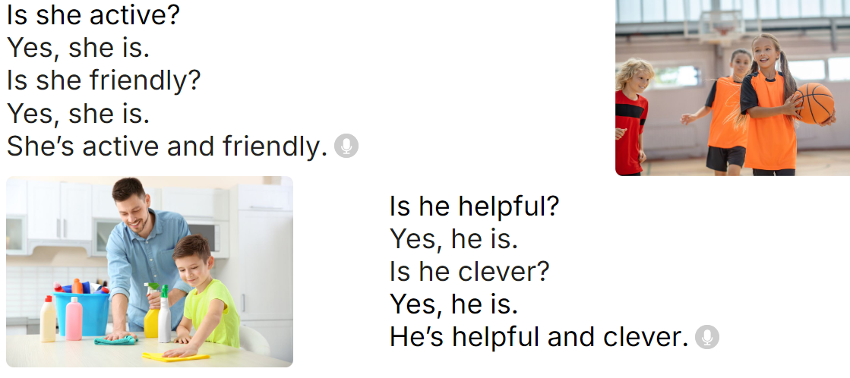  - Play the recording for Ss to listen to the whole chant.  + Have them repeat the title and lyrics line by line.  + Ask Ss to attend to two-syllable words with the stress on the first syllable in the chant, active, friendly, helpful and clever  - Play the recording all the way through for Ss to listen to pronunciation and melody.  - Play the recording line by line for Ss to listen and repeat  - Play the recording for Ss to chant and clap along.  - Ask Ss to practice chant and clap along in pairs or groups.  - Invite groups to the front of the classroom to perform the chant  Game: Circle jump  - Divide the class into groups. Have two groups make two lines to play the game.  - Draw four large circles on the floor.  - Place some word cards (active, friendly, clever, helpful) in each circle.  - Call out a word, and a student from each group has to run and stand inside the corresponding circle as quickly as possible.  - Ask Ss to say the word when standing in the circle.  - The first student saying the correct word gets a point for their group. The group with more points wins the game. | - Follow the T’s instructions.  - Look at the crossword puzzle carefully, then complete the words in it.  - Do the task in two minutes.  - Check the answers in the class.  *Key:  0. personality 1. clever  2. round 3. slim 4. Short  5. friendly 6. active  7. helpful 8. big  9. tall 10. young  - Praise the winner.  - Read all the words aloud  - Ss open their books  - - Ss point and pay attention  - Ss listen to the recording again and repeat.  -Ss work in pairs and practice  -Ss say the language in front of the class  - Ss pay and listen to the teacher’s explanation.  - Ss do the task  - Ss listen to the recording to check their answers (individual)  - Ss swap books with a partner and check the answers  - Ss listen to the recording again and check their answers again.  - Ss stand up and read aloud the words.  - Ss look and listen.  - Ss listen to the chant  - Ss listen and repeat line by line without clap their hands  - Ss note the rhythm and pronunciation.  -Ss listen to melody of the chant  - Ss listen and chant line by line.  - Ss chant and clap along.  - Ss work in groups (two groups) to chant  -Ss perform in front of the class.  -Ss listen  -Ss listen  -Ss play the game  -Ss praise the winner
D. ADJUSTMENTS (if necessary):
………………………………………………………………………………………….…..……………………………………………………………………………...……

Week 6 Preparing date: 13/10, 2024
Period 22 Teaching date: 14/10, 2024

Unit 3: My foreign friends
Lesson 3 (4, 5, 6)
A. OBJECTIVES:
By the end of the lesson, Ss will be able to:
1. Knowledge:
- read and show the understanding of the text by completing the table.
- fill in the form with some information about a foreign friend.
- work in groups, search and find the names of five countries and their nationality adjectives, use the information to make a poster and give a presentation.
- Vocabulary: Review
- Skills: speaking, listening, reading and writing.
2. Competences:
- Communication and collaboration: work in pairs and groups to complete the learning tasks.
- Self-control and independent learning: perform reading and writing tasks.
3. Attitude/ Qualities:
- Show their pride in where they come from and great respect for where someone comes from by asking and answering about nationality
B. TEACHING AIDS:
- Teacher: Teacher’s guide Pages 54, 55, 56; website hoclieu.vn, posters, laptop, pictures, textbook, lesson plan, TV or projector.
- Students: Pupil’s book Page 27, notebooks, workbooks, school things.
C. PROCEDURES:
Stages/  Time | Teacher’s activities | Students’ activities
1.Warm- up and review: (5’)  2.Practice: (8’)  3.Production: (18’)  4. Fun corner and wrap- up (4’) | Game: “A happy circle”  *Aims: to revise the new words and structures from previous lessons.  *Procedure:  - Write the question and answer on the board.  - Explain that they are going to make a circle, then ask and answer the questions about their friends’ personality.  - Put Ss in groups of six.  - Model the game. Have two Ss of each group make a question and answer about their friends’ personality.  - Have the class play the game.  - Invite one or two groups to perform in the front of the class. Praise Ss to encourage their performance.  - Say “Open your book page 27” and look at “Unit 3, Lesson 3 (4,5,6)”.  Activity 1. Read and complete:  *Aims: Ss will be able to read and show the understanding of the text by completing the table.  *Procedure:  - Ask Ss to study the table. Make sure that they understand the information in each column.  - Model number 1  + Have Ss read the information in the table and decide what information they need (nationality).  + Have Ss find the information about Emma’s nationality in the text. Write the word to fill in blank 1 is American.  - Set a time limit for Ss to do the task in groups  - Get Ss to swap their books with other groups and check their answers before checking as a class.  - Ask Ss to choose five keywords about Emma (American, hair, classmates, dishes, and friendly). Have Ss work in pairs and talk about Emma.  Key: 1. American, 2. long,  3. helpful, 4. friends  Activity 2. Let’s write  *Aims: Ss will be able to fill in the form with some information about a foreign friend  *Procedure:  - Tell the class the goal of the activity and explain that they should read fill in the form with the information about a foreign friend.  - Model question 1.  - Give Ss time to do the writing task independently.  - Get Ss to swap books with a partner and check their answers before checking as a class.  - Invite one or two Ss to stand up and read aloud their answers.  Key: Pupil’s answer  Ex:  Activity 3. Project.  *Aims: Ss will be able to work in groups, search and find the names of five countries and their nationality adjectives, use the information to make a poster and give a presentation.  *Procedure:  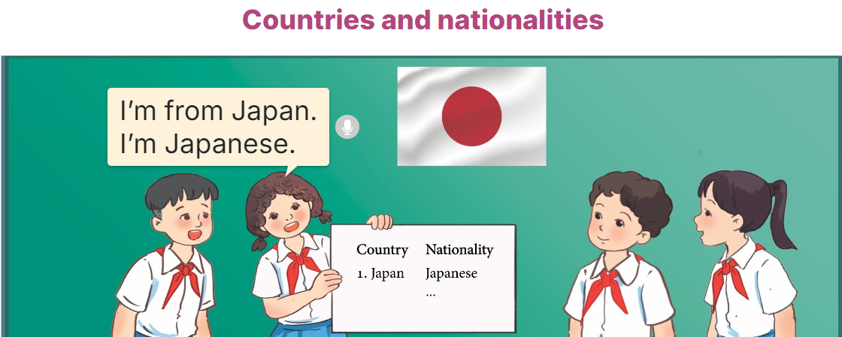  - Explain that they have searched for the names of five countries and their nationality adjectives and prepared a poster to present in class.  - Have groups put the posters on the desk and practice the presentation.  - Get two groups to work together and take turns to give their presentations.  - Invite a few groups to show their poster and give their presentations in front of the class. Praise good performances.  Game: Who’s faster?  - Tell Ss that they are going to look at pictures or word cards and answer the teacher's questions.  - Prepare sets of pictures (Australian, Malaysian, American, Japanese) and word cards (friendly, helpful, clever, active).  - Ask Ss to work in two groups.  - Show a picture or a word card on the board and ask a question related to the picture or the word card.  - Ask Ss to raise their hands as fast as they can to answer the question.  - The student with the correct answer will get points for their group.  - Remark Ss’ pronunciation. Praise the winner. | - Ss listen  - Ss listen to the rules  -Ss play game  Ex: A: What’s Hoang (he) like?  B: He’s active.  - Ss open their books  - Ss study the table.  - Ss follow the teacher demonstrating the example.  -Ss find the information about Emma’s nationality in the text.  - Ss do the task  - Ss swap their books and check their answers before checking as a class.  - Ss work in pairs and talk about Emma.  - Ss listen to the teacher’s explanation.  - Ss fill in the first blank  - Ss complete the form independently.  - Ss swap their books and check their answers  - Ss read their completed form in front of the class.  - Ss listen to the teacher  - Ss work in groups and practice the presentation.  - Two groups work and take turns to give their presentations.  - Ss show their poster and give their presentations  -Ss listen to the teacher  -Ss play the game  -Ss congratulate the winner
  My foreign friend’s name | Kitty
  His / Her age | 10
  His / Her nationality | British
  His / Her appearance | long hair, short
  His / Her personality | friendly and active
D. ADJUSTMENTS (if necessary):
………………………………………………………………………………………….…..……………………………………………………………………………...……

Week 6 Preparing date: 14/10, 2024
Period 23 Teaching date:15/10, 2024

Unit 4: Our free-time activities
Lesson 1 (1, 2, 3)
A. OBJECTIVES:
By the end of the lesson, Ss will be able to:
1. Knowledge:

- understand and correctly repeat the sentences in two communicative contexts focusing on asking and answering questions about personal information

- correctly say the words and use What do you like doing in your free time? – I like _____. to ask and answer questions about hobbies

- enhance the correct use of What do you like doing in your free time? – I like _____ . to ask and answer questions about hobbies in freer contexts

- Vocabulary: play the violin, surf the Internet, go for a walk, water the flower.

- Structures:
A: What do you like doing in your free time?
B: I like playing the violin.
- Skills: speaking and listening
2. Competences:
- Critical thinking and creativity: learn how to ask and answer questions about personal information correctly and fluently.
- Self-control and independent learning: perform speaking tasks.
3. Attitude/ Qualities:
- Show their pride in their personal information and what they like doing in their free time.
B. TEACHING AIDS:
- Teacher: Teacher’s guide Pages 61, 62, 63, 64, audio Tracks 35, 36, website hoclieu.vn, posters, laptop, pictures, textbook, lesson plan, TV or projector.
- Students: Students’ book Page 28, notebooks, workbooks, school things.
C. PROCEDURES:
Stages/  Time | Teacher’s activities | Students’ activities
1.Warm- up and review: (3’)  2. Presentation (15’)  3.Practice: (7’)  4. Production: (6’)  5. Fun corner and wrap- up (4’) | Game: Slap the board  *Aims: to revise the vocabulary about different activities.  *Procedure:  - Prepare some flashcards about different activities and stick on the board  (play football, listen to music, read books, watch TV, clean the floor…)  - Divide class into 2 groups: Tom and Jerry.  - How to play:  + Each group chooses five Ss to play.  + Class will read aloud.  + Look at the picture, listen and slap the picture you heard.  + Who faster will get 1 mark.  + Which group with higher mark is the winner.  - Say “Open your book page 28” and look at “Unit 4, Lesson 1 (1,2,3)”.  Activity 1. Vocabulary.  *Aims: Ss will be able to know the vocabulary in the new lesson.  *Procedure:  -T elicits the new words  + play the violin : chơi đàn violin  (picture)  + surf the Internet : lướt mạng in-tơ-net (picture)  + go for a walk : đi dạo bộ (picture)  + water the flowers : tưới nước hoa  (picture )  + free time: thời gian rãnh (situation)  - T models (3 times).  - T writes the words on the board.  - Checking: Matching  Activity 2. Look, listen and repeat:  *Aims: Ss will be able to understand and correctly repeat the sentences in two communicative contexts in which characters ask and answer questions about what someone likes doing in their free time.  *Procedure:  - Have Ss look at Pictures a and b and identify the characters and their activities. + Who is he/ she?  + Where is he/ she?  + What is he/ she doing in the picture?  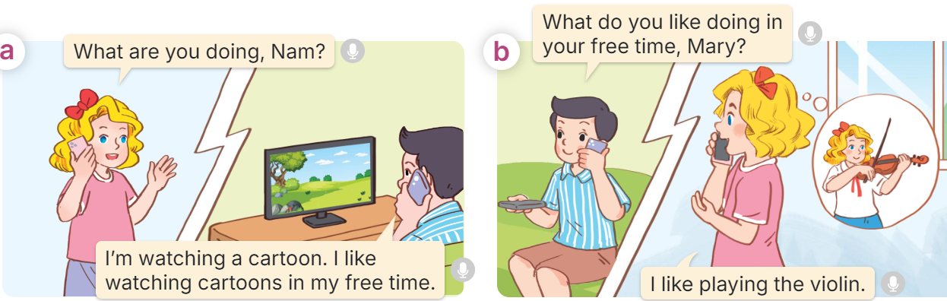  - Play the audio twice (sentence by sentence). Correct their pronunciation where necessary.  - Have Ss to practice the dialogue  - T invites a few pairs to the front of the class to practice.  - T checks pronunciation for ss.  Activity 3 Listen, point and say.  *Aims: Ss will be able to correctly say the words and use What do you like doing in your free time? – I like _____. to ask and answer questions about what someone likes doing in their free time.  *Procedure:  * Structures:  - T asks Ss look at picture b in activity 1 and helps Ss know the structure from the dialogue.  - T introduces new structures for Ss.  - T explains, models and gives meaning.  - Have Ss repeat the structures  A: What do you like doing in your free time? B: I like playing the violin.  *Drill pictures  - Have Ss look at the pictures and identify the characters and their activities. 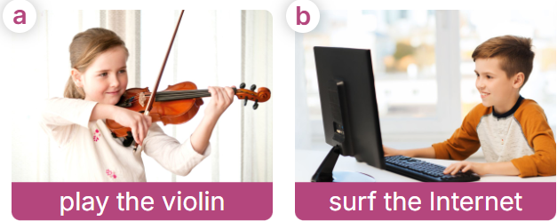  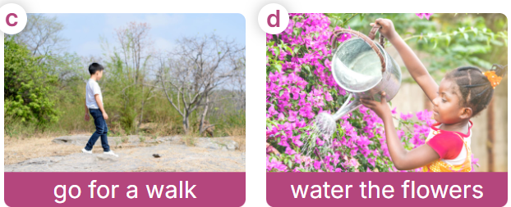  - Have Ss point at pictures, listen and run through all the pictures.  - Have Ss point at the bubbles, listen and run through model sentences.  - Have Ss to practise:  + T asks the first picture, Ss answer  + Ss asks the second picture, T answers  + Group A asks the third picture, group B  answers  + Group B asks the last picture, group A  - Ask Ss to work in pairs to practise asking and answering the What do you like doing in your free time? - I like _____.  - T controls and corrects.  - Invite a few pairs to point at the pictures and say the questions and answers in front of the class.  Activity 4. Let’s talk.  *Aims: Ss will be able to correctly use What do you like doing in your free time? - ____. to ask and answer questions about what someone likes doing in their free time in a freer context.  *Procedure:  - Ask Ss to look at the pictures and elicit the context  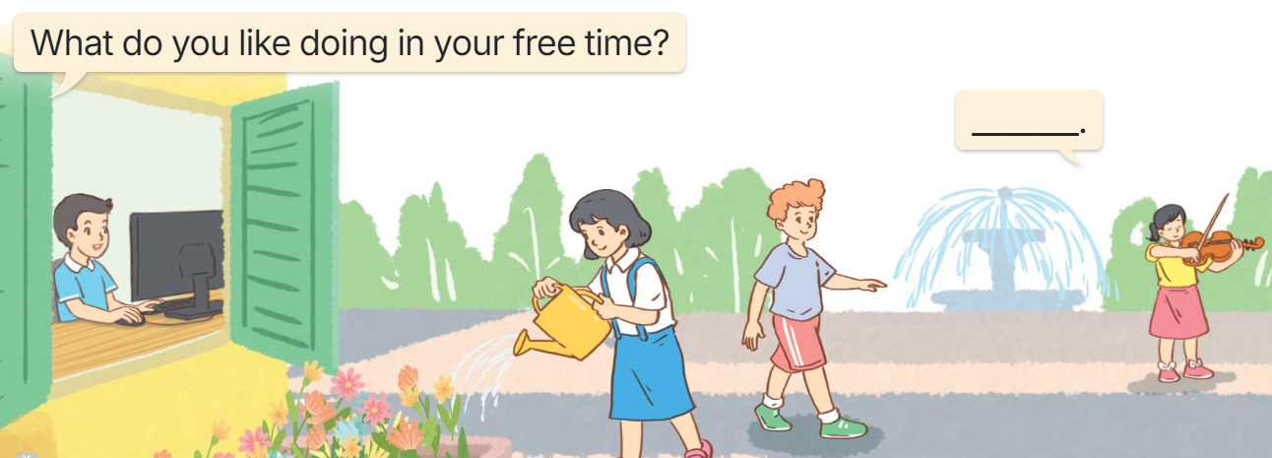  - Point at the ﬁrst building and elicit the question in the ﬁrst speech bubble What do you like doing in your free time? and the answer in the second speech bubble I like……… as an example.  - Give Ss time to work in pairs and take turns pointing at each picture to ask and answer using What do you like doing in your free time? - ………..  - Invite a few pairs to come to the front of the classroom and act out the exchanges.  Game: Racing car  - The teacher divides the class into two teams.  - Each team takes turns choosing the number and answering the question.  -The team that drives the car to the finish line first is the winner. | -Ss listen and pay attention  - Ss listen to the teacher  -Ss play the game  .  -Ss continute playing the game  - Ss listen and open their books  -Ss listen and answer  - - Ss listen and repeat  + Choral repetition  (3 times).  + Individual repetition  (3 ss)  - Ss take note  - Ss look and match  -Look at the pictures and say.  + In picture a:  Mary: What are you doing, Nam? Nam: I’m watching a cartoon. I like watching cartoons in my free time.  + In picture b:  Nam: What do you like doing in your free time, Mary?  Mary: I like playing the violin.  -Ss listen and repeat in chorus (twice)  -Ss work in pairs to practice  -Ss come to the front of the classroom to practice.  -Ss listen  - Ss look at the picture and answer.  -Ss listen  -Ss listen and repeat  -Ss repeat to the structures  - Ss look, listen and repeat  +Picture a: a girl playing the violin  + Picture b: a boy surfing the Internet  + Picture c: a boy going for a walk + Picture d: a girl watering the flowers  -Ss point at pictures, listen and repeat  -Ss point at the bubbles, listen and repeat  -Ss practice in chorus  -Ss practice in chorus  -Ss work in pairs to practise asking and answering the question  - Pairs of Ss point at the pictures and say in front of the class  -Ss look at the picture and say  - Ss look at the first building and elicit the missing words in speech bubbles and say the completed sentences.  - Ss role-play to practise asking and answering questions  - Ss practise asking and answering questions in front of the class.  -Ss listen to the teacher  -Ss play the game  -Ss congratulate the winner
D. ADJUSTMENTS (if necessary):
………………………………………………………………………………………….…..……………………………………………………………………………...……

Week 6 Preparing date: 14/10, 2024
Period 24 Teaching date: 15/10, 2024

Unit 4: Our free-time activities
Lesson 1 (4, 5, 6)
A. OBJECTIVES:
By the end of the lesson, Ss will be able to:
1. Knowledge:
- listen to and understand four communicative contexts about what someone likes doing in their free time and number the pictures.
- complete four gapped exchanges with the help of picture cues.
- revise target words about free-time activities by playing Who has more correct answers?
- Vocabulary: Review
- Skills: speaking, listening, reading and writing.
2. Competences:
- Communication and collaboration: work in pairs and groups to complete the learning tasks.
- Self-control and independent learning: perform listening and reading tasks.
3. Attitude/ Qualities:
- Show their pride in their personal information and what they like doing in their free time.
B. TEACHING AIDS:
- Teacher: Teacher’s guide Pages 64, 65, 66; audio Tracks 37; website hoclieu.vn, posters, laptop, pictures, textbook, lesson plan, TV or projector.
- Students: Student’s book Page 29, notebooks, workbooks, school things.
C. PROCEDURES:
Stages/ Time | Teacher’s activities | Students’ activities
1.Warm- up and review: (5’)  2.Practice: (25’)  3. Fun corner and wrap- up (5’) | Game: “Pass the ball”  *Aims: to revise the learned different nationalities.  *Procedure:  - Ss pass the ball while the teacher plays the music.  - When the music stops, a student holding the ball says the sentence: “I like _________ in my free time”.  - Say “Open your book page 29” and look at “Unit 4, Lesson 1 (4,5,6)”.  Activity 1. Listen and number:  *Aims: Ss will be able to listen to and understand four communicative contexts about what someone likes doing in their free time and number the pictures.  *Procedure:  - Draw Ss’ attention to the pictures and ask questions  + What’s he/she doing?  + What does he/she like doing in their free time?  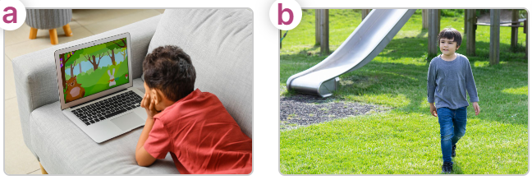  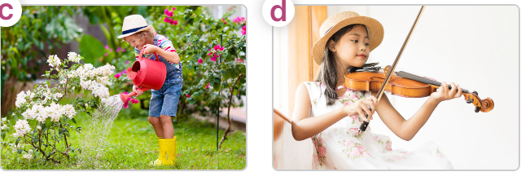  - T ask Ss to guess the answers.  + T writes Ss’guessing on the board.  - Listen to the tape:  + Play the recording  + Play the recording again for pupils to do the task.  + Play the recording a third time for pupils to check their answers.  - Get Ss to swap books with their partner, then check answers as a class.  + Write the answers on the board for Ss to correct their answers. Then checks Ss’ guessing.  - Play the recording, sentence by sentence, for Ss to listen and repeat individually and in chorus Key: 1. d 2. c 3. b 4. A  Activity 2. Read and complete  *Aims: Ss will be able to complete four gapped exchanges with the help of picture cues.  *Procedure:  - Have Ss look at the pictures and identify the activities of the characters in the pictures.  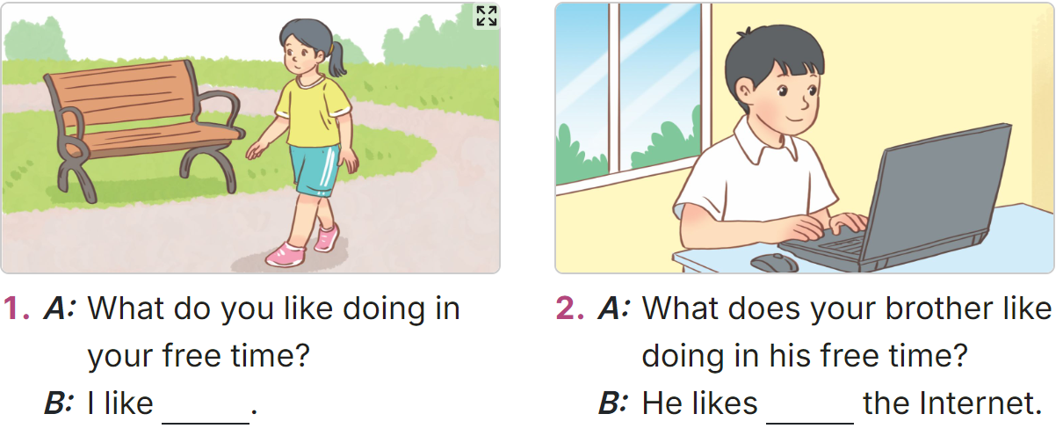  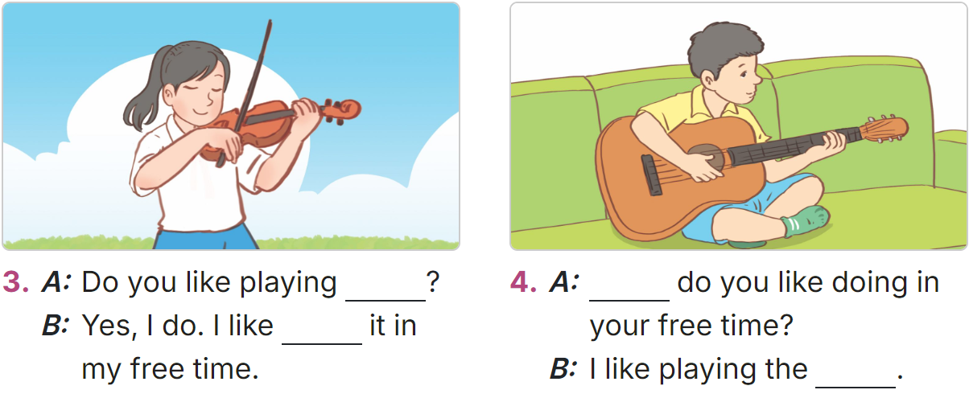  -Model sentences: have Ss read the question and ask what words are missing (go for a walk)  - Give Ss a time limit to read the gapped dialogues, look at the pictures and do the task independently.  - Get Ss to swap books with a partner and check their answers before checking as a class.  + Invite one student to write the answers on the board.  - Invite two pairs of Ss to act out the completed dialogues.  Key: 1. going for a walk  2. surfing  3. the violin; playing  4. What; guitar  Activity 3. Let’s play  *Aims: Ss will be able to revise target words about free-time activities by playing Who has more correct answers?  *Procedure:  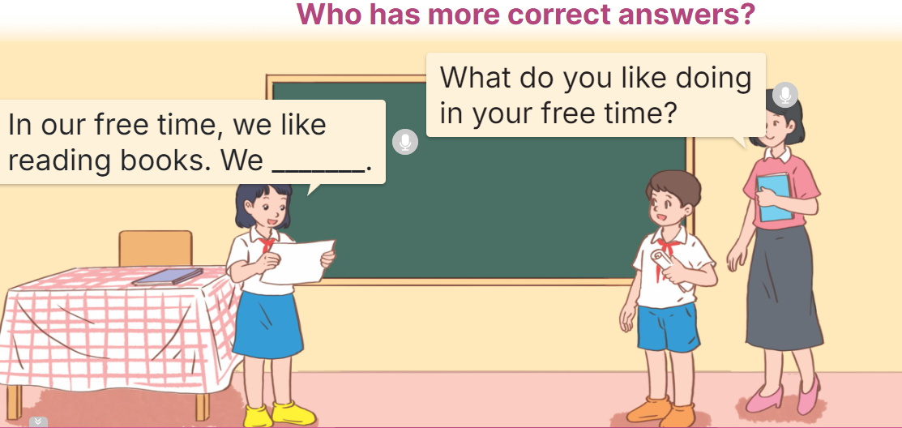  - Tell Ss that they are going to play Who has more correct answers? in groups.  - The groups will write as many sentences as possible about their free-time activities within five minutes on their paper, Ex: In our free time, we like reading books. We like watching TV.  + The group that gets more correct sentences is the winner.  - Have Ss work in groups of five or six.  - Invite representatives of two groups to the front of the class to read their sentences aloud.  - Check answers together as a class and decide which group is the winner.  Game: Spinner the wheel  - Divide the class into 2 teams.  - In teams, they take turns to look at the picture and answer the questions. If they have the correct ones, they will get the points.  - The team with more points wins the game. | -Ss listen to the teacher  -Ss play the game  - Ss open their books  -Look at the pictures and say:  + Picture a: a boy watching a cartoon.  + Picture b: a boy going for a walk in the park.  + Picture c: a girl watering the flowers.  + Picture d: a girl playing the violin.  -Ss guess the answers  - Ss listen to the tape  - Ss listen again and do the task.  - Ss listen and check their answers  - Ss swap books with their partner, then check answers as a class and guessing  -Ss write the answer on the board  -Ss listen and repeat  -Ss look at the picture and say  -Ss follow the teacher  - Ss do the task independently.  - Ss swap books with a partner and check their answers.  - Ss write the answers on the board  - Pairs of Ss read the completed dialogues aloud  - Ss follow the teacher’s instructions.  - Ss discuss and make as many sentences as possible to answer the questions: “What do you like doing in your free time?”  -Ss work in groups  - The representative of each group read aloud their sentences in their group.  -Ss congratulate the winner  -Ss listen to the teacher  - Ss play the game.  - Ss praise the winner.
D. ADJUSTMENTS (if necessary):
………………………………………………………………………………………….…..……………………………………………………………………………...…..…

