Week 34 Preparing date: May 5th , 2025
Period 133 Teaching date: May 6th , 2025

Unit 20: At summer camp
Lesson 2 (4, 5, 6)
A. OBJECTIVES:
By the end of the lesson, Ss will be able to:
1. Knowledge:
- listen to and demonstrate understanding of simple communicative contexts in relation to the topic “At summer camp”.
- complete two gapped exchanges with the help of picture cues.
- Vocabulary: Review
- Skills: speaking, listening, reading and writing.
2. Competences:
- Co-operation: ready to help friends in pair work/ group work.
- Self-control and independent learning: perform listening tasks.
3. Attitude/ Qualities:
- Kindness: Help partners to complete learning tasks.
- Honesty: tell the truth about feelings and emotions.
B. TEACHING AIDS:
- Teacher: Teacher’s guide Pages 287, 288, 289; audio Tracks 97, 98; website hoclieu.vn, posters, laptop, pictures, textbook, lesson plan, TV or projector.
- Students: Pupil’s book Page 67, notebooks, workbooks, school things.
C. PROCEDURES:
Teacher’s activities | Students’ activities
1.Warm- up: (5’)  Sing a song: “Pass the picture.”  *Aims: to create a friendly and active atmosphere in the class to beginning the lesson.  *Procedure:  - Ss pass the picture around the class while the music is playing.  - When the music stops, the Ss with the animal/picture must answer the questions from the teacher.  T: What can you see?  Ss: I can see a ...  Tr: What are they doing?  Ss: They’re………..  - Say “Open your book page 67” and look at “Unit 20, Lesson 2 (4,5,6)”.  2.Practice: (27’)  Activity 1. Listen and tick:  *Aims: Ss will be able to listen to and understand two communicative contexts in which pupils ask and answer questions about what people are doing at a camp and tick the correct pictures.  *Procedure:  - Have Ss look at the pair of picture and ask questions to help them identify the characters and their activities. 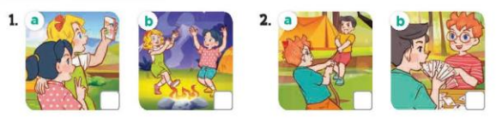  - T ask Ss to guess the answers.  + T writes Ss’guessing on the board.  - Listen to the tape:  + Play the recording  + Play the recording again and get Ss to swap books with their partners.  + Play the recording again to check answers together as a class.  + Write the answers on the board for Ss to correct their answers. Then checks Ss’ guessing.  - Play the recording, sentence by sentence, for the class to listen and repeat in chorus.  Key: 1.b 2. a  Activity 2. Look, complete and read.  *Aims: Ss will be able to complete two gapped exchanges with the help of picture cues.  *Procedure:  - Have Ss look at the pictures and identify the places, characters and their activities in the pictures  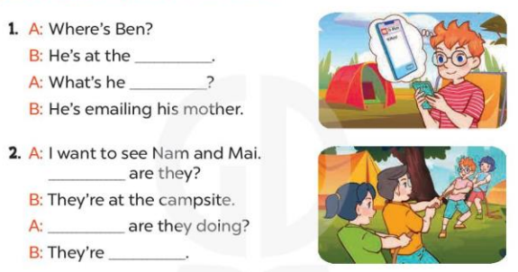  - T models with sentence 1.  + Have Ss look at the sentence.  + Ask them what is missing in the answer (campsite).  + Have Ss complete the gap.  + Have Ss read the completed sentence in chorus.  -Have Ss work in pairs and complete the other sentences.  - Invite pairs of pupils to stand up and read aloud the sentences.  - T gives feedbacks.  Key: 1. campsite; doing  2. Where; What; playing tug of war  Activity 3. Let’s sing  *Aims: Ss will be able to sing the song What are you doing? with the correct pronunciation, melody and intonation.  *Procedure:  - Introduce the title and lyrics of the song  “ What are you doing? ”  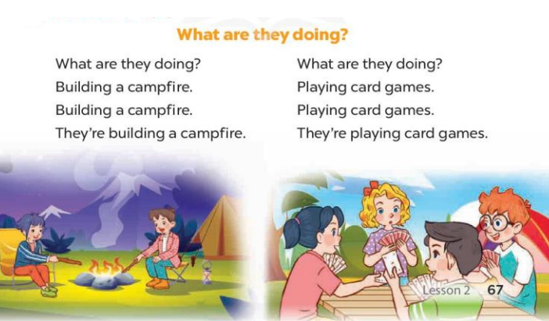  - Play the recording for Ss to listen to the whole song.  + Have them repeat the title and lyrics line by line.  + Tell Ss to point at the pictures  while singing.  - Play the recording all the way through for Ss to listen to pronunciation and melody of the song.  - Play the recording line by line for Ss to listen, repeat and point to the pictures  - Play the recording for Ss to sing and do actions.  - Ask Ss to practice singing and doing actions in pairs or groups.  - Invite groups to the front of the classroom to perform the song  -T gives feedback.  *Consolidation  *Aims: Ss will be able consolidate and wrap up the content of the lesson.  *Procedure:  - T asks ss to answer the following questions:  + What have you learnt from the lesson today?  +What are the core values of the lesson? (if the teacher can take from the lesson).  - T praises some Ss who are hardworking / active/ good…. as well as encourage others to try more.  3. Homework. (3’)  - Prepare the new lesson: Unit 20, Lesson 3 (1,2,3). | - Ss listen and play the game  - Ss open their books  -Look at the pictures and say:  + Picture 1a. Mary and Mai taking a photo  + Picture 1b. Mary and Mai dancing around the campfire  + Picture 2a. Nam and Ben playing tug of war  + Picture 2b. Nam and Ben playing a card game  -Ss guess the answers  - Ss listen to the tape and tick  - Ss listen again, tick and swap books  -Ss check their partners.  - Ss write the asnwer and check ss’ guessing  -Ss listen and repeat.  -Ss look at the pictures and say  -Ss listen and answer  -Ss read and complete  -Ss complete the gap  -Ss read the completed sentence  -Ss work in pairs and do the task  -Ss read aloud the sentences  - Ss listen  -Ss listen to the song  - Ss listen and repeat line by line without the action.  -Ss point to the pictures while singing  -Ss listen to melody of the song  - Ss listen and sing line by line.  - Ss sing and do actions.  + Ss work in groups (two groups) to sing.  -Ss perform in front of the class.  -Ss listen  -Ss listen and answer  -Ss listen and take note

D. ADJUSTMENTS (if necessary):
………………………………………………………………………………………….…..……………………………………………………………………………...………………………………………….…..……………………………………………………………………………….……………………………………………………………………...
Week 34 Preparing date: May 5th , 2025
Period 134 Teaching date: May 6th , 2025

Unit 20: At summer camp
Lesson 3 (1, 2, 3)
A. OBJECTIVES:
By the end of the lesson, Ss will be able to:
1. Knowledge:
- correctly repeat the words 'visit and 'email with the stress on the first syllable in isolation and in the sentences They 'visit their grandparents in summer. and We 'email our friends at the weekend. with the correct pronunciation and intonation.
- identify the target words visit and email while listening.
- say the chant with the correct rhythm and pronunciation.
- Vocabulary: Review
- Skills: speaking, listening, reading and writing.
2. Competences:
- Co-operation: ready to help friends in pair work/ group work.
- Self-control and independent learning: perform listening tasks.
3. Attitude/ Qualities:
- Kindness: Help partners to complete learning tasks.
- Honesty: tell the truth about feelings and emotions
B. TEACHING AIDS:
- Teacher: Teacher’s guide Pages 289, 290; audio Tracks 99, 100, 101; website hoclieu.vn, posters, laptop, pictures, textbook, lesson plan, TV or projector.
- Students: Pupil’s book Page 68, notebooks, workbooks, school things.
C. PROCEDURES:
Teacher’s activities | Students’ activities
1.Warm- up: (5’)  Game: lip-reading  *Aims: to create a friendly and active atmosphere in the class to beginning the lesson.  *Procedure:  - Guide Ss to pronounce without making sound  - Divide Ss into groups, each pupil takes turns to pronounce without making sound while the rest guess the sound  - Say “Open your book page 68” and look at “Unit 20, Lesson 3 (1,2,3)”.  2. Presentation (9’)  Activity 1. Listen and repeat:  *Aims: Ss will be able to correctly repeat the words 'visit and 'email with the stress on the first syllable in isolation and in the sentences They 'visit their grandparents in summer. and We 'email our friends at the weekend. with the correct pronunciation and intonation  *Procedure:  - Draw pupils’ attention to the words 'visit and ‘email, the sentence They 'visit their grandparents in summer and We 'email our friends at the weekend.  - Play the recording and encourage them to point at the word and the sentence while listening.  - Play the recording again and encourage pupils to listen to and repeat the word and the sentence.  - Have Ss work in pairs or groups, saying the words and reading the sentences until they feel confident.  3.Practice: (19’)  Activity 2. Listen and circle.  *Aims: Ss will be able to identify the target words visit and email while listening.  *Procedure:  - Explain that they have to listen to the recording and circle the correct options.  - T ask Ss to guess the answers.  + T writes Ss’guessing on the board.  - Listen to the tape:  + Play the recording  + Play the recording again and get Ss to swap books with their partners.  + Play the recording again to check answers together as a class.  + Write the answers on the board for Ss to correct their answers. Then checks Ss’ guessing.  - Play the recording, sentence by sentence, for the class to listen and repeat in chorus.  - Invite one or two Ss to stand up and read the completed sentences.  Key: 1.b 2.c  Activity 3. Let’s chant  *Aims: Ss will be able to say the chant with the correct rhythm and pronunciation.  *Procedure:  - Introduce the title and lyrics of the chant.  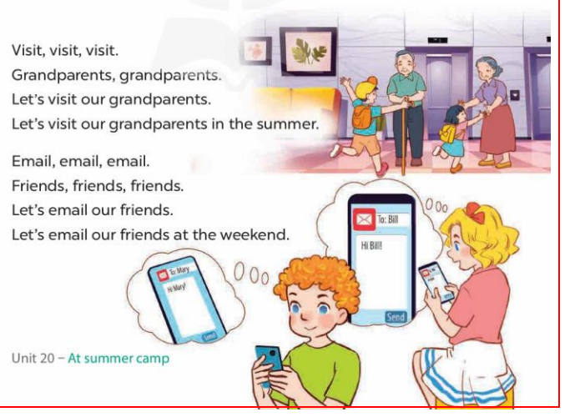  - Play the recording for Ss to listen to the whole chant.  + Have them repeat the title and lyrics line by line.  + Ask Ss to attend to the sounds of the words visit and email.  - Play the recording all the way through for Ss to listen to pronunciation and melody.  - Play the recording line by line for Ss to listen and repeat  - Play the recording for Ss to chant and clap along.  - Ask Ss to practice chant and clap along in pairs or groups.  - Invite groups to the front of the classroom to perform the chant  -T gives feedback.  *Consolidation  *Aims: Ss will be able consolidate and wrap up the content of the lesson.  *Procedure:  - T asks ss to answer the following questions:  + What have you learnt from the lesson today?  +What are the core values of the lesson? (if the teacher can take from the lesson).  - T praises some Ss who are hardworking / active/ good…. as well as encourage others to try more.  4. Homework. (2’)  - Practice the chant more.  - Prepare the new lesson: Unit 20, Lesson 3 (4,5,6). | - Ss listen  -Ss play game  - Ss open their books  - Ss pay attention the words and sentences  - Ss listen and point at the words and the sentnces  - Ss listen again and repeat  -Ss practice several times  -Ss listen and say  -Ss guess the answers  - Ss listen to the tape and circle  - Ss listen again, circle and swap books with their partners.  - Ss check their answers  -Ss write the correct answer and check ss’ guessing  -Ss listen and repeat.  -Ss read the sentences  - Ss look and listen.  -Ss listen to the chant  - Ss listen and repeat line by line without clap their hands  -Ss note the sounds, words  -Ss listen to melody of the chant  - Ss listen and chant line by line.  - Ss chant and clap along.  - Ss work in groups (two groups) to chant  -Ss perform in front of the class.  -Ss listen  -Ss answer the questions  -Ss listen and clap their hands  -Ss listen and take note
D. ADJUSTMENTS (if necessary):
………………………………………………………………………………………….…..……………………………………………………………………………...………………………………………….…..…………………………………………………………
Week 34 Preparing date: May 5th , 2025
Period 135 Teaching date: May 8th , 2025

Unit 20: At summer camp
Lesson 3 (4, 5, 6)
A. OBJECTIVES:
By the end of the lesson, Ss will be able to:
1. Knowledge:
- read and write about what someone is / people are doing at a camp.
- draw a simple picture of friends and their activities at a camp, then tell the class about it at Project time.
- Vocabulary: Review
- Skills: speaking, listening, reading and writing.
2. Competences:
- Co-operation: ready to help friends in pair work/ group work.
- Self-control and independent learning: perform reading tasks.
3. Attitude/ Qualities:
- Kindness: Help partners to complete learning tasks.
- Honesty: tell the truth about feelings and emotions.
B. TEACHING AIDS:
- Teacher: Teacher’s guide Pages 291, 292; website hoclieu.vn, posters, laptop, pictures, textbook, lesson plan, TV or projector.
- Students: Pupil’s book Page 69, notebooks, workbooks, school things.
C. PROCEDURES:
Teacher’s activities | Students’ activities
1.Warm- up: (5’)  Game: Who’s faster?  *Aims: to review the vocabulary and structure about greet and respond to greetings.  *Procedure:  - Tell Ss that they are going to look at the cards in 60 seconds, memorise the phrases  (building a campfire, dancing around the campfire, playing card games, playing tug of war, putting up a tent, singing songs, taking a photo and telling a story ) then remember as many of the words as possible.  - Put the cards on a desk or stick them on the board. Then cover them with a piece of cloth.  - Divide the class into 2 or 4 groups. - Remove the cloth and show the cards for 60 seconds. Then cover them again.  - In their groups, Ss try to say as many of the words as they can remember.  - Have the groups say the names of the things aloud.  - For each correct word, give them a star or a point.  - The group with the most stars / points wins.  - Say “Open your book page 69” and look at “Unit 20, Lesson 3 (4,5,6)”.  2.Practice: (8’)  Activity 1. Read and tick True or False:  *Aims: Ss will be able to read a text and decide whether statements about Minh and his friends’ activities are true or false. *Procedure:  - Draw pupils’ attention to the four statements focusing on what Minh and his friends are doing.  - Ask Ss to read the text individually first, then in pairs to decide if the statements are true or false.  - Set a time limit for Ss to do the task.  - Get Ss to provide reasons for their answers, then check their answers.  Key: 1. True 2. False  3. True 4. True  3.Production: (19’)  Activity 2. Let’s write  *Aims: Ss will be able to complete a text about what pupils are doing at a camp.  *Procedure:  - Ask Ss to read the gapped text and fill in the gaps with details about what pupils and their friends are doing at a camp.  - Have Ss do the first gapped sentence together as an example. Ask them to read the sentence and elicit what day it is today.  - Give Ss time to complete the text independently.  - Get Ss to swap their books with a partner and check their answers in pairs before checking as a class.  - Invite a few Ss to read their completed texts in front of the class.  Key: Pupils’ own answers  Example: Today is Sunday. We are at the campsite. Teacher is telling a story with the girls. Some girls are singing songs. The boys are playing soccer. I am taking a photo.  Activity 3. Project.  *Aims: Ss will be able to draw a simple picture of three or four friends and their activities at a camp, and tell the class about what the friends are doing.  *Procedure:  - Explain that each pupil has to show a simple picture of three or four friends and their activities at a camp which they have drawn at home.  - Have Ss work in groups of six. Each pupil shows his / her picture to the group and describes what the characters in the picture are doing.  - Invite a few Ss to show their pictures and tell the class about the activities of their friends, ex: Look at this picture. They are my friends. They’re dancing around the campfire.  *Consolidation  *Aims: Ss will be able consolidate and wrap up the content of the lesson.  *Procedure:  - T asks ss to answer the following questions:  + What have you learnt from the lesson today?  - T praises some Ss who are hardworking / active/ good…. as well as encourage others to try more.  4. Homework. (3’)  - Prepare the new lesson: Review 4 | - Ss listen  -Ss play game  -Ss play game  - Ss open their books  -Ss pay attention  -Ss read the text  -Ss work in pairs and tick T or F  - Ss check their answer  -Ss read the gapped text and fill in the gaps  -Ss read and answer  -Ss complete the text  -Ss swap books and check their answers  -Ss read the completed texts.  -Ss pay attention  -Ss work in groups and describes the picture  -Ss perform in front of the class.  -Ss answer the questions  -Ss listen and clap their hands  -Ss listen and take note
D. ADJUSTMENTS (if necessary):
………………………………………………………………………………………….…..……………………………………………………………………………...…………
Week 34 Preparing date: May 5th , 2025
Period 136 Teaching date: May 8th , 2025

Review 4
Parts 1, 2
A. OBJECTIVES:
By the end of the lesson, Ss will be able to:
1. Knowledge:
- correctly use the following sentence patterns:
+What was the weather like last weekend? – It was …….
+Do you want to go to the ……….? – Great! Let’s go. / Sorry, I can’t.
+What does it say? – It says ʽ…………ʼ.
+How can I get to the ………? – ……….
+Where’s the bookshop? – It’s …………
+How much is the ………..? – It’s ……..
+What are these animals? – They’re ………..
+Why do you like ………..? – Because they ……….
+What's he / she doing? – He's / She's ………..
+What are they doing? – They’re ……….
- Vocabulary: Review
- Skills: speaking, listening, reading and writing.
2. Competences:
- Co-operation: ready to help friends in pair work/ group work.
- Self-control and independent learning: perform listening tasks.
3. Attitude/ Qualities:
- Kindness: Help partners to complete learning tasks.
- Honesty: tell the truth about feelings and emotions.
B. TEACHING AIDS:
- Teacher: Teacher’s guide Pages 293, 294; Track 102; website hoclieu.vn, posters, laptop, pictures, textbook, lesson plan, TV or projector.
- Students: Pupil’s book Page 70, notebooks, workbooks, school things.
C. PROCEDURES:
Teacher’s activities | Students’ activities
1.Warm- up: (5’)  Game: Choose and throw  *Aims: to review the vocabulary and structure about greet and respond to greetings.  *Procedure:  - Divide class into 2 teams.  - Call 1 pupil from each team to come to the board and throw a sticky ball at the answer.  - Teacher marks the place where they throw it.  - Teacher reveals the score for the correct answer.  - Say “Open your book page 70” and look at Review 4.  2.Practice: (27)  Activity 1. Listen and tick:  *Aims: Ss will be able to listen to and understand five communicative contexts in which characters talk about familiar topics such as weather, directions, items price, animals and camp activities and tick the correct pictures.  *Procedure:  - Elicit the words or phrases to describe the pictures in each option.  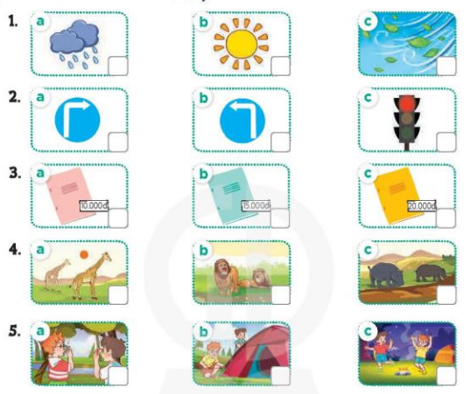  - T ask Ss to guess the answers.  + T writes Ss’guessing on the board.  - Listen to the tape:  + Play the recording  + Play the recording again and get Ss to swap books with their partners.  + Play the recording again to check answers together as a class.  + Write the answers on the board for Ss to correct their answers. Then checks Ss’ guessing.  - Play the recording, sentence by sentence, for the class to listen and repeat in chorus.  Key: 1. b 2. a 3. b 4. c 5. b  Activity 2. Ask and answer  *Aims: Ss will be able to ask and answer questions using picture cues.  *Procedure:  - Elicit the answer and give feedback.  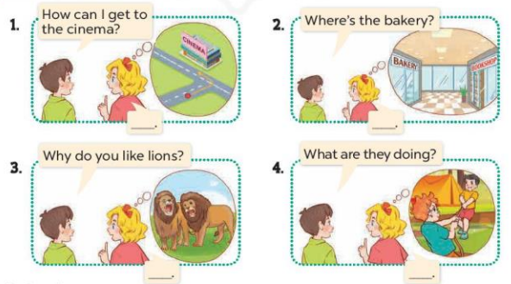  - Get Ss to role-play the exchange. Repeat the same procedure with the rest of the questions.  - Give Ss time to take it in turns to role-play the four exchanges.  - Invite pairs of Ss to stand up and take it in turns to role-play the target exchanges.  *Consolidation  *Aims: Ss will be able consolidate and wrap up the content of the lesson.  *Procedure:  - T asks ss to answer the following questions:  + What have you learnt from the lesson today?  - T praises some Ss who are hardworking / active/ good…. as well as encourage others to try more.  4. Homework. (3’)  - Prepare the new lesson: Review 4 (3,4,5) | - Ss listen  -Ss play game  - Ss open their books  -Look at the pictures and say  1a. a rainy icon  1b. a sunny icon  1c. a windy icon  2a. a ʽturn rightʼ road sign  2b. a ʽturn leftʼ road sign  2c. a ʽstopʼ road sign  3a. a notebook and a price tag: 10,000 dong  3b. a notebook and a price tag: 15,000 dong  3c. a notebook and a price tag: 20,000 dong  4a. Two giraffes  4b. Two lions  4c. Two hippos  5a. Two boys taking a photo  5b. Two boys putting up a tent  5c. Two boys dancing around the campfire  -Ss guess the answers  - Ss listen to the tape and tick  - Ss listen again, tick and swap books with their partners.  - Ss check their answers and guessing  -Ss listen and repeat.  -Look at the pictures and say  -Ss role-play with the rest of the question  - Ss role-play the four exchanges  - Ss stand up and take it in turns to role-play.  -Ss listen and answer  -Ss listen and clap their hands  -Ss listen and take note
D. ADJUSTMENTS (if necessary):
………………………………………………………………………………………….…..……………………………………………………………………………...…………

