Week 33 Preparing date: April 28th , 2025
Period 129 Teaching date: April 29th , 2025

Unit 19: The animal world
Lesson 3 (4, 5, 6)
A. OBJECTIVES:
By the end of the lesson, Ss will be able to:
1. Knowledge:
- read and show understanding of a paragraph by answering four questions about it.
- complete a gapped paragraph about a visit to the zoo, their favourite animals and the reasons why they like these animals.
- collect or draw pictures of favourite animals at home and present them to the class by using the target language.
- Vocabulary: Review
- Skills: speaking, listening, reading and writing.
2. Competences:
- Co-operation: ready to help friends in pair work/ group work.
- Self-control and independent learning: perform reading tasks.
3. Attitude/ Qualities:
- Honesty: tell the truth about feelings and emotions.
- Diligence: complete learning tasks.
B. TEACHING AIDS:
- Teacher: Teacher’s guide Pages 278, 279, website hoclieu.vn, posters, laptop, pictures, textbook, lesson plan, TV or projector.
- Students: Pupil’s book Page 63, notebooks, workbooks, school things.
C. PROCEDURES:
Teacher’s activities | Students’ activities
1.Warm- up: (5’)  Game: “collect the candies”  *Aims: to review the vocabulary and structure about greet and respond to greetings.  *Procedure:  - Have Ss compete in two groups, answer questions to get candy.  + Ss choose a number, and the teacher clicks on the number to go to the question.  + If pupils answer correctly, the teacher clicks back to this slide, clicks the play button with the color of that team to get candy into the jars.  - Once finished, click the candy machine to go to the next slide.  - Say “Open your book page 63” and look at “Unit 19, Lesson 3 (4,5,6)”.  2.Practice: (8’)  Activity 1. Read and answer:  *Aims: Ss will be able to read and show understanding of a paragraph by answering four questions about it.  *Procedure:  - Ask Ss to attend to four questions and the animals in the passage.  - Have Ss work individually.  - Set a time limit for Ss to read and answer the questions.  - Tell Ss to swap the answers with a partner, then check answers as a class.  - Write the answers on the board.  - Invite Ss to read the texts aloud  -T gives feedbacks.  Key: 1. They are at the zoo.  2. They want to see the animals  3. Because they have long necks and legs. They can run very quickly.  4. Because they sing merrily.  3.Production: (19’)  Activity 2. Let’s write  *Aims: Ss will be able to complete a gapped paragraph about a visit to the zoo, their favourite animals and the reasons why they like these animals  *Procedure:  - Tell Ss what they are going to do: complete a paragraph about a visit to the zoo.  - Remind Ss to pay attention to the context (the words before and after the gaps) before completing the paragraph with appropriate words.  - Have Ss fill in the first gap as an example, using the animals they like.  - Set a time limit for SS to complete the paragraph independently.  - Get Ss to swap books with their partners and check their answers in pairs or groups before checking as a class  Key: Pupils’ own answers  Example: It is a sunny Sunday. My brother and I are at the zoo. I like giraffes because they have long necks and legs. My brother likes lions because they run quickly.  Activity 3. Project.  *Aims: Ss will be able to collect or draw pictures of favourite animals at home and present them to the class by using the target language.  *Procedure:  - Explain that each pupil has to show a simple picture of their favourite animals (ex: lions) which they have prepared at home as homework  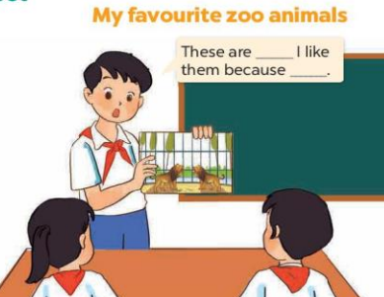  - Have Ss work in groups of six.  + Each pupil shows his / her picture to the group and describes what the animals in his / her picture are, and tells why he / she likes these animals.  - Invite a few pupils to show their pictures and tell the class about the animals and the reasons why they like these animals in front of the class, ex: These are lions. I like them because they roar loudly.  - Have the rest of the class comment and praise their friends’ performance.  *Consolidation  *Aims: Ss will be able consolidate and wrap up the content of the lesson.  *Procedure:  - T asks ss to answer the following questions:  + What have you learnt from the lesson today?  - T praises some Ss who are hardworking / active/ good…. as well as encourage others to try more.  4. Homework. (3’)  - Prepare the new lesson: Unit 20- Lesson 1 (1,2,3). | - Ss listen  -Ss play game  -Ss play game  - Ss open their books  -Ss listen and answer  -Ss read the text silently  -Ss read and answer  -Ss swap books and check their answer  -Ss write the correct answer  -Ss read aloud the text  -Ss listen  -Ss listen  -Ss pay attention  -Ss fill in the first gap  -Ss complete the paragraph  -Ss swap books and check their answer  -Ss listen  -Ss work in groups and describes about their pictures  -Ss perform in front of the class.  -Ss congratulation and clap their hands  -Ss answer the questions  -Ss listen and clap their hands  -Ss listen and take note
D. ADJUSTMENTS (if necessary):
………………………………………………………………………………………….…..……………………………………………………………………………...…………

Week 33 Preparing date: April 28th , 2025
Period 130 Teaching date: April 29th , 2025

Unit 20: At summer camp
Lesson 1 (1, 2, 3)
A. OBJECTIVES:
By the end of the lesson, Ss will be able to:
1. Knowledge:
- use the phrases building a campfire, putting up a tent, taking a photo and telling a story in relation to the topic “At summer camp”
- use What’s he / she doing? – He's / She’s _____. to ask and answer questions about what someone is doing at a camp
- Vocabulary: building a campfire, putting up a tent, taking a photo and telling a story
- Model sentences:
A: What’s he / she doing?
B: He's / She’s building a campsite
- Skills: speaking and listening
2. Competences:
- Co-operation: ready to help friends in pair work/ group work.
- Sociability: Talk to each other, say good words to others.
3. Attitude/ Qualities:
- Kindness: Help partners to complete learning tasks.
- Honesty: tell the truth about feelings and emotions
B. TEACHING AIDS:
- Teacher: Teacher’s guide Pages 280, 281, audio Tracks 92, 93, website hoclieu.vn, posters, laptop, pictures, textbook, lesson plan, TV or projector.
- Students: Pupil’s book Page 64, notebooks, workbooks, school things.
C. PROCEDURES:
Teacher’s activities | Students’ activities
1.Warm- up: (3’)  Sing: Summer camp  *Aims: to create a friendly and active atmosphere in the class to beginning the lesson.  *Procedure:  - Show the song on the screen.  https://www.youtube.com/watch?v=ifPAX00PRRk  - Ask Ss to listen, sing and dance the song.  - Say “Open your book page 64” and look at “Unit 20, Lesson 1 (1,2,3)”.  2. Presentation(16’)  Activity 1. Vocabulary.  *Aims: Ss will be able to know the vocabulary in the new lesson.  *Procedure:  -T elicits the new words  + build a campfire: đốt lửa trại (picture)  + put up a tent : dựng, cắm trại (picture)  + tell a story :kể chuyện (situation)  + take photos : chụp hình (mime)  - T models (3 times).  - T writes the words on the board.  - Checking: Matching  Activity 2. Look, listen and repeat:  *Aims: Ss will be able to understand and correctly repeat the sentences in two communicative contexts focusing on asking and answering questions about what someone is doing at a camp.  *Procedure:  - Have Ss look at Pictures a and b and identify the characters and their activities at the summer camp.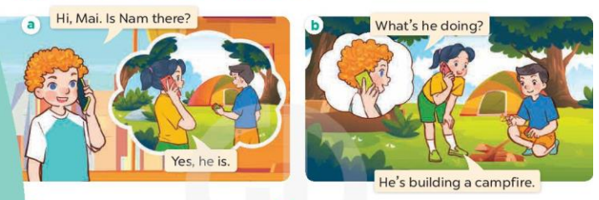  - Play the audio twice (sentence by sentence). Correct their pronunciation where necessary.  - Have Ss to practice the dialogue  - T invites a few pairs to the front of the class to practice.  - T checks pronunciation for ss.  Activity 3 Listen, point and say.  *Aims: Ss will be able to correctly say the phrases and use What's he / she doing? – He's / She's ……. to ask and answer questions about what someone is doing at a camp.  *Procedure:  * Model sentences:  - T asks Ss look at picture b and helps Ss know the structure from the dialogue.  - T introduces new structure for Ss.  - T explains, models and gives meaning.  -Have Ss repeat the model sentences.  A: What’s he / she doing?  B: He's / She’s building a campsite  3.Practice: (7’)  *Drill pictures  - Have Ss look at the pictures and elicit the activities of the characters.  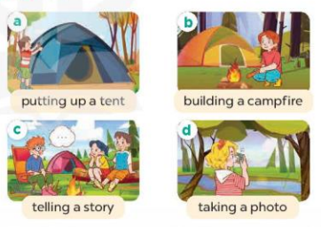  - Run through all the pictures.  - Run through model sentences.  +Run through the question sentences  +Run through the answer sentences  - Have Ss to practise:  + T asks, Ss answer picture a  + Ss ask, T answers picture b  + Group A ask, group B answer picture c  + Group B ask, group A answer picture d  - Ask Ss to work in pairs.  - T controls and corrects.  - Invite a few pairs to come to the front of the classroom and point at the pictures and say the questions and answers in front of the class.  - T gives feedbacks.  4.Production: (7’)  Activity 4. Let’s talk.  *Aims: Ss will be able to enhance the correct use of What's he / she doing? – He's / She's ……. to ask and answer questions about what someone is doing at a camp in a freer context.  *Procedure:  - Have Ss look at the picture and ask questions to help them identify the context 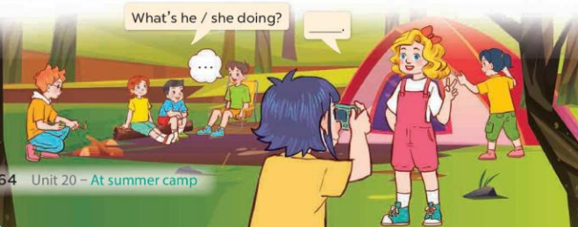  - Elicit the missing words in the speech bubble and write them on the board. Get Ss to say the completed sentences.  - Put Ss into pairs and encourage them to practise asking and answering questions about what someone is doing at a camp.  - Invite a few pairs to the front of the class to ask and answer questions about what someone is doing at a camp using the picture cue.  *Consolidation  *Aims: Ss will be able consolidate and wrap up the content of the lesson.  *Procedure:  - T asks ss to answer the following questions:  + What have you learnt from the lesson today?  - T review the vocabulary and model sentences.  - T praises some Ss who are hardworking / active/ good…. as well as encourage others to try more.  5. Homework. (2’)  - Learn the vocabulary and model sentences by heart  - Prepare the new lesson: Unit 20, Lesson 1 (4,5,6). | - Ss listen  - Ss sing a song  - Ss open their books  -Ss listen and answer  - - Ss listen and repeat  + Choral repetition (3 times).  + Individual repetition (3 ss)  - Ss take note  - Ss look, remember and match  -Look at the pictures and say  + In picture a:  Bill: Hi, Mai. Is Nam there?  Mai: Yes, he is  + In picture b:  Bill: What’s he doing?  Mai: He’s building a campfire.  -Ss listen and repeat in chorus (twice)  -Ss work in pairs to practice  -Ss practice the dialogue  -Ss listen  -Ss look at the picture and answer.  -Ss listen  -Ss listen and repeat  -Ss repeat  - Ss look, listen and answer  + Picture a: A boy putting up a tent  + Picture b. A girl building a campfire  + Picture c. A boy telling a story and his friends listening to him  + Picture d. A girl taking a photo  -Ss listen and repeat  -Ss listen and repeat  -Ss practice in chorus  -Ss work in pairs to practice  -Ss pay attention  -Ss point at the pictures and say the questions and answers  -Ss listen.  -Ss look at the picture and listen  + a boy building a campfire, a boy telling a story and his friends listening to him, a girl taking a photo of her friend, a girl putting up a tent.  -Ss look and answer  -Ss work in pairs to ask and answer  -Ss perform in front of the class.  -Ss answer the questions  - Ss listen  -Ss listen and clap their hands  -Ss listen and take note
D. ADJUSTMENTS (if necessary):
………………………………………………………………………………………….…..……………………………………………………………………………...……………
Week 33 Preparing date: April 28th , 2025
Period 131 Teaching date: May 2nd , 2025

Unit 20: At summer camp
Lesson 1 (4, 5, 6)
A. OBJECTIVES:
By the end of the lesson, Ss will be able to:
1. Knowledge:
- use the phrases building a campfire, putting up a tent, taking a photo and telling a story in relation to the topic “At summer camp”
- listen to and understand four communicative contexts in which characters ask and answer questions about what someone is doing at a camp and match the correct pictures.
- complete four gapped exchanges with the help of picture cues.
- Vocabulary: Review
- Skills: speaking, listening, reading and writing.
2. Competences:
- Co-operation: ready to help friends in pair work/ group work.
- Self-control and independent learning: perform listening tasks.
3. Attitude/ Qualities:
- Kindness: Help partners to complete learning tasks.
- Honesty: tell the truth about feelings and emotions.
B. TEACHING AIDS:
- Teacher: Teacher’s guide Pages 283, 284; audio Tracks 94; website hoclieu.vn, posters, laptop, pictures, textbook, lesson plan, TV or projector.
- Students: Pupil’s book Page 65, notebooks, workbooks, school things.
C. PROCEDURES:
Teacher’s activities | Students’ activities
1.Warm- up: (5’)  Game: Who says faster?  *Aims: to create a friendly and active atmosphere in the class to beginning the lesson.  *Procedure:  - - Hold a activity card, then reveal it slowly.  - Ask What’s he/ she doing?  - Ask the Ss guess the answer as fast as possible.  - Then have Ss do the same with the rest.  - This can be played in groups to make it more interesting.  - Say “Open your book page 65” and look at “Unit 20, Lesson 1 (4,5,6)”.  2.Practice: (27’)  Activity 1. Listen and match:  *Aims: Ss will be able to listen to and understand four communicative contexts in which characters ask and answer questions about what someone is doing at a camp and match the correct pictures.  *Procedure:  - Ask questions to help Ss identify the characters in the pictures and the activities of the stick figures.  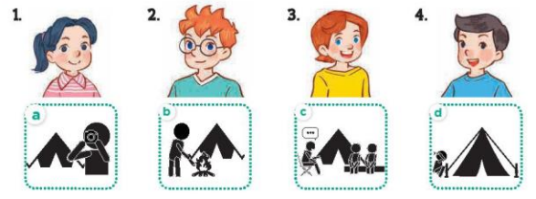  - Play the recording for Ss to listen to.  - Play the recording again for them to do the task by matching the characters to their activities.  - Play the recording a third time to give Ss another listening opportunity.  - Check answers as a class.  - Play the recording, sentence by sentence, for the class to listen and repeat individually and in chorus.  Key: 1. c 2. d 3. a 4. b  Activity 2. Look, complete and read  *Aims: Ss will be able to complete four gapped exchanges with the help of picture cues.  *Procedure:  - Have Ss look at the pictures and get them to identify the characters and their activities in the pictures  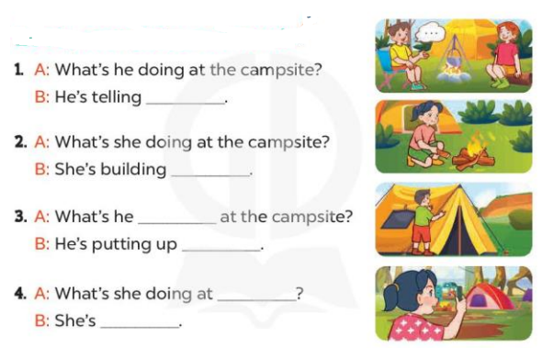  - Have Ss look at the four sentences and the pictures. Elicit and model with picture 1  + Ask Ss to read the sentence 1 in chorus.  + Ask them what is missing in the question (a story). Then have them complete the gap (He’s telling a story).  -Have Ss work in pairs and complete the dialogue 2, 3, 4.  - Ask a few Ss to stand up and read the sentences aloud.  -T gives feedbacks.  Key:  1. a story 2. a campfire  3. doing; a tent 4. the campsite; taking a photo  Activity 3. Let’s play  *Aims: Ss will be able to revise target words about what someone is doing at a camp by playing “Guess what they are doing”.  *Procedure:  - Explain how the game is played.  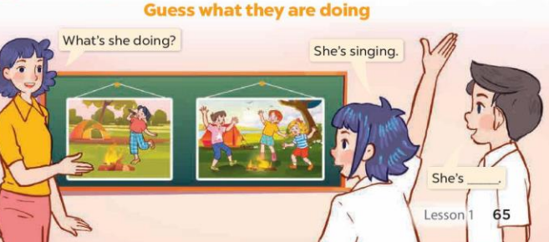  - Divide Ss into groups of five  + Have Ss look at the first picture and answer the question What’s she doing?  + The Ss in each group guess the girl’s activities in the picture and give the answers  (Ex: She’s singing. She’s dancing….)  - Have Ss practise asking and answering questions about what the pupils are doing with the help of picture.  *Consolidation  *Aims: Ss will be able consolidate and wrap up the content of the lesson.  *Procedure:  - T asks ss to answer the following questions:  + What have you learnt from the lesson today?  - T praises some Ss who are hardworking / active/ good…. as well as encourage others to try more.  3. Homework. (3’)  - Prepare the new lesson: Unit 20, Lesson 2 (1,2,3). | - Ss listen  - Ss play the game  - Ss open their books  -Look at the pictures and say:  1. Mai 2. Ben 3. Lucy 4. Nam  - a. a person taking a photo (stick figure)  - b. a person building a campfire (stick figure)  - c. a person telling a story and two friends listening (stick figures)  - d. a person putting up a tent (stick figure)  - Ss listen to the tape  - Ss listen again and tick  - Ss listen again and  - Ss check their answers  -Ss listen and repeat, sentence by sentence,  -Ss look at the picture and say  -Ss look and answer  -Ss read  -Ss say and complete  -Ss work in pairs and complete  -Ss read aloud the sentences  - Ss listen  -Ss listen how to play a game  -Ss play the game  -Ss answer the questions  -Ss listen and clap their hands  -Ss listen and take note
D. ADJUSTMENTS (if necessary):
………………………………………………………………………………………….…..……………………………………………………………………………...………………………………………….…..……………………………………………………………………………….……………………………………………………………………...
Week 33 Preparing date: April 28th , 2025
Period 132 Teaching date: May 2nd , 2025

Unit 20: At summer camp
Lesson 2 (1, 2, 3)
A. OBJECTIVES:
By the end of the lesson, Ss will be able to:
1. Knowledge:
- use the phrases dancing around the campfire, playing card games, playing tug of war, singing songs in relation to the topic “At summer camp”.
- use What are they doing? – They’re ……. to ask and answer questions about what people are doing at a camp
- Vocabulary: dancing around the campfire, playing card games, playing tug of war, singing songs
- Model sentences: A: What are they doing?
B: They’re playing card games.
- Skills: speaking and listening
2. Competences:
- Co-operation: ready to help friends in pair work/ group work.
- Sociability: Talk to each other, say good words to others.
3. Attitude/ Qualities:
- Kindness: Help partners to complete learning tasks.
- Honesty: tell the truth about feelings and emotions
B. TEACHING AIDS:
- Teacher: Teacher’s guide Pages 285, 286; audio Tracks 95, 96, website hoclieu.vn, posters, laptop, pictures, textbook, lesson plan, TV or projector.
- Students: Pupil’s book Page 66, notebooks, workbooks, school things.
C. PROCEDURES:
Teacher’s activities | Students’ activities
1.Warm- up: (3’)  Game: Pass the ball  *Aims: to create a friendly and active atmosphere in the class to beginning the lesson.  *Procedure:  - Stand up and pass the ball with music.  - When music stops, those who keep the ball must look at a picture on the board and say a sentence: He’s/ she’s…….  - Say “Open your book page 66” and look at “Unit 20, Lesson 2 (1,2,3)”.  2. Presentation(16’)  Activity 1. Vocabulary.  *Aims: Ss will be able to know the vocabulary in the new lesson.  *Procedure:  -T elicits the new words  + play tug a war : chơi kéo co (picture)  + play card games : chơi bài (picture)  + dance around the campfire: nhảy múa quanh lửa trại (explain)  + sing songs: hát hò (mime)  - T models (3 times).  - T writes the words on the board.  - Checking: Rub out and remember  Activity 2. Look, listen and repeat:  *Aims: Ss will be able to understand and correctly repeat the sentences in two communicative contexts focusing on asking and answering questions about what people are doing at a camp.  *Procedure:  - Have Ss look at Pictures a and b and identify the places, characters and their activities.  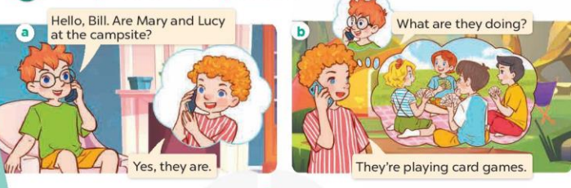  - Play the audio twice (sentence by sentence). Correct their pronunciation where necessary.  - Have Ss to practice the diaguage  - T invites a few pairs to the front of the class to practice.  - T checks pronunciation for ss.  Activity 3. Listen, point and say.  *Aims: Ss will be able to correctly say the phrases and use What are they doing? – They’re ……. to ask and answer questions about what people are doing at a camp. *Procedure:  * Model sentences:  - T asks Ss look at picture b and helps Ss know the structure from the dialogue.  - T introduces new structure for Ss.  - T explains, models and gives meaning.  - Have Ss repeat the model sentences.  A: What are they doing?  B: They’re playing card games.  3.Practice: (7’)  *Drill pictures  - Have Ss look at the pictures and elicit the activities.  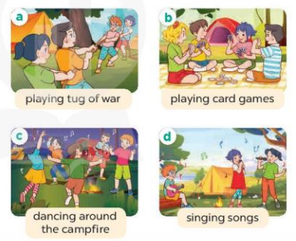  - Run through all the pictures.  - Run through model sentences.  +Run through the question sentences  +Run through the answer sentences  - Have Ss to practise:  + T asks, Ss answer picture a  + Ss ask, T answers picture b  + Group A ask, group B answer picture c  + Group B ask, group A answer picture d  - Ask Ss to work in pairs.  - T controls and corrects.  - Invite a few pairs to come to the front of the classroom, point at the pictures and say in front of the class.  - T gives feedbacks.  4.Production: (7’)  Activity 4. Let’s talk.  *Aims: Ss will be able to enhance the correct use of What are they doing? – They’re …… to ask and answer questions about what people are doing at a camp in a freer context.  *Procedure:  - Draw Ss’ attention to the pictures and ask questions to help them identify the context.  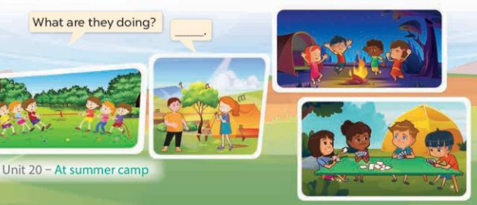  - Elicit the missing words in the bubble and write them on the board. Get Ss to say the completed sentences.  - Put Ss into pairs and encourage them to ask and answer questions about what people are doing at the camp, using What are they doing? – They’re ……..  - Invite a few pairs to the front of the class to perform their conversations.  *Consolidation  *Aims: Ss will be able consolidate and wrap up the content of the lesson.  *Procedure:  - T asks ss to answer the following questions:  + What have you learnt from the lesson today?  - T review the vocabulary and model sentences.  - T praises some Ss who are hardworking / active/ good…. as well as encourage others to try more.  5. Homework. (2’)  - Learn the vocabulary and model sentences by heart  - Prepare the new lesson: Unit 20, Lesson 2 (4,5,6). | - Ss listen  - Ss play the game  - Ss open their books  -Ss listen and answer  - - Ss listen and repeat  + Choral repetition (3 times).  + Individual repetition (3 ss)  - Ss take note  - Ss look, remember and write  -Look at the pictures and get to know the characters in the pictures.  + In picture a:  Ben: Hello, Bill. Are Mary and Lucy at the campsite?  Bill: Yes, they are.  – In picture b:  Ben: What are they doing?  Bill: They’re playing card games.  -Ss listen and repeat in chorus (twice)  -Ss work in pairs to practice  -Ss practice the diaguage  -Ss listen  -Ss look at the picture and answer.  -Ss listen  -Ss listen and repeat  -Ss repeat  -Ss listen and answer  +Picture a. Two teams of friends playing tug of war  +Picture b. Some friends playing card games  +Picture c. Some friends dancing around a campfire  +Picture d. Some friends singing songs  - Ss look, listen and repeat  - Ss look, listen and repeat  - Ss practice in chorus  -Ss work in pairs to practice  -Ss listen  -Ss go to the board and point and say  -Ss listen  -Ss look at the picture and answer  + two teams playing tug of war, two characters singing songs, four characters playing card games and four characters dancing around the campfire.  -Ss pay attention and say  -Ss work in pairs to ask and answer the questions  -Ss practise in pair in front of the class.  -Ss answer the question  - Ss listen  -Ss listen and clap their hands  -Ss listen and take note
D. ADJUSTMENTS (if necessary):
………………………………………………………………………………………….…..……………………………………………………………………………...……………

