Week 32 Preparing date: April 20th ,2025
Period 125 Teaching date : April 21st , 2025

Unit 19: The animal world
Lesson 1 (4, 5, 6)
A. OBJECTIVES:
By the end of the lesson, Ss will be able to:
1. Knowledge:
- use the words and phrases crocodiles, giraffes, hippos, lions in relation to the topic “The animal world”.
- listen to and demonstrate understanding of simple communicative contexts in relation to the topic “The animal world”.
- Vocabulary: Review
- Skills: speaking, listening, reading and writing.
2. Competences:
- Co-operation: ready to help friends in pair work/ group work.
- Self-control and independent learning: perform listening tasks.
3. Attitude/ Qualities:
- Kindness: Help partners to complete learning tasks.
- Honesty: tell the truth about feelings and emotions.
B. TEACHING AIDS:
- Teacher: Teacher’s guide Pages 269, 270; audio Tracks 84, 85; website hoclieu.vn, posters, laptop, pictures, textbook, lesson plan, TV or projector.
- Students: Pupil’s book Page 59, notebooks, workbooks, school things.
C. PROCEDURES:
Teacher’s activities | Students’ activities
1.Warm- up: (5’)  Game: What is missing?  *Aims: to create a friendly and active atmosphere in the class to beginning the lesson.  *Procedure:  - Show the pictures of animals “lions, crocodiles, giraffes, hippos”.  - Ask Ss to close their eyes and take away 1 picture.  + Ss open their eyes and guess what is missing.  - Say “Open your book page 59” and look at “Unit 19, Lesson 1 (4,5,6)”.  2.Practice: (27’)  Activity 1. Listen and number  *Aims: Ss will be able to listen to and understand four communicative contexts in which pupils ask and answer questions about animals and number the correct pictures  *Procedure:  - Get Ss to look at the pictures and ask them to identify the animals  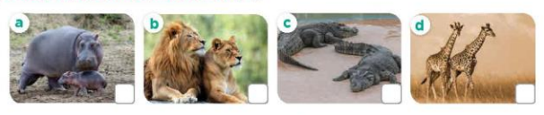  - T ask Ss to guess the answers.  + T writes Ss’guessing on the board.  - Listen to the tape:  + Play the recording  + Play the recording again and get Ss to swap books with their partners.  + Play the recording again to check answers together as a class.  + Write the answers on the board for Ss to correct their answers. Then checks Ss’ guessing.  - Play the recording, sentence by sentence, for the class to listen and repeat in chorus.  Key: 1. d 2. a 3. b 4. c  Activity 2. Look, complete and read  *Aims: Ss will be able to complete four exchanges about animals with the help of picture cues.  *Procedure:  - Get Ss to look at the pictures and identify the animals.  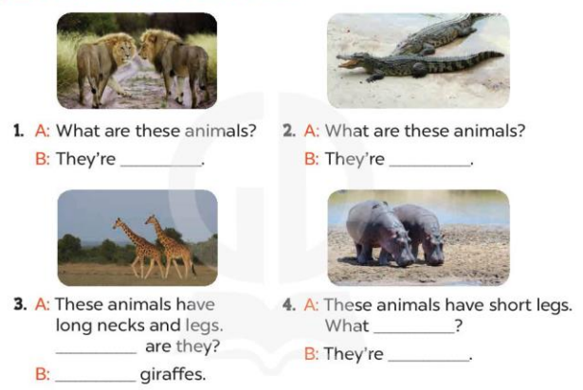  - Have Ss look at the four sentences and the pictures. Elicit and model with picture 1  + Ask Ss to read the sentence 1 in chorus.  + Ask them what is missing in the question (playing football). Then have them complete the gap (he’s playing football.).  -Have Ss work in pairs and complete the dialogue 2, 3, 4.  - Ask a few Ss to stand up and read the sentences aloud.  -T gives feedbacks.  Key:  - lions 2. crocodiles  3. What; They’re 4. are they; hippos  Activity 3. Let’s sing  *Aims: Ss will be able to sing the song Animals with the correct pronunciation, rhythm and melody.  *Procedure:  - Introduce the title and lyrics of the song: “What are these animals?  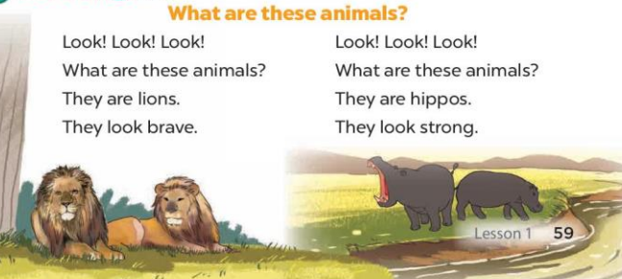  - Play the recording for Ss to listen to the whole song.  + Have them repeat the title and lyrics line by line.  + Tell Ss to point at the pictures while singing.  - Play the recording all the way through for Ss to listen to pronunciation and melody of the song.  - Play the recording line by line for Ss to listen, repeat and point to the pictures  - Play the recording for Ss to sing and do actions.  - Ask Ss to practice singing and doing actions in pairs or groups.  - Invite groups to the front of the classroom to perform the song  -T gives feedback.  *Consolidation  *Aims: Ss will be able consolidate and wrap up the content of the lesson.  *Procedure:  - T asks ss to answer the following questions:  + What have you learnt from the lesson today?  - T praises some Ss who are hardworking / active/ good…. as well as encourage others to try more.  3. Homework. (3’)  - Prepare the new lesson: Unit 19, Lesson 2 (1,2,3). | - Ss listen  - Ss play the game  - Ss open their books  -Look at the pictures and say:  + Picture 1: two hippos  + Picture 2: two lions  + Picture 3: two crocodiles  + Picture 4: two giraffes  -Ss guess the answers  - Ss listen to the tape and write  - Ss listen again, write number and swap books with their partners.  - Ss check their answers and guessing  -Ss listen and repeat.  -Ss look at the picture and say  -Ss look and answer  -Ss read  -Ss say and complete  -Ss work in pairs and complete  -Ss read the sentences aloud  - Ss listen  -Ss listen to the song  - Ss listen and repeat line by line without the action.  -Ss point to the pictures while singing  -Ss listen to melody of the song  - Ss listen and sing line by line.  - Ss sing and do actions.  + Ss work in groups (two groups) to sing.  -Ss perform in front of the class.  -Ss listen  -Ss answer the questions  -Ss listen and clap their hands  -Ss listen and take note
D. ADJUSTMENTS (if necessary):
………………………………………………………………………………………….…..……………………………………………………………………………...………………………………………….…..……………………………………………………………………………….……………………………………………………………………...
Week 32 Preparing date: April 20th ,2025
Period 126 Teaching date : April 21st , 2025

Unit 19: The animal world
Lesson 2 (1, 2, 3)
A. OBJECTIVES:
By the end of the lesson, Ss will be able to:
1. Knowledge:
- use the words and phrases dance beautifully, roar loudly, run quickly and sing merrily in relation to the topic “The animal world”
- use Why do you like ….? – Because they …….. to ask for and give reasons for liking animals;
- Vocabulary: dance beautifully, roar loudly, run quickly and sing merrily.
- Model sentences:
A: Why do you like peacocks?
B: Because they dance beautifully.
- Skills: speaking and listening
2. Competences:
- Co-operation: ready to help friends in pair work/ group work.
- Sociability: Talk to each other, say good words to others.
3. Attitude/ Qualities:
- Kindness: Help partners to complete learning tasks.
- Honesty: tell the truth about feelings and emotions
B. TEACHING AIDS:
- Teacher: Teacher’s guide Pages 272, 273; audio Tracks 86, 87, website hoclieuvn, posters, laptop, pictures, textbook, lesson plan, TV or projector.
- Students: Pupil’s book Page 60, notebooks, workbooks, school things.
C. PROCEDURES:
Teacher’s activities | Students’ activities
1.Warm- up: (3’)  Game: “ Whose tail is this?”  *Aims: to create a friendly and active atmosphere in the class to beginning the lesson.  *Procedure:  - Put Ss into pairs.  - Give Ss the dice. Ss in pairs answer the questions. For each correct answer pupil can roll the dice.  - The student (in each pair) who has the most points is the winner.  - Say “Open your book page 60” and look at “Unit 19, Lesson 2 (1,2,3)”.  2. Presentation(16’)  Activity 1. Vocabulary.  *Aims: Ss will be able to know the vocabulary in the new lesson.  *Procedure:  -T elicits the new words  + dance beautifully : nhảy thật đẹp (example)  + run quikly: chạy thật nhanh (mime)  + roar loudly : gầm thật to (situation)  + sing merrily : hát thật hay (translation)  - T models (3 times).  - T writes the words on the board.  - Checking: Rub out and remember  Activity 2. Look, listen and repeat:  *Aims: Ss will be able to understand and correctly repeat the sentences in two communicative contexts focusing on asking for and giving reasons for liking animals *Procedure:  - Have Ss look at the pictures and identify the characters and the animals.  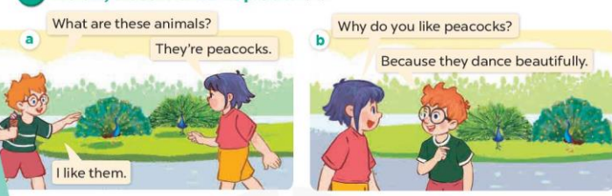  - Play the audio twice (sentence by sentence). Correct their pronunciation where necessary.  - Have Ss to practice the diaguage  - T invites a few pairs to the front of the class to practice.  - T checks pronunciation for ss.  Activity 3. Listen, point and say.  *Aims: Ss will be able to correctly say the phrases and use Why do you like ……? – Because they ……. to ask for and give reasons for liking animals  *Procedure:  * Model sentences:  - T asks Ss look at picture b and helps Ss know the structure from the dialogue.  - T introduces new structure for Ss.  - T explains, models and gives meaning.  - Have Ss repeat the model sentences.  A: Why do you like peacocks?  B: Because they dance beautifully.  3.Practice: (7’)  *Drill pictures  - Have Ss look at the pictures and elicit the names of the animals and what they are doing.  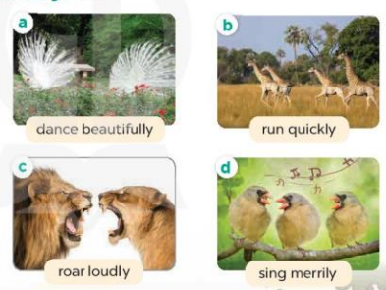  - Run through all the pictures.  - Run through model sentences.  +Run through the question sentences  +Run through the answer sentences  - Have Ss to practise:  + T asks, Ss answer picture a  + Ss ask, T answers picture b  + Group A ask, group B answer picture c  + Group B ask, group A answer picture d  - Ask Ss to work in pairs.  - T controls and corrects.  - Invite a few pairs to come to the front of the classroom, point at the pictures and say in front of the class.  - T gives feedbacks.  4.Production: (7’)  Activity 4. Let’s talk.  *Aims: Ss will be able to enhance the correct use of Why do you like ……? – Because they …. to ask for and give reasons for liking animals in a freer context.  *Procedure:  - Have Ss look at the picture and elicit the names of the animals and reasons for liking them.  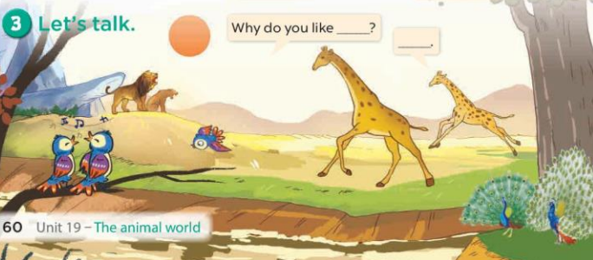  - Ask Ss work in pairs to ask and answer questions about Why do you like…….?  - Invite some pairs to role play in front of the class to point at the activity in the picture cue in their books.  *Consolidation  *Aims: Ss will be able consolidate and wrap up the content of the lesson.  *Procedure:  - T asks ss to answer the following questions:  + What have you learnt from the lesson today?  - T praises some Ss who are hardworking / active/ good…. as well as encourage others to try more.  5. Homework. (2’)  - Learn the vocabulary and model sentences by heart  - Prepare the new lesson: Unit 19, Lesson 2 (4,5,6). | - Ss listen  - Ss play the game  - Ss open their books  -Ss listen and answer  - - Ss listen and repeat  + Choral repetition (3 times).  + Individual repetition (3 ss)  - Ss take note  - Ss look, remember and write  -Look at the pictures and answer.  + In picture a:  Ben: What are these animals?  Linh: They’re peacocks.  Ben: I like them.  – In picture b:  Linh: Why do you like peacocks?  Ben: Because they dance beautifully.  -Ss listen and repeat in chorus (twice)  -Ss work in pairs to practice  -Ss practice the diaguage  -Ss listen  -Ss look at the picture and answer.  -Ss listen  -Ss listen and repeat  -Ss repeat  -Ss listen and answer  +Picture a: Two peacocks dancing +Picture b: Four giraffes running  +Picture c: Two lions roaring  +Picture d: Three birds singing  - Ss look, listen and repeat  - Ss look, listen and repeat  - Ss practice in chorus  -Ss work in pairs to practice  -Ss listen  -Ss go to the board and point and say  -Ss listen  -Ss look at the picture and answer  + a view of wild animals: two peacocks, two giraffes, three birds and two lions.  -Ss work in pairs  -Ss practise in pair in front of the class.  -Ss answer the question  -Ss listen and clap their hands  -Ss listen and take note
D. ADJUSTMENTS (if necessary):
………………………………………………………………………………………….…..……………………………………………………………………………...……………
Week 32 Preparing date: April 20th ,2025
Period 127 Teaching date : April 23rd , 2025

Unit 19: The animal world
Lesson 2 (4, 5, 6)
A. OBJECTIVES:
By the end of the lesson, Ss will be able to:
1. Knowledge:
- use the words and phrases dance beautifully, roar loudly, run quickly and sing merrily in relation to the topic “The animal world”
- listen to and demonstrate understanding of simple communicative contexts in relation to the topic “The animal world”.
- Vocabulary: Review
- Skills: speaking, listening, reading and writing.
2. Competences:
- Co-operation: ready to help friends in pair work/ group work.
- Self-control and independent learning: perform listening tasks.
3. Attitude/ Qualities:
- Honesty: tell the truth about feelings and emotions.
- Diligence: complete learning tasks.
B. TEACHING AIDS:
- Teacher: Teacher’s guide Pages 274, 275; audio Tracks 88; website hoclieu.vn, posters, laptop, pictures, textbook, lesson plan, TV or projector.
- Students: Pupil’s book Page 61, notebooks, workbooks, school things.
C. PROCEDURES:
Teacher’s activities | Students’ activities
1.Warm- up: (5’)  Game: Piggy bank game (PPT)  *Aims: to create a friendly and active atmosphere in the class to beginning the lesson.  *Procedure:  - Divide the class into 3 teams.  - Have Ss from each team choose a pig, ask and answer the questions.  + If the Ss answer correctly, they get the points for that question.  - After 8 pigs, the team with the most points is the winner.  - Say “Open your book page 61” and look at “Unit 19, Lesson 2 (4,5,6)”.  2.Practice: (27’)  Activity 1. Listen and circle:  *Aims: Ss will be able to listen to and understand two communicative contexts in which characters ask for and give reasons for liking animals.  *Procedure:  - Have Ss look at the pictures and elicit the names of the animals.  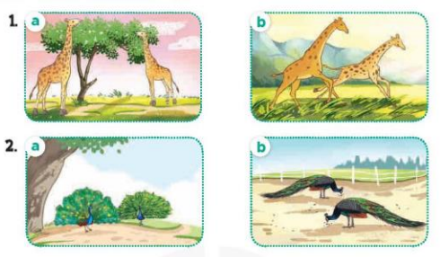  - T ask Ss to guess the answers.  + T writes Ss’guessing on the board.  - Listen to the tape:  + Play the recording  + Play the recording again and get Ss to swap books with their partners.  + Play the recording again to check answers together as a class.  + Write the answers on the board for Ss to correct their answers. Then checks Ss’ guessing.  - Play the recording, sentence by sentence, for the class to listen and repeat in chorus.  Key: 1.b 2. a  Activity 2. Look, complete and read.  *Aims: Ss will be able to complete two gapped dialogues about reasons for liking animals with the help of picture cues *Procedure:  - Have Ss look at the pictures and ask them the names of the animals they see in the picture and what they are doing. 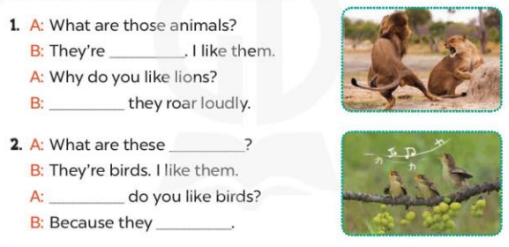  - T models with sentence 1.  + Have Ss look at the sentence.  + Ask them what is missing in the answer (lions).  + Have Ss complete the gap.  + Have Ss read the completed sentence in chorus.  -Have Ss work in pairs and complete the other sentences.  - Invite pairs of pupils to stand up and read aloud the sentences.  - T gives feedbacks.  Key: 1. lions; Because  - animals; Why; sing merrily  Activity 3. Let’s play.  *Aims: Ss will be able to review the animal names that pupils have learnt in the previous lessons by playing a Guessing animals game *Procedure: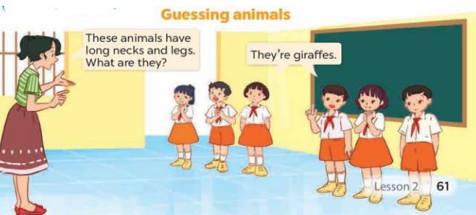  - Invite two teams, each team has three players, to the front of the class.  - Give an example by describing some physical features of animals for the players in the teams to guess.  - One of the teams describes animals for the other one to guess.  - If the guessing team gives a wrong guess, the describing team gives the correct answer, and gets one point.  + Write the correct answer on the board. The game continues.  - If the guessing team gives a correct guess, they take over the role of describing. The team with the most points wins the game when time is up.  - Give a time limit for pupils to play the game.  - When the game is over, get some pairs of pupils to take turns asking and answering the question What are these animals? and use the animal names on the board as the answers.  *Consolidation  *Aims: Ss will be able consolidate and wrap up the content of the lesson.  *Procedure:  - T asks ss to answer the following questions:  + What have you learnt from the lesson today?  +What are the core values of the lesson? (if the teacher can take from the lesson).  - T praises some Ss who are hardworking / active/ good…. as well as encourage others to try more.  3. Homework. (3’)  - Prepare the new lesson: Unit 19, Lesson 3 (1,2,3). | - Ss listen  -Ss play the game  - Ss open their books  -Look at the pictures and say:  + Picture 1a. Two giraffes eatting leaves on the branches  + Picture 1b. Two giraffes running fast in the meadow  + Picture 2a. Two peacocks dancing  + Picture 2b. Two peacocks eating the grass  -Ss guess the answers  - Ss listen to the tape and circle  - Ss listen again, circle and swap books with their partners.  - Ss check their answers  -Ss write the correct answer and check Ss’ guessing  -Ss listen and repeat.  -Ss look at the pictures and say  -Ss listen and answer  -Ss read and complete  -Ss complete the gap  -Ss work in pairs and do the task  -Ss read aloud the sentnces  - Ss listen  -Ss play the game  -Ss play the game  -Ss listen and answer  -Ss listen and take note

D. ADJUSTMENTS (if necessary):
………………………………………………………………………………………….…..……………………………………………………………………………...………………………………………….…..……………………………………………………………………………….……………………………………………………………………...
Week 32 Preparing date: April 20th ,2025
Period 128 Teaching date : April 23rd , 2025

Unit 19: The animal world
Lesson 3 (1, 2, 3)
A. OBJECTIVES:
By the end of the lesson, Ss will be able to:
1. Knowledge:
- correctly pronounce the words 'loudly and 'quickly with the stress on the first syllable in isolation and in the sentences These animals are roaring 'loudly. and Those animals are running 'quickly.
- identify the target words 'loudly and 'quickly while listening.
- say the chant with the correct rhythm and pronunciation.
- Vocabulary: Review
- Skills: speaking, listening, reading and writing.
2. Competences:
- Co-operation: ready to help friends in pair work/ group work.
- Self-control and independent learning: perform listening tasks.
3. Attitude/ Qualities:
- Kindness: Help partners to complete learning tasks.
- Honesty: tell the truth about feelings and emotions
B. TEACHING AIDS:
- Teacher: Teacher’s guide Pages 276, 277; audio Tracks 89, 90, 91; website hoclieu.vn, posters, laptop, pictures, textbook, lesson plan, TV or projector.
- Students: Pupil’s book Page 62, notebooks, workbooks, school things.
C. PROCEDURES:
Teacher’s activities | Students’ activities
1.Warm- up: (5’)  Game: Animal dice  *Aims: to create a friendly and active atmosphere in the class to beginning the lesson.  *Procedure:  - Divide the class into 8 groups.  - Each pupil in groups takes a turn rolling the dice.  - Then he/she names the animal. Next he/she will read the sentence “I like … because ….” Lastly, he/she moves/makes a sound like that animal.  - Say “Open your book page 62” and look at “Unit 19, Lesson 3 (1,2,3)”.  2. Presentation(9’)  Activity 1. Listen and repeat:  *Aims: Ss will be able to correctly repeat the words 'loudly and 'quickly with the stress on the first syllable in isolation and in the sentences These animals are roaring 'loudly. and Those animals are running 'quickly. with the correct pronunciation and intonation.  *Procedure:  - Draw Ss’ attention to the word 'loudly and ‘quickly the sentence These animals are roaring 'loudly. And Those animals are running 'quickly. Play the recording and encourage them to point at the word and the sentence while listening.  - Play the recording again for pupils to listen and repeat.  - Invite a few pupils to stand up, listen to and repeat the word and the sentence.  - Give Ss work in pairs to practise saying the words 'slowly and 'quickly, and reading the sentences These animals are roaring 'loudly. and Those animals are running 'quickly.  3.Practice: (19’)  Activity 2. Listen and circle.  *Aims: Ss will be able to identify the target words loudly and quickly while listening.  *Procedure:  - Elicit the sentences and explain that they have to listen.  - T ask Ss to guess the answers.  + T writes Ss’guessing on the board.  - Listen to the tape:  + Play the recording  + Play the recording again and get Ss to swap books with their partners.  + Play the recording again to check answers together as a class.  + Write the answers on the board for Ss to correct their answers. Then checks Ss’ guessing.  - Play the recording, sentence by sentence, for the class to listen and repeat in chorus.  - Invite one or two Ss to stand up and read the completed sentences.  Key: 1.a 2.a  Activity 3. Let’s chant  *Aims: Ss will be able to say the chant with the correct rhythm and pronunciation.  *Procedure:  - Introduce the title and lyrics of the chant.  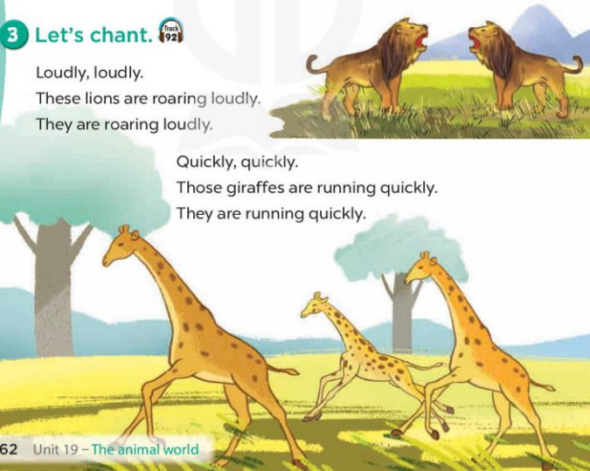  - Play the recording for Ss to listen to the whole chant.  + Have them repeat the title and lyrics line by line.  + Ask Ss to attend to the sounds of the words loudly and quickly.  - Play the recording all the way through for Ss to listen to pronunciation and melody.  - Play the recording line by line for Ss to listen and repeat  - Play the recording for Ss to chant and clap along.  - Ask Ss to practice chant and clap along in pairs or groups.  - Invite groups to the front of the classroom to perform the chant  -T gives feedback.  *Consolidation  *Aims: Ss will be able consolidate and wrap up the content of the lesson.  *Procedure:  - T asks ss to answer the following questions:  + What have you learnt from the lesson today?  +What are the core values of the lesson? (if the teacher can take from the lesson).  - T praises some Ss who are hardworking / active/ good…. as well as encourage others to try more.  4. Homework. (2’)  - Practice the chant more.  - Prepare the new lesson: Unit 19, Lesson 3 (4,5,6). | - Ss listen  -Ss play game  - Ss open their books  - Ss listen and point the words and the sentences  - Ss listen again and reapeat  - Ss listen again and repeat in front of the class  -Ss work in pairs and say the words and the sentence  -Ss listen and say  -Ss guess the answers  - Ss listen to the tape and circle  - Ss listen again, circle and swap books with their partners.  - Ss check their answers  -Ss write the correct answer and check their guessing  -Ss listen and repeat.  -Ss read the sentences  - Ss look and listen.  -Ss listen to the chant  - Ss listen and repeat line by line without clap their hands  -Ss note the sounds, words  -Ss listen to melody of the chant  - Ss listen and chant line by line.  - Ss chant and clap along.  - Ss work in groups (two groups) to chant  -Ss perform in front of the class.  -Ss listen  -Ss listen.  -Ss answer the questions  -Ss listen and clap their hands  -Ss listen and take note
D. ADJUSTMENTS (if necessary):
………………………………………………………………………………………….…..……………………………………………………………………………...………………………………………….…..…………………………………………………………

