Week 30 Preparing date: April 6th , 2025
Period 117 Teaching date: April 7th , 2025

Unit 17: In the city
Lesson 3 (4, 5, 6)
A. OBJECTIVES:
By the end of the lesson, Ss will be able to:
1. Knowledge:
- read and understand a passage about directions
- write a short paragraph about give directions with the help of the suggested questions, a map and an in complete paragraph..
- draw a map and present it by giving directions in class at Project time.
- Vocabulary: Review
- Skills: speaking, listening, reading and writing.
2. Competences:
- Co-operation: ready to help friends in pair work/ group work.
- Self-control and independent learning: perform reading tasks.
3. Attitude/ Qualities:
- Kindness: Help partners to complete learning tasks.
- Honesty: tell the truth about feelings and emotions.
B. TEACHING AIDS:
- Teacher: Teacher’s guide Pages 251, 252, website hoclieu.vn, posters, laptop, pictures, textbook, lesson plan, TV or projector.
- Students: Pupil’s book Page 51, notebooks, workbooks, school things.
C. PROCEDURES:
Teacher’s activities | Students’ activities
1.Warm- up: (5’)  Game: What’s in the box?  *Aims: to review the vocabulary and structure about greet and respond to greetings.  *Procedure:  - Divide class into 4 teams.  - Set rules: invite 1 pupil from each team go to the board look at the place  (bookshop,bakery,waterpark,supermarket, cinema, …) then unscramble the words by writing on the board and say aloud what the place is. The fastest will get more points than the rest.  - Encourage Ss join in the game.  - Give points for the teams.  - Say “Open your book page 51” and look at “Unit 17, Lesson 3 (4,5,6)”.  2.Practice: (8’)  Activity 1. Read and tick True or False:  *Aims: Ss will be able to read and show the understanding of the text by deciding if the statements are true or false.  *Procedure:  - Explain that they should read the text and tick if the Sentences 1- 4 are true or false.  - Do Statement 1 as an example.  + First, have Ss read Statement 1 and find what the statement is about (It’s about the bakery) and where it is (in Nguyen Hue Street).  + Then, find the information about the bakery in the text.  + Read carefully to decide if the statement is true or false.  - Ask Ss to do the task independently.  - Get Ss to swap their books with a partner and check their answers before checking as a class.  Key: 1. True 2. False 3. False 4. True  3.Production: (19’)  Activity 2. Let’s write  *Aims: Ss will be able to complete a gapped text about giving directions.  *Procedure:  - Explain that they should read the gapped text and fill in the gaps with their own information.  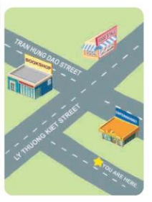  - Have Ss do the first gapped sentence together as an example.  + Ask Ss to read the first sentence and elicit the words (ex: books, cakes, pencils). Then have them write it in the gap.  - Give Ss time to complete other gaps independently.  - Get Ss to swap their books with a partner and check their answers before checking as a class.  - Invite one or two Ss to read their completed texts in front of the class.  Key: Pupils’ own answers  Example: Today is Sunday. I want to buy some books. The bookshop is on Tran Hung Dao Street. I can go straight and turn right. The bookshop is on the left.  Activity 3. Project.  *Aims: Ss will be able to draw a map and present it by giving directions to three places with visual aids.  *Procedure:  - Explain again that they are making a map of their neighbourhood to give directions from their house to at least three different places.  - Draw a map, mark the directions from their house to at least three places on the map, and prepare how to present it at home.  - Make a presentation to a group.  - Ask Ss to show their map.  - Use Nam’s map and his presentation as an example.  - Have Ss work in their groups. Each pupil shows his / her map and gives the directions from their house to three places.  - Invite a few Ss to show the map and make a presentation in front of the class.  *Consolidation  *Aims: Ss will be able consolidate and wrap up the content of the lesson.  *Procedure:  - T asks ss to answer the following questions:  + What have you learnt from the lesson today?  4. Homework. (3’)  - Prepare the new lesson: Unit 18- Lesson 1 (1,2,3). | - Ss listen  -Ss play game  - Ss open their books  -Ss read and answer  -Ss pay attention  -Ss read statement 1 and answer  - Ss find the information  -Ss answer true or false  -Ss do the task  -Ss swap books and check the answer together  -Ss listen  -Ss read and answer  -Ss write the words in the gap  -Ss complete the gaps  -Ss swap books and check their answer  -Ss read their completed texts aloud  -Ss listen to the teacher  -Ss listen and pay attention  -Ss work in groups to show the map and give the direction  -Ss perform in front of the class.  -Ss answer the questions  -Ss listen and take note
D. ADJUSTMENTS (if necessary):
………………………………………………………………………………………….…..……………………………………………………………………………...…………

Week 30 Preparing date: April 6th , 2025
Period 118 Teaching date: April 7th , 2025

Unit 18: At the shopping center
Lesson 1 (1, 2, 3)
A. OBJECTIVES:
By the end of the lesson, Ss will be able to:
1. Knowledge:
- use the words behind, between, near, opposite, gift shop in relation to the topic “At the shopping centre”.
-vuse Where’s the bookshop? – It’s…. to ask and answer questions about locations.
- Vocabulary: behind, between, near, opposite, gift shop
- Model sentences: A: Where’s the bookshop?
B: It’s near the gift shop.
- Skills: speaking and listening
2. Competences:
- Co-operation: ready to help friends in pair work/ group work.
- Sociability: Talk to each other, say good words to others.
3. Attitude/ Qualities:
- Kindness: Help partners to complete learning tasks.
- Honesty: tell the truth about feelings and emotions
B. TEACHING AIDS:
- Teacher: Teacher’s guide Pages 253, 254, audio Tracks 72, 73, website hoclieu.vn, posters, laptop, pictures, textbook, lesson plan, TV or projector.
- Students: Pupil’s book Page 52, notebooks, workbooks, school things.
C. PROCEDURES:
Teacher’s activities | Students’ activities
1.Warm- up: (3’)  Sing: Head, shoulders, knees and toes  *Aims: to create a friendly and active atmosphere in the class to beginning the lesson.  *Procedure:  - Show the song on the screen.  https://www.youtube.com/watch?v=WX8HmogNyCY  - Ask Ss to listen, sing and dance the song.  - Say “Open your book page 52” and look at “Unit 18, Lesson 1 (1,2,3)”.  2. Presentation(16’)  Activity 1. Vocabulary.  *Aims: Ss will be able to know the vocabulary in the new lesson.  *Procedure:  -T elicits the new words  + gift shop : cửa hàng quà tặng (picture)  + near : gần (situation)  + opposite :đối diện (situation)  + behind : đằng sau (picture)  + between :ở giữa (translation)  - T models (3 times).  - T writes the words on the board.  - Checking: Matching  Activity 2. Look, listen and repeat:  *Aims: Ss will be able to understand and correctly repeat the sentences in two communicative contexts focusing on asking and answering questions about locations of some shops at the shopping centre.  *Procedure:  - Have Ss look at Pictures a and b and identify names of the speakers in the pictures.  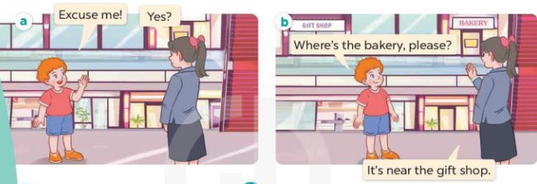  - Play the audio twice (sentence by sentence). Correct their pronunciation where necessary.  - Have Ss to practice the dialogue  - T invites a few pairs to the front of the class to practice.  - T checks pronunciation for ss.  Activity 3 Listen, point and say.  *Aims: Ss will be able to correctly say the words and use Where’s the bookshop? – It’s …, ask and answer questions about locations of a bookshop  *Procedure:  * Model sentences:  - T asks Ss look at picture b and helps Ss know the structure from the dialogue.  - T introduces new structure for Ss.  - T explains, models and gives meaning.  - Have Ss repeat the model sentences.  A: Where’s the bookshop?  B: It’s near the gift shop.  3.Practice: (7’)  *Drill pictures  - Have pupils point at Picture a, listen to the recording and repeat the word near .  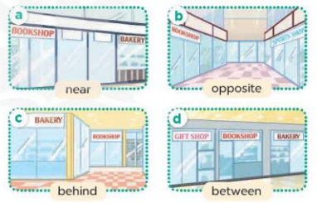  - Repeat the same procedure with Pictures b, c and d  - Run through all the pictures.  - Run through model sentences.  - Have Ss to practise:  - Ask Ss to work in pairs.  - T controls and corrects.  - Invite a few pairs to come to the front of the classroom and point at the pictures and say the questions and answers in front of the class.  - T gives feedbacks.  4.Production: (7’)  Activity 4. Let’s talk.  *Aims: Ss will be able to enhance the correct use of Where’s the ….? – It’s ….. to ask and answer questions about locations in a freer context.  *Procedure:  - Elicit the words or phrases to describe locations.  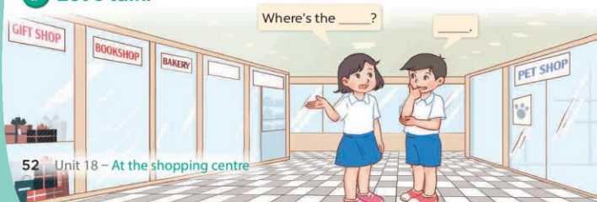  - Elicit the missing word in the first bubble.  + Ask Ss to look at the second bubble and identify what the answer should be.  + Give an example conversation: Where’s the bakery? – It’s near the bookshop.  + Get Ss to repeat the question and answer several times.  - Have pairs practise asking and answering questions about the locations of the shops in the picture.  - Invite a few pairs to practise asking and answering questions in front of the class.  *Consolidation  *Aims: Ss will be able consolidate and wrap up the content of the lesson.  *Procedure:  - T asks ss to answer the following questions:  + What have you learnt from the lesson today?  +What are the core values of the lesson? (if the teacher can take from the lesson).  - T review the vocabulary and model sentences.  - T praises some Ss who are hardworking / active/ good…. as well as encourage others to try more.  5. Homework. (2’)  - Learn the vocabulary and model sentences by heart  - Prepare the new lesson: Unit 18, Lesson 1 (4,5,6). | - Ss listen  - Ss sing a song  - Ss open their books  -Ss listen and answer  - - Ss listen and repeat  + Choral repetition (3 times).  + Individual repetition (3 ss)  - Ss take note  - Ss look, remember and match  -Look at the pictures and say  + In picture a:  Bill: Excuse me!  Shop assistant: Yes?  + In picture b:  Bill: Where’s the bakery, please?  Shop assistant: It’s near the gift shop.  -Ss listen and repeat in chorus (twice)  -Ss work in pairs to practice  -Ss practice the dialogue  -Ss listen  -Ss look at the picture and answer.  -Ss listen  -Ss listen and repeat  -Ss repeat  - Ss look, listen and repeat  + Picture a: a bookshop that is near a bakery.  + Picture b: a bookshop that is opposite a sports shop  + Picture c: a bookshop that is behind a bakery  + Picture d: a bookshop that is between a gift shop and a bakery  -Ss listen and repeat  -Ss practice in chorus  -Ss listen and repeat  -Ss practice in chorus  -Ss work in pairs to practice  -Ss point and say  -Ss listen.  -Ss look at the picture and listen  -Ss look and answer  -Ss answer  -Ss repeat the question and answer  -Ss work in pairs to ask and answer  -Ss ask and answer in front of the class  -Ss answer the questions  - Ss listen  -Ss listen and clap their hands  -Ss listen and take note
D. ADJUSTMENTS (if necessary):
………………………………………………………………………………………….…..……………………………………………………………………………...……………

Week 30 Preparing date: April 6th , 2025
Period 119 Teaching date: April 9th , 2025

Unit 18: At the shopping center
Lesson 1 (4, 5, 6)
A. OBJECTIVES:
By the end of the lesson, Ss will be able to:
1. Knowledge:
- listen to and understand two communicative contexts.
- complete four gapped exchanges about locations with the help of picture cues.
- sing the song Where’s the bookshop? with the correct pronunciation, rhythm and melody.
- Vocabulary: Review
- Skills: speaking, listening, reading and writing.
2. Competences:
- Co-operation: ready to help friends in pair work/ group work.
- Self-control and independent learning: perform listening tasks.
3. Attitude/ Qualities:
- Kindness: Help partners to complete learning tasks.
- Honesty: tell the truth about feelings and emotions.
- Diligence: complete learning tasks.
B. TEACHING AIDS:
- Teacher: Teacher’s guide Pages 256, 257; audio Tracks 74, 75; website hoclieu.vn, posters, laptop, pictures, textbook, lesson plan, TV or projector.
- Students: Pupil’s book Page 53, notebooks, workbooks, school things.
C. PROCEDURES:
Teacher’s activities | Students’ activities
1.Warm- up: (5’)  Game: Lucky number  *Aims: to create a friendly and active atmosphere in the class to beginning the lesson.  *Procedure:  - Divide the class into 2 teams (boys and girls).  + Each team takes turns to choose a number.  + They need to ask and answer with the picture corresponding to that number to get points.  - The group with more points at the end of the game will be the winner.  - Praise the winner, encourage the other team  - Say “Open your book page 53” and look at “Unit 18, Lesson 1 (4,5,6)”.  2.Practice: (27’)  Activity 1. Listen and tick:  *Aims: Ss will be able to listen to and understand two communicative contexts in which pupils ask and answer questions about the locations of shops at the shopping centre and tick the correct pictures.  *Procedure:  - Have Ss look at the picture and ask:  + How many pairs of pictures are there?  + What can you see in each picture?  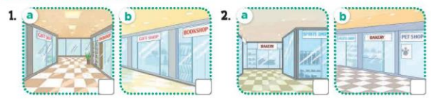  - T ask Ss to guess the answers.  + T writes Ss’guessing on the board.  - Listen to the tape:  + Play the recording  + Play the recording again and get Ss to swap books with their partners.  + Play the recording again to check answers together as a class.  + Write the answers on the board for Ss to correct their answers. Then checks Ss’ guessing.  - Play the recording, sentence by sentence, for the class to listen and repeat in chorus.  Key: 1. a 2. b  Activity 2. Look, complete and read  *Aims: Ss will be able to complete four gapped exchanges about locations with the help of picture cues.  *Procedure:  - Ask Ss to look at the pictures and identify the locations of shops  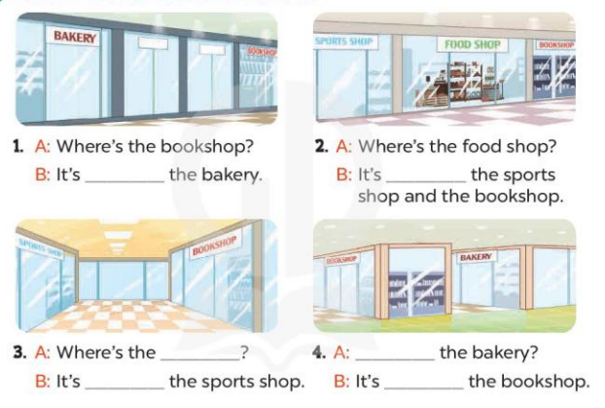  - Have Ss look at the four sentences and the pictures. Elicit and model with picture 1  + Ask Ss to read the sentence 1 in chorus.  + Ask them what is missing in the question (near). Then have them complete the gap (It’s near the bakery)  -Have Ss work in pairs and complete the dialogue 2, 3, 4.  - Ask a few Ss to stand up and read the sentences aloud.  -T gives feedbacks.  Key:  - near 2. between  3. bookshop; opposite 4. Where’s; behind  Activity 3. Let’s sing  *Aims: Ss will be able to sing the song Where’s the bookshop? with the correct pronunciation, rhythm and melody *Procedure:  - Introduce the title and lyrics of the song: “ Where’s the bookshop? ”  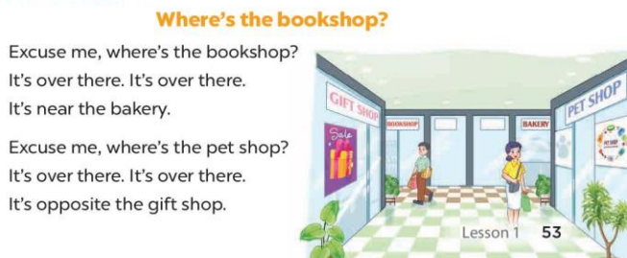  - Play the recording for Ss to listen to the whole song.  + Have them repeat the title and lyrics line by line.  + Tell Ss to point at the pictures while singing.  - Play the recording all the way through for Ss to listen to pronunciation and melody of the song.  - Play the recording line by line for Ss to listen, repeat and point to the pictures  - Play the recording for Ss to sing and do actions.  - Ask Ss to practice singing and doing actions in pairs or groups.  - Invite groups to the front of the classroom to perform the song  -T gives feedback.  .  *Consolidation  *Aims: Ss will be able consolidate and wrap up the content of the lesson.  *Procedure:  - T asks ss to answer the following questions:  + What have you learnt from the lesson today?  - T praises some Ss who are hardworking / active/ good…. as well as encourage others to try more.  3. Homework. (3’)  - Prepare the new lesson: Unit 18, Lesson 2 (1,2,3). | - Ss listen  - Ss play game  - Ss open their books  -Look at the pictures and say:  + Picture 1a: a gift shop that is opposite a bookshop  + Picture 1b: a gift shop that is near a bookshop  + Picture 2a: a bakery that is behind a sports shop  + Picture 2b: a bakery that is between a sports shop and a pet shop  -Ss guess the answers  - Ss listen to the tape and tick  - Ss listen again, tick and swap books with their partners.  - Ss check their answers and guessing  -Ss write the correct answer  -Ss listen and repeat.  -Ss look at the picture and say  -Ss look and answer  -Ss read  -Ss say and complete  -Ss work in pairs and complete  -Ss read the sentences aloud  - Ss listen  Ss listen to the song  - Ss listen and repeat line by line without the action.  -Ss point to the pictures while singing  -Ss listen to melody of the song  - Ss listen and sing line by line.  - Ss sing and do actions.  + Ss work in groups (two groups) to sing.  -Ss perform in front of the class.  -Ss listen  -Ss answer the questions  -Ss listen and clap their hands  -Ss listen and take note
D. ADJUSTMENTS (if necessary):
………………………………………………………………………………………….…..……………………………………………………………………………...………………………………………….…..……………………………………………………………………………….……………………………………………………………………...
Week 30 Preparing date: April 6th , 2025
Period 120 Teaching date: April 9th , 2025

Unit 18: At the shopping center
Lesson 2 (1, 2, 3)
A. OBJECTIVES:
By the end of the lesson, Ss will be able to:
1. Knowledge:
- use the words skirt, T-shirt, dong and thousand in relation to the topic “At the shopping centre”.
- use How much is the …….? – It’s ……to ask and answer questions about prices.
- Vocabulary: skirt, T-shirt, dong, thousand, pet shop
- Model sentences:
A: How much is the skirt?
B: It’s seventy thousand dong.
- Skills: speaking and listening
2. Competences:
- Co-operation: ready to help friends in pair work/ group work.
- Sociability: Talk to each other, say good words to others.
3. Attitude/ Qualities:
- Kindness: Help partners to complete learning tasks.
- Honesty: tell the truth about feelings and emotions
B. TEACHING AIDS:
- Teacher: Teacher’s guide Pages 258, 259; audio Tracks 76, 77, website hoclieu.vn, posters, laptop, pictures, textbook, lesson plan, TV or projector.
- Students: Pupil’s book Page 54, notebooks, workbooks, school things.
C. PROCEDURES:
Teacher’s activities | Students’ activities
1.Warm- up: (3’)  Game: Pass the ball  *Aims: to create a friendly and active atmosphere in the class to beginning the lesson.  *Procedure:  - Stand up and pass the ball with music.  - When music stops, those who keep the ball must look at a picture on the board and say a sentence. I have……..  - Say “Open your book page 54” and look at “Unit 18, Lesson 2 (1,2,3)”.  2. Presentation(16’)  Activity 1. Vocabulary.  *Aims: Ss will be able to know the vocabulary in the new lesson.  *Procedure:  -T elicits the new words  + skirt : váy (realia)  + T-shirt: áo thun (realia)  + dong : đồng (đơn vị tiền tệ Việt Nam)  (realia)  + thousand : nghìn (translation)  - T models (3 times).  - T writes the words on the board.  - Checking: What and where  Activity 2. Look, listen and repeat:  *Aims: Ss will be able to understand and correctly repeat the sentences in two communicative contexts focusing on asking and answering questions about prices.  *Procedure:  - Have Ss look at Pictures a and b and elicit the names of the speakers in the pictures.  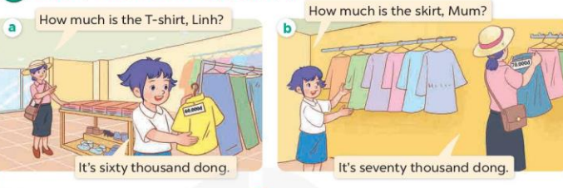  - Play the audio twice (sentence by sentence). Correct their pronunciation where necessary.  - Have Ss to practice the diaguage  - T invites a few pairs to the front of the class to practice.  - T checks pronunciation for ss.  Activity 3. Listen, point and say.  *Aims: Ss will be able to correctly say the words and phrases and use How much is the…….? – It’s ………. to ask and answer questions about prices.  *Procedure:  * Model sentences:  - T asks Ss look at picture b and helps Ss know the structure from the dialogue.  - T introduces new structure for Ss.  - T explains, models and gives meaning.  - Have Ss repeat the model sentences.  A: How mauch is the skirt?  B: It’s seventy thousand dong  3.Practice: (7’)  *Drill pictures  - Have Ss point at Picture a, listen to the recording and repeat the word and phrase pen / twenty thousand dong. 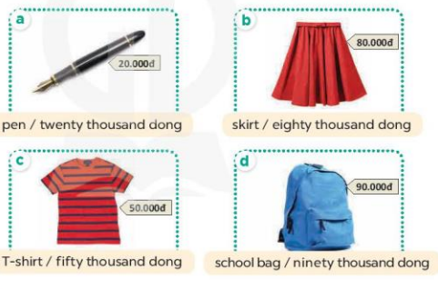  - Run through all the pictures.  - Run through model sentences.  +Run through the question sentences  +Run through the answer sentences  - Have Ss to practise:  + T asks, Ss answer picture a  + Ss ask, T answers picture b  + Group A ask, group B answer picture c  + Group B ask, group A answer picture d  - Ask Ss to work in pairs.  - T controls and corrects.  - Invite a few pairs to come to the front of the classroom, point at the pictures and say in front of the class.  - T gives feedbacks.  4.Production: (7’)  Activity 4. Let’s talk.  *Aims: Ss will be able to enhance the correct use of How much is the …..? – It’s ……... to ask and answer questions about prices in a freer context.  *Procedure:  - Elicit the words or phrases used to describe prices.  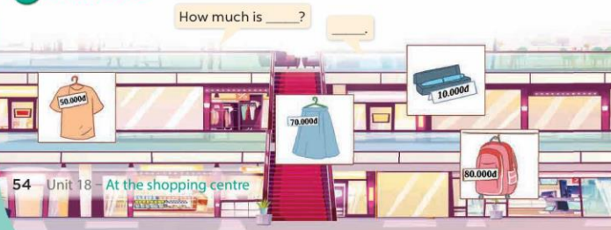  - Elicit the missing words in the first bubble.  + Ask Ss to look at the second bubble and identify what the answer should be.  + Give an example conversation, ex: How much is the T-shirt? – It’s fifty thousand dong.  + Get Ss to repeat the question and the answer several times  - Have pairs practise asking and answering the questions about the prices of the items in the picture.  - Invite a few pairs to practise asking and answering questions in front of the class.  *Consolidation  *Aims: Ss will be able consolidate and wrap up the content of the lesson.  *Procedure:  - T asks ss to answer the following questions:  + What have you learnt from the lesson today?  - T praises some Ss who are hardworking / active/ good…. as well as encourage others to try more.  5. Homework. (2’)  - Learn the vocabulary and model sentences by heart  - Prepare the new lesson: Unit 18, Lesson 2 (4,5,6). | - Ss listen  - Ss play the game  - Ss open their books  -Ss listen and answer  - - Ss listen and repeat  + Choral repetition (3 times).  + Individual repetition (3 ss)  - Ss take note  - Ss look, remember and say  -Look at the pictures and get to know the characters in the pictures.  + In picture a:  Linh’s mother: How much is the T-shirt, Linh?  Linh: It’s sixty thousand dong.  – In picture b:  Linh: How much is the skirt, Mum?  Linh’s mother: It’s seventy thousand dong.  -Ss listen and repeat in chorus (twice)  -Ss work in pairs to practice  -Ss practice the diaguage  -Ss listen  -Ss look at the picture and answer.  -Ss listen  -Ss listen and repeat  -Ss repeat  -Ss listen and answer  +Picture a: a pen with its price tag of twenty thousand dong  +Picture b. a skirt with its price tag of eighty thousand dong  +Picture c. a T-shirt with its price tag of fifty thousand dong  +Picture d. a school bag with its price tag of ninety thousand dong  - Ss look, listen and repeat  - Ss look, listen and repeat  - Ss practice in chorus  -Ss work in pairs to practice  -Ss listen  -Ss go to the board and point and say  -Ss listen  -Ss look at the picture and answer  -Ss look at the bubble and answer  -Ss answer  -Ss repeat the question and answer  -Ss work in pairs to ask and answer  -Ss practise in pair in front of the class.  -Ss answer the question  - Ss listen  -Ss listen and clap their hands  -Ss listen and take note
D. ADJUSTMENTS (if necessary):
………………………………………………………………………………………….…..……………………………………………………………………………...……………

