Week 21 Preparing date: February 2nd 2025
Period 81 Teaching date: February 3rd 2025

Unit 12: Jobs
Lesson 2 (1, 2, 3)
A. OBJECTIVES:
By the end of the lesson, Ss will be able to:
1. Knowledge:
- Use the words actor, farmer, nurse, office worker, policeman, factory, farm, hospital, and nursing home in relation to the topic "Jobs";
- Use Where does he / she work? – He / She works …… to ask and answer questions about places of work.
- Vocabulary: farm, nursing home, gardener.
- Model sentences:
A: Where does he/ she work?
B: He/ She works at a nursing home.
- Skills: speaking and listening
2. Competences:
- Critical Thinking: talk about jobs
- Co-operation: ready to help friends in pair work/ group work.
- Oral Communication: speak about someone, ask and answer the questions
3. Attitude/ Qualities:
- Kindness: Help partners to complete learning tasks.
B. TEACHING AIDS:
- Teacher: Teacher’s guide Pages 174, 175; audio Tracks 15,16, website hoclieu.vn, posters, laptop, pictures, textbook, lesson plan, TV or projector.
- Students: Pupil’s book Page 14, notebooks, workbooks, school things.
C. PROCEDURES:
Teacher’s activities | Students’ activities
1.Warm- up: (3’)  Game: Pass the ball  *Aims: to create a friendly and active atmosphere in the class to beginning the lesson.  *Procedure:  - T gives Ss a ball.  - T asks Ss to listen to music and transfer a ball around the class.  - When the music stops, Ss who keep a ball have to practice with partner using: What does he/ she do? and He’s/ She’s……..  - T gives feedback.  - Say “Open your book page 8” and look at “Unit 12, Lesson 2 (1,2,3)”.  2. Presentation (16’)  Activity 1. Vocabulary.  *Aims: Ss will be able to know the vocabulary in front of starting the new lesson.  *Procedure:  -T elicits the new words  + nursing home : viện dưỡng lão (picture)  + farm : nông trại (situation)  + gardener : nười làm vườn (situation)  - T models (3 times).  - T writes the words on the board.  - Checking: Rub out and remember  Activity 2. Look, listen and repeat:  *Aims: Ss will be able to understand and correctly repeat the sentences in two communicative contexts in which pupils ask and answer questions about the place of work of a family member.  *Procedure:  - Have Ss look at Pictures a and b and identify the characters and jobs in the pictures.  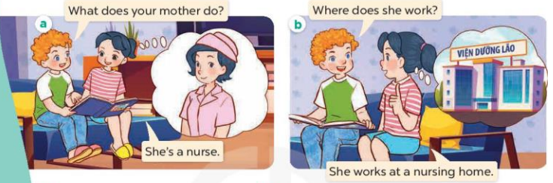  - Play the audio twice (sentence by sentence). Correct their pronunciation where necessary.  - Have Ss to practice the diaguage  - T invites a few pairs to the front of the class to practice.  - T checks pronunciation for ss.  Activity 3. Listen, point and say.  *Aims: Ss will be able to correctly say the phrases and use Where does he / she work? – He / She works ……. to ask and answer questions about places of work.  *Procedure:  * Model sentences:  - T asks Ss look at picture b and helps Ss know the structure from the dialogue.  - T introduces new structure for Ss.  - T explains, models and gives meaning.  - Have Ss repeat the model sentences.  A: Where does he/ she work?  B: He/ She works at a nursing home.  3.Practice: (7’)  *Drill pictures  - Elicit and check comprehension the name of each character.  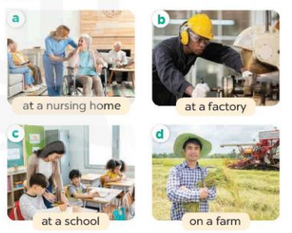  - Run through all the pictures.  - Run through model sentences.  +Run through the question sentences  +Run through the answer sentences  - Have Ss to practise:  + T asks, Ss answer picture a  + Ss ask, T answers picture b  + Group A ask, group B answer picture c  + Group B ask, group A answer picture d  - Ask Ss to work in pairs.  - T controls and corrects.  - Invite a few pairs to come to the front of the classroom, point at the relevant character in each picture, and act out his/her role.  - T gives feedbacks.  4.Production: (7’)  Activity 4. Let’s talk.  *Aims: Ss will be able to enhance the correct use of Where does he / she work?  – He / She works ………. to ask and answer questions about someone’s job in a freer context.  *Procedure:  - Have Ss look at the pictures and elicit the jobs  + What can you see in the picture?  +Who are they?  +What does he/she do?    - T fills the gaps and writes the sentences on the board.  - T models  - T asks Ss use of Where does he/ she work? to ask and answer (pairs)  - Invite some groups to perform.  - Give feedbacks  *Consolidation  *Aims: Ss will be able consolidate and wrap up the content of the lesson.  *Procedure:  - T asks ss to answer the following questions:  + What have you learnt from the lesson today?  - T review the vocabulary and model sentences.  5. Homework. (2’)  - Learn the number by heart  - Prepare the new lesson: Unit 12, Lesson 2 (4,5,6). | - Ss listen and keep the ball  - Ss listen to music and play the game  - Ss open their books  -Ss listen and answer  - - Ss listen and repeat  + Choral repetition (3 times).  + Individual repetition (3 ss)  - Ss take note  - Ss look, remember and write  -Look at the pictures and get to know the characters in the pictures.  + In picture a:  Bill: What does your mother do? Mai: She’s a nurse  – In picture b:  Bill: Where does she work?  Mai: She works at a nursing home.  -Ss listen and repeat in chorus (twice)  -Ss work in pairs to practice  -Ss practice the diaguage  -Ss listen  -Ss look at the picture and answer.  -Ss listen  -Ss listen and repeat  -Ss repeat  - Ss look, listen and answer  + Picture a. A woman working at a nursing home  + Picture b. A man working at a factory  + Picture c. A woman teaching at a school  + Picture d. A man working on a farm  -Ss practice in chorus  - Ss practice in chorus  - Ss practice in chorus  -Ss work in pairs to practice  -Ss listen  -Ss go to the board and role play.  -Ss listen  -Ss look at the picture and answer  + a woman working at a nursing home, a man teaching in a classroom, a woman working at a factory, a man working on a farm  -Ss note  - Ss say the completed sentences.  -Ss work in pairs, ask and answer  -Ss perform in front of the class.  -Ss answer the questions  -Ss listen and clap their hands  -Ss listen and take note

D. ADJUSTMENTS (if necessary):
………………………………………………………………………………………….…..……………………………………………………………………………...………………………………………….…..……………………………………………………………………………….……………………………………………………………………...

Week 21 Preparing date: February 2nd 2025
Period 82 Teaching date: February 3rd 2025

Unit 12: Jobs
Lesson 2 (4, 5, 6)
A. OBJECTIVES:
By the end of the lesson, Ss will be able to:
1. Knowledge:
- Use Where does he / she work? – He / She works …….. to ask and answer questions about places of work.
- Listen to and demonstrate understanding of simple communicative contexts in relation to the topic “Jobs”
- Vocabulary: Review
- Skills: speaking, listening, reading and writing.
2. Competences:
- Co-operation: ready to help friends in pair work/ group work.
- Self-control and independent learning: perform listening tasks.
3. Attitude/ Qualities:
- Kindness: Help partners to complete learning tasks.
- Diligence: complete learning tasks.
B. TEACHING AIDS:
- Teacher: Teacher’s guide Pages 176, 177; audio Tracks 17; website hoclieu.vn, posters, laptop, pictures, textbook, lesson plan, TV or projector.
- Students: Pupil’s book Page 15, notebooks, workbooks, school things.
C. PROCEDURES:
Teacher’s activities | Students’ activities
1.Warm- up: (5’)  Sing a song: “throw the ball”  *Aims: to create a friendly and active atmosphere in the class to beginning the lesson.  *Procedure:  - Divide the class into 2 teams.  - Stick the pictures of jobs on the board.  + T says a word, a pupil from each team has to point/throw the ball to the right picture and says the word three times.  + The one says faster will get points.  - Encourage Ss to take part in the game.  - Give points for Ss.  - Say “Open your book page 15” and look at “Unit 12, Lesson 2 (4,5,6)”.  2.Practice: (27’)  Activity 1. Listen and tick:  *Aims: Ss will be able to listen to and understand two communicative contexts in which pupils ask and answer questions about jobs and workplaces of family members and tick the correct pictures.  *Procedure:  - Elicit the names and jobs of the characters in the pictures.  - Point at the pictures respectively to explain the context.  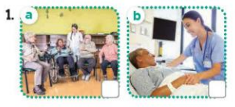  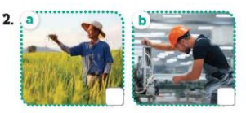  - T ask Ss to guess the answers.  + T writes Ss’guessing on the board.  - Listen to the tape:  + Play the recording  + Play the recording again and get Ss to swap books with their partners.  + Play the recording again to check answers together as a class.  + Write the answers on the board for Ss to correct their answers. Then checks Ss’ guessing.  - Play the recording, sentence by sentence, for the class to listen and repeat in chorus.  Key: 1.b 2. b  Activity 2. Look, complete and read.  *Aims: Ss will be able to complete two gapped exchanges with the help of picture cues. *Procedure:  - Have Ss look at the pictures and ask identify the jobs in the pictures.  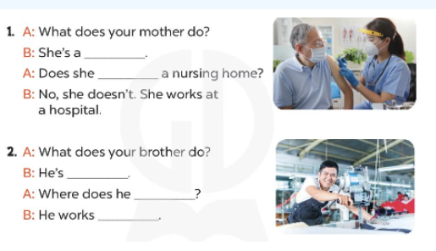  - T models with sentence 1.  + Have Ss look at the sentence.  + Ask them what is missing in the answer (nurse).  + Have Ss complete the gap.  + Have Ss read the completed sentence in chorus.  -Have Ss work in pairs and complete the sentences 2  - Invite pairs of pupils to stand up and read aloud the sentences.  -T gives feedbacks.  Key: 1. Nurse / work at  3. a worker/ work / at a factory.  Activity 3. Let’s play- Gussing game  *Aims: Ss will be able to revise the target vocabulary and sentence patterns by playing the game Gussing game.  *Procedure:  - Explain that they have to listen to the teacher’s sentences and reply the places where they work as quickly as possible.  - Invite two groups of pupils (three pupils in each group) to the front of the class.  -Then say (ex: He’s a farmer.) and ask the groups to reply (ex: He works on a farm.).  +The group that gives the correct answer more quickly gets one point / star.  +The group with more points / stars is the winner.  - When pupils feel confident with the game, call on one or two pupils to act as the teacher to say the sentences to the groups.  *Consolidation  *Aims: Ss will be able consolidate and wrap up the content of the lesson.  *Procedure:  - T asks ss to answer the following questions:  + What have you learnt from the lesson today?  - T praises some Ss who are hardworking / active/ good…. as well as encourage others to try more.  3. Homework. (3’)  - Prepare the new lesson: Unit 12, Lesson 3 (1,2,3). | - Ss listen and play the game  - Ss open their books  -Look at the pictures and say:  + Picture 1a: A nurse working at nursing home  + Picture 1b: A nurse working at a hospital  + Picture 2a: A man working on a farm  + Picture 2b: A man working at a factory  -Ss guess the answers  - Ss listen to the tape and tick  - Ss listen again, tick and swap books with their partners.  - Ss check their answers and guessing  -Ss wrirte the correct answer  -Ss listen and repeat.  -Ss look at the pictures and say  -Ss listen and answer  -Ss read and complete  -Ss compelet the gap  -Ss read the compeled sentence  -Ss work in pairs and do the task  -Ss read aloud the sentences.  - Ss listen  -Ss play the game  - Ss play the game  - Ss play the game  -Ss listen and answer  -Ss listen and take note
D. ADJUSTMENTS (if necessary):
………………………………………………………………………………………….…..……………………………………………………………………………...………………………………………………………………………………………………….………
Week 21 Preparing date: February 2nd 2025
Period 83 Teaching date: February 5th 2025

Unit 12: Jobs
Lesson 3 (1, 2, 3)
A. OBJECTIVES:
By the end of the lesson, Ss will be able to:
1. Knowledge:
- correctly repeat the sounds of the letters ar and ur in isolation, the words farmer and nurse and the sentences My father is a farmer and My mother is a nurse with the correct pronunciation and intonation.
- identify the target words farmer and nurse while listening.
- say the chant with the correct rhythm and pronunciation.
- Vocabulary: Review
- Skills: speaking, listening, reading and writing.
2. Competences:
- Co-operation: ready to help friends in pair work/ group work.
3. Attitude/ Qualities:
- Kindness: Help partners to complete learning tasks.
B. TEACHING AIDS:
- Teacher: Teacher’s guide Pages 179, 180; audio Tracks 18,19, 20; website hoclieu.vn, posters, laptop, pictures, textbook, lesson plan, TV or projector.
- Students: Pupil’s book Page 16, notebooks, workbooks, school things.
C. PROCEDURES:

Teacher’s activities | Students’ activities
1.Warm- up: (5’)  Game: Find and circle the words  *Aims: to create a friendly and active atmosphere in the class to beginning the lesson.  *Procedure:  - Divide class into 2 groups  - Ask Ss to find and circle the words that they learnt.  - Which groups find the best correct words is winner.  - Give Ss time to play the game.  Rows: gardener  Columns: nurse, farmer, Thursday.  -T checks who’s winner?  - Say “Open your book page 16” and look at “Unit 12, Lesson 3 (1,2,3)”.  2. Presentation(9’)  Activity 1. Listen and repeat:  *Aims: Ss will be able to correctly pronounce the sounds of the letters ar and ur in isolation, the words farmer and nurse and the sentences My father is a farmer and My mother is a nurse.  *Procedure:  - T gives instruction to the ar and ur in isolation, the words farmer and nurse and the sentences My father is a farmer and My mother is a nurse.  - Play the recording for the letter ar, ur.  - Encourage Ss to point at the letter/ word/ sentence while listening.  - Play the recording again and encourage Ss to listen and repeat.  - Do this several times until Ss feel confident.  - T calls some Ss to practice.  - T gives feedbacks.  3.Practice: (19’)  Activity 2. Listen and circle.  *Aims: Ss will be able to identify the target words farmer and nurse while listening.  *Procedure:  - Elicit the sentences and explain that they have to listen.  - T ask Ss to guess the answers.  + T writes Ss’guessing on the board.  - Listen to the tape:  + Play the recording  + Play the recording again and get Ss to swap books with their partners.  + Play the recording again to check answers together as a class.  + Write the answers on the board for Ss to correct their answers. Then checks Ss’ guessing.  - Play the recording, sentence by sentence, for the class to listen and repeat in chorus.  - Invite one or two Ss to stand up and read the completed sentences.  Key: 1.b 2.c  Activity 3. Let’s chant  *Aims: Ss will be able to say the chant with the correct rhythm and pronunciation.  *Procedure:  - Introduce the title and lyrics of the chant.  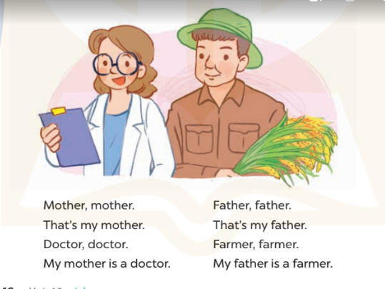  - Play the recording for Ss to listen to the whole chant.  + Have them repeat the title and lyrics line by line.  + Ask Ss to attend to the sounds of the letters ar and ur and the words farmerr and nurse.  - Play the recording all the way through for Ss to listen to pronunciation and melody.  - Play the recording line by line for Ss to listen and repeat  - Play the recording for Ss to chant and clap along.  - Ask Ss to practice chant and clap along in pairs or groups.  - Invite groups to the front of the classroom to perform the chant  -T gives feedback.  *Consolidation  *Aims: Ss will be able consolidate and wrap up the content of the lesson.  *Procedure:  - T asks ss to answer the following questions:  + What have you learnt from the lesson today?  +What are the core values of the lesson? (if the teacher can take from the lesson).  - T praises some Ss who are hardworking / active/ good…. as well as encourage others to try more.  4. Homework. (2’)  - Practice the chant more.  - Prepare the new lesson: Unit 12, Lesson 3 (4,5,6). | - Ss listen  -Ss play game  - Ss open their books  - Ss recognize the differences about color of letter  - Ss listen  - Ss listen and point  - Ss listen again and repeat  -Ss listen again and repeat  -Ss practice  -Ss listen  -Ss listen and say  -Ss guess the answers  - Ss listen to the tape and circle  - Ss listen again, circle and swap books with their partners.  - Ss check their answers and guessing  -Ss write the correct answer  -Ss listen and repeat.  -Ss read the sentences  - Ss look and listen.  -Ss listen to the chant  - Ss listen and repeat line by line without clap their hands  -Ss note the sounds, words  -Ss listen to melody of the chant  - Ss listen and chant line by line.  - Ss chant and clap along.  - Ss work in groups (two groups) to chant  -Ss perform in front of the class.  -Ss listen  -Ss listen.  -Ss answer the questions  -Ss listen and clap their hands  -Ss listen and take note
  N | B | K | K | E | P | S | C | F | T
  U | C | T | H | N | E | H | C | F | H
  R | L | U | A | A | E | A | O | T | U
  S | E | L | N | F | C | T | S | T | R
  E | A | W | K | A | I | O | G | E | D
  E | C | O | O | R | C | I | S | R | A
  S | R | O | E | M | C | V | E | A | Y
  G | A | R | D | E | N | E | R | A | Y
  D | T | S | S | R | S | O | R | S | M
  A | C | E | B | F | A | Z | Y | W

D. ADJUSTMENTS (if necessary):
………………………………………………………………………………………….…..……………………………………………………………………………...………………………………………….…..……………………………………………………………………………….……………………………………………………………………...
Week 21 Preparing date: February 2nd 2025
Period 84 Teaching date: February 5th 2025

Unit 12: Jobs
Lesson 3 (4, 5, 6)
A. OBJECTIVES:
By the end of the lesson, Ss will be able to:
1. Knowledge:
- Read and write about the jobs and the places of work of family members.
- Present to the class at Project time.
- Vocabulary: Review
- Skills: speaking, listening, reading and writing.
2. Competences:
- Co-operation: ready to help friends in pair work/ group work.
- Self-control and independent learning: perform reading tasks.
3. Attitude/ Qualities:
- Kindness: Help partners to complete learning tasks.
- Diligence: complete learning tasks.
B. TEACHING AIDS:
- Teacher: Teacher’s guide Pages 180, 1181, website hoclieu.vn, posters, laptop, pictures, textbook, lesson plan, TV or projector.
- Students: Pupil’s book Page 17, notebooks, workbooks, school things.
C. PROCEDURES:
Teacher’s activities | Students’ activities
1.Warm- up: (5’)  Game: Guessing  *Aims: to review the vocabulary and structure about greet and respond to greetings.  *Procedure:  - Divide the class into 4 teams.  - Look at the cards (1-8), there are pictures behind them.  + Let Ss guess the pictures then say aloud the job.  + Who can make it will have points for the team. (Spin the lucky wheel to get the points)  - Encourage Ss to take part in the game and practice speaking English.  - Give points for Ss.  - Say “Open your book page 17” and look at “Unit 12, Lesson 3 (4, 5, 6)”.  2.Practice: (8’)  Activity 1. Read and complete:  *Aims: Ss will be able to read and show understanding of the text by filling in the gaps in the table.  *Procedure:  - Tell Ss about the context of the paragraphs  - Point at the table and elicit the type of information they need to find in the texts.  - Ask Ss attend to the blank in number 1 and find the missing word.  - Write the missing word on the board and get the class to read the completeed sentence together.  - Have Ss work in pairs and complete  - Tell Ss to swap books with a partner, then check answers together as a class.  - Write the correct answers on the board for pupils to correct their answers.  - Invite Ss to read the text aloud  - T gives feedbacks.  Key: 1. A nurse 2. At a nursing home  3. woker 4. At a factory  3.Production: (19’)  Activity 2. Let’s write  *Aims: Ss will be able to use the target language to complete a gapped text about pupils’ family members.  *Procedure:  - Explain to the class the goal of this activity.  - Ask Ss to read each gapped sentence, guess the missing information and complete the sentence with their own personal information.  - Give Ss time to write their answers  - Ask Ss to swap and correct their answers in pairs.  - Check the answers as a class.  Key: Pupils’ answer.  Example: There are four people in my family. My mother is a nurse. She works at a nursing home. My father is a worker. He works at a factory. My sister and I are pupils. We study at a school.  Activity 3. Project.  *Aims: Ss will be able to collect photos or draw pictures of family members at home and present them to the class by using the target language  *Procedure:  - Explain that they have to show the photos / pictures that they have prepared at home and present them to the class.  - Have Ss show the mind map that they have prepared for the project.  - Revise some structures and vocabulary that Ss need for their presentations.  +Example: Hello, everyone. My name’s Huong. I’m nine years old. This is my family. There are four people in my family. My mother is a nurse. She works at a nursing home. My father is a worker. He works at a factory. My sister and I are pupils. We study at a school.  - Give Ss time to practise their presentations by themselves.  - Give Ss time to practise presenting their picture within their groups.  - Select a few Ss to present their picture to the class if there is enough time.  - Create a class display of the projects and organise a vote to find the most beautiful ones.  *Consolidation  *Aims: Ss will be able consolidate and wrap up the content of the lesson.  *Procedure:  - T asks ss to answer the following questions:  + What have you learnt from the lesson today?  +What are the core values of the lesson?  - T praises some Ss who are hardworking / active/ good…. as well as encourage others to try more.  4. Homework. (3’)  - Prepare the new lesson: Unit 13: Lesson 1 (1,2,3). | - Ss listen  -Ss play game  - Ss open their books  - Ss listen  - Ss read and answer  - Ss read and complete  -Ss write the first word  -Ss work in pairs and complete  -Ss swap books and check the correct their answers  -Ss write the correct answer  -Ss read the text aloud  -Ss listen  -Ss listen  -Ss read and answer  -Ss write  -Ss swap books and check their answers  -Ss check  -Ss listen  -Ss listen and show the photos/ picture  -Ss listen and pay attention  -Ss practice  -Ss work in groups and say  -Ss show the picture and perform in front of the class.  -Ss vote the most beautiful ones  -Ss answer the questions  -Ss listen and clap their hands  -Ss listen and take note
D. ADJUSTMENTS (if necessary):
………………………………………………………………………………………….…..……………………………………………………………………………...…………

