Week 18 Preparing date: January 5th 2024
Period 69 Teaching date: January 6th 2024
Review 2
Parts 3, 4, 5
A. OBJECTIVES:
By the end of the lesson, Ss will be able to:
1. Knowledge:
- correctly use the following sentence patterns:
Where’s your school? – It’s in the ………
How many … are there at your school? – There is / are ………
What subjects do you have today? – I have ……..
When do you have ……..? – I have it on …………
What’s your favourite subject? – It’s ……….
Why do you like ………..? – Because I want to be ………….
Is your sports day in ……..? – Yes, it is. / No, it isn't. It's in ………….
When's your sports day? – It's in …………..
Were you ………. last weekend? – Yes, I was. / No, I wasn't.
Where were you last summer? – I was in ………..
- Vocabulary: Review
- Skills: speaking, listening, reading and writing.
2. Competences:
- Co-operation: ready to help friends in pair work/ group work.
- Self-control and independent learning: perform listening tasks.
3. Attitude/ Qualities:
- Diligence: complete learning tasks.
B. TEACHING AIDS:
- Teacher: Teacher’s guide Pages 153,154; website hoclieu.vn, posters, laptop, pictures, textbook, lesson plan, TV or projector.
- Students: Pupil’s book Page 75, notebooks, workbooks, school things.
C. PROCEDURES:
Teacher’s activities | Students’ activities
1.Warm- up: (5’)  Game: Whispering  *Aims: to review the vocabulary and structure about greet and respond to greetings.  *Procedure:  - Divide class into 2 groups.  -Ask 5 Ss in each group stand in a straight line.  - T says a word or phrase to the first pupil in this line.  - Then, the first pupil whispers what she/ he hear to the second person in line; the second one whispers what he/ she hears to the third one and so on until the last pupil in group hears the word or phrase.  - The last pupil says the word or phrase out loud.  - The faster group has correct word or phrase is the winner.  - Say “Open your book page 75” and look at Review 2.  2.Practice: (27’)  Activity 1. Read and match  *Aims: Ss will be able to read and match pairs of target sentence patterns  *Procedure:  - Tell Ss about this activity. Point at sentence 1, elicit the answer and models.  - Give Ss work in pairs to do the sentence 2,3,4.  - Tell Ss to swap their books with their partners, then check answers together as a class.  - Write the correct answers on the board for Ss to correct their answers.  - Invite some pairs to stand up and read the matched exchanges aloud.  Key: 1. b 2. d 3. a 4. c  Activity 2. Read and complete.  *Aims: Ss will be able to read and show the understanding of a letter by choosing the words to complete a gapped text about a familiar topic  *Procedure:  - Explain that they should read a letter and choose the words in the box to complete.  - Model the first sentence and read aloud as a class.  + Elicit the missing word and give feedback. + Complete the sentence and get pupils to read the completed sentence in chorus.  - Have pupils to do the task independently.  - Get pupils to swap their books with a partner and check their answers  - Invite one or two pupils to read the text in front of the class.  Key:  1. village 2. computer room  3. music 4. sing 5. were  Activity 3. Let’s write  *Aims: Ss will be able to use the target language to complete a gapped letter about their school.  *Procedure:  - Explain that they should read the gapped letter and fill in the gaps with their own information.  - Have pupils do the first gapped sentence together as an example. Ask them to read the first sentence and elicit the words (ex: a city, the mountains, a town, a village).  - Give pupils time to complete the text independently.  - Get pupils to swap their books with a partner and check their answers.  - Invite one or two pupils to read their completed letters in front of the class.  Key: Pupil’s answer  Example:  Dear Joe,  My school is in the city. There are twenty-two classrooms, two computer rooms, a playground and a beautiful garden My favorite subject is English. I like it because I want to become a translator in the future. I also love sports. Our last sports day was in March.  Bye!  Linh  * Game: Pass the ball  - Divide class into 3 teams.  - Each team has 1 sticky ball.  - Play the music, pupils in each team take turn to pass the ball. After the music ends, 3 pupils have the ball – stand up and say the name, using the sentence model.  *Consolidation  *Aims: Ss will be able consolidate and wrap up the content of the lesson.  *Procedure:  - T asks ss to answer the following questions:  + What have you learnt from the lesson today?  +What are the core values of the lesson?  - T praises some Ss who are hardworking / active/ good…. as well as encourage others to try more.  3. Homework. (3’)  - Prepare Extension activities. | - Ss listen  -Ss play game  - Ss open their books  -Ss look at the sentence 1 and say  -Ss work in pairs and match  -Ss swap their books and match  -Ss write the correct answer and check  -Ss read aloud  -Ss listen and pay attention  - Ss look at text and read aloud  - Ss complete  -Ss read the completed sentence  -Ss do the tssk  -Ss swap their books and check their answer  -Ss read aloud  -Ss listen and answer  -Ss answer and write the first word  -Ss complete the text  -Ss swap books and check  -Ss read in front of the class.  -Ss listen and play game  -Ss listen and answer  -Ss listen and clap their hands  -Ss listen and take note
D. ADJUSTMENTS (if necessary):
………………………………………………………………………………………….…..……………………………………………………………………………...…………
Week 18 Preparing date: January 5th 2024
Period 70 Teaching date: January 6th 2024

Extension activities
A. OBJECTIVES:
By the end of the lesson, Ss will be able to:
1. Knowledge:
- take part in three fun activities to apply their language knowledge and competences.
- Vocabulary: Review
- Skills: speaking, writing and listening
2. Competences:
- Co-operation: ready to help friends in pair work/ group work.
- Sociability: Talk to each other, say good words to others.
3. Attitude/ Qualities:
- Kindness: Help partners to complete learning tasks.
- Show pride in what they have learnt
B. TEACHING AIDS:
- Teacher: Teacher’s guide Pages 155,156,157; website hoclieu.vn, posters, laptop, pictures, textbook, lesson plan, TV or projector.
- Students: Pupil’s book Page 76, 77, notebooks, workbooks, school things.
C. PROCEDURES:
Teacher’s activities | Students’ activities
1.Warm- up: (3’)  Sing: Head, shoulders, knees and toes  *Aims: to create a friendly and active atmosphere in the class to beginning the lesson.  *Procedure:  - Show the song on the screen.  https://www.youtube.com/watch?v=WX8HmogNyCY  - Ask Ss to listen, sing and dance the song.  - Say “Open your book page 76, 77” and look at “Extension activities”.  2. Practice (30’)  Activity 1. Read and match  *Aims: Ss will be able to read and match two reading texts with the pictures of city and country; distinguish the features of the city and the country.  *Procedure:  - Have pupils look at the Pictures a and b and elicit the features of them.  + What can you see in the city?  + What can you see in in the countryside?  - Read text 1 aloud. Ask pupils to match text 1 to Picture a or b. Continue with text 2.  - Get pupils to swap books with a partner, and check answers together as a class.  - Write the correct answers on the board.  - Have pupils underline the features of the city in text 1 and the features of the country in text 2.  - Invite a few pairs of pupils to stand up and read the text aloud.  Key: 1.b 2.a  Activity 2. Write countryside (a) or city (b).  *Aims: Ss will be able to distinguish the features of the city and the country. *Procedure:  - Check comprehention about this activity.  - Do Number 1 together. Read the phrase in Number 1 aloud and elicit the answer (city). Have pupils write 1. city in the notebook.  - Give pupils do the task.  - Get pupils to swap books with a partner and check answers together as a class.  -Write the correct answers on the board.  Key: 1.b 2.b 3.a 4.a 5.b 6.b 7.b 8.a  Activity 3. Board game. Roll a dice. Listen and answer.  *Aims: Ss will be able to revise the target vocabulary and sentence patterns by playing Board game.  *Procedure:  - Divide the class into four groups.  - Each group rolls the dice in turn. On their turns, they move their game piece along the path according to the number of space by the dice.  - When the groups land on a space, the teacher asks a question.  + The group gives the answer.  + If it is correct, they can stay in the box.  + There are some boxes like back to start, move ahead one space, miss a turn, move ahead three spaces, go back one space.  - The game continues until one or all groups reach the “Finish” space.  - Write the questions on the board. Have pupils sit in groups of three or four and repeat Steps 1- 4 to play in groups.  *Consolidation  *Aims: Ss will be able consolidate and wrap up the content of the lesson.  *Procedure:  - T asks ss to answer the following questions:  + What have you learnt from the lesson today?  +What are the core values of the lesson? (if the teacher can take from the lesson).  - T praises some Ss who are hardworking / active/ good…. as well as encourage others to try more.  3. Homework. (2’)  - Prepare the first test. | - Ss listen  - Ss sing a song  -Ss look at the picture and answer  - - Ss read the text and match  - Ss swap books and check the answer  - Ss write the correct answer  -Ss underline the features on the text  -Ss read the text aloud  -Ss answer the question  -Ss read and write the first answer.  -Ss do the task  -Ss swap books and check their answers  -Write the correct answer  -Ss listen  Questions:  1: Where’s his school?  2: How many buildings are there at your school?  3: Go back one space  4: What subjects do you have today?  5: Move ahead one space  6: When does she have music?  7: Miss a turn  8: Were you in the countryside last weekend?  9: Move ahead three spaces  10: Where were you last summer?  11: Go back one space  12: Is your sports day in June?  -Ss play the game  -Ss answer the questions  -Ss listen and clap their hands  -Ss listen and take note

D. ADJUSTMENTS (if necessary):
………………………………………………………………………………………….…..……………………………………………………………………………...………………………………………….…..……………………………………………………………………………….……………………………………………………………………...
Week 18 Preparing date: January 5th 2024
Period 71,72 Teaching date: January 8th 2024

The first term test

A. OBJECTIVES:
By the end of the lesson, Ss will be able to:
1. Knowledge:
- Check Ss’ comprehension about this theme and get marks.
- Vocabulary: Review
- Model sentences: Review
- Skills: speaking, writing and listening
2. Competences:
- Co-operation: ready to help friends in pair work/ group work.
- Sociability: Talk to each other, say good words to others.
3. Attitude/ Qualities:
- Kindness: Help partners to complete learning tasks.
- Honesty: tell the truth about feelings and emotions
B. TEACHING AIDS:
- Teacher: Textbook, lesson plan, TV or projector, wordsheets.
- Students: School things.
C. PROCEDURES:
Teacher’s activities | Students’ activities
Give the students papers test to do  - T recommends  - Prepare Unit 11: Lesson 1 (1, 2, 3). | Whole class to do the test.  -Ss listen
D. ADJUSTMENTS (if necessary):
………………………………………………………………………………………….…..……………………………………………………………………………...……………
I. LISTENING: ( 2pts)

Task 1. Listen and tick. ( 1pt) (nghe và đánh dấu)

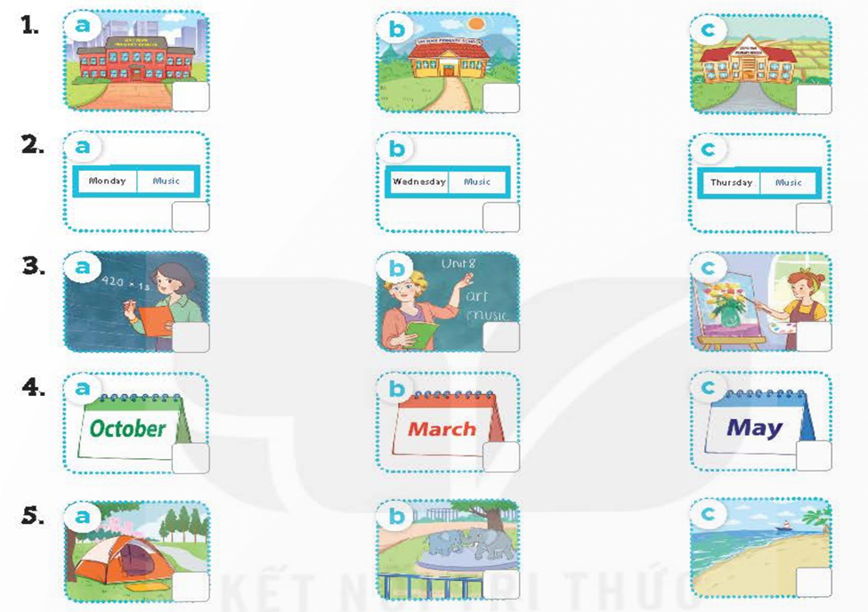
R

Task 2. Listen and number (1pt) (nghe và đánh số)


II.VOCABULARY AND GRAMMAR
Task 3 :choose the right word. (1pt) (chọn từ đúng)
1.I can _______ a horse.
- ride B. play C. swim D. drive
2. ____ is your sports day? – It’s in May.
A. How B. When C. Who D. What
3. When is your ________? – It’s on the first of November.
A. book B. birthday C. nationality D. national
4. They are from Australia, so they are _______.
- American B. England C. Britain D. Australian

Task 4 : Read and match (1pt) (đọc và nối)
- What time is it? A. It’s in May.
- When’s your birthday? B. It’s Monday.
- What day is it today? C. I have English, PE, Vietnamese and IT.
- What subjects do you have today? D. It’s seven o’clock.

Keys: 1. ----- 2.----- 3.----- 4.-----
III. READING
Task 5: Read and complete (1pt) ( đọc và hoàn thành)
has; school; playground; favorite; study; town;
Hi, I'm Rose. This is my (0) school with two buildings. It's in the (1)................ There are two gardens and a (2)............... in my school. Here is our music room. We (3)................... Music here on there on Fridays. My school has an art room. We study Art on Wednesdays. It's one of my (4).......... subjects. It's really fun.
Task 6: Read the sentences and check T (True) or F (False) (1pt).
My name is Annie. I’m nine years old. I live in a big city. I can ride a bike but I can’t swim. Every Monday, I play football with my brother. Every Tuesday, I sing English songs with my friends at school. On Wednesdays, I help my mum do housework. On Thursdays, I roller skate in the park. Every Friday, I ride a bike.
 | T | F
1. Annie sings English songs on Tuesdays.

2. Annie lives in a village.
3. Annie can swim.
4. Annie does housework with her mum every Thursday.
IV.WRITING:
Task 7:Put the words in order to make sentences( 1pt) ( sắp xếp thành câu)
- she / from? / is / Where/
________________________________________________________
- day/ is /it / What / today/ ?
_________________________________________________________
- English / IT/ today. / have / I / and
_________________________________________________________
- Music. / is / favourite/ My/ subject /
__________________________________________________________

Task 8: Look and write (1pt) ( nhìn và viết)

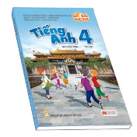
1. I can _________________ 2. I have___________ on Mondays and Tuesdays.

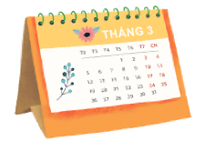
3.My birthday is in ________________ 4. I want to be ___________

