Week 17 Preparing date: December 29th 2024
Period 65 Teaching date: December 30th , 2024

Unit 10: Our summer holidays
Lesson 2 (4, 5, 6)
A. OBJECTIVES:
By the end of the lesson, Ss will be able to:
1. Knowledge:
- use the phrases Bangkok, London, Sydney and Tokyo in relation to the topic “Our summer holidays”
- someone was in the past; listen to and demonstrate understanding of simple communicative contexts in relation to the topic “Our summer holidays”.
- Vocabulary: Review
- Skills: speaking, listening, reading and writing.
2. Competences:
- Critical Thinking: look, complete and read
- Co-operation: ready to help friends in pair work/ group work.
- Self-control and independent learning: perform listening tasks.
3. Attitude/ Qualities:
- Honesty: tell the truth about feelings and emotions.
- Diligence: complete learning tasks.
B. TEACHING AIDS:
- Teacher: Teacher’s guide Pages 145, 146; audio Tracks 103; website hoclieu.vn, posters, laptop, pictures, textbook, lesson plan, TV or projector.
- Students: Pupil’s book Page 71, notebooks, workbooks, school things.
C. PROCEDURES:
Teacher’s activities | Students’ activities
1.Warm- up: (5’)  Game: Who says fast?  *Aims: to create a friendly and active atmosphere in the class to beginning the lesson.  *Procedure:  - Hold a places card, then reveal it slowly.  - Ask Where was you last summer?  - Ask the Ss guess the answer as fast as possible.  - Then have Ss do the same with the rest.  - This can be played in groups to make it more interesting.  - Say “Open your book page 71” and look at “Unit 10, Lesson 2 (4,5,6)”.  2.Practice: (27’)  Activity 1. Listen and match:  *Aims: Ss will be able to listen to and understand four communicative contexts about where someone was in the past and match the correct pictures.  *Procedure:  - Elicit the action of the character in each picture.  + Who are they?  + Which places are they?  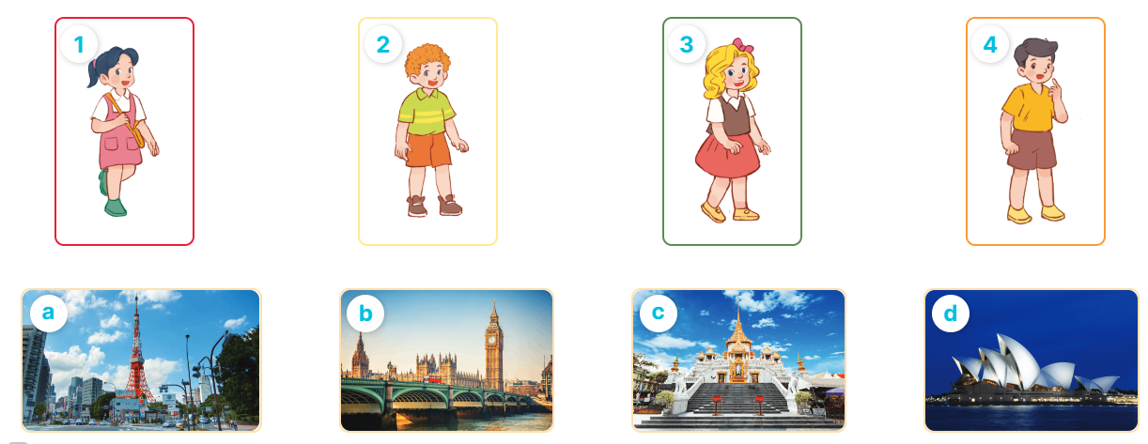  - T ask Ss to guess the answers.  + T writes Ss’guessing on the board.  - Listen to the tape:  + Play the recording  + Play the recording again and get Ss to swap books with their partners.  + Play the recording again to check answers together as a class.  + Write the answers on the board for Ss to correct their answers. Then checks Ss’ guessing.  - Play the recording, sentence by sentence, for the class to listen and repeat in chorus.  Key: 1. d 2. c 3. a 4. b  Activity 2. Look, complete and read  *Aims: Ss will be able to complete two gapped dialogues with the help of picture cues.  *Procedure:  - Get Ss to look at the pictures and identify the characters and the places in the pictures.  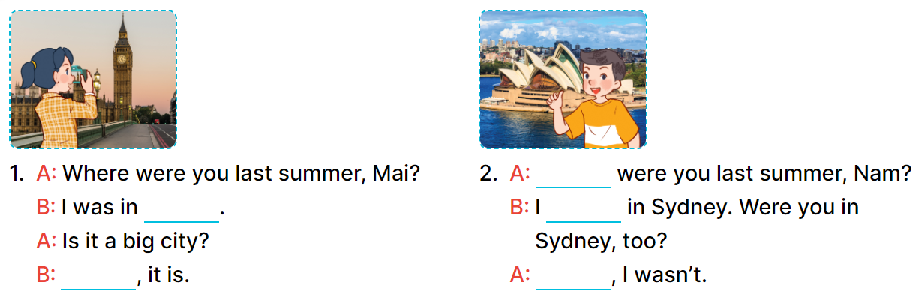  - Have Ss look at the first sentence and the pictures. Elicit and model with number 1: I was in London.  + Ask Ss read and complete the sentence.  -Have Ss work in pairs and complete the other gaps  - Ask a few Ss to stand up and read the sentences aloud.  -T gives feedbacks.  Key:  1. London, Yes 2. Where, was, No  Activity 3. Let’s play  *Aims: Ss will be able to review target words to make sentences about where someone was in the past by playing the game Making sentences.  *Procedure:  - Tell pupils that they are going to play the game Making sentences in groups of four or five.  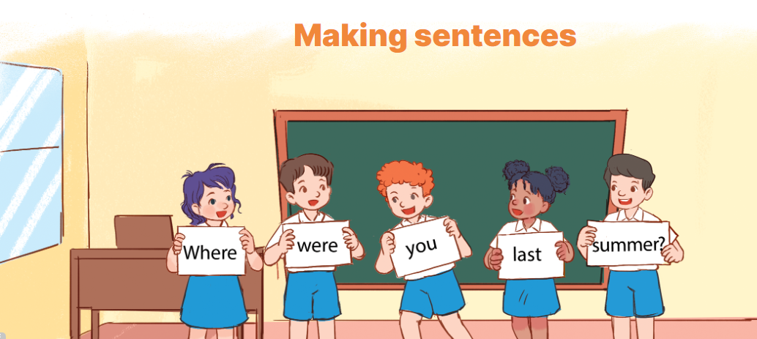  - Nominate one pupil in each group as a leader.  + The leader says a sentence and the other group members have to stand in a line, holding the word cards to make a sentence. Example: Where were you last summer?  - Have pupil work in groups to play the game.  - Invite two groups to the front of the class to play the game.  - Have the class give comments and announce the winner.  - The group that makes most correct sentences will win.  *Consolidation  *Aims: Ss will be able consolidate and wrap up the content of the lesson.  *Procedure:  - T asks ss to answer the following questions:  + What have you learnt from the lesson today?  +What are the core values of the lesson? (if the teacher can take from the lesson).  - T praises some Ss who are hardworking / active/ good…. as well as encourage others to try more.  3. Homework. (3’)  - Practice part 5 again.  - Prepare the new lesson: Unit 10, Lesson 3 (1,2,3). | - Ss listen  - Ss play game  -Ss play game  - Ss open their books  -Look at the pictures and say:  1. Mai 2. Bill 3. Mary 4. Nam  + Picture a. Tokyo Tower  + Picture b. Big Ben  + Picture c. Temple of the Golden Buddha  + Picture d. Opera House  -Ss guess the answers  - Ss listen to the tape and match  - Ss listen again, match and swap books with their partners.  -Ss listen again and check together  - Ss check their answers and guessing  -Ss listen and repeat.  -Ss look at the picture and say  -Ss look and answer  -Ss read and complete  -Ss work in pairs and do the task  -Ss read aloud  -Ss listen and pay attention  -Ss listen  - Ss listen  -Ss play the game  - Ss play the game  -Ss answer the questions  -Ss listen and clap their hands  -Ss listen and take note
D. ADJUSTMENTS (if necessary):
………………………………………………………………………………………….…..……………………………………………………………………………...………………………………………….…..……………………………………………………………………………….……………………………………………………………………...

Week 17 Preparing date: December 29th 2024
Period 66 Teaching date: December 30th , 2024

Unit 10: Our summer holidays
Lesson 3 (1, 2, 3)
A. OBJECTIVES:
By the end of the lesson, Ss will be able to:
1. Knowledge:
- correctly repeat the sounds of the letter ere in isolation, in the words were and where, and in the sentences Were you on the beach last summer? and Where were you last weekend? with correct pronunciation and intonation.
- identify the target words were and where while listening.
- listen to and demonstrate understanding of simple communicative contexts in relation to the topic “Our summer holidays”
- say the chant with the correct rhythm and pronunciation.
- Vocabulary: Review
- Skills: speaking, listening, reading and writing.
2. Competences:
- Co-operation: ready to help friends in pair work/ group work.
- Sociability: Talk to each other, say good words to others.
3. Attitude/ Qualities:
- Kindness: Help partners to complete learning tasks.
- Honesty: tell the truth about feelings and emotions
B. TEACHING AIDS:
- Teacher: Teacher’s guide Pages 147, 148; audio Tracks 104, 105, 106; website hoclieu.vn, posters, laptop, pictures, textbook, lesson plan, TV or projector.
- Students: Pupil’s book Page 72, notebooks, workbooks, school things.
C. PROCEDURES:
Teacher’s activities | Students’ activities
1.Warm- up: (5’)  Sing a song: If you’re happy and you know it  *Aims: to create a friendly and active atmosphere in the class to beginning the lesson.  *Procedure:  - Show the song in the screen  https://www.youtube.com/watch?v=zyMWcWqmhRc  - Have pupils to sing and dance together  - Say “Open your book page 72” and look at “Unit 10, Lesson 3 (1,2,3)”.  2. Presentation (9’)  Activity 1. Listen and repeat:  *Aims: Ss will be able to correctly repeat the sounds of the letter ere in isolation, in the words were and where, and in the sentences Were you on the beach last summer? and Where were you last weekend? with correct pronunciation and intonation.  *Procedure:  - T gives instruction to the letter ere, the words were and where, and in the sentences Were you on the beach last summer? and Where were you last weekend?  - Play the recording for the letter ere.  - Encourage Ss to point at the letter/ word/ sentence while listening.  - Play the recording again and encourage Ss to listen and repeat.  - Do this several times until Ss feel confident.  - T calls some Ss to practice.  - T gives feedbacks.  3.Practice: (19’)  Activity 2. Listen and circle.  *Aims: Ss will be able to identify the target words were and where while listening.  *Procedure:  - Explain that they have to listen to the recording and circle the correct options.  - Play the recording for pupils to listen.  - Play the recording again for them to listen and circle the correct options.  - Tell pupils to swap books with a partner, then check the answers together as a class. - Write the correct answers on the board.  - Play the recording again for pupils to double-check their answers.  - Invite one or two pupils to stand up, listen to and repeat the sentences.  Key: 1.b 2.c  Activity 3. Let’s chant  *Aims: Ss will be able to say the chant with the correct rhythm and pronunciation  *Procedure:  - Introduce the title and lyrics of the chant.  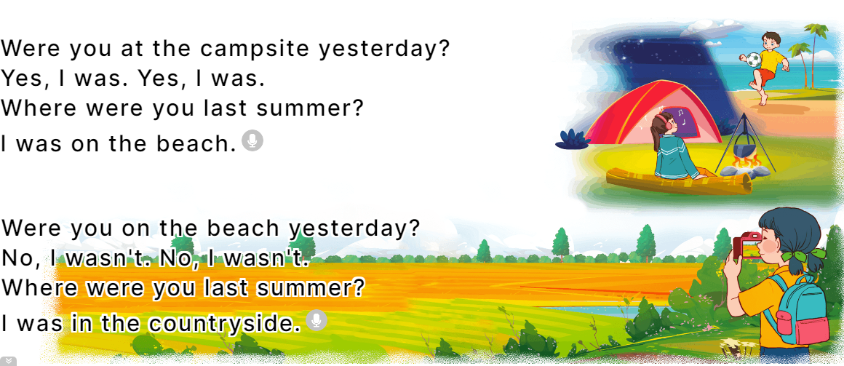  - Play the recording for Ss to listen to the whole chant.  + Have them repeat the title and lyrics line by line.  + Ask Ss to attend to the sounds of the letters ere and the words were and where.  - Play the recording all the way through for Ss to listen to pronunciation and melody.  - Play the recording line by line for Ss to listen and repeat  - Play the recording for Ss to chant and clap along.  - Ask Ss to practice chant and clap along in pairs or groups.  - Invite groups to the front of the classroom to perform the chant  -T gives feedback.  *Consolidation  *Aims: Ss will be able consolidate and wrap up the content of the lesson.  *Procedure:  - T asks ss to answer the following questions:  + What have you learnt from the lesson today?  +What are the core values of the lesson? (if the teacher can take from the lesson).  - T praises some Ss who are hardworking / active/ good…. as well as encourage others to try more.  4. Homework. (2’)  - Practice the chant more.  - Prepare the new lesson: Unit 10, Lesson 3 (4, 5, 6). | - Ss listen  -Ss sing and dance  - Ss open their books  - Ss recognize the differences about color of letter  - - Ss listen  - Ss listen and point  - Ss listen again and repeat  -Ss listen again and repeat  -Ss practice  -Ss listen  -Ss listen and pay attention  -Ss listen to the tape  - Ss listen to the tape and circle  - Ss listen again, circle and swap books with their partners.  - Ss write the correct answer  - Ss check their answers  -Ss listen and repeat.  - Ss look and listen.  -Ss listen to the chant  - Ss listen and repeat line by line without clap their hands  -Ss note the sounds, words  -Ss listen to melody of the chant  - Ss listen and chant line by line.  - Ss chant and clap along.  - Ss work in groups (two groups) to chant  -Ss perform in front of the class.  -Ss listen  -Ss answer the questions  -Ss listen and clap their hands  -Ss listen and take note

D. ADJUSTMENTS (if necessary):
………………………………………………………………………………………….…..……………………………………………………………………………...……………
Week 17 Preparing date: December 29th 2024
Period 67 Teaching date: December 31st , 2024

Unit 10: Our summer holidays
Lesson 3 (4, 5, 6)
A. OBJECTIVES:
By the end of the lesson, Ss will be able to:
1. Knowledge:
- read and write about if someone was somewhere and where someone was in the past.
- make a mind map of where pupils were on holiday in the previous summer and present the results to the class at Project time.
- Vocabulary: Review
- Skills: speaking, listening, reading and writing.
2. Competences:
- Critical thinking: complete a task in reading a text.
- Co-operation: ready to help friends in pair work/ group work.
- Self-control and independent learning: perform listening tasks.
3. Attitude/ Qualities:
- Show pride in the travelling experience in their summer holidays.
B. TEACHING AIDS:
- Teacher: Teacher’s guide Pages 149, 150; website hoclieu.vn, posters, laptop, pictures, textbook, lesson plan, TV or projector.
- Students: Pupil’s book Page 73, notebooks, workbooks, school things.
C. PROCEDURES:
Teacher’s activities | Students’ activities
1.Warm- up: (5’)  Game: “Chant”  *Aims: to review the vocabulary and structure about greet and respond to greetings.  *Procedure:  - Ask Ss chant and do the actions in Unit 10, Lesson 3 page 66 in groups.  - Give point for the groups and encourage them.  - Say “Open your book page 73” and look at “Unit 10, Lesson 3 (4, 5, 6)”.  2.Practice: (8’)  Activity 1. Read and complete:  *Aims: Ss will be able to read two texts and complete the sentences about Mai’s and Tony’s summer holiday.  *Procedure:  - Elicit Sentence 1 about the location, Sentence 2 about the description of Ha Long Bay, Sentence 3 about the people in London, and Sentence 4 about Mai’s and Tony’s feelings of their summer holidays.  - Have pupils read the texts to find the information and complete four sentences.  - Have pupils work in pairs and do the task  - Get pupils to swap their answers with a partner.  - Check answers together as a class.  Key: 1. Ha Long Bay. 2. beautiful.  3. helpful 4. great.  3.Production: (19’)  Activity 2. Let’s write  *Aims: Ss will be able to read and complete a gapped paragraph about where someone was on holiday in the previous summer *Procedure:  - Check comprehension and elicit to Ss read the gapped text and fill in the gaps.  - Let Ss read the gapped text and fill in the gaps.  - Have Ss complete the first gap together as an example: I am Huong.  - Ask Ss to look at the gap and ask them what is missing. Then let them identify the the name. After that, let them write down the suitable word in the gap.  - Give Ss time to complete the text independently.  - In pairs or groups, ask Ss to swap their complete texts before checking as a class.  - Invite some Ss to come to the board and read the answer.  Key: Pupils’ answer  Example: I am Huong. Last summer, I was on holiday in London with my family. The city was busy. The food was good. The people were friendly. My holiday was great!  Activity 3. Project.  *Aims: Ss will be able to make a mind map of where pupils were on holiday in the previous summer, and use the notes to make a presentation to the class  *Procedure:  - Explain that they have to look at the notes in their mind maps and present the results to the class.  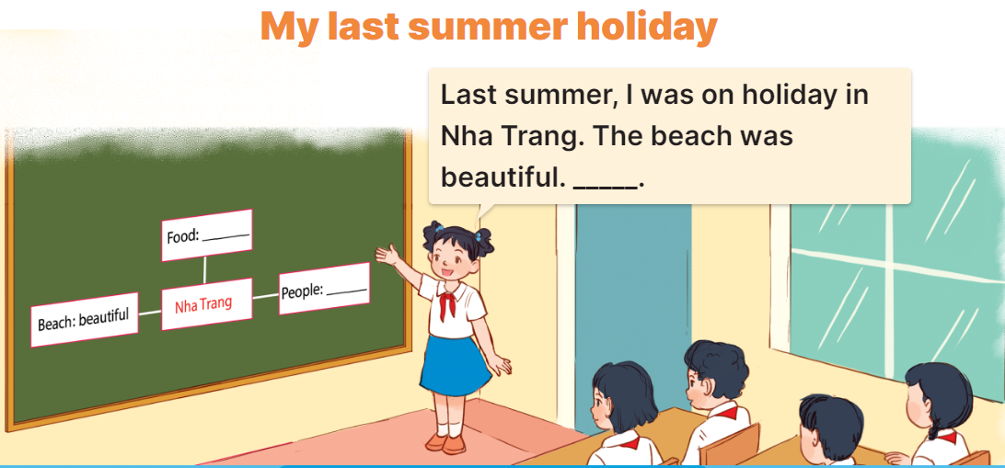  - Have pupils work in groups of five.  + Each pupil looks at the notes in his / her mind map and tells the group about where he / she was on holiday in the previous summer, and describe the place.  - Invite a few pupils to look at the notes in their mind maps and tell the class about them, ex: Last summer, I was on holiday in Nha Trang. The beach was beautiful ...  - Have the rest of the class give comments and praise pupils if they perform well.  *Consolidation  *Aims: Ss will be able consolidate and wrap up the content of the lesson.  *Procedure:  - T asks ss to answer the following questions:  + What have you learnt from the lesson today?  +What are the core values of the lesson? (if the teacher can take from the lesson).  - T praises some Ss who are hardworking / active/ good…. as well as encourage others to try more.  4. Homework. (3’)  - Prepare the new lesson: Review 2 (1, 2). | - Ss listen and chant  - Ss open their books  -Ss read  -Ss read the text and complete  -Ss work in pairs and complete  -Ss swap their answers  -Ss check their answer  -Ss pay attention and read  -Ss read the gapped text  -Ss complete the first gap  -Ss answer and write  - Ss complete the text independently.  -Ss swap the book and check together  -Ss read the answer  - Ss listen and answer  -Ss work in groups and tell about their holiday.  -Ss look at the notes in their mind maps and tall the class.  -Ss clap their hands or congratulation.  -Ss answer the questions  -Ss listen and clap their hands  -Ss listen and take note
D. ADJUSTMENTS (if necessary):
………………………………………………………………………………………….…..……………………………………………………………………………...…………
Week 17 Preparing date: December 29th 2024
Period 68 Teaching date: December 31st , 2024
Review 2
Parts 1, 2
A. OBJECTIVES:
By the end of the lesson, Ss will be able to:
1. Knowledge:
- correctly use the following sentence patterns:
Where’s your school? – It’s in the …...
How many ….. are there at your school? – There is / are …………
What subjects do you have today? – I have ………..
When do you have……….. – I have it on ………..
What’s your favourite subject? – It’s ………
Why do you like ……….? – Because I want to be ………..
Is your sports day in ……….? – Yes, it is. / No, it isn't. It's in ……………
When's your sports day? – It's in ………..
Were you ……..last weekend? – Yes, I was. / No, I wasn't.
Where were you last summer? – I was in ………
- Vocabulary: Review
- Skills: speaking, listening, reading and writing.
2. Competences:
- Co-operation: ready to help friends in pair work/ group work.
- Self-control and independent learning: perform listening tasks.
3. Attitude/ Qualities:
- Kindness: Help partners to complete learning tasks.
- Diligence: complete learning tasks.
B. TEACHING AIDS:
- Teacher: Teacher’s guide Pages 151,152; Track 107, website hoclieu.vn, posters, laptop, pictures, textbook, lesson plan, TV or projector.
- Students: Pupil’s book Page 74, notebooks, workbooks, school things.
C. PROCEDURES:

Teacher’s activities | Students’ activities
1.Warm- up: (5’)  Game: Whispering  *Aims: to review the vocabulary and structure about greet and respond to greetings.  *Procedure:  - Divide class into 2 groups.  -Ask 5 Ss in each group stand in a straight line.  - T says a word or phrase to the first pupil in this line.  - Then, the first pupil whispers what she/ he hear to the second person in line; the second one whispers what he/ she hears to the third one and so on until the last pupil in group hears the word or phrase.  - The last pupil says the word or phrase out loud.  - The faster group has correct word or phrase is the winner.  - Say “Open your book page 74” and look at Review 2.  2.Practice: (27’)  Activity 1. Listen and tick:  *Aims: Ss will be able to listen to and understand five communicative contexts in which characters talk about familiar topics such as our school, our timetable, my favourite subjects, our sports day, our summer holidays and tick the correct pictures.  *Procedure:  - Elicit the words or phrases to describe the pictures in each option.  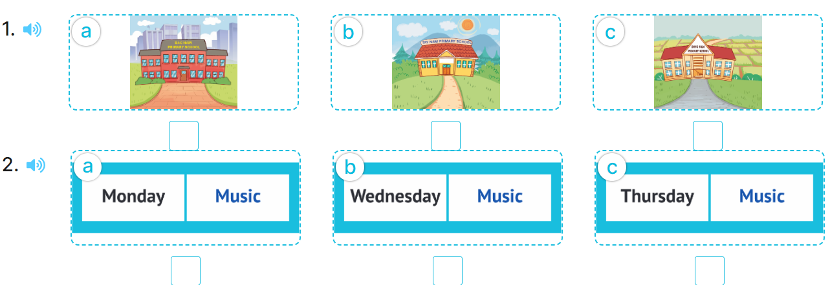  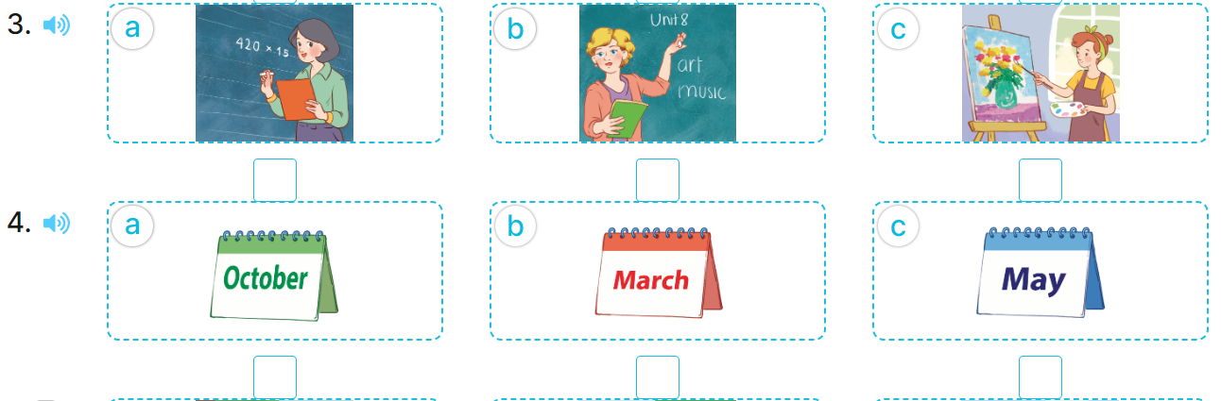  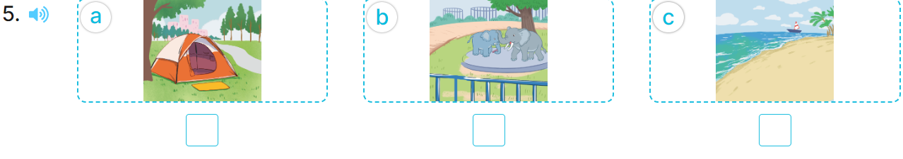  - T ask Ss to guess the answers.  + T writes Ss’guessing on the board.  - Listen to the tape:  + Play the recording  + Play the recording again and get Ss to swap books with their partners.  + Play the recording again to check answers together as a class.  + Write the answers on the board for Ss to correct their answers. Then checks Ss’ guessing.  - Play the recording, sentence by sentence, for the class to listen and repeat in chorus.  Key: 1. b 2. c 3. b 4. c 5. b  Activity 2. Ask and answer  *Aims: Ss will be able to ask and answer questions using picture cues or personal information.  *Procedure:  - Elicit the content and context of each picture.  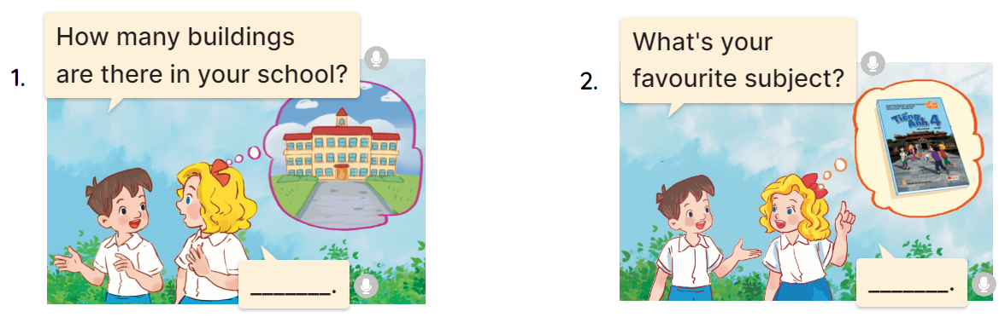  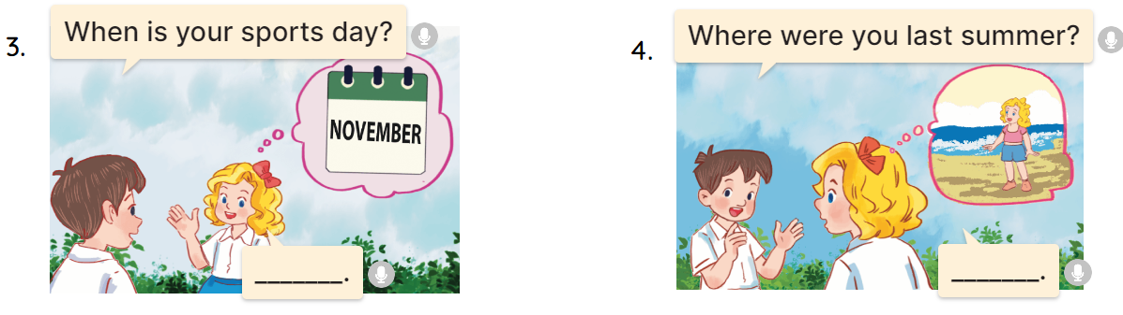  - Draw pupils’ attention to the first question and read it in chorus.  - Elicit the answer and give feedback.  - Have pupils to role-play the exchange.  - Give pupils role-play the four exchanges.  - Invite a few pairs of pupils to stand up and take it in turns to role-play the target exchanges.  * Game: Play game (ppt)  - Play the game “chain game”.  + Divide the class into a lot of groups. There are four or five pupils in each group.  + T says a sentence. Then, the first pupil repeats teacher’s sentence and adds to it. Next, the second pupil repeats what the first pupil has said and adds to it, ect.  - T gives feedback by a game  *Consolidation  *Aims: Ss will be able consolidate and wrap up the content of the lesson.  *Procedure:  - T asks ss to answer the following questions:  + What have you learnt from the lesson today?  +What are the core values of the lesson?  - T praises some Ss who are hardworking / active/ good…. as well as encourage others to try more.  3. Homework. (3’)  - Prepare the new lesson: review 2 (3,4,5) | - Ss listen  -Ss play game  - Ss open their books  -Look at the pictures and say:  + Picture 1a. a school in a city  + Picture 1b. a school in the mountains  + Picture 1c. a school in a village  + Picture 2a. a timetable having music on Monday  + Picture 2b. a timetable having music on Wednesday  + Picture 2c. a timetable having music on Thursday  + Picture 3a. a Math teacher  + Picture 3b. an English teacher  + Picture 3c. a painter  + Picture 4a. a calendar of October  + Picture 4b. a calendar of March  + Picture 4c. a calendar of May  + Picture 5a. a tent  + Picture 5b. a zoo  5c. a beach  -Ss guess the answers  - Ss listen to the tape and tick  - Ss listen again, tick and swap books with their partners.  - Ss check their answers and guessing  -Ss listen and repeat.  -Look at the pictures  -Ss pay attention and read  - Ss answer the question  - Ss ask and answer  - Ss ask and answer  -Ss role play  -Ss listen and play game  -Ss listen and answer  -Ss listen and clap their hands  -Ss listen and take note
D. ADJUSTMENTS (if necessary):
………………………………………………………………………………………….…..……………………………………………………………………………...…………..

