Week 10 Preparing date: November 10th , 2024
Period 37 Teaching date: November 11th , 2024

Extension activities
A. OBJECTIVES:
By the end of the lesson, Ss will be able to:
1. Knowledge:
- take part in fun activities to apply their language knowledge and competences.
- Vocabulary: Review
- Skills: speaking, writing and listening
2. Competences:
- Co-operation: ready to help friends in pair work/ group work.
- Sociability: Talk to each other, say good words to others.
3. Attitude/ Qualities:
- Kindness: Help partners to complete learning tasks.
- Honesty: tell the truth about feelings and emotions
B. TEACHING AIDS:
- Teacher: Teacher’s guide Pages 76, 77; website hoclieu.vn, posters, laptop, pictures, textbook, lesson plan, TV or projector.
- Students: Pupil’s book Page 42, 43, notebooks, workbooks, school things.
C. PROCEDURES:
Teacher’s activities | Students’ activities
1.Warm- up: (3’)  Sing: Head, shoulders, knees and toes  *Aims: to create a friendly and active atmosphere in the class to beginning the lesson.  *Procedure:  - Show the song on the screen.  https://www.youtube.com/watch?v=WX8HmogNyCY  - Ask Ss to listen, sing and dance the song.  - Say “Open your book page 42, 43” and look at “Extension activites”.  2. Practice (30’)  Activity 1. Look and write  *Aims: Ss will be able to identify five different countries in the pictures.  *Procedure:  - Have Ss look at the pictures and ask  + What do you see in the pictures?  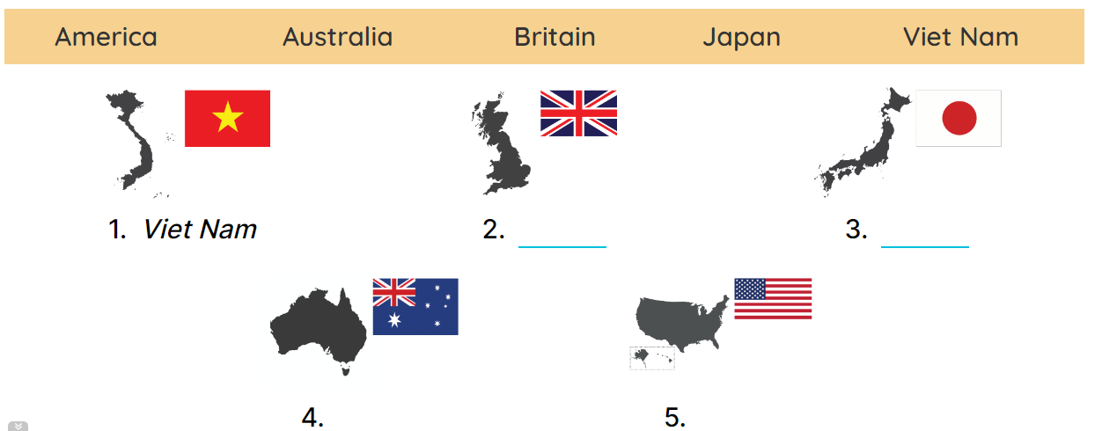  - Draw pupils’ attention to the pictures.  - Ask Where is Viet Nam? and encourage pupils to point to it. Write Viet Nam on the board.  - Point and ask about the other pictures: England, Japan, Australia and America.  - Have pupils complete the activity by writing the name next to each country.  - Check answers together as a class.  Key: 1. Viet Nam 2. England  3. Japan 4. Australia 5.America.  Activity 2. Look and write  *Aims: Ss will be able to identify the different times in different countries.  *Procedure:  - Have pupils look at the clocks. 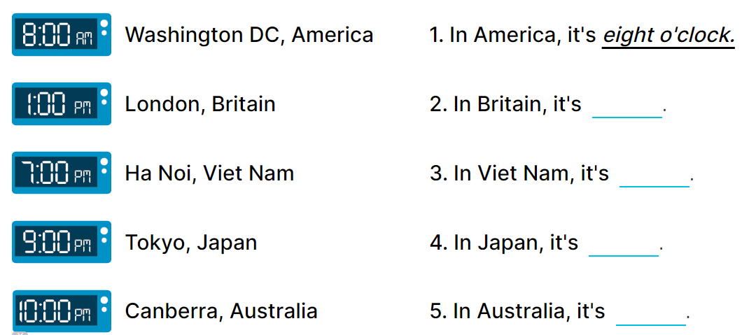  - Draw pupils’ attention to the different times in different countries.  - Write In America, it’s _____. on the board.  -Read the first part of the sentence aloud and encourage pupils to complete it. When pupils answer correctly, write the answer on the board: 8:00 AM.  - Have pupils work in pairs and complete the activity by completing the sentences.  - Check answers as a class.  Key: 1. 8:00 AM 2. 1:00 PM  3. 7:00 PM 4. 9:00 PM  5. 10:00 PM  Activity 3. Read the questions. Then tick the answers.  *Aims: Ss will be able to read the questions and tick the correct answers, then say what countries are near / far from Viet Nam.  *Procedure:  - Draw pupils’ attention to Question 1 and read it as a class.  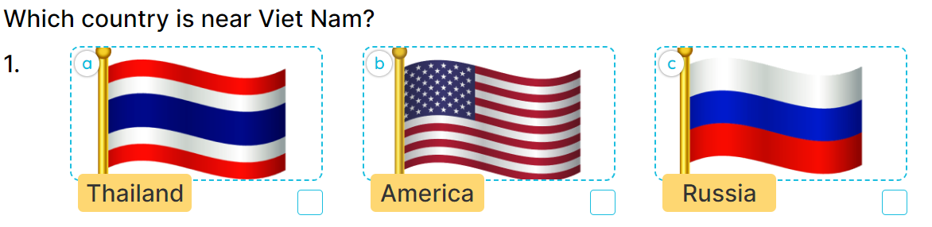  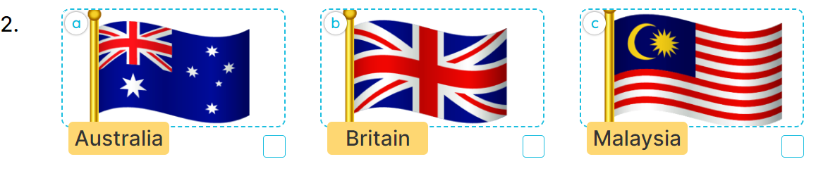  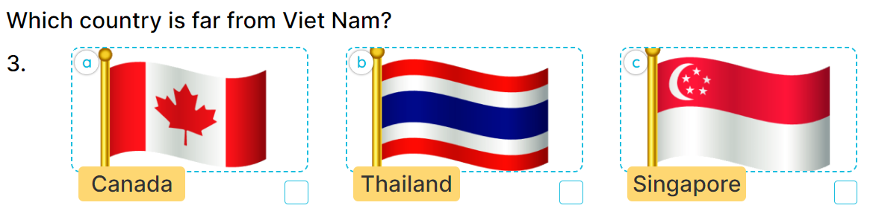  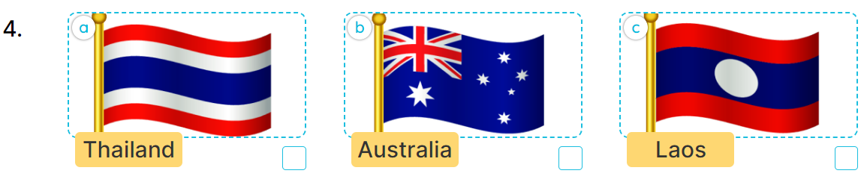  - Ask pupils to look at Answer A with three answer options a, b and c.  - Explain the new word Russia. Get them to look at the flags of Thailand, America and Russia, elicit the right answer and tick it (Picture a).  - Repeat the same procedure with Answer B and question 2.  - Get pupils to swap books with a partner, then check answers together as a class.  - Write the correct answers on the board for pupils to correct their answers.  - Have pupils say the answers by asking them Questions 1 and 2  Key: 1. A. It’s Thailand. B. It’s Malaysia  . 2. A. It’s Canada. B. It’s Australia.  *Consolidation  *Aims: Ss will be able consolidate and wrap up the content of the lesson.  *Procedure:  - T asks ss to answer the following questions:  + What have you learnt from the lesson today?  +What are the core values of the lesson? (if the teacher can take from the lesson).  - T praises some Ss who are hardworking / active/ good…. as well as encourage others to try more.  3. Homework. (2’)  - Prepare the new lesson: Unit 6, Lesson 1 (1,2,3). | - Ss listen  - Ss sing a song  -Ss open the book  -Ss look at the picture and answer  - - Ss note  -Ss answer  -SS point and answer  -Ss do the task  -Ss check their answer  -Ss look at the clocks  -Ss pay attention  -Ss listen and answer  -Ss answer  -Ss complete the sentences  -Ss check their answers  - Ss look, listen and answer  - Ss answer  -Ss listen and answer  -Ss do the task  -Ss swap books and check their answer.  -Ss write the correct answer on the board  - Ss ask and answer the questions  -Ss answer the questions  -Ss listen and clap their hands  -Ss listen and take note

D. ADJUSTMENTS (if necessary):
………………………………………………………………………………………….…..……………………………………………………………………………...………………………………………….…..……………………………………………………………………………….……………………………………………………………………...
Week 10 Preparing date: November 10th , 2024
Period 38 Teaching date: November 11th , 2024

Unit 6: Our school facilities
Lesson 1 (1, 2, 3)
A. OBJECTIVES:
By the end of the lesson, Ss will be able to:
1. Knowledge:
- use the words city, mountains, town, village in relation to the topic "Our school facilities".
- use Where’s your school? – It’s in the …………. to ask and answer questions about the location of a school;
-listen to and demonstrate understanding of simple communicative contexts in relation to the topic “Our school facilities”.
- read and write about school locations
- Vocabulary: city, mountains, village, town
- Skills: speaking and listening
2. Competences:
- Co-operation: ready to help friends in pair work/ group work.
- Sociability: Talk to each other, say good words to others.
3. Attitude/ Qualities:
- Kindness: Help partners to complete learning tasks.
- Honesty: Show pride in where they’re from and great respect for other people’s locations by using appropriate gesture and intonation when asking and answering about school locations.
B. TEACHING AIDS:
- Teacher: Teacher’s guide Pages 78,79, audio Tracks 58, 59, website hoclieu.vn, posters, laptop, pictures, textbook, lesson plan, TV or projector.
- Students: Pupil’s book Page 44, notebooks, workbooks, school things.
C. PROCEDURES:
Teacher’s activities | Students’ activities
1.Warm- up: (3’)  Sing: Jigsaw puzzle  *Aims: to create a friendly and active atmosphere in the class to beginning the lesson.  *Procedure:  - Divide class into 4 groups: Tom, Jerry, Miu and Chit.  - Ask Ss look at the pieces of picture.    - Ask Ss go to the board and jigsaw puzzle into the correct picture.  -T checks who’s the winner?  - Say “Open your book page 44” and look at “Unit 6, Lesson 1 (1,2,3)”.  2. Presentation (16’)  Activity 1. Vocabulary.  *Aims: Ss will be able to know the vocabulary in the new lesson.  *Procedure:  -T elicits the new words  + city : thành phố (picture)  + mountain : vùng núi (picture)  + town :thị trấn (picture)  + village : ngôi làng (picture)  - T models (3 times).  - T writes the words on the board.  - Checking: Matching  Activity 2. Look, listen and repeat:  *Aims: Ss will be able to understand and correctly repeat the sentences in two communicative contexts focusing on asking and answering questions about the location of a school.  *Procedure:  - Have Ss look at Pictures a and b and guess the locations of the schools.  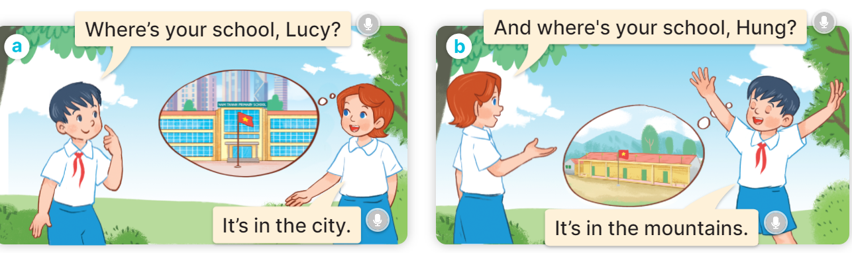  - Play the audio twice (sentence by sentence). Correct their pronunciation where necessary.  - Have Ss to practice the dialogue  - T invites a few pairs to the front of the class to practice.  - T checks pronunciation for ss.  Activity 3 Listen, point and say.  *Aims: Ss will be able to correctly say the words and use Where’s your school? – It’s in the ……….. to ask and answer questions about the location of a school.  *Procedure:  * Model sentences:  - T asks Ss look at picture a and helps Ss know the structure from the dialogue.  - T introduces new structure for Ss.  - T explains, models and gives meaning.  -Have Ss repeat the model sentences.  A: Where is your school?  B: It’s in the village.  3.Practice: (7’)  *Drill pictures  - Elicit and check comprehension the places of school  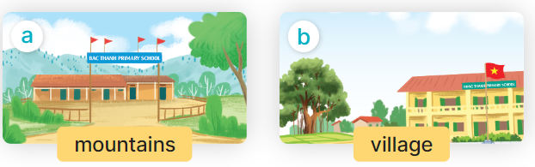  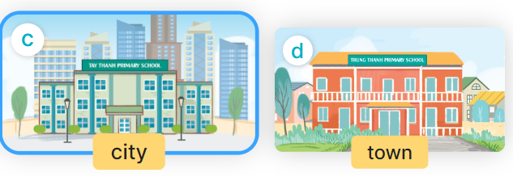  - Run through all the pictures.  - Run through model sentences.  +Run through the question sentences  +Run through the answer sentences  - Have Ss to practise:  + T asks, Ss answer picture a  + Ss ask, T answers picture b  + Group A ask, group B answer picture c  + Group B ask, group A answer picture d  - Ask Ss to work in pairs.  - T controls and corrects.  - Invite a few pairs to come to the front of the classroom and point at the pictures and say the questions and answers in front of the class.  - T gives feedbacks.  4.Production: (7’)  Activity 4. Let’s talk.  *Aims: Ss will be able to enhance the correct use of Where’s your school? – It’s in the ……. to ask and answer questions about the location of a school in a freer context *Procedure:  - Have Ss look at the picture and elicit the question and the answer in context.  + What can you see in the picture?  + How many places are there?  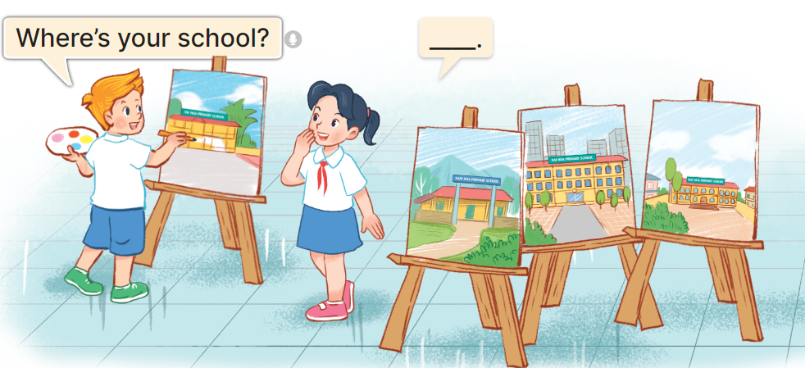  - Ask pupils to look at the second bubble and identify what the answer should be.  -Give an example answer It’s in the village. - Get pupils to repeat the question and the answer several times.  - Have pairs of pupils practise asking and answering questions about the locations of the schools in the paintings.  - Invite some pairs of Ss to the front of the class to perform their conversations.  *Consolidation  *Aims: Ss will be able consolidate and wrap up the content of the lesson.  *Procedure:  - T asks ss to answer the following questions:  + What have you learnt from the lesson today?  +What are the core values of the lesson? (if the teacher can take from the lesson).  - T review the vocabulary and model sentences.  - T praises some Ss who are hardworking / active/ good…. as well as encourage others to try more.  5. Homework. (2’)  - Learn the vocabulary and model sentences by heart  - Prepare the new lesson: Unit 6, Lesson 1 (4,5,6). | - Ss listen  -Ss look at the pieces of the picture  -Ss put into the correct picture  -Ss check  - Ss open their books  -Ss listen and answer  - - Ss listen and repeat  + Choral repetition (3 times).  + Individual repetition (3 ss)  - Ss take note  - Ss look, remember and match  -Look at the pictures and say  + In picture a:  Hung: Where’s your school, Lucy?  Lucy: It’s in the city  + In picture b:  Lucy: And where’s your school, Hung?  Hung: It’s in the mountains  -Ss listen and repeat in chorus (twice)  -Ss work in pairs to practice  -Ss practice the dialogue  -Ss listen  -Ss look at the picture and answer.  -Ss listen  -Ss listen and repeat  -Ss repeat to the place  - Ss look, listen and answer  + Picture a. a school in the mountains  + Picture b. a school in the village  + Picture c. a school in the city  + Picture d. a school in the town  -Ss listen and repeat  -Ss practice in chorus  -Ss work in pairs to practice  -Ss point and say  -Ss listen.  -Ss look at the picture and answer  + I can see 4 places…  + There are 4 pictures  -Ss look and answer  -Ss pay attention and answer  -Ss repeat and answer  -Ss work in pairs to ask and answer  -Ss perform in front of the class.  -Ss answer the questions  - Ss listen  -Ss listen and clap their hands  -Ss listen and take note
D. ADJUSTMENTS (if necessary):
………………………………………………………………………………………….…..……………………………………………………………………………...………………………………………….…..……………………………………………………………………………….……………………………………………………………………...
Week 10 Preparing date: November 10th , 2024
Period 39 Teaching date: November 13th , 2024
Unit 6: Our school facilities
Lesson 1 (4, 5, 6)
A. OBJECTIVES:
By the end of the lesson, Ss will be able to:
1. Knowledge:
- use the words city, mountains, town, village in relation to the topic "Our school facilities";
- use Where’s your school? – It’s in the ……. to ask and answer questions about the location of a school;
- listen to and demonstrate understanding of simple communicative contexts in relation to the topic “Our school facilities”.
- read and write about school locations
- Vocabulary: Review
- Skills: speaking, listening, reading and writing.
2. Competences:
- Critical Thinking: self-introduce
- Co-operation: ready to help friends in pair work/ group work.
- Self-control and independent learning: perform listening tasks.
3. Attitude/ Qualities:
- Kindness: Help partners to complete learning tasks.
- Honesty: tell the truth about feelings and emotions.
- Diligence: complete learning tasks.
B. TEACHING AIDS:
- Teacher: Teacher’s guide Pages 80,81,82; audio Tracks 60; website hoclieu.vn, posters, laptop, pictures, textbook, lesson plan, TV or projector.
- Students: Pupil’s book Page 45, notebooks, workbooks, school things.
C. PROCEDURES:
Teacher’s activities | Students’ activities
1.Warm- up: (5’)  Game: play the Doraemon Game ( ppt)  *Aims: to create a friendly and active atmosphere in the class to beginning the lesson.  *Procedure:  - Divide the class into 3 teams.  - Pupils from each team choose a letter, then answer the question  - Pupils answer correctly get some points corresponding to the number of pies.  - Say “Open your book page 45” and look at “Unit 6, Lesson 1 (4,5,6)”.  2.Practice: (27’)  Activity 1. Listen and number:  *Aims: Ss will be able to listen to and understand four communicative contexts in which pupils ask and answer questions about school locations and number the correct pictures.  *Procedure:  - Point at the pictures respectively to explain the context.  + How many pictures are there?  + What can you see in each picture?  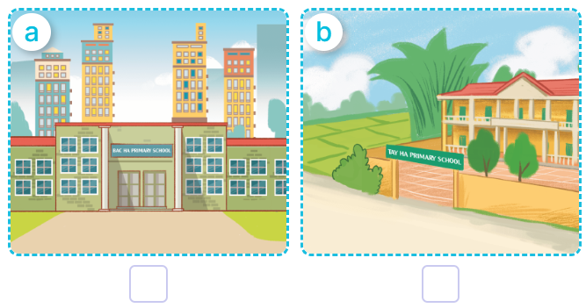  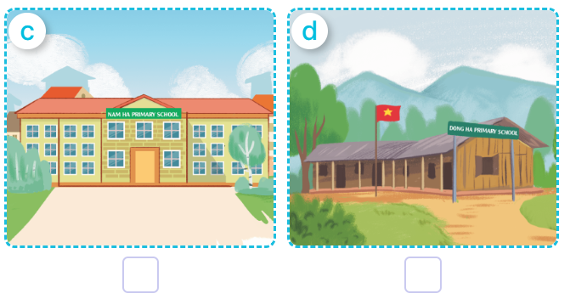  - T ask Ss to guess the answers.  + T writes Ss’guessing on the board.  - Listen to the tape:  + Play the recording  + Play the recording again and get Ss to swap books with their partners.  + Play the recording again to check answers together as a class.  + Write the answers on the board for Ss to correct their answers. Then checks Ss’ guessing.  - Play the recording, sentence by sentence, for the class to listen and repeat in chorus.  Key: 1. c 2. d 3.a 4.b  Activity 2. Look, complete and read  *Aims: Ss will be able to complete four target gapped exchanges with the help of picture cues  *Procedure:  - Ask pupils to look at the pictures and identify the school locations in the four pictures.  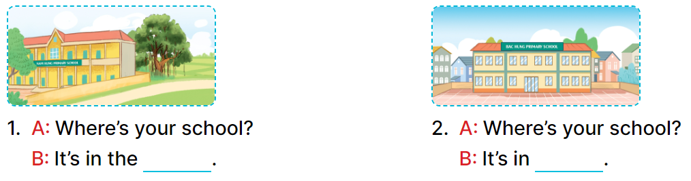  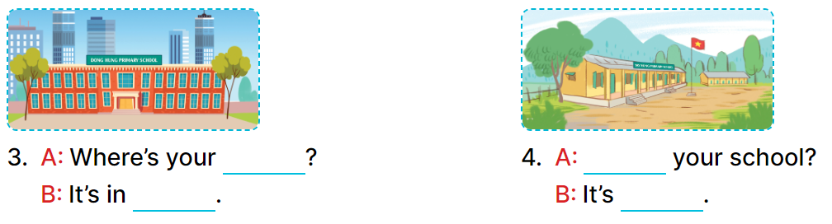  - Have Ss look at the four dialogue and the pictures. Elicit and model with picture 1  + Ask Ss to read the sentence 1 in chorus.  + Ask them what is missing in the question (village). Then have them complete the gap (Is It’s in the village).  -Have Ss work in pairs and complete the dialogue 2, 3, 4.  - Ask a few Ss to stand up and read the sentences aloud.  -T gives feedbacks.  Key:  1. village 2. the town  3. school, the city  4. Where’s, in the mountains  Activity 3. Let’s play  Matching pairs  *Aims: Ss will be able to review the words mountains, village, city and town by playing the game Matching pairs.  *Procedure:  -Tell pupils that they are going to find four pairs of pictures and words as quickly as possible.  - Stick the picture cards face down in the left column on the board. Stick the word cards face down in the right column on the board.  - Invite one pupil to play the game by selecting a picture card and a word card, turning them over.  + If two cards are a matching pair, ask the pupil to say the word aloud.  + The pupil can continue to take another turn.  + If the cards do not make a match, ask the pupil to turn them face down again, and invite another pupil to take the next turn.  - Let pupils play the game until all pairs have been matched.  - Play the game several times if there is enough time.  *Consolidation  *Aims: Ss will be able consolidate and wrap up the content of the lesson.  *Procedure:  - T asks ss to answer the following questions:  + What have you learnt from the lesson today?  +What are the core values of the lesson? (if the teacher can take from the lesson).  - T praises some Ss who are hardworking / active/ good…. as well as encourage others to try more.  3. Homework. (3’)  - Practice part 5 again.  - Prepare the new lesson: Unit 6, Lesson 2 (1,2,3). | - Ss read the words  - Ss play game  -Ss play game  - Ss open their books  -Look at the pictures and say:  + Picture a. a school in the city  + Picture b. a school in the village  + Picture c. a school in the town  + Picture d. a school in the mountains  -Ss guess the answers  - Ss listen to the tape and number  - Ss listen again, number and swap books with their partners.  - Ss check their answers and guessing  -Ss listen and repeat.  -Ss look at the picture and say  -Ss look and answer  -Ss read  -Ss say and complete  -Ss work in pairs and complete  -Ss read aloud  - Ss listen  -Ss listen  -Ss play the game  -Ss play the game  -Ss play the game  -Ss answer the questions  -Ss listen and clap their hands  -Ss listen and take note
D. ADJUSTMENTS (if necessary):
………………………………………………………………………………………….…..……………………………………………………………………………...………………………………………….…..……………………………………………………………………………….……………………………………………………………………...
Week 10 Preparing date: November 10th , 2024
Period 40 Teaching date: November 13th , 2024
Unit 6: Our school facilities
Lesson 2 (1, 2, 3)
A. OBJECTIVES:
By the end of the lesson, Ss will be able to:
1. Knowledge:
- use How many ….. are there at your school? – There is ….. / There are …… to ask and answer questions about the quantity of school facilities;
-listen to and demonstrate understanding of simple communicative contexts in relation to the topic “Our school facilities”.
-draw their school with some facilities and present it to the class.
- Vocabulary: building, garden.
- Skills: speaking and listening
2. Competences:
- Co-operation: ready to help friends in pair work/ group work.
- Sociability: Talk to each other, say good words to others.
3. Attitude/ Qualities:
- Kindness: Help partners to complete learning tasks.
- Honesty: tell the truth about feelings and emotions
B. TEACHING AIDS:
- Teacher: Teacher’s guide Pages 82, 83, 84; audio Tracks 61, 62, website hoclieu.vn, posters, laptop, pictures, textbook, lesson plan, TV or projector.
- Students: Pupil’s book Page 46, notebooks, workbooks, school things.
C. PROCEDURES:
Teacher’s activities | Students’ activities
1.Warm- up: (3’)  Game: Guessing and Choosing  *Aims: to create a friendly and active atmosphere in the class to beginning the lesson.  *Procedure:  - T shows 4 pictures of places and calls 4 Ss to come to the board and choose.  - T asks 4 Ss to come to the board and choose 1 picture of place and keep them in secret by covering them.  - The others will write their place in the board at their desks and keep their ideas in secret.  - The Ss on the board will 1 by 1 show their pictures they choose.  - When the teacher says the word of the pictures 1 by 1 shown on the board, who has the same places will raise their board or raise their hands.  - The Ss on the board will get the same points as the numbers of Ss raising their hands.  - Say “Open your book page 46” and look at “Unit 6, Lesson 2 (1,2,3)”.  2. Presentation (16’)  Activity 1. Vocabulary.  *Aims: Ss will be able to know the vocabulary in the new lesson.  *Procedure:  -T elicits the new words  + building : tòa nhà (picture)  + garden : khu vườn (picture)  - T models (3 times).  - T writes the words on the board.  - Checking: What and where  Activity 2. Look, listen and repeat:  *Aims: Ss will be able to understand and correctly repeat the sentences in two communicative contexts focusing on asking and answering questions about the quantity of school facilities.  *Procedure:  - Have Ss look at Pictures a and b and identify the characters in the pictures.  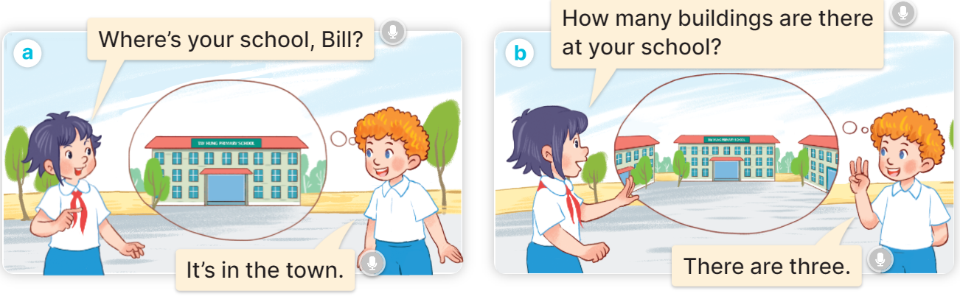  - Play the audio twice (sentence by sentence). Correct their pronunciation where necessary.  - Have Ss to practice the diaguage  - T invites a few pairs to the front of the class to practice.  - T checks pronunciation for ss.  Activity 3. Listen, point and say.  *Aims: Ss will be able to correctly say the phrases and use How many …… are there at your school? – There is …….. / There are …….. to ask and answer questions about the quantity of school facilities.  *Procedure:  * Model sentences:  - T asks Ss look at picture a and helps Ss know the structure from the dialogue.  - T introduces new structure for Ss.  - T explains, models and gives meaning.  - Have Ss repeat the model sentences.  A: How many buildings are there at your school?  B: – There is one. / There are two.  3.Practice: (7’)  *Drill pictures  - Have Ss look at the pictures and elicit the names of the places  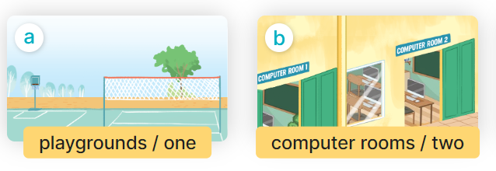  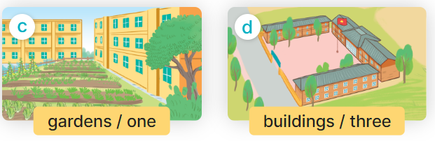  - Run through all the pictures.  - Run through model sentences.  - Have Ss to practise:  + T say – Ss respond (change role).  + Ss – Ss (change role).  - Ask Ss to work in pairs.  - T controls and corrects.  - Invite a few pairs to come to the front of the classroom, point at the pictures and say the questions and answers in front of the class.  - T gives feedbacks.  4.Production: (7’)  Activity 4. Let’s talk.  *Aims: Ss will be able to enhance the correct use of How many…… are there at your school? and There is …….. / There are ……… to ask and answer questions about the quantity of school facilities in a freer context.  *Procedure:  - Ask questions to help them identify the context.  + What can you see in the picture?  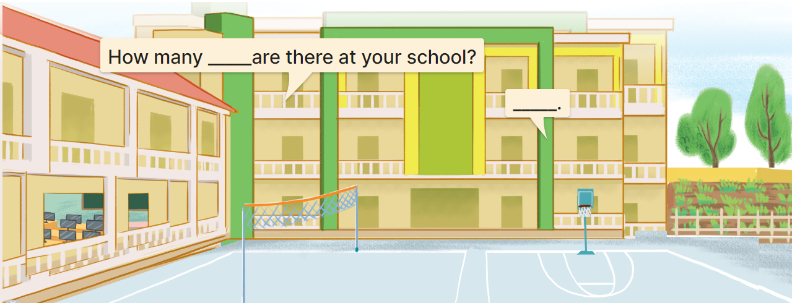  - Elicit the missing words in the speech bubbles and write them on the board. Get pupils to say the completed sentences.  - Have pairs of pupils practise asking and answering the questions about the quantity of school facilities in the picture.  - Invite some pairs to practise asking and answering questions about the quantity of school facilities in front of the class.  *Consolidation  *Aims: Ss will be able consolidate and wrap up the content of the lesson.  *Procedure:  - T asks ss to answer the following questions:  + What have you learnt from the lesson today?  - T review the vocabulary and model sentences.  - T praises some Ss who are hardworking / active/ good…. as well as encourage others to try more.  5. Homework. (2’)  - Learn the vocabulary and model sentences by heart  - Prepare the new lesson: Unit 6, Lesson 2 (4,5,6). | - Ss listen  - Ss play the game  -Ss play game  - Ss open their books  -Ss listen and answer  - - Ss listen and repeat  + Choral repetition (3 times).  + Individual repetition (3 ss)  - Ss take note  - Ss look, remember and slap  -Look at the pictures and get to know the characters in the pictures.  + In picture a:  Linh: Where’s your school, Bill?  Bill: It’s in the town.  – In picture b:  Linh: How many buildings are there at your school?  Bill: There are three.  -Ss listen and repeat in chorus (twice)  -Ss work in pairs to practice  -Ss practice the diaguage  -Ss listen  -Ss look at the picture and answer.  -Ss listen  -Ss listen and repeat  -Ss repeat to the hobbies  -Ss listen and answer  +Picture a: one playground  +Picture b: two computer rooms  +Picture c: one garden  +Picture d: three buildings  - Ss look, listen and repeat  - Ss practice in chorus  - Ss practice in chorus  -Ss work in pairs to practice  -Ss listen  -Ss go to the board and point and say  -Ss listen  -Ss look at the picture and answer  + a school with two buildings, a playground, a computer room and a garden  -Ss listen and answer  -Ss work in pairs and ask, answer  -Ss perform in font of the class.  -Ss answer the questions  - Ss listen  -Ss listen and clap their hands  -Ss listen and take note
D. ADJUSTMENTS (if necessary):
………………………………………………………………………………………….…..……………………………………………………………………………...……………

Made by facebook Huong Le - 0374629390

