Week 2 Preparing date: September 15th , 2024
Period 5 Teaching date: September 16th , 2024

Unit 1: My friends
Lesson 1 (1, 2, 3)
A. OBJECTIVES:
By the end of the lesson, Ss will be able to:
1. Knowledge:
- use the words America, Australia, Britain and Viet Nam in relation to the topic “My friends”
- use Where are you from? – I’m from _____. to ask and answer questions about where someone comes from
- Vocabulary: America, Australia, Britain and Viet Nam
- Skills: speaking and listening
2. Competences:
- Co-operation: ready to help friends in pair work/ group work.
- Sociability: Talk to each other, say good words to others.
3. Attitude/ Qualities:
- Kindness: Help partners to complete learning tasks.
- Honesty: Show pride in where they come from and great respect for where someone
comes from by using appropriate gestures and intonation when asking and
answering about nationality.
B. TEACHING AIDS:
- Teacher: Teacher’s guide Pages 17, 18, 19, audio Tracks 6,7, website hoclieu.vn, posters, laptop, pictures, textbook, lesson plan, TV or projector.
- Students: Pupil’s book Page 10, notebooks, workbooks, school things.
C. PROCEDURES:
Teacher’s activities | Students’ activities
1.Warm- up: (5’)  Game: Find the flags  *Aims: to create a friendly and active atmosphere in the class to beginning the lesson.  *Procedure:  - Elicit that there are many countries around the world.    - Ask pupils to say the name as many countries as they know.  - Say “Open your book page 10” and look at “Unit 1, Lesson 1 (1,2,3)”.  2. Presentation (16’)  Activity 1. Vocabulary.  *Aims: Ss will be able to know the vocabulary in the new lesson.  *Procedure:  -T elicits the new words  + America : nước Mỹ (picture)  + Australia : nước Úc (picture)  + Britain : nước Anh (picture)  + Viet Nam: nước Việt Nam (picture)  - T models (3 times).  - T writes the words on the board.  - Checking: Rub out and remember  Activity 2. Look, listen and repeat:  *Aims: Ss will be able to understand and correctly repeat the sentences in two communicative contexts (pictures) in which pupils ask and answer questions about where someone is from  *Procedure:  - Have Ss look at Pictures a and b and identify the characters in the pictures.  + Who is he/ she?  + Where is he/ she?  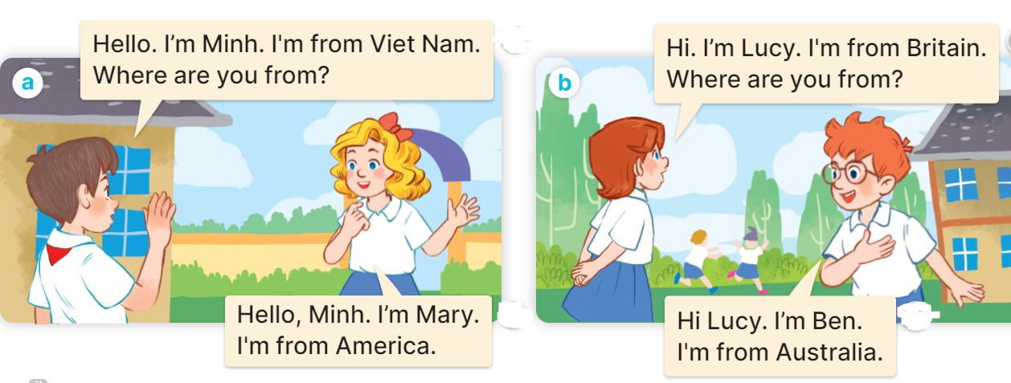  - Play the audio twice (sentence by sentence). Correct their pronunciation where necessary.  - Have Ss to practice the dialogue  - T invites a few pairs to the front of the class to practice.  - T checks pronunciation for ss.  Activity 3 Listen, point and say.  *Aims: Ss will be able to correctly say the words and use Where are you from? – I’m from _____. to ask and answer questions about where someone is from.  *Procedure:  * Model sentences:  - T asks Ss look at picture a and helps Ss know the structure from the dialogue.  - T introduces new structure for Ss.  - T explains, models and gives meaning.  -Have Ss repeat the model sentences.  A: Where are you from?  B: I’m from America.  3.Practice: (7’)  *Drill pictures  - Elicit and check comprehension the name of each character and countries.      - Run through all the pictures.  - Run through model sentences.  - Have Ss to practise:  + T asks the first picture, Ss answer  + Ss asks the second picture, T answers  + Group A asks the third picture, group B  answers  + Group B asks the last picture, group A  - Ask Ss to work in pairs.  - T controls and corrects.  - Invite a few pairs to come to the front of the classroom, point at the relevant character in each picture, and act out his/her role.  - Encourage Ss to practise speaking English.  - T gives feedbacks.  4.Production: (7’)  Activity 4. Let’s talk.  *Aims: Ss will be able to enhance the correct use of Where are you from? – I’m……….. to ask and answer questions about where someone is from in a freer context  *Procedure:  - T asks ss to guess each character and what the children say.  + What can you see in the picture?  +Who are they?  +Where are they?  +What are they saying?  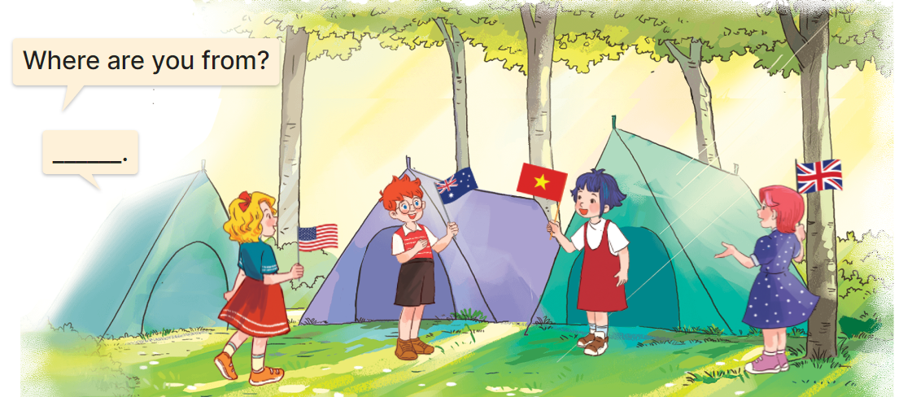  - Elicit the answer in the speech bubble and write it on the board. Get pupils to say the completed sentences.  - Put pupils into pairs to practise the exchanges.  - Invite a few pairs to point at the pictures and ask and answer questions about where the pupils are from.  - Give feedbacks  *Consolidation  *Aims: Ss will be able consolidate and wrap up the content of the lesson.  *Procedure:  - T asks ss to answer the following questions:  + What have you learnt from the lesson today?  +What are the core values of the lesson? (if the teacher can take from the lesson).  - T review the vocabulary and model sentences.  - T praises some Ss who are hardworking / active/ good…. as well as encourage others to try more.  5. Homework. (2’)  - Learn the number by heart  - Prepare the new lesson: Unit 1, Lesson 1 (4,5,6). | - Ss listen and say some countries  - Ss open their books  -Ss listen and answer  - - Ss listen and repeat  + Choral repetition (3 times).  + Individual repetition (3 ss)  - Ss take note  - Ss look, remember and write  -Look at the pictures and get to know the characters in the pictures.  +In picture a:  Minh says and asks: Hello. I’m Minh. I’m from Viet Nam. Where are you from?  Mary answers: Hello, Minh. I’m Mary. I’m from America.  + In picture b:  Lucy says and asks: Hi. I’m Lucy. I’m from Britain. Where are you from?  Ben answers: Hi, Lucy. I’m Ben. I’m from Australia.  -Ss listen and repeat in chorus (twice)  -Ss work in pairs to practice  -Ss practice the dialogue  -Ss listen  -Ss look at the picture and answer.  -Ss listen  -Ss listen and repeat  -Ss repeat to the introduce and respond to greetings.  - Ss look, listen and repeat  +Picture a: Britain  + Picture b: Viet Nam  + Picture c: America  + Picture d: Australia  -Ss practice in chorus  -Ss practice in chorus  -Ss work in pairs to practice  -Ss point and say  -Ss listen.  -Ss listen  -Ss look at the picture and answer  + They are four pupils at a campsite and holding their national flags.  - Ss say the completed sentences.  -Ss work in pairs  -Ss perform in front of the class.  -Ss listen.  -Ss answer the questions  - Ss listen  -Ss listen and clap their hands  -Ss listen and take note

D. ADJUSTMENTS (if necessary):
………………………………………………………………………………………….…..……………………………………………………………………………...………………………………………….…..……………………………………………………………………………….……………………………………………………………………...

Week 2 Preparing date: September 15th , 2024
Period 6 Teaching date: September 16th ., 2024

Unit 1: Hello
Lesson 1 (4,5,6)
A. OBJECTIVES:
By the end of the lesson, Ss will be able to:
1. Knowledge:
- use the words America, Australia, Britain, and Viet Nam in relation to the
topic “My friends”;
- listen to and demonstrate understanding of simple communicative contexts
in relation to the topic “My friends”.
- read and write about where someone comes from.
- Vocabulary: Review
- Skills: speaking, listening, reading and writing.
2. Competences:
- Critical Thinking: self-introduce
- Co-operation: ready to help friends in pair work/ group work.
- Self-control and independent learning: perform listening tasks.
3. Attitude/ Qualities:
- Kindness: Help partners to complete learning tasks.
- Honesty: Show pride in where they come from and great respect for where someone
comes from by using appropriate gestures and intonation when asking and
answering about nationality
- Diligence: complete learning tasks.
B. TEACHING AIDS:
- Teacher: Teacher’s guide Pages 20,21; audio Tracks 8, 9; website sachmem.vn, posters, laptop, pictures, textbook, lesson plan, TV or projector.
- Students: Pupil’s book Page 11, notebooks, workbooks, school things.
C. PROCEDURES:
Teacher’s activities | Students’ activities
1.Warm- up: (5’)  Game: “Lucky number”  *Aims: to create a friendly and active atmosphere in the lesson.  *Procedure:  - Divide the class into 3 teams.  - Pupils from each team choose a number (or throw sticky balls on the grid to choose the number), then have 2 pupils  from each team ask and answer with the picture in that number.  - Pupils or teachers click on the flag to reveal the icons indicating the points for that team.  - After 9 numbers, the team with the most points is the winner  - Say “Open your book page 11” and look at “Unit 1, Lesson 1 (4,5,6)”.  2.Practice: (27’)  Activity 1. Listen and number:  *Aims: Ss will be able to listen to and understand four communicative contexts in which pupils ask and answer questions about where someone is from and number the correct pictures.  *Procedure:  - Elicit the names of the characters in the pictures. Point at the pictures respectively to explain the context.  +Who is he/ she?  +Where is he/ she from?  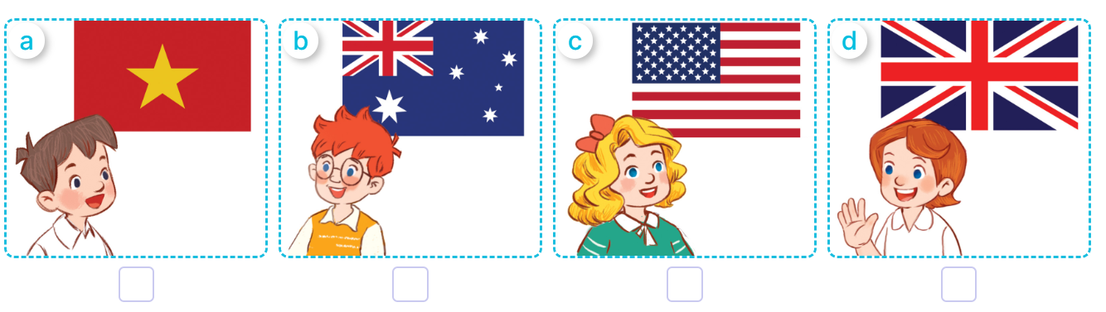  - T ask Ss to guess the answers.  + T writes Ss’guessing on the board.  - Listen to the tape:  + Play the recording  + Play the recording again and get Ss to swap books with their partners.  + Play the recording again to check answers together as a class.  + Write the answers on the board for Ss to correct their answers. Then checks Ss’ guessing.  - Invite one pupil to read aloud sentences 1 and 2 and a pair of pupils to act out Exchanges 3 and 4 in front of the  class.  Key: 1. b 2. d 3. C 4. a  Activity 2. Look, complete and read.  *Aims: Ss will be able to complete the gapped sentences and read them aloud with the help of the picture cues.  *Procedure:  - Get Ss to look at the pictures and identify the characters  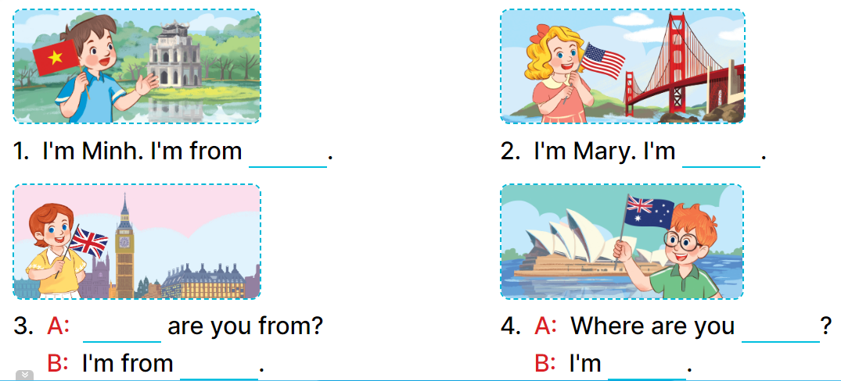  - Have Ss look at the four incomplete sentences and elicits the missing words in the sentences.  - T models with sentence 1  + Ask Ss what is missing in the sentence.  + Have Ss look at the picture and complete the gap, then read the completed sentence in chorus.  -Have Ss work in groups and complete the sentences 2,3 and 4.  - Ask a few Ss to stand up and read the completed sentences aloud.  -T gives feedbacks.  Key:  1. Viet Nam 2. from America  3. Where; Britain  4. from; from Australia  Activity 3. Let’s sing.  *Aims: Ss will be able to sing the song I’m from … with the correct pronunciation, rhythm and melody  *Procedure:  - Introduce the title and lyrics of the song: “Where are you from” song.  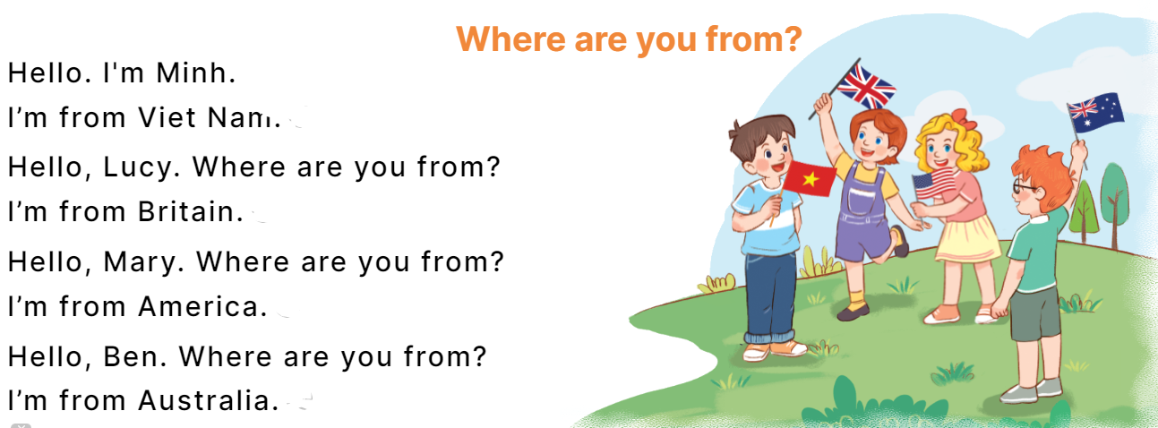  - Play the recording for Ss to listen to the whole song.  + Have them repeat the title and lyrics line by line.  + Tell Ss to point at the relevant character while singing his or her name.  - Play the recording all the way through for Ss to listen to pronunciation and melody of the song.  - Play the recording line by line for Ss to listen, repeat and point at the relevant character.  - Play the recording for Ss to sing and do actions.  - Ask Ss to practice singing and doing actions in pairs or groups.  - Invite groups to the front of the classroom to perform the song  -T gives feedback.  *Consolidation  *Aims: Ss will be able consolidate and wrap up the content of the lesson.  *Procedure:  - T asks ss to answer the following questions:  + What have you learnt from the lesson today?  +What are the core values of the lesson? (if the teacher can take from the lesson).  - T praises some Ss who are hardworking / active/ good…. as well as encourage others to try more.  3. Homework. (3’)  - Learn the song by heart  - Prepare the new lesson: Unit 1, Lesson 2 (1,2,3). | - Ss listen and pay attention  - Ss play the game  -Ss listen and clap their hands  - Ss open their books  -Look at the pictures and say:  + Picture a: . Minh from Viet Nam  + Picture b: Ben from Australia  + Picture c: ary from America  + Picture d: ucy from Britain  -Ss guess the answers  - Ss listen to the tape and number the pictures  - Ss listen again, write number and swap books with their partners.  - Ss check their answers and guessing  -Ss listen and read aloud  -Ss look at the picture and say:  + They’re Minh, Mary, Lucy and Bill.  -Ss look and answer  -Ss answer: I’m from Viet Nam  -Ss look, complete and read the completed sentence in chorus.  -Ss complete the sentence  -Ss work in groups and complete  -Ss read aloud  -Ss listen  - Ss look and listen.  -Ss listen to the song  - Ss listen and repeat line by line without the action.  -Ss point to the character while singing  -Ss listen to melody of the song  - Ss listen and sing line by line.  - Ss sing and do actions.  + Ss work in groups (two groups) to sing.  -Ss perform in front of the class.  -Ss listen  -Ss answer the questions  -Ss listen and clap their hands  -Ss listen and take note
D. ADJUSTMENTS (if necessary):
………………………………………………………………………………………….…..……………………………………………………………………………...……………
Week 2 Preparing date: September 15th , 2024
Period 7 Teaching date: September 18th ., 2024

Unit 1: Hello
Lesson 2 (1, 2, 3)
A. OBJECTIVES:
By the end of the lesson, Ss will be able to:
1. Knowledge:
- use the words Japan, Malaysia, Singapore and Thailand in relation to the
topic “My friends”.
- use Where’s he / she from? – He’s / She’s from …………. to ask and answer questions about where someone comes from.
- listen to and demonstrate understanding of simple communicative contexts
in relation to the topic “My friends”.
- Vocabulary: Japan, Malaysia, Singapore and Thailand
- Skills: speaking and listening
2. Competences:
- Communication and collaboration: work in pairs and groups to complete the
learning tasks
- Self-control and independent learning: perform listening tasks
3. Attitude/ Qualities:
- Kindness: Help partners to complete learning tasks.
- Honesty: tell the truth about feelings and emotions
B. TEACHING AIDS:
- Teacher: Teacher’s guide Pages 22, 23; audio Tracks 10,11, website hoclieu.vn, posters, laptop, pictures, textbook, lesson plan, TV or projector.
- Students: Pupil’s book Page 12, notebooks, workbooks, school things.
C. PROCEDURES:
Teacher’s activities | Students’ activities
1.Warm- up: (3’)  Game: Pass the ball  *Aims: to create a friendly and active atmosphere in the lesson.  *Procedure:  - T gives Ss a ball.  - T asks Ss to listen to music and transfer a ball around the class.  - When the music stops, Ss who keep a ball have to practice with partner using: Where are you from? and I’m from……..  - T gives feedback.  - Say “Open your book page 12” and look at “Unit 1, Lesson 2 (1,2,3)”.  2. Presentation (16’)  Activity 1. Vocabulary.  *Aims: Ss will be able to know the vocabulary in the new lesson.  *Procedure:  -T elicits the new words  + Japan : nước Nhật Bản (picture)  + Thailand: nước Thái Lan (picture)  + Malaysia: nước Ma-lai-xi-a (picture)  + Singapore : nước Xin-ga-po (picture)  - T models (3 times).  - T writes the words on the board.  - Checking: Rub out and remember  Activity 2. Look, listen and repeat:  *Aims: Ss will be able to understand and correctly repeat the sentences in two communicative contexts (pictures) in which pupils ask and answer questions about where someone is from.  *Procedure:  - Have Ss look at Pictures a and b and identify the characters in the pictures.  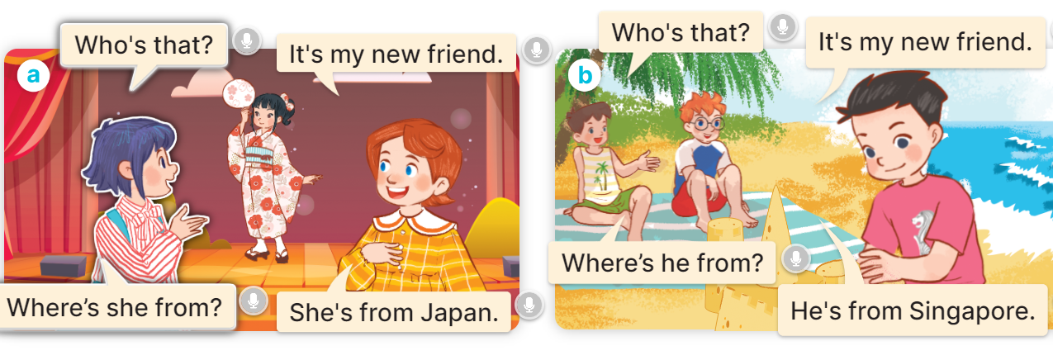  - Play the audio twice (sentence by sentence). Correct their pronunciation where necessary.  - Have Ss to practice the diaguage  - T invites a few pairs to the front of the class to practice.  - T checks pronunciation for ss.  Activity 3. Listen, point and say.  *Aims: Ss will be able to correctly say the words and use Where’s he / she from? – He’s / She’s from ……. to ask and answer questions about where someone is from.  *Procedure:  * Model sentences:  - T asks Ss look at picture a, b and helps Ss know the structure from the dialogue.  - T introduces new structure for Ss.  - T explains, models and gives meaning.  - Have Ss repeat the model sentences.  A: Where’s he / she from?  B: He’s / She’s from …….  3.Practice: (7’)  *Drill pictures  - Elicit and check comprehension the name of each character and the name of the country.    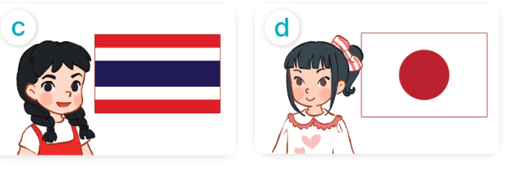  - Run through all the pictures.  - Run through model sentences.  - Have Ss to practise:  + T asks the first picture, Ss answer  + Ss asks the second picture, T answers  + Group A asks the third picture, group B  answers  + Group B asks the last picture, group A  - Ask Ss to work in pairs.  - T controls and corrects.  - Invite a few pairs to come to the front of the classroom, point at the relevant character in each picture, and act out his/her role.  - Invite Ss to go to the board and role play. Encourage Ss to practise speaking English.  - T gives feedbacks.  4.Production: (7’)  Activity 4. Let’s talk.  *Aims: Ss will be able to enhance the correct use of Where’s he / she from? – He’s/ she’s from……….. to ask and answer questions about where someone is from in a freer context.  *Procedure:  - T asks ss to guess each character and what the children say.  + What can you see in the picture?  +Who are they?  +Where are they?  +What are they saying?  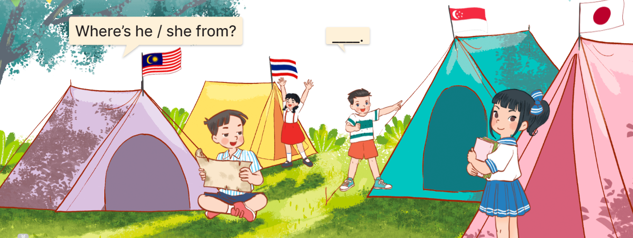  - T fills the gaps and writes the sentences on the board.  - T models  - Give pupils time to work in pairs and take turns saying the role of each character in the picture  - Invite a few pairs to come to the front of the classroom and act out the roles  - Give feedbacks  *Consolidation  *Aims: Ss will be able consolidate and wrap up the content of the lesson.  *Procedure:  - T asks ss to answer the following questions:  + What have you learnt from the lesson today?  +What are the core values of the lesson? (if the teacher can take from the lesson).  - T review the vocabulary and model sentences.  - T praises some Ss who are hardworking / active/ good…. as well as encourage others to try more.  5. Homework. (2’)  - Learn the vocabulary by heart  - Prepare the new lesson: Unit 1, Lesson 2 (4,5,6). | - Ss listen and keep the ball  - Ss listen to music and play the game  - Ss open their books  -Ss listen and answer  - - Ss listen and repeat  + Choral repetition (3 times).  + Individual repetition (3 ss)  - Ss take note  - Ss look, remember and write  -Look at the pictures and get to know the characters in the pictures.  + In picture a:  Linh: Who’s that? Lucy: It’s my new friend.  Linh: Where’s she from? Lucy: She’s from Japan.  – In picture b:  Minh: Who’s that? Ben: It’s my new friend.  Minh: Where’s he from? Ben: He’s from Singapore.  -Ss listen and repeat in chorus (twice)  -Ss work in pairs to practice  -Ss practice the diaguage  -Ss listen  -Ss look at the picture and answer.  -Ss listen  -Ss listen and repeat  -Ss repeat to the introduce and respond to greetings.  - Ss look, listen and answer  a. a boy with the Singaporean flag  b. a boy with the Malaysian flag  c. a girl with the Thai flag  d. a girl with the Japanese flag  - Ss listen and repeat  - Ss practice in chorus  - Ss practice in chorus  - Ss work in pairs to practice  -Ss listen  -Ss point and say  -Ss go to the board and role play.  -Ss listen  -Ss look at the picture and answer  + four pupils at a campsite, standing in front of their tents with their national flags  -Ss note  - Ss say the completed sentences.  -Ss work in pairs  -Ss perform in front of the class.  -Ss listen  -Ss answer the questions  - Ss listen  -Ss listen and clap their hands  -Ss listen and take note

D. ADJUSTMENTS (if necessary):
………………………………………………………………………………………….…..……………………………………………………………………………...………………………………………….…..……………………………………………………………………………….……………………………………………………………………...

Week 2 Preparing date: September 15th , 2024
Period 8 Teaching date: September 18th ., 2024

Unit 1: Hello
Lesson 2 (4, 5, 6)
A. OBJECTIVES:
By the end of the lesson, Ss will be able to:
1. Knowledge:
- use the words Japan, Malaysia, Singapore and Thailand in relation to the
topic “My friends”.
- use Where’s he / she from? – He’s / She’s from ………. to ask and answer questions about where someone comes from.
- listen to and demonstrate understanding of simple communicative contexts
in relation to the topic “My friends”.
- read and write about where someone comes from.
- Vocabulary: Review
- Skills: speaking, listening, reading and writing.
2. Competences:
- Critical Thinking: self-introduce
- Co-operation: ready to help friends in pair work/ group work.
- Self-control and independent learning: perform listening tasks.
3. Attitude/ Qualities:
- Kindness: Help partners to complete learning tasks.
- Honesty: Show pride in where they come from and great respect for where someone
comes from
- Diligence: complete learning tasks.
B. TEACHING AIDS:
- Teacher: Teacher’s guide Pages 24, 25, 26; audio Tracks 12; website hoclieu.vn, posters, laptop, pictures, textbook, lesson plan, TV or projector.
- Students: Pupil’s book Page 13, notebooks, workbooks, school things.
C. PROCEDURES:
Teacher’s activities | Students’ activities
1.Warm- up: (5’)  Play a game: “Slap the board”  *Aims: to create a friendly and active atmosphere in the class to beginning the lesson.  *Procedure:  - Divide the class into two or three teams.  - Teacher puts up a set of pictures or words on a board  - A pupil from each team come up to the board with fly swatters  - They listen as the teacher calls out a word or a sentence and they race to slap the correct picture  - Whoever is the fastest with the correct slap gets a point for their team  - Team with the most points is the winner.  - Say “Open your book page 13” and look at “Unit 1, Lesson 2 (4,5,6)”.  2.Practice: (27’)  Activity 1. Listen and tick:  *Aims: Ss will be able to listen to and understand two communicative contexts in which pupils ask and answer questions about where someone comes from and tick the  correct pictures  *Procedure:  - Elicit the names of the characters in the pictures.  - Point at the pictures respectively to explain the context.  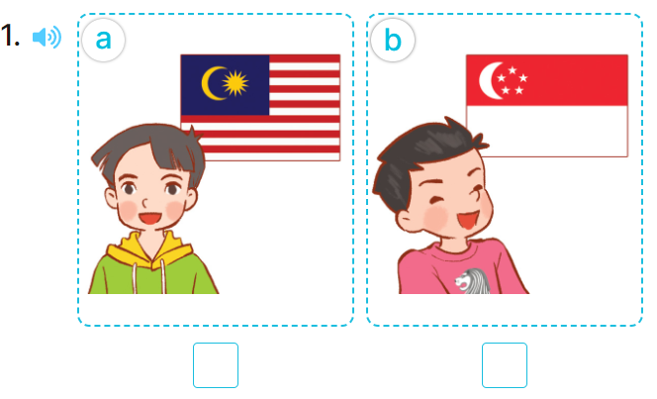  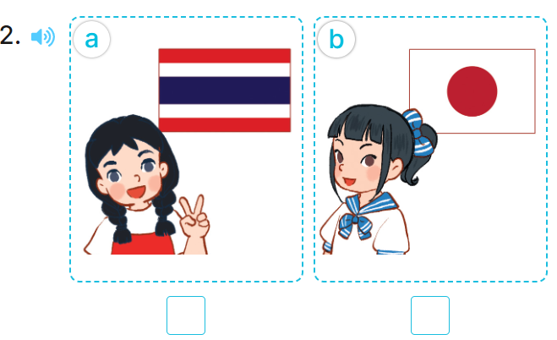  - T ask Ss to guess the answers.  + T writes Ss’guessing on the board.  - Listen to the tape:  + Play the recording  + Play the recording again and get Ss to swap books with their partners.  + Play the recording again to check answers together as a class.  + Write the answers on the board for Ss to correct their answers. Then checks Ss’ guessing.  - Play the recording, sentence by sentence, for the class to listen and repeat in chorus.  Key: 1.a 2. a  Activity 2. Look, complete and read  *Aims: Ss will be able to correctly two gapped sentences and two gapped exchanges with the help of picture cues.  *Procedure:  - Have pupils read the exchange and guess the missing word.  - Elicit the name of country that can be used to fill the gap.  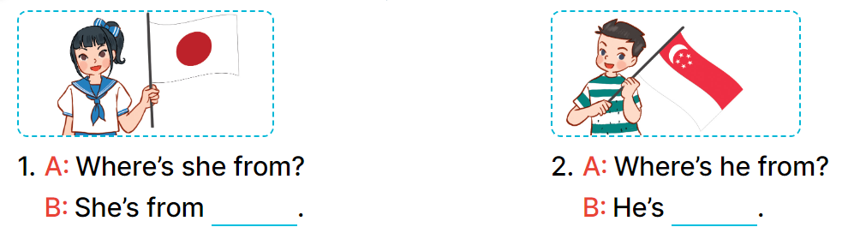  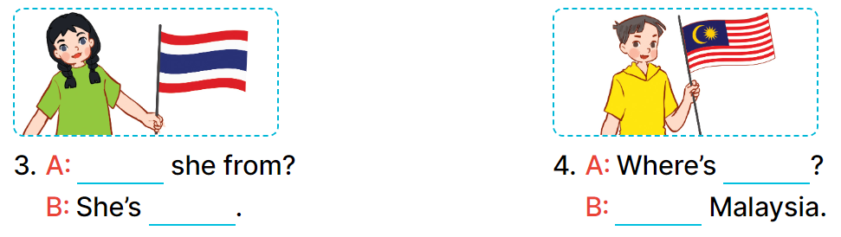  - T models with sentence 1.  - Have Ss work in pairs and look at the pictures and fill in the gaps  - Get pupils to swap books with a partner and check their answers before checking as a class.  - Invite pairs of pupils to write the answers on the board.  -T gives feedbacks.  Key: 1. Japan 2. from Singapore  3. Where’s; from Thailand  4. he from; He’s from  Activity 3. Let’s play.  *Aims: Ss will be able to revise the target vocabulary items through the game Find someone who is from …  *Procedure:  - Tell pupils that they are going to revise the target vocabulary items they have learnt in Lessons 1 and 2.  - Explain how the game is played.  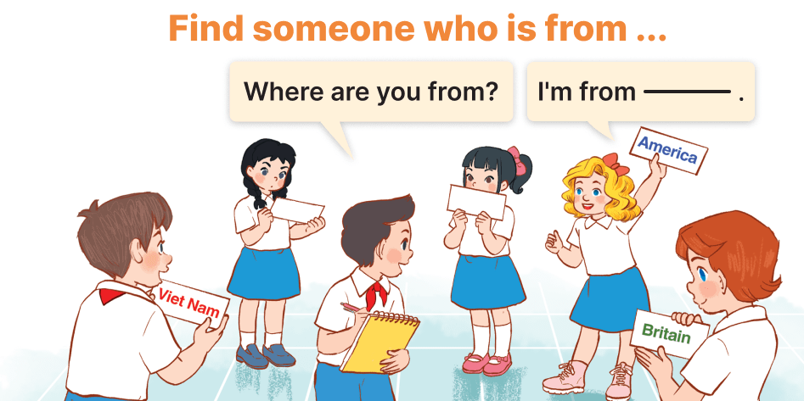  - Divide pupils into groups of six and give each group a set of five flashcards.  + One player in each group points to  the other players and asks Where are you from?  + The other players take turns looking at the flash cards and answering (ex: I’m from Britain.).  + If the player has the correct answer,  he / she gets a point / star.  + If the answer does not match the  flash card, he / she will be out  - The game ends when all the flashcards are gone.  - Give feedbacks  *Consolidation  *Aims: Ss will be able consolidate and wrap up the content of the lesson.  *Procedure:  - T asks ss to answer the following questions:  + What have you learnt from the lesson today?  +What are the core values of the lesson? (if the teacher can take from the lesson).  - T praises some Ss who are hardworking / active/ good…. as well as encourage others to try more.  3. Homework. (3’)  - Prepare the new lesson: Unit 1, Lesson 3 (1,2,3). | - Ss listen and do action  - Ss pay attention.  -Ss play the game  -Ss play the game  - Ss open their books  -Look at the pictures and say:  + Number 1:  Picture a: a boy and the Malaysian flag  Picture b: a boy and the Singaporean flag  + Number 2:  Picture a: a girl and the Thai flag Picture b: a girl and the Japanese flag  -Ss guess the answers  - Ss listen to the tape and tick  - Ss listen again, tick and swap books with their partners.  - Ss check their answers and guessing  - Ss answer and check  -Ss listen and repeat.  -Ss read and guess  -Ss read and complete  -Ss read and answer  -Ss work in pairs and fill in the gaps  - Ss swap books and check  -Ss write on the board  -Ss listen  - Ss listen and remember  -Ss listen and pay attention  - Ss listen  - Ss play the game  -Ss play the game  -Ss listen  -Ss answer the questions  - Ss listen  -Ss listen and clap their hands  -Ss listen and take note

D. ADJUSTMENTS (if necessary):
………………………………………………………………………………………….…..……………………………………………………………………………...………………………………………….…..……………………………………………………………………………….……………………………………………………………………...

