Week 34 Preparing date: May 5th ,2025
Period 133 Teaching date : May 6th , 2025

Unit 20: At the zoo
Lesson 2 (4, 5, 6)
A. OBJECTIVES:
By the end of the lesson, Ss will be able to:
1. Knowledge:
- listen to and demonstrate understanding of simple communicative contexts in relation to the topic “At the zoo”.
- Vocabulary: Review
- Skills: speaking, listening, reading and writing.
2. Competences:
- Co-operation: ready to help friends in pair work/ group work.
- Self-control and independent learning: perform listening tasks.
3. Attitude/ Qualities:
- Kindness: Help partners to complete learning tasks.
- Honesty: tell the truth about feelings and emotions.
- Diligence: complete learning tasks.
B. TEACHING AIDS:
- Teacher: Teacher’s guide Pages 248, 249; audio Tracks 99, 100; website sachmem.vn, posters, laptop, pictures, textbook, lesson plan, TV or projector.
- Students: Pupil’s book Page 67, notebooks, workbooks, school things.
C. PROCEDURES:
Teacher’s activities | Students’ activities
1.Warm- up: (5’)  Sing a song: “Pass the animal.”  *Aims: to create a friendly and active atmosphere in the class to beginning the lesson.  *Procedure:  - Ss pass the Stuffed Animal (or picture) around the class while the music is playing.  - When the music stops, the Ss with the animal/picture must answer the questions from the teacher.  Tr: What can you see?  Ss: I can see a ...  Tr: What is the ... doing?  Ss: The ... is ...  T: Make a monkey dance!/ Let’s roar like a tiger/...  - Say “Open your book page 67” and look at “Unit 20, Lesson 2 (4,5,6)”.  2.Practice: (27’)  Activity 1. Listen and tick:  *Aims: Ss will be able to listen to and understand two communicative contexts in which pupils ask and answer questions about what animals they can see at the zoo and each of them is doing and tick the correct pictures.  *Procedure:  - Have Ss look at the pair of picture and check comprehension  + What can you see?  + What is it doing?  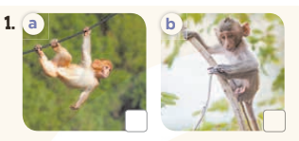  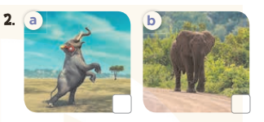  - T ask Ss to guess the answers.  + T writes Ss’guessing on the board.  - Listen to the tape:  + Play the recording  + Play the recording again and get Ss to swap books with their partners.  + Play the recording again to check answers together as a class.  + Write the answers on the board for Ss to correct their answers. Then checks Ss’ guessing.  - Play the recording, sentence by sentence, for the class to listen and repeat in chorus.  Key: 1.a 2. a  Activity 2. Look, complete and read.  *Aims: Ss will be able to complete the four gapped exchanges with the help of the picture cues.  *Procedure:  - Have Ss look at the pictures and identify the animals in the picture.  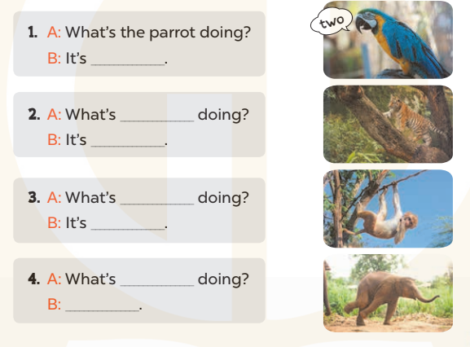  - T models with sentence 1.  + Have Ss look at the sentence.  + Ask them what is missing in the answer (counting).  + Have Ss complete the gap.  + Have Ss read the completed sentence in chorus.  -Have Ss work in pairs and complete the sentences 2, 3 and 4.  - Invite pairs of pupils to stand up and read aloud the sentences.  - T gives feedbacks.  Key: 1. counting  2. the tiger; climbing (the tree)  3. the monkey; swinging  4. the elephant; It's dancing  Activity 3. Let’s sing  *Aims: Ss will be able to sing the song At the zoo with the correct pronunciation, melody and intonation.  *Procedure:  - Introduce the title and lyrics of the song “At the zoo”  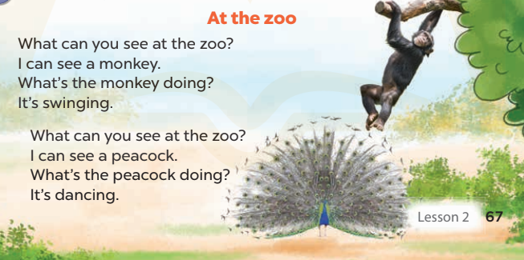  - Play the recording for Ss to listen to the whole song.  + Have them repeat the title and lyrics line by line.  + Tell Ss to point at the pictures  while singing.  - Play the recording all the way through for Ss to listen to pronunciation and melody of the song.  - Play the recording line by line for Ss to listen, repeat and point to the pictures  - Play the recording for Ss to sing and do actions.  - Ask Ss to practice singing and doing actions in pairs or groups.  - Invite groups to the front of the classroom to perform the song  -T gives feedback.  *Consolidation  *Aims: Ss will be able consolidate and wrap up the content of the lesson.  *Procedure:  - T asks ss to answer the following questions:  + What have you learnt from the lesson today?  +What are the core values of the lesson? (if the teacher can take from the lesson).  - T praises some Ss who are hardworking / active/ good…. as well as encourage others to try more.  3. Homework. (3’)  - Prepare the new lesson: Unit 20, Lesson 3 (1,2,3). | - Ss listen and play the game  - Ss open their books  -Look at the pictures and say:  + Picture a: a monkey swinging on a branch  + Picture b: a monkey climbing a tree.  + Picture c: an elephant dancing.  + Picture d: an elephant walking.  -Ss guess the answers  - Ss listen to the tape and tick  - Ss listen again, tick and swap books with their partners.  - Ss check their answers and guessing  -Ss listen and repeat.  -Ss look at the pictures and say  -Ss listen and answer  -Ss read and complete  -Ss work in pairs and do the task  -Ss read aloud  - Ss listen  -Ss listen to the song  - Ss listen and repeat line by line without the action.  -Ss point to the pictures while singing  -Ss listen to melody of the song  - Ss listen and sing line by line.  - Ss sing and do actions.  + Ss work in groups (two groups) to sing.  -Ss perform in front of the class.  -Ss listen  -Ss listen and answer  -Ss listen and take note

D. ADJUSTMENTS (if necessary):
………………………………………………………………………………………….…..……………………………………………………………………………...………………………………………….…..……………………………………………………………………………….……………………………………………………………………...
Week 34 Preparing date: May 5th ,2025
Period 134 Teaching date : May 6th , 2025

Unit 20: At the zoo
Lesson 3 (1, 2, 3)
A. OBJECTIVES:
By the end of the lesson, Ss will be able to:
1. Knowledge:
- correctly repeat the sounds of the letters a in isolation, the words parrot and dancing and the sentences I can see a parrot. and The peacock is dancing. with the correct pronunciation and intonation.
- identify the target words parrot and dancing while listening.
- say the chant with the correct rhythm and pronunciation.
- Vocabulary: Review
- Skills: speaking, listening, reading and writing.
2. Competences:
- Co-operation: ready to help friends in pair work/ group work.
- Self-control and independent learning: perform listening tasks.
3. Attitude/ Qualities:
- Kindness: Help partners to complete learning tasks.
- Honesty: tell the truth about feelings and emotions
B. TEACHING AIDS:
- Teacher: Teacher’s guide Pages 250, 251; audio Tracks 101,102,103; website sachmem.vn, posters, laptop, pictures, textbook, lesson plan, TV or projector.
- Students: Pupil’s book Page 68, notebooks, workbooks, school things.
C. PROCEDURES:
Teacher’s activities | Students’ activities
1.Warm- up: (5’)  Game: Find and circle the words  *Aims: to create a friendly and active atmosphere in the class to beginning the lesson.  *Procedure:  - Divide class into 2 groups  - Ask Ss to find and circle the words that they learnt.  - Which groups find the best correct words is winner.  - Give Ss time to play the game.  Rows: skating, can  Columns: parrot, cat, dancing  -T checks who’s winner?  - Say “Open your book page 68” and look at “Unit 20, Lesson 3 (1,2,3)”.  2. Presentation (9’)  Activity 1. Listen and repeat:  *Aims: Ss will be able to correctly pronounce the sounds of the letters a in isolation, the words parrot and dancing and the sentences I can see a parrot. and The peacock is dancing. with correct pronunciation and intonation.  *Procedure:  - T gives instruction to the letters a in isolation, the words parrot and dancing and the sentences I can see a parrot. and The peacock is dancing  - Play the recording for the letter pl and fl  - Encourage Ss to point at the letter/ word/ sentence while listening.  - Play the recording again and encourage Ss to listen and repeat.  - Do this several times until Ss feel confident.  - T calls some Ss to practice.  - T gives feedbacks.  3.Practice: (19’)  Activity 2. Listen and circle.  *Aims: Ss will be able to identify the target words parrot and dancing while listening.  *Procedure:  - Elicit the sentences and explain that they have to listen.  - T ask Ss to guess the answers.  + T writes Ss’guessing on the board.  - Listen to the tape:  + Play the recording  + Play the recording again and get Ss to swap books with their partners.  + Play the recording again to check answers together as a class.  + Write the answers on the board for Ss to correct their answers. Then checks Ss’ guessing.  - Play the recording, sentence by sentence, for the class to listen and repeat in chorus.  - Invite one or two Ss to stand up and read the completed sentences.  Key: 1.c 2.a  Activity 3. Let’s chant  *Aims: Ss will be able to say the chant with the correct rhythm and pronunciation.  *Procedure:  - Introduce the title and lyrics of the chant.  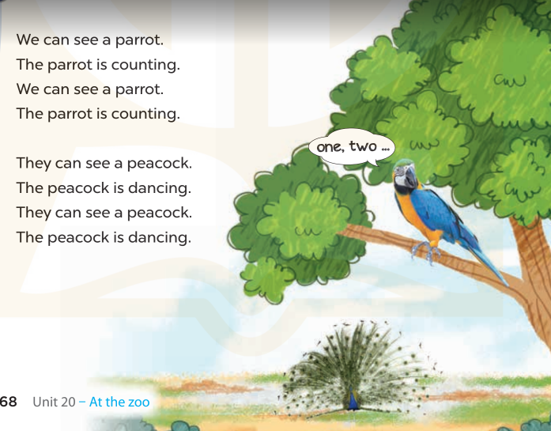  - Play the recording for Ss to listen to the whole chant.  + Have them repeat the title and lyrics line by line.  + Ask Ss to attend to the sounds of the letters a and the words parrot and dancing.  - Play the recording all the way through for Ss to listen to pronunciation and melody.  - Play the recording line by line for Ss to listen and repeat  - Play the recording for Ss to chant and clap along.  - Ask Ss to practice chant and clap along in pairs or groups.  - Invite groups to the front of the classroom to perform the chant  -T gives feedback.  *Consolidation  *Aims: Ss will be able consolidate and wrap up the content of the lesson.  *Procedure:  - T asks ss to answer the following questions:  + What have you learnt from the lesson today?  +What are the core values of the lesson? (if the teacher can take from the lesson).  - T praises some Ss who are hardworking / active/ good…. as well as encourage others to try more.  4. Homework. (2’)  - Practice the chant more.  - Prepare the new lesson: Unit 20, Lesson 3 (4,5,6). | - Ss listen  -Ss play game  - Ss open their books  - Ss recognize the differences about color of letter  - - Ss listen  - Ss listen and point  - Ss listen again and repeat  -Ss listen again and repeat  -Ss practice  -Ss listen  -Ss listen and say:  + Number 1: I can see a…..  + Number 2: The monkey is…  -Ss guess the answers  - Ss listen to the tape and circle  - Ss listen again, circle and swap books with their partners.  - Ss check their answers and guessing  -Ss listen and repeat.  -Ss read the sentences  - Ss look and listen.  -Ss listen to the chant  - Ss listen and repeat line by line without clap their hands  -Ss note the sounds, words  -Ss listen to melody of the chant  - Ss listen and chant line by line.  - Ss chant and clap along.  - Ss work in groups (two groups) to chant  -Ss perform in front of the class.  -Ss listen  -Ss answer the questions  -Ss listen and clap their hands  -Ss listen and take note
  D | B | K | K | E | P | S | C | P | T
  P | E | S | E | E | D | D | X | O | H
  P | P | S | Y | Y | E | A | Z | M | I
  C | A | N | M | F | C | N | Y | X | N
  Y | R | G | N | N | A | C | S | Z | K
  G | R | S | K | A | T | I | N | G | B
  S | O | O | A | P | E | N | T | G | H
  M | T | R | K | K | C | G | E | A | Y
  D | F | M | K | G | C | I | N | S | M
  A | C | E | B | F | A | Z | Y | W

D. ADJUSTMENTS (if necessary):
………………………………………………………………………………………….…..……………………………………………………………………………...………………………………………….…..……………………………………………………………………………….……………………………………………………………………...
Week 34 Preparing date: May 5th ,2025
Period 135 Teaching date : May 6th , 2025

Unit 20: At the zoo
Lesson 3 (4, 5, 6)
A. OBJECTIVES:
By the end of the lesson, Ss will be able to:
1. Knowledge:
- use the target language in real context by reading and writing a gapped text about what pupils can see at the zoo.
- use the target language items they have learnt in a real context by showing the class some photos of animals and saying what animals they can see at home or at the zoo.
- Vocabulary: Review
- Skills: speaking, listening, reading and writing.
2. Competences:
- Co-operation: ready to help friends in pair work/ group work.
- Self-control and independent learning: perform reading tasks.
3. Attitude/ Qualities:
- Kindness: Help partners to complete learning tasks.
- Honesty: tell the truth about feelings and emotions.
- Diligence: complete learning tasks.
B. TEACHING AIDS:
- Teacher: Teacher’s guide Pages 251, 252, website sachmem.vn, posters, laptop, pictures, textbook, lesson plan, TV or projector.
- Students: Pupil’s book Page 69, notebooks, workbooks, school things.
C. PROCEDURES:
Teacher’s activities | Students’ activities
1.Warm- up: (5’)  Game: Who’s faster?  *Aims: to review the vocabulary and structure about greet and respond to greetings.  *Procedure:  - Tell Ss that they are going to look at the cards in 60 seconds, memorise the words (tiger, elephant, monkey, peacock) then remember as many of the words as possible.  - Put the cards on a desk or stick them on the board. Then cover them with a piece of cloth.  - Divide the class into 2 or 4 groups. - Remove the cloth and show the cards for 60 seconds. Then cover them again.  - In their groups, Ss try to say as many of the words as they can remember.  - Have the groups say the names of the things aloud.  - For each correct word, give them a star or a point.  - The group with the most stars / points wins.  - Say “Open your book page 69” and look at “Unit 20, Lesson 3 (4,5,6)”.  2.Practice: (8’)  Activity 1. Read and tick True or False:  *Aims: Ss will be able to read and understand the text.  *Procedure:  - Tell the class the goal of this activity and how to complete the task.  - Have Ss read the sentence and identify where Linh and her mother are. Then have them read the text and find the appropriate information to tick in the True box or False box.  - Set a time limit for Ss to do the activity independently.  - Let Ss swap and check the answers.  - Invite Ss to read the texts aloud  - T gives feedbacks.  Key: 1. True 2. False  3. True 4. True  3.Production: (19’)  Activity 2. Let’s write  *Aims: Ss will be able to use the target language in real context by completing a gapped text about themselves.  *Procedure:  - Tell the class the goal of this activity  - Explain that the first gap should be animals, the second gap should be what the monkey is doing, the next gap can be an animal and the last gap can be what the pupils think about the animals at the zoo.  - Give Ss time to complete the text independently.  - In pairs or groups, ask Ss to swap their complete text before checking as a class.  Key: Pupils’ own answers  Activity 3. Project.  *Aims: Ss will be able to use the target language items they have learnt in a real context by showing the class some photos of animals and saying what animals they can see at home or at the zoo.  *Procedure:  - Tell pupils about the goal of the activity.  - Explain that they are going to show some photos of animals (at home or at the zoo) which they have found as homework and tell the class about them.  - Have Ss work in groups. Each member shows his / her photos and introduces them, ex: I can see a dog at home. I can see two monkeys at the zoo.  - Invite one or two Ss to show their photos to the class and say what animals they can see at home or / and at the zoo.  *Consolidation  *Aims: Ss will be able consolidate and wrap up the content of the lesson.  *Procedure:  - T asks ss to answer the following questions:  + What have you learnt from the lesson today?  - T praises some Ss who are hardworking / active/ good…. as well as encourage others to try more.  4. Homework. (3’)  - Prepare the new lesson: Review 4 | - Ss listen  -Ss play game  -Ss play game  - Ss open their books  -Ss listen and answer  + The text is about a visit to a zoo and what some animals are doing.  -Ss read the text silently  -Ss read and tick T or F  -Ss swap books and check  - Ss check their answer  -Ss read aloud  -Ss listen  -Ss listen, read the gapped text and fill in the gaps  -Ss read and answer  -Ss write down  My friends and I are at the zoo. We can see many………..  A monkey is……………………  A……….is dancing. We………  The animals at the zoo.  -Ss read aloud  -Ss listen  -Ss listen  -Ss work in groups  -Ss perform in front of the class.  -Ss answer the questions  -Ss listen and clap their hands  -Ss listen and take note
D. ADJUSTMENTS (if necessary):
………………………………………………………………………………………….…..……………………………………………………………………………...…………
Week 34 Preparing date: May 5th ,2025
Period 136 Teaching date : May 8th , 2025

Review 4
Parts 1, 2
A. OBJECTIVES:
By the end of the lesson, Ss will be able to:
1. Knowledge:
- correctly use the following sentence patterns:
+ Do you have any…….? Yes, I do/ No, I don’t
+ How many……do you have? I have……
+ He/ She has…………
+ They have………..
+ I’m………….
+ What are you doing? I’m……….
+ He’s/ She’s………
+ What’s he/ she doing? He’s/ She’s…………
+ What can you see? I can see……
+ What’s the………….doing? It’s………..
- Vocabulary: Review
- Skills: speaking, listening, reading and writing.
2. Competences:
- Co-operation: ready to help friends in pair work/ group work.
- Self-control and independent learning: perform listening tasks.
3. Attitude/ Qualities:
- Kindness: Help partners to complete learning tasks.
- Honesty: tell the truth about feelings and emotions.
- Diligence: complete learning tasks.
B. TEACHING AIDS:
- Teacher: Teacher’s guide Pages 253, 254; Track 104, 105; website sachmem.vn, posters, laptop, pictures, textbook, lesson plan, TV or projector.
- Students: Pupil’s book Page 70, notebooks, workbooks, school things.
C. PROCEDURES:
Teacher’s activities | Students’ activities
1.Warm- up: (5’)  Game: Whispering  *Aims: to review the vocabulary and structure about greet and respond to greetings.  *Procedure:  - Divide class into 2 groups.  -Ask 5 Ss in each group stand in a straight line.  - T says a word or phrase to the first pupil in this line.  - Then, the first pupil whispers what she/ he hear to the second person in line; the second one whispers what he/ she hears to the third one and so on until the last pupil in group hears the word or phrase.  - The last pupil says the word or phrase out loud.  - The faster group has correct word or phrase is the winner.  - Say “Open your book page 70” and look at Review 4.  2.Practice: (27)  Activity 1. Listen and tick:  *Aims: Ss will be able to listen to and understand five communicative contexts  *Procedure:  - Elicit the names of the characters in each picture and check comprehension.  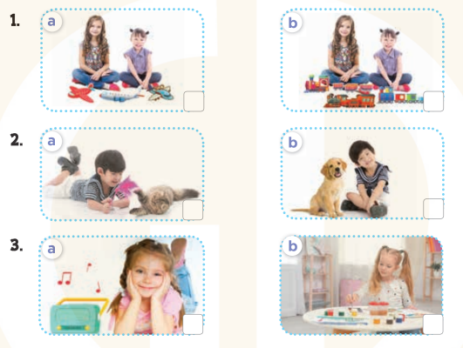  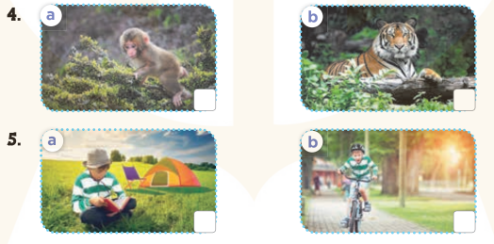  - T ask Ss to guess the answers.  + T writes Ss’guessing on the board.  - Listen to the tape:  + Play the recording  + Play the recording again and get Ss to swap books with their partners.  + Play the recording again to check answers together as a class.  + Write the answers on the board for Ss to correct their answers. Then checks Ss’ guessing.  - Play the recording, sentence by sentence, for the class to listen and repeat in chorus.  Key: 1. a 2. b 3. a 4. a 5. b  Activity 2. Listen and number  *Aims: Ss will be able to listen to and understand four communicative contexts  *Procedure:  - Elicit the context in each picture  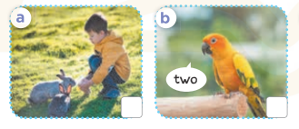    - T ask Ss to guess the answers.  + T writes Ss’guessing on the board.  - Listen to the tape:  + Play the recording  + Play the recording again and get Ss to swap books with their partners.  + Play the recording again to check answers together as a class.  + Write the answers on the board for Ss to correct their answers. Then checks Ss’ guessing.  - Play the recording, sentence by sentence, for the class to listen and repeat in chorus.  Key: 1. c 2. a 3. d 4. b  *Consolidation  *Aims: Ss will be able consolidate and wrap up the content of the lesson.  *Procedure:  - T asks ss to answer the following questions:  + What have you learnt from the lesson today?  - T praises some Ss who are hardworking / active/ good…. as well as encourage others to try more.  4. Homework. (3’)  - Prepare the new lesson: Review 4 (3,4,5) | - Ss listen  -Ss play game  - Ss open their books  -Look at the pictures and say:  + Picture 1a. two girls having three planes  + Picture 1b. two girls having three trains  + Picture 2a. a boy playing with a cat  + Picture 2b. a boy playing with a dog  + Picture 3a. a girl listening to music  + Picture 3b. a girl drawing a picture  + Picture 4a. a monkey + Picture 4b. a tiger  + Picture 5a. a boy reading a book  + Picture 5b. a boy cycling.  -Ss guess the answers  - Ss listen to the tape and tick  - Ss listen again, tick and swap books with their partners.  - Ss check their answers and guessing  -Ss listen and repeat.  -Look at the pictures and say:  + Picture a: a boy and his two rabbits  + Picture b: one parrot counting  + Picture c: a girl holding a teddy bear  + Picture d: a grandfather watching TV  -Ss guess the answers  - Ss listen to the tape and write the number  - Ss listen again, write number and swap books with their partners.  - Ss check their answers and guessing  -Ss listen and repeat.  -Ss listen and answer  -Ss listen and clap their hands  -Ss listen and take note
D. ADJUSTMENTS (if necessary):
………………………………………………………………………………………….…..……………………………………………………………………………...…………

