Week 33 Preparing date: April 28th ,2025
Period 129 Teaching date : April 29th , 2025

Unit 19: Outdoor activities
Lesson 3 (4, 5, 6)
A. OBJECTIVES:
By the end of the lesson, Ss will be able to:
1. Knowledge:
- read a passage and answer the questions about what someone is doing outdoors.
- complete a paragraph about what a pupil and his/her friend are doing outdoors.
- trace and colour the friends, then tell the class where they are and what they are doing.
- Vocabulary: Review
- Skills: speaking, listening, reading and writing.
2. Competences:
- Co-operation: ready to help friends in pair work/ group work.
- Self-control and independent learning: perform reading tasks.
3. Attitude/ Qualities:
- Kindness: Help partners to complete learning tasks.
- Honesty: tell the truth about feelings and emotions.
- Diligence: complete learning tasks.
B. TEACHING AIDS:
- Teacher: Teacher’s guide Pages 240, 241, website sachmem.vn, posters, laptop, pictures, textbook, lesson plan, TV or projector.
- Students: Pupil’s book Page 63, notebooks, workbooks, school things.
C. PROCEDURES:
Teacher’s activities | Students’ activities
1.Warm- up: (5’)  Game: Who’s faster?  *Aims: to review the vocabulary and structure about greet and respond to greetings.  *Procedure:  - Tell Ss that they are going to look at the cards in 60 seconds, memorise the words (playing volleyball, flying a kite, skating, running, cycling, skipping) then remember as many of the words as possible.  - Put the cards on a desk or stick them on the board. Then cover them with a piece of cloth.  - Divide the class into 2 or 4 groups. - Remove the cloth and show the cards for 60 seconds. Then cover them again.  - In their groups, Ss try to say as many of the words as they can remember.  - Have the groups say the names of the things aloud.  - For each correct word, give them a star or a point.  - The group with the most stars / points wins.  - Say “Open your book page 63” and look at “Unit 19, Lesson 3 (4,5,6)”.  2.Practice: (8’)  Activity 1. Read and answer:  *Aims: Ss will be able to read a passage and answer the questions about what someone is doing outdoors.  *Procedure:  - Ask Ss to attend to four questions and his / her outdoor activity in the passage.  - Have Ss work individually.  - Set a time limit for Ss to read and answer the questions.  - Tell Ss to swap the answers with a partner, then check answers as a class.  - Write the answers on the board.  - Invite Ss to read the texts aloud  -T gives feedbacks.  Key: 1. They’re in the park.  2. She’s cycling.  3. He’s flying a kite.  4. He’s playing football.  3.Production: (19’)  Activity 2. Let’s write  *Aims: Ss will be complete a paragraph about what a pupil and his / her friend are doing outdoors.  *Procedure:  - Tell the class the goal of this activity  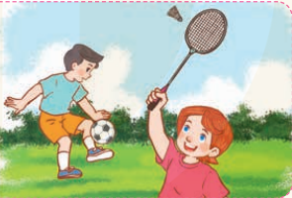  - Have Ss fill in the first gap together as an example.  - Ask Ss to look at the first gap, ask What do they like? and elicit the words (sports and games)  - Let Ss write down the word in the gap.  - Repeat the same procedure with the other incomplete sentences.  - Give Ss time to write the answers in their notebooks.  - Invite a few Ss to read aloud the paragraph they have completed in front of the class.  Key: Pupils’ own answers  Activity 3. Project.  *Aims: Ss will be able to trace and colour the friends, then tell the class where they are and what they are doing.  *Procedure:  - Have pupils work in groups.  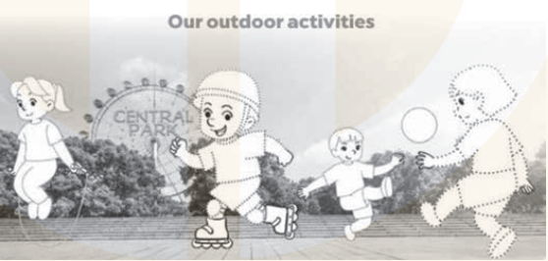  - Model by saying: Look at this boy. He is Bill. I’ll trace and colour him. Then trace and colour the character (Bill) in different colours.  - Finally, describe the character.  + For example: Look! This is my friend Bill. He’s in the Central Park now. He’s skating…  - Hand out copies of the picture to pupils and coloured pencils.  - Give time for all groups to do their task.  - Invite some Ss to present in front of the class tell the class about the characters they have traced and coloured, then describe where and what they are doing.  *Consolidation  *Aims: Ss will be able consolidate and wrap up the content of the lesson.  *Procedure:  - T asks ss to answer the following questions:  + What have you learnt from the lesson today?  - T praises some Ss who are hardworking / active/ good…. as well as encourage others to try more.  4. Homework. (3’)  - Prepare the new lesson: Unit 20- Lesson 1 (1,2,3). | - Ss listen  -Ss play game  -Ss play game  - Ss open their books  -Ss listen and answer  -Ss read the text silently  -Ss read and answer  -Ss swap books and check  - Ss check their answer  -Ss read aloud  -Ss listen  -Ss listen  -Ss read and answer  -Ss listen and answer  -Ss write down  Lucy and Nam are my friends. They like ……………… Lucy is …………………………………  Nam is ………………….. I like …………… I’m ……………… What are you doing?  -Ss read aloud  -Ss work in groups  -Ss listen  -Ss listen  -Ss practise  -Ss work in groups  -Ss perform in front of the class.  -Ss answer the questions  -Ss listen and clap their hands  -Ss listen and take note
D. ADJUSTMENTS (if necessary):
………………………………………………………………………………………….…..……………………………………………………………………………...…………
Week 33 Preparing date: April 28th ,2025
Period 130 Teaching date : April 29th , 2025

Unit 20: At the zoo
Lesson 1 (1, 2, 3)
A. OBJECTIVES:
By the end of the lesson, Ss will be able to:
1. Knowledge:
- use the words tiger, monkey, elephant, horse, peacock, parrot in relation to the topic “At the zoo”.
- correctly use What can you see? – I can see …….. to ask and answer questions about what animals someone can see at the zoo.
- Vocabulary: tiger, monkey, elephant, horse, peacock, zoo, see
- Model sentences:
A: What can you see?
B: I can see a tiger.
- Skills: speaking and listening
2. Competences:
-Critical Thinking: talk about friends.
- Co-operation: ready to help friends in pair work/ group work.
- Sociability: Talk to each other, say good words to others.
3. Attitude/ Qualities:
- Kindness: Help partners to complete learning tasks.
- Honesty: tell the truth about feelings and emotions
B. TEACHING AIDS:
- Teacher: Teacher’s guide Pages 242, 243, audio Tracks 94, 95, website sachmem.vn, posters, laptop, pictures, textbook, lesson plan, TV or projector.
- Students: Pupil’s book Page 64, notebooks, workbooks, school things.
C. PROCEDURES:
Teacher’s activities | Students’ activities
1.Warm- up: (3’)  Sing: If you’re happy and you know  *Aims: to create a friendly and active atmosphere in the class to beginning the lesson.  *Procedure:  - Show the song on the screen.  https://www.youtube.com/watch?v=zyMWcWqmhRc  - Ask Ss to listen, sing and dance the song.  - Say “Open your book page 64” and look at “Unit 20, Lesson 1 (1,2,3)”.  2. Presentation(16’)  Activity 1. Vocabulary.  *Aims: Ss will be able to know the vocabulary in front of starting the new lesson.  *Procedure:  -T elicits the new words  + tiger : con hổ (visual)  + horse : con ngựa (visual)  + monkey :con khỉ (visual)  + peacock : con công (picture)  + elephant :con voi (visual)  + zoo: sở thú (translation)  + see : nhìn thấy (translation)  - T models (3 times).  - T writes the words on the board.  - Checking: Matching  Activity 2. Look, listen and repeat:  *Aims: Ss will be able to understand and correctly repeat the sentences in two communicative contexts (pictures) to ask and answer questions about what animals someone can see at the zoo.  *Procedure:  - Have Ss look at Pictures a and b and identify names of the speakers in the pictures.  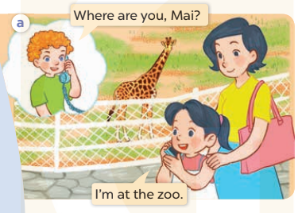  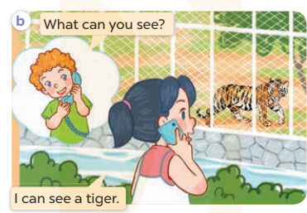  - Play the audio twice (sentence by sentence). Correct their pronunciation where necessary.  - Have Ss to practice the dialogue  - T invites a few pairs to the front of the class to practice.  - T checks pronunciation for ss.  Activity 3 Listen, point and say.  *Aims: Ss will be able to correctly use What can you see? – I can see …….. to ask and answer questions about what animals someone can see at the zoo.  *Procedure:  * Model sentences:  - T asks Ss look at picture a, b and helps Ss know the structure from the dialogue.  - T introduces new structure for Ss.  - T explains, models and gives meaning.  -Have Ss repeat the model sentences.  A: What can you see?  B: I can see a tiger.  3.Practice: (7’)  *Drill pictures  - Elicit elicit the names of the animals in each picture.  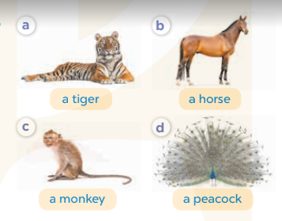  - Run through all the pictures.  - Run through model sentences.  +Run through the question sentences  +Run through the answer sentences  - Have Ss to practise:  + T asks, Ss answer picture a  + Ss ask, T answers picture b  + Group A ask, group B answer picture c  + Group B ask, group A answer picture d  - Ask Ss to work in pairs.  - T controls and corrects.  - Invite a few pairs to come to the front of the classroom and point at the pictures and say the questions and answers in front of the class.  - T gives feedbacks.  4.Production: (7’)  Activity 4. Let’s talk.  *Aims: Ss will be able to enhance the correct use of What can you see? – I can see …… to ask and answer questions about what animals someone can see at the zoo.  *Procedure:  - Have Ss look at the picture and tell names of the animals.  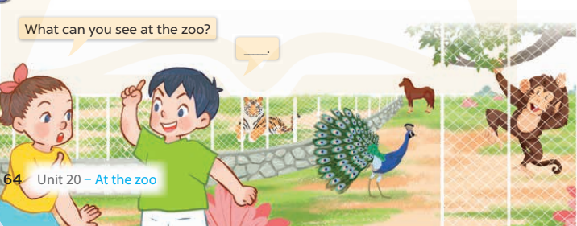  - Put Ss into groups of four.  - Ask Ss to say using What can you see? I can see……..  - Invite some Ss to the front of the class to say about the activity.  *Consolidation  *Aims: Ss will be able consolidate and wrap up the content of the lesson.  *Procedure:  - T asks ss to answer the following questions:  + What have you learnt from the lesson today?  +What are the core values of the lesson? (if the teacher can take from the lesson).  - T review the vocabulary and model sentences.  - T praises some Ss who are hardworking / active/ good…. as well as encourage others to try more.  5. Homework. (2’)  - Learn the vocabulary and model sentences by heart  - Prepare the new lesson: Unit 20, Lesson 1 (4,5,6). | - Ss listen  - Ss sing a song  - Ss open their books  -Ss listen and answer  - - Ss listen and repeat  + Choral repetition (3 times).  + Individual repetition (3 ss)  - Ss take note  - Ss look, remember and match  -Look at the pictures and say  + In picture a: Bill calls and asks Mai: Where are you, Mai? Mai answers: I’m at the zoo.  + In picture b: Bill continues asking Mai: What can you see? Mai answers: I can see a tiger.  -Ss listen and repeat in chorus (twice)  -Ss work in pairs to practice  -Ss practice the dialogue  -Ss listen  -Ss look at the picture and answer.  -Ss listen  -Ss listen and repeat  -Ss repeat  - Ss look, listen and answer  + Picture a: a tiger  + Picture b. a horse.  + Picture c. a monkey.  + Picture d. a peacock  -Ss listen and repeat  -Ss practice in chorus  -Ss work in pairs to practice  -Ss point and say  -Ss listen.  -Ss look at the picture and listen  -Ss look and answer  -Ss perform in front of the class.  -Ss answer the questions  - Ss listen  -Ss listen and clap their hands  -Ss listen and take note
D. ADJUSTMENTS (if necessary):
………………………………………………………………………………………….…..……………………………………………………………………………...………………………………………….…..……………………………………………………………………………….……………………………………………………………………...
Week 33 Preparing date: April 28th ,2025
Period 131 Teaching date : April 29th , 2025

Unit 20: At the zoo
Lesson 1 (4, 5, 6)
A. OBJECTIVES:
By the end of the lesson, Ss will be able to:
1. Knowledge:
- listen to and understand four communicative contexts in which pupils ask and answer questions about what animals they can see at the zoo and number the correct pictures.
- complete the four gapped exchanges with the help of the picture cues.
- Vocabulary: Review
- Skills: speaking, listening, reading and writing.
2. Competences:
- Critical Thinking: talk about friends
- Co-operation: ready to help friends in pair work/ group work.
- Self-control and independent learning: perform listening tasks.
3. Attitude/ Qualities:
- Kindness: Help partners to complete learning tasks.
- Honesty: tell the truth about feelings and emotions.
- Diligence: complete learning tasks.
B. TEACHING AIDS:
- Teacher: Teacher’s guide Pages 244, 245; audio Tracks 96; website sachmem.vn, posters, laptop, pictures, textbook, lesson plan, TV or projector.
- Students: Pupil’s book Page 65, notebooks, workbooks, school things.
C. PROCEDURES:
Teacher’s activities | Students’ activities
1.Warm- up: (5’)  Game: Simon says.  *Aims: to create a friendly and active atmosphere in the class to beginning the lesson.  *Procedure:  - T is the leader and calls out the actions with “Simon says”.  - Ss must follow the leader and do the action.  - Then teacher has to try and get pupils to do an action without saying “Simon says”. If pupil does the action, he/she is out of the game.  Simons says swim like a fish.  Simons says jump like a monkey.  Simon says run like a horse.  Touch your ears like a rabbit!  Did you touch your ears?  I didn’t say Simon says.  Simons says roar like a tiger.  Dance like a peacock.  Did you dance?  I didn’t say Simon says.  - Say “Open your book page 65” and look at “Unit 20, Lesson 1 (4,5,6)”.  2.Practice: (27’)  Activity 1. Listen and number:  *Aims: Ss will be able to listen to and understand four communicative contexts in which pupils ask and answer questions about what animals they can see at the zoo and number the correct pictures  *Procedure:  - Have Ss look at each picture in and ask them What can you see? and let them give the answers.  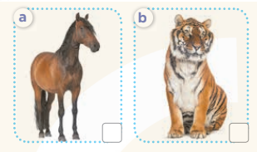  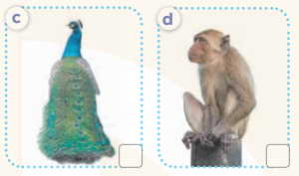  - T ask Ss to guess the answers.  + T writes Ss’guessing on the board.  - Listen to the tape:  + Play the recording  + Play the recording again and get Ss to swap books with their partners.  + Play the recording again to check answers together as a class.  + Write the answers on the board for Ss to correct their answers. Then checks Ss’ guessing.  - Play the recording, sentence by sentence, for the class to listen and repeat in chorus.  Key: 1. d 2. a 3. b 4. c  Activity 2. Look, complete and read  *Aims: Ss will be able to complete the four gapped exchanges with the help of the picture cues.  *Procedure:  - Get Ss to look at the pictures and identify the animals in the pictures.  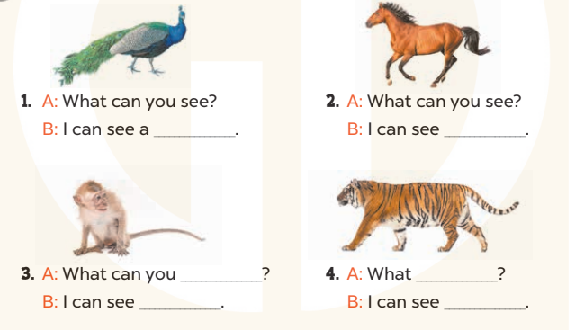  - Have Ss look at the four sentences and the pictures. Elicit and model with picture 1  + Ask Ss to read the sentence 1 in chorus.  + Ask them what is missing in the question (peacock). Then have them complete the gap (I can see a peacock).  -Have Ss work in pairs and complete the dialogue 2, 3, 4.  - Ask a few Ss to stand up and read the sentences aloud.  -T gives feedbacks.  Key:  1. peacock  2. a horse  3. see; a monkey  4. can you see; a tiger  Activity 3. Let’s play  *Aims: Ss will be able to revise the target vocabulary items through the Miming game.  *Procedure:  - Tell Ss that they are going to revise the target vocabulary items they have learnt in Lesson 1.  - Divide Ss into groups of five and give each group a set of cards.  - Have each player in group 1 in turn look at the card and mime / act out the animal on the card (ex: peacock) without making any sounds or lip movements.  + The other player in the group asks What can you see? The players in group 2 answer (ex:I can see a peacock.).  + If the second group has the correct answer, they get a point.  + If the answer does not match the action, switch the groups and let each player in group 2 mime the animal while the first group gives the answer.  - The game ends when all the cards are gone.  *Consolidation  *Aims: Ss will be able consolidate and wrap up the content of the lesson.  *Procedure:  - T asks ss to answer the following questions:  + What have you learnt from the lesson today?  - T praises some Ss who are hardworking / active/ good…. as well as encourage others to try more.  3. Homework. (3’)  - Prepare the new lesson: Unit 20, Lesson 2 (1,2,3). | - Ss listen  - Ss play the game  - Ss open their books  -Look at the pictures and say:  + Picture a: a horse  + Picture b: a tiger.  + Picture c: a peacock.  + Picture d: a monkey.  -Ss guess the answers  - Ss listen to the tape and tick  - Ss listen again, tick and swap books with their partners.  - Ss check their answers and guessing  -Ss listen and repeat.  -Ss look at the picture and say  -Ss look and answer  -Ss read  -Ss say and complete  -Ss work in pairs and complete  -Ss read aloud  - Ss listen  -Ss play the game  -Ss answer the questions  -Ss listen and clap their hands  -Ss listen and take note
D. ADJUSTMENTS (if necessary):
………………………………………………………………………………………….…..……………………………………………………………………………...………………………………………….…..……………………………………………………………………………….……………………………………………………………………...

Week 33 Preparing date: April 28th ,2025
Period 132 Teaching date : May 2nd , 2025

Unit 20: At the zoo
Lesson 2 (1, 2, 3)
A. OBJECTIVES:
By the end of the lesson, Ss will be able to:
1. Knowledge:
- use What is the ……… doing? – It's ……. to ask and answer questions about what a zoo animal is doing.
-enhance the correct use of What’s the …..doing? – It’s ………to ask and answer questions about what a zoo animal is doing.
- Vocabulary: counting, swinging, climbing
- Model sentences:
A: What’s the elephant doing?
B: It’s dancing.
- Skills: speaking and listening
2. Competences:
- Co-operation: ready to help friends in pair work/ group work.
- Sociability: Talk to each other, say good words to others.
3. Attitude/ Qualities:
- Kindness: Help partners to complete learning tasks.
- Honesty: tell the truth about feelings and emotions
B. TEACHING AIDS:
- Teacher: Teacher’s guide Pages 246, 247; audio Tracks 97, 98, website sachmem.vn, posters, laptop, pictures, textbook, lesson plan, TV or projector.
- Students: Pupil’s book Page 660, notebooks, workbooks, school things.
C. PROCEDURES:
Teacher’s activities | Students’ activities
1.Warm- up: (3’)  Game: Pass the ball  *Aims: to create a friendly and active atmosphere in the class to beginning the lesson.  *Procedure:  - Stand up and pass the ball with music.  - When music stops, those who keep the ball must look at a picture on the board and say a sentence: I can see….  - Say “Open your book page 66” and look at “Unit 20, Lesson 2 (1,2,3)”.  2. Presentation(16’)  Activity 1. Vocabulary.  *Aims: Ss will be able to know the vocabulary in front of starting the new lesson.  *Procedure:  -T elicits the new words  + counting : đếm (mime)  + swinging : đu chuyền (explain)  + climbing : leo trèo (explain)  - T models (3 times).  - T writes the words on the board.  - Checking: Rub out and remember  Activity 2. Look, listen and repeat:  *Aims: Ss will be able to understand and correctly repeat What is the …….doing? It's …….. to ask and answer questions about what a zoo animal is doing.  *Procedure:  - Have Ss look at Pictures a and b and elicit the names of the speakers in the pictures.  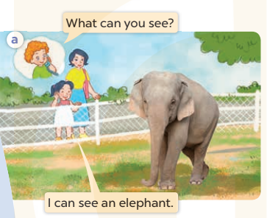  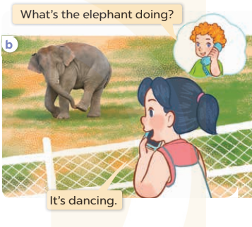  - Play the audio twice (sentence by sentence). Correct their pronunciation where necessary.  - Have Ss to practice the diaguage  - T invites a few pairs to the front of the class to practice.  - T checks pronunciation for ss.  Activity 3. Listen, point and say.  *Aims: Ss will be able to correctly use What is the …. doing? – It's …... to ask and answer questions about what a zoo animal is doing. *Procedure:  * Model sentences:  - T asks Ss look at picture b and helps Ss know the structure from the dialogue.  - T introduces new structure for Ss.  - T explains, models and gives meaning.  - Have Ss repeat the model sentences.  A: What’s the elephant doing?  B: It’s dancing.  3.Practice: (7’)  *Drill pictures  - Have Ss look at the pictures and elicit the name of the animal.  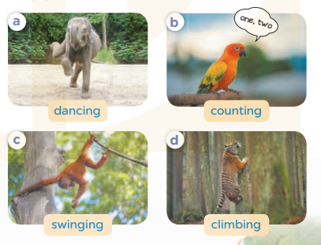  - Run through all the pictures.  - Run through model sentences.  +Run through the question sentences  +Run through the answer sentences  - Have Ss to practise:  + T asks, Ss answer picture a  + Ss ask, T answers picture b  + Group A ask, group B answer picture c  + Group B ask, group A answer picture d  - Ask Ss to work in pairs.  - T controls and corrects.  - Invite a few pairs to come to the front of the classroom, point at the pictures and say in front of the class.  - T gives feedbacks.  4.Production: (7’)  Activity 4. Let’s talk.  *Aims: Ss will be able to enhance the correct use of What is the ….. doing? – …….. to ask and answer questions about what a zoo animal is doing.  *Procedure:  - Have Ss look at the picture and elicit the question and answer: What’s the…… doing? It’s…..  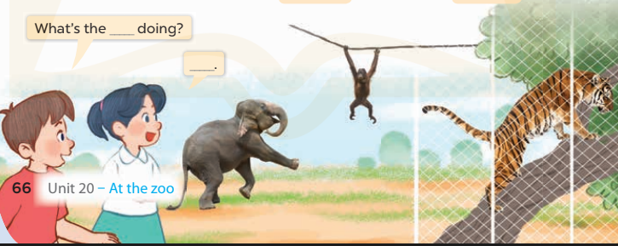  - Ask Ss work in pairs to ask and answer questions about what is the animal doing?  - Invite some pairs to role play in front of the class to point at the activity in the picture cue in their books.  *Consolidation  *Aims: Ss will be able consolidate and wrap up the content of the lesson.  *Procedure:  - T asks ss to answer the following questions:  + What have you learnt from the lesson today?  - T review the vocabulary and model sentences.  - T praises some Ss who are hardworking / active/ good…. as well as encourage others to try more.  5. Homework. (2’)  - Learn the vocabulary and model sentences by heart  - Prepare the new lesson: Unit 20, Lesson 2 (4,5,6). | - Ss listen  - Ss play the game  - Ss open their books  -Ss listen and answer  - - Ss listen and repeat  + Choral repetition (3 times).  + Individual repetition (3 ss)  - Ss take note  - Ss look, remember and write  -Look at the pictures and get to know the characters in the pictures.  + In picture a: Bill calls and asks Mai: What can you see? Mai answers: I can see an elephant.  – In picture b: Bill continues asking Mai: What is the elephant doing?  And Mai says: It's dancing.  -Ss listen and repeat in chorus (twice)  -Ss work in pairs to practice  -Ss practice the diaguage  -Ss listen  -Ss look at the picture and answer.  -Ss listen  -Ss listen and repeat  -Ss repeat  -Ss listen and answer  +Picture a: an elephant dancing  +Picture b: a parrot counting  +Picture c: a monkey swinging  +Picture d: a tiger climbing  - Ss look, listen and repeat  - Ss practice in chorus  -Ss work in pairs to practice  -Ss listen  -Ss go to the board and point and say  -Ss listen  -Ss look at the picture and answer  -Ss work in pairs  -Ss practise in pair in front of the class.  -Ss answer the question  - Ss listen  -Ss listen and clap their hands  -Ss listen and take note
D. ADJUSTMENTS (if necessary):
………………………………………………………………………………………….…..……………………………………………………………………………...……………

