Week 30 Preparing date: April 6th ,2025
Period 117 Teaching date : April 7th , 2025

Unit 17: Our toys
Lesson 3 (4, 5, 6)
A. OBJECTIVES:
By the end of the lesson, Ss will be able to:
1. Knowledge:
- read and understand a passage about toys.
– read, understand and complete a paragraph about toys that Lucy has.
– revise the target language by making paper toys and talking about them to the class.
- Vocabulary: Review
- Skills: speaking, listening, reading and writing.
2. Competences:
- Co-operation: ready to help friends in pair work/ group work.
- Self-control and independent learning: perform reading tasks.
3. Attitude/ Qualities:
- Kindness: Help partners to complete learning tasks.
- Honesty: tell the truth about feelings and emotions.
- Diligence: complete learning tasks.
B. TEACHING AIDS:
- Teacher: Teacher’s guide Pages 219, 220, website sachmem.vn, posters, laptop, pictures, textbook, lesson plan, TV or projector.
- Students: Pupil’s book Page 51, notebooks, workbooks, school things.
C. PROCEDURES:
Teacher’s activities | Students’ activities
1.Warm- up: (5’)  Game: What’s in the box?  *Aims: to review the vocabulary and structure about greet and respond to greetings.  *Procedure:  - Divide class into 4 teams.  - Set rules: invite 1 pupil from each team go to the board look at the toy  (kite, plane, doll, train, bus, car, ship) then unscramble the words by writing on the board and say aloud what the toy is. The fastest will get more points than the rest.  - Encourage Ss join in the game.  - Give points for the teams.  - Say “Open your book page 51” and look at “Unit 17, Lesson 3 (4,5,6)”.  2.Practice: (8’)  Activity 1. Read and circle a, b, or c:  *Aims: Ss will be able to read and understand a passage about toys.  *Procedure:  - Tell Ss attend to the passage about Linh’s and Lucy’s toys and read it together as a class.  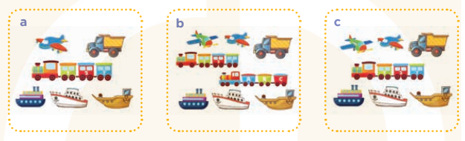  - Have Ss spot the differences between the pictures (the quantity of toys in each picture) and check comprehension.  - Get Ss to read and circle the correct letter.  - Get Ss to swap books with a partner, then check answers together as a class.  - Invite Ss to read the complete text aloud  -T gives feedbacks.  Key: c  3.Production: (19’)  Activity 2. Let’s write  *Aims: Ss will be read, understand and complete a paragraph about toys that Lucy has.  *Procedure:  - Tell the class the goal of this activity: Ss read the passage about Lucy’s toys and fill in the gaps.  - Have Ss fill in the first gap together as an example.  - Ask Ss to look at the gap and guess what is missing (the word She).  - Let Ss write down the word in the gap.  - Repeat the same procedure with the other incomplete sentences.  - If time allows, invite a few Ss to read aloud the paragraph they have completed in front of the class.  Key: Pupils’ own answers  Activity 3. Project.  *Aims: Ss will be able to revise the target language by making paper toys and talking about them to the class.  *Procedure:  - Elicit the language needed to do the task: He / She has ___. and ask Ss to repeat it several times  - Ask Ss to work in groups of six.  + Ask Ss to show the paper toys that they have made at home, then tell the group about them and check comprehension.  - Give Ss time to do the task.  - Invite some Ss to show and tell the class about the toys they have made using the language learnt.  - Have Ss display their toys on the classroom walls.  *Consolidation  *Aims: Ss will be able consolidate and wrap up the content of the lesson.  *Procedure:  - T asks ss to answer the following questions:  + What have you learnt from the lesson today?  - T praises some Ss who are hardworking / active/ good…. as well as encourage others to try more.  4. Homework. (3’)  - Prepare the new lesson: Unit 18- Lesson 1 (1,2,3). | - Ss listen  -Ss play game  - Ss open their books  -Ss listen and answer  + Picture a: a plane, a truck, a train, three ships  + Picture b: two planes, a truck, two trains, three ships  + Picture c: two planes, a truck, a train, three ships  -Ss read and answer  -Ss read and circle  -Ss swap books and check  -Ss read aloud  -Ss listen  -Ss listen  -Ss read and answer  -Ss listen and answer  -Ss write down  Lucy is my friend. She has a doll………is my friend. She/ He has……………. ………and  ………..are my friends. They have…………..  -Ss read aloud  -Ss listen and repeat  -Ss work in groups  -Ss work in groups  -Ss perform in front of the class.  -Ss display their toys on the classroom walls.  -Ss answer the questions  -Ss listen and clap their hands  -Ss listen and take note
D. ADJUSTMENTS (if necessary):
………………………………………………………………………………………….…
..……………………………………………………………………………...…………
Week 30 Preparing date: April 6th ,2025
Period 118 Teaching date : April 7th , 2025

Unit 18: Playing and doing
Lesson 1 (1, 2, 3)
A. OBJECTIVES:
By the end of the lesson, Ss will be able to:
1. Knowledge:
- understand and correctly repeat the sentences in two communicative contexts to talk about an action in progress.
- correctly say the words and use I’m …… to identify an action in progress.
- enhance the correct use of I’m……… to identify an action in progress in a freer context.
- Vocabulary: writing, dancing, singing, reading, song.
- Model sentences:
I’m dancing.
- Skills: speaking and listening
2. Competences:
- Co-operation: ready to help friends in pair work/ group work.
- Sociability: Talk to each other, say good words to others.
3. Attitude/ Qualities:
- Kindness: Help partners to complete learning tasks.
- Honesty: tell the truth about feelings and emotions
B. TEACHING AIDS:
- Teacher: Teacher’s guide Pages 221, 222, audio Tracks 74, 75, website sachmem.vn, posters, laptop, pictures, textbook, lesson plan, TV or projector.
- Students: Pupil’s book Page 52, notebooks, workbooks, school things.
C. PROCEDURES:
Teacher’s activities | Students’ activities
1.Warm- up: (3’)  Sing: Head, shoulders, knees and toes  *Aims: to create a friendly and active atmosphere in the class to beginning the lesson.  *Procedure:  - Show the song on the screen.  https://www.youtube.com/watch?v=WX8HmogNyCY  - Ask Ss to listen, sing and dance the song.  - Say “Open your book page 52” and look at “Unit 18, Lesson 1 (1,2,3)”.  2. Presentation(16’)  Activity 1. Vocabulary.  *Aims: Ss will be able to know the vocabulary in front of starting the new lesson.  *Procedure:  -T elicits the new words  + writing : viết (mime)  + dancing : nháy múa (mime)  + singing :hát (mime)  + reading : đọc (mime)  + song :bài hát (translation)  - T models (3 times).  - T writes the words on the board.  - Checking: Matching  Activity 2. Look, listen and repeat:  *Aims: Ss will be able to understand and correctly repeat the sentences in two communicative contexts to talk about an action in progress.  *Procedure:  - Have Ss look at Pictures a and b and identify names of the speakers in the pictures.  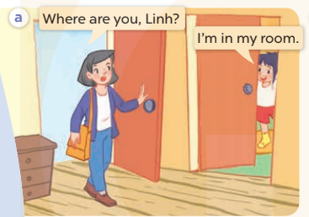  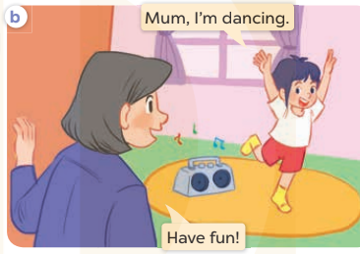  - Play the audio twice (sentence by sentence). Correct their pronunciation where necessary.  - Have Ss to practice the dialogue  - T invites a few pairs to the front of the class to practice.  - T checks pronunciation for ss.  Activity 3 Listen, point and say.  *Aims: Ss will be able to correctly say the words and use I’m ……. to identify an action in progress  *Procedure:  * Model sentences:  - T asks Ss look at picture b and helps Ss know the structure from the dialogue.  - T introduces new structure for Ss.  - T explains, models and gives meaning.  -Have Ss repeat the model sentences.  I’m dancing.  3.Practice: (7’)  *Drill pictures  - Elicit the character and the quantity of toys in each picture.  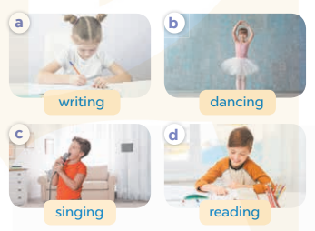  - Run through all the pictures.  - Run through model sentences.  - Have Ss to practise:  - Ask Ss to work in pairs.  - T controls and corrects.  - Invite a few pairs to come to the front of the classroom and point at the pictures and say the questions and answers in front of the class.  - T gives feedbacks.  4.Production: (7’)  Activity 4. Let’s talk.  *Aims: Ss will be able to enhance the correct use of I’m ….. to identify an action in progress in a freer context.  *Procedure:  - Have Ss look at the picture and tell them about the activity.  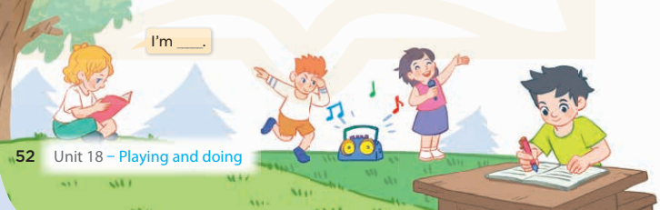  - Put Ss into groups of four.  - Ask Ss to say using I’m…..  - Invite some Ss to the front of the class to say about the activity.  *Consolidation  *Aims: Ss will be able consolidate and wrap up the content of the lesson.  *Procedure:  - T asks ss to answer the following questions:  + What have you learnt from the lesson today?  +What are the core values of the lesson? (if the teacher can take from the lesson).  - T review the vocabulary and model sentences.  - T praises some Ss who are hardworking / active/ good…. as well as encourage others to try more.  5. Homework. (2’)  - Learn the vocabulary and model sentences by heart  - Prepare the new lesson: Unit 18, Lesson 1 (4,5,6). | - Ss listen  - Ss sing a song  - Ss open their books  -Ss listen and answer  - - Ss listen and repeat  + Choral repetition (3 times).  + Individual repetition (3 ss)  - Ss take note  - Ss look, remember and match  -Look at the pictures and say  + In picture a: Mum asks: Where are you, Linh? Linh answers: I’m in my room.  + In picture b: Linh says: Mum, I’m dancing and Mum says: Have fun!  -Ss listen and repeat in chorus (twice)  -Ss work in pairs to practice  -Ss practice the dialogue  -Ss listen  -Ss look at the picture and answer.  -Ss listen  -Ss listen and repeat  -Ss repeat  - Ss look, listen and answer  + Picture a: a girl is writing + Picture b: a girl is dancing + Picture c: a boy is singing  + Picture d: a boy is reading  -Ss listen and repeat  -Ss practice in chorus  -Ss work in pairs to practice  -Ss point and say  -Ss listen.  -Ss look at the picture and listen  -Ss look and answer  -Ss perform in front of the class.  -Ss answer the questions  - Ss listen  -Ss listen and clap their hands  -Ss listen and take note
D. ADJUSTMENTS (if necessary):
………………………………………………………………………………………….…..……………………………………………………………………………...………………………………………….…..……………………………………………………………………………….……………………………………………………………………...
Week 30 Preparing date: April 6th ,2025
Period 119 Teaching date : April 9th , 2025

Unit 18: Playing and doing
Lesson 1 (4, 5, 6)
A. OBJECTIVES:
By the end of the lesson, Ss will be able to:
1. Knowledge:
- listen to and understand two communicative contexts about identifying actions in progress and tick the correct pictures.
- complete the four target sentence patterns with the help of picture cues.
- practise the target vocabulary and sentence patterns by playing the Miming game.
- Vocabulary: Review
- Skills: speaking, listening, reading and writing.
2. Competences:
- Critical Thinking: talk about activity
- Co-operation: ready to help friends in pair work/ group work.
- Self-control and independent learning: perform listening tasks.
3. Attitude/ Qualities:
- Kindness: Help partners to complete learning tasks.
- Honesty: tell the truth about feelings and emotions.
- Diligence: complete learning tasks.
B. TEACHING AIDS:
- Teacher: Teacher’s guide Pages 223, 224; audio Tracks 76, 77; website sachmem.vn, posters, laptop, pictures, textbook, lesson plan, TV or projector.
- Students: Pupil’s book Page 53, notebooks, workbooks, school things.
C. PROCEDURES:
Teacher’s activities | Students’ activities
1.Warm- up: (5’)  Game: A letter to the Santa Claus  *Aims: to create a friendly and active atmosphere in the class to beginning the lesson.  *Procedure:  - Divide class into 4 teams.  - Set rules: invite 1 pupil to go to the board, look at the picture, then say aloud what toy the boy wants for Christmas. The fastest has one points for his/her team.  (writing, dancing, singing, reading)  - Encourage Ss join in the game.  - Give point for Ss.  - Say “Open your book page 53” and look at “Unit 18, Lesson 1 (4,5,6)”.  2.Practice: (27’)  Activity 1. Listen and tick:  *Aims: Ss will be able to listen to and understand two communicative contexts about identifying actions in progress and tick the correct pictures  *Procedure:  - Elicit the word for the action in each picture.  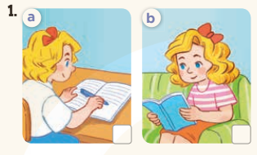  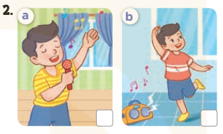  - T ask Ss to guess the answers.  + T writes Ss’guessing on the board.  - Listen to the tape:  + Play the recording  + Play the recording again and get Ss to swap books with their partners.  + Play the recording again to check answers together as a class.  + Write the answers on the board for Ss to correct their answers. Then checks Ss’ guessing.  - Play the recording, sentence by sentence, for the class to listen and repeat in chorus.  Key: 1. b 2. b  Activity 2. Look, complete and read  *Aims: Ss will be able to read and complete four target gapped dialogues with the help of the picture cues.  *Procedure:  - Get Ss to look at the pictures and identify the actions in the pictures.  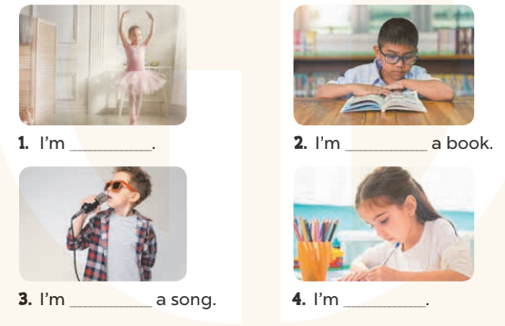  - Have Ss look at the four sentences and the pictures. Elicit and model with picture 1  + Ask Ss to read the sentence 1 in chorus.  + Ask them what is missing in the question (dancing). Then have them complete the gap (I’m dancing.).  -Have Ss work in pairs and complete the dialogue 2, 3, 4.  - Ask a few Ss to stand up and read the sentences aloud.  -T gives feedbacks.  Key:  1. dancing 2. reading  3. singing 4. writing  Activity 3. Let’s play  *Aims: Ss will be able to practise the target vocabulary and sentence patterns by playing the Miming game.  *Procedure:  - Tell Ss the goal of the game and how to play it  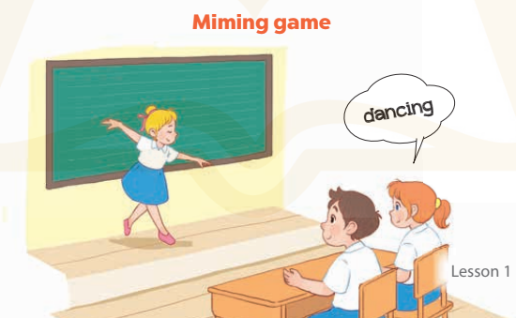  - Point at the game illustration, point at the girl, do an action, pretend to be the girl to elicit the word dancing. Then say: Yes. I’m dancing.  - Nominate a pupil to come to the front of the class. Show him or her a flash card and tell him / her to do the action for the class to guess.  - Divide the class into two groups. Have Ss in each group choose a picture and do the action. The group that guesses correctly wins a star.  -After three or four rounds, the group with more stars is the winner.  *Consolidation  *Aims: Ss will be able consolidate and wrap up the content of the lesson.  *Procedure:  - T asks ss to answer the following questions:  + What have you learnt from the lesson today?  - T praises some Ss who are hardworking / active/ good…. as well as encourage others to try more.  3. Homework. (3’)  - Prepare the new lesson: Unit 18, Lesson 2 (1,2,3). | - Ss listen  - Ss play game  - Ss open their books  -Look at the pictures and say:  + Picture 1a: a girl is writing  + Picture 1b: a girl is reading  + Picture 2a: a boy is singing  + Picture 2b: a boy is dancing  -Ss guess the answers  - Ss listen to the tape and tick  - Ss listen again, tick and swap books with their partners.  - Ss check their answers and guessing  -Ss listen and repeat.  -Ss look at the picture and say  -Ss look and answer  -Ss read  -Ss say and complete  -Ss work in pairs and complete  -Ss read aloud  - Ss listen  -Ss play the game  -Ss answer the questions  -Ss listen and clap their hands  -Ss listen and take note
D. ADJUSTMENTS (if necessary):
………………………………………………………………………………………….…..……………………………………………………………………………...………………………………………….…..……………………………………………………………………………….……………………………………………………………………...
Week 30 Preparing date: April 6th ,2025
Period 120 Teaching date : April 9th , 2025

Unit 18: Playing and doing
Lesson 2 (1, 2, 3)
A. OBJECTIVES:
By the end of the lesson, Ss will be able to:
1. Knowledge:
- understand and correctly repeat the sentences in two communicative contexts to ask and answer questions about an action in progress.
- correctly say the words and use What are you doing? – I’m …….. to ask and answer questions about an action in progress.
- enhance the correct use of What are you doing? – I’m …….. to ask and answer questions about an action in progress in a freer context
- Vocabulary: playing basketball, drawing a picture, watching TV, listening to music.
- Model sentences:
A: What are you doing?
B: I’m watching TV.
- Skills: speaking and listening
2. Competences:
- Critical Thinking: talk about activity
- Co-operation: ready to help friends in pair work/ group work.
- Sociability: Talk to each other, say good words to others.
3. Attitude/ Qualities:
- Kindness: Help partners to complete learning tasks.
- Honesty: tell the truth about feelings and emotions
B. TEACHING AIDS:
- Teacher: Teacher’s guide Pages 224, 225; audio Tracks 77, 78, website sachmem.vn, posters, laptop, pictures, textbook, lesson plan, TV or projector.
- Students: Pupil’s book Page 54, notebooks, workbooks, school things.
C. PROCEDURES:
Teacher’s activities | Students’ activities
1.Warm- up: (3’)  Game: Pass the ball  *Aims: to create a friendly and active atmosphere in the class to beginning the lesson.  *Procedure:  - Stand up and pass the ball with music.  - When music stops, those who keep the ball must look at a picture on the board and say a sentence. I’m……………  - Say “Open your book page 48” and look at “Unit 18, Lesson 2 (1,2,3)”.  2. Presentation(16’)  Activity 1. Vocabulary.  *Aims: Ss will be able to know the vocabulary in front of starting the new lesson.  *Procedure:  -T elicits the new words  + watching TV : xem ti vi (picture)  + playing basketball: chơi bóng rổ  (picture)  + drawing a picture : vẽ tranh (mime)  + listening to music : nghe nhạc (mime)  - T models (3 times).  - T writes the words on the board.  - Checking: What and where  Activity 2. Look, listen and repeat:  *Aims: Ss will be able to understand and correctly repeat the sentences in two communicative contexts to ask and answer questions about an action in progress.  *Procedure:  - Have Ss look at Pictures a and b and elicit the names of the speakers in the pictures.  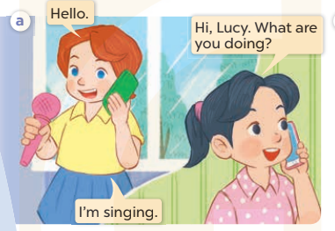  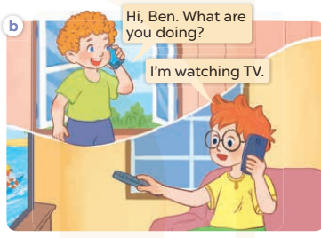  - Play the audio twice (sentence by sentence). Correct their pronunciation where necessary.  - Have Ss to practice the diaguage  - T invites a few pairs to the front of the class to practice.  - T checks pronunciation for ss.  Activity 3. Listen, point and say.  *Aims: Ss will be able to correctly say the words and use What are you doing? – I’m …… to ask and answer questions about an action in progress.  *Procedure:  * Model sentences:  - T asks Ss look at picture a, b and helps Ss know the structure from the dialogue.  - T introduces new structure for Ss.  - T explains, models and gives meaning.  - Have Ss repeat the model sentences.  A: What are you doing?  B: I’m watching TV.  3.Practice: (7’)  *Drill pictures  - Have Ss look at the pictures and elicit the actions in progress.  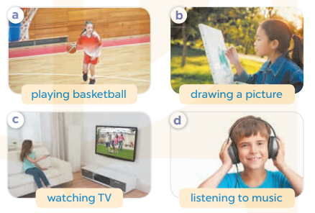  - Run through all the pictures.  - Run through model sentences.  +Run through the question sentences  +Run through the answer sentences  - Have Ss to practise:  + T asks, Ss answer picture a  + Ss ask, T answers picture b  + Group A ask, group B answer picture c  + Group B ask, group A answer picture d  - Ask Ss to work in pairs.  - T controls and corrects.  - Invite a few pairs to come to the front of the classroom, point at the pictures and say in front of the class.  - T gives feedbacks.  4.Production: (7’)  Activity 4. Let’s talk.  *Aims: Ss will be able to enhance the correct use of What are you doing? – I’m ……. to ask and answer questions about an action in progress in a freer context.  *Procedure:  - Have Ss look at the picture and elicit the answer I’m drawing a picture.  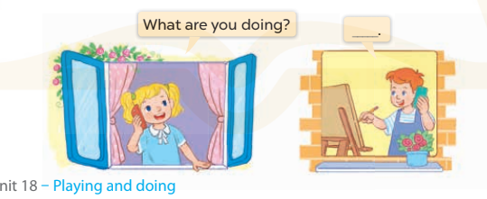  - Have Ss do the action for drawing a picture. Pretend to start a phone call and ask pupils: What are you doing? and elicit the full answer: I’m drawing a picture.  - Have Ss repeat the question a few times, and then the answer  - Have Ss sit back-to-back in pairs. One pupil is doing something while the other calls and asks: What are you doing?  - Invite some pairs to the front of the class to interact with each other, pointing at the activity in the picture cue in their books.  *Consolidation  *Aims: Ss will be able consolidate and wrap up the content of the lesson.  *Procedure:  - T asks ss to answer the following questions:  + What have you learnt from the lesson today?  - T review the vocabulary and model sentences.  - T praises some Ss who are hardworking / active/ good…. as well as encourage others to try more.  5. Homework. (2’)  - Learn the vocabulary and model sentences by heart  - Prepare the new lesson: Unit 18, Lesson 2 (4,5,6). | - Ss listen  - Ss play the game  - Ss open their books  -Ss listen and answer  - - Ss listen and repeat  + Choral repetition (3 times).  + Individual repetition (3 ss)  - Ss take note  - Ss look, remember and write  -Look at the pictures and get to know the characters in the pictures.  + In picture a: Lucy says: Hello, and Mai says: Hi, Lucy. What are you doing? Lucy answers: I’m singing.  – In picture b: Bill says: Hi, Ben. What are you doing? And Ben says: I’m watching TV.  -Ss listen and repeat in chorus (twice)  -Ss work in pairs to practice  -Ss practice the diaguage  -Ss listen  -Ss look at the picture and answer.  -Ss listen  -Ss listen and repeat  -Ss repeat  -Ss listen and answer  +Picture a: a girl is playing basketball  +Picture b: a girl is drawing a picture  +Picture c: a girl is watching TV  +Picture d: a boy is listening to music  - Ss look, listen and repeat  - Ss practice in chorus  -Ss work in pairs to practice  -Ss listen  -Ss go to the board and point and say  -Ss listen  -Ss look at the picture and answer  -Ss do action and say  -Ss repeat the question and answer  -Ss practise in pair in front of the class.  -Ss answer the question  - Ss listen  -Ss listen and clap their hands  -Ss listen and take note
D. ADJUSTMENTS (if necessary):
………………………………………………………………………………………….…..……………………………………………………………………………...……………

