Week 28 Preparing date: March …….,
Period 109 Teaching date: March…………,

Unit 16: My pets
Lesson 2 (4, 5, 6)
A. OBJECTIVES:
By the end of the lesson, Ss will be able to:
1. Knowledge:
- listen to and demonstrate understanding of simple communicative contexts in relation to the topic "Pets"
- complete the four gapped exchanges with the help of picture cues.
- play the game How many ...? to review vocabulary and structure words related to the topic “Pets”
- Vocabulary: Review
- Skills: speaking, listening, reading and writing.
2. Competences:
- Critical Thinking: talk about someone’s pets
- Co-operation: ready to help friends in pair work/ group work.
- Self-control and independent learning: perform listening tasks.
3. Attitude/ Qualities:
- Kindness: Help partners to complete learning tasks.
- Honesty: tell the truth about feelings and emotions.
- Diligence: complete learning tasks.
B. TEACHING AIDS:
- Teacher: Teacher’s guide Pages 205, 206; audio Tracks 60; website sachmem.vn, posters, laptop, pictures, textbook, lesson plan, TV or projector.
- Students: Pupil’s book Page 43, notebooks, workbooks, school things.
C. PROCEDURES:
Stages/Time | Teacher’s activities | Students’ activities
1.Warm- up:  (5’)  2.Presentation: (10’)  3.Practice(10’)  4.Production(5’)  3. Homework. (5’) | Sing a song: “throw the ball”  *Aims: to create a friendly and active atmosphere in the class to beginning the lesson.  *Procedure:  - Divide the class into 2 teams.  - Stick the pictures of things in the room on the board.  + T says a word, a pupil from each team has to point/throw the ball to the right picture and says the word three times.  + The one says faster will get points.  - Encourage Ss to take part in the game.  - Give points for Ss.  - Say “Open your book page 43” and look at “Unit 16, Lesson 2 (4,5,6)”.  Activity 1. Listen and number:  *Aims: Ss will be able to listen to and understand four communicative contexts in which pupils ask and answer questions about the quantity of rabbits.  *Procedure:  - Have Ss look at the pictures and ask them some questions such as What pets? and How many…? 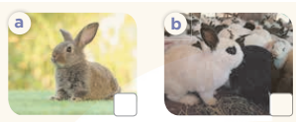  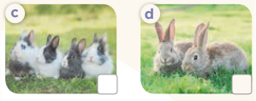  - T ask Ss to guess the answers.  + T writes Ss’guessing on the board.  - Listen to the tape:  + Play the recording  + Play the recording again and get Ss to swap books with their partners.  + Play the recording again to check answers together as a class.  + Write the answers on the board for Ss to correct their answers. Then checks Ss’ guessing.  - Play the recording, sentence by sentence, for the class to listen and repeat in chorus.  Key: 1.b 2. c 3. d 4. a  Activity 2. Look, complete and read.  *Aims: Ss will be able to complete four gapped dialogues with the help of picture cues.  *Procedure:  - Have Ss look at the pictures and ask identify pets in the pictures.  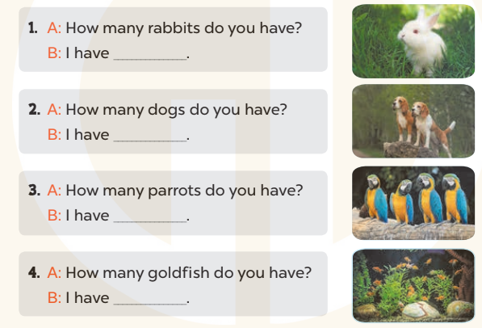  - T models with sentence 1.  + Have Ss look at the sentence.  + Ask them what is missing in the answer ( one).  + Have Ss complete the gap.  + Have Ss read the completed sentence in chorus.  -Have Ss work in pairs and complete the sentences 2, 3 and 4.  - Invite pairs of pupils to stand up and read aloud the sentences.  -T gives feedbacks.  Key: 1. one 2. two 3. some 4. many  Activity 3. Let’s play.  *Aims: Ss will be able to play the game How many ...? to review vocabulary and structure words related to the topic “Pets”.  *Procedure:  - Ask Ss to look at the picture carefully, then listen to the questions to find the right answers.  - Invite a group of four to the front of the class to demonstrate the game. - Two Ss compete as a pair in one round.  + A teacher asks the question How many_________do you have? and the player who first correctly answers I have________. wins one point for his / her group.  - Give Ss time to play the game in groups of four.  *Consolidation  *Aims: Ss will be able consolidate and wrap up the content of the lesson.  *Procedure:  - T asks ss to answer the following questions:  + What have you learnt from the lesson today?  +What are the core values of the lesson? (if the teacher can take from the lesson).  - T praises some Ss who are hardworking / active/ good…. as well as encourage others to try more.  - Prepare the new lesson: Unit 16, Lesson 3 (1,2,3). | - Ss listen and play the game  - Ss open their books  -Look at the pictures and say:  + Picture a: one rabbit  + Picture b: many rabbits  + Picture c: four rabbits  + Picture d: two rabbits  -Ss guess the answers  - Ss listen to the tape and write number  - Ss listen again, write number and swap books with their partners.  - Ss check their answers and guessing  -Ss listen and repeat.  -Ss look at the pictures and say  -Ss listen and answer  -Ss read and complete  -Ss work in pairs  -Ss read  - Ss look and listen.  -Ss play the game  -Ss listen and answer  -Ss listen and take note

D. ADJUSTMENTS (if necessary):
………………………………………………………………………………………….…..……………………………………………………………………………...………………………………………….…..……………………………………………………………………………….……………………………………………………………………...

Week 28 Preparing date: March …….,
Period 110 Teaching date: March…………,

Unit 16: My pets
Lesson 3 (1, 2, 3)
A. OBJECTIVES:
By the end of the lesson, Ss will be able to:
1. Knowledge:
- correctly repeat the sounds of the letters o in isolation, the words dog and goldfish and the sentences Do you have any dogs? and How many goldfish do you have? with the correct pronunciation and intonation.
- identify the target words dog and goldfish while listening.
- say the chant with the correct rhythm and pronunciation.
- Vocabulary: Review
- Skills: speaking, listening, reading and writing.
2. Competences:
- Co-operation: ready to help friends in pair work/ group work.
- Self-control and independent learning: perform listening tasks.
3. Attitude/ Qualities:
- Kindness: Help partners to complete learning tasks.
- Honesty: tell the truth about feelings and emotions
B. TEACHING AIDS:
- Teacher: Teacher’s guide Pages 207, 208; audio Tracks 61, 62, 63; website sachmem.vn, posters, laptop, pictures, textbook, lesson plan, TV or projector.
- Students: Pupil’s book Page 44, notebooks, workbooks, school things.
C. PROCEDURES:
Stages/Time | Teacher’s activities | Students’ activities
1.Warm- up:  (5’)  2. Presentation  (9’)  3.Practice: (14’)  4.Production(5’)  5. Homework. (2’) | Game: Find and circle the words  *Aims: to create a friendly and active atmosphere in the class to beginning the lesson.  *Procedure:  - Divide class into 2 groups  - Ask Ss to find and circle the words that they learnt.  - Which groups find the best correct words is winner.  - Give Ss time to play the game.  Rows: goldfish  Columns: dog, door, parrot  -T checks who’s winner?  - Say “Open your book page 44” and look at “Unit 16, Lesson 3 (1,2,3)”.  Activity 1. Listen and repeat:  *Aims: Ss will be able to correctly pronounce the sounds of the letters o in isolation, the words dog and goldfish and the sentences Do you have any dogs? and How many goldfish do you have? with correct pronunciation and intonation.  *Procedure:  - T gives instruction to the letters o in isolation, the words dog and goldfish and the sentences Do you have any dogs? and How many goldfish do you have?  - Play the recording for the letter o  - Encourage Ss to point at the letter/ word/ sentence while listening.  - Play the recording again and encourage Ss to listen and repeat.  - Do this several times until Ss feel confident.  - T calls some Ss to practice.  - T gives feedbacks.  Activity 2. Listen and circle.  *Aims: Ss will be able to identify the target words dog and goldfish while listening.  *Procedure:  - Elicit the sentences and explain that they have to listen.  - T ask Ss to guess the answers.  + T writes Ss’guessing on the board.  - Listen to the tape:  + Play the recording  + Play the recording again and get Ss to swap books with their partners.  + Play the recording again to check answers together as a class.  + Write the answers on the board for Ss to correct their answers. Then checks Ss’ guessing.  - Play the recording, sentence by sentence, for the class to listen and repeat in chorus.  - Invite one or two Ss to stand up and read the completed sentences.  Key: 1.b 2.a  Activity 3. Let’s chant  *Aims: Ss will be able to say the chant with the correct rhythm and pronunciation.  *Procedure:  - Introduce the title and lyrics of the chant.  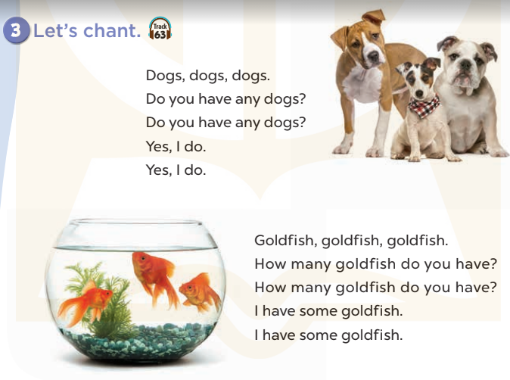  - Play the recording for Ss to listen to the whole chant.  + Have them repeat the title and lyrics line by line.  + Ask Ss to attend to the sounds of the letters o and the words dog and goldfish.  - Play the recording all the way through for Ss to listen to pronunciation and melody.  - Play the recording line by line for Ss to listen and repeat  - Play the recording for Ss to chant and clap along.  - Ask Ss to practice chant and clap along in pairs or groups.  - Invite groups to the front of the classroom to perform the chant  -T gives feedback.  *Consolidation  *Aims: Ss will be able consolidate and wrap up the content of the lesson.  *Procedure:  - T asks ss to answer the following questions:  + What have you learnt from the lesson today?  +What are the core values of the lesson? (if the teacher can take from the lesson).  - T praises some Ss who are hardworking / active/ good…. as well as encourage others to try more.  - Practice the chant more.  - Prepare the new lesson: Unit 16, Lesson 3 (4,5,6). | - Ss listen  -Ss play game  - Ss open their books  - Ss recognize the differences about color of letter  - - Ss listen  - Ss listen and point  - Ss listen again and repeat  -Ss listen again and repeat  -Ss practice  -Ss listen  -Ss listen and say:  + Number 1: How many…do you have?  + Number 2: Do you have any….?  -Ss guess the answers  - Ss listen to the tape and circle  - Ss listen again, circle and swap books with their partners.  - Ss check their answers and guessing  -Ss listen and repeat.  -Ss read the sentences  - Ss look and listen.  -Ss listen to the chant  - Ss listen and repeat line by line without clap their hands  -Ss note the sounds, words  -Ss listen to melody of the chant  - Ss listen and chant line by line.  - Ss chant and clap along.  - Ss work in groups (two groups) to chant  -Ss perform in front of the class.  -Ss listen  -Ss listen.  -Ss answer the questions  -Ss listen and clap their hands  -Ss listen and take note
  D | B | K | K | E | P | S | C | P | T
  O | E | T | E | E | D | D | C | A | H
  G | E | U | A | A | E | C | O | R | I
  R | A | M | M | F | C | C | S | R | N
  T | A | B | N | N | N | L | S | O | K
  G | O | L | D | F | I | S | H | T | B
  S | R | O | O | R | C | V | T | A | H
  M | M | T | O | H | R | S | T | A | Y
  D | P | P | R | E | S | E | R | S | M
  A | C | E | B | F | A | Z | Y | W

D. ADJUSTMENTS (if necessary):
………………………………………………………………………………………….…..……………………………………………………………………………...………………………………………….…..……………………………………………………………………………….……………………………………………………………………...
Week 28 Preparing date: March …….,
Period 111 Teaching date: March…………,

Unit 16: My pets
Lesson 3 (4, 5, 6)
A. OBJECTIVES:
By the end of the lesson, Ss will be able to:
1. Knowledge:
- listen to and demonstrate understanding of simple communicative contexts in relation to the topic "Pets"
- read and write about pets.
- use the target language items they have learnt in a real context by showing the photos of their pets and telling the class about them.
- Vocabulary: Review
- Skills: speaking, listening, reading and writing.
2. Competences:
- Co-operation: ready to help friends in pair work/ group work.
- Self-control and independent learning: perform reading tasks.
3. Attitude/ Qualities:
- Kindness: Help partners to complete learning tasks.
- Honesty: tell the truth about feelings and emotions.
- Diligence: complete learning tasks.
B. TEACHING AIDS:
- Teacher: Teacher’s guide Pages 208, 209, website sachmem.vn, posters, laptop, pictures, textbook, lesson plan, TV or projector.
- Students: Pupil’s book Page 45, notebooks, workbooks, school things.
C. PROCEDURES:
Stages/Time | Teacher’s activities | Students’ activities
1.Warm- up:  (5’)  2.Practice: (8’)  3.Production: (14’)  4.Production(5’)  4. Homework. (3’) | Game: Brainstorming  *Aims: to review the vocabulary and structure about greet and respond to greetings.  *Procedure:  - Divide the class into four groups.  - Each group chooses one pupil to be the 'runner'. The runners go to the teacher's desk and read the category.  Ex: Find pets  - The runners then go back to their group and tell their group members the category. Their group brainstorm words from that category and write them down.  - The first group to finish shouts 'stop' and then calls out their answers. If their answers are correct, they score one point for each word in the category.  - The group with the highest score at the end of the game wins.  - Say “Open your book page 45” and look at “Unit 16, Lesson 3 (4, 5, 6)”.  Activity 1. Read and complete:  *Aims: Ss will be able to read and complete a target paragraph using the four words provided.  *Procedure:  - Tell Ss how to complete the task.  - Point at the words provided in the box and the five gaps in the passage - Ask Ss attend to the blank in number 1 and find the missing word.  - Write the missing word on the board and get the class to read the completeed sentence together.  - Have Ss work in pairs and complete  - Tell Ss to swap books with a partner, then check answers together as a class.  - Write the correct answers on the board for pupils to correct their answers.  - Invite Ss to read the complete text aloud  -T gives feedbacks.  Key: 1. many 2. have 3. and 4. Do  Activity 2. Let’s write  *Aims: Ss will be able read, understand and complete a gapped text about pets.  *Procedure:  - Explain to the class the goal of this activity.  - Ask Ss to read each gapped sentence, look at the picture and fill in the gap.  - Give Ss time to write their answers  - Ask Ss to swap and correct their answers in pairs.  - Check the answers as a class.  Key: Pupils’ own answers  Activity 3. Project.  *Aims: Ss will be able to use the target language items they have learnt in a real context by showing the photos of their pets and telling the class about them  *Procedure:  - Point at the prompt picture and explain what they should do to complete the project.  - Prepare two photos to share with pupils. Point at one photo and say: I have some…. and point at the other photo and say: I have some ….  - Have Ss work in groups. Each pupil shares his / her photos and says what pets he / she has in the photos.  - Give the class time to complete the project.  - Invite some Ss to the front of the class to present the photos.  *Consolidation  *Aims: Ss will be able consolidate and wrap up the content of the lesson.  *Procedure:  - T asks ss to answer the following questions:  + What have you learnt from the lesson today?  - T praises some Ss who are hardworking / active/ good…. as well as encourage others to try more.  - Prepare the new lesson: Unit 17- Lesson 1 (1,2,3). | - Ss listen  -Ss play game  - Ss open their books  -Ss listen  - Ss read and answer  -Ss read and complete  -Ss write the first word  -Ss work in pairs  -Ss swap books and check  -Ss check the correct their answers  -Ss read  -Ss listen  -Ss listen  -Ss read and answer  -Ss write  My name………I love pets. I have a cat. It is big. I have….  It is ……………..Do you have  any……….?  -Ss swap books and check their answers  -Ss check  -Ss listen  -Ss listen and say  -Ss work in groups  -Ss complete the project  -Ss perform in front of the class.  -Ss answer the questions  -Ss listen and clap their hands  -Ss listen and take note
D. ADJUSTMENTS (if necessary):
………………………………………………………………………………………….…..……………………………………………………………………………...…………

Week 28 Preparing date: March …….,
Period 112 Teaching date: March…………,

Unit 17: Our toys
Lesson 1 (1, 2, 3)
A. OBJECTIVES:
By the end of the lesson, Ss will be able to:
1. Knowledge:
- use the words car, kite, train, plane, in relation to the topic “Our toys”
- understand and correctly repeat the sentences in two communicative contexts (pictures) to identify someone’s toys.
- correctly say the words and use He / She has …….. to identify someone’s toys.
- enhance the correct use of He / She has …... to identify someone’s toys in a freer context.
- Vocabulary: car, kite, train, plane, doll, toy.
- Model sentences:
He/ she has ………..

- Skills: speaking and listening
2. Competences:
- Co-operation: ready to help friends in pair work/ group work.
- Sociability: Talk to each other, say good words to others.
3. Attitude/ Qualities:
- Kindness: Help partners to complete learning tasks.
- Honesty: tell the truth about feelings and emotions
B. TEACHING AIDS:
- Teacher: Teacher’s guide Pages 179, 180, audio Tracks 54, 55, website sachmem.vn, posters, laptop, pictures, textbook, lesson plan, TV or projector.
- Students: Pupil’s book Page 40, notebooks, workbooks, school things.
C. PROCEDURES:
Stages/Time | Teacher’s activities | Students’ activities
1.Warm- up:  (3’)  2. Presentation  (16’)  3.Practice: (7’)  4.Production: (7’)  5. Homework. (2’) | Sing: Jigsaw puzzle  *Aims: to create a friendly and active atmosphere in the class to beginning the lesson.  *Procedure:  - Divide class into 4 groups: Tom, Jerry, Miu and Chit.  - Ask Ss look at the pieces of picture.  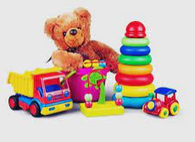  - Ask Ss go to the board and jigsaw puzzle into the correct picture.  -T checks who’s the winner?  - Say “Open your book page 40” and look at “Unit 17, Lesson 1 (1,2,3)”.  Activity 1. Vocabulary.  *Aims: Ss will be able to know the vocabulary in front of starting the new lesson.  *Procedure:  -T elicits the new words  + car : xe ô tô (visual)  + kite : con diều (realia)  + train :tàu lửa (visual)  + plane : máy bay (visual)  + doll :búp bê (realia)  + toy : đồ chơi (translation)  - T models (3 times).  - T writes the words on the board.  - Checking: Matching  Activity 2. Look, listen and repeat:  *Aims: Ss will be able to understand and correctly repeat the sentences in two communicative contexts (pictures) to identify someone’s toys  *Procedure:  - Have Ss look at Pictures a and b and identify names of the speakers in the pictures.  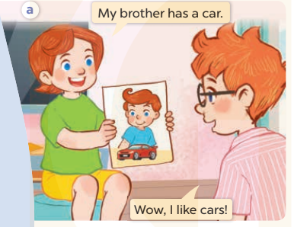  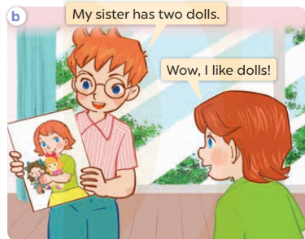  - Play the audio twice (sentence by sentence). Correct their pronunciation where necessary.  - Have Ss to practice the dialogue  - T invites a few pairs to the front of the class to practice.  - T checks pronunciation for ss.  Activity 3 Listen, point and say.  *Aims: Ss will be able to correctly say the words and use He / She has …….. to identify someone’s toys.  *Procedure:  * Model sentences:  - T asks Ss look at picture a, b and helps Ss know the structure from the dialogue.  - T introduces new structure for Ss.  - T explains, models and gives meaning.  -Have Ss repeat the model sentences.  He/ she has a car.  *Drill pictures  - Elicit the character and the quantity of toys in each picture.  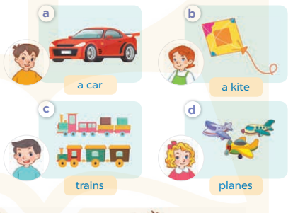  - Run through all the pictures.  - Run through model sentences.  - Have Ss to practise:  - Ask Ss to work in pairs.  - T controls and corrects.  - Invite a few pairs to come to the front of the classroom and point at the pictures and say the questions and answers in front of the class.  - T gives feedbacks.  Activity 4. Let’s talk.  *Aims: Ss will be able to enhance the correct use of He / She has ….. to identify someone’s toys in a freer context.  *Procedure:  - Have Ss look at the picture and elicit the question and the answer in context.  + What can you see in the picture?  + How many toys are there?  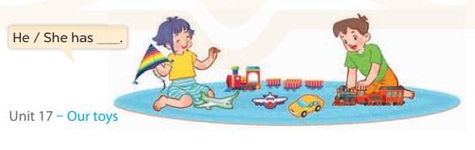  - Put Ss into groups of four.  - Ask Ss to say using He/ she has…..  - Invite some Ss to the front of the class to say about their toys  *Consolidation  *Aims: Ss will be able consolidate and wrap up the content of the lesson.  *Procedure:  - T asks ss to answer the following questions:  + What have you learnt from the lesson today?  +What are the core values of the lesson? (if the teacher can take from the lesson).  - T review the vocabulary and model sentences.  - T praises some Ss who are hardworking / active/ good…. as well as encourage others to try more.  - Learn the vocabulary and model sentences by heart  - Prepare the new lesson: Unit 17, Lesson 1 (4,5,6). | - Ss listen  -Ss look at the pieces of the picture  -Ss put into the correct picture  -Ss check  - Ss open their books  -Ss listen and answer  - - Ss listen and repeat  + Choral repetition (3 times).  + Individual repetition (3 ss)  - Ss take note  - Ss look, remember and match  -Look at the pictures and say  + In picture a: Lucy says: My brother has a car. Ben says: Wow, I like cars!  + In picture b: Ben says: My sister has two dolls. Lucy says: Wow, I like dolls!  -Ss listen and repeat in chorus (twice)  -Ss work in pairs to practice  -Ss practice the dialogue  -Ss listen  -Ss look at the picture and answer.  -Ss listen  -Ss listen and repeat  -Ss repeat  - Ss look, listen and answer  + Picture a: a boy and a car  + Picture b: a girl and a kite  + Picture c: a boy and two trains  + Picture d: a girl and three planes  -Ss listen and repeat  -Ss practice in chorus  -Ss work in pairs to practice  -Ss point and say  -Ss listen.  -Ss look at the picture and answer  + A girl and a boy are playing with some toys.  -Ss look and answer  -Ss perform in front of the class.  -Ss answer the questions  - Ss listen  -Ss listen and clap their hands  -Ss listen and take note
D. ADJUSTMENTS (if necessary):
………………………………………………………………………………………….…..……………………………………………………………………………...………………………………………….…..……………………………………………………………………………….……………………………………………………………………...

