Week 27 Preparing date: March …….,
Period 105 Teaching date: March ………,

Fun time 3
A. OBJECTIVES:
By the end of the lesson, Ss will be able to:
1. Knowledge:
- revise the spelling of five words: teacher, brother, driver, mother and worker.
- improve their speed and flexibility when checking vocabulary.
- use the target vocabulary and sentence patterns to carry out a survey.
- identify healthy and unhealthy foods.
- Vocabulary: Review
- Skills: speaking, writing and listening
2. Competences:
- Co-operation: ready to help friends in pair work/ group work.
- Sociability: Talk to each other, say good words to others.
3. Attitude/ Qualities:
- Kindness: Help partners to complete learning tasks.
- Honesty: tell the truth about feelings and emotions
B. TEACHING AIDS:
- Teacher: Teacher’s guide Pages 197; website sachmem.vn, posters, laptop, pictures, textbook, lesson plan, TV or projector.
- Students: Pupil’s book Page 38, 39, notebooks, workbooks, school things.
C. PROCEDURES:
Stages/Time | Teacher’s activities | Students’ activities
1.Warm- up:  (3’)  2. Practice  (30’)  3. Homework. (2’) | Sing: Head, shoulders, knees and toes  *Aims: to create a friendly and active atmosphere in the class to beginning the lesson.  *Procedure:  - Show the song on the screen.  https://www.youtube.com/watch?v=WX8HmogNyCY  - Ask Ss to listen, sing and dance the song.  - Say “Open your book page 38” and look at “Fun time”.  Activity 1. Do the puzzle:  *Aims: Ss will be able to revise the spelling of five words: teacher, brother, driver, mother and worker.  and improve pupils’ speed and flexibility when checking vocabulary.  *Procedure:  - Have Ss look at the puzzle and ask: Who do you see in the pictures?  - Stick the flash cards of the words, one by one, on the board.  - Point to each word on the board, and have Ss say the word as a class.  - Point at Picture 1, elicit the word, write it in the crossword as an example.  - Ask Ss to repeat the same procedure with the other picture cues.  - Check the answers as a class.  Key:  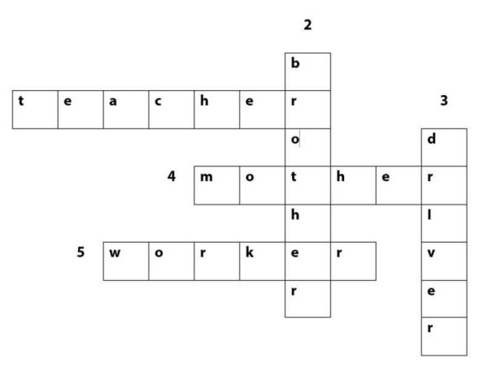  Activity 2. Quiz time  *Aims: Ss will be able to use the target vocabulary and sentence patterns to carry out a survey *Procedure:  -Tell Ss that each of them needs to interview three different classmates to find out their favourite food or drinks.  - Give Ss 10 minutes to circulate and complete their survey tables  - After Ss have interviewed their classmates and taken notes, give them another 5 to 10 minutes to prepare to share their findings.  - Invite different Ss to come to the front of the class and share their findings.  Activity 3. Circle the healthy foods.  *Aims: Ss will be able to identify healthy and unhealthy foods.  *Procedure:  - T elicits the names of the foods: apple, chips, water, rice, fish, noodles, cake.  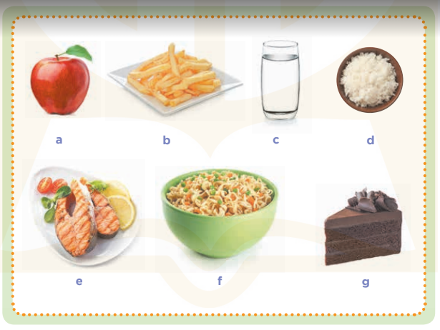  - Put Ss into pairs and tell them to work together to circle the healthy foods.  - Display a picture of an apple on the board.  - Ask Ss if it is healthy or unhealthy. When they answer correctly, write healthy under the picture and model it for Ss to repeat.  - Repeat the same procedure for the other foods. If a food is unhealthy, write unhealthy under the picture.  Key: Ss’ own answer  *Consolidation  *Aims: Ss will be able consolidate and wrap up the content of the lesson.  *Procedure:  - T asks ss to answer the following questions:  + What have you learnt from the lesson today?  +What are the core values of the lesson? (if the teacher can take from the lesson).  - T praises some Ss who are hardworking / active/ good…. as well as encourage others to try more.  - Prepare the new lesson: Unit 16, Lesson 1 (1,2,3). | - Ss listen  - Ss sing a song  -Ss look at the puzzle and answer  - - Ss note  - Ss say the word  - Ss look and write  -Ss find the words  -Ss check their answer  -Ss listen  -Ss interview and complete the survey tables.  -Ss prepare to share their findings.  -Ss come to the front of the class and share their findings.  - Ss look, listen and answer  - Ss answer  -Ss look  -Ss listen and repeat  -Ss repeat  -Ss answer the questions  -Ss listen and clap their hands  -Ss listen and take note

D. ADJUSTMENTS (if necessary):
………………………………………………………………………………………….…..……………………………………………………………………………...………………………………………….…..……………………………………………………………………………….……………………………………………………………………...

Week 27 Preparing date: March …….,
Period 106 Teaching date: March ………,

Unit 16: My pets
Lesson 1 (1, 2, 3)
A. OBJECTIVES:
By the end of the lesson, Ss will be able to:
1. Knowledge:
- use the words birds, cats, parrots, rabbits in relation to the topic "Pets".
- use some and many to identify the quantity of pets
- use Do you have any…….? – Yes, I do. / No, I don’t. to ask and answer questions about pets
- listen to and demonstrate understanding of simple communicative contexts in relation to the topic "Pets".
- Vocabulary: bird, cat, dog, parrot, rabbit, pet, any.
- Model sentences:
A: Do you have any cats?
B: Yes, I do. / No, I don’t.
- Skills: speaking and listening
2. Competences:
- Co-operation: ready to help friends in pair work/ group work.
- Sociability: Talk to each other, say good words to others.
3. Attitude/ Qualities:
- Kindness: Help partners to complete learning tasks.
- Honesty: tell the truth about feelings and emotions
B. TEACHING AIDS:
- Teacher: Teacher’s guide Pages 179, 180, audio Tracks 54, 55, website sachmem.vn, posters, laptop, pictures, textbook, lesson plan, TV or projector.
- Students: Pupil’s book Page 40, notebooks, workbooks, school things.
C. PROCEDURES:
Stages/Time | Teacher’s activities | Students’ activities
1.Warm- up:  (3’)  2. Presentation  (16’)  3.Practice: (7’)  4.Production: (7’)  5. Homework. (2’) | Sing: Jigsaw puzzle  *Aims: to create a friendly and active atmosphere in the class to beginning the lesson.  *Procedure:  - Divide class into 4 groups: Tom, Jerry, Miu and Chit.  - Ask Ss look at the pieces of picture.  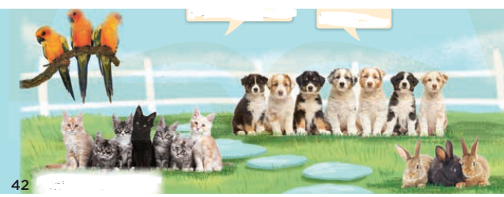  - Ask Ss go to the board and jigsaw puzzle into the correct picture.  -T checks who’s the winner?  - Say “Open your book page 40” and look at “Unit 16, Lesson 1 (1,2,3)”.  Activity 1. Vocabulary.  *Aims: Ss will be able to know the vocabulary in front of starting the new lesson.  *Procedure:  -T elicits the new words  + cat : con mèo (picture)  + dog : con chó (picture)  + parrot :con vẹt (picture)  + rabbit : con thỏ (picture)  + bird :con chim (picture)  + any : bất cứ (translation)  - T models (3 times).  - T writes the words on the board.  - Checking: Matching  Activity 2. Look, listen and repeat:  *Aims: Ss will be able to understand and correctly repeat the sentences in two communicative contexts (pictures) focusing on pets.  *Procedure:  - Have Ss look at Pictures a and b and identify names of the speakers in the pictures.  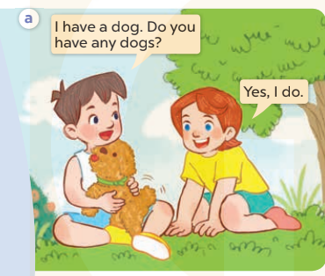  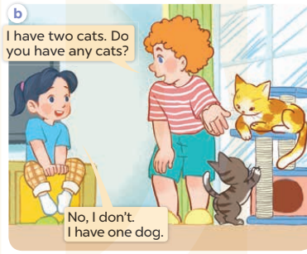  - Play the audio twice (sentence by sentence). Correct their pronunciation where necessary.  - Have Ss to practice the dialogue  - T invites a few pairs to the front of the class to practice.  - T checks pronunciation for ss.  Activity 3 Listen, point and say.  *Aims: Ss will be able to correctly say the words birds, parrots, rabbits, cats and use Do you have any….? – Yes, I do./ No, I don’t. to ask and answer questions about pets  *Procedure:  * Model sentences:  - T asks Ss look at picture a, b and helps Ss know the structure from the dialogue.  - T introduces new structure for Ss.  - T explains, models and gives meaning.  -Have Ss repeat the model sentences.  A: Do you have any cats?  B: Yes, I do. / No, I don’t.  *Drill pictures  - Elicit and check comprehension the places of school  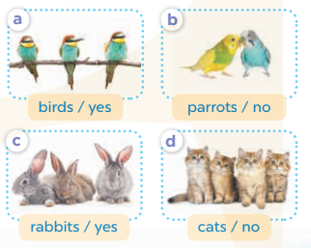  - Run through all the pictures.  - Run through model sentences.  +Run through the question sentences  +Run through the answer sentences  - Have Ss to practise:  + T asks, Ss answer picture a  + Ss ask, T answers picture b  + Group A ask, group B answer picture c  + Group B ask, group A answer picture d  - Ask Ss to work in pairs.  - T controls and corrects.  - Invite a few pairs to come to the front of the classroom and point at the pictures and say the questions and answers in front of the class.  - T gives feedbacks.  Activity 4. Let’s talk.  *Aims: Ss will be able to enhance the correct use of Do you have any….? − Yes, / No,….. to ask and answer questions about pets.  *Procedure:  - Have Ss look at the picture and elicit the question and the answer in context.  + What can you see in the picture?  + How many pets are there?  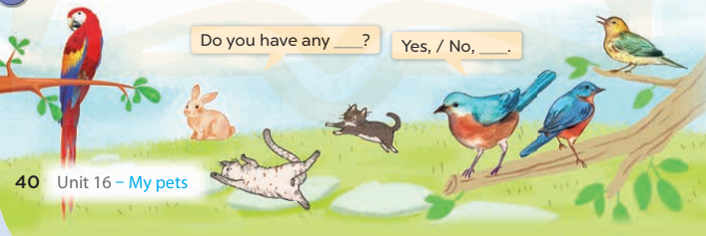  - Put Ss into groups of four.  - Tell them to ask and answer questions using Do you have any…..? – Yes, / No,…..  - Invite some Ss to the front of the class to ask and answer questions about their pets.  *Consolidation  *Aims: Ss will be able consolidate and wrap up the content of the lesson.  *Procedure:  - T asks ss to answer the following questions:  + What have you learnt from the lesson today?  +What are the core values of the lesson? (if the teacher can take from the lesson).  - T review the vocabulary and model sentences.  - T praises some Ss who are hardworking / active/ good…. as well as encourage others to try more.  - Learn the vocabulary and model sentences by heart  - Prepare the new lesson: Unit 16, Lesson 1 (4,5,6). | - Ss listen  -Ss look at the pieces of the picture  -Ss put into the correct picture  -Ss check  - Ss open their books  -Ss listen and answer  - - Ss listen and repeat  + Choral repetition (3 times).  + Individual repetition (3 ss)  - Ss take note  - Ss look, remember and match  -Look at the pictures and say  + In picture a: Minh says: I have a dog. Do you have any dogs? Lucy answers: Yes, I do.  + In picture b: Bill: I have two cats. Do you have any cats? Mai answers: No, I don’t. I have one dog.  -Ss listen and repeat in chorus (twice)  -Ss work in pairs to practice  -Ss practice the dialogue  -Ss listen  -Ss look at the picture and answer.  -Ss listen  -Ss listen and repeat  -Ss repeat to the place  - Ss look, listen and answer  + Picture a: birds / yes  + Picture b: parrots / no  + Picture c: rabbits / yes  + Picture d: cats / no  -Ss listen and repeat  -Ss practice in chorus  -Ss work in pairs to practice  -Ss point and say  -Ss listen.  -Ss look at the picture and answer  + I can see the pets  + There are 4  -Ss look and answer  -Ss work in pairs  -Ss perform in front of the class.  -Ss answer the questions  - Ss listen  -Ss listen and clap their hands  -Ss listen and take note
D. ADJUSTMENTS (if necessary):
………………………………………………………………………………………….…..……………………………………………………………………………...………………………………………….…..……………………………………………………………………………….……………………………………………………………………...

Week 27 Preparing date: March …….,
Period 107 Teaching date: March ………,

Unit 16: My pets
Lesson 1 (4, 5, 6)
A. OBJECTIVES:
By the end of the lesson, Ss will be able to:
1. Knowledge:
- listen to and understand two communicative contexts in which pupils ask and answer questions about pets and tick the correct pictures.
- read and complete four target gapped dialogues with the help of the picture cues.
- sing the song My pets with the correct pronunciation and melody.
- Vocabulary: Review
- Skills: speaking, listening, reading and writing.
2. Competences:
- Critical Thinking: talk about names of the pets.
- Co-operation: ready to help friends in pair work/ group work.
- Self-control and independent learning: perform listening tasks.
3. Attitude/ Qualities:
- Kindness: Help partners to complete learning tasks.
- Honesty: tell the truth about feelings and emotions.
- Diligence: complete learning tasks.
B. TEACHING AIDS:
- Teacher: Teacher’s guide Pages 201, 202; audio Tracks 56, 57; website sachmem.vn, posters, laptop, pictures, textbook, lesson plan, TV or projector.
- Students: Pupil’s book Page 41, notebooks, workbooks, school things.
C. PROCEDURES:
Stages/Time | Teacher’s activities | Students’ activities
1.Warm- up:  (5’)  2.Presentation: (10’)  3.Practice(10’)  4.Production(5’)  3. Homework. (5’) | Game: Pass the ball  *Aims: to create a friendly and active atmosphere in the class to beginning the lesson.  *Procedure:  - Divide class into 3 teams.  - Each team has 1 sticky ball.  - Play the music, students in each team take turn to pass the ball. After the music ends, 3 Ss have the ball – stand up and say the name, using the sentence model.  - Say “Open your book page 41” and look at “Unit 16, Lesson 1 (4,5,6)”.  Activity 1. Listen and tick:  *Aims: Ss will be able to listen to and understand two communicative contexts in which pupils ask and answer questions about pets and tick the correct pictures.  *Procedure:  - Elicit the word for the pets in each picture  - Point at the pictures respectively to explain the context.  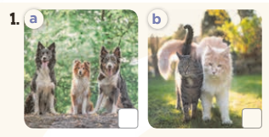  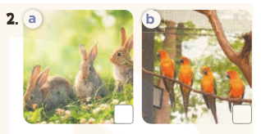  - T ask Ss to guess the answers.  + T writes Ss’guessing on the board.  - Listen to the tape:  + Play the recording  + Play the recording again and get Ss to swap books with their partners.  + Play the recording again to check answers together as a class.  + Write the answers on the board for Ss to correct their answers. Then checks Ss’ guessing.  - Play the recording, sentence by sentence, for the class to listen and repeat in chorus.  Key: 1. b 2. a  Activity 2. Look, complete and read  *Aims: Ss will be able to read and complete four target gapped dialogues with the help of the picture cues.  *Procedure:  - Get Ss to look at the pictures and identify the pets in the pictures.  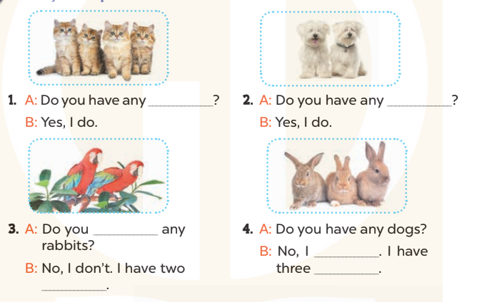  - Have Ss look at the four dialogue and the pictures. Elicit and model with picture 1  + Ask Ss to read the sentence 1 in chorus.  + Ask them what is missing in the question (cats). Then have them complete the gap (Do you have any cats?).  -Have Ss work in pairs and complete the dialogue 2, 3, 4.  - Ask a few Ss to stand up and read the sentences aloud.  -T gives feedbacks.  Key:  1. cats 2. dogs 3. have; parrots  4. don’t; rabbits  Activity 3. Let’s sing  *Aims: Ss will be able to sing the song My pets with the correct pronunciation and melody.  *Procedure:  - Introduce the title and lyrics of the song: “My pets”  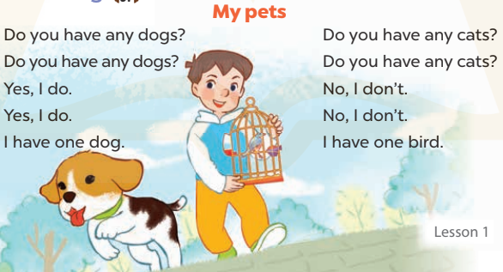  - Play the recording for Ss to listen to the whole song.  + Have them repeat the title and lyrics line by line.  + Tell Ss to point at the pictures while singing.  - Play the recording all the way through for Ss to listen to pronunciation and melody of the song.  - Play the recording line by line for Ss to listen, repeat and point to the pictures  - Play the recording for Ss to sing and do actions.  - Ask Ss to practice singing and doing actions in pairs or groups.  - Invite groups to the front of the classroom to perform the song  -T gives feedback.  *Consolidation  *Aims: Ss will be able consolidate and wrap up the content of the lesson.  *Procedure:  - T asks ss to answer the following questions:  + What have you learnt from the lesson today?  +What are the core values of the lesson? (if the teacher can take from the lesson).  - T praises some Ss who are hardworking / active/ good…. as well as encourage others to try more.  - Practice part 5 again.  - Prepare the new lesson: Unit 16, Lesson 2 (1,2,3). | - Ss listen  - Ss play game  - Ss open their books  -Look at the pictures and say:  + Picture 1a: three dogs + Picture 1b: two cats  + Picture 2a: three rabbits  + Picture 2b: four parrots  -Ss guess the answers  - Ss listen to the tape and tick  - Ss listen again, tick and swap books with their partners.  - Ss check their answers and guessing  -Ss listen and repeat.  -Ss look at the picture and say  -Ss look and answer  -Ss read  -Ss say and complete  -Ss work in pairs and complete  -Ss read aloud  - Ss listen  -Ss listen to the song  - Ss listen and repeat line by line without the action.  -Ss point to the pictures while singing  -Ss listen to melody of the song  - Ss listen and sing line by line.  - Ss sing and do actions.  + Ss work in groups (two groups) to sing.  -Ss perform in front of the class.  -Ss listen  -Ss answer the questions  -Ss listen and clap their hands  -Ss listen and take note
D. ADJUSTMENTS (if necessary):
………………………………………………………………………………………….…..……………………………………………………………………………...………………………………………….…..……………………………………………………………………………….……………………………………………………………………...

Week 27 Preparing date: March …….,
Period 108 Teaching date: March ………,

Unit 16: My pets
Lesson 2 (1, 2, 3)
A. OBJECTIVES:
By the end of the lesson, Ss will be able to:
1. Knowledge:
- use some and many to identify the quantity of pets
- use How many…..do you have? – I have………. to ask and answer questions about the quantity of pets
- Vocabulary: goldfish, some, many, how many
- Model sentences:
A: How many cats do you have?
B: I have some
- Skills: speaking and listening
2. Competences:
- Critical Thinking: talk about someone’s pets
- Co-operation: ready to help friends in pair work/ group work.
- Sociability: Talk to each other, say good words to others.
3. Attitude/ Qualities:
- Kindness: Help partners to complete learning tasks.
- Honesty: tell the truth about feelings and emotions
B. TEACHING AIDS:
- Teacher: Teacher’s guide Pages 203, 204; audio Tracks 58, 59, website sachmem.vn, posters, laptop, pictures, textbook, lesson plan, TV or projector.
- Students: Pupil’s book Page 42, notebooks, workbooks, school things.
C. PROCEDURES:
Stages/Time | Teacher’s activities | Students’ activities
1.Warm- up:  (3’)  2. Presentation  (16’)  3.Practice: (7’)  4.Production: (7’)  5. Homework. (2’) | Game: Guessing and Choosing  *Aims: to create a friendly and active atmosphere in the class to beginning the lesson.  *Procedure:  - T shows 4 pictures of places and calls 4 Ss to come to the board and choose.  - T asks 4 Ss to come to the board and choose 1 picture of place and keep them in secret by covering them.  - The others will write their place in the board at their desks and keep their ides in secret.  - The Ss on the board will 1 by 1 show their pictures they chose.  - When the teacher says the word of the pictures 1 by 1 shown on the board, who has the same places will raise their board or raise their hands.  - The Ss on the board will get the same points as the numbers of Ss raising their hands.  - Say “Open your book page 42” and look at “Unit 16, Lesson 2 (1,2,3)”.  Activity 1. Vocabulary.  *Aims: Ss will be able to know the vocabulary in front of starting the new lesson.  *Procedure:  -T elicits the new words  + goldfish : con cá vàng (picture)  + some: một vài (example)  + many : nhiều (example)  + how many : bao nhiêu (translation)  - T models (3 times).  - T writes the words on the board.  - Checking: What and where  Activity 2. Look, listen and repeat:  *Aims: Ss will be able to understand and correctly repeat How many …..do you have? − I have….. to ask and answer questions about the quantity of pets.  *Procedure:  - Have Ss look at Pictures a and b and identify the characters in the pictures.  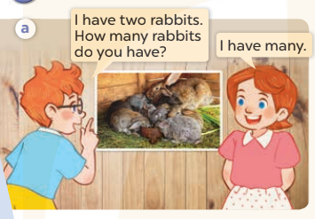  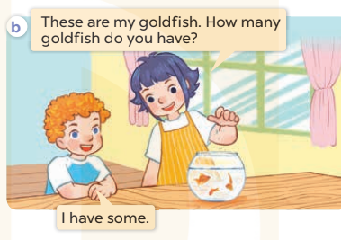  - Play the audio twice (sentence by sentence). Correct their pronunciation where necessary.  - Have Ss to practice the diaguage  - T invites a few pairs to the front of the class to practice.  - T checks pronunciation for ss.  Activity 3. Listen, point and say.  *Aims: Ss will be able to correctly say the words and use How many…..do you have? − I have….. to ask and answer questions about the quantity of pets.  *Procedure:  * Model sentences:  - T asks Ss look at picture a, b and helps Ss know the structure from the dialogue.  - T introduces new structure for Ss.  - T explains, models and gives meaning.  - Have Ss repeat the model sentences.  A: How many cats do you have?  B: I have some  *Drill pictures  - Have Ss look at the pictures and elicit the names of the pets  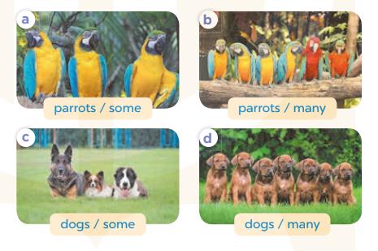  - Run through all the pictures.  - Run through model sentences.  +Run through the question sentences  +Run through the answer sentences  - Have Ss to practise:  + T asks, Ss answer picture a  + Ss ask, T answers picture b  + Group A ask, group B answer picture c  + Group B ask, group A answer picture d  - Ask Ss to work in pairs.  - T controls and corrects.  - Invite a few pairs to come to the front of the classroom, point at the pictures and say the questions and answers in front of the class.  - T gives feedbacks.  Activity 4. Let’s talk.  *Aims: Ss will be able to enhance the correct use of How many……? − I have…… to ask and answer questions about the quantity of pets.  *Procedure:  - Tell Ss about the activity  + What can you see in the picture?  +Let’s count the pets.  +Where are the pets?  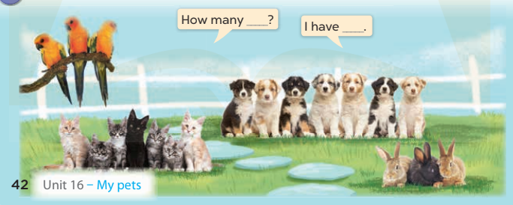  - Put Ss into pairs and encourage them to ask and answer questions using How many……? − I have……  - Invite some pairs to stand up to perform their exchanges.  *Consolidation  *Aims: Ss will be able consolidate and wrap up the content of the lesson.  *Procedure:  - T asks ss to answer the following questions:  + What have you learnt from the lesson today?  - T review the vocabulary and model sentences.  - T praises some Ss who are hardworking / active/ good…. as well as encourage others to try more.  - Learn the vocabulary and model sentences by heart  - Prepare the new lesson: Unit 16, Lesson 2 (4,5,6). | - Ss listen  - Ss play the game  -Ss play game  - Ss open their books  -Ss listen and answer  - - Ss listen and repeat  + Choral repetition (3 times).  + Individual repetition (3 ss)  - Ss take note  - Ss look, remember and write  -Look at the pictures and get to know the characters in the pictures.  + In picture a: Ben says: I have two rabbits. How many rabbits do you have? And Lucy says: I have many.  – In picture b: Linh says: These are my goldfish. How many goldfish do you have? And Bill says: I have some  -Ss listen and repeat in chorus (twice)  -Ss work in pairs to practice  -Ss practice the diaguage  -Ss listen  -Ss look at the picture and answer.  -Ss listen  -Ss listen and repeat  -Ss repeat  -Ss listen and answer  +Picture a: three parrots (some)  +Picture b. six parrots (many)  +Picture c. three dogs (some)  +Picture d. seven dogs (many)  - Ss look, listen and repeat  - Ss practice in chorus  -Ss work in pairs to practice  -Ss listen  -Ss go to the board and point and say  -Ss listen  -Ss look at the picture and answer  + Three parrots, seven cats, three rabbits and seven puppies are in the garden.  -Ss work in pairs  -Ss ask and answer  -Ss answer the questions  - Ss listen  -Ss listen and clap their hands  -Ss listen and take note
D. ADJUSTMENTS (if necessary):
………………………………………………………………………………………….…..……………………………………………………………………………...……………

