Week 34 Preparing date: …… ………, 2025
Period 133 Teaching date: …….. ………, 2025

Unit 20: Our summer holidays
Lesson 2 (4, 5, 6)
A. OBJECTIVES:
By the end of the lesson, Ss will be able to:
1. Knowledge:
- listen to and understand two communicative contexts in which characters talk about places someone plans to visit and activities to do in the summer, and circle the correct pictures
- complete two gapped exchanges with the help of picture cues.
- revise the target vocabulary items and structures related to the topic “Our summer holidays” by playing the game Who has more correct answers?
- Vocabulary: Review
- Skills: speaking, listening, reading and writing.
2. Competences:
- Communication and collaboration: work in pairs and groups to complete the learning tasks.
3. Attitude/ Qualities:
- They can remember or imagine places they might visit and all the things they might do during summer break, like playing games, going on trips, or spending time with family.
B. TEACHING AIDS:
- Teacher: Teacher’s guide Pages 323, 324, 325; audio Tracks 98; website hoclieu.vn, posters, laptop, pictures, textbook, lesson plan, TV or projector.
- Students: Student’s book Page 67, notebooks, workbooks, school things.
C. PROCEDURES:
Teacher’s activities | Students’ activities
1.Warm- up and review: (4’)  Play a game: Board race  *Aims: to revise the learnt structure *Procedure:  - Divide the class into two teams.  - Arrange the flash cards on the board.  - Invite a student from each team to go to the board.  - Teacher says a word and the ss run to tap the right card as quickly as possible.  - If they tap the right card, they will get 1 point for their team.  - The team with more points wins.  - Say “Open your book page 67” and look at “Unit 20, Lesson 2 (4,5,6)”.  2. Practice: (27’)  Activity 1. Listen and circle:  *Aims: Ss will be able to listen to and understand two communicative contexts in which characters talk about places someone plans to visit and activities to do in the summer, and circle the correct pictures  *Procedure:  - Have ss look at the pictures and ask  + What place can you see in each picture?  + What means of transport can you see in each picture?  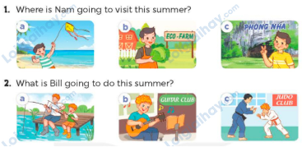  - T ask Ss to guess the answers.  + T writes Ss’guessing on the board.  - Listen to the tape:  + Play the recording  + Play the recording again and get Ss to swap books with their partners.  + Play the recording again to check answers together as a class.  + Write the answers on the board for Ss to correct their answers. Then checks Ss’ guessing.  - Play the recording, sentence by sentence, for the class to listen and repeat in chorus.  Key: 1. b 2. c  Activity 2. Read and complete  *Aims: Ss will be able to complete two gapped exchanges with the help of picture cues.  *Procedure:  - Ask Ss to look at the pictures and identify the places to visit and activities to do in the summer.  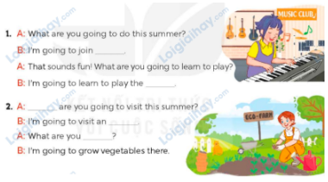  - Have Ss look at the 2 incomplete exchanges and elicits the missing words in the sentences.  - T models with the first sentence  + Ask Ss what is missing in the sentence (a music club).  + Have Ss look at the picture and identify the needed information (I’m going to join a music club)  - Have Ss work in pairs and complete  - Get Ss to swap books with a partner and check their answers before checking as a class.  Key: 1. a music club; piano  2. Where; eco-farm; going to do  Activity 3. Let’s play.  *Aims: Ss will be able to revise the target vocabulary items and structures related to the topic “Our summer holidays” by playing the game Who has more correct answers?  *Procedure:  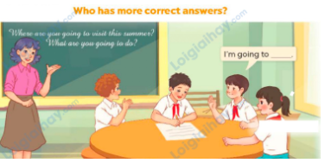  - Tell ss that they are going to play the game Who has more correct answers.  - Ss play the game in groups of five. Each group makes a list of answers to the questions What are you going to do this summer? What are you going to do this summer? within three minutes.  - When time is up, invite each group to read about their answers. Count the correct answers of each group.  - Reward the group with the most correct answers.  3. Fun corner and wrap- up (4’)  Game: Pass the balls  - Give two different colored balls to two pupils, a red ball (ask the question about a place to visit or means of transport to get there) and a yellow ball (answer the question).  - Ask ss to listen to music and pass the balls.  - Stop music suddenly.  - Have the student with a red ball ask a question. Have the student with a yellow ball answer the question.  - Praise ss if they do the activity well. | - Ss pay attention.  -Ss play the game  - Ss congratulate to the winner  - Ss open their books  - Ss look at the pictures and answers.  -Ss guess the answers  - Ss listen to the tape  - Ss listen again, tick or cross and swap books with their partners.  - Ss check their answers and guessing  - Ss answer and check  -Ss listen and repeat.  -Ss look at the picture and say  -Ss follow the teacher.  -Ss read and answer  -Ss work in pairs and fill in the gaps  - Ss swap books and check  - Ss listen to the teacher’s explanation.  - Ss play the game  - Ss continue to play the game  -Ss listen to the teacher  -Ss play the game  A: What are you going to do this summer?  B: I’m going to join a swimming club.  -Ss praise the winner.

D. ADJUSTMENTS (if necessary):
………………………………………………………………………………………….…..……………………………………………………………………………...……

Week 34 Preparing date: ………………….
Period 134 Teaching date: …………………

Unit 20: Our summer holidays
Lesson 3 (1, 2, 3)
A. OBJECTIVES:
By the end of the lesson, Ss will be able to:
1. Knowledge:
- correctly pronounce the falling intonation in Wh-questions such as Where are you going to visit this summer? and What are you going to do this summer?
- listen to and demonstrate understanding of simple communicative contexts in relation to the topic “Our summer holidays”.
- Vocabulary: Review
- Skills: speaking, listening, reading and writing.
2. Competences:
- Communication and collaboration: work in pairs and groups to complete the learning tasks.
- Self-control and independent learning: perform pronunciation and listening tasks.
3. Attitude/ Qualities:
- Show their interests in plans for summer vacations and their experiences
B. TEACHING AIDS:
- Teacher: Teacher’s guide Pages 325, 326; audio Tracks 99, 100, 101; website hoclieu.vn, posters, laptop, pictures, textbook, lesson plan, TV or projector.
- Students: Students’ book Page 68, notebooks, workbooks, school things.
C. PROCEDURES:
Teacher’s activities | Students’ activities
1.Warm- up and review: (5’)  Talk about your summer vacation plans *Aims: to create a friendly and active atmosphere in the class to beginning the lesson.  *Procedure:  - Show the questions and picture hints and call pairs of ss to ask and answer about summer vacation plans.  - The hints are fewer and fewer until students have a free content to share about their plans. Teacher encourages them to imagine where they might visit and what they might do in their vacation.  - Say “Open your book page 68” and look at “Unit 20, Lesson 3 (1,2,3)”.  2. Presentation (9’)  Activity 1. Listen and repeat:  *Aims: Ss will be able to correctly pronounce the falling intonation in the Wh-questions Where are you going to visit this summer? and What are you going to do this summer?  *Procedure:  - Ask ss to pay attention to the arrow indicating falling intonation at the end of the Wh- question Where are you going to visit this summer? and What are you going to do this summer?  - Have ss listen to the recording and repeat the sentence until they feel confident.  - Give ss a time limit to practise saying the questions in pairs or groups.  - Invite some ss to say the questions in front of the class. Give feedback and corrections when necessary.  3.Practice: (17’)  Activity 2. Listen and repeat. Pay attention to the intonation.  *Aims: Ss will be able to listen and say the Wh-questions with a falling intonation.  *Procedure:  - Have ss read the questions and explain that they will hear the question,  - Have ss listen and repeat with falling intonation.  - Invite a few ss to say the questions in front of the class. Give corrections and feedback where necessary.  Activity 3. Let’s chant  *Aims: Ss will be able to say the chant with the correct rhythm and pronunciation.  *Procedure:  - Introduce the lyrics of the chant.  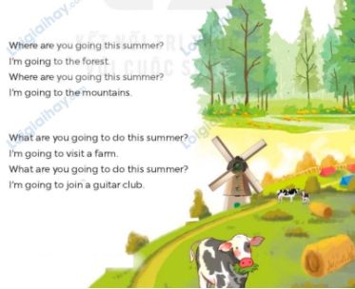  - Play the recording for Ss to listen to the whole chant.  + Have them repeat the title and lyrics line by line.  - Play the recording all the way through for Ss to listen to the rising intonation in the Yes/ No questions.  - Play the recording line by line for Ss to listen and repeat  - Play the recording for Ss to chant and clap along.  - Ask Ss to practice chant and clap along in pairs or groups.  - Invite groups to the front of the classroom to perform the chant  3. Fun corner and wrap- up (4’)  Game: Get the money to travel  - Divide the class into 2 teams.  - Ss take turns choosing a suitcase and unscrambling the words to make a meaningful question. Ss say the questions, pay attention to the intonation.  - Check the Ss’ answers as a whole class.  - If they give the correct answers, they can get points for their team. | - Ss listen to the teacher’s instruction  -Ss say their summer vacation plans  - Ss open their books  - Ss pay attention to the arrow for a falling intonation at the end of the Wh- question  - Ss listen and repeat the sentence.  - Ss practise saying the questions in pairs or groups.  -Ss say in front of the class  - Ss read the questions  - Ss listen and repeat  - Ss say the questions in front of the class.  - Ss look and listen.  - Ss listen to the chant  - Ss listen and repeat line by line  -Ss listen to melody of the chant  and draw a rising line in the air for the rising intonation.  - Ss listen and chant line by line.  - Ss chant and clap along.  - Ss work in groups (two groups) to chant  -Ss perform in front of the class.  -Ss listen  -Ss play the game  -Ss continue play the game
D. ADJUSTMENTS (if necessary):
………………………………………………………………………………………….…..……………………………………………………………………………...……

Week 34 Preparing date: ………………
Period 135 Teaching date: ………………….

Unit 20: Our summer holidays
Lesson 3 (4, 5, 6)
A. OBJECTIVES:
By the end of the lesson, Ss will be able to:
1. Knowledge:
- read a paragraph about Linh’s plan for her summer holidays and decide if the four
questions are true or false.
- write a paragraph about a plan for summer holidays using the clues from a
picture and a gapped paragraph.
- make a poster that shows places to visit and activities to do for the summer
holidays, and make a presentation to the class.
- Vocabulary: Review
- Skills: speaking, listening, reading and writing.
2. Competences:
- Communication and collaboration: work in pairs and groups to complete the learning tasks.
- Self-control and independent learning: perform reading and writing tasks.
3. Attitude/ Qualities:
- Show their interest in making plans for the summer vacation.
B. TEACHING AIDS:
- Teacher: Teacher’s guide Pages 326, 327, 328; website hoclieu.vn, posters, laptop, pictures, textbook, lesson plan, TV or projector.
- Students: Student’s book Page 69, notebooks, workbooks, school things.
C. PROCEDURES:
Teacher’s activities | Students’ activities
1.Warm- up and review: (5’)  Game: Lucky numbers  *Aims: to revise the new words and structures from previous lessons.  *Procedure:  - Divide the class into two teams.  - The teacher prepares some cards (join a music club, go camping, visit an eco-farm, practise swimming, Huong River, Phu Quoc Island.) with random points on their backs (ex: 10 / 20 / 30 points) and put them in a box.  - Have two ss from each team come to the board alternatively.  - One student picks up one card and asks a question matching the given card. Ex. Where are you going to visit this summer? / What are you going to do this summer?  - Then his / her partner has to answer.  - If the question and the answer are all correct, teams will get the points written at the back of the cards.  - Continue the games with other teams.  - The team that gets more points wins.  - Say “Open your book page 69” and look at “Unit 20, Lesson 3 (4,5,6)”.  2.Practice: (8’)  Activity 1. Read and tick True or False:  *Aims: Ss will be able to read a paragraph about Linh’s plan for her summer holidays and decide if the four questions are true or false.  *Procedure:  - Set a time limit and ask ss to read through the paragraph to get a general idea of it.  - Ask ss to read Question 1. Encourage them to underline some keywords that can help them find the correct answer.  - Let ss do the activity independently, then swap their books with a partner and check the answers.  - Ask a few ss to read their answers in front of the class.  Key: 1. T 2. F 3. T 4. F  3.Production: (18’)  Activity 2. Let’s write  *Aims: Ss will be able to write a paragraph about a plan for summer holidays using the clues from a picture and a gapped paragraph.  *Procedure:  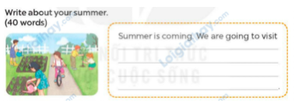  - Ask ss to read the title My summer and talk about the activities they can see from the picture.  - Give ss enough time to write their paragraph.  - Ask ss work in pairs for cross checks.  - Have some ss read their paragraph aloud. Give corrections and feedback where necessary.  Suggested answer:  Summer is coming! We are going to visit an eco-farm. We are going to ride a bicycle. We are going to water the vegetables and plant trees. We will enjoy our summer in the fresh air.  Activity 3. Project.  *Aims: Ss will be able to make a poster that shows places to visit and activities to do for the summer holidays, and make a presentation to the class.  *Procedure: 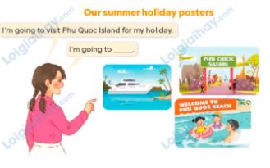  - Point at the sample poster and explain that ss are going to present their posters of some places to visit and activities to do for the summer holidays.  - Give ss some time to practise their presentations by themselves and within groups.  - Select a few ss to give their presentations in front of the class.  4. Fun corner and wrap- up (4’)  Sing a song: A ram sam sam  - Show the video on the screen  https://www.youtube.com/watch?v=SwjvlJCelN0  -Have Ss watch, sing and dance | - Ss listen  - Ss listen to the rules  -Ss play game  -Ss play game  - Ss open their books  - Ss read through the email  - Ss read Question 1 and answer the question.  - Ss do the activity independently, swap their books and check the answers.  - Ss read their answers in front of the class.  - Ss listen to the teacher’s instruction  - Ss write their paragraphs independently.  -Ss work in pairs and checks.  - Ss read their paragraphs aloud.  - Ss listen to the teacher’s explanation.  - Ss work in groups and report their poster  - Ss present their poster in front of the class.  -Ss listen, sing and dance
D. ADJUSTMENTS (if necessary):
………………………………………………………………………………………….…..……………………………………………………………………………...……

Week 34 Preparing date: …………………..
Period 136 Teaching date: ……………………..

Review 4
Parts 1, 2
A. OBJECTIVES:
By the end of the lesson, Ss will be able to:
1. Knowledge:
- listen to and understand five communicative contexts 2 in which characters talk about familiar topics such as seasons and weather, stories for children, means of transports, places of interest, summer holidays, and tick the correct pictures.
- ask and answer questions using picture cues or personal information.
- Vocabulary: Review
- Skills: speaking, listening, reading and writing.
2. Competences:
- Communication and collaboration: work in pairs and teams to complete the learning tasks.
- Self-control and independent learning: perform reading and writing tasks.
3. Attitude/ Qualities:
- Study hard to review the vocabulary and sentence patterns they have learnt.
- Be honest in the learning tasks.
B. TEACHING AIDS:
- Teacher: Teacher’s guide Pages 329, 330, 331; Track 102; website hoclieu.vn, posters, laptop, pictures, textbook, lesson plan, TV or projector.
- Students: Pupil’s book Page 70, notebooks, workbooks, school things.
C. PROCEDURES:
Teacher’s activities | Students’ activities
1.Warm- up and review: (5’)  Game: Whispering  *Aims: to revise the sentence structures they have learnt.  *Procedure:  - Divide class into 2 groups.  - Ask 5 Ss in each group stand in a straight line.  - T says a word or phrase to the first student in this line.  - Then, the first student whispers what she/ he hear to the second person in line; the second one whispers what he/ she hears to the third one and so on until the last student in group hears the word or phrase.  - The last student says the word or phrase out loud.  - The faster group has correct word or phrase is the winner.  - Say “Open your book page 70” and look at Review 4.  2.Practice: (26’)  Activity 1. Listen and tick:  *Aims: Ss will be able to listen to and understand five communicative contexts2 in which characters talk about familiar topics such as seasons and weather, stories for children, means of transports, places of interest, summer holidays, and tick the correct pictures.  *Procedure:  - Draw Ss’ attention to the pictures and elicit the informations  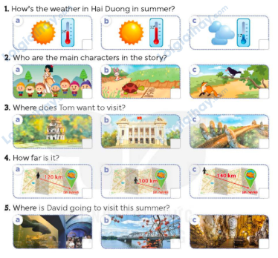  - Play the recording for Ss to do the task. (three times)  - Get Ss to swap books with a partner, then check answers as a class.  - Write the correct answers on the board.  - Play the recording for S to double-check their answers.  - Play the recording, have Ss listen and repeat in chorus.  Key: 1 b 2 c 3 a 4 b 5 c  Activity 2. Ask and answer:  *Aims: Ss will be able to ask and answer questions using picture cues personal information.  *Procedure:  - Draw ss’ attention to look at the picture, the questions and elicit the answer.  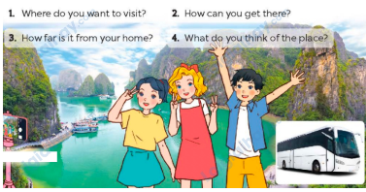  - Have Ss look at the picture to answer the question.  - Have Ss work in pairs to role-play the four questions  - Invite pairs of Ss to stand up and take it in turns to role-play the target exchanges.  Suggested answers:  1. I want to visit Ha Long Bay.  2. I can get there by bus (coach).  3. It’s about 79 km from Hai Phong.  4. I think it’s fantastic.  3. Fun corner and wrap- up (4’)  Game: “Pass the ball”  - Give two different colored balls to two pupils, a blue ball (ask the question) and a white ball (answer the question).  - Ask Ss to listen to music and pass the balls.  - Stop music suddenly. Have the student with a blue ball make a question. Have the student with a white ball answer the question.  - Repeat the game several times. | - Ss listen  -Ss play game  -Ss play game  -Ss praise the winner  - Ss open their books  - Ss listen and say  + Picture 1a: Icon for sunny, 24oC + Picture 1b: Icon for sunny, 32oC + Picture 1c: Icon for cloudy, 12oC + Picture 2a: Story Snow White and the seven dwarfs  + Picture 2b: Story the Tortoise and the Hare  + Picture 2c: Story the Fox and the Crow  + Picture 3a: Hoan Kiem Lake  + Picture 3b: Hanoi Opera House + Picture 3c: Golden Bridge in Da Nang  + Picture 4a: A map showing the distance from a place to Danang: 120 km  + Picture 4b: A map showing the distance from a place to Danang: 100 km  + Picture 4c: A map showing the distance from a place to Danang: 140 km  + Picture 5a: Dam Sen Aquarium in Ho Chi Minh City  + Picture 5b: Huong River in Hue  + Picture 5c: Phong Nha Cave in Quang Binh  - Ss listen to the recording and do the task.  - Ss swap books with a partner, then check answers as a class.  - Ss listen to the recording to double-check their answers.  - Sls listen to the recording and repeat  -Look at the pictures and say  - Ss look at and answer.  - Ss work in pairs to role play  - Ss role play  -Ss listen to the teacher  -Ss play the game  Ex: A: Where do you want to visit?  B: I want to visit My Khe Beach  -Ss continue playing the game.
D. ADJUSTMENTS (if necessary):
………………………………………………………………………………………….…..……………………………………………………………………………...…….

