Week 25(3/3/25-7/3/25) Preparing date: March….., 2025
Period 97 Teaching date: March 3rd, 2025

Unit 15: My family’s weekend
Lesson 1 (1, 2, 3)
A. OBJECTIVES:
By the end of the lesson, Ss will be able to:
1. Knowledge:
- use the words and phrases cinema, shopping centre, sports centre, swimming pool in relation to the topic “My family’s weekends”
– use Where does he / she go on Saturdays? – He / She goes to the ………to ask and answer questions about where someone goes
- Vocabulary: cinema, shopping centre, sports centre, swimming pool
- Model sentences:
A: Where does he / she go on Saturdays?
B: He/ She goes to the gym.
- Skills: speaking and listening
2. Competences:
- Co-operation: ready to help friends in pair work/ group work.
- Sociability: Talk to each other, say good words to others.
3. Attitude/ Qualities:
- Kindness: Help partners to complete learning tasks.
- Honesty: tell the truth about feelings and emotions
B. TEACHING AIDS:
- Teacher: Teacher’s guide Pages 209, 210; audio Tracks 41, 42, website hoclieu.vn, posters, laptop, pictures, textbook, lesson plan, TV or projector.
- Students: Pupil’s book Page 30, notebooks, workbooks, school things.
C. PROCEDURES:
Stages/Time | Teacher’s activities | Students’ activities
1.Warm- up:  (5’)  2. Presentation  (16’)  3.Practice: (7’)  4.Production: (5’)  5. Homework. (2’) | Sing: weekend song  *Aims: to create a friendly and active atmosphere in the class to beginning the lesson.  *Procedure:  https://www.youtube.com/watch?v=Fz8weSgTBiA  -Show the song on the screen  -Ask Ss sing and dance  - Say “Open your book page 30” and look at “Unit 15, Lesson 1 (1,2,3)”.  Activity 1. Vocabulary.  *Aims: Ss will be able to know the vocabulary in the new lesson.  *Procedure:  -T elicits the new words  + sports centre : trung tâm thể thao  (picture)  + shoppping center: trung tâm mua sắm  (situation)  + swimming pool : hồ bơi (picture  + cinema : rạp chiếu phim (picture)  - T models (3 times).  - T writes the words on the board.  - Checking: Rub out and remember  Activity 2. Look, listen and repeat:  *Aims: Ss will be able to understand and correctly repeat the sentences in two communicative contexts in which the characters ask and answer questions about where a family member goes at the weekend.  *Procedure:  - Have Ss look at Pictures a and b and identify the characters in the pictures.  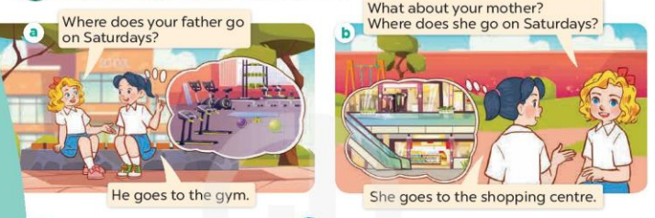  - Play the audio twice (sentence by sentence). Correct their pronunciation where necessary.  - Have Ss to practice the dialogue  - T invites a few pairs to the front of the class to practice.  - T checks pronunciation for ss.  Activity 3 Listen, point and say.  *Aims: Ss will be able to correctly say the words and use Where does he / she go on Saturdays?– He / She goes to the …... to ask and answer questions about where a family member goes at the weekend.  *Procedure:  * Model sentences:  - T asks Ss look at picture a and helps Ss know the structure from the dialogue.  - T introduces new structure for Ss.  - T explains, models and gives meaning.  -Have Ss repeat the model sentences.  A: Where does he / she go on Saturdays?  B: He’ She goes to the gym.  *Drill pictures  - Elicit and check comprehension the name of the rooms.  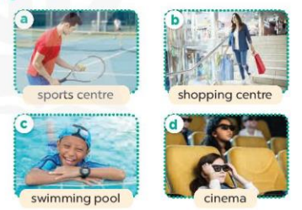  - Run through all the pictures.  - Run through model sentences.  + Run through the questions.  + Run through the answers  - Have Ss to practise:  + T says asks and Ss answer (change role).  + Ss – Ss (change role).  - Ask Ss to work in pairs.  - T controls and corrects.  - Invite a few pairs to come to the front of the classroom, point at the relevant character in each picture, and act out his/her role.  - Encourage Ss to practise speaking English.  - T gives feedbacks.  Activity 4. Let’s talk.  *Aims: Ss will be able to enhance the correct use of Where does he / she go on Saturdays? – He /She goes to the …….. to ask and answer questions about where a family member goes at the weekend in a freer context.  *Procedure:  - Ask questions to help them identify the context 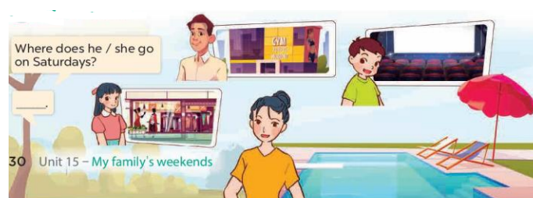  - T fills the gaps and writes the sentences on the board.  - T models  - T asks Ss to work in pairs to ask and answer  - Invite some pupils to the front of the class to present their exchanges.  - Give feedbacks.  *Consolidation  *Aims: Ss will be able consolidate and wrap up the content of the lesson.  *Procedure:  - T asks ss to answer the following questions:  + What have you learnt from the lesson today?  - T review the vocabulary and model sentences.  - T praises some Ss who are hardworking / active/ good…. as well as encourage others to try more.  - Prepare the new lesson: Unit 15, Lesson 1 (4,5,6). | - Ss listen  - Ss sing and dance  - Ss open their books  -Ss listen and answer  - - Ss listen and repeat  + Choral repetition (3 times).  + Individual repetition (3 ss)  - Ss take note  - Ss look, remember and write  -Look at the pictures and get to know the characters in the pictures.  + Picture a:  Mary: Where does your father go on Saturdays?  Mai: He goes to the gym.  + Picture b  Mary: What about your mother? Where does she go on Saturdays?  Mai: She goes to the shopping centre.  -Ss listen and repeat in chorus (twice)  -Ss work in pairs to practice  -Ss practice the dialogue  -Ss listen  -Ss look at the picture and answer.  -Ss listen  -Ss listen and repeat  -Ss repeat  - Ss look, listen and answer  + Picture a: father at the sports centre  + Picture b. a mother at the shopping centre  + Picture c. a brother at the swimming pool  + Picture d. a sister at the cinema  -Ss practice in chorus  -Ss practice in chorus  -Ss practice in chorus  -Ss work in pairs to practice  -Ss point and say  -Ss listen.  -Ss listen  -Ss look at the picture and answer  + a father at the gym, a brother at the cinema, a sister at the shopping centre, a mother at the swimming pool.  -Ss note  - Ss say the completed sentences.  -Ss work in pairs  -Ss perform in front of the class.  -Ss answer the questions  - Ss listen  -Ss listen and clap their hands  -Ss listen and take note
D. ADJUSTMENTS (if necessary):
Good
Week 25 Preparing date: March….., 2025
Period 98 Teaching date: March 3rd, 2025

Unit 15: My family’s weekend
Lesson 1 (4, 5, 6)
A. OBJECTIVES:
By the end of the lesson, Ss will be able to:
1. Knowledge:
- use the words and phrases cinema, shopping centre, sports centre, swimming pool in relation to the topic “My family’s weekends”
- listen to and demonstrate understanding of simple communicative contexts in relation to the topic “My family’s weekends”
- Vocabulary: Review
- Skills: speaking, listening, reading and writing.
2. Competences:
- Co-operation: ready to help friends in pair work/ group work.
- Self-control and independent learning: perform listening tasks.
3. Attitude/ Qualities:
- Kindness: Help partners to complete learning tasks.
- Diligence: complete learning tasks.
B. TEACHING AIDS:
- Teacher: Teacher’s guide Pages 212,213 audio Tracks 43, 44; website hoclieu.vn, posters, laptop, pictures, textbook, lesson plan, TV or projector.
- Students: Pupil’s book Page 31, notebooks, workbooks, school things.
C. PROCEDURES:
Stages/Time | Teacher’s activities | Students’ activities
1.Warm- up:  (5’)  2.Practice: (27’)  3. Homework. (3’) | Game: slap the board  *Aims: to create a friendly and active atmosphere in the class to beginning the lesson.  *Procedure:  - Divides class into 2 teams.  - T calls 1 pupil from each team to come to the board.  - T shows clues (picture and some given letters) on the slides, pupils need to slap the board as quickly as possible to choose the missing letters.  - The first pupils slapping at the correct answer will get 1 point for their team.  - Say “Open your book page 31” and look at “Unit 15, Lesson 1 (4,5,6)”.  Activity 1. Listen and tick:  *Aims: Ss will be able to listen to and understand two communicative contexts about where a family member goes at the weekend and tick the correct pictures.  *Procedure:  - Elicit the name of the food in each picture   - T ask Ss to guess the answers.  + T writes Ss’guessing on the board.  - Listen to the tape:  + Play the recording  + Play the recording again and get Ss to swap books with their partners.  + Play the recording again to check answers together as a class.  + Write the answers on the board for Ss to correct their answers. Then checks Ss’ guessing.  - Play the recording, sentence by sentence, for the class to listen and repeat in chorus.  Key: 1.b 2.a  Activity 2. Look, complete and read.  *Aims: Ss will be able to complete two gapped sentences and two gapped exchanges with the help of picture cues.  *Procedure:  - Have Ss look at the pictures and identify the places and characters in the pictures. 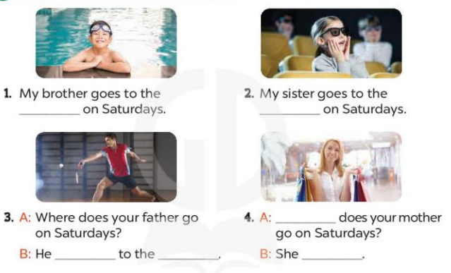  - Have Ss look at the four incomplete exchanges and elicits the missing words in the sentences.  - T models with sentence 1  + Ask Ss what is missing in the sentence.  + Have Ss look at the picture and complete the gap, then read the completed sentence in chorus.  -Have Ss work in groups and complete the sentences 2,3 and 4.  - Ask a few Ss to stand up and read the completed sentences aloud.  -T gives feedbacks.  Key:  - : 1. swimming pool  - 2. cinema  - 3. goes; sports centre  4. Where; goes to the shopping centre  Activity 3. Let’s sing.  *Aims: Ss will be able to sing the song Where do they go on Saturdays? with the correct pronunciation, rhythm and melody.  *Procedure:  - Introduce the title and lyrics of the song: “ Where do they go on Saturdays? ” song.  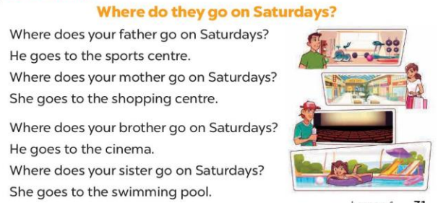  - Play the recording for Ss to listen to the whole song.  + Have them repeat the title and lyrics line by line.  + Tell Ss to point at the relevant character while singing his or her name.  - Play the recording all the way through for Ss to listen to pronunciation and melody of the song.  - Play the recording line by line for Ss to listen, repeat and point at the relevant character.  - Play the recording for Ss to sing and do actions.  - Ask Ss to practice singing and doing actions in pairs or groups.  - Invite groups to the front of the classroom to perform the song  -T gives feedback.  *Consolidation  *Aims: Ss will be able consolidate and wrap up the content of the lesson.  *Procedure:  - T asks ss to answer the following questions:  + What have you learnt from the lesson today?  - T praises some Ss who are hardworking / active/ good…. as well as encourage others to try more.  - Learn the sing by heart  - Prepare the new lesson: Unit 15, Lesson 2 (1,2,3). | - Ss listen  -Ss play the game  - Ss open their books  -Look at the pictures and say:  + Picture 1a: a sister at the cinema  + Picture 1b: a sister at the swimming pool  + Picture 2a: a mother at the shopping centre  + Picture 2b: a mother at the gym  -Ss guess the answers  - Ss listen to the tape and tick  - Ss listen again, tick and swap books with their partners.  - Ss check their answers and guessing  -Ss write the answers  -Ss listen and repeat.  -Ss look at the picture and say  -Ss look and answer  -Ss answer: swimming pool  -Ss look, complete and read the completed sentence in chorus.  -Ss complete the sentence  -Ss read aloud  - Ss look and listen.  -Ss listen to the song  - Ss listen and repeat line by line without the action.  -Ss point to the character while singing  -Ss listen to melody of the song  - Ss listen and sing line by line.  - Ss sing and do actions.  - Ss work in groups (two groups) to sing.  -Ss perform in front of the class.  -Ss listen  -Ss answer the questions  -Ss listen and clap their hands  -Ss listen and take note
D. ADJUSTMENTS (if necessary):
Good

Week 25 Preparing date: March….., 2025
Period 99 Teaching date: March 5th , 2025

Unit 15: My family’s weekend
Lesson 2 (1, 2, 3)
A. OBJECTIVES:
By the end of the lesson, Ss will be able to:
1. Knowledge:
- Use the words and phrases cook meals, do yoga, play tennis and watch films in relation to the topic “My family’s weekends”
- use What does he / she do on Sundays? – He / She ……. to ask and answer questions about what someone does;
- Vocabulary: cook meals, do yoga, play tennis and watch films
- Model sentences:
A: What does he / she do on Sundays?
B: He/ She plays tennis.
- Skills: speaking and listening
2. Competences:
- Co-operation: ready to help friends in pair work/ group work.
- Oral Communication: speak about someone, ask and answer the questions
3. Attitude/ Qualities:
- Kindness: Help partners to complete learning tasks.
- Honesty: tell the truth about feelings and emotions
B. TEACHING AIDS:
- Teacher: Teacher’s guide Pages 214, 215; audio Tracks 45, 46, website hoclieu.vn, posters, laptop, pictures, textbook, lesson plan, TV or projector.
- Students: Pupil’s book Page 32, notebooks, workbooks, school things.
C. PROCEDURES:
Stages/Time | Teacher’s activities | Students’ activities
1.Warm- up:  (3’)  2. Presentation  (16’)  3.Practice: (7’)  4.Production: (7’)  5. Homework. (2’) | Game: Lucky Wheel game (ppt)  *Aims: to create a friendly and active atmosphere in the class to beginning the lesson.  *Procedure:  - Divide the class into 2 teams.  - Have Ss from each team choose a number, then answer the questions.  - If the Ss answer correctly, T spins the wheel on the slide to get the points for that question.  - After 6 numbers, the team with the most points is the winner.  - Say “Open your book page 32” and look at “Unit 13, Lesson 2 (1,2,3)”.  Activity 1. Vocabulary.  *Aims: Ss will be able to know the vocabulary in the new lesson.  *Procedure:  -T elicits the new words  + cook meals : nấu các bữa ăn (realia)  + play tennis : chơi quần vợt (realia)  + watch films : xem phim (realia)  + do yoga : tập yoga (visual)  - T models (3 times).  - T writes the words on the board.  - Checking: Rub out and remember  Activity 2. Look, listen and repeat:  *Aims: Ss will be able to understand and correctly repeat the sentences in two communicative contexts focusing on asking and answering questions about what a family member does at the weekend  *Procedure:  - Have Ss look at Pictures a and b and identify the places, characters and their activities in the pictures.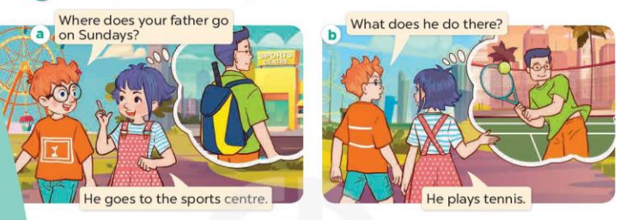  - Play the audio twice (sentence by sentence). Correct their pronunciation where necessary.  - Have Ss to practice the diaguage  - T invites a few pairs to the front of the class to practice.  - T checks pronunciation for ss.  Activity 3. Listen, point and say.  *Aims: Ss will be able to correctly say the phrases and use What does he / she do on Sundays? – He / She …... to ask and answer questions about what a family member does at the weekend.  *Procedure:  * Model sentences:  - T asks Ss look at picture b and helps Ss know the structure from the dialogue.  - T introduces new structure for Ss.  - T explains, models and gives meaning.  - Have Ss repeat the model sentences.  A: What does he / she do on Sundays?  B: He/ She plays tennis  *Drill pictures  - Elicit the activities of the people.  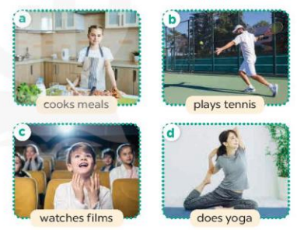  - Run through all the pictures.  - Run through model sentences.  +Run through the question sentences  +Run through the answer sentences  - Have Ss to practise:  + T asks, Ss answer picture a  + Ss ask, T answers picture b  + Group A ask, group B answer picture c  + Group B ask, group A answer picture d  - Ask Ss to work in pairs.  - T controls and corrects.  - Invite a few pairs to come to the front of the classroom, point at the relevant character in each picture, and act out his/her role.  - T gives feedbacks.  Activity 4. Let’s talk.  *Aims: Ss will be able to enhance the correct use of What does he / she do on Sundays? – He / She …….. to ask and answer questions about what a family member does at the weekend in a freer context.  *Procedure:  - Ask questions to help them identify the context.  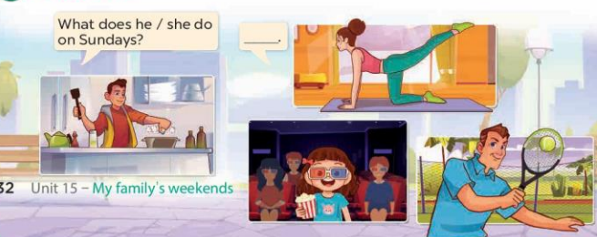  - Put pupils into pairs and encourage them to ask and answer questions about what a family member does at the weekend.  - Invite a few pairs to practise asking and answering questions about what a family member does at the weekend.  - Invite a few pairs to the front of the class to perform their conversations.  *Consolidation  *Aims: Ss will be able consolidate and wrap up the content of the lesson.  *Procedure:  - T asks ss to answer the following questions:  +What are the core values of the lesson? (if the teacher can take from the lesson).  - T review the vocabulary and model sentences.  - T praises some Ss who are hardworking / active/ good…. as well as encourage others to try more.  - Learn the vocabulary by heart  - Prepare the new lesson: Unit 15, Lesson 2 (4,5,6). | - Ss listen  - Ss play the game  - Ss open their books  -Ss listen and answer  - - Ss listen and repeat  + Choral repetition (3 times).  + Individual repetition (3 ss)  - Ss take note  - Ss look, remember and write  -Look at the pictures and get to know the characters in the pictures.  + In picture a:  Ben: Where does your father go on Sundays?  Linh: He goes to the sports centre  + In picture b:  Ben: What does he do there?  Linh: He plays tennis  -Ss listen and repeat in chorus (twice)  -Ss work in pairs to practice  -Ss practice the diaguage  -Ss listen  -Ss look at the picture and answer.  -Ss listen  -Ss listen and repeat  -Ss repeat  - Ss look, listen and answer  + Picture a: a sister cooking  + Picture b: a father playing tennis  + Picture c: a brother watching a film  + Picture d: a mother doing yoga  -Ss practice in chorus  -Ss practice in chorus  - Ss practice in chorus  -Ss work in pairs to practice  -Ss listen  -Ss go to the board and role play  -Ss listen  -Ss look at the picture and answer  + a mother doing yoga, a brother cooking a meal, a sister watching a film, a father playing tennis  -Ss work in pairs to ask and answer  -Ss ask and answer  -Ss perform in front of the class.  -Ss answer the questions  - Ss listen  -Ss listen and clap their hands  -Ss listen and take note
D. ADJUSTMENTS (if necessary):
Good

Week 25 Preparing date: March….., 2025
Period 100 Teaching date: March 5th , 2025

Unit 15: My family’s weekend
Lesson 2 (4, 5, 6)
A. OBJECTIVES:
By the end of the lesson, Ss will be able to:
1. Knowledge:
- use the words and phrases cinema, shopping centre, sports centre, swimming pool in relation to the topic “My family’s weekends”
-listen to and demonstrate understanding of simple communicative contexts in relation to the topic “My family’s weekends”
- Vocabulary: Review
- Skills: speaking, listening, reading and writing.
2. Competences:
- Co-operation: ready to help friends in pair work/ group work.
- Self-control and independent learning: perform listening tasks.
3. Attitude/ Qualities:
- Kindness: Help partners to complete learning tasks.
- Honesty: tell the truth about feelings and emotions.
B. TEACHING AIDS:
- Teacher: Teacher’s guide Pages 216, 217; audio Tracks 47; website hoclieu.vn, posters, laptop, pictures, textbook, lesson plan, TV or projector.
- Students: Pupil’s book Page 33, notebooks, workbooks, school things.
C. PROCEDURES:
Stages/Time | Teacher’s activities | Students’ activities
1.Warm- up:  (5’)  2.Practice: (27’)  3. Homework. (3’) | Game: “Lucky wheel”  *Aims: to create a friendly and active atmosphere in the class to beginning the lesson.  *Procedure:  - Teacher divides the class into 2 teams (boys and girls).  - Each team takes turns to choose the flag and answer the question.  - The team that has more points is the winner.  - Say “Open your book page 33” and look at “Unit 15, Lesson 2 (4,5,6)”.  Activity 1. Listen and match:  *Aims: Ss will be able to listen to and understand four communicative contexts aboutwhat a family member does at the weekend and match the correct pictures  *Procedure:  - Ask questions to help Ss identify the people in the pictures and the icons.    - T ask Ss to guess the answers.  + T writes Ss’guessing on the board.  - Listen to the tape:  + Play the recording  + Play the recording again and get Ss to swap books with their partners.  + Play the recording again to check answers together as a class.  + Write the answers on the board for Ss to correct their answers. Then checks Ss’ guessing.  - Play the recording, sentence by sentence, for the class to listen and repeat in chorus.  Key: 1.c 2. d 3. a 4. b  Activity 2. Look, complete and read.  *Aims: Ss will be able to complete two gapped exchanges with the help of picture cues.  *Procedure:  - Have Ss look at the pictures and identify the people and their activities in the pictures 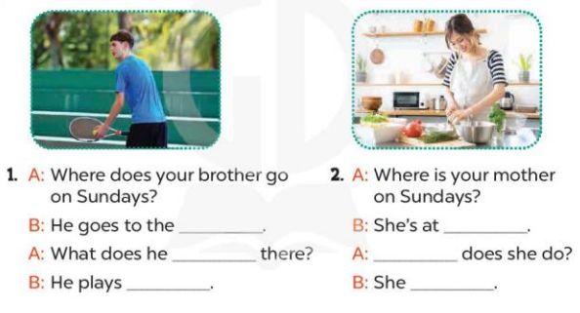  - Have Ss look at the two gapped exchanges. Draw their attention to the missing words.  - Have Ss look at the first gap. Ask them what word is missing (sports centre). Then have them complete the sentence (He goes to the sports centre.).  +Get them to guess the missing words in the following sentences (do; tennis).  - Repeat the same procedure with Exchange 2.  - Get Ss to swap books with a partner and check their answers before checking as a class.  - Ask a few pairs to read the completed exchanges aloud.  -T gives feedbacks.  Key: 1. sports centre; do; tennis  2. home; What; cooks meals  Activity 3. Let’s play.  *Aims: Ss will be able to revise target words about family weekend activities by playing Matching game  *Procedure:  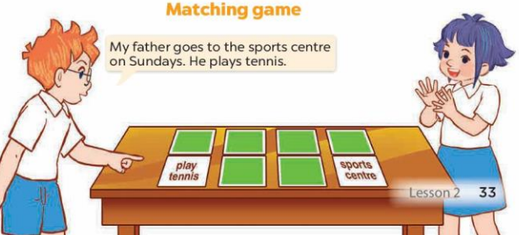  - Tell Ss that they are going to play Matching game in pairs.  - The player turns over a pair of cards.  +If the cards show an activity and a place that matches, the player scores a point, ex: the card play tennis matches the card sports centre.  - The player continues to turn over pairs of cards.  + If the cards do not match, the other player has a turn.  + The player who gets more points is the winner.  - Have Ss work in pairs. Invite one or two pairs to the front of the class to play the game.  - Ask Ss to make sentences with the words on the cards they have, ex: My father goes to the sports centre on Sundays. He plays tennis.  *Consolidation  *Aims: Ss will be able consolidate and wrap up the content of the lesson.  *Procedure:  - T asks ss to answer the following questions:  + What have you learnt from the lesson today?  +What are the core values of the lesson? (if the teacher can take from the lesson).  - T praises some Ss who are hardworking / active/ good…. as well as encourage others to try more.  - Prepare the new lesson: Unit 15, Lesson 3 (1,2,3). | - Sing and dance the song in chorus.  - Ss open their books  -Look at the pictures and say:  + Picture a: cinema icon  + Picture b: yoga icon  + Picture c: tennis icon  + Picture d: cooking icon  -Ss guess the answers  - Ss listen to the tape and match  - Ss listen again, match and swap books with their partners.  - Ss check their answers and guessing  -Ss write the answer  -Ss listen and repeat.  -Ss look at the pictures and say  -Ss look at the gap and pay attention  -Ss answer and complete the sentence  -Ss read and complete  -Ss do the task with exchange 2  -Ss swap books and check answer  -Ss read the completed  - Ss listen  - Ss listen  -Ss play the game  - Ss play the game  -Ss listen and answer  -Ss listen and take note

D. ADJUSTMENTS (if necessary):
Good

