Week 24(24/2/25-28/2/25) Preparing date: February………, 2025
Period: 93 Teaching date: February 24th , 2025

Unit 14: Daily activities
Lesson 2 (1, 2, 3)
A. OBJECTIVES:
By the end of the lesson, Ss will be able to:
1. Knowledge:
- use the phrases wash the clothes, clean the ﬂoor, help with the cooking and wash the dishes in relation to the topic “Daily activities”.
- use What do you do in the morning? – I …..to ask and answer questions about what daily activities someone does in the morning;
- Vocabulary: wash the clothes, clean the floor, help with the cooking, wash the dishes
- Model sentences:
A: What do you do in the morning?
B: I clean the floor.
- Skills: speaking and listening
2. Competences:
- Co-operation: ready to help friends in pair work/ group work.
- Oral Communication: speak about someone, ask and answer the questions
3. Attitude/ Qualities:
- Kindness: Help partners to complete learning tasks.
- Honesty: tell the truth about feelings and emotions
B. TEACHING AIDS:
- Teacher: Teacher’s guide Pages 201, 202; audio Tracks 35, 36; website hoclieu.vn, posters, laptop, pictures, textbook, lesson plan, TV or projector.
- Students: Pupil’s book Page 26, notebooks, workbooks, school things.
C. PROCEDURES:
Stages/Time | Teacher’s activities | Students’ activities
1.Warm- up:  (3’)  2. Presentation  (16’)  3.Practice: (7’)  4.Production: (7’)  5. Homework. (2’) | Game: Play game (PPT)  *Aims: to create a friendly and active atmosphere in the class to beginning the lesson.  *Procedure:  - Divide the class into 3 teams.  - Have Ss from each team take turns choose a letter and answer a question  - If Ss answer correctly get some points  - Say “Open your book page 26” and look at “Unit 14, Lesson 2 (1,2,3)”.  Activity 1. Vocabulary.  *Aims: Ss will be able to know the vocabulary in starting the new lesson.  *Procedure:  -T elicits the new words  + clean the floor : lau sàn nhà (picture)  + wash the clothes: giặt quần áo (picture)  + wash the dishes : rửa chén bát (picture)  + help with the cooking : giúp đỡ việc nấu ăn (picture)  - T models (3 times).  - T writes the words on the board.  - Checking: Rub out and remember  Activity 2. Look, listen and repeat:  *Aims: Ss will be able to understand and correctly repeat the sentences in two communicative contexts focusing on asking and answering questions about what daily activity someone does.  *Procedure:  - Have Ss look at Pictures a and b and identify what activities Linh does on Sundays.  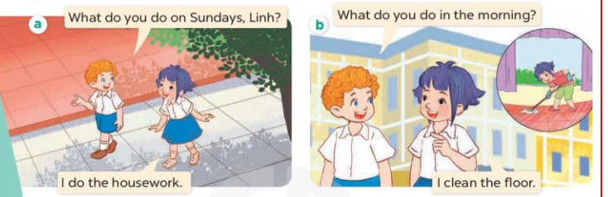  - Play the audio twice (sentence by sentence). Correct their pronunciation where necessary.  - Have Ss to practice the diaguage  - T invites a few pairs to the front of the class to practice.  - T checks pronunciation for ss.  Activity 3. Listen, point and say.  *Aims: Ss will be able to correctly say the phrases and use What do you do in the morning? - I ………. to ask and answer questions about what activity someone does in the morning.  *Procedure:  * Model sentences:  - T asks Ss look at picture b and helps Ss know the structure from the dialogue.  - T introduces new structure for Ss.  - T explains, models and gives meaning.  - Have Ss repeat the model sentences.  A: What do you do in the morning?B: I clean the floor.  *Drill pictures  - Have Ss look at the pictures and elicit what activity each child is doing.  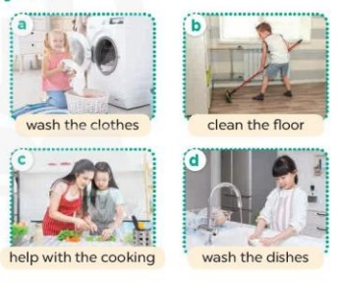  - Run through all the pictures.  - Run through model sentences.  - Have Ss to practise:  - Ask Ss to work in pairs.  - T controls and corrects.  - Invite a few pairs to come to the front of the classroom, point at the relevant character in each picture, and act out his/her role.  - T gives feedbacks.  Activity 4. Let’s talk.  *Aims: Ss will be able to enhance the correct use of What do you do in the morning / afternoon / evening? – I …….. to ask and answer questions about what activity someone does in the morning / afternoon / evening in a freer context.  *Procedure:  - Explain that each picture shows the members of a family doing the housework together  . 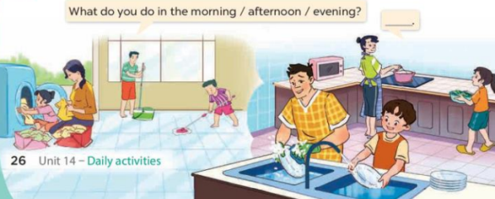  - Ask Ss to repeat the question a few times: What do you do in the morning / afternoon / evening?  - Point at the boy who is cleaning the floor to elicit the answer (I clean the floor.).  - Have Ss repeat it a few times.  - Split the class into two groups to take turns pointing at each activity that a character is doing, asking and answering in chorus.  - Ask S to practise asking and answering What do you do in the morning / afternoon / evening? – I ……..  - Invite some pairs of pupils to the front of the class to take turns asking and answering  *Consolidation  *Aims: Ss will be able consolidate and wrap up the content of the lesson.  *Procedure:  - T asks ss to answer the following questions:  +What are the core values of the lesson? (if the teacher can take from the lesson).  - T review the vocabulary and model sentences.  - T praises some Ss who are hardworking / active/ good…. as well as encourage others to try more.  - Prepare the new lesson: Unit 14, Lesson 2 (4,5,6). | - Ss listen  - Ss play the game  - Ss open their books  -Ss listen and answer  - - Ss listen and repeat  + Choral repetition (3 times).  + Individual repetition (3 ss)  - Ss take note  - Ss look, remember and write  -Look at the pictures and get to know the characters in the pictures.  + In picture a:  Bill: What do you do on Sundays, Linh?  Linh: I do the housework.  – In picture b:  Bill:What do you do in the morning? Mai: I clean the floor  -Ss listen and repeat in chorus (twice)  -Ss work in pairs to practice  -Ss practice the diaguage  -Ss listen  -Ss look at the picture and answer.  -Ss listen  -Ss listen and repeat  -Ss repeat  - Ss look, listen and answer  + Picture a: wash the clothes  + Picture b: clean the floor  + Picture c: help with the cooking  + Picture d: wash the dishes  -Ss practice in chorus  - Ss practice in chorus  -Ss work in pairs to practice  -Ss listen  -Ss point and say  -Ss go to the board and role play.  -Ss listen  -Ss look at the picture and answer  + Family members doing the housework together (washing the clothes, cleaning the floor, washing the dishes, helping with the cooking)  -Ss repeat a few times the questions  - Ss answer  -Ss reapeat the answer  -Ss pay attention  -Ss work in groups to ask and answer  -Ss ask and answer in front of the class.  -Ss answer the questions  - Ss listen  -Ss listen and clap their hands  -Ss listen and take note
D. ADJUSTMENTS (if necessary):
Play a game to review the vocabulary and model sentences.

Week 24 Preparing date: February………, 2025
Period: 94 Teaching date: February 24th , 2025

Unit 14: Daily activities
Lesson 2 (4, 5, 6)
A. OBJECTIVES:
By the end of the lesson, Ss will be able to:
1. Knowledge:
- use the phrases wash the clothes, clean the ﬂoor, help with the cooking and wash the dishes in relation to the topic “Daily activities”
- listen to and demonstrate understanding of simple communicative contexts in relation to the topic “Daily activities”
- Vocabulary: Review
- Skills: speaking, listening, reading and writing.
2. Competences:
- Co-operation: ready to help friends in pair work/ group work.
- Self-control and independent learning: perform listening tasks.
3. Attitude/ Qualities:
- Kindness: Help partners to complete learning tasks.
- Diligence: complete learning tasks.
B. TEACHING AIDS:
- Teacher: Teacher’s guide Pages 203, 204; audio Tracks 37, website hoclieu.vn, posters, laptop, pictures, textbook, lesson plan, TV or projector.
- Students: Pupil’s book Page 27, notebooks, workbooks, school things.
C. PROCEDURES:
Stages/Time | Teacher’s activities | Students’ activities
1.Warm- up:  (5’)  2.Practice: (27’)  3. Homework. (3’) | “Listen and draw” (ppt)  *Aims: to create a friendly and active atmosphere in the class to beginning the lesson.  *Procedure:  - Teacher plays the audios, ss listen and draw pictures in their white board/ paper.  - Say “Open your book page 27” and look at “Unit 14, Lesson 2 (4,5,6)”.  Activity 1. Listen and number:  *Aims: Ss will be able to listen to and understand four exchanges about what activities characters do at a specific time of the day and number the correct pictures.  *Procedure:  - Elicit the activity that the girl is doing in each picture.  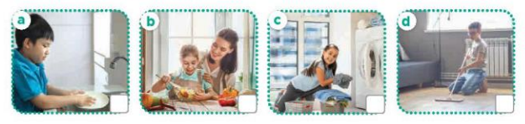  - T ask Ss to guess the answers.  + T writes Ss’guessing on the board.  - Listen to the tape:  + Play the recording  + Play the recording again and get Ss to swap books with their partners.  + Play the recording again to check answers together as a class.  + Write the answers on the board for Ss to correct their answers. Then checks Ss’ guessing.  - Play the recording, sentence by sentence, for the class to listen and repeat in chorus.  Key: 1.c 2. a 3. d 4. b  Activity 2. Look, complete and read.  *Aims: Ss will be able to complete two gapped exchanges with the help of picture cues and sentences  *Procedure:  - Elicit the missing words in the question and answer from the picture cue and sentence.  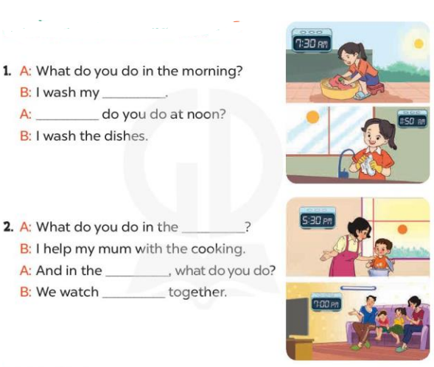  - T models with sentence 1.  + Have Ss look at the sentence.  + Ask them what is missing in the answer ( clothes).  + Have Ss complete the gap.  + Have Ss read the completed sentence in chorus.  -Have Ss work in pairs and complete the sentences 2.  - Invite pairs of pupils to stand up and read aloud the sentences.  -T gives feedbacks.  Key: 1. Clothes; What  2. afternoon; evening; TV  Activity 3. Let’s play- Miming game  *Aims: Ss will be able to review asking and answering questions about what activity someone does at a specific time of the day by playing Miming game.  *Procedure:  - Explain how the game is played.  + Write the question on the board What do you do in the ...?  +Ask one player from each team to come to the front of the class and whisper the answer to the question he / she wants to revise to the two players.  +They take turns miming the sentences they are told for their team to guess.  +The team gets one point if their guess is correct.  +The game continues until the time is up. + The team with the most points at the end of the game wins.  - Write all correct answers on the board, under the question What do you do in the …?  - When the game is over, get pairs of pupils to take turns asking and answering the question What do you do in the morning / afternoon / evening? using the answers on the board.  *Consolidation  *Aims: Ss will be able consolidate and wrap up the content of the lesson.  *Procedure:  - T asks ss to answer the following questions:  + What have you learnt from the lesson today?  +What are the core values of the lesson? (if the teacher can take from the lesson).  - T praises some Ss who are hardworking / active/ good…. as well as encourage others to try more.  - Prepare the new lesson: Unit 14, Lesson 3 (1,2,3). | - Ss listen and play the game  - Ss open their books  -Look at the pictures and say:  + Picture a. a boy washing dishes  + Picture b. a girl helping her mum with the cooking  + Picture c. a girl washing clothes  + Picture d. a boy cleaning the floor  -Ss guess the answers  - Ss listen to the tape and write number  - Ss listen again, write number and swap books with their partners.  - Ss check their answers and guessing  - Ss write the correct answer  -Ss listen and repeat.  -Ss look at the pictures and say  -Ss listen and answer  -Ss complete the gap  -Ss read and complete  -Ss work in pairs  -Ss read aloud the sentence  - Ss look and listen.  -Ss listen to the rule of the game  -Ss listen  -Ss play the game  -Ss ask and answer  -Ss answer the questions  -Ss listen and take note

D. ADJUSTMENTS (if necessary):
Encourage poor Ss & praise good Ss in front of the class

Week 24 Preparing date: February………, 2025
Period: 95 Teaching date: February 26th , 2025

Unit 14: Daily activities
Lesson 3 (1, 2, 3)
A. OBJECTIVES:
By the end of the lesson, Ss will be able to:
1. Knowledge:
- correctly repeat the sounds of the letters tch and sh in isolation, the words watch and wash and the sentences When do you watch TV? and I wash my clothes in the evening. with the correct pronunciation and intonation.
- identify the target words watch and wash while listening.
- say the chant with the correct rhythm and pronunciation.
- Vocabulary: Review
- Skills: speaking, listening, reading and writing.
2. Competences:
- Co-operation: ready to help friends in pair work/ group work.
- Self-control and independent learning: perform listening tasks.
3. Attitude/ Qualities:
- Kindness: Help partners to complete learning tasks.
- Honesty: tell the truth about feelings and emotions
B. TEACHING AIDS:
- Teacher: Teacher’s guide Pages 206, 207; audio Tracks 38, 39, 40; website hoclieu.vn, posters, laptop, pictures, textbook, lesson plan, TV or projector.
- Students: Pupil’s book Page 28, notebooks, workbooks, school things.
C. PROCEDURES:
Stages/Time | Teacher’s activities | Students’ activities
1.Warm- up:  (5’)  2. Presentation  (9’)  3.Practice: (19’)  4. Homework. (2’) | Game: Pass the bomb game (ppt)  *Aims: to create a friendly and active atmosphere in the class to beginning the lesson.  *Procedure:  - Teacher gives students an object to pass around.  - Whoever got the object when the bomb goes off will have to answer the question  - Say “Open your book page 28” and look at “Unit 14, Lesson 3 (1,2,3)”.  Activity 1. Listen and repeat:  *Aims: Ss will be able to correctly pronounce the sounds of the letters tch and sh in isolation, in the words watch and wash, and in the sentences When do you watch TV? and I wash my clothes in the evening with correct pronunciation and intonation.  *Procedure:  - T gives instruction to the letters tch and sh in isolation, in the words watch and wash, and in the sentencesWhen do you watch TV? and I wash my clothes in the evening.  - Play the recording for the letter tch, sh  - Encourage Ss to point at the letter/ word/ sentence while listening.  - Play the recording again and encourage Ss to listen and repeat.  - Do this several times until Ss feel confident.  - T calls some Ss to practice.  - T gives feedbacks.  Activity 2. Listen and circle.  *Aims: Ss will be able to identify the target words watch and wash while listening.  *Procedure:  - Elicit the sentences and explain that they have to listen.  - T ask Ss to guess the answers.  + T writes Ss’guessing on the board.  - Listen to the tape:  + Play the recording  + Play the recording again and get Ss to swap books with their partners.  + Play the recording again to check answers together as a class.  + Write the answers on the board for Ss to correct their answers. Then checks Ss’ guessing.  - Play the recording, sentence by sentence, for the class to listen and repeat in chorus.  - Invite one or two Ss to stand up and read the completed sentences.  Key: 1.c 2.b  Activity 3. Let’s chant  *Aims: Ss will be able to say the chant with the correct rhythm and pronunciation.  *Procedure:  - Introduce the title and lyrics of the chant.  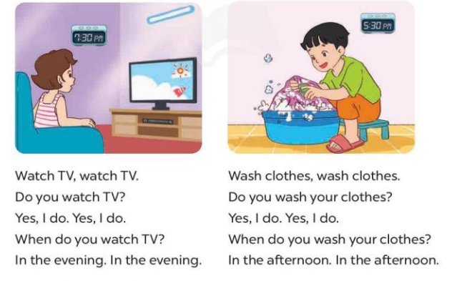  - Play the recording for Ss to listen to the whole chant.  + Have them repeat the title and lyrics line by line.  + Ask Ss to attend to the sounds of the letters tch and sh and the words watch and wash.  - Play the recording all the way through for Ss to listen to pronunciation and melody.  - Play the recording line by line for Ss to listen and repeat  - Play the recording for Ss to chant and clap along.  - Ask Ss to practice chant and clap along in pairs or groups.  - Invite groups to the front of the classroom to perform the chant  -T gives feedback.  *Consolidation  *Aims: Ss will be able consolidate and wrap up the content of the lesson.  *Procedure:  - T asks ss to answer the following questions:  + What have you learnt from the lesson today?  +What are the core values of the lesson? (if the teacher can take from the lesson).  - T praises some Ss who are hardworking / active/ good…. as well as encourage others to try more.  - Practice the chant more.  - Prepare the new lesson: Unit 14, Lesson 3 (4,5,6). | - Ss listen  -Ss play game  - Ss open their books  - Ss recognize the differences about color of letter  - - Ss listen  - Ss listen and point  - Ss listen again and repeat  -Ss listen again and repeat  -Ss practice  -Ss listen  -Ss listen and say  -Ss guess the answers  - Ss listen to the tape and circle  - Ss listen again, circle and swap books with their partners.  - Ss check their answers and guessing  -Ss write the answer  -Ss listen and repeat.  -Ss read the sentences  - Ss look and listen.  -Ss listen to the chant  - Ss listen and repeat line by line without clap their hands  -Ss note the sounds, words  -Ss listen to melody of the chant  - Ss listen and chant line by line.  - Ss chant and clap along.  - Ss work in groups (two groups) to chant  -Ss perform in front of the class.  -Ss listen  -Ss listen.  -Ss answer the questions  -Ss listen and clap their hands  -Ss listen and take note

D. ADJUSTMENTS (if necessary):
Good

Week 24 Preparing date: February………, 2025
Period: 96 Teaching date: February 26th , 2025

Unit 14: Daily activities
Lesson 3 (4, 5, 6)
A. OBJECTIVES:
By the end of the lesson, Ss will be able to:
1. Knowledge:
- use the phrases wash the clothes, clean the ﬂoor, help with the cooking and wash the dishes in relation to the topic “Daily activities”
- read and write about someone’s daily activities.
- draw pictures or take notes of what daily activities pupils do at home and present the results to the class at Project time.
- Vocabulary: Review
- Skills: speaking, listening, reading and writing.
2. Competences:
- Co-operation: ready to help friends in pair work/ group work.
- Self-control and independent learning: perform reading tasks.
3. Attitude/ Qualities:
- Kindness: Help partners to complete learning tasks.
- Diligence: complete learning tasks.
B. TEACHING AIDS:
- Teacher: Teacher’s guide Pages 207, 208, website hoclieu.vn, posters, laptop, pictures, textbook, lesson plan, TV or projector.
- Students: Pupil’s book Page 29, notebooks, workbooks, school things.
C. PROCEDURES:
Stages/Time | Teacher’s activities | Students’ activities
1.Warm- up: (5’)  2.Practice: (8’)  3.Production: (19’)  4. Homework. (3’) | Game: Brainstorming  *Aims: to review the vocabulary and structure about greet and respond to greetings.  *Procedure:  - Hold a activity card, then reveal it slowly.  - Ask What’s activity?  - Ask the Ss guess the answer as fast as possible.  - Then have Ss do the same with the rest.  - This can be played in groups to make it more interesting.  - Say “Open your book page 29” and look at “Unit 14, Lesson 3 (4, 5, 6)”.  Activity 1. Read and match:  *Aims: Ss will be able to read a paragraph and show understanding of it by matching time phrases with the appropriate activities  *Procedure:  - Have Ss read all the phrases under the paragraph. Tell them to read Phrase 1: in the morning.  - Ask Ss scan the paragraph for the appropriate activity related to the phrase.  -Have Ss to do the activity independently.  - Get Ss to swap books with their partners and check their answers before checking as a class.  - Invite some Ss to stand up and read the paragraph aloud.  Key: 1.a 2. a, d 3. b  Activity 2. Let’s write  *Aims: Ss will be able to complete a paragraph about pupils’ activities on Sundays.  *Procedure:  - Explain to the class the goal of this activity.  - Ask Ss to read each gapped sentence, look at the picture and fill in the gap.  - Give Ss time to write their answers  - Ask Ss to swap and correct their answers in pairs.  - Check the answers as a class.  Example: I do a lot of housework on Sundays. In the morning, I wake up and have breakfast. In the afternoon, I watch TV and play games. In the evening, I have dinner with my family.  Activity 3. Project.  *Aims: Ss will be able to draw pictures or take notes of what daily activities pupils do on Sundays and present the results to the class, using the target language  *Procedure:  - Explain that they have to look at the pictures or notes they have prepared at home and present the results to the class.  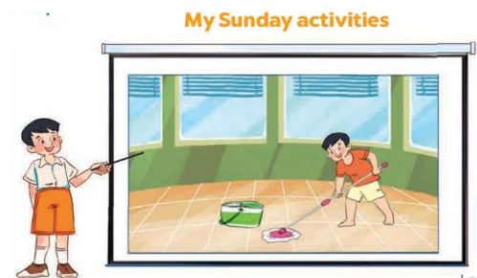  - Have Ss work in groups of five.  + Each pupil looks at their pictures or notes and tells the group about what daily activities he / she does on Sundays.  - Invite a few Ss to look at their pictures or notes and tell the class about them  - Have the rest of class applaud if pupils perform well  +Example: Hello, everyone. My name’s Huong. I’m nine years old. This is my picture. I do a lot of housework on Sundays. In the morning, I wake up and have breakfast. In the afternoon, I watch TV and play games. In the evening, I have dinner with my family.  *Consolidation  *Aims: Ss will be able consolidate and wrap up the content of the lesson.  *Procedure:  - T asks ss to answer the following questions:  + What have you learnt from the lesson today?  +What are the core values of the lesson?  - T praises some Ss who are hardworking / active/ good…. as well as encourage others to try more.  - Prepare the new lesson: Unit 15: Lesson 1 (1,2,3). | - Ss listen  -Ss play game  - Ss open their books  - Ss read and answer  -Ss scan the paragraph  -Ss do the task  -Ss swap books and check  -Ss read the paragraph aloud  -Ss listen  -Ss read and answer  -Ss write  -Ss swap books and check their answers  -Ss check the answer  -Ss listen  -Ss work in groups  -Ss show the picture and say.  -Ss perform in front of the class.  -Ss answer the questions  -Ss listen and clap their hands  -Ss listen and take note
D. ADJUSTMENTS (if necessary):
…Good

