Preparing date: March ……., 2025
Teaching date: March …………, 2025
Week 26
Period 101 Unit 15: My family’s weekend
Lesson 3 (1, 2, 3)
A. OBJECTIVES:
By the end of the lesson, Ss will be able to:
1. Knowledge:
- correctly repeat the sounds of the letters g and s in isolation, in the words go and television, and in the sentences I go to the cinema on Saturdays. and We watch television on Sundays
- identify the target words go and television while listening.
- say the chant with the correct rhythm and pronunciation.
- Vocabulary: Review
- Skills: speaking, listening, reading and writing.
2. Competences:
- Co-operation: ready to help friends in pair work/ group work.
- Self-control and independent learning: perform listening tasks.
3. Attitude/ Qualities:
- Kindness: Help partners to complete learning tasks.
- Honesty: tell the truth about feelings and emotions
B. TEACHING AIDS:
- Teacher: Teacher’s guide Pages 218, 219; audio Tracks 48, 49, 50; website hoclieu.vn, posters, laptop, pictures, textbook, lesson plan, TV or projector.
- Students: Pupil’s book Page 34, notebooks, workbooks, school things.
C. PROCEDURES:
Stages/Time | Teacher’s activities | Students’ activities
1.Warm- up:  (5’)  2. Presentation  (9’)  3.Practice: (19’)  4. Homework. (2’) | Game: play the Build the city game (PPT)  *Aims: to create a friendly and active atmosphere in the class to beginning the lesson.  *Procedure:  - Divide the class into 2 teams, Ss choose any number, the teacher clicks on the NUMBER to go to the question, after pupils answer correctly, the teacher clicks on the key next to it to unlock.  - Teacher clicks on start to build to go to the city building slide.  - Teacher clicks on the corresponding picture to put the object in the right place.  - The game ends when the city is built.  - Teachers can also add points for students to have more fun  - Say “Open your book page 34” and look at “Unit 15, Lesson 3 (1,2,3)”.  Activity 1. Listen and repeat:  *Aims: Ss will be able to correctly pronounce the sounds of the letters g and s in isolation, in the words go and television, and in the sentences I go to the cinema on Saturdays. and We watch television on Sundays  *Procedure:  - T gives instruction to the letters g and s in isolation, in the words go and television, and in the sentences I go to the cinema on Saturdays. and We watch television on Sundays  - Play the recording for the letter ea.  - Encourage Ss to point at the letter/ word/ sentence while listening.  - Play the recording again and encourage Ss to listen and repeat.  - Do this several times until Ss feel confident.  - T calls some Ss to practice.  - T gives feedbacks.  Activity 2. Listen and circle.  *Aims: Ss will be able to identify the target words go and television while listening.  *Procedure:  - Elicit the sentences and explain that they have to listen.  - T ask Ss to guess the answers.  + T writes Ss’guessing on the board.  - Listen to the tape:  + Play the recording  + Play the recording again and get Ss to swap books with their partners.  + Play the recording again to check answers together as a class.  + Write the answers on the board for Ss to correct their answers. Then checks Ss’ guessing.  - Play the recording, sentence by sentence, for the class to listen and repeat in chorus.  - Invite one or two Ss to stand up and read the completed sentences.  Key: 1.c 2.d  Activity 3. Let’s chant  *Aims: Ss will be able to say the chant with the correct rhythm and pronunciation.  *Procedure:  - Introduce the title and lyrics of the chant.  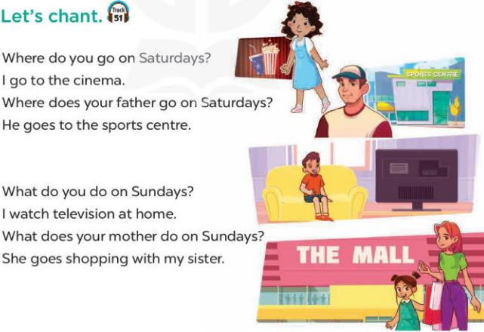  - Play the recording for Ss to listen to the whole chant.  + Have them repeat the title and lyrics line by line.  + Ask Ss to attend to the sounds of the letters g and s and the words go and television  - Play the recording all the way through for Ss to listen to pronunciation and melody.  - Play the recording line by line for Ss to listen and repeat  - Play the recording for Ss to chant and clap along.  - Ask Ss to practice chant and clap along in pairs or groups.  - Invite groups to the front of the classroom to perform the chant  -T gives feedback.  *Consolidation  *Aims: Ss will be able consolidate and wrap up the content of the lesson.  *Procedure:  - T asks ss to answer the following questions:  + What have you learnt from the lesson today?  +What are the core values of the lesson? (if the teacher can take from the lesson).  - T praises some Ss who are hardworking / active/ good…. as well as encourage others to try more.  - Practice the chant more.  - Prepare the new lesson: Unit 15, Lesson 3 (4,5,6). | - Ss listen  -Ss play game  - Ss open their books  - Ss recognize the differences about color of letter  - - Ss listen  - Ss listen and point  - Ss listen again and repeat  -Ss listen again and repeat  -Ss practice  -Ss listen  -Ss listen and say  -Ss guess the answers  - Ss listen to the tape and circle  - Ss listen again, circle and swap books with their partners.  - Ss check their answers and guessing  -Ss write the answer  -Ss listen and repeat.  -Ss read the sentences  - Ss look and listen.  -Ss listen to the chant  - Ss listen and repeat line by line without clap their hands  -Ss note the sounds, words  -Ss listen to melody of the chant  - Ss listen and chant line by line.  - Ss chant and clap along.  - Ss work in groups (two groups) to chant  -Ss perform in front of the class.  -Ss listen  -Ss listen.  -Ss answer the questions  -Ss listen and clap their hands  -Ss listen and take note

D. ADJUSTMENTS (if necessary):
………………………………………………………………………………………….…..……………………………………………………………………………...………………………………………….…..…………………………………………………………

Preparing date: March ……., 2025
Teaching date: March …………, 2025
Week 26
Period 102 Unit 15: My family’s weekend
Lesson 3 (4, 5, 6)
A. OBJECTIVES:
By the end of the lesson, Ss will be able to:
1. Knowledge:
- read and write about where someone goes and what someone does at the weekend;
- make notes about where their family members go and what they do at the weekend, and present the results to the class at Project time
- Vocabulary: Review
- Skills: speaking, listening, reading and writing.
2. Competences:
- Co-operation: ready to help friends in pair work/ group work.
- Self-control and independent learning: perform reading tasks.
3. Attitude/ Qualities:
- Honesty: tell the truth about feelings and emotions.
- Diligence: complete learning tasks.
B. TEACHING AIDS:
- Teacher: Teacher’s guide Pages 220, 221, website hoclieu.vn, posters, laptop, pictures, textbook, lesson plan, TV or projector.
- Students: Pupil’s book Page 35, notebooks, workbooks, school things.
C. PROCEDURES:
Stages/Time | Teacher’s activities | Students’ activities
1.Warm- up: (5’)  2.Practice: (8’)  3.Production: (19’)  4. Homework. (3’) | Game: Catch the sentence (PPT)  *Aims: to review the vocabulary and structure about greet and respond to greetings.  *Procedure:  - Divide the class into 2 or 3 teams  - T calls one pupil from each team to come up to the front.  - T explains the rules:  - Letters or words will appear then disappear.  - Read them quickly, the quicker one gets points for their team.  - Say “Open your book page 35” and look at “Unit 15, Lesson 3 (4, 5, 6)”.  Activity 1. Read and tick True or False:  *Aims: Ss will be able to read a text and decide whether the statements about Ben and his family’s Sunday activities are true or false.  *Procedure:  - Draw pupils’ attention to the four statements, focusing on the activities of each member of Ben’s family on Sunday.  - Ask Ss to read the text individually first, then in pairs to decide if the statements are true or false.  - Have Ss to do the task.  - Select a few pupils to read their answers in front of the class.  - Check answers as a class and give explanations where necessary.  Key: 1. T 2. F 3. T 4. T  Activity 2. Let’s write  *Aims: Ss will be able to complete a text about what Mai’s family members do at the weekend by writing the target words in the gaps.  *Procedure:  - Explain to the class the goal of this activity.  - Ask Ss to read each gapped sentence, look at the picture and fill in the gap.  - Give Ss time to write their answers  - Ask Ss to swap and correct their answers in pairs.  - Check the answers as a class.  Key: Pupils’ own answers  Example: Mai and her family do a lot of things at the weekend. On Saturdays, her father goes to the sports centre. Her mother goes to the supermarket. Her brother goes to the zoo. Mai does her homework at home. On Sundays, her family has dinner together.  Activity 3. Project.  *Aims: Ss will be able to make notes about where pupils’ family members go and what they do at the weekend, and present the results to the class, using the target language.  *Procedure:  - Explain that they have to look at the notes they have prepared at home and present the results to the class.  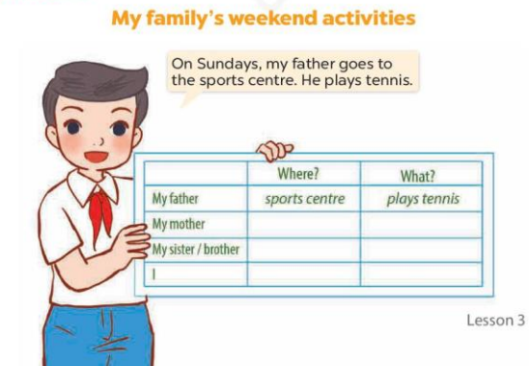  - Have pupils work in groups of five.  + Each pupil looks at his / her notes and tells the group about where each member of his / her family goes at the weekend and what each of them does there.  - Invite a few pupils to look at their notes and tell the class about them, ex: On Sundays, my father goes to the sports centre. He plays tennis.  *Consolidation  *Aims: Ss will be able consolidate and wrap up the content of the lesson.  *Procedure:  - T asks ss to answer the following questions:  + What have you learnt from the lesson today?  - T praises some Ss who are hardworking / active/ good…. as well as encourage others to try more.  - Prepare the new lesson: Review 3. | - Ss listen  -Ss play game  - Ss open their books  - Ss read and answer  -Ss read and choose the correct answer  -Ss do the task  -Ss read the answer in front of the class  -Ss check the correct their answers  -Ss listen  -Ss read and answer  -Ss write  -Ss swap books and check their answers  -Ss check  -Ss listen and answer  -Ss work in groups  -Ss tell the group  -Ss perform in front of the class.  -Ss answer the questions  -Ss listen and clap their hands  -Ss listen and take note
D. ADJUSTMENTS (if necessary):
………………………………………………………………………………………….…..………………………………………………………………………………...…………

Preparing date: March ……, 2025
Teaching date: March ……, 2025
Week 26
Period 103, 104 Review 3
Parts 1, 2, 3, 4, 5
A. OBJECTIVES:
By the end of the lesson, Ss will be able to:
1. Knowledge:
- correctly use the following sentence patterns:
+Where do you live? – I live ____.
+What’s the ____ like? – It’s ____.
+What does he / she do? – He’s / She’s ____.
+Where does he / she work? – He / She works ____.
+What does he / she look like? – He’s / She’s ____.
+What does he / she look like? – He / She has ____.
+When do you watch TV? – I watch TV ____.
+What do you do in the morning? – I ____.
+Where does he / she go on Saturdays? – He / She goes to the ____.
+What does he / she do on Sundays? – He / She ____.
- Vocabulary: Review
- Skills: speaking, listening, reading and writing.
2. Competences:
- Co-operation: ready to help friends in pair work/ group work.
- Self-control and independent learning: perform listening tasks.
3. Attitude/ Qualities:
- Kindness: Help partners to complete learning tasks.
- Honesty: tell the truth about feelings and emotions.
- Diligence: complete learning tasks.
B. TEACHING AIDS:
- Teacher: Teacher’s guide Pages 222, 223; Track 51; website hoclieu.vn, posters, laptop, pictures, textbook, lesson plan, TV or projector.
- Students: Pupil’s book Page 36, 37, notebooks, workbooks, school things.
C. PROCEDURES:
Stages/Time | Teacher’s activities | Students’ activities
1.Warm- up:  (5’)  2.Practice: (52’)  3.Production: (10’)  4. Homework. (3’) | Game: Whispering  *Aims: to review the vocabulary and structure about greet and respond to greetings.  *Procedure:  - Divide class into 2 groups.  -Ask 5 Ss in each group stand in a straight line.  - T says a word or phrase to the first pupil in this line.  - Then, the first pupil whispers what she/ he hear to the second person in line; the second one whispers what he/ she hears to the third one and so on until the last pupil in group hears the word or phrase.  - The last pupil says the word or phrase out loud.  - The faster group has correct word or phrase is the winner.  - Say “Open your book page 36, 37” and look at Review 3.  Activity 1. Listen and number:  *Aims: Ss will be able to listen to and understand four communicative contexts and number the correct pictures.  *Procedure:  - Elicit what is shown in each picture.  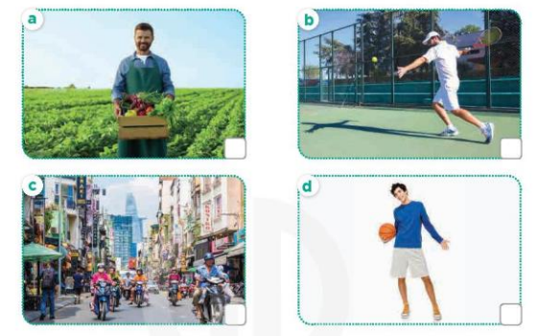  - T ask Ss to guess the answers.  + T writes Ss’guessing on the board.  - Listen to the tape:  + Play the recording  + Play the recording again and get Ss to swap books with their partners.  + Play the recording again to check answers together as a class.  + Write the answers on the board for Ss to correct their answers. Then checks Ss’ guessing.  - Play the recording, sentence by sentence, for the class to listen and repeat in chorus.  Key: 1. c 2. a 3. d 4. b  Activity 2. Ask and answer  *Aims: Ss will be able to ask and answer questions using picture cues.  *Procedure:  - Get them to look at Mary’s thought bubble to identify what the girl looks like.  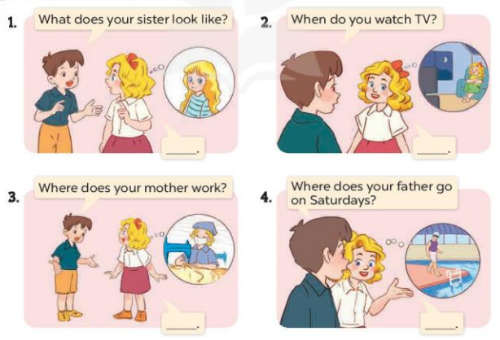  - Draw pupils’ attention to Nam’s question (What does your sister look like?).  - Have Ss look at the girl in Mary’s thought bubble to answer the question.  - Have Ss work in pairs to role-play the four exchanges.  - Invite some pairs of Ss to stand up and take it in turns to role-play the target exchanges  Activity 3. Read and match  *Aims: Ss will be able to read and match pairs of target sentence patterns  *Procedure:  - Draw pupils’ attention to the sentences. Point at Sentence 1, elicit the answer and give feedback. + Draw a line to match Sentence 1 with the letter d.  - Give Ss time to do the task individually  - Get Ss to swap books with a partner, then check answers as a class.  - Write the correct answers on the board.  - Invite some pairs of pupils to stand up and read the matched exchanges aloud.  Key: 1.d 2. a 3. e 4. c 5. b  Activity 4. Read and complete  *Aims: Ss will be able to read and show understanding of a text by completing the gaps.  *Procedure:  - Draw Ss’ attention to the words in the box and the paragraph.  + Point at the first gapped sentence and have pupils read it aloud as a class.  + Elicit the missing word and give feedback.  + Complete the sentence and get pupils to read the completed sentence in chorus.  - Give Ss time to do the task individually.  - Get Ss to swap books with a partner, then check answers as a class.  - Write the correct answers on the board.  - Invite a few Ss to stand up and read the completed paragraph aloud.  Key:1. factory 2. slim 3. works 4. pupil 5. watch  Activity 5. Let’s write  *Aims: Ss will be able to use the target language to complete a gapped paragraph using a picture cue.  *Procedure:  - Ask Ss to read the gapped text and fill in the gaps using the picture cue.  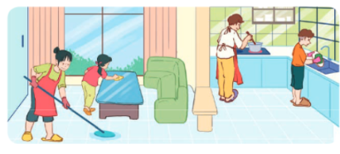  - Write the sentence with the first gap on the board: My father ____.  - Ask Ss to point at the father in the picture and encourage pupils to say what he does on Sundays (cooks meals). Give pupils time to write the answers.  - Invite a few pupils to read the paragraph they have completed in front of the class.  Key: 1. cooks meals 2. cleans the floor  3. washes the dishes 4. clean the table  *Consolidation  *Aims: Ss will be able consolidate and wrap up the content of the lesson.  *Procedure:  - T asks ss to answer the following questions:  + What have you learnt from the lesson today?  - T praises some Ss who are hardworking / active/ good…. as well as encourage others to try more.  - Prepare the new lesson: Extension activities | - Ss listen  -Ss play game  - Ss open their books  -Look at the pictures and say:  + Picture a. a farmer  + Picture b: a man playing tennis  + Picture c: a busy street  + Picture d: a tall boy  -Ss guess the answers  - Ss listen to the tape and write number  - Ss listen again, write number and swap books with their partners.  -Ss write the answer and check their answers and guessing  -Ss listen and repeat.  -Look at the pictures and say  - Ss pay attention  -Ss an swer the question  -Ss work in pairs and role play  -Ss role play in front of the class  -Ss read and match sentence 1  -Ss do the task  -Ss swap their books and check answer  -Ss erite the correct answer  -Ss read aloud  -Ss read the passge  -Ss read the first gapped sentence  -Ss complete and read aloud the completed sentence  -Ss do the task  -Ss swap books and check answer  -Ss write the correct answer  -Ss read the completed paragraph aloud  -Ss role play sentence 1  -Ss write the first gap  -Ss point the picture and write  -Ss read the paragraph in font of the class  -Ss listen  -Ss listen and clap their hands  -Ss listen and take note
D. ADJUSTMENTS (if necessary):
………………………………………………………………………………………….…..………………………………………………………………………………...…………

