Preparing date: February………, 2025
Teaching date: February 17th , 2025
Week 23
Period: 89
Unit 13: Appearance
Lesson 3 (1, 2, 3)
A. OBJECTIVES:
By the end of the lesson, Ss will be able to:
1. Knowledge:
- correctly repeat the sounds of the letters l and r in isolation, the words long and round and the sentences My sister has long hair and My brother has round eyes with the correct pronunciation and intonation.
- identify the target words long and round while listening.
- say the chant with the correct rhythm and pronunciation.
- Vocabulary: Review
- Skills: speaking, listening, reading and writing.
2. Competences:
- Co-operation: ready to help friends in pair work/ group work.
- Self-control and independent learning: perform listening tasks.
3. Attitude/ Qualities:
- Kindness: Help partners to complete learning tasks.
- Honesty: tell the truth about feelings and emotions
B. TEACHING AIDS:
- Teacher: Teacher’s guide Pages 192, 193; audio Tracks 28,29,30; website hoclieu.vn, posters, laptop, pictures, textbook, lesson plan, TV or projector.
- Students: Pupil’s book Page 22, notebooks, workbooks, school things.
C. PROCEDURES:
Stages/Time | Teacher’s activities | Students’ activities
1.Warm- up:  (5’)  2. Presentation  (9’)  3.Practice: (19’)  4. Homework. (2’) | Game: play the Doraemon game (PPT)  *Aims: to create a friendly and active atmosphere in the class to beginning the lesson.  *Procedure:  - Divide the class into 3 teams.  - Pupils from each team choose a number, then ask and answer with the picture in that number.  - If the Ss answer correctly, they get the points (dorayaki) for that question.  - After 9 numbers, the team with the most points is the winner.  - Say “Open your book page 22” and look at “Unit 13, Lesson 3 (1,2,3)”.  Activity 1. Listen and repeat:  *Aims: Ss will be able to correctly pronounce the sounds of the letters l and r in isolation, in the words long and house, and in the sentences My sister has long hair and My brother has round eyes with correct pronunciation and intonation.  *Procedure:  - T gives instruction to the l and r in isolation, in the words long and round, and in the sentences My sister has long hair and My brother has round eyes.  - Play the recording for the letter l, r.  - Encourage Ss to point at the letter/ word/ sentence while listening.  - Play the recording again and encourage Ss to listen and repeat.  - Do this several times until Ss feel confident.  - T calls some Ss to practice.  - T gives feedbacks.  Activity 2. Listen and circle.  *Aims: Ss will be able to identify the target words long and round while listening.  *Procedure:  - Elicit the sentences and explain that they have to listen.  - T ask Ss to guess the answers.  + T writes Ss’guessing on the board.  - Listen to the tape:  + Play the recording  + Play the recording again and get Ss to swap books with their partners.  + Play the recording again to check answers together as a class.  + Write the answers on the board for Ss to correct their answers. Then checks Ss’ guessing.  - Play the recording, sentence by sentence, for the class to listen and repeat in chorus.  - Invite one or two Ss to stand up and read the completed sentences.  Key: 1.b 2.b  Activity 3. Let’s chant  *Aims: Ss will be able to say the chant with the correct rhythm and pronunciation.  *Procedure:  - Introduce the title and lyrics of the chant.  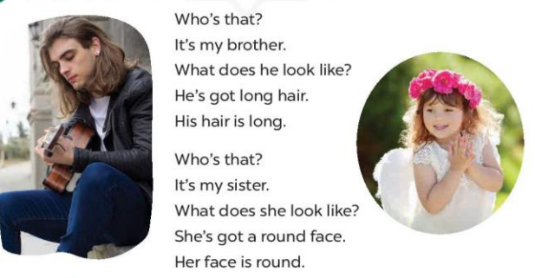  - Play the recording for Ss to listen to the whole chant.  + Have them repeat the title and lyrics line by line.  + Ask Ss to attend to the sounds of the letters l and r and the words long and round.  - Play the recording all the way through for Ss to listen to pronunciation and melody.  - Play the recording line by line for Ss to listen and repeat  - Play the recording for Ss to chant and clap along.  - Ask Ss to practice chant and clap along in pairs or groups.  - Invite groups to the front of the classroom to perform the chant  -T gives feedback.  *Consolidation  *Aims: Ss will be able consolidate and wrap up the content of the lesson.  *Procedure:  - T asks ss to answer the following questions:  + What have you learnt from the lesson today?  +What are the core values of the lesson? (if the teacher can take from the lesson).  - T praises some Ss who are hardworking / active/ good…. as well as encourage others to try more.  - Practice the chant more.  - Prepare the new lesson: Unit 13, Lesson 3 (4,5,6). | - Ss listen  -Ss play game  - Ss open their books  - Ss recognize the differences about color of letter  - - Ss listen  - Ss listen and point  - Ss listen again and repeat  -Ss listen again and repeat  -Ss practice  -Ss listen  -Ss listen and say  -Ss guess the answers  - Ss listen to the tape and circle  - Ss listen again, circle and swap books with their partners.  - Ss check their answers and guessing  -Ss write the correct answer  -Ss listen and repeat.  -Ss read the sentences  - Ss look and listen.  -Ss listen to the chant  - Ss listen and repeat line by line without clap their hands  -Ss note the sounds, words  -Ss listen to melody of the chant  - Ss listen and chant line by line.  - Ss chant and clap along.  - Ss work in groups (two groups) to chant  -Ss perform in front of the class.  -Ss listen  -Ss listen.  -Ss answer the questions  -Ss listen and clap their hands  -Ss listen and take note

D. ADJUSTMENTS (if necessary):
Good

Period: 89

Preparing date: February………, 2025
Teaching date: February 17th , 2025
Week 23
Period: 90
Unit 13: Appearance
Lesson 3 (4, 5, 6)
A. OBJECTIVES:
By the end of the lesson, Ss will be able to:
1. Knowledge:
- read and write about someone’s appearance.
- do a survey about the appearance of family members and use it to practise talking in the classroom at Project time.
- Vocabulary: Review
- Skills: speaking, listening, reading and writing.
2. Competences:
- Co-operation: ready to help friends in pair work/ group work.
- Self-control and independent learning: perform reading tasks.
3. Attitude/ Qualities:
- Kindness: Help partners to complete learning tasks.
- Honesty: tell the truth about feelings and emotions.
- Diligence: complete learning tasks.
B. TEACHING AIDS:
- Teacher: Teacher’s guide Pages 194, 195, website hoclieu.vn, posters, laptop, pictures, textbook, lesson plan, TV or projector.
- Students: Pupil’s book Page 23, notebooks, workbooks, school things.
C. PROCEDURES:
Stages/Time | Teacher’s activities | Students’ activities
1.Warm- up: (5’)  2.Practice: (8’)  3.Production: (19’)  4. Homework. (3’) | Game: Slap the board  *Aims: to review the vocabulary and structure about greet and respond to greetings.  *Procedure:  - Divide pupils into 2-3 teams.  - Each team sends one representative to the board. Teacher draws two boxes and writes l and r in each box.  - Teacher reads a word and the representatives slap the box containing letters l or r according to the sound that they hear.  - The first pupil to touch the box gets one point.  - Say “Open your book page 23” and look at “Unit 13, Lesson 3 (4, 5, 6)”.  Activity 1. Read and complete:  *Aims: Ss will be able to read a text and complete four gapped sentences about appearance.  *Procedure:  - Have pupils look at the picture and guess what the text is about.  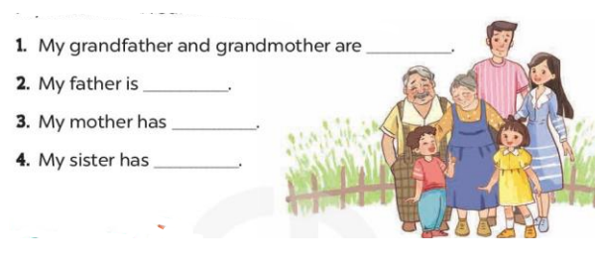  - Have Ss look at four incomplete sentences below the text.  - Ask Ss to read through the text to find the information and complete four sentences  - Ask Ss to do the task individually.  - Have Ss swap their books with a partner and check the answers.  Key: 1. big 2. very tall 3. long hair  4. a round face and big eyes  Activity 2. Let’s write  *Aims: Ss will be able to complete a gapped paragraph with personal information about family members.  *Procedure:  - Have Ss read through the paragraph to get the general idea.  - Ask Ss to read each gapped sentence, guess the missing information and complete the sentence with their own personal information.  - Give Ss time to write their answers  - Ask Ss to swap and correct their answers in pairs.  - Check the answers as a class.  Key: Pupils’ answer.  Example: There are four people in my family. My father is tall. He has short hair. My mother is slim. She has long hair. My brother is big. We love our family  Activity 3. Project.  *Aims: Ss will be able to carry out a survey on the appearance of pupils’ family members and present it to the class.  *Procedure:  - Explain that pupils are going to report the results of their surveys about their family members’ appearance.  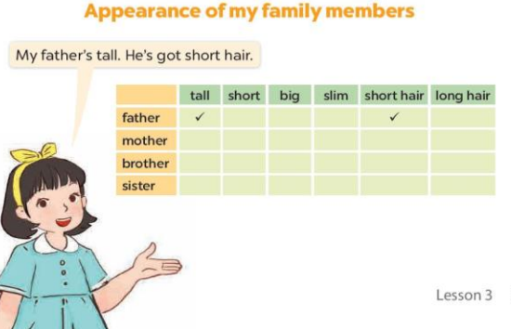  - Have Ss hold up their completed surveys. - Revise some words and sentence patterns that pupils can use for their presentations.  - Give Ss some time to practise their presentations by themselves and within groups.  - Select a few pupils to give their presentations in front of the class.  - Have the rest of the class give comments and praise pupils if they perform well.  *Consolidation  *Aims: Ss will be able consolidate and wrap up the content of the lesson.  *Procedure:  - T asks ss to answer the following questions:  + What have you learnt from the lesson today?  +What are the core values of the lesson?  - T praises some Ss who are hardworking / active/ good…. as well as encourage others to try more.  - Prepare the new lesson: Unit 14: Lesson 1 (1,2,3). | - Ss listen  -Ss play game  - Ss open their books  -Ss listen  - Ss read and answer  -Ss read and complete  -Ss read the text and do the task  -Ss swap books and check  -Ss listen  -Ss read and answer  -Ss write  -Ss swap books and check their answers  -Ss check  -Ss listen  -Ss note  -Ss pay attention  -Ss practice  -Ss present in front of class.  -Ss vote the most pesenter ones  -Ss answer the questions  -Ss listen and clap their hands  -Ss listen and take note
D. ADJUSTMENTS (if necessary):
Tell about members in the family

Preparing date: February………, 2025
Teaching date: February 19th , 2025
Week 23
Period: 91 Unit 14: Daily activities
Lesson 1 (1, 2, 3)
A. OBJECTIVES:
By the end of the lesson, Ss will be able to:
1. Knowledge:
- use the phrases in the morning, at noon, in the afternoon, in the evening in relation to the topic “Daily activities”
- use When do you watch TV? – I watch TV ………. to ask and answer questions about when someone watches TV;
- Vocabulary: in the morning, in the afternoon, in the evening, at noon
- Model sentences:
A: When do you watch TV?
B: I watch TV in the evening.
- Skills: speaking and listening
2. Competences:
- Co-operation: ready to help friends in pair work/ group work.
- Sociability: Talk to each other, say good words to others.
3. Attitude/ Qualities:
- Kindness: Help partners to complete learning tasks.
- Honesty: tell the truth about feelings and emotions
B. TEACHING AIDS:
- Teacher: Teacher’s guide Pages 196,197, audio Tracks 31, 32, website hoclieu.vn, posters, laptop, pictures, textbook, lesson plan, TV or projector.
- Students: Pupil’s book Page 24, notebooks, workbooks, school things.
C. PROCEDURES:

Stages/Time | Teacher’s activities | Students’ activities
1.Warm- up:  (5’)  2. Presentation  (16’)  3.Practice: (7’)  4.Production: (5’)  5. Homework. (2’) | Game: Guessing game (PPT)  *Aims: to create a friendly and active atmosphere in the class to beginning the lesson.  *Procedure:  - Look at the picture and guess the answer for the question.  - Say “Open your book page 24” and look at “Unit 14, Lesson 1 (1,2,3)”.  Activity 1. Vocabulary.  *Aims: Ss will be able to know the vocabulary in the new lesson.  *Procedure:  -T elicits the new words  + in the morning : vào buổi sáng (explain)  + in the afternoon: vào buổi chiều (situation)  + in the evening: vào buổi tối (situation)  + at noon : vào buổi trưa (example)  - T models (3 times).  - T writes the words on the board.  - Checking: Rub out and remember  Activity 2. Look, listen and repeat:  *Aims: Ss will be able to understand and correctly repeat the sentences in two communicative contexts focusing on asking and answering questions about when someone watches TV.  *Procedure:  - Have Ss look at Pictures a and b and identify the time of the day in the pictures.  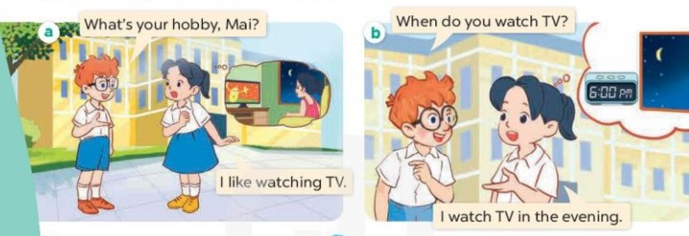  - Play the audio twice (sentence by sentence). Correct their pronunciation where necessary.  - Have Ss to practice the dialogue  - T invites a few pairs to the front of the class to practice.  - T checks pronunciation for ss.  Activity 3 Listen, point and say.  *Aims: Ss will be able to correctly say the phrases and use When do you watch TV? – I watch TV ……….to ask and answer questions about when someone watches TV.  *Procedure:  * Model sentences:  - T asks Ss look at picture b and helps Ss know the structure from the dialogue.  - T introduces new structure for Ss.  - T explains, models and gives meaning.  -Have Ss repeat the model sentences.  A: When do you watch TV?  B: I watch TV in the evening.  *Drill pictures  - Elicit the time of the day from pupils (looking at the clock and the sun in the pictures).  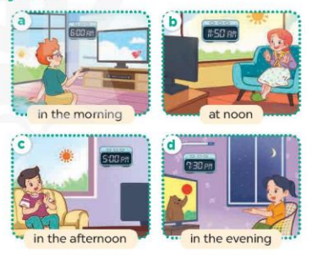  - Run through all the pictures.  - Run through model sentences.  - Have Ss to practise  - Ask Ss to work in pairs.  - T controls and corrects.  - Invite a few pairs to come to the front of the classroom, point at the relevant character in each picture, and act out his/her role.  - Encourage Ss to practise speaking English.  - T gives feedbacks.  Activity 4. Let’s talk.  *Aims: Ss will be able to enhance the correct use of When do you watch TV? – I watch TV ……..to ask and answer questions about when someone watches TV in a freer context.  *Procedure:  - Draw Ss’ attention to the clocks and the sun for the answers I watch TV in the morning / at noon / in the afternoon / in the evening.  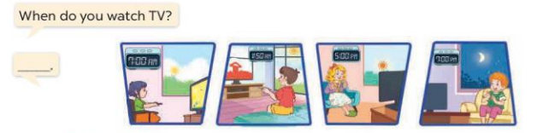  - Get pupils to repeat the questions and answers several times.  - Have Ss to work in pairs, point at the diﬀerent pictures in this section, ask and answer the question When do you watch TV?  - Invite some pairs to take turns asking and answering questions about when someone watches TV in front of the class.  *Consolidation  *Aims: Ss will be able consolidate and wrap up the content of the lesson.  *Procedure:  - T asks ss to answer the following questions:  + What have you learnt from the lesson today?  - T review the vocabulary and model sentences.  - T praises some Ss who are hardworking / active/ good…. as well as encourage others to try more  - Prepare the new lesson: Unit 14, Lesson 1 (4,5,6). | - Ss play the game  - Ss open their books  -Ss listen and answer  - - Ss listen and repeat  + Choral repetition (3 times).  + Individual repetition (3 ss)  - Ss take note  - Ss look, remember and write  -Look at the pictures and get to know the time of day in the pictures.  + Picture a:  Ben: What’s your hobby, Mai?  Mai: I like watch TV.  + Picture b:  Ben: When do you watch TV?  Mai: I watch TV in the evening.  -Ss listen and repeat in chorus (twice)  -Ss work in pairs to practice  -Ss practice the dialogue  -Ss listen  -Ss look at the picture and answer.  -Ss listen  -Ss listen and repeat  -Ss repeat  - Ss look, listen and answer  + Picture a. a boy watching TV in the morning  + Picture b. a girl watching TV at noon  + Picture c. a boy watching TV in the afternoon  + Picture d. a girl watching TV in the evening  -Ss practice in chorus  -Ss practice in chorus  -Ss work in pairs to practice  -Ss point and say, ask and answer  -Ss listen.  -Ss listen  -Ss look at the picture and answer  -Ss repeat the questions and answers  -Ss work in pairs, point and ask and answer  -Ss perform in front of the class.  -Ss answer the questions  - Ss listen  -Ss listen and clap their hands  -Ss listen and take note
D. ADJUSTMENTS (if necessary):
Good

Preparing date: February………, 2025
Teaching date: February , 2025
Week 23
Period: 92 Unit 14: Daily activities
Lesson 1 (4, 5, 6)
A. OBJECTIVES:
By the end of the lesson, Ss will be able to:
1. Knowledge:
- use the phrases in the morning, at noon, in the afternoon, in the evening in relation to the topic “Daily activities”.
- listen to and demonstrate understanding of simple communicative contexts in relation to the topic “Daily activities”.
- Vocabulary: Review
- Skills: speaking, listening, reading and writing.
2. Competences:
- Co-operation: ready to help friends in pair work/ group work.
- Self-control and independent learning: perform listening tasks.
3. Attitude/ Qualities:
- Kindness: Help partners to complete learning tasks.
- Honesty: tell the truth about feelings and emotions.
B. TEACHING AIDS:
- Teacher: Teacher’s guide Pages 199, 200; audio Tracks 33, 34; website hoclieu.vn, posters, laptop, pictures, textbook, lesson plan, TV or projector.
- Students: Pupil’s book Page 25, notebooks, workbooks, school things.
C. PROCEDURES:
Stages/Time | Teacher’s activities | Students’ activities
1.Warm- up:  (5’)  2.Practice: (27’)  3. Homework. (3’) | Game: “pass the ball”  *Aims: to create a friendly and active atmosphere in the class to beginning the lesson.  *Procedure:  - T gives Ss a ball.  - T asks Ss to listen to music and transfer a ball around the class.  - When the music stops, Ss who keep a ball have to answer the question using: When do you watch TV? and I watch TV…….  - Say “Open your book page 25” and look at “Unit 14, Lesson 1 (4,5,6)”.  Activity 1. Listen and tick or cross:  *Aims: Ss will be able to listen to and understand four communicative contexts in which pupils ask and answer questions about when someone does an activity, and tick or cross the pictures  *Procedure:  - Elicit and identify the activities and the time of the day by looking at the clocks and the sun or moon.  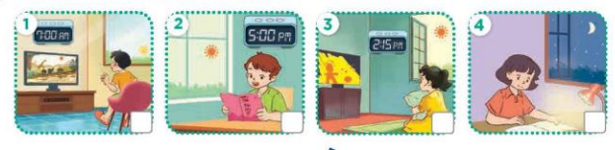  - T ask Ss to guess the answers.  + T writes Ss’guessing on the board.  - Listen to the tape:  + Play the recording  + Play the recording again and get Ss to swap books with their partners.  + Play the recording again to check answers together as a class.  + Write the answers on the board for Ss to correct their answers. Then checks Ss’ guessing.  - Play the recording, sentence by sentence, for the class to listen and repeat in chorus.  Key: 1.x 2.v 3.x 4.x  Activity 2. Look, complete and read.  *Aims: Ss will be able to complete four gapped exchanges about when someone does an activity with the help of picture cues  *Procedure:  - Ask Ss to look at the pictures and identify the activities and time of the day.  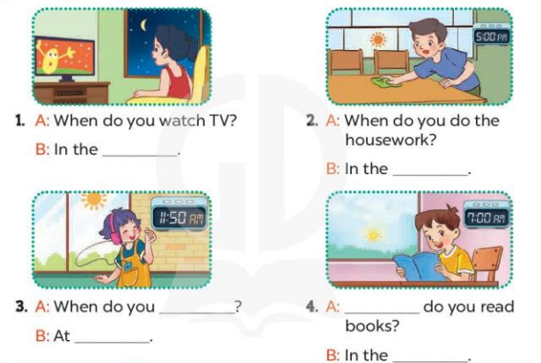  - Have Ss look at the four incomplete sentnces and elicits the missing words in the sentences.  - T models with sentence 1  + Ask Ss what is missing in the sentence.  + Have Ss look at the picture and complete the gap, then read the completed sentence in chorus.  -Have Ss work in groups and complete the sentences 2,3 and 4.  - Ask a few Ss to stand up and read the completed sentences aloud.  -T gives feedbacks.  Key:  1. evening 2. afternoon  3. listen to music; room  4. When; morning  Activity 3. Let’s sing  *Aims: Ss will be able to sing the song When do you watch TV and read books? with the correct pronunciation, rhythm and melody  *Procedure:  - Have pupils read the lyrics to familiarise themselves with the questions and answers.  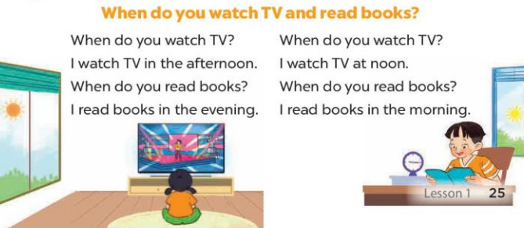  - Encourage them to identify two activities (watch TV; read books) and time of the day in the pictures.  - Have Ss listen to the whole song, drawing their attention to the pronunciation and tune.  - Play the recording of the song once or twice for pupils to listen and repeat, line after line, and do related actions.  - Ask Ss to sing the whole song while doing actions or clapping hands.  - Invite a few groups to the front of the class to sing the song.  *Consolidation  *Aims: Ss will be able consolidate and wrap up the content of the lesson.  *Procedure:  - T asks ss to answer the following questions:  + What have you learnt from the lesson today?  +What are the core values of the lesson? (if the teacher can take from the lesson).  - T praises some Ss who are hardworking / active/ good…. as well as encourage others to try more.  - Prepare the new lesson: Unit 14, Lesson 2 (1,2,3). | - Ss listen and pay attention  -Ss play the game.  - Ss open their books  -Look at the pictures and say:  + Picture 1. a boy watching TV in the morning  + Picture 2. a boy reading a book in the afternoon  + Picture 3. a girl watching TV in the afternoon  + Picture 4. a girl reading a book in the evening  -Ss guess the answers  - Ss listen to the tape and tick/ cross  - Ss listen again, tick/ cross and swap books with their partners.  - Ss check their answers and guessing  -Ss write the correct answer  -Ss listen and repeat.  -Ss look at the picture and answer  -Ss look and answer  -Ss answer: evening  -Ss look, complete and read the completed sentence in chorus.  -Ss complete the sentence  -Ss read the completed sentences aloud  - Ss look and listen.  - Ss pay attention and say  -Ss listen the whole song  -Ss listen and repeat, line by line  -Ss sing the whole song  -Ss sing the song in front of the class  -Ss answer the questions  -Ss listen and clap their hands  -Ss listen and take note

D. ADJUSTMENTS (if necessary):
Good…………………………….…..……………………………………………………………………………….……………………………………………………………………...

