Preparing date: February………, 2025
Teaching date: February…….., 2025
Week 22
Period 85 Unit 13: Appearance
Lesson 1 (1, 2, 3)
A. OBJECTIVES:
By the end of the lesson, Ss will be able to:
1. Knowledge:
- use the words and phrases big, short, slim, tall in relation to the topic "Appearance”
- use What does he / she look like? – He's / She's ……. to ask and answer questions about someone’s appearance;
- Vocabulary: short, slim, tall, look like
- Model sentences:
A: What does he/ she look like?
B: He’s/ She’s tall.
- Skills: speaking and listening
2. Competences:
- Co-operation: ready to help friends in pair work/ group work.
- Sociability: Talk to each other, say good words to others.
3. Attitude/ Qualities:
- Kindness: Help partners to complete learning tasks.
- Honesty: tell the truth about feelings and emotions
B. TEACHING AIDS:
- Teacher: Teacher’s guide Pages 183, 84, audio Tracks 21, 22, website hoclieu.vn, posters, laptop, pictures, textbook, lesson plan, TV or projector.
- Students: Pupil’s book Page 18, notebooks, workbooks, school things.
C. PROCEDURES:
Stages/Time | Teacher’s activities | Students’ activities
1.Warm- up:  (5’)  2. Presentation  (16’)  3.Practice: (7’)  4.Production: (5’)  5. Homework. (2’) | Game: jigsaw puzzle  *Aims: to create a friendly and active atmosphere in the class to beginning the lesson.  *Procedure:  - Divide class into 4 groups: Doreamon, Nobita, Xuka and Xeko.  - Ask Ss look at the pieces of picture.  - Ask Ss go to the board and jigsaw puzzle into the correct picture  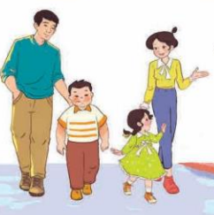  -T checks who’s the winner?  - Ask Ss look at the pieces of picture  - Say “Open your book page 18” and look at “Unit 13, Lesson 1 (1,2,3)”.  Activity 1. Vocabulary.  *Aims: Ss will be able to know the vocabulary in the new lesson.  *Procedure:  -T elicits the new words  + short : thấp, ngắn (picture)  + slim : mảnh mai (situation)  + tall : cao (picture)  + look like : trông như (translation)  - T models (3 times).  - T writes the words on the board.  - Checking: Rub out and remember  Activity 2. Look, listen and repeat:  *Aims: Ss will be able to understand and correctly repeat the sentences in two communicative contexts focusing on asking and answering questions about someone’s appearance.  *Procedure:  - Have Ss look at Pictures a and b and identify the characters in the pictures.  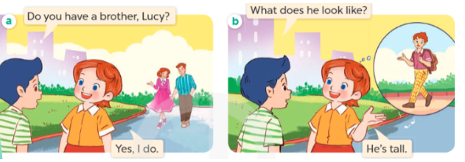  - Play the audio twice (sentence by sentence). Correct their pronunciation where necessary.  - Have Ss to practice the dialogue  - T invites a few pairs to the front of the class to practice.  - T checks pronunciation for ss.  Activity 3 Listen, point and say.  *Aims: Ss will be able to correctly say the words and use What does he / she look like? – He’s / She’s ….. to ask and answer questions about someone’s appearance *Procedure:  * Model sentences:  - T asks Ss look at picture b and helps Ss know the structure from the dialogue.  - T introduces new structure for Ss.  - T explains, models and gives meaning.  -Have Ss repeat the model sentences.  A: What does he/ she look like?  B: He’s/ She’s tall.  *Drill pictures  - Elicit and check comprehension the appearance  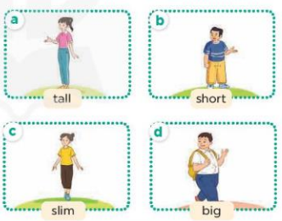  - Run through all the pictures.  - Run through model sentences.  + Run through the questions.  + Run through the answers  - Have Ss to practise:  + T says asks and Ss answer (change role).  + Ss – Ss (change role).  - Ask Ss to work in pairs.  - T controls and corrects.  - Invite a few pairs to come to the front of the classroom, point at the relevant character in each picture, and act out his/her role.  - Encourage Ss to practise speaking English.  - T gives feedbacks.  Activity 4. Let’s talk.  *Aims: Ss will be able to enhance the correct use of What does he / she look like? – He’s / She’s …….. to ask and answer questions about someone’s appearance in a freer context.  *Procedure:  - T asks ss to guess each  + What can you see in the picture?  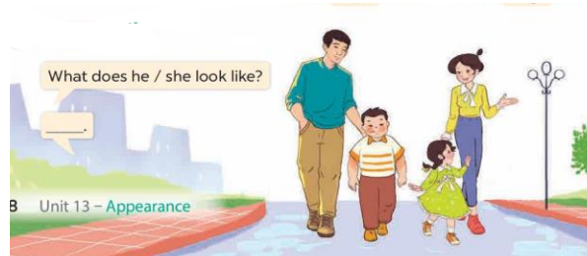  - T fills the gaps and writes the sentences on the board.  - T models  - T asks Ss to work in pairs to ask and answer  - Invite some pupils to the front of the class to present their exchanges.  - Give feedbacks  *Consolidation  *Aims: Ss will be able consolidate and wrap up the content of the lesson.  *Procedure:  - T asks ss to answer the following questions:  + What have you learnt from the lesson today?  - T review the vocabulary and model sentences.  - T praises some Ss who are hardworking / active/ good…. as well as encourage others to try more.  - Learn the number by heart  - Prepare the new lesson: Unit 13, Lesson 1 (4,5,6). | - Ss listen  - Ss play the game  - Ss open their books  -Ss listen and answer  - - Ss listen and repeat  + Choral repetition (3 times).  + Individual repetition (3 ss)  - Ss take note  - Ss look, remember and write  -Look at the pictures and get to know the characters in the pictures.  + Picture a  Nam: Do you have a brother, Lucy? Lucy: Yes, I do  + Picture b  Nam: What does he look like?  Lucy: He’s tall.  -Ss listen and repeat in chorus (twice)  -Ss work in pairs to practice  -Ss practice the dialogue  -Ss listen  -Ss look at the picture and answer.  -Ss listen  -Ss listen and repeat  -Ss repeat  - Ss look, listen and repeat  -Ss practice in chorus  -Ss practice in chorus  -Ss practice in chorus  -Ss work in pairs to practice  -Ss listen to the teacher  -Ss point and say  -Ss listen.  -Ss listen  -Ss look at the picture and answer  +I can see a family of four people with different appearances  -Ss note  - Ss say the completed sentences.  -Ss pay attention  -Ss work in pairs  -Ss perform in front of the class.  -Ss answer the questions  - Ss listen  -Ss listen and clap their hands  -Ss listen and take note

D. ADJUSTMENTS (if necessary):
………………………………………………………………………………………….…..……………………………………………………………………………...………………………………………….…..……………………………………………………………………………….……………………………………………………………………...

Preparing date: February………, 2025
Teaching date: February…….., 2025
Week 22
Period 86 Unit 13: Appearance
Lesson 1 (4, 5, 6)
A. OBJECTIVES:
By the end of the lesson, Ss will be able to:
1. Knowledge:
- use the words and phrases big, short, slim, tall in relation to the topic "Appearance"
- listen to and demonstrate understanding of simple communicative contexts in relation to the topic “Appearance
- Vocabulary: Review
- Skills: speaking, listening, reading and writing.
2. Competences:
- Co-operation: ready to help friends in pair work/ group work.
- Self-control and independent learning: perform listening tasks.
3. Attitude/ Qualities:
- Kindness: Help partners to complete learning tasks.
- Honesty: tell the truth about feelings and emotions.
- Diligence: complete learning tasks.
B. TEACHING AIDS:
- Teacher: Teacher’s guide Pages 186, 187; audio Tracks 23, 24; website hoclieu.vn, posters, laptop, pictures, textbook, lesson plan, TV or projector.
- Students: Pupil’s book Page 19, notebooks, workbooks, school things.
C. PROCEDURES:
Stages/Time | Teacher’s activities | Students’ activities
1.Warm- up:  (5’)  2.Practice: (27’)  3. Homework. (3’) | Game: “Passing the ball”  *Aims: to create a friendly and active atmosphere in the class to beginning the lesson.  *Procedure:  - Divide class into 3 teams.  - Each team has 1 sticky ball.  - Play the music, ss in each team take turn to pass the ball.  - After the music ends, 3 ss have the ball – stand up and say the name, using the sentence model.  - Say “Open your book page 19” and look at “Unit 13, Lesson 1 (4,5,6)”.  Activity 1. Listen and tick:  *Aims: Ss will be able to listen to and understand two communicative contexts in which characters ask and answer questions about a family member’s appearance, and tick the correct pictures.  *Procedure:  - Elicit the name of the room in each picture 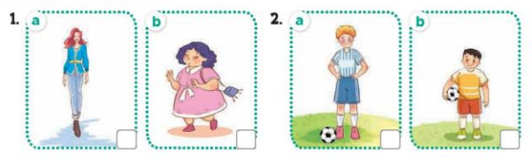  - T ask Ss to guess the answers.  + T writes Ss’guessing on the board.  - Listen to the tape:  + Play the recording  + Play the recording again and get Ss to swap books with their partners.  + Play the recording again to check answers together as a class.  + Write the answers on the board for Ss to correct their answers. Then checks Ss’ guessing.  - Play the recording, sentence by sentence, for the class to listen and repeat in chorus.  Key: 1.a 2.b  Activity 2. Look, complete and read.  *Aims: Ss will be able to complete the target sentence patterns in four exchanges about appearance with the help of picture cues.  *Procedure:  - Have Ss look at the pictures and identify the appearance of the people (tall, short, big, slim).  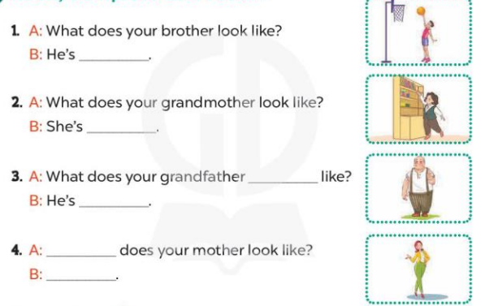  - Have Ss look at the four incomplete exchanges and elicits the missing words in the sentences.  - T models with sentence 1  + Ask Ss what is missing in the sentence.  + Have Ss look at the picture and complete the gap, then read the completed sentence in chorus.  -Have Ss work in groups and complete the sentences 2,3 and 4.  - Ask a few Ss to stand up and read the completed sentences aloud.  -T gives feedbacks.  Key:  - tall 2. short 3. look; big  4. What; She’s slim.  Activity 3. Let’s sing.  *Aims: Ss will be able to sing the song What do your parents look like? with the correct melody and pronunciation.  *Procedure:  - Introduce the title and lyrics of the song: “ What do your parents look like? ” song.  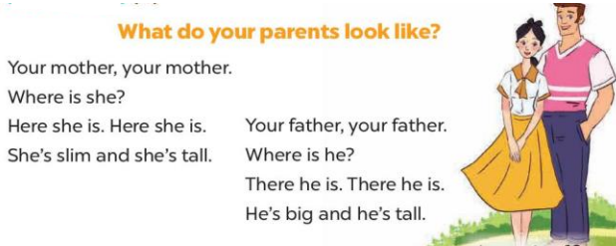  - Play the recording for Ss to listen to the whole song.  + Have them repeat the title and lyrics line by line.  + Tell Ss to point at the relevant character while singing his or her name.  - Play the recording all the way through for Ss to listen to pronunciation and melody of the song.  - Play the recording line by line for Ss to listen, repeat and point at the relevant character.  - Play the recording for Ss to sing and do actions.  - Ask Ss to practice singing and doing actions in pairs or groups.  - Invite groups to the front of the classroom to perform the song  -T gives feedback.  *Consolidation  *Aims: Ss will be able consolidate and wrap up the content of the lesson.  *Procedure:  - T asks ss to answer the following questions:  + What have you learnt from the lesson today?  +What are the core values of the lesson? (if the teacher can take from the lesson).  - T praises some Ss who are hardworking / active/ good…. as well as encourage others to try more.  - Learn the number by heart  - Prepare the new lesson: Unit 13, Lesson 2 (1,2,3). | - Ss listen and keep the puppet  - Ss listen to music and play the game  -Ss listen  - Ss open their books  -Look at the pictures and say:  + Picture 1a: a slim woman  + Picture 1b: a short woman  + Picture 2a: a tall boy playing football  + Picture 2b: a short boy playing football  -Ss guess the answers  - Ss listen to the tape and tick  - Ss listen again, tick and swap books with their partners.  - Ss check their answers and guessing  -Ss write the correct answer  -Ss listen and repeat.  -Ss look at the picture and say  -Ss look and answer  -Ss answer: tall  -Ss look, complete and read the completed sentence in chorus.  -Sswork in groups and complete the sentence  -Ss read aloud  - Ss look and listen.  -Ss listen to the song  - Ss listen and repeat line by line without the action.  -Ss point to the character while singing  -Ss listen to melody of the song  - Ss listen and sing line by line.  - Ss sing and do actions.  + Ss work in groups (two groups) to sing.  -Ss perform in front of the class.  -Ss listen  -Ss answer the questions  -Ss listen and clap their hands  -Ss listen and take note

D. ADJUSTMENTS (if necessary):
………………………………………………………………………………………….…..……………………………………………………………………………...……………
Preparing date: February………, 2025
Teaching date: February…….., 2025
Week 22
Period 87 Unit 13: Appearance
Lesson 2 (1, 2, 3)
A. OBJECTIVES:
By the end of the lesson, Ss will be able to:
1. Knowledge:
- use the words and phrases a round face, big eyes, long hair, and short hair in relation to the topic "Appearance"
- use What does he / she look like? –He / She has …… to ask and answer questions about someone’s appearances
- Vocabulary: long, round
- Model sentences:
A: What does he / she look like?
B: He/ She has a round face.
- Skills: speaking and listening
2. Competences:
- Co-operation: ready to help friends in pair work/ group work.
- Oral Communication: speak about someone, ask and answer the questions
3. Attitude/ Qualities:
- Kindness: Help partners to complete learning tasks.
- Honesty: tell the truth about feelings and emotions
B. TEACHING AIDS:
- Teacher: Teacher’s guide Pages 188, 189; audio Tracks 25, 26, website hoclieu.vn, posters, laptop, pictures, textbook, lesson plan, TV or projector.
- Students: Pupil’s book Page 20, notebooks, workbooks, school things.
C. PROCEDURES:
Stages/Time | Teacher’s activities | Students’ activities
1.Warm- up:  (3’)  2. Presentation  (16’)  3.Practice: (7’)  4.Production: (7’)  5. Homework. (2’) | Game: Teacher says  *Aims: to create a friendly and active atmosphere in the class to beginning the lesson.  *Procedure:  - Teachers quickly review body parts, focusing on Face features.  -Teacher plays "Teacher says": Touch your ears/nose/face/eyes/hair .... to review face features.  - Say “Open your book page 20” and look at “Unit 13, Lesson 2 (1,2,3)”.  Activity 1. Vocabulary.  *Aims: Ss will be able to know the vocabulary in the new lesson.  *Procedure:  -T elicits the new words  + round : tròn (realia)  + long : dài (realia)  - T models (3 times).  - T writes the words on the board.  - Checking: Rub out and remember  Activity 2. Look, listen and repeat:  *Aims: Ss will be able to understand and correctly repeat the sentences in two communicative contexts focusing on asking and answering questions about someone’s appearance, using the verb to have  *Procedure:  - Have Ss look at Pictures a and b and identify the characters in the pictures.  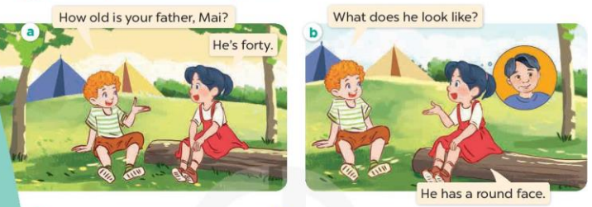  - Play the audio twice (sentence by sentence). Correct their pronunciation where necessary.  - Have Ss to practice the diaguage  - T invites a few pairs to the front of the class to practice.  - T checks pronunciation for ss.  Activity 3. Listen, point and say.  *Aims: Ss will be able to correctly say the phrases and use What does he / she look like? – He / She has …... to ask and answer questions about someone’s appearance.  *Procedure:  * Model sentences:  - T asks Ss look at picture b and helps Ss know the structure from the dialogue.  - T introduces new structure for Ss.  - T explains, models and gives meaning.  - Have Ss repeat the model sentences.  A: What does he / she look like?  B: He/ She has a round face.  *Drill pictures  - Elicit and check comprehension the name of each character.  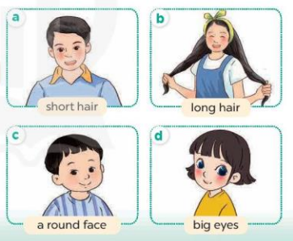  - Run through all the pictures.  - Run through model sentences.  +Run through the question sentences  +Run through the answer sentences  - Have Ss to practise:  + T asks, Ss answer picture a  + Ss ask, T answers picture b  + Group A ask, group B answer picture c  + Group B ask, group A answer picture d  - Ask Ss to work in pairs.  - T controls and corrects.  - Invite a few pairs to come to the front of the classroom, point at the relevant character in each picture, and act out his/her role.  - T gives feedbacks.  Activity 4. Let’s talk.  *Aims: Ss will be able to enhance the correct use of What does he / she look like? – He / She has ………. to ask and answer questions about someone’s appearance in a freer context.  *Procedure:  - T asks ss to attend to the picture.  + What can you see in the picture?  +Where are they?  + What do they look like?  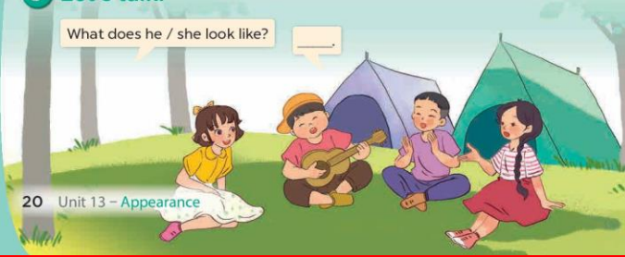  - T fills the gaps and writes the sentences on the board.  - T models  - T asks Ss use of What does he/ she look like? and He has/ She has……. to ask and answer (pairs work)  - Invite some groups to perform.  - Give feedbacks  *Consolidation  *Aims: Ss will be able consolidate and wrap up the content of the lesson.  *Procedure:  - T asks ss to answer the following questions:  + What have you learnt from the lesson today?  - T review the vocabulary and model sentences.  - Learn the vocabulary by heart  - Prepare the new lesson: Unit 13, Lesson 2 (4,5,6). | - Ss listen  - Ss play the game  - Ss open their books  -Ss listen and answer  - - Ss listen and repeat  + Choral repetition (3 times).  + Individual repetition (3 ss)  - Ss take note  - Ss look, remember and write  -Look at the pictures and get to know the characters in the pictures.  + In picture a:  Bill: How old is your brother, Mai? Mai: He’s four  – In picture b:  Bill: What does he look like?  Mai: He has a round face.  -Ss listen and repeat in chorus (twice)  -Ss work in pairs to practice  -Ss practice the diaguage  -Ss listen  -Ss look at the picture and answer.  -Ss listen  -Ss listen and repeat  -Ss repeat  - Ss look, listen and answer  + Picture a: a boy with short hair + Picture b: a girl with long hair  + Picture c: a boy with a round face  + Picture d: a girl with big eyes  -Ss practice in chorus  - Ss practice in chorus  -Ss practice in chorus  -Ss work in pairs to practice  -Ss listen  -Ss go to the board and role play.  -Ss listen  -Ss look at the picture and answer  + a group of four pupils with different appearance  -Ss note  - Ss say the completed sentences.  -Ss work in pairs and ask and answer  -Ss perform in front of the class.  -Ss answer the questions  - Ss listen  -Ss listen and take note
D. ADJUSTMENTS (if necessary):
………………………………………………………………………………………….…..……………………………………………………………………………...……………
Preparing date: February………, 2025
Teaching date: February…….., 2025
Week 22
Period 88 Unit 13: Appearance
Lesson 2 (4, 5, 6)
A. OBJECTIVES:
By the end of the lesson, Ss will be able to:
1. Knowledge:
- use the words and phrases big, short, slim, tall, a round face, big eyes, long hair, and short hair in relation to the topic "Appearance".
- listen to and demonstrate understanding of simple communicative contexts in relation to the topic “Appearance”
- Vocabulary: Review
- Skills: speaking, listening, reading and writing.
2. Competences:
- Co-operation: ready to help friends in pair work/ group work.
- Self-control and independent learning: perform listening tasks.
3. Attitude/ Qualities:
- Kindness: Help partners to complete learning tasks.
- Diligence: complete learning tasks.
B. TEACHING AIDS:
- Teacher: Teacher’s guide Pages 190, 191; audio Tracks 27; website hoclieu.vn, posters, laptop, pictures, textbook, lesson plan, TV or projector.
- Students: Pupil’s book Page 21, notebooks, workbooks, school things.
C. PROCEDURES:
Stages/Time | Teacher’s activities | Students’ activities
1.Warm- up:  (5’)  2.Practice: (27’)  3. Homework. (3’) | Game: play the Angry Bird game (PPT)  *Aims: to create a friendly and active atmosphere in the class to beginning the lesson.  *Procedure:  - Divide the class into 2 teams.  - Pupils from each team choose a number, then answer the question in that number.  - If the Ss answer correctly, the teacher clicks on the brick of that number to find out the scores.  - Say “Open your book page 21” and look at “Unit 13, Lesson 2 (4,5,6)”.  Activity 1. Listen and number:  *Aims: Ss will be able to listen to and understand four communicative contexts in which characters ask and answer questions about someone’s appearance, and number the correct pictures.  *Procedure:  - Elicit the questions to ask for the appearance of the character in each picture.  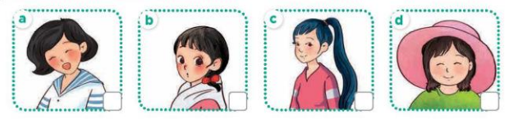  - T ask Ss to guess the answers.  + T writes Ss’guessing on the board.  - Listen to the tape:  + Play the recording  + Play the recording again and get Ss to swap books with their partners.  + Play the recording again to check answers together as a class.  + Write the answers on the board for Ss to correct their answers. Then checks Ss’ guessing.  - Play the recording, sentence by sentence, for the class to listen and repeat in chorus.  Key: 1.d 2. a 3. c 4. b  Activity 2. Look, complete and read.  *Aims: Ss will be able to complete the target sentence patterns in two exchanges about appearance with the help of picture cues  *Procedure:  - Have Ss look at the pictures and identify the appearance of the characters in the pictures 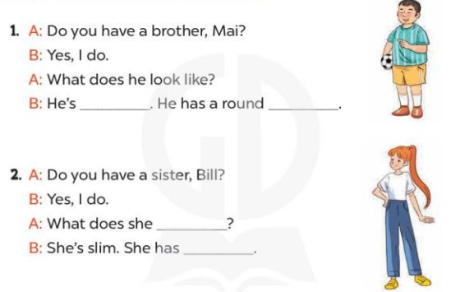  - T models with sentence 1.  + Have Ss look at the sentence.  + Ask them what is missing in the answer (big).  + Have Ss write the first word  + Have Ss read the completed sentence in chorus.  -Have Ss work in pairs and complete the sentences 2.  - Invite pairs of pupils to stand up and read aloud the sentences.  -T gives feedbacks.  Key: 1. big / short, face 2. look like, long hair  Activity 3. Let’s play.  *Aims: Ss will be able to review vocabulary about family members and appearance by playing the game Tic-tac-toe.  *Procedure:  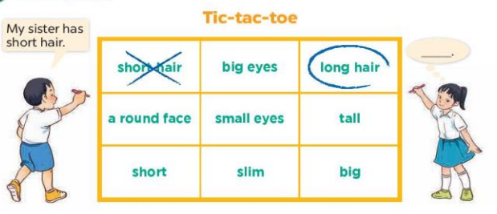  - Tell pupils that they are going to play the game Tic-tac-toe.  +Two pupils play at a time. One pupil is X, and the other is O.  +The pupils take turns choosing a square by saying a word and putting their mark in the corresponding square.  +The first pupil to write three marks in a vertical, horizontal or diagonal line is the winner.  - Invite two pupils to play at a time.  - Change the words in the grid and let pupils play the game several times if there is enough time.  *Consolidation  *Aims: Ss will be able consolidate and wrap up the content of the lesson.  *Procedure:  - T asks ss to answer the following questions:  + What have you learnt from the lesson today?  +What are the core values of the lesson? (if the teacher can take from the lesson).  - T praises some Ss who are hardworking / active/ good…. as well as encourage others to try more.  - Prepare the new lesson: Unit 13, Lesson 3 (1,2,3). | - Ss listen and play the game  - Ss open their books  -Look at the pictures and say:  + Picture a: a girl with short hair + Picture b: a girl with big eyes  + Picture c: a girl with long hair + Picture d: a girl with a round face  -Ss guess the answers  - Ss listen to the tape and write number  - Ss listen again, write number and swap books with their partners.  - Ss check their answers and guessing  -Ss write the correct answer  -Ss listen and repeat.  -Ss look at the pictures and say  -Ss listen and answer  -Ss read and complete  -Ss write  -Ss read the completed sentence  -Ss work in pairs and complete  -Ss read aloud  - Ss listen the rule of the game  - Ss listen the rule of the game  - Ss listen the rule of the game  -Ss play the game  - Ss play the game  -Ss listen and answer  -Ss listen and take note

D. ADJUSTMENTS (if necessary):
………………………………………………………………………………………….…..……………………………………………………………………………...………………………………………….…..……………………………………………………………………………….……………………………………………………………………...

