Preparing date: January ….., 2025
Teaching date: January …….., 2025
Week 19
Period 73 Unit 11: My home
Lesson 1 (1, 2, 3)
A. OBJECTIVES:
By the end of the lesson, Ss will be able to:
1. Knowledge:
- use the words at, in, live, road, street, in relation to the topic “My home”.
- use Where do you live? – I live ……..to ask and answer questions about where someone lives.
- Vocabulary: live, road, street.
- Model sentences:
A: Where do you live?
B: I live in Tran Hung Dao Street.
- Skills: speaking and listening
2. Competences:
- Co-operation: ready to help friends in pair work/ group work.
- Sociability: Talk to each other, say good words to others.
3. Attitude/ Qualities:
- Kindness: Help partners to complete learning tasks.
- Honesty: tell the truth about feelings and emotions
B. TEACHING AIDS:
- Teacher: Teacher’s guide Pages 158, 159, audio Tracks 1,2 , website hoclieu.vn, posters, laptop, pictures, textbook, lesson plan, TV or projector.
- Students: Pupil’s book Page 6, notebooks, workbooks, school things.
C. PROCEDURES:
Stages/Time | Teacher’s activities | Students’ activities
1.Warm- up:  (5’)  2. Presentation  (16’)  3.Practice: (7’)  4.Production: (5’)  5. Homework. (2’) | Game: jigsaw puzzle  *Aims: to create a friendly and active atmosphere in the class to beginning the lesson.  *Procedure:  - Divide class into 4 groups: Doreamon, Nobita, Xuka and Xeko.  - Ask Ss look at the pieces of picture.  - Ask Ss go to the board and jigsaw puzzle into the correct picture  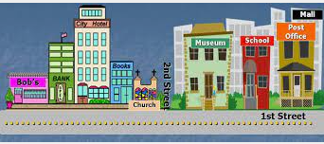  - T checks who’s the winner?  - Ask Ss look at the pieces of picture  - Say “Open your book page 6” and look at “Unit 11, Lesson 1 (1,2,3)”.  Activity 1. Vocabulary.  *Aims: Ss will be able to know the vocabulary in the new lesson.  *Procedure:  -T elicits the new words  + live : sống (situation)  + road : con đường (translation)  + street : đường phố (picture)  - T models (3 times).  - T writes the words on the board.  - Checking: Rub out and remember  Activity 2. Look, listen and repeat:  *Aims: Ss will be able to understand and correctly repeat the sentences in two communicative contexts (pictures) in which characters ask and answer the question about where Mary lives.  *Procedure:  - Have Ss look at Pictures a and b and identify the characters in the pictures and say what they can see in the pictures  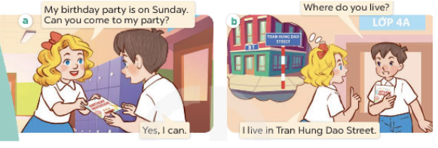  - Play the audio twice (sentence by sentence). Correct their pronunciation where necessary.  - Have Ss to practice the dialogue  - T invites a few pairs to the front of the class to practice.  - T checks pronunciation for ss.  Activity 3 Listen, point and say.  *Aims: Ss will be able to correctly say the phrases and use Where do you live? – I live ……….. to ask and answer questions about where someone lives  *Procedure:  * Model sentences:  - T asks Ss look at picture a, b and helps Ss know the structure from the dialogue.  - T introduces new structure for Ss.  - T explains, models and gives meaning.  -Have Ss repeat the model sentences.  A: Where do you live?  B: I live in Tran Hung Dao Street.  *Drill pictures  - Elicit and check comprehension and tell what the words and numbers on the plaques are about  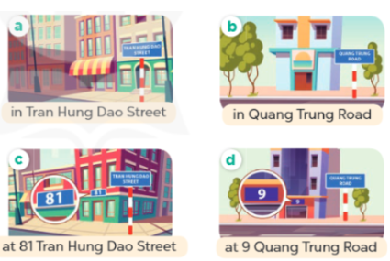  - Run through all the pictures.  - Run through model sentences.  + Run through the questions.  + Run through the answers  - Have Ss to practise:  + T says asks and Ss answer (change role).  + Ss – Ss (change role).  - Ask Ss to work in pairs.  - T controls and corrects.  - Invite a few pairs to come to the front of the classroom, point at the relevant character in each picture, and act out his/her role.  - Encourage Ss to practise speaking English.  - T gives feedbacks.  Activity 4. Let’s talk.  *Aims: Ss will be able to enhance the correct use of Where do you live? – I live …. to ask and answer questions about where someone lives in a freer context.  *Procedure:  - Ask questions to help them identify the names of the streets and roads, the house numbers and the houses without specific numbers.  + What can you see in the picture?  +Where are they?  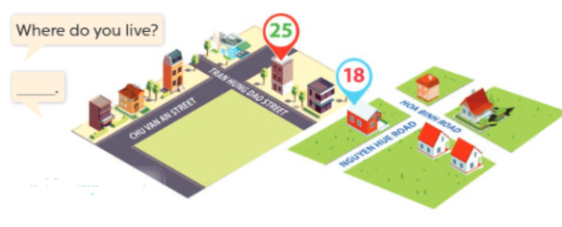  - T fills the gaps and writes the sentences on the board.  - T models  - T asks Ss to work in pairs to ask and answer  - Invite some pupils to the front of the class to present their exchanges.  - Give feedbacks  *Consolidation  *Aims: Ss will be able consolidate and wrap up the content of the lesson.  *Procedure:  - T asks ss to answer the following questions:  + What have you learnt from the lesson today?  - T review the vocabulary and model sentences.  - T praises some Ss who are hardworking / active/ good…. as well as encourage others to try more.  - Learn the vocabulary by heart  - Prepare the new lesson: Unit 11, Lesson 1 (4,5,6). | - Ss listen  - Ss play the game  - Ss open their books  -Ss listen and answer  - - Ss listen and repeat  + Choral repetition (3 times).  + Individual repetition (3 ss)  - Ss take note  - Ss look, remember and write  -Look at the pictures and get to know the characters in the pictures.  + Picture a.  Mary: My birthday party is on Sunday. Can you come to my party?  Minh: Yes, I can  + Picture b.  Minh: Where do you live?  Mary: I live in Tran Hung Dao Street  -Ss listen and repeat in chorus (twice)  -Ss work in pairs to practice  -Ss practice the dialogue  -Ss listen  -Ss look at the picture and answer.  -Ss listen  -Ss listen and repeat  -Ss repeat  - Ss look, listen and repeat  + Picture a: A house (without a house number) in Tran Hung Dao Street  + Picture b: A house (without a house number) in Quang Trung Road  + Picture c: A house at 81 Tran Hung Dao Street  + Picture d: A house at 9 Quang Trung Road  -Ss practice in chorus  -Ss practice in chorus  -Ss practice in chorus and individual  -Ss work in pairs to practice  -Ss listen  -Ss point and say  -Ss listen.  -Ss listen  -Ss look at the picture and answer  + some houses on two maps  -Ss note  - Ss say the completed sentences.  -Ss work in pairs  -Ss perform in front of the class.  -Ss answer the questions  - Ss listen  -Ss listen and clap their hands  -Ss listen and take note

D. ADJUSTMENTS (if necessary):
………………………………………………………………………………………….…..……………………………………………………………………………...………………………………………….…..…………………………………………………………

Preparing date: January …….., 2025
Teaching date: January …….., 2025
Week 19
Period 74 Unit 11: My home
Lesson 1 (4, 5, 6)
A. OBJECTIVES:
By the end of the lesson, Ss will be able to:
1. Knowledge:
- Identity specific information by listening to conversation related to topic my home.
- Fill in the gaps using given picture cues.
- Recall some vocabulary related to the topic “my home” by playing the whispering game.
- Vocabulary: Review
- Skills: speaking, listening, reading and writing.
2. Competences:
- Co-operation: ready to help friends in pair work/ group work.
- Self-control and independent learning: perform listening tasks.
3. Attitude/ Qualities:
- Kindness: Help partners to complete learning tasks.
- Honesty: tell the truth about feelings and emotions.
- Diligence: complete learning tasks.
B. TEACHING AIDS:
- Teacher: Teacher’s guide Pages 160, 161, 162; audio Tracks 3; website hoclieu.vn, posters, laptop, pictures, textbook, lesson plan, TV or projector.
- Students: Pupil’s book Page 7, notebooks, workbooks, school things.
C. PROCEDURES:
Stages/Time | Teacher’s activities | Students’ activities
1.Warm- up:  (5’)  2.Practice: (27’)  3. Homework. (3’) | Game: “Passing the picture”  *Aims: to create a friendly and active atmosphere in the class to beginning the lesson.  *Procedure:  - T gives Ss a picture about some places  - T asks Ss to listen to music and transfer a puppet around the class.  - When the music stops, Ss who keep a picture have to practice with partner using: I live………..  - T gives feedback.  - Say “Open your book page 7” and look at “Unit 11, Lesson 1 (4,5,6)”.  Activity 1. Listen and tick or cross:  *Aims: Ss will be able to listen to and understand four communicative contexts in which the characters talk about where they live and tick or cross the correct pictures.  *Procedure:  - Elicit the names of the streets or roads, and the house numbers 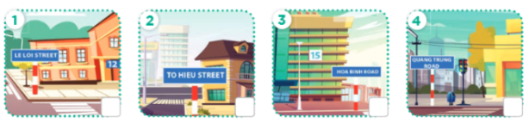  - T ask Ss to guess the answers.  + T writes pupils’guessing on the board.  - Listen to the tape:  + Play the recording  + Play the recording again and get pupils to swap books with their partners.  + Play the recording again to check answers together as a class.  + Write the answers on the board for Ss to correct their answers. Then checks Ss’ guessing.  - Play the recording, sentence by sentence, for the class to listen and repeat in chorus.  Key: 1.v 2.x 3.x 4.v  Activity 2. Look, complete and read.  *Aims: Ss will be able to complete four gapped exchanges with the help of picture cues.  *Procedure:  - Have Ss read the exchange and guess the missing word in the answer.  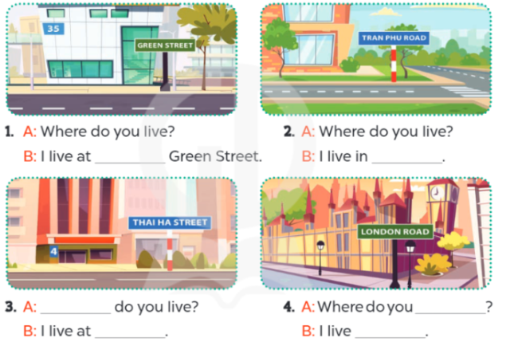  - Have Ss look at the four incomplete sentences and elicits the missing words in the sentences.  - T models with sentence 1  + Ask Ss what is missing in the sentence.  + Have Ss look at the picture and complete the gap, then read the completed sentence in chorus.  -Have Ss work in groups and complete the sentences 2,3 and 4.  - Ask a few Ss to stand up and read the completed sentences aloud.  -T gives feedbacks.  Key:  1. 35  2. Tran Phu Road  3. Where; 4 Thai Ha Street.  4. live; in London Road  Activity 3. Let’s play.  *Aims: Ss will be able to practise the target vocabulary and sentence patterns by playing the game Whispering.  *Procedure:  - Invite two or three teams of four pupils to the front. Each team makes a line.  - Show a sentence to the last pupil of each team.  + Ask them to whisper the sentence to the next pupil.  + The pupil continues whispering until the one at the front of the line gets the sentence.  + The pupil at the front of the line shouts out the sentence or writes the sentence on the board.  + If it is correct, the team gets one star.  - Play the game with other teams in the class.  *Consolidation  *Aims: Ss will be able consolidate and wrap up the content of the lesson.  *Procedure:  - T asks ss to answer the following questions:  + What have you learnt from the lesson today?  +What are the core values of the lesson? (if the teacher can take from the lesson).  - T praises some Ss who are hardworking / active/ good…. as well as encourage others to try more.  - Learn the vocabulary by heart  - Prepare the new lesson: Unit 11, Lesson 2 (1,2,3). | - Ss listen and keep the picture  - Ss listen to music and play the game  -Ss listen  - Ss open their books  -Look at the pictures and say:  + Picture 1. A house at 12 Le Loi Street + Picture 2. A house in To Hieu Street  + Picture 3. A house at 15 Hoa Binh Road  + Picture 4. A house in Quang Trung Road  -Ss guess the answers  - Ss listen to the tape and tick/ cross  - Ss listen again, tick/ cross and swap books with their partners.  - Ss check their answers and guessing  -Ss write the answer  -Ss listen and repeat.  -Ss look at the picture and say  -Ss look and answer  -Ss answer: thirty-five  -Ss say the missing word  -Ss look, complete and read the completed sentence in chorus.  -Ss complete the sentences  -Ss read aloud  -Ss listen  -Ss listen  -Ss play the game  -Ss play the game  -Ss answer the questions  -Ss listen and clap their hands  -Ss listen and take note
D. ADJUSTMENTS (if necessary):
………………………………………………………………………………………….…..……………………………………………………………………………...………………………………………….…..…………………………………………………………

Preparing date: January ……, 2025
Teaching date: January …….., 2025
Week 19
Period 75 Unit 11: My home
Lesson 2 (1, 2, 3)
A. OBJECTIVES:
By the end of the lesson, Ss will be able to:
1. Knowledge:
- Identify the situation between Nam and Bill.
- use the phrases a big city, a noisy road, a busy street, a quiet village in relation to the topic “My home”
- use What’s the ……….like? – It’s …….. to ask and answer questions about what a place is like
- Vocabulary: busy, noisy, quiet
- Model sentences:
A: What’s the street like?
B: It’s a busy street.
- Skills: speaking and listening
2. Competences:
- Co-operation: ready to help friends in pair work/ group work.
- Oral Communication: speak about someone, ask and answer the questions
3. Attitude/ Qualities:
- Kindness: Help partners to complete learning tasks.
- Honesty: tell the truth about feelings and emotions
B. TEACHING AIDS:
- Teacher: Teacher’s guide Pages 162,163,164; audio Tracks 4, 5, website hoclieu.vn, posters, laptop, pictures, textbook, lesson plan, TV or projector.
- Students: Pupil’s book Page 8, notebooks, workbooks, school things.
C. PROCEDURES:
Stages/Time | Teacher’s activities | Students’ activities
1.Warm- up:  (3’)  2. Presentation  (16’)  3.Practice: (7’)  4.Production: (7’)  5. Homework. (2’) | Game: Pass the ball  *Aims: to create a friendly and active atmosphere in the class to beginning the lesson.  *Procedure:  - T gives Ss a ball.  - T asks Ss to listen to music and transfer a ball around the class.  - When the music stops, Ss who keep a ball have to practice with partner using: Where do you live? and I live……..  - T gives feedback.  - Say “Open your book page 8” and look at “Unit 11, Lesson 2 (1,2,3)”.  Activity 1. Vocabulary.  *Aims: Ss will be able to know the vocabulary in the new lesson.  *Procedure:  -T elicits the new words  + busy : nhộn nhịp (situation)  + quiet : yên tĩnh (situation)  + noisy : ồn ào (situation)  - T models (3 times).  - T writes the words on the board.  - Checking: Rub out and remember  Activity 2. Look, listen and repeat:  *Aims: Ss will be able to understand and correctly repeat the sentences in two communicative contexts (pictures) in which characters ask and answer the question about what a place is like.  *Procedure:  - Have Ss look at Pictures a and b and identify the characters and predict  what they are talking about in the pictures.  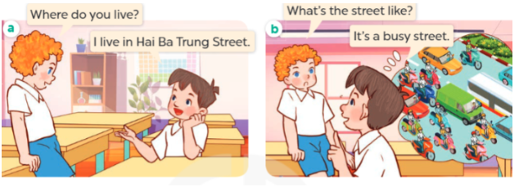  - Play the audio twice (sentence by sentence). Correct their pronunciation where necessary.  - Have Ss to practice the diaguage  - T invites a few pairs to the front of the class to practice.  - T checks pronunciation for ss.  Activity 3. Listen, point and say.  *Aims: Ss will be able to correctly say the phrases and use What’s the …. like? – It’s …… to ask and answer questions about what a place is like.  *Procedure:  * Model sentences:  - T asks Ss look at picture b and helps Ss know the structure from the dialogue.  - T introduces new structure for Ss.  - T explains, models and gives meaning.  - Have Ss repeat the model sentences.  A: What’s the street like?  B: It’s a busy street.  *Drill pictures  - Elicit and identify the places in the pictures.  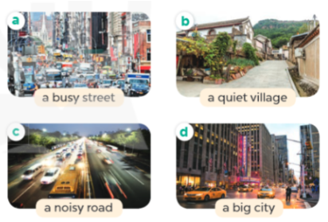  - Run through all the pictures.  - Run through model sentences.  +Run through the question sentences  +Run through the answer sentences  - Have Ss to practise:  + T asks, Ss answer picture a  + Ss ask, T answers picture b  + Group A ask, group B answer picture c  + Group B ask, group A answer picture d  - Ask Ss to work in pairs.  - T controls and corrects.  - Invite a few pairs to come to the front of the classroom, point at the relevant character in each picture, and act out his/her role.  - T gives feedbacks.  Activity 4. Let’s talk.  *Aims: Ss will be able to enhance the correct use of What’s the …. like? – It’s ….. to ask and answer  questions about what a place is like in a freer context.  *Procedure:  - Ask Ss to look at the pictures and elicit the phrase to describe the place in each picture.  + What can you see in the picture?  +How many places are there?  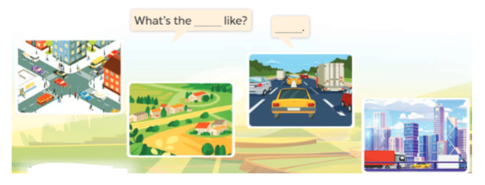  - T fills the gaps and writes the sentences on the board.  - T models  - T asks Ss use of What’s the …….like? and It’s ……. to ask and answer (groups of four)  - Invite some groups to perform.  - Give feedbacks  *Consolidation  *Aims: Ss will be able consolidate and wrap up the content of the lesson.  *Procedure:  - T asks ss to answer the following questions:  + What have you learnt from the lesson today?  +What are the core values of the lesson? (if the teacher can take from the lesson).  - T review the vocabulary and model sentences.  - T praises some Ss who are hardworking / active/ good…. as well as encourage others to try more.  - Learn the number by heart  - Prepare the new lesson: Unit 11, Lesson 2 (4,5,6). | - Ss listen and keep the ball  - Ss listen to music and play the game  - Ss open their books  -Ss listen and answer  - - Ss listen and repeat  + Choral repetition (3 times).  + Individual repetition (3 ss)  - Ss take note  - Ss look, remember and write  -Look at the pictures and get to know the characters in the pictures.  + In picture a:  Bill: Where do you live?  Minh: I live in Hai Ba Trung Street  – In picture b:  Bill: What’s the street like?  Minh: It’s a busy street.  -Ss listen and repeat in chorus (twice)  -Ss work in pairs to practice  -Ss practice the diaguage  -Ss practice in front of the class  -Ss listen  -Ss look at the picture and answer.  -Ss listen  -Ss listen and repeat  -Ss repeat  - Ss look, listen and answer  + Picture a: a busy street  + Picture b: a quiet village  + Picture c: a noisy road  + Picture d: a big city  -Ss practice in chorus  -Ss practice in chorus  - Ss practice in chorus and individual  -Ss work in pairs to practice  -Ss listen  -Ss go to the board and role play.  -Ss listen  -Ss look at the picture and answer  + a busy street, a quiet village, a noisy road, a big city  -Ss note  - Ss say the completed sentences.  -Ss work in groups  -Ss perform in front of the class.  -Ss answer the questions  - Ss listen  -Ss listen and clap their hands  -Ss listen and take note

D. ADJUSTMENTS (if necessary):
………………………………………………………………………………………….…..……………………………………………………………………………...………………………………………….…..……………………………………………………………………………….……………………………………………………………………...

Preparing date: January …., 2025
Teaching date: January ……., 2025
Week 19
Period 76 Unit 11: My home
Lesson 2 (4, 5, 6)
A. OBJECTIVES:
By the end of the lesson, Ss will be able to:
1. Knowledge:
- Identify the specific information by listening 2 conversations about my school to tick the correct pictures.
- Using clue pictures to complete the gaps.
- Perform the song “my house” in interesting ways, using appropriate and meaningful gestures.
- Vocabulary: Review
- Skills: speaking, listening, reading and writing.
2. Competences:
- Co-operation: ready to help friends in pair work/ group work.
- Self-control and independent learning: perform listening tasks.
3. Attitude/ Qualities:
- Show their pride about their places/ address.
- Honesty: tell the truth about feelings and emotions.
- Diligence: complete learning tasks.
B. TEACHING AIDS:
- Teacher: Teacher’s guide Pages 164, 165; audio Tracks 6, 7; website hoclieu.vn, posters, laptop, pictures, textbook, lesson plan, TV or projector.
- Students: Pupil’s book Page 9, notebooks, workbooks, school things.
C. PROCEDURES:
Stages/Time | Teacher’s activities | Students’ activities
1.Warm- up:  (5’)  2.Practice: (27’)  3. Homework. (3’) | Sing a song: “how are you”  *Aims: to create a friendly and active atmosphere in the class to beginning the lesson.  *Procedure:  - Show the song on the screen.  https://www.youtube.com/watch?v=O13gITUS5t4  - Ask pupils to listen, sing and dance the song.  - Say “Open your book page 9” and look at “Unit 11, Lesson 2 (4,5,6)”.  Activity 1. Listen and tick:  *Aims: Ss will be able to listen to and understand two communicative contexts in which characters ask and answer questions about what a place is like and tick the correct pictures.  *Procedure:  - Elicit the words and phrases to describe the pictures.  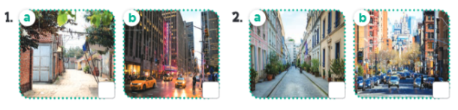  - T ask Ss to guess the answers.  + T writes Ss’guessing on the board.  - Listen to the tape:  + Play the recording  + Play the recording again and get Ss to swap books with their partners.  + Play the recording again to check answers together as a class.  + Write the answers on the board for Ss to correct their answers. Then checks Ss’ guessing.  - Play the recording, sentence by sentence, for the class to listen and repeat in chorus.  Key: 1.b 2. a  Activity 2. Look, complete and read.  *Aims: Ss will be able to complete two gapped exchanges with the help of picture cues.  *Procedure:  - Have pupils read the sentence and guess the missing words.  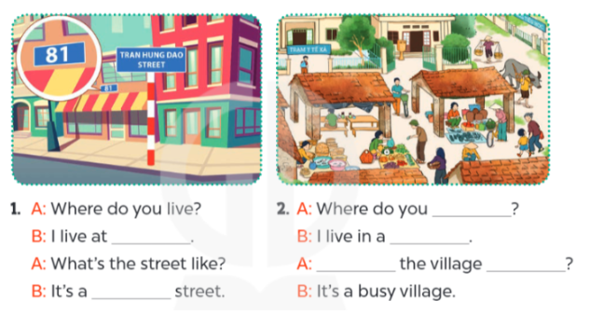  - T models with sentence 1.  + Have Ss look at the sentence.  + Ask them what is missing in the answer (81 Tran Hung Dao Street).  + Have Ss complete the gap.  + Have Ss read the completed sentence in chorus.  -Have Ss work in pairs and complete the sentences 2.  - Invite pairs of pupils to stand up and read aloud the sentences.  -T gives feedbacks.  Key: 1. 81 Tran Hung Dao Street; quiet  2. live; village; What’s; like  Activity 3. Let’s sing.  *Aims: Ss will be able to sing the song My house with the correct pronunciation, rhythm and melody.  *Procedure:  - Tell the Ss the title and the lyrics of the song.  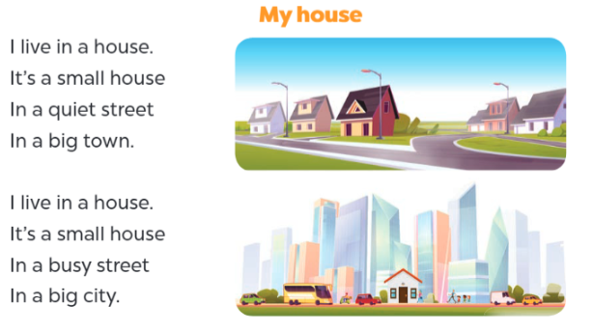  - Have Ss read the first verse of the lyrics.  + Explain that the first verse is about a house in a town.  + Have Ss listen to the first verse, drawing their attention to the pronunciation, rhythm and melody.  +Have Ss listen to and practise singing it, line by line, while making gestures for small, quiet and big  - Explain that it is about a house in a city.  - Ask pupils to listen to and sing the whole song while making gestures.  - Invite a few groups to the front of the class to sing the song.  + The class may sing along and clap to reinforce the activity.  *Consolidation  *Aims: Ss will be able consolidate and wrap up the content of the lesson.  *Procedure:  - T asks ss to answer the following questions:  + What have you learnt from the lesson today?  +What are the core values of the lesson? (if the teacher can take from the lesson).  - T praises some Ss who are hardworking / active/ good…. as well as encourage others to try more.  - Prepare the new lesson: Unit 11, Lesson 3 (1,2,3). | - Sing and dance the song in chorus.  - Ss open their books  -Look at the pictures and say:  + Picture a: a small village  + Picture b: a big city  + Picture c: a quiet street  + Picture d: a busy street.  -Ss guess the answers  - Ss listen to the tape and tick  - Ss listen again, tick and swap books with their partners.  - Ss check their answers and guessing  -Ss write the correct answer  -Ss listen and repeat.  -Ss look at the pictures and say  -Ss look at the sentence  -Ss listen and answer  -Ss read and complete  -Ss complete the gap  -Ss work in pairs  -Ss read aloud the sentences.  -SS listen  - Ss listen  -Ss read the song  - Ss listen and pay attention the pronunciation, rhythm and melody.  -Ss listen and sing, sentence by sentence  -Ss listen  -Ss listen and sing the whole song  -Ss sing a song in front of the class  -Ss sing and clap  -Ss listen and answer  -Ss listen and take note

D. ADJUSTMENTS (if necessary):
………………………………………………………………………………………….…..……………………………………………………………………………...………………………………………….…..……………………………………………………………………………….……………………………………………………………………...

