Preparing date: 25/09/2024
Teaching date: 30/09/2024
Week 5
Period 17
Unit 3: My week
Lesson 1 (1, 2, 3)
I. OBJECTIVES:
By the end of the lesson, Ss will be able to:
- understand and correctly repeat the sentences in two communicative contexts (pictures) in which pupils ask and answer questions about the days of the week.
- correctly say the words and use What day is it today? – It’s ………. to ask and answer questions about the days of the week.
- enhance the correct use of What day is it today? – It’s …….. to ask and answer questions about the days of the week in a freer context.
- Critical Thinking: self-introduce
- Co-operation: ready to help friends in pair work/ group work.
- Sociability: Talk to each other, say good words to others.
- Kindness: Help partners to complete learning tasks.
- Honesty: tell the truth about feelings and emotions
II. TEACHING AIDS:
- Teacher: Teacher’s guide Pages 43, 44, 45, audio Tracks 26, 27, website hoclieu.vn, posters, laptop, pictures, textbook, lesson plan, TV or projector.
- Students: Pupil’s book Page 22, notebooks, workbooks, school things.
III. PROCEDURES:
Stages/Time | Teacher’s activities | Students’ activities
1.Warm- up:  (5’)  2. Presentation  (16’)  3. Practice: (7’)  4.Production: (5’)  5. Homework. (2’) | Sing: What day is it today?  - Show the song on the screen.  https://www.youtube.com/watch?v=ij0iWJB2uMo  - Ask pupils to listen, sing and dance the song.  - Say “Open your book page 22” and look at “Unit 3, Lesson 1 (1,2,3)”.  Activity 1. Vocabulary.  -T elicits the new words  + Monday : thứ 2 (situation)  + Tuesday : thứ 3 (situation)  + Wednesday :thứ 4 (situation)  + Thursday : thứ 5 (translation)  + Friday : thứ 6 (translation)  + Saturday : thứ 7 (situation)  + Sunday : chủ nhật (situation)  + today : hôm nay (translation)  - T models (3 times).  - T writes the words on the board.  - Checking: Matching  Activity 2. Look, listen and repeat:  - Have Ss look at Pictures a and b and identify the characters in the pictures.  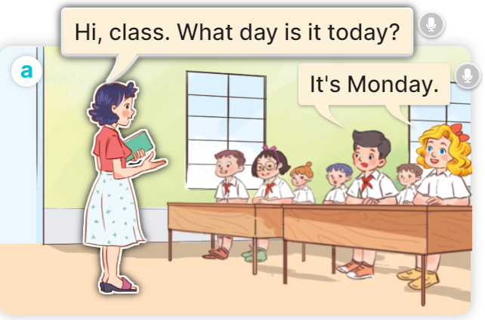  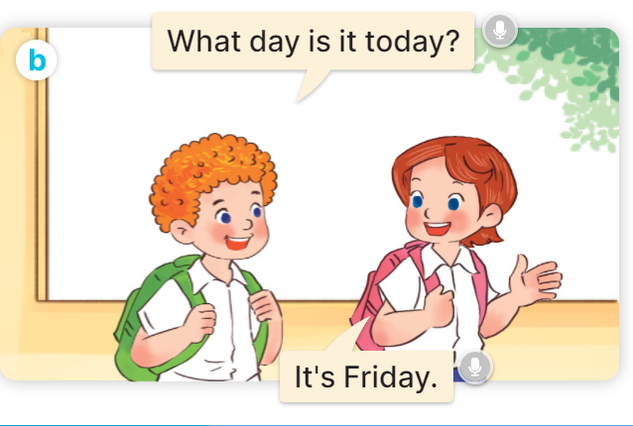  - Play the audio twice (sentence by sentence). Correct their pronunciation where necessary.  - Have Ss to practice the dialogue  - T invites a few pairs to the front of the class to practice.  - T checks pronunciation for ss.  Activity 3 Listen, point and say.  * Model sentences:  - T asks Ss look at picture a, b and helps Ss know the structure from the dialogue.  - T introduces new structure for Ss.  - T explains, models and gives meaning.  - Have Ss repeat the model sentences.  A: What day is it today?  B: It’s Monday.  *Drill pictures  - Elicit and check comprehension the name of each character.      - Run through all the pictures.  - Run through model sentences.  - Have Ss to practise:  + T says the first picture  + Ss says the second picture  + Group A says the third picture  + Group B say the last picture.  - Ask Ss to work in pairs.  - T controls and corrects.  - Invite a few pairs to come to the front of the classroom, point at the relevant character in each picture, and act out his/her role.  - Encourage Ss to practise speaking English.  - T gives feedbacks.  Activity 4. Let’s talk.  - T asks ss to guess each character and what the children say.  + What can you see in the picture?  +Who are they?  +Where are they?  +What are they saying?  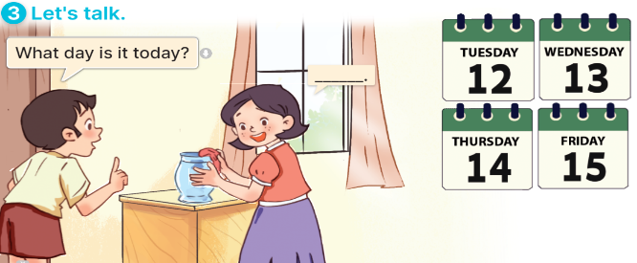  - T fills the gaps and writes the sentences on the board.  - T models  - T asks Ss to greet and introduce someone. (groups of four)  - Invite some groups to perform.  - Give feedbacks  - T review the vocabulary and model sentences.  - T praises some Ss who are hardworking / active/ good…. as well as encourage others to try more.  - Learn the vocabulary and model sentences by heart  - Prepare the new lesson: Unit 3, Lesson 1 (4,5,6). | - Ss sing and dance the song  - Ss open their books  -Ss listen and answer  - - Ss listen and repeat  + Choral repetition (3 times).  + Individual repetition (3 ss)  - Ss take note  - Ss look, remember and match  -Look at the pictures and get to know the characters in the pictures.  + In picture a: Ms Hoa says: Hi, class. What day is it today? And Mr Long says: It’s Monday.  + In picture b: Mai says: That’s Mr Long. And Bill says: Hello, Mr Long.  -Ss listen and repeat in chorus (twice)  -Ss work in pairs to practice  -Ss practice the dialogue  -Ss listen  -Ss look at the picture and answer.  -Ss listen  -Ss listen and repeat  -Ss repeat to the introduce someone.  - Ss look, listen and answer  +Picture a: Monday  + Picture b: Tuesday  + Picture c: Wednesday  + Picture d: Thursday  -Ss listen and repeat  -Ss practice in chorus  -Ss practice  -Ss work in pairs to practice  -Ss point and say  -Ss listen.  -Ss listen  -Ss look at the picture and answer  + a boy asks a girl about the days of the week: Tuesday, Wednesday, Thursday, Friday (illustrated by calendars).  -Ss note  - Ss say the completed sentences.  -Ss pay attention  -Ss work in groups  -Ss perform in front of the class  - Ss listen  -Ss listen and clap their hands  -Ss listen and take note

IV. ADJUSTMENTS (if necessary):
………………………………………………………………………………………….…..……………………………………………………………………………...………………………………………….…..………………………………………

Preparing date: 25/09/2024
Teaching date: 30/09/2024

Week 5
Period 18
Unit 3: My week
Lesson 1 (4,5,6)
I. OBJECTIVES:
By the end of the lesson, Ss will be able to:
- listen to and understand two communicative contexts about the days of the week and tick the correct pictures.
- complete four gapped exchanges with the help of picture cues.
- revise target words about the days of the week by playing the game Slap the board.
- Vocabulary: Review
- Skills: speaking, listening, reading and writing.
- Critical Thinking: self-introduce
- Co-operation: ready to help friends in pair work/ group work.
- Self-control and independent learning: perform listening tasks.
- Kindness: Help partners to complete learning tasks.
- Honesty: tell the truth about feelings and emotions.
- Communication and collaboration: work in pairs and groups to complete the learning tasks
II. TEACHING AIDS:
- Teacher: Teacher’s guide Pages 45,46,47; audio Tracks 29; website hoclieu.vn, posters, laptop, pictures, textbook, lesson plan, TV or projector.
- Students: Pupil’s book Page 23, notebooks, workbooks, school things.
III. PROCEDURES:
Stages/Time | Teacher’s activities | Students’ activities
1.Warm- up:  (5’)  2.Practice: (20’)  3. Production  5’  4. Homework. (5’) | Game: Lucky number  - Divide the class into 2 teams (boys and girls).  - Each team takes turns to choose a number.  - They need to ask and answer with the picture corresponding to that number to get points.  - The group with more points at the end of the game will be the winner.  - Praise the winner, encourage the other team.  - Say “Open your book page 23” and look at “Unit 3, Lesson 1 (4,5,6)”.  Activity 1. Listen and tick:  - Elicit the days of the week.  - Point at the pictures respectively to explain the context.  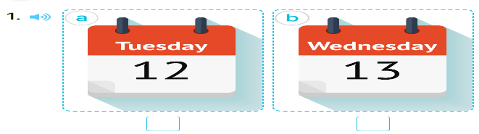  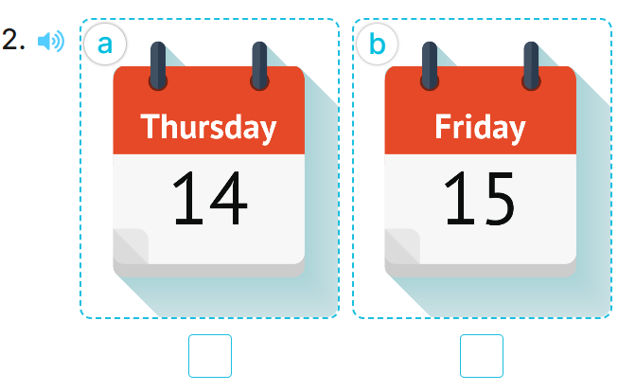  - T ask Ss to guess the answers.  + T writes Ss’guessing on the board.  - Listen to the tape:  + Play the recording  + Play the recording again and get Ss to swap books with their partners.  + Play the recording again to check answers together as a class.  + Write the answers on the board for Ss to correct their answers. Then checks Ss’ guessing.  - Play the recording, sentence by sentence, for the class to listen and repeat in chorus.  Key: 1.b 2.a  Activity 2. Look, complete and read.  - Have pupils look at the pictures and identify the days of the week in the pictures. 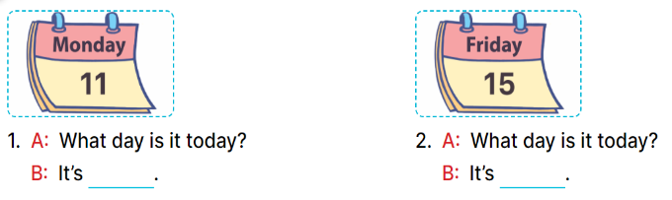  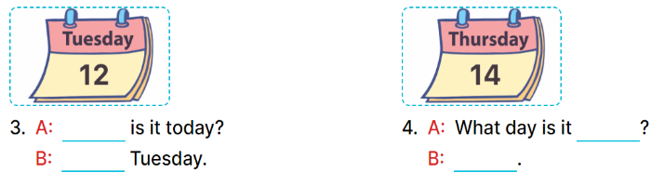  - Have Ss look at the two incomplete dialogue and elicits the missing words in the sentences.  - T models with picture 1  + Ask Ss what is missing in the sentence.  + Have Ss look at the picture and complete the gap, then read the completed sentence in chorus.  -Have Ss work in groups and complete the picture 2.  - Ask a few Ss to stand up and read the completed sentences aloud.  -T gives feedbacks.  Key:  - Monday 2. Friday  - 3. What day; It’s  - 4. today; It’s Thursday  Activity 3. Let’s play: Slap the board  - Tell pupils that they are going to listen to and slap the correct words as quickly as possible.  - Have them look at the days of the week on the board to recall the days of the week.  - Call two pupils to the front. Get them to stand at a certain distance from the board.  - Say a day of the week using It’s …….with one of the words on the board, for example, It’s Monday.  - The pupil who is the quickest to slap the right word (Monday) gets one point.  - The pupil who slaps the most words is the winner.  - Invite a few pairs to the front of the class to play the game.  - Praise pupils if they perform well.  - T praises some Ss who are hardworking / active/ good…. as well as encourage others to try more.  - Practice part 5 again.  - Prepare the new lesson: Unit 3, Lesson 2 (1,2,3). | - Ss listen to the rule  - Ss play game  Ex: What day is it today?  It’s Tuesday.  -Ss listen  - Ss open their books  -Look at the pictures and say:  + Picture 1a: Tuesday  + Picture 1b: Wednesday  + Picture 2a: Thursday  + Picture 2b: Friday  -Ss guess the answers  - Ss listen to the tape and tick  - Ss listen again, tick and swap books with their partners.  -Ss listen again and check  - Ss check their answers and guessing  -Ss listen and repeat.  -Ss look at the picture and say:  -Ss look and answer  -Ss answer: Monday  -Ss look, complete and read the completed sentence in chorus.  -Ss work in groups and complete the sentences  -Ss read aloud  -Ss listen  - Ss look and listen.  - Ss listen  - Ss pay attention  -Ss play the game  -Ss listen and play games  -Ss listen  -Ss listen and clap their hands  -Ss listen and take note

IV. ADJUSTMENTS (if necessary):
………………………………………………………………………………………….…..……………………………………………………………………………...………………………………………….…..………………………………………

Preparing date: 25/09/2024
Teaching date: 01/10/2024

Week 5
Period 19

Unit 3: My week
Lesson 2 (1, 2, 3)
A. OBJECTIVES:
By the end of the lesson, Ss will be able to:
- understand and correctly repeat the sentences in two communicative contexts focusing on asking and answering questions about what someone does on certain days of the week.
- correctly say the phrases and use What do you do on ……? – I ……... to ask and answer questions about what someone does on certain days of the week.
- enhance the correct use of What do you do on ……? – ………. to ask and answer questions about what someone does on certain days of the week in a freer context.
- Co-operation: ready to help friends in pair work/ group work.
- Sociability: Talk to each other, say good words to others.
- Kindness: Help partners to complete learning tasks.
- Honesty: tell the truth about feelings and emotions
II. TEACHING AIDS:
- Teacher: Teacher’s guide Pages 47,48,49; audio Tracks 29,30, website hoclieu.vn, posters, laptop, pictures, textbook, lesson plan, TV or projector.
- Students: Pupil’s book Page 24, notebooks, workbooks, school things.
III. PROCEDURES:
Stages/Time | Teacher’s activities | Students’ activities
1.Warm- up:  (5’)  2. Presentation  (12’)  3.Practice: (10’)  4.Production:  5’  5. Homework. (2’) | Game: Pass the ball  - T gives Ss a ball.  - T asks Ss to listen to music and transfer a ball around the class.  - When the music stops, Ss who keep a ball have to look at the picture and answer the question using: What day is it today? and It’s……..  - T gives feedback.  - Say “Open your book page 24” and look at “Unit 3, Lesson 2 (1,2,3)”.  Activity 1. Vocabulary.  -T elicits the new words  + study at school : học ở trường (situation)  + do housework : làm việc nhà (situation)  + listen to music : nghe nhạc (mime)  + stay at home : ở nhà (translation)  - T models (3 times).  - T writes the words on the board.  - Checking: What and where  Activity 2. Look, listen and repeat:  - Have Ss look at Pictures a and b and identify the characters in the pictures.  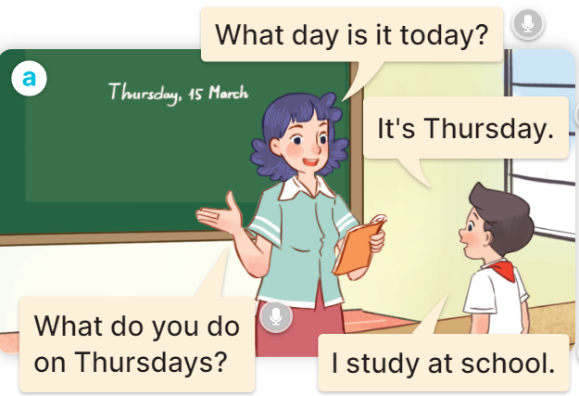  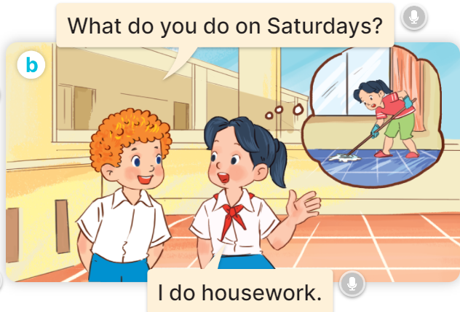  - Play the audio twice (sentence by sentence). Correct their pronunciation where necessary.  - Have Ss to practice the diaguage  - T invites a few pairs to the front of the class to practice.  - T checks pronunciation for ss.  Activity 3. Listen, point and say.  * Model sentences:  - T asks Ss look at picture a, b and helps Ss know the structure from the dialogue.  - T introduces new structure for Ss.  - T explains, models and gives meaning.  - Have Ss repeat the model sentences.  A: What do you do on Mondays?  B: I study at school.  *Drill pictures  - Have pupils look at the pictures and elicit the activities and the days of the week.      - Run through all the pictures.  - Run through model sentences.  + Run through the questions  + Run through the answers  - Have Ss to practise:  + T asks Ss answer (change role).  + Ss – Ss (change role).  - Ask Ss to work in pairs.  - T controls and corrects.  - Invite a few pairs to come to the front of the classroom, point at the relevant character in each picture, and act out his/her role.  - Invite Ss to go to the board and role play. Encourage Ss to practise speaking English.  - T gives feedbacks.  Activity 4. Let’s talk.  - Ask questions to help them identify the context.  + What can you see in the picture?  +Who are they?  +Where are they?  +What are they saying?  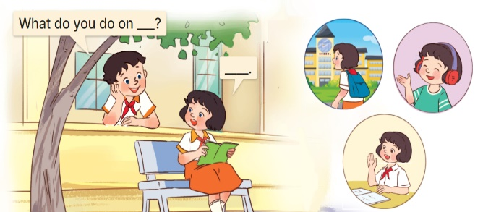  - T fills the gaps and writes the sentences on the board.  - T models  - T asks Ss use of What do you do on….? to ask, and answer (work in pairs)  - Invite some groups to perform.  - Give feedbacks  - T review the vocabulary and model sentences.  - T praises some Ss who are hardworking / active/ good…. as well as encourage others to try more.  - Learn the vocabulary and model sentences by heart  - Prepare the new lesson: Unit 3, Lesson 2 (4,5,6). | - Ss listen  - Ss play the game  - Ss open their books  -Ss listen and answer  - - Ss listen and repeat  + Choral repetition (3 times).  + Individual repetition (3 ss)  - Ss take note  - Ss look, remember and slap  -Look at the pictures and get to know the characters in the pictures.  + In picture a:  Ms Hoa: What day is it today?  Nam: It’s Thursday.  Ms Hoa: What do you do on Thursdays?  Nam: I study at school.  – In picture b:  Bill: What do you do on Saturdays?  Mai: I do housework.  -Ss listen and repeat in chorus (twice)  -Ss work in pairs to practice  -Ss practice the diaguage  -Ss listen  -Ss look at the picture and answer.  -Ss listen  -Ss listen and repeat  -Ss repeat to the introduce someone  -Ss listen and answer  - Ss look, listen and repeat  - Ss practice in chorus  Ex: Mondays/ study at school  A: What do you do on Mondays?  B: I study at school.  -Ss work in pairs to practice  -Ss listen  -Ss point and say  -Ss go to the board and role play.  -Ss listen  -Ss look at the picture and answer  + A boy asks a girl about what she does on Tuesdays, Fridays and Sundays (illustrated by the calendars and her activities)  -Ss note  - Ss say the completed sentences.  -Ss work in pairs  -Ss perform in front of the class.  -Ss listen  - Ss listen  -Ss listen and clap their hands  -Ss listen and take note

D. ADJUSTMENTS (if necessary):
………………………………………………………………………………………….…..……………………………………………………………………………...………………………………………….…..……………………………………………………………………………….………………………………………………

Preparing date: 25/09/2024
Teaching date: 01/10/2024
Week 5
Period 20

Unit 3: My week
Lesson 2 (4, 5, 6)
I. OBJECTIVES:
By the end of the lesson, Ss will be able to:
- listen to and understand four communicative contexts about days of the week and what someone does on certain days of the week and number the correct pictures.
- complete four gapped exchanges with the help of picture cues.
- sing the song My week with the correct pronunciation, rhythm and melody.
- Co-operation: ready to help friends in pair work/ group work.
- Self-control and independent learning: perform listening tasks.
- Kindness: Help partners to complete learning tasks.
- Honesty: tell the truth about feelings and emotions.
- Diligence: complete learning tasks.
II. TEACHING AIDS:
- Teacher: Teacher’s guide Pages 49, 50,51; audio Tracks 31, 32; website hoclieu.vn, posters, laptop, pictures, textbook, lesson plan, TV or projector.
- Students: Pupil’s book Page 25, notebooks, workbooks, school things.
III. PROCEDURES:
Stages/Time | Teacher’s activities | Students’ activities
1.Warm- up:  (5’)  2. Practice: (27’)  3. Homework. (3’) | Play a game: Guess the pictures  - The first Ss has to take the last four or three letters of that word and form a new word.  - The second Ss does the same, and the chain continues until a Ss is unable to form a word.  - The Ss who fails to form a word or misspells it is out of the game.  -T give feedback  - Say “Open your book page 25” and look at “Unit 3, Lesson 2 (4,5,6)”.  Activity 1. Listen and number:  - Elicit the activities and the days of the week.  - Point at the pictures respectively to explain the context.      - T ask Ss to guess the answers.  + T writes Ss’guessing on the board.  - Listen to the tape:  + Play the recording  + Play the recording again and get Ss to swap books with their partners.  + Play the recording again to check answers together as a class.  + Write the answers on the board for Ss to correct their answers. Then checks Ss’ guessing.  - Play the recording, sentence by sentence, for the class to listen and repeat in chorus.  Key: 1. c 2. d 3. b 4. a  Activity 2. Look, complete and read  - Have pupils look at the pictures and identify the days of the week and the activities in the pictures.  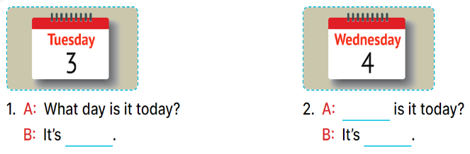  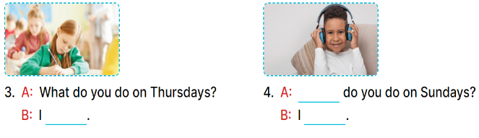  - Have Ss look at the four incomplete dialogue and elicits the missing words in the sentences.  - T models with picture 1  + Ask Ss what is missing in the sentence.  + Have Ss look at the picture and complete the gap, then read the completed sentence in chorus.  -Have Ss work in groups and complete the picture 2, 3 and 4.  - Ask a few Ss to stand up and read the completed sentences aloud.  -T gives feedbacks.  Key: 1. Tuesday  2. What day; Wednesday  3. study at school  4. What; listen to music  Activity 3. Let’s sing.  - Draw pupils’ attention to the title and lyrics of the song.  - Encourage pupils to point at the characters’ activities to reinforce their understanding.  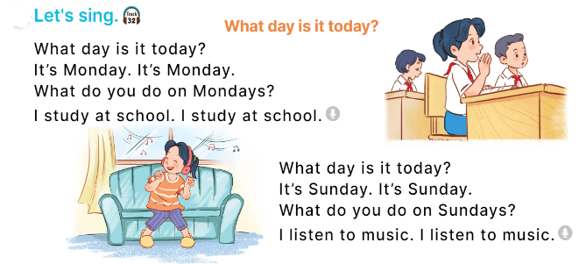  - Play the recording all the way through for pupils to listen to the whole song.  - Play the recording line by line for pupils to listen and repeat.  - Play the recording all the way through for pupils to sing along.  - Play the recording again for pupils to sing and clap along with the recording.  - Pupils can sing the song What day is it today? with the correct pronunciation, rhythm and melody.  - T praises some Ss who are hardworking / active/ good…. as well as encourage others to try more.  - Practice part 5 again.  - Prepare the new lesson: Unit 3, Lesson 3 (1,2,3). | - Sing and dance the song in chorus.  - Ss open their books  -Look at the pictures and say:  a. a girl listening to music on Sundays  b. a calendar: Friday  c. a calendar: Monday  d. a boy doing housework on Saturdays  -Ss guess the answers  - Ss listen to the tape and write number  - Ss listen again, write number and swap books with their partners.  - Ss check their answers and guessing  -Ss listen and repeat.  -Ss look and answer  -Ss answer: It’s Tuesday.  -Ss look, complete and read the completed sentence in chorus.  -Ss work in groups and complete the sentence  -Ss read aloud  - Ss listen  -Ss listen to the song  -Ss listen and repeat line by line  -Ss listen and sing along  -Ss sing and clap along  -Ss sing with the correct pronunciation, rhythm and melody.  -Ss listen and clap their hands  -Ss listen

IV. ADJUSTMENTS (if necessary):
………………………………………………………………………………………….…..……………………………………………………………………………...………………………………………….…..………………………………………

