Preparing date: March 30th,2025
Teaching date: April 2nd.2025
Week 29
Period :113 Unit 17: Our toys
Lesson 1 (4, 5, 6)
A. OBJECTIVES:
By the end of the lesson, Ss will be able to:
1. Knowledge:
- listen to and understand four communicative contexts in which pupils identify someone’s toys and number the correct pictures.
- correctly four target sentence patterns with the help of picture cues.
- sing the song Their toys with the correct pronunciation and melody
- Vocabulary: Review
- Skills: speaking, listening, reading and writing.
2. Competences:
- Critical Thinking: talk about toys.
- Co-operation: ready to help friends in pair work/ group work.
- Self-control and independent learning: perform listening tasks.
3. Attitude/ Qualities:
- Kindness: Help partners to complete learning tasks.
- Honesty: tell the truth about feelings and emotions.
- Diligence: complete learning tasks.
B. TEACHING AIDS:
- Teacher: Teacher’s guide Pages 212, 213; audio Tracks 66, 67; website sachmem.vn, posters, laptop, pictures, textbook, lesson plan, TV or projector.
- Students: Pupil’s book Page 47, notebooks, workbooks, school things.
C. PROCEDURES:
Stages/Time | Teacher’s activities | Students’ activities
1.Warm- up:  (5’)  2.Practice: (27’)  3. Homework. (3’) | Game: A letter to the Santa Claus  *Aims: to create a friendly and active atmosphere in the class to beginning the lesson.  *Procedure:  - Divide class into 4 teams.  - Set rules: invite 1 pupil to go to the board, look at the picture, then say aloud what toy the boy wants for Christmas. The fastest has one points for his/her team.  (kite, car, plane, train.)  - Encourage Ss join in the game.  - Give point for Ss.  - Say “Open your book page 47” and look at “Unit 17, Lesson 1 (4,5,6)”.  Activity 1. Listen and number:  *Aims: Ss will be able to listen to and understand four communicative contexts in which pupils identify someone’s toys and number the correct pictures.  *Procedure:  - Elicit the toys the characters are holding in the pictures.  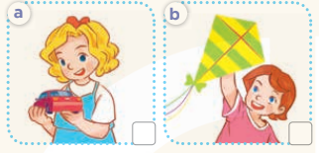  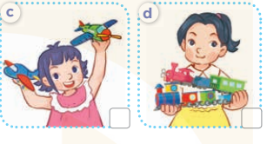  - T ask Ss to guess the answers.  + T writes Ss’guessing on the board.  - Listen to the tape:  + Play the recording  + Play the recording again and get Ss to swap books with their partners.  + Play the recording again to check answers together as a class.  + Write the answers on the board for Ss to correct their answers. Then checks Ss’ guessing.  - Play the recording, sentence by sentence, for the class to listen and repeat in chorus.  Key: 1. b 2. d 3. c 4. a  Activity 2. Look, complete and read  *Aims: Ss will be able to read and complete four target gapped dialogues with the help of the picture cues.  *Procedure:  - Get Ss to look at the pictures and identify the toys in the pictures.  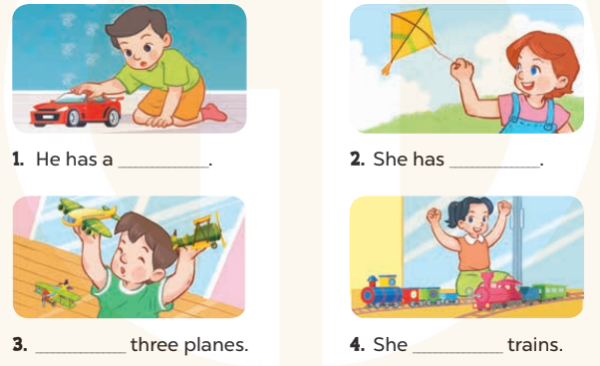  - Have Ss look at the four sentences and the pictures. Elicit and model with picture 1  + Ask Ss to read the sentence 1 in chorus.  + Ask them what is missing in the question (a car). Then have them complete the gap (He has a car).  -Have Ss work in pairs and complete the dialogue 2, 3, 4.  - Ask a few Ss to stand up and read the sentences aloud.  -T gives feedbacks.  Key:  1. car 2. a kite 3. He has 4. has two  Activity 3. Let’s sing  *Aims: Ss will be able to sing the song Their toys with the correct pronunciation and melody.  *Procedure:  - Introduce the title and lyrics of the song: “Their toys”  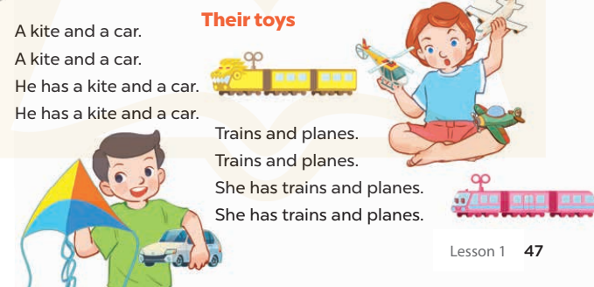  - Play the recording for Ss to listen to the whole song.  + Have them repeat the title and lyrics line by line.  + Tell Ss to point at the pictures while singing.  - Play the recording all the way through for Ss to listen to pronunciation and melody of the song.  - Play the recording line by line for Ss to listen, repeat and point to the pictures  - Play the recording for Ss to sing and do actions.  - Ask Ss to practice singing and doing actions in pairs or groups.  - Invite groups to the front of the classroom to perform the song  -T gives feedback.  *Consolidation  *Aims: Ss will be able consolidate and wrap up the content of the lesson.  *Procedure:  - T asks ss to answer the following questions:  + What have you learnt from the lesson today?  - T praises some Ss who are hardworking / active/ good…. as well as encourage others to try more.  - Practice part 5 again.  - Prepare the new lesson: Unit 17, Lesson 2 (1,2,3). | - Ss listen  - Ss play game  - Ss open their books  -Look at the pictures and say:  + Picture a: a girl holding a car  + Picture b: a girl holding a kite  + Picture c: a girl holding two planes  + Picture d: a girl holding two trains  -Ss guess the answers  - Ss listen to the tape and write number  - Ss listen again, write number and swap books with their partners.  - Ss check their answers and guessing  -Ss listen and repeat.  -Ss look at the picture and say  -Ss look and answer  -Ss read  -Ss say and complete  -Ss work in pairs and complete  -Ss read aloud  - Ss listen  -Ss listen to the song  - Ss listen and repeat line by line without the action.  -Ss point to the pictures while singing  -Ss listen to melody of the song  - Ss listen and sing line by line.  - Ss sing and do actions.  + Ss work in groups (two groups) to sing.  -Ss perform in front of the class.  -Ss listen  -Ss answer the questions  -Ss listen and clap their hands  -Ss listen and take note
D. ADJUSTMENTS (if necessary):
………………………………………………………………………………………….…..……………………………………………………………………………...………………………………………….…..……………………………………………………………………………….……………………………………………………………………...

Preparing date: April , 2025
Teaching date: April , 2025
Week 29
Period 114 Unit 17: Our toys
Lesson 2 (1, 2, 3)
A. OBJECTIVES:
By the end of the lesson, Ss will be able to:
1. Knowledge:
- understand and correctly repeat the sentences in two communicative contexts (pictures) to identify someone’s toys that some people have.
- correctly say the words and use They have ….. to talk about the quantity of toys that some people have.
- enhance the correct use of They have ……… to talk about the quantity of toys that some people have in a freer context.
- Vocabulary: truck, bus, ship, teddy bear
- Model sentences:
They have two trucks
- Skills: speaking and listening
2. Competences:
- Critical Thinking: talk about toys
- Co-operation: ready to help friends in pair work/ group work.
- Sociability: Talk to each other, say good words to others.
3. Attitude/ Qualities:
- Kindness: Help partners to complete learning tasks.
- Honesty: tell the truth about feelings and emotions
B. TEACHING AIDS:
- Teacher: Teacher’s guide Pages 214, 215; audio Tracks 68, 69, website sachmem.vn, posters, laptop, pictures, textbook, lesson plan, TV or projector.
- Students: Pupil’s book Page 48, notebooks, workbooks, school things.
C. PROCEDURES:
Stages/Time | Teacher’s activities | Students’ activities
1.Warm- up:  (3’)  2. Presentation  (16’)  3.Practice: (7’)  4.Production: (7’)  5. Homework. (2’) | Game: Guessing and Choosing  *Aims: to create a friendly and active atmosphere in the class to beginning the lesson.  *Procedure:  - T shows 4 pictures of toys (kite, doll, train, plane) and calls 4 Ss to come to the board and choose.  - T asks 4 Ss to come to the board and choose 1 picture of toys and keep them in secret by covering them.  - The others will write their toys in the board at their desks and keep their ides in secret.  - The Ss on the board will 1 by 1 show their pictures they chose.  - When the teacher says the word of the pictures 1 by 1 shown on the board, who has the same toys will raise their board or raise their hands.  - The Ss on the board will get the same points as the numbers of Ss raising their hands.  - Say “Open your book page 48” and look at “Unit 17, Lesson 2 (1,2,3)”.  Activity 1. Vocabulary.  *Aims: Ss will be able to know the vocabulary in front of starting the new lesson.  *Procedure:  -T elicits the new words  + truck : xe tải (visual)  + bus: xe buýt (picture)  + ship : con tàu (visual)  + teddy bear : gấu bông (realia)  - T models (3 times).  - T writes the words on the board.  - Checking: What and where  Activity 2. Look, listen and repeat:  *Aims: Ss will be able to understand and correctly repeat the sentences in two communicative contexts (pictures) to identify someone’s toys that some people have  *Procedure:  - Have Ss look at Pictures a and b and identify the characters in the pictures.  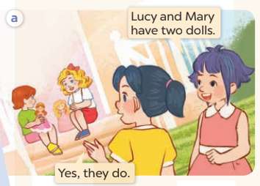  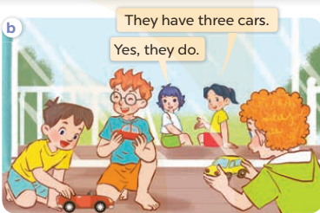  - Play the audio twice (sentence by sentence). Correct their pronunciation where necessary.  - Have Ss to practice the diaguage  - T invites a few pairs to the front of the class to practice.  - T checks pronunciation for ss.  Activity 3. Listen, point and say.  *Aims: Ss will be able to correctly say the words and use They have …... to talk about the quantity of toys that some people have.  *Procedure:  * Model sentences:  - T asks Ss look at picture a, b and helps Ss know the structure from the dialogue.  - T introduces new structure for Ss.  - T explains, models and gives meaning.  - Have Ss repeat the model sentences.  They have two trucks  *Drill pictures  - Have Ss look at the pictures and elicit the names of the toys  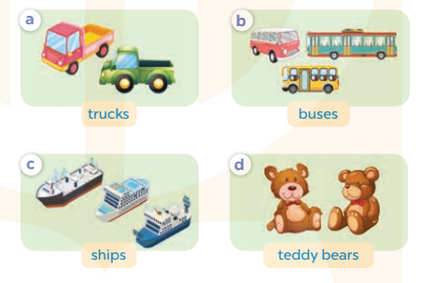  - Run through all the pictures.  - Run through model sentences.  - Ask Ss to work in pairs.  - T controls and corrects.  - Invite a few pairs to come to the front of the classroom, point at the pictures and say in front of the class.  - T gives feedbacks.  Activity 4. Let’s talk.  *Aims: Ss will be able to enhance the correct use of They have ……. to talk about the quantity of toys that some people have in a freer context.  *Procedure:  - Tell Ss about the activity  + What can you see in the picture?  +Let’s count the toys.  +How many toys?  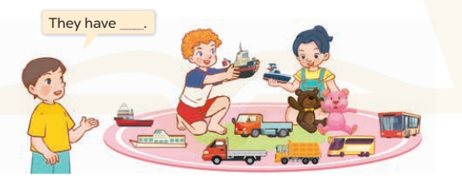  - Put Ss into pairs and encourage them to say using They have…….  - Invite some pairs to stand up to perform their exchanges.  *Consolidation  *Aims: Ss will be able consolidate and wrap up the content of the lesson.  *Procedure:  - T asks ss to answer the following questions:  + What have you learnt from the lesson today?  - T review the vocabulary and model sentences.  - T praises some Ss who are hardworking / active/ good…. as well as encourage others to try more.  - Learn the vocabulary and model sentences by heart  - Prepare the new lesson: Unit 17, Lesson 2 (4,5,6). | - Ss listen  - Ss play the game  -Ss play game  - Ss open their books  -Ss listen and answer  - - Ss listen and repeat  + Choral repetition (3 times).  + Individual repetition (3 ss)  - Ss take note  - Ss look, remember and write  -Look at the pictures and get to know the characters in the pictures.  + In picture a: Linh says: Lucy and Mary have two dolls And Mai says: Yes, they do.  – In picture b: Mai says: They have three cars. And Linh says: Yes, they do  -Ss listen and repeat in chorus (twice)  -Ss work in pairs to practice  -Ss practice the diaguage  -Ss listen  -Ss look at the picture and answer.  -Ss listen  -Ss listen and repeat  -Ss repeat  -Ss listen and answer  +Picture a: two trucks +Picture b. three buses +Picture c. three ships +Picture d. two teddy bears  - Ss look, listen and repeat  - Ss practice in chorus  -Ss work in pairs to practice  -Ss listen  -Ss go to the board and point and say  -Ss listen  -Ss look at the picture and answer  + A boy and a girl playing with various toys.  -Ss work in pairs  -Ss ask and answer  -Ss answer the questions  - Ss listen  -Ss listen and clap their hand  -Ss listen and take note
D. ADJUSTMENTS (if necessary):
………………………………………………………………………………………….…..……………………………………………………………………………...……………

Preparing date: April ,2025
Teaching date: April , 2025
Week 29
Period 115 Unit 17: Our toys
Lesson 2 (4, 5, 6)
A. OBJECTIVES:
By the end of the lesson, Ss will be able to:
1. Knowledge:
- listen to and understand two communicative contexts in which pupils talk about the quantity of toys that some people have and tick the correct pictures.
- complete four sentences with the help of picture cues.
- review vocabulary words for toys by playing Kim’s game.
- Vocabulary: Review
- Skills: speaking, listening, reading and writing.
2. Competences:
- Critical Thinking: talk about toys
- Co-operation: ready to help friends in pair work/ group work.
- Self-control and independent learning: perform listening tasks.
3. Attitude/ Qualities:
- Kindness: Help partners to complete learning tasks.
- Honesty: tell the truth about feelings and emotions.
- Diligence: complete learning tasks.
B. TEACHING AIDS:
- Teacher: Teacher’s guide Pages 215, 216; audio Tracks 70; website sachmem.vn, posters, laptop, pictures, textbook, lesson plan, TV or projector.
- Students: Pupil’s book Page 49, notebooks, workbooks, school things.
C. PROCEDURES:
Stages/Time | Teacher’s activities | Students’ activities
1.Warm- up:  (5’)  2.Practice: (27’)  3. Homework. (3’) | Sing a song: “What is missing?”  *Aims: to create a friendly and active atmosphere in the class to beginning the lesson.  *Procedure:  - Divide class into 4 teams.  - Set rules: Look at the pictures and find out what is missing (kite, car, plane, train, truck, ship, bus, teddy bear)  + Invite Ss to find out which one is missing.  + The fastest have correct answer get points for the team.  - Encourage Ss to join in the game.  - Give point for Ss.  - Say “Open your book page 43” and look at “Unit 17, Lesson 2 (4,5,6)”.  Activity 1. Listen and tick:  *Aims: Ss will be able to listen to and understand two communicative contexts in which pupils talk about the quantity of toys that some people have and tick the correct pictures.  *Procedure:  - Elicit the quantity of toys that the boys have in each picture 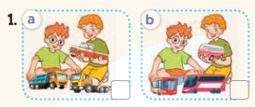  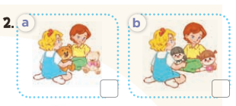  - T ask Ss to guess the answers.  + T writes Ss’guessing on the board.  - Listen to the tape:  + Play the recording  + Play the recording again and get Ss to swap books with their partners.  + Play the recording again to check answers together as a class.  + Write the answers on the board for Ss to correct their answers. Then checks Ss’ guessing.  - Play the recording, sentence by sentence, for the class to listen and repeat in chorus.  Key: 1.b 2. a  Activity 2. Look, complete and read.  *Aims: Ss will be able to complete four sentences with the help of picture cues.  *Procedure:  - Have Ss look at the pictures and identify the quantity of toys in the picture.  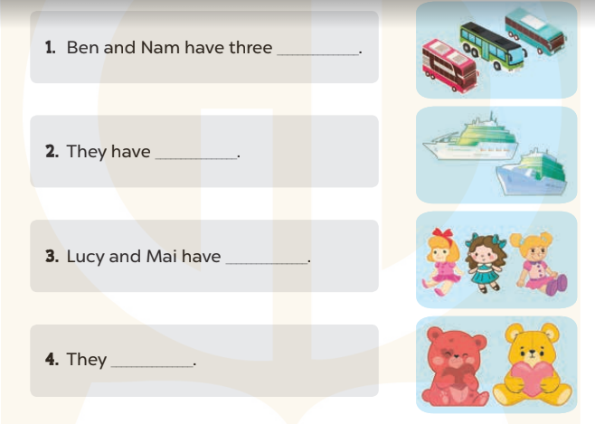  - T models with sentence 1.  + Have Ss look at the sentence.  + Ask them what is missing in the answer (buses).  + Have Ss complete the gap.  + Have Ss read the completed sentence in chorus.  -Have Ss work in pairs and complete the sentences 2, 3 and 4.  - Invite pairs of pupils to stand up and read aloud the sentences.  - T gives feedbacks.  Key: 1. buses 2. two ships  3. three dolls 4. have two teddy bears  Activity 3. Let’s play.  *Aims: Ss will be able to review vocabulary words for toys by playing Kim’s game.  *Procedure:  - Elicit the language that pupils need to name the toys.  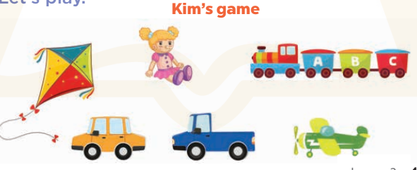  - Tell the Ss the goal of the game and how to play it: Ss should look at the cards carefully and recall their names and positions successfully.  - Divide the class into two teams.  - Display both sets of cards face up on the board. Give Ss two minutes to memorise their set. Turn the cards face down on the board.  + Explain that when you say a word, a nominated pupil from each team must run to their set, try to remember which card shows the relevant picture and turn it over to show to their team.  + A correct card scores one point. When the Ss’ turn is over, they must put the cards back on the board and return to their seats.  + Remember to nominate a pupil from each team before saying the word.  - Count the points for each team and announce the winner.  + The team with the most points wins.  + The winning team must then correctly pronounce all of the words.  *Consolidation  *Aims: Ss will be able consolidate and wrap up the content of the lesson.  *Procedure:  - T asks ss to answer the following questions:  + What have you learnt from the lesson today?  +What are the core values of the lesson? (if the teacher can take from the lesson).  - T praises some Ss who are hardworking / active/ good…. as well as encourage others to try more.  - Prepare the new lesson: Unit 17, Lesson 3 (1,2,3). | - Ss listen and play the game  - Ss open their books  -Look at the pictures and say:  + Picture a: Ben and Bill playing with three trucks  + Picture b: Ben and Bill playing with three buses  + Picture c: Lucy and Mary playing with two teddy bears  + Picture d: Lucy and Mary playing with two dolls  -Ss guess the answers  - Ss listen to the tape and tick  - Ss listen again, tick and swap books with their partners.  - Ss check their answers and guessing  -Ss listen and repeat.  -Ss look at the pictures and say  -Ss listen and answer  -Ss read and complete  -Ss work in pairs and do the task  -Ss read aloud  - Ss look and listen.  -Ss play the game  -Ss play the game  -Ss play the game  -Ss listen and answer  -Ss listen and take note

D. ADJUSTMENTS (if necessary):
………………………………………………………………………………………….…..……………………………………………………………………………...………………………………………….…..……………………………………………………………………………….……………………………………………………………………...

Preparing date: April ,2025
Teaching date: April ,2025
Week 29
Period 116 Unit 17: Our toys
Lesson 3 (1, 2, 3)
A. OBJECTIVES:
By the end of the lesson, Ss will be able to:
1. Knowledge:
- correctly repeat the sounds of the letters i and oy in isolation, the words kite and toy and the sentences She has a kite.? and He has a toy. with the correct pronunciation and intonation.
- identify the target words kite and toy while listening.
- say the chant with the correct rhythm and pronunciation.
- Vocabulary: Review
- Skills: speaking, listening, reading and writing.
2. Competences:
- Co-operation: ready to help friends in pair work/ group work.
- Self-control and independent learning: perform listening tasks.
3. Attitude/ Qualities:
- Kindness: Help partners to complete learning tasks.
- Honesty: tell the truth about feelings and emotions
B. TEACHING AIDS:
- Teacher: Teacher’s guide Pages 217, 218; audio Tracks 71, 62, 63; website sachmem.vn, posters, laptop, pictures, textbook, lesson plan, TV or projector.
- Students: Pupil’s book Page 50, notebooks, workbooks, school things.
C. PROCEDURES:
Stages/Time | Teacher’s activities | Students’ activities
1.Warm- up:  (5’)  2. Presentation  (9’)  3.Practice: (19’)  4. Homework. (2’) | Game: Find and circle the words  *Aims: to create a friendly and active atmosphere in the class to beginning the lesson.  *Procedure:  - Divide class into 2 groups  - Ask Ss to find and circle the words that they learnt.  - Which groups find the best correct words is winner.  - Give Ss time to play the game.  Rows: bike, toy  Columns: kite, boy  -T checks who’s winner?  - Say “Open your book page 50” and look at “Unit 17, Lesson 3 (1,2,3)”.  Activity 1. Listen and repeat:  *Aims: Ss will be able to correctly pronounce the sounds of the letters i and oy in isolation, the words kite and toy and the sentences She has a kite.? and He has a toy. with correct pronunciation and intonation.  *Procedure:  - T gives instruction to the letters i and oy in isolation, the words kite and toy and the sentences She has a kite.? and He has a toy.  - Play the recording for the letter i and oy  - Encourage Ss to point at the letter/ word/ sentence while listening.  - Play the recording again and encourage Ss to listen and repeat.  - Do this several times until Ss feel confident.  - T calls some Ss to practice.  - T gives feedbacks.  Activity 2. Listen and circle.  *Aims: Ss will be able to identify the target words kite and toy while listening.  *Procedure:  - Elicit the sentences and explain that they have to listen.  - T ask Ss to guess the answers.  + T writes Ss’guessing on the board.  - Listen to the tape:  + Play the recording  + Play the recording again and get Ss to swap books with their partners.  + Play the recording again to check answers together as a class.  + Write the answers on the board for Ss to correct their answers. Then checks Ss’ guessing.  - Play the recording, sentence by sentence, for the class to listen and repeat in chorus.  - Invite one or two Ss to stand up and read the completed sentences.  Key: 1.c 2.b  Activity 3. Let’s chant  *Aims: Ss will be able to say the chant with the correct rhythm and pronunciation.  *Procedure:  - Introduce the title and lyrics of the chant.  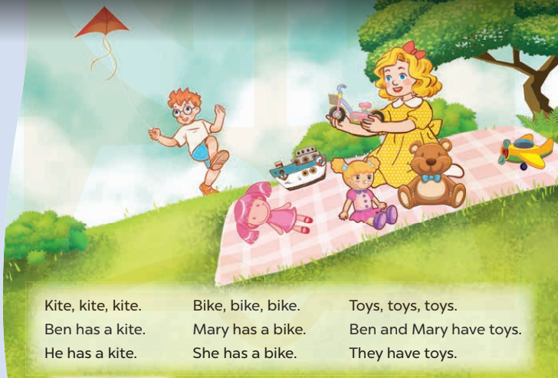  - Play the recording for Ss to listen to the whole chant.  + Have them repeat the title and lyrics line by line.  + Ask Ss to attend to the sounds of the letters i and oy and the words kite and toy.  - Play the recording all the way through for Ss to listen to pronunciation and melody.  - Play the recording line by line for Ss to listen and repeat  - Play the recording for Ss to chant and clap along.  - Ask Ss to practice chant and clap along in pairs or groups.  - Invite groups to the front of the classroom to perform the chant  -T gives feedback.  *Consolidation  *Aims: Ss will be able consolidate and wrap up the content of the lesson.  *Procedure:  - T asks ss to answer the following questions:  + What have you learnt from the lesson today?  +What are the core values of the lesson? (if the teacher can take from the lesson).  - T praises some Ss who are hardworking / active/ good…. as well as encourage others to try more.  - Practice the chant more.  - Prepare the new lesson: Unit 17, Lesson 3 (4,5,6). | - Ss listen  -Ss play game  - Ss open their books  - Ss recognize the differences about color of letter  - - Ss listen  - Ss listen and point  - Ss listen again and repeat  -Ss listen again and repeat  -Ss practice  -Ss listen  -Ss listen and say:  + Number 1: She has a…..  + Number 2: He has a…..  -Ss guess the answers  - Ss listen to the tape and circle  - Ss listen again, circle and swap books with their partners.  - Ss check their answers and guessing  -Ss listen and repeat.  -Ss read the sentences  - Ss look and listen.  -Ss listen to the chant  - Ss listen and repeat line by line without clap their hands  -Ss note the sounds, words  -Ss listen to melody of the chant  - Ss listen and chant line by line.  - Ss chant and clap along.  - Ss work in groups (two groups) to chant  -Ss perform in front of the class.  -Ss listen  -Ss listen.  -Ss answer the questions  -Ss listen and clap their hands  -Ss listen and take note
  D | B | K | K | E | P | S | C | P | T
  G | E | I | E | E | D | D | B | Z | H
  G | E | T | O | Y | E | C | O | Y | I
  R | A | E | M | F | C | C | Y | R | N
  T | A | B | N | N | N | L | S | O | K
  G | L | Y | D | F | I | I | W | T | B
  S | R | O | W | R | C | V | T | A | H
  M | M | B | I | K | E | S | T | A | Y
  D | P | P | R | E | S | E | R | S | M
  A | C | E | B | F | A | Z | Y | W

D. ADJUSTMENTS (if necessary):
………………………………………………………………………………………….…..……………………………………………………………………………...………………………………………….…..……………………………………………………………………………….……………………………………………………………………...

