Preparing date: November , 2024
Teaching date: November , 2024

Week 15 UNIT 8: IN THE VILLAGE
Period 29 Lesson 1

A.OBJECTIVES:
1. Knowledge: By the end of the lesson, pupils will be able to:
- pronounce the sound of the letter V/v in isolation.
- say the words village, van and volleyball.
- Skills: Speaking and Listening.
2. Competences:
- Co-operation: ready to help friends in pair work/ group work.
- Self-control and independent learning: perform listening tasks.
3. Attitude/ Qualities:
- Kindness: Help partners to complete learning tasks.
- Honesty: tell the truth about feelings and emotions.
- Diligence: complete learning tasks.
B. METHODS:
- Work in pairs, work in groups, ask and answer.
- Communicative approach, teaching methods with game, teaching methods by visual, teaching methods by practicing, prediction.
C. TEACHING AIDS:
- Teacher: Posters, laptop, pictures, textbook, lesson plan, TV or projector.
- Students: Textbooks, notebooks, workbooks, school things.
D. PROCEDURES:
Teacher’s activities | Students’ activities | Disabled sts’ activities
1.Warm- up: 5 minutes  Greeting and Sing a song: HELLO SONG  *Aims: to create a friendly and active atmosphere in the class to beginning the lesson.  *Procedure:  - Says “Hello” and asks: “How are you today?”  - Guides Ss to do the actions: good, great, tired, hungry, not so good.  - Shows the video “Hello song” and asks Ss sing and do the actions.  2. New lesson  Activity 1. 1. Listen and repeat: 10 minutes  *Aims: to correctly pronounce the name of letter V/v and the sound / v/ both in isolation and in the words village, volleyball, van  *Procedure:  - Has ss look at the picture and asks the questions:  1. Who’s she?/ What’s her name?  2. Where is she going?  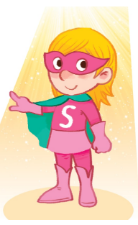  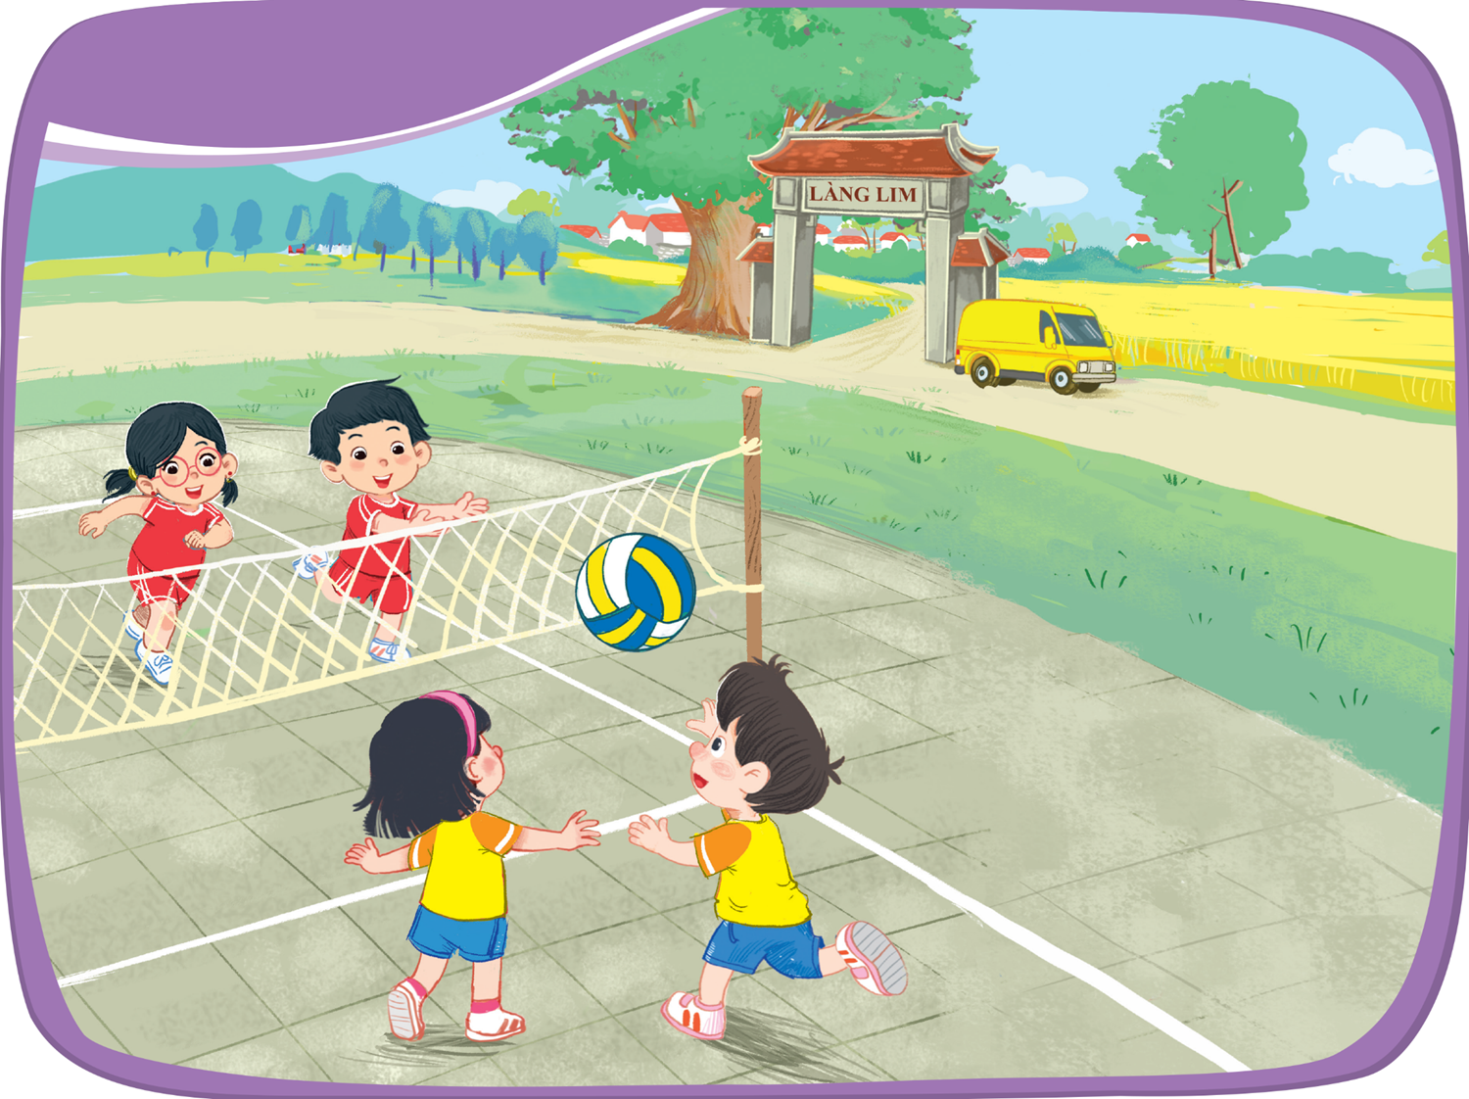  3. What can you see in the picture?  - Shows 3 words: Village, van, volleyball one by one and asks Ss repeat.  -Play the recording again and have them listen, point to the letter V/v and the village, volleyball, van and repeat until they feel confident. Correct pronunciation, if necessary.  - Asks Ss: 3 words have the same letter what’s it?  - Has ss look at the picture and draw ss’ attention to the letter V/v,  - Has Ss play the game: Stick the ball  Rule: T sticks pictures on the board, divides Ss into 2 teams, T says the word and asks Ss throw the ball to the picture. If the team has a good throw, it’ll get 1 mark.  - Asks Ss play the game.  - Check and give the mark.  - Has Ss read the words aloud again. Calls some Ss read in front of the class.  - Asks Ss match the words with the correct pictures.  Activity 2 2. Point and say: 10 minutes  *Aims: to correctly identify and pronounce the name the words village, volleyball, van  *Procedure:  - Have ss look at the picture again and ask them to describe the picture again (in Vietnamese). Draw their attention to the letter V/v, village, volleyball, van if necessary.  - Get them to point to the letter V/v and say it. Let them point to the word and say,  - Give further support to those ss who find it difficult to do the task.  - Follow the same Procedure: with other things. Give further support to those Ss who find it difficult to do the task.  - Ask ss to work in pairs or in groups to point to the picture and say the sound of the letter V/v and the words. Go around and offer help or correct pronunciation, if necessary.  -Invite two or three ss to point to the picture and say the sound of the letter and the words in front of the class.  - T gets feedback.  Activity 3. 8 minutes*Play game: Who’s faster?  *Aims: to correctly pronounce the target words.  *Procedure:  - Divide the class into two teams.  - Two Ss each turn, stand in the middle of class and back to back.  - T gives each of Ss a picture, asks all others must be quite  - Explain that one student make a step forward (4 steps), then turen back and try to say their friend’s picture loudly. The first to say it’s the winner.  - Have time for ss to play game.  - The team with the most word cards wins  *Consolidation  *Aims: Ss will be able consolidate and wrap up the content of the lesson.  *Procedure:  - T asks ss to answer the following questions:  + What letter you learn today?  +What is the sound?  + What are the words?  - T praises some Ss who are hardworking / active/ good…. as well as encourage others to try more.  3. Homework: 2 minutes  - Practice more at home.  - Prepare for the next lesson. | - SS listen and answer the question.  - pay attention, then sing a song and do the actions.  - Look at the picture and answer the questions:  1. She’s Super Sue.  2. She’s goinf to Ba’s Village.  3. I can see a van/ a volleyball.  - Listen and repeat.  -Look at the picture and listen.  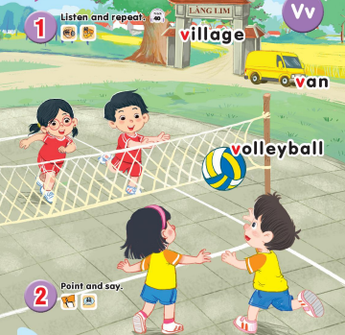  - Answer the question.  - Listen to the teacher.  - work in team and play the game.  - Speak loudly.  - Listen and do the task.  - Listen to the teacher.  -Point, listen and repeat  -Point and say  -Work in pairs or in groups.  -Point and say  -Ss look and listen.  -Ss play the game  -Ss answer the questions. | - SS listen and answer the question.  - pay attention, then sing a song and do the actions.  - Look at the picture and answer the questions:  1. She’s Super Sue.  2. She’s goinf to Ba’s Village.  . I can see a van/ a volleyball.  - Listen and repeat.  -Look at the picture and listen.  - Answer the question.  - Listen to the teacher.  - work in team and play the game.  - Speak loudly.  - Listen and do the task.  - Listen to the teacher.  -Point, listen and repeat  -Point and say  -Work in pairs or in groups.  -Point and say  -Ss play the game  -Ss answer the questions

E. ADJUSTMENTS (if necessary):
………………………………………………………………………………………….…..……………………………………………………………………………...………….….........................................................................................................................................................................................................................................................................

Preparing date: December , 2024
Teaching date: December , 2024

Week 15 UNIT 8: IN THE VILLAGE
Period 30 Lesson 2
A. OBJECTIVES:
1. Knowledge:
- Sound /v/
- Vocabulary: review
- Sentence pattern: This is a ________
- Skills: speaking and listening
2. Competences:
- Correctly pronounce the words village, volleyball, van and say the sentence pattern: This is a ________ in a chant.
3. Attitude/ Qualities:
-Actively participate in activities with their classmates in pairs, groups or class. Educate Ss to become studious and obedient students, love life in the village.
B. METHODS:
- Work in pairs, work in groups, ask and answer.
- Communicative approach, teaching methods with game, teaching methods by visual, teaching methods by practicing, prediction.
C. TEACHING AIDS:
- Teacher: Posters, laptop, pictures, textbook, lesson plan, TV or projector.
- Students: Textbooks, notebooks, workbooks, school things.
D. PROCEDURES:
Teacher’s activities | Students’ activities | Disabled sts’ activities
1.Warm- up: Check-up:  *Aims: to help ss remember the words that they have learn in lesson 1.  *Procedure:  -T asks ss to say the letter and the sound they learnt in lesson 1(V/v, /v/)  Say “Open your book page 35 and look at lesson 2”  2. New lesson  Activity 1. 3. Listen and chant:  *Aims: to correctly pronounce the words village, volleyball, van and say the sentence pattern: This is a ________ in a chant.  *Procedure:  - Have ss look at the chant on p. 35 in their books and draw ss’ attention to the first line and explain its meaning. Ask them to pay attention to the letter V/v and the words: village, volleyball, van. Check comprehension.  - Play the recording of the first verse for Ss to listen and to get familiarized with the tune.  - Play the recording again, ask ss to listen and repeat the first line. Then play the recording for them to listen and repeat until they feel confident.  - Follow the same Procedure: with the other verse. Show ss how to chant and clap their hands. Correct pronunciation, if necessary.  - Play the recording all the way through. Ask ss to listen and repeat the chant individually and in chorus. Give further support to those ss who find it difficult to do the task.  - Select some ss to the front of the class to chant and clap their hands. The rest of the class may sing the chant along and clap their hands.  Activity 2 4. Listen and circle:  *Aims: to recognize the words village, volleyball, van and the sentence pattern: This is a ________  *Procedure:  -Have Ss look at two pictures and say what they can see. Draw ss’ attention to the boxes next to the letters a and b. Check comprehension.  -Encourage some ss to point to the pictures and say the words in front of the class. E.g. 1a: car, 1b: van  - Play the recording for ss to listen and circle  - Let ss to listen again and check.  -T gets feedback.  *Keys: 1.b / 2.a  Activity 3. 5. Look and write:  *Aims: to write the letter V/v and complete the words: village, volleyball, van  *Procedure:  - Have Ss look at the letter V (upper case) and v (lower case). Ask ss to make sure if they recognize the two forms of the letter.  - Tell ss to trace the letter V/v. T can demonstrate by air tracing or tracing the broken lines of the letter V/v on the board.  -Then let ss write the letter. Then find out the missing letter to complete the correct word. Give further support to those Ss who find it difficult to do the task.  - Check the results of ss’ tracing and give feedback. Ask ss to work in pairs and swap their answers. Give ss time to work. Go around and offer help, if necessary.  - Ask some ss to show what they have done.  3. Homework  - Practice more at home.  - Prepare for the next lesson. | - SS say the letter and the sound.  -SS open their book.  -Look at the picture and listen.  -Ss listen.  -Ss listen and repeat.  -SS listen and chant.  -SS chant.  -SS chant in front of the class.  -Look at the picture and describe.  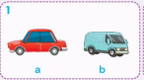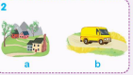  -Point and say  -SS listen and do the task.  -Ss look and listen.  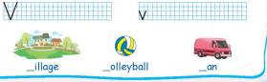  -Ss listen.  -SS do the task.  -Check in pairs.  -Ss show their work.  -SS listen. | - SS say the letter and the sound.  -SS open their book.  -Look at the picture and listen.  -Ss listen.  -Ss listen and repeat.  -SS listen and chant.  -SS chant.  -Look at the picture and describe.  -Point and say  -SS listen and do the task.  -Ss look and listen.  -Ss listen.  -SS do the task.  -Check in pairs.  -Ss show their work.  -SS listen.

E. ADJUSTMENTS (if necessary):
………………………………………………………………………………………….…..………………………………………………………………….…………….………………………………………………………………………………..…………….

