Preparing date: November , 2024
Teaching date: November , 2024
Week 11 UNIT 6: ON THE FARM
Period 21 Lesson 1

A.OBJECTIVES:
1. Knowledge:
- Sound /x/
- Vocabulary: box, fox ox
- Skills: Integrated skills (speaking and listening)
2. Competences:
- Correctly pronounce the name of letter X/x and the sound /x/ in isolation.
- Say correctly the words: box, fox ox
3. Attitude/ Qualities:
- Actively participate in activities with their classmates in pairs, groups or class. Educate Ss to become studious and obedient students, love life on the farm.
B. METHODS:
- Work in pairs, work in groups, ask and answer.
- Communicative approach, teaching methods with game, teaching methods by visual, teaching methods by practicing, prediction.
C. TEACHING AIDS:
- Teacher: Posters, laptop, pictures, textbook, lesson plan, TV or projector.
- Students: Textbooks, notebooks, workbooks, school things.
D. PROCEDURES:
Teacher’s activities | Students’ activities | Disabled sts’ activities
1.Warm- up:  Game: Guessing game  *Aims: to help ss review some vocabulary that they learnt.  *Procedure:  -Have ss to look through 3 pictures (which is closed). T opens each piece of each picture for ss to guess about the pets and then read aloud name of the food. T checks and have ss read all the words.  - Say “Open your book page 26 and look at Unit 6, Lesson 1”  2. New lesson  Activity 1. 1. Listen and repeat:  *Aims: to correctly pronounce the name of letter X/x and the sound / x/ both in isolation and in the words box, fox, ox  *Procedure:  - Have ss look at the picture and draw ss’ attention to the letter X/x, the words next to the things and the colour of the letter X/x  -Ask ss to point to the letter X/x  -Tell ss to point to box. Ask them to listen and repeat the word.  -Repeat the same Procedure: with the words: fox ox, Give further support to those ss who find it difficult to do the task.  -Play the recording again and have them listen, point to the letter X/x and the box, fox ox and repeat until they feel confident. Correct pronunciation, if necessary.  -Play the recording again and call some ss to say the letter X/x and the words box, fox ox in front of the class.  Activity 2 2. Point and say:  *Aims: to correctly identify and pronounce the name the words box, fox ox  *Procedure:  - Have ss look at the picture again and ask them to describe the picture again (in Vietnamese). Draw their attention to the letter X/x, box, fox ox  if necessary.  - Get them to point to the letter X/x and say it. Let them point to the word and say,  - Give further support to those ss who find it difficult to do the task.  - Follow the same Procedure: with other things. Give further support to those Ss who find it difficult to do the task.  - Ask ss to work in pairs or in groups to point to the picture and say the sound of the letter X/x and the words. Go around and offer help or correct pronunciation, if necessary.  -Invite two or three ss to point to the picture and say the sound of the letter and the words in front of the class.  - T gets feedback.  Activity 3. Play game: Whisper(race version)  *Aims: to correctly pronounce the target words: box, ox, fox  *Procedure:  - Divide the class into 2 teams to play game. Tell team to form a line  - Explain that when you whisper a word to the first student in each line. He/ she must turn whisper it to the second student in the line , and the turn whisper to other students in the line. When the word reaches the last student in the line he/ she should call it out. A correct word scores one point.  - Have time for ss to play game.  -Count the points for each team and announce the winner. The team with the most points wins  3. Homework  - Practice more at home.  - Prepare for the next lesson. | - SS listen and play game.  -SS open their book.  -Look at the picture and listen.  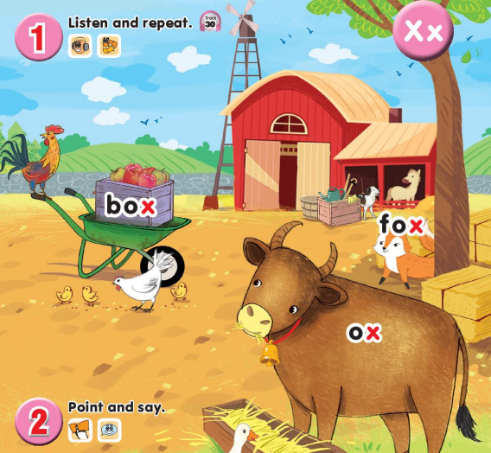  -Point, listen and repeat.  -Ss repeat.  -Ss listen and repeat.  -SS listen, point and repeat.  -SS say in front of the class.  -Look at the picture and describe.  -Point and say  -Work in pairs or in groups.  -Point and say  -Ss look and listen  -Ss play game.  -Ss listen. | - SS listen and play game.  -SS open their book.  -Look at the picture and listen.  -Point, listen and repeat.  -Ss repeat.  -Ss listen and repeat.  -SS listen, point and repeat.  -SS say in front of the class.  -Look at the picture and describe.  -Point and say  -Work in pairs or in groups.  -Ss look and listen  -Ss play game.  Ss listen

E. ADJUSTMENTS (if necessary):
………………………………………………………………………………………….…..……………………………………………………………………………...………….…....................................................................................................................................................................................................

Preparing date: November , 2024
Teaching date: November , 2024
Week 11 UNIT 6: ON THE FARM
Period 22 Lesson 2
A. OBJECTIVES:
1. Knowledge:
- Sound /x/
- Vocabulary: review
- Sentence pattern: I can see a/ an ________
- Skills: Integrated skills (speaking and listening)
2. Competences:
- Correctly pronounce the words box, fox ox and say the sentence pattern: I can see a/ an ________ in a chant.
3. Attitude/ Qualities:
-Actively participate in activities with their classmates in pairs, groups or class. Educate Ss to become studious and obedient students, love life on the farm.
B. METHODS:
- Work in pairs, work in groups, ask and answer.
- Communicative approach, teaching methods with game, teaching methods by visual, teaching methods by practicing, prediction.
C. TEACHING AIDS:
- Teacher: Posters, laptop, pictures, textbook, lesson plan, TV or projector.
- Students: Textbooks, notebooks, workbooks, school things.
D. PROCEDURES:
Teacher’s activities | Students’ activities | Disabled sts’ activities
1.Warm- up: Check-up:  *Aims: to help ss remember the words that they have learn in lesson 1.  *Procedure:  -T asks ss to say the letter and the sound they learnt in lesson 1(X/x, /x/)  Say “Open your book page 27 and look at lesson 2”  2. New lesson  Activity 1. 3. Listen and chant:  *Aims: to correctly pronounce the words box, fox ox and say the sentence pattern: I can see a/ an ________in a chant.  *Procedure:  - Have ss look at the chant on p. 27 in their books and draw ss’ attention to the first line and explain its meaning. Ask them to pay attention to the letter X/x and the words: box, fox ox. Check comprehension.  - Play the recording of the first verse for Ss to listen and to get familiarized with the tune.  - Play the recording again, ask ss to listen and repeat the first line. Then play the recording for them to listen and repeat until they feel confident.  - Follow the same Procedure: with the other verse. Show ss how to chant and clap their hands. Correct pronunciation, if necessary.  - Play the recording all the way through. Ask ss to listen and repeat the chant individually and in chorus. Give further support to those ss who find it difficult to do the task.  - Select some ss to the front of the class to chant and clap their hands. The rest of the class may sing the chant along and clap their hands.  Activity 2 4. Listen and circle:  *Aims: to recognize the words box, fox ox  and the sentence pattern: I can see a/ an ____  *Procedure:  -Have Ss look at two pictures and say what they can see. Draw ss’ attention to the boxes next to the letters a and b. Check comprehension.  -Encourage some ss to point to the pictures and say the words in front of the class. E.g. 1a: fox, 1b: ox  - Play the recording for ss to listen and circle.  - Let ss to listen again and check.  -T gets feedback.  *Keys: 1.b / 2.a  Activity 3. 5. Look and write:  *Aims: to write the letter X/x and complete the words: kite, kitten, bike  *Procedure:  - Have Ss look at the letter X (upper case) and x (lower case). Ask ss to make sure if they recognize the two forms of the letter.  - Tell ss to trace the letter X/x. T can demonstrate by air tracing or tracing the broken lines of the letter , X/x on the board.  -Then let ss write the letter. Then find out the missing letter to complete the correct word. Give further support to those Ss who find it difficult to do the task.  - Check the results of ss’ tracing and give feedback. Ask ss to work in pairs and swap their answers. Give ss time to work. Go around and offer help, if necessary.  - Ask some ss to show what they have done.  3. Homework  - Practice more at home.  - Prepare for the next lesson. | - SS say the letter and the sound.  -SS open their book.  -Look at the picture and listen.  -Ss listen.  -Ss listen and repeat.  -SS listen and chant.  -SS chant.  -SS chant in front of the class.  -Look at the picture and describe.  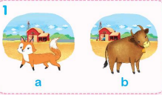  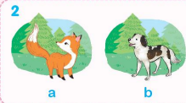  -Point and say  -SS listen and do the task.  -Ss look and listen.  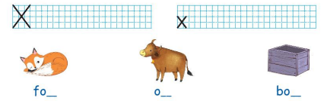  -Ss listen.  -SS do the task.  -Check in pairs.  -Ss show their work.  -SS listen. | - SS say the letter and the sound.  -SS open their book.  -Look at the picture and listen.  -Ss listen.  -Ss listen and repeat.  -SS listen and chant.  -SS chant.  -Look at the picture and describe.  -Point and say  -SS listen and do the task.  Ss look and listen.  -Ss listen.  -SS do the task.  -Check in pairs.  -Ss show their work.  -SS listen.

E. ADJUSTMENTS (if necessary):

………………………………………………………………………………………….…..………………………………………………………………….…………….…………………………………………………………….

