Preparing date: October , 2024
Teaching date: October , 2024

Week 6 UNIT 3: AT THE SEASIDE
Period 11 Lesson 3

A. OBJECTIVES:
1. Knowledge:
- Vocabulary: review
- Sentence pattern: Let’s look at the _____!
- Skills: Integrated skills (speaking and listening)
2. Competences:
- By the end of the lesson, students will be able to:
- Use: Let’s look at the _____! to suggest doing something.
- Sing a song about suggesting doing something.
3. Attitude/ Qualities:
-Actively participate in activities with their classmates in pairs, groups or class. Educate Ss to become studious and obedient students, love nature, love learning English
B. METHODS:
- Work in pairs, work in groups, ask and answer.
- Communicative approach, teaching methods with game, teaching methods by visual, teaching methods by practicing, prediction.
C. TEACHING AIDS:
- Teacher: Posters, laptop, pictures, textbook, lesson plan, TV or projector.
- Students: Textbooks, notebooks, workbooks, school things.
D. PROCEDURES:
Teacher’s activities | Students’ activities | Disabled sts’ activities
1.Warm- up: 5’  Game: Slap the board  *Aims: to help ss review some vocabulary that they learnt.  *Procedure:  -Write the words on the board  - Call 2 Ss to go to the board and ask them to slap the word when T says one word aloud.  - After finishing the game, the student slaps more correct words will be the winner.  - Say “Open your book page 16 and look at lesson 3”  2. New lesson  Activity 1. 6. Listen and repeat:  *Aims: to use Let’s look at the _____! to suggest doing something.  *Procedure:  - Have Ss look at the first picture. Play the recording for ss to listen and repeat,  - Have ss look at the sentence: Let’s look at the sea! Explain the meaning of the sentence and how it is used. Check comprehension.  -Play the recording several times for ss to listen and repeat the sentence. Give more support to those ss who find it difficult to do the task.  - Invite some ss to say the sentences in front of the class.  - T checks and corrects.  Activity 2 7. Let’s talk:  *Aims: to use Let’s look at the _____! to suggest doing something.  *Procedure:  - Have ss look at the first picture. Point to the pictures and ask them What are they doing? Tell them about suggesting doing something.  - Ask ss to work in pairs to practise suggesting doing something. Offer help, if necessary.  - Have ss look at the second picture. And practise in pairs.  - Ask a few pairs of ss to practise in front of the class. Offer help, if necessary.  - T gets feedback.  Activity 3. 8. Let’s sing:  *Aims: to Sing a song about at the seaside  *Procedure:  -Have ss read the lyrics to familiarize themselves with the first verse of the song. Explain the meanings of the verse, if necessary. Check comprehension.  -Play the recording several times for ss to repeat line after line to make sure that they can sing the verse correctly.  - Do the same with the second verse of the lyrics. Play the recording several times for ss to repeat to make sure that they can sing the verse correctly. Check comprehension.  -Have time for ss practise singing the song. Help them sing the song sentence by sentence first. Then help them to sing the whole song.  - Call one or two groups to sing the song in front of the class.  3. Homework:  - Practice more at home.  - Prepare for Unit 4 lesson 1. | - SS listen and play game.  -SS open their book.  -Look at the picture and listen and repeat.  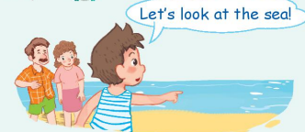  -Ss listen.  -Ss listen and repeat.  -SS say.  -Look at the picture and describe.    -Point and say  -SS practice in pairs.  -SS practice in front of the class.  -Ss look and listen.  -Ss listen and repeat.  -SS do the task.  -SS sing the song.  -Ss sing in front of the class.  -SS listen. | - SS listen and play game.  -SS open their book.  -Look at the picture and listen and repeat.  -Ss listen.  -Ss listen and repeat.  -SS say.  -Look at the picture and describe.  -Point and say  -SS practice in pairs.  -SS practice in front of the class.  -Ss look and listen.  -Ss listen and repeat.  -SS do the task.  -SS listen.

E. ADJUSTMENTS (if necessary):
………………………………………………………………………………………….…..……………………………………………………………………………………….….........................................................................................................................................................................................................................................................

Preparing date: October , 2024
Teaching date: October , 2024
Week 6 UNIT 4: IN THE COUNTRYSIDE
Period 12 Lesson 1

A. OBJECTIVES:
1. Knowledge:
- Sound /r/
- Vocabulary: river, rainbow, road
- Skills: Integrated skills (speaking and listening)
2. Competences:
- Pronounce correctly pronounce the name of letter R/r and the sound /r/ in
isolation.
- Say correctly the words river, rainbow, road
3. Attitude/ Qualities:
-Actively participate in activities with their classmates in pairs, groups or class. Educate Ss to become studious and obedient students, love nature and countryside
B. METHODS:
- Work in pairs, work in groups, ask and answer.
- Communicative approach, teaching methods with game, teaching methods by visual, teaching methods by practicing, prediction.
C. TEACHING AIDS:
- Teacher: Posters, laptop, pictures, textbook, lesson plan, TV or projector.
- Students: Textbooks, notebooks, workbooks, school things.
D. PROCEDURES:

Teacher’s activities | Students’ activities | Disabled sts’ activities
1.Warm- up:  Game: Guessing game  *Aims: to help ss review some vocabulary that they learnt.  *Procedure:  -Have ss to look through 3 pictures (which is closed). T opens each piece of each picture for ss to guess about the pets and then read aloud name of the food. T checks and have ss read all the words.  - Say “Open your book page 17 and look at Unit 4, Lesson 1”  2. New lesson  Activity 1. 1. Listen and repeat:  *Aims: to correctly pronounce the name of letter R/r and the sound / r/ both in isolation and in the words river, rainbow, road  *Procedure:  - Have ss look at the picture and draw ss’ attention to the letter R/r, the words next to the things and the colour of the letter R/r.  -Ask ss to point to the letter R/r Have them listen and repeat the sound of the letter R/r more than once, if necessary.  -Tell ss to point to rainbow. Ask them to listen and repeat the word.  -Play the recording again and have them listen, point to the letter R/r and the river, rainbow, road and repeat until they feel confident. Correct pronunciation, if necessary.  -Play the recording again and call some ss to say the letter R/r and the words river, rainbow, road in front of the class.  Activity 2 2. Point and say:  *Aims: to correctly identify and pronounce the name the words river, rainbow, road  *Procedure:  - Have ss look at the picture again and ask them to describe the picture again (in Vietnamese). Draw their attention to the letter R/r, river, rainbow, road  if necessary.  - Get them to point to the letter R/r and say it. Let them point to the word and say,  - Give further support to those ss who find it difficult to do the task.  - Follow the same Procedure: with other things. Give further support to those Ss who find it difficult to do the task.  - Ask ss to work in pairs or in groups to point to the picture and say the sound of the letter R/r and the words. Go around and offer help or correct pronunciation, if necessary.  -Invite two or three ss to point to the picture and say the sound of the letter and the words in front of the class.  - T gets feedback.  Activity 3. *Play game: Board Race  *Aims: to match the beginning and endings of target words as quickly as possible.  *Procedure:  - Divide the class into teams to play game.  - Have ss to stand in in a circle and hold up their flashcards, so that they can all see what is written on them. Explain that when you call out, e.g: rainbow, the two ss who are holding the beginning and ending of the word must find each other, run to the board and stick the flashcards in the correct order. The fastest pair wins one point. The team with most point wins.  - Have time for ss to play game.  -Count the points for each team and announce the winner. The team with the most points wins  3. Homework  - Practice more at home.  - Prepare for the next lesson. | - SS listen and play game.  -SS open their book.  -Look at the picture and listen  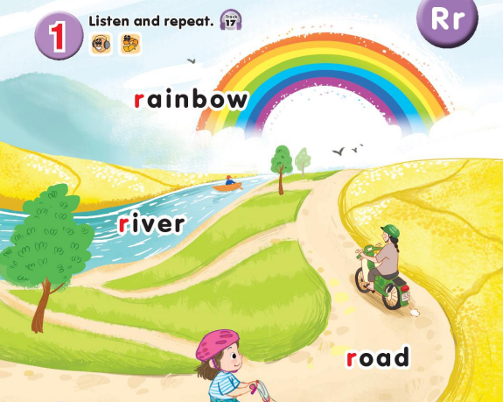  -Point, listen and repeat.  -Ss repeat.  -Ss listen and repeat.  -SS listen, point and repeat.  -SS say in front of the class.  -Look at the picture and describe.  -Point and say  -Work in pairs or in groups.  -Point and say  -Ss look and listen.  -Ss play game.  -Ss listen. | - SS listen and play game.  -SS open their book.  -Look at the picture and listen  -Point, listen and repeat.  -Ss repeat.  -Ss listen and repeat.  -SS listen, point and repeat.  -SS say in front of the class.  -Look at the picture and describe.  -Point and say  -Work in pairs or in groups.  -Point and say  -Ss look and listen.  -Ss listen.
E. ADJUSTMENTS (if necessary):

………………………………………………………………………………………….…..………………………………………………………………….…………….……

