Preparing date: September , 2024
Teaching date: September , 2024
Week 2 UNIT 1: AT MY BIRTHDAY PARTY
Period 3 Lesson 3

A. OBJECTIVES:
1. Knowledge:
- Sound /p/
- Vocabulary: pasta, popcorn, pizza
- Skills: Integrated skills (speaking and listening)
2. Competences:
- Pronounce correctly pronounce the name of letter P/p and the sound /p/ in isolation.
- Say correctly the words pasta, popcorn, pizza
3. Attitude/ Qualities:
-Actively participate in activities with their classmates in pairs, groups or class. Educate Ss to become studious and obedient students, love food, love learning English
B. METHODS:
- Work in pairs, work in groups, ask and answer.
- Communicative approach, teaching methods with game, teaching methods by visual, teaching methods by practicing, prediction.
C. TEACHING AIDS:
- Teacher: Posters, laptop, pictures, textbook, lesson plan, TV or projector.
- Students: Textbooks, notebooks, workbooks, school things.
D. PROCEDURES:
Teacher’s activities | Students’ activities | Disabled sts’ activities
1.Warm- up:  Game: Slap the board  *Aims: to help ss review some vocabulary that they learnt.  *Procedure:  -Write the words on the board  - Call 2 Ss to go to the board and ask them to slap the word when T says one word aloud.  - After finishing the game, the student slaps more correct words will be the winner.  - Say “Open your book page 8 and look at lesson 3”  2. New lesson  Activity 1. 6. Listen and repeat  *Aims: to Use: The ____is yummy to express this feeling about a particular food.  *Procedure:  - Have Ss look at the first picture. Play the recording for ss to listen and repeat,  - Have ss look at the sentence: The popcorn is yummy. Explain the meaning of the sentence and how it is used. Check comprehension.  -Play the recording several times for ss to listen and repeat the sentence. Give more support to those ss who find it difficult to do the task.  - Invite some ss to say the sentences in front of the class.  - T checks and corrects.  Activity 2 7. Let’s talk  *Aims: to use: The ____is yummy to express this feeling about a particular food.  *Procedure:  - Have ss look at the first picture. Point to the food and ask them What is this? Tell them how to express this feeling about a particular food. (The popcorn is yummy.)  - Ask ss to work in pairs to practise expressing this feeling about a particular food. Offer help, if necessary.  - Have ss look at the second picture. And practise in pairs.  - Ask a few pairs of ss to practise in front of the class. Offer help, if necessary.  - T gets feedback.  Activity 3. 8. Let’s sing  *Aims: to Sing a song about feeling with a particular food.  *Procedure:  -Have ss read the lyrics to familiarize themselves with the first verse of the song. Explain the meanings of the verse, if necessary. Check comprehension.  -Play the recording several times for ss to repeat line after line to make sure that they can sing the verse correctly.  - Do the same with the second verse of the lyrics. Play the recording several times for ss to repeat to make sure that they can sing the verse correctly. Check comprehension.  -Have time for ss practise singing the song. Help them sing the song sentence by sentence first. Then help them to sing the whole song.  - Call one or two groups to sing the song in front of the class.  3. Homework  - Practice more at home.  - Prepare for Unit 2 lesson 1. | - SS listen and play game.  -SS open their book.  -Look at the picture and listen and repeat.  -Ss listen.  -Ss listen and repeat.  -SS say.  -Look at the picture and describe.  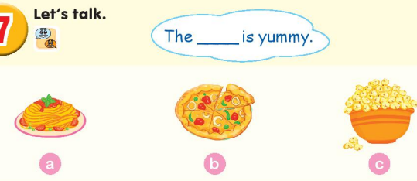  -Point and say  -SS practice in pairs.  -SS practice in front of the class.  -Ss look and listen.  -Ss listen and repeat.  -SS do the task.  -SS sing the song.  -Ss sing in front of the class.  -SS listen. | - SS listen and play game.  -SS open their book  -Look at the picture and listen and repeat.  -Ss listen.  -Ss listen and repeat.  -SS say.  -Look at the picture and describe.  -Point and say  -Ss look and listen.  -Ss listen and repeat.  -SS sing the song.

E. Adjustments (if necessary):
………………………………………………………………………………………….…..……………………………………………………………………………………….….........................................................................................................................................................................................................................................................

Preparing date: September , 2024
Teaching date: September , 2024

Week 2 UNIT 2: IN THE BACKYARD
Period 4 Lesson 1

A. OBJECTIVES:
1. Language focus/Knowledge:
- Sound /k/
- Vocabulary: kite, kitten, bike
- Skills: Integrated skills (speaking and listening)
2. Competences:
- Correctly pronounce the name of letter K/ k and the sound /k/ in isolation.
- Say correctly the words kite, kitten, bike
3. Attitude/ Qualities:
-Actively participate in activities with their classmates in pairs, groups or class. Educate Ss to become studious and obedient students, love activities, love learning English
B. METHODS:
- Work in pairs, work in groups, ask and answer.
- Communicative approach, teaching methods with game, teaching methods by visual, teaching methods by practicing, prediction.
C. TEACHING AIDS:
- Teacher: Posters, laptop, pictures, textbook, lesson plan, TV or projector.
- Students: Textbooks, notebooks, workbooks, school things.
D. PROCEDURES:

Teacher’s activities | Students’ activities | Disabled sts’ activities
1.Warm- up:  Game: Guessing game  *Aims: to help ss review some vocabulary that they learnt.  *Procedure:  -Have ss to look through 3 pictures (which is closed). T opens each piece of each picture for ss to guess about the pets and then read aloud name of the food. T checks and has ss read all the words.  - Say “Open your book page 9 and look at Unit 2, Lesson 1”  2. New lesson  Activity 1. 1. Listen and repeat:  *Aims: to correctly pronounce the name of letter K/ k and the sound / k/ both in isolation and in the words kite, kitten, bike  *Procedure:  - Have ss look at the picture and draw ss’ attention to the letter K/ k, the words next to the things and the colour of the letter K/ k.  -Ask ss to point to the letter K/ k Have them listen and repeat the sound of the letter K/ k more than once, if necessary.  -Tell ss to point to kite. Ask them to listen and repeat the word.  -Repeat the same Procedure: with the words: kitten, bike, Give further support to those ss who find it difficult to do the task.  -Play the recording again and have them listen, point to the letter K/ k and the kite, kitten, bike and repeat until they feel confident. Correct pronunciation, if necessary.  -Play the recording again and call some ss to say the letter K/ k and the words kite, kitten, bike in front of the class.  Activity 2 2. Point and say:  *Aims: to correctly identify and pronounce the name the words kite, kitten, bike  - using flash cards, recording, pictures…  *Procedure:  - Have ss look at the picture again and ask them to describe the picture again (in Vietnamese). Draw their attention to the letter K/ k, kite, kitten, bike  if necessary.  - Get them to point to the letter K/ k and say it. Let them point to the word and say,  - Give further support to those ss who find it difficult to do the task.  - Follow the same Procedure: with other things. Give further support to those Ss who find it difficult to do the task.  - Ask ss to work in pairs or in groups to point to the picture and say the sound of the letter K/ k and the words. Go around and offer help or correct pronunciation, if necessary.  -Invite two or three ss to point to the picture and say the sound of the letter and the words in front of the class.  - T gets feedback.  Activity 3. *Play Word game:  *Aims: to identify words containing a particular sound.  *Procedure:  - Divide the class into 2 teams to play game.  - Have ss to pronounce the sound of the letter, eg: /k/, ss should look through their pack of flashcards to find a word containing that sound, eg: bike, kite. When they found the correct word, they should stick the flashcard on the board. A correct word scores one point.  - Have time for ss to play game.  -Count the points for each team and announce the winner. The team with the most points wins  4. Homework  - Practice more at home.  - Prepare for the next lesson. | - SS listen and play game.  -SS open their book.  -Look at the picture and listen.  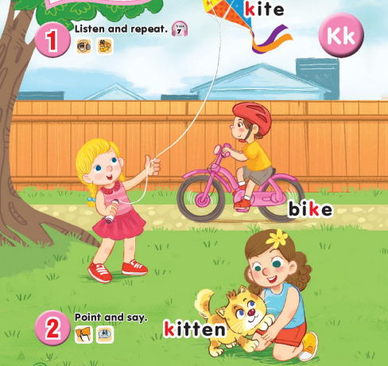  -Point, listen and repeat.  -Ss repeat.  -Ss listen and repeat.  -SS listen, point and repeat.  -SS say in front of the class.  -Look at the picture and describe.  -Point and say  -Work in pairs or in groups.  -Point and say  -Ss look and listen.  -Ss play game.  -Ss listen. | - SS listen and play game.  -SS open their book  -Look at the picture and listen.  -Point, listen and repeat  -Ss repeat.  -Ss listen and repeat.  -Point and say  -Work in pairs  Point and say  -Ss look and listen.  -Ss listen.
E. Adjustments (if necessary):
………………………………………………………………………………………….…..……………………………………………………………………………

